AgentCare — Agentic AI for Patient Administration and Care Coordination
Build an agentic healthcare administration system that coordinates a patient's non-clinical journey — from registration and department routing to appointment booking, document collection, reminders, and follow-up — while keeping medical decisions under human supervision.
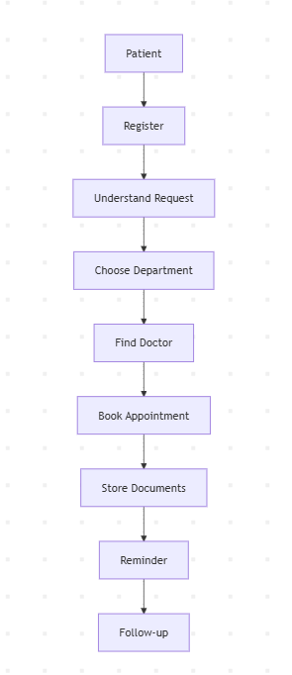
Agents plan
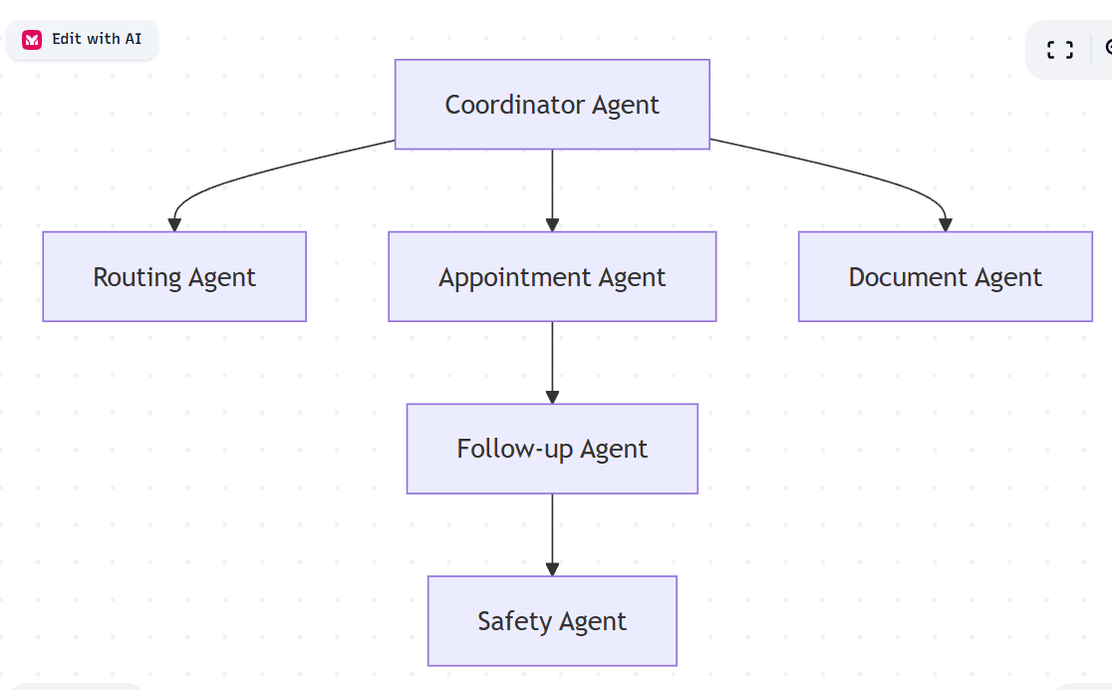
Tech Stack
- Backend: FastAPI
- Frontend: Streamlit
- Agent Framework: LangGraph
- LLM: Claude / OpenAI / Groq (configurable)
- Database: SQLite + SQLAlchemy
- Authentication: JWT
- Document Processing: PyMuPDF
- Scheduling: APScheduler
- Deployment: Docker + Render
Design the Database
Patient

Doctor

Department

Appointment

AppointmentSlot

Document

Workflow

Reminder

Audit

Escalation
Build the Backend
FastAPI

↓

CRUD APIs

↓

Business Logic

↓

Tools

↓

SQLite

Build the LangGraph Workflow
START

↓

Coordinator

↓

Routing

↓

Appointment

↓

Document

↓

Reminder

↓

Safety

↓

END

AgentCare/
│
├── app/
│ ├── agents/
│ │ ├── coordinator.py
│ │ ├── routing.py
│ │ ├── appointment.py
│ │ ├── document.py
│ │ ├── followup.py
│ │ └── safety.py
│ │
│ ├── tools/
│ ├── database/
│ ├── models/
│ ├── schemas/
│ ├── services/
│ ├── auth/
│ ├── api/
│ └── main.py
│
├── frontend/
│ └── streamlit_app.py
│
├── langgraph_workflow.py
├── requirements.txt
├── Dockerfile
├── README.md
└── .env.example

app/
├── agents/
├── api/
├── auth/
├── core/
├── database/
├── models/
├── repositories/
├── services/
├── tools/
├── workflows/
└── frontend/

