**Graphs and Analysis**

1. A. From first graph we see that number of females who have attempted the survey is more than the number of males.

B. From the second graph we see that the most people belong to the age group of 36-60 years.

C. More number of people who do not prefer home remedies belong to the below 20 age group.

D. Slightly more number of males do not prefer home remedies eventhough the number of males who attempted the survey is lower.

1. A. From first graph we see that number of people who have attempted the survey are more from Urban than Rural locality.

B. From the second graph we see that the most people have either completed or are doing the Graduate.

C. The number of people who do not prefer Home Remedies seem to be equal in those who are educated up to High School and Post Graduate.

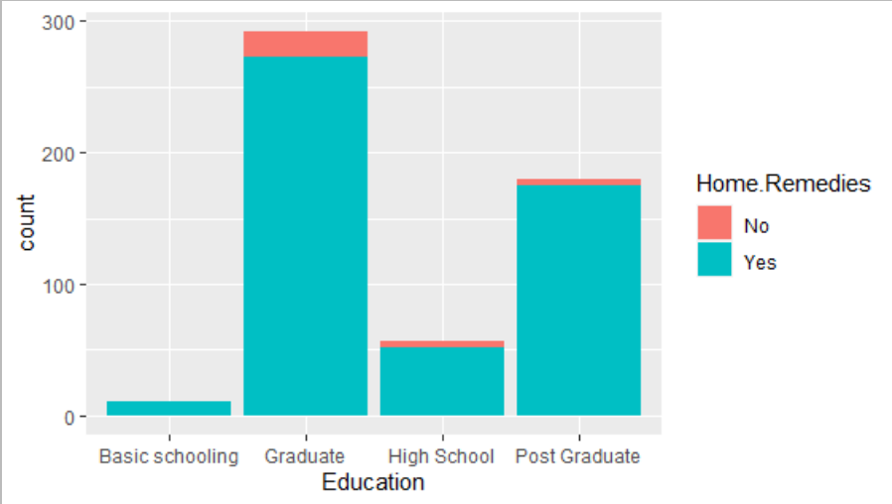

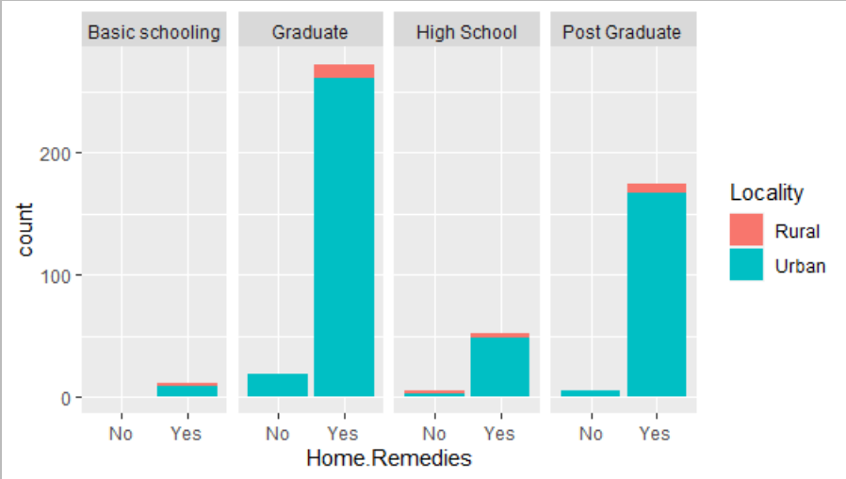

**Once in a while** – Slightly Positively/Right skewed

**Never** – Highly Positively/Right skewed

**Most of the time** - Negatively / Left skewed

**Always** – Negatively / Left skewed. Has an outlier

**Once in a while** – Slightly Negatively / Left skewed

**Never** – Highly Positively/Right skewed.

**Most of the time** - Negatively / Left skewed

**Always** – Negatively / Left skewed. Has outliers

**Once in a while** – Almost Normally distributed

**Never** – Highly Positively/Right skewed. Has an outlier

**Most of the time** - Negatively / Left skewed

**Always** – Negatively / Left skewed. Has an outlier

**Once in a while** – Slightly Negatively / Left skewed

**Never** – Highly Positively/Right skewed Has an outlier

**Most of the time** - Negatively / Left skewed. Has an outlier

**Always** – Almost Normally distributed

**Once in a while** – Slightly Positively/Right skewed.

**Never** – Highly Positively/Right skewed.

**Most of the time** - Negatively / Left skewed

**Always** – Negatively / Left skewed. Has an outlier

**Once in a while** – Negatively / Left skewed

**Never** – Almost Normally distributed

**Most of the time** - Negatively / Left skewed

**Always** – Slightly skewed. Has an outlier

**Once in a while** – Almost Normally distributed

**Never** – Highly Positively/Right skewed.

**Most of the time** – Highly Negatively / Left skewed

**Always** – Negatively / Left skewed. Has an outlier

**Once in a while** – Negatively / Left skewed

**Never** – Almost Normally distributed

**Most of the time** - Highly Negatively / Left skewed

**Always** – Negatively / Left skewed. Has an outlier

Irrespective of the age groups, majority of the people have used Home Remedies at least once.

Irrespective of age groups, majority have used Kadha / Herbal Tea for cough and cold.

Irrespective of age groups, majority have applied Turmeric (Haldi) on wounds/acne/pimples.

Irrespective of age groups, majority have used Turmeric (Haldi) milk for Cough/Fever or even other general purposes.

Irrespective of age groups, majority have used Hot water steam Cold / Sinus / Glowing skin.

Irrespective of age groups, majority have gargled with salty hot water for sore throat.

For all age groups except 21 – 35, the number of people using Aloe Vera / Onion Juice / Egg for hairs is almost equal to the number of people not using it.

But for age group 21 – 35, the number of people using it is more than those not using it.

The reason behind this might be that it is a new age remedy and people (especially higher age groups) might not be much aware about it.

For the age groups Below 20 and 21-35, most people haven’t used Fennel seeds for Constipation.

For the age groups 36-60 and above 60, the number of people who used Fennel seeds is almost equal to those who do not.

This might be because Constipation is more prone in older generations.

For the age groups 21 and above, more people have used other uncommon remedies which wasn’t specified in the survey.

For people Below 20, more people have used the common remedies mentioned in the survey.

1. A. We can see that for Sore throat/Cough and Running Nose most people use Home Remedies most of the time or sometimes even always.

B. We can see that for Diarrhoea and Back/Joint pain most people prefer not to use Home Remedies (i.e. Never or Once in a while).

1. A. We can see that for both, Constipation and Headache almost equal number of people prefer both, to use or not to use Home Remedies

B. We can see that for Wounds/Minor Cuts and Bruises slightly more number of people prefer to use Home Remedies.

C. We can see that for Sleeping problems or Nervousness more number of people prefer not to use Home Remedies.

