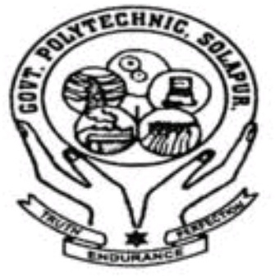 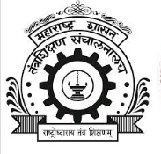

**Government Polytechnic, Solapur.**

**Maharashtra State Board Of Technical Education, Mumbai.**

**A PROJECT REPORT**

**C Language Application Devlopment**

***Submitted******by***

**Roll No. 029 YOGESH ADAKI**

**Roll No. 30 PRASHANT MHANTA**

**Roll No.37 VISHAL GANGJI**

**Roll No.21 ABHISHEK KORACHGAO**

**In Partial Fulfilment of the sixth semester**

**Of**

**Diploma in Engineering and technology**

**In**

**Information Technology**

***Under the guidance of***

**Mrs. S.N.Gaikwad**

** CERTIFICATE **

MAHARASHTRA STATE BOARD OF TECHNICAL , MUMBAI.

GOVERNMENT POLYTECHNIC, SOLAPUR.

*This is to certify that the following student*

**Roll No. 29 YOGESH ADAKI**

**Roll No. 30 PRASHANT MHANTA**

**Roll No.37 VISHAL GANGJI**

**Roll No.21 ABHISHEK KORACHGAO**

Of sixth semester of diploma in Information Technology of institute ***Government Polytechnic, Solapur (code:0015)*** have completed the micro – project Work satisfactorily under my supervision guidance in **MAD(22617)**

the academic year 2020-2021 as prescribed in the I-Scheme curriculum.

**Mrs. S.N.Gaikwad**

(Project Guide) H.O.D Principal

**ACKOWLEDGEMENT**

We Wish to express our profound and sincere gratitude to our guided **Mrs. S.N.Gaikwad.** Who Guided us into the intricacies of this micro-project non chalantly with matchless magnanimity. We are indebte to his constant encouragement cooperation and help. It was his enthusiastic support that helped us in overcoming the various obstacles in this project.

We would also like to express our thankfulness to our beloved principal H.O.D. and other faculty members of our Third Year Department for extending their support and motivation.

Finally, we would be failing in our duty, if we don’t acknowledge the cooperation rendered during various stages of this micro-project by

THANK YOU…!!!!

**Part – A Micro-Project Proposal**

**Title of Micro-Project**

**“C Language App Development”**

1. **Aims/Benefits of the Micro-Project -- “C Language App Development”**
2. **Course Outcomes Addressed**

* Interpreter features of Android operating system.
* Configure Android environment and development tools.
* Develop rich user Interfaces by using layouts and controls.
* Use User Interface components for android application development.
* Create Android application using database.
* Publish Android applications.

1. **Proposed Methodology**

* First up all we known about what is C Language App Development .
* Then we studied about how the work C Language App Development.
* After that we collected all related information of C Language App Development .
* After that we created the presentation of C Language App Development.
* Finally we created the report of C Language App Development.

**4.0 Action Plan**

|  |  |  |  |  |
| --- | --- | --- | --- | --- |
| **S. No.** | **Details of activity** | **Planned Start date** | **Planned Finish date** | **Name of Responsible Team Members** |
|  | Discussion of micro project | 10-05-2021 | 15-05-2021 | Y.K.Adaki,V.D.Gangji  A.S.Korachgao,P.S.Mhanta |
|  | Collecting information | 16-05-2021 | 23-05-2021 | Y.K.Adaki, A.S.Korachgao |
|  | Creating Project | 24-05-2021 | 02-06-2021 | V.D.Gangji,Y.K.Adaki  A.S.Korachgao,P.S.Mhanta |
|  | Project Report | 03-06-2021 | 06-06-2021 | P.S.Mhanta,A.S.Korachgao |

**5.0 Resources Required**

|  |  |  |  |  |
| --- | --- | --- | --- | --- |
| **S. No.** | **Name of Resource/material** | **Specifications** | **Qty** | **Remarks** |
|  | Software | Android Studio | - |  |
|  | Computer | Windows 10 | - |  |
| 3 | internet | -- | - |  |

6.0 **Name with Roll No.**

1. Roll No. 21. Name Abhishek Korachgao
2. Roll No. 29. Name. Yogesh Adaki
3. Roll No. 30. Name. Prashant Mhanta
4. Roll No 37. Name. Vishal Gangji

**\*\*\*\*\*\*\*\*\*\*\*\*\*\***

**Part – B Micro-Project Report**

**Title of Micro-Project**

**“C Language App Development ”**

1. **Rationale**

Android application development is one of the rising and growing trend in the industry of mobile. This course examines the principles of mobile application design and covers the necessary concepts which are required to understand mobile based applications and develop Android based Applications in particular. After completing this course students will design and build a variety of real-time Apps using Android.

1. **Aims/Benefits of the Micro-Project – C Language App Development**
2. **Course Outcomes Addressed**

* Interpreter features of Android operating system.
* Configure Android environment and development tools.
* Develop rich user Interfaces by using layouts and controls.
* Use User Interface components for android application development.
* Create Android application using database.
* Publish Android applications.

1. **Literature Review**

We had taken reference of the links given below

<https://en.wikipedia.org>

<http://www.youtube.com>

<http://www.google.com>

1. **Actual Methodology Followed.**

* First up all we known about what is C Language App Development .
* Then we studied about how the work C Language App Development.
* After that we collected all related information of C Language App Development .
* After that we created the presentation of C Language App Development.
* Finally we created the report of C Language App Development.

**6.0 Resources Required**

|  |  |  |  |  |
| --- | --- | --- | --- | --- |
| **S. No.** | **Name of Resource/material** | **Specifications** | **Qty** | **Remarks** |
|  | Software | Android Studio | - |  |
|  | Computer | Windows 10 | 1 |  |
|  | internet | -- | - |  |

1. 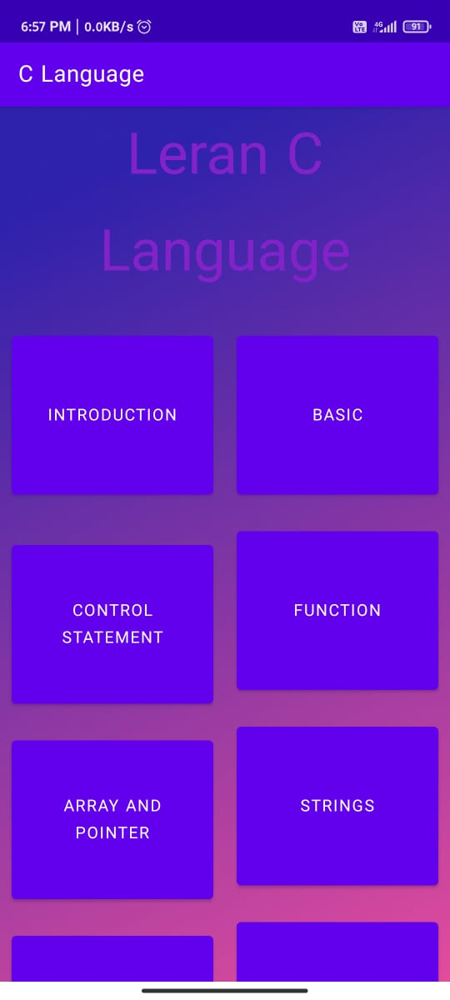 **Outputs of the Micro-Projects**

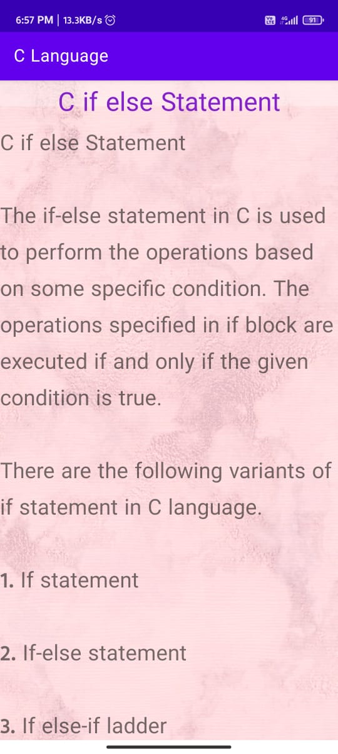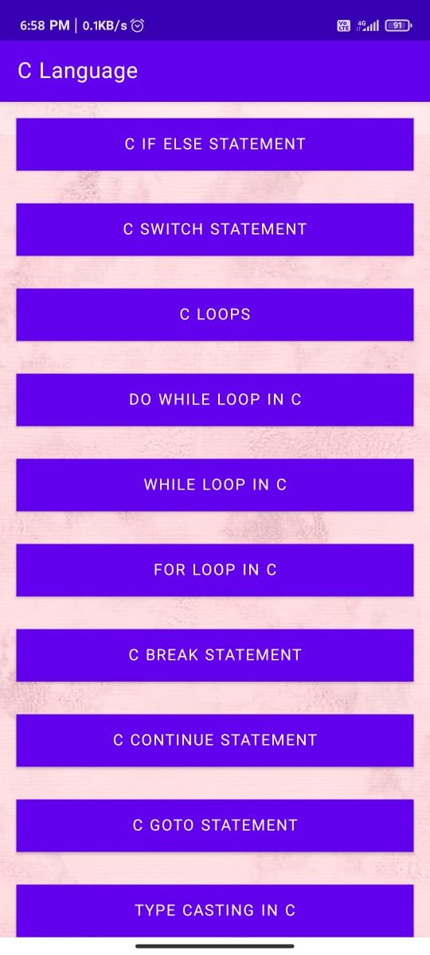

1. **Skill Developed / Learning outcome of this Micro-Project**

* **Analytical Skills. Mobile developers have to understand user needs in order to create applications they want to use.**
* **Communication. Mobile developers need to be able to communicate both orally and in writing.**

**9.0 Applications of this Micro-Project**

* This app is used for learning C Language to beginners

**************