**Part – A Micro-Project Proposal**

**Title of Micro-Project**

**TCP/IP commands**

1. **Aims/Benefits of the Micro-Project – TCP/IP commands**
2. **Course Outcomes Addressed**

* Set up computer network for specific requirements.
* Configure the different TCP/IP services.

1. **Proposed Methodology**

* First up all we known about what is TCP/IP commands and how many types of

TCP/IP commands are there.

* Then we studied about how it is working of the various types of TCP/IP .
* After that we collected all correlated information of TCP/IP commands.
* We created the report of TCP/IP commands.

**4.0 Action Plan**

|  |  |  |  |  |
| --- | --- | --- | --- | --- |
| **S. No.** | **Details of activity** | **Planned Start date** | **Planned Finish date** | **Name of Responsible Team Members** |
|  | Discussion of micro project | 19-01-2020 | 28-01-2020 | Y.K.Adaki,V.D.Gangji  A.S.Korachgao,P.S.Mhanta |
|  | Collecting information | 28-01-2020 | 10-02-2020 | Y.K.Adaki, A.S.Korachgao |
|  | Creating Project | 10-02-2020 | 20-02-2020 | P.S.Mhanta,V.D.Gangji |
|  | Project Report | 20-02-2020 | 28-02-2020 | P.S.Mhanta,A.S.Korachgao |
|  |  |  |  |  |

**5.0 Resources Required**

|  |  |  |  |  |
| --- | --- | --- | --- | --- |
| **S. No.** | **Name of Resource/material** | **Specifications** | **Qty** | **Remarks** |
|  | Software | Command Prompt | 1 |  |
|  | Computer | Windows 10 | 1 |  |

6.0 **Name with Roll No.**

1. Roll No 01 Name Yogesh Adaki
2. Roll No. 09. Name. Vishal Gangji
3. Roll No. 15. Name. Abhishek Korachgao
4. Roll No 20 Name. Prashant Mhanta

.

**\*\*\*\*\*\*\*\*\*\*\*\*\*\***

**Part – B Micro-Project Report**

**Title of Micro-Project**

**“TCP/IP commands”**

1. **Rationale**

TCP/IP commands.It allows you to communicate with another terminal or system merely by executing a command or program. TCP/IP is part of the underlying structure of your system. It allows you to communicate with another terminal or system merely by executing a command or program. Your system takes care of the rest.

1. **Aims/Benefits of the Micro-Project – TCP/IP commands**

1. **Course Outcomes Addressed**

* Set up computer network for specific requirements.
* Configure the different TCP/IP services.

1. **Literature Review**

We had taken reference of the links given below :

https://www.computernetworkingnotes.com

<https://en.wikipedia.org>

<http://www.youtube.com>

<http://www.google.com>

1. **Actual Methodology Followed.**

* First up all we known about what is TCP/IP commands and how many types of

TCP/IP commands are there.

* Then we studied about how it is working of the various types of TCP/IP .
* After that we collected all correlated information of TCP/IP commands.
* We created the report of TCP/IP commands.

**6.0 Resources Required**

|  |  |  |  |  |
| --- | --- | --- | --- | --- |
| **S. No.** | **Name of Resource/material** | **Specifications** | **Qty** | **Remarks** |
|  | Software | Command Prompt | 1 |  |
|  | Computer | Windows 10 | 1 |  |

1. **Outputs of the Micro-Projects**
2. **Ping 192.168.1.217**

The ping command is a Command Prompt command used to test the ability of the source computer to reach a specified destination computer. The ping command is usually used as a simple way to verify that a computer can communicate over the network with another computer or network device

Syntax=ping ip_addr_of _computer

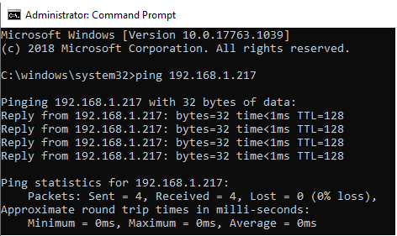

1. Ipconfig

In Windows, **ipconfig**is a console application designed to run from the Windows command prompt. This utility allows you to get the IP address information of a Windows computer.

Syntax =ipconfig

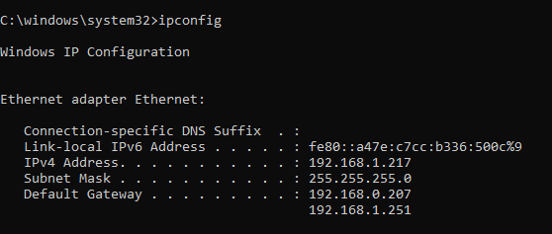

1. Tracert

The tracert command is a Command Prompt command that's used to show several details about the path that a packet takes from the computer or device you're on to whatever destination you specify.

Syntax =tracert

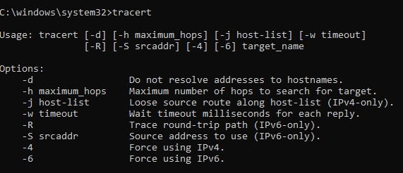

1. Netstat

The netstat command, meaning network statistics, is a Command Prompt command used to display *very* detailed information about how your computer is communicating with other computers or network devices.

Syntex =netstat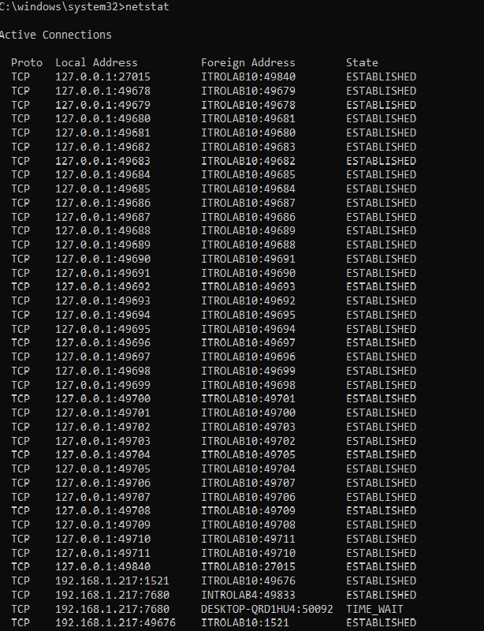

1. Net start

The netstat command, meaning network statistics, is a Command Prompt command used to display *very* detailed information about how your computer is communicating with other computers or network devices.

Syntax = net start

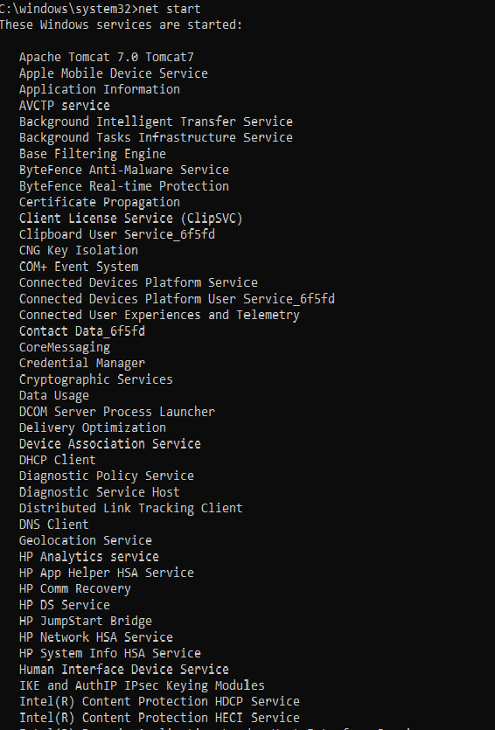

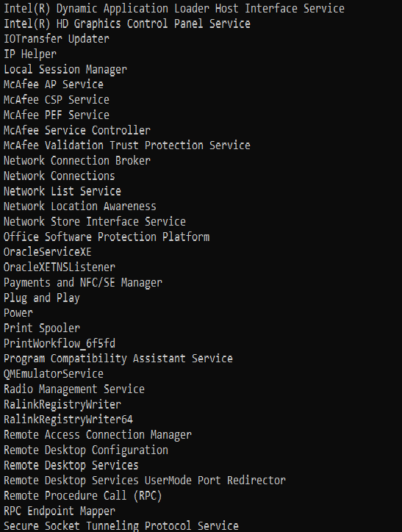

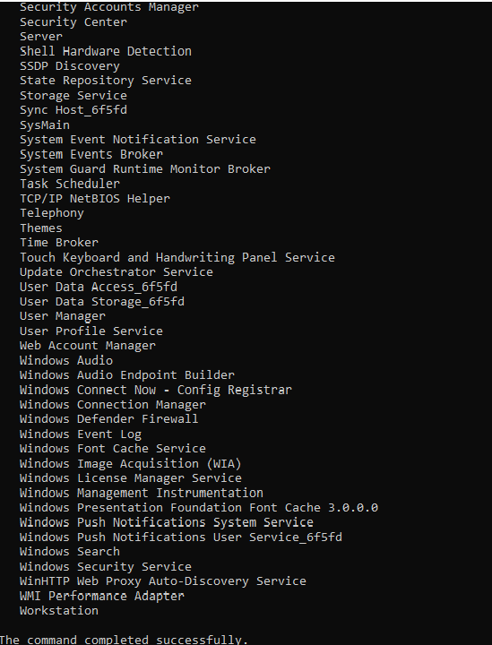

1. ARP

Arp is a protocol used to determine host IP addresses from their physical MAC or Ethernet address. Windows operating systems provides arp command in order to manage arp related information. With arp command we can display, add and remove arp entries in ARP cache.

Syntax = arp

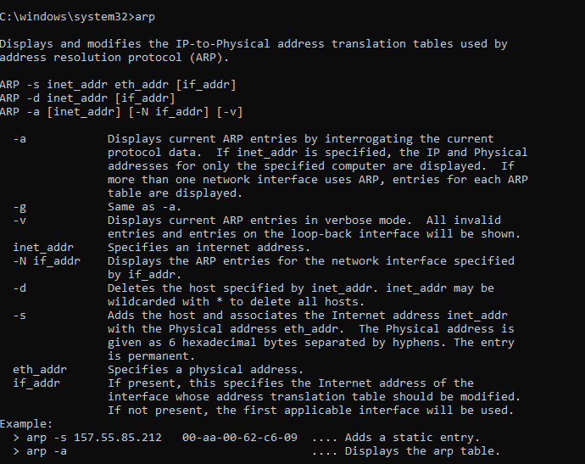

## **finger**

The finger command available in Unix and Linux variants allows a user to find sometimes personal information about a user. This information can include the last time the user logged in, and when they read their e-mail, etc. If the user creates a .PLAN or other related file, the user can also display additional information.

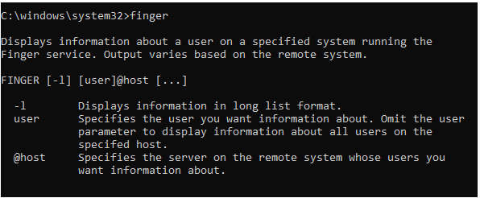

1. **Nbtstat**

The nbtstat MS-DOS utility that displays protocol statistics and current TCP/IP connections using NBT.

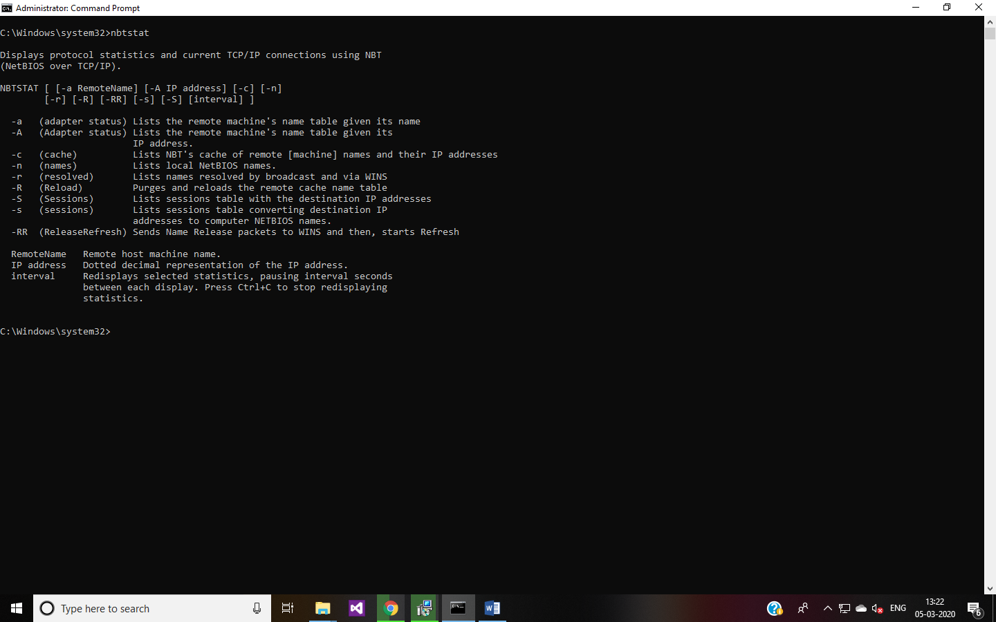s

1. Route

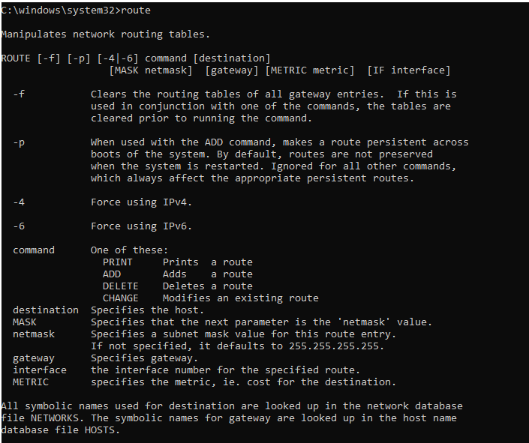

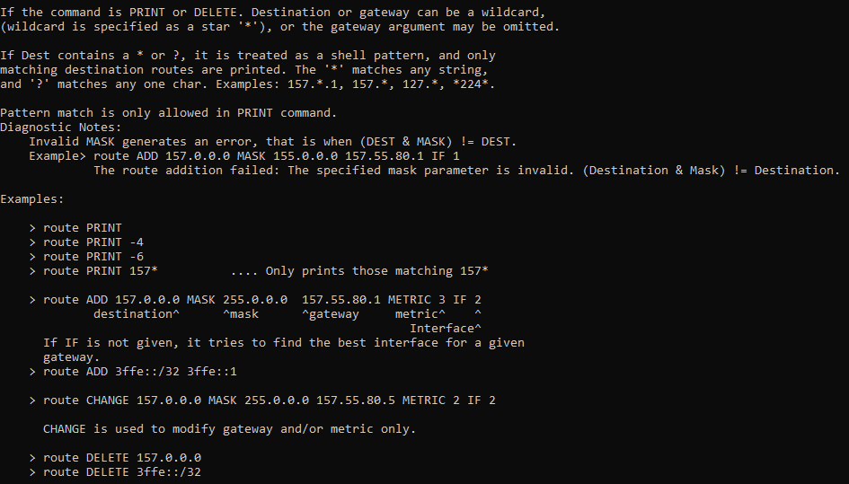

**8.0** **Skill Developed / Learning outcome of this Micro-Project**

* From this practical we know about TCP/IP commands and it’s uses.
* Hence from this practical we found the some advanced features of the system.

**9.0 Applications of this Micro-Project**

* The top 7 tools that include: Ping, Tracert, ARP, Netstat, Nbtstat, NSLookup, and IPconfig. These tools will help you to check the status of your network and allow you to troubleshoot and test connectivity to remote hosts.

**************