

Guided By: Asma Hannure mam

Mobile Application Development

Number System

converter

2021-22

Submitted by

1. Ganesh Kokate

CERTIFICATE

### MAHARASHTRASTATEBOARDOFTECHNICAL EDUCATION, MUMBAI

**GOVERNMENT POLYTECHNIC, SOLAPUR.**

This is to certify that **Ganesh Kokate** Roll **no 82** Of **6th** Semester of Diploma in Computer Technology has satisfactory completed Report Work in this subject **Android application development (22519)** under the guidance of Mrs. **Asma Hannure** the academic year 2021-2022 as prescribed in the curriculum.

#### Place: Enrollmentno:1900150328

**Date: Exam seat no:**

**Subject teacher. HOD. Principal**

**Acknowledgement**

We wish to express our profound and sincere gratitude to our guide, who **Asma Hannure** guided us in the structure of micro project as well as some main points in that micro project also they cleared our all doubts about micro project. We are Indebted to his constant encouragement, co-operation and help. It was his enthusiastic support that helped us in overcoming various obstacles in the project.

We would also like to express our thankfulness to our beloved Principal as well as HOD and other faculty members of our Second-year department for extending their support and motivation

Finally, we completed our micro project that regarding to our syllabus as well as department, Once more thanks for all Group members, Respected **Asma Hannure**, Principal, HOD and other Faculty Members who helped us in the micro project completion.

Thank You...!!!

**PART A – Micro-Project Proposal**

**1.0 Brief Introduction**

In this Micro-Project we are going to make **Number System Convertor** programs in Android, In this project I am doing conversion of Binary, Octal, Decimal, Hexadecimal numbers. I going to use some inbuilt function of java for doing conversion.

**2.0 Aim of the Micro-Project** (in about 1 to 2 Sentences)

The aim of this project to develop programming skill and make Micro-Project for Mobile application.

**3.0 Intended Course Outcomes**

1. Develop application using android.
2. Develop application using java.

**4.0 Literature Review**

We searched information for the suggested topic by our project guide. Collected the data required for the micro –project.

**5.0 Proposed Methodology**

1. First searched information for the suggested micro-project.
2. Collected information for the suggested topic.
3. Started for the micro-project.
4. Completed micro-project.
5. Showed to respected teacher.
6. Teacher suggested some changes.
7. Done the changes into the project as told by teacher.

**6.0 Resources Required.**

|  |  |  |  |  |
| --- | --- | --- | --- | --- |
| S. No. | Name of Resource/material | Specifications | Qty | Remarks |
| 1 | Computer System | Intel core2duo Processor 4th gen  2 GB RAM ,160GB HDD | 1 | - |
| 2 | Notepad | Version 1909 | 1 | - |

**7.0 Action Plan**

|  |  |  |  |  |
| --- | --- | --- | --- | --- |
| Sr. no | Details of activity | Planned start date | Planed finish date | Name of responsible team member |
| 1 | **Topic selection** | **18/11/21** | **19/11/21** | 1. **Ganesh Kokate** |
| 2 | **Information Collection related to the topic** | **20/11/21** | **25/11/21** |
| 3 | **System Designing** | **26/11/21** | **8/12/21** |
| 4 | **Data collection for the project** | **9/12/21** | **18/12/21** |
| 7 | **Testing** | **19/12/21** | **20/12/21** |
| 8 | **Error/Defect handling** | **21/12/21** | **22/12/21** |
| 10 | **Project report forming** | **25/12/21** | **26/12/21** |

**Index**

|  |  |
| --- | --- |
| Sr.no | Topic |
| 1 | **Information about project** |
| 2 | **AIM** |
| 3 | **Advantages** |
| 4 | **Course Outcomes** |
| 5 | **Literature Review** |
| 6 | **Actual Methodology** |
| 7 | **Resources** |
| 8 | **Source Code** |
| 9 | **Outputs** |
| 10 | **Skill Developed** |
| 11 | **Application** |
| 12 | **Area of Future** |
| 11 | **Conclusion & Reference website** |

**Information about project**

Numeral System Converter is a converter which allows you to convert between different numeral systems like the binary system, hexadecimal system, octal number system, decimal system and vice versa.  
 It is very easy to use and shows you the calculation method if you want to.  
It has calculation mode, you can calculate Decimal, Binary, Octal and Hexadecimal number.  
Binary Coded Decimal to Decimal and Decimal to Binary Coded Decimal conversion.

**Advantages**

* This application is simple to use.
* You can convert number from one number system to another number system easily.
* There is dropdown menu to select one number system and another dropdown for another number system.
* You can convert number from one number system to another in one click
* Application is very light

**Course Outcomes**

1. Develop application using android.
2. Develop application using java.

**Literature Review**

In This Micro-Project we created a Application which convert one number system to another number system .We made this Micro-Project Using Android studio we use java to developed this application using java. This Micro Project contains limited features but the essential one. The User can get to know about the source code whichever he need.

**Actual Methodology**

* Collected information for the suggested topic.
* Started the Micro-project.
* Completed Micro-project.
* Showed to respected teacher.
* Submitted the Micro-project.

**Resources**

1. Software-JDK
2. Software-SDK
3. IDE-android studio
4. Windows 10
5. YouTube: Some programming

**Source Code**

**activity_main.xml**

*<?*xml version="1.0" encoding="utf-8"*?>*<LinearLayout xmlns:android="http://schemas.android.com/apk/res/android"  
 xmlns:app="http://schemas.android.com/apk/res-auto"  
 xmlns:tools="http://schemas.android.com/tools"  
 android:layout_width="match_parent"  
 android:layout_height="match_parent"  
 android:orientation="vertical"  
 tools:context=".MainActivity">  
  
 <TextView  
 android:id="@+id/heading"  
 android:layout_width="wrap_content"  
 android:layout_height="wrap_content"  
 android:layout_gravity="center"  
 android:layout_marginTop="40dp"  
 android:text="Number System Converter"  
 android:textSize="30dp"  
  
 >  
  
 </TextView>  
  
 <LinearLayout  
 android:layout_width="wrap_content"  
 android:layout_height="wrap_content"  
 android:layout_gravity="center"  
 android:orientation="vertical">  
  
 <TextView  
 android:layout_width="wrap_content"  
 android:layout_height="wrap_content"  
 android:layout_marginTop="20dp"  
 android:text="number to be converted"  
 android:textSize="20dp">  
  
 </TextView>  
  
 <EditText  
 android:id="@+id/edittext"  
 android:layout_width="250dp"  
 android:layout_height="50dp"  
 android:layout_gravity="center"  
 android:layout_marginBottom="40dp"  
 android:digits="0123456789abcddefABCDEF"></EditText>  
  
 <TextView  
 android:layout_width="wrap_content"  
 android:layout_height="wrap_content"  
 android:text="From"  
 android:textSize="20dp">  
  
 </TextView>  
  
 <Spinner  
 android:id="@+id/from"  
 android:layout_width="250dp"  
 android:layout_height="50dp"  
 android:layout_gravity="center"  
 android:layout_marginBottom="40dp"></Spinner>  
  
 <TextView  
 android:layout_width="wrap_content"  
 android:layout_height="wrap_content"  
 android:text="To"  
 android:textSize="20dp">  
  
 </TextView>  
  
 <Spinner  
 android:id="@+id/to"  
 android:layout_width="250dp"  
 android:layout_height="50dp"  
 android:layout_gravity="center"  
 android:layout_marginBottom="40dp"></Spinner>  
  
 <Button  
 android:id="@+id/button"  
 android:layout_width="wrap_content"  
 android:layout_height="wrap_content"  
 android:layout_gravity="center"  
 android:layout_margin="20dp"  
 android:text="BUTTON"></Button>  
 </LinearLayout>  
  
 <TextView  
 android:id="@+id/val"  
 android:layout_width="wrap_content"  
 android:layout_height="wrap_content"  
 android:layout_gravity="center"  
 android:text="VALUE"  
 android:textSize="30dp">  
  
 </TextView>  
  
</LinearLayout>

**MainActivity.java**

package com.example.num_sys_conv;  
import androidx.appcompat.app.AppCompatActivity;  
  
import android.content.Intent;  
import android.os.Bundle;  
import android.view.View;  
import android.widget.ArrayAdapter;  
import android.widget.Button;  
import android.widget.EditText;  
import android.widget.Spinner;  
import android.widget.TextView;  
import android.widget.Toast;  
  
public class MainActivity extends AppCompatActivity {  
  
 Spinner spinner1,spinner2;  
 EditText editText;  
 Button button1;  
 TextView textView;  
 @Override  
 protected void onCreate(Bundle savedInstanceState) {  
 super.onCreate(savedInstanceState);  
 setContentView(R.layout.*activity_main*);  
  
 editText =(EditText) findViewById(R.id.*edittext*);  
 spinner1 = (Spinner) findViewById(R.id.*from*);  
 spinner2 = (Spinner) findViewById(R.id.*to*);  
 textView= (TextView) findViewById(R.id.*val*);  
  
 String[] from_currency={"DEC","BIN","OCT","HEX"};  
 ArrayAdapter ad=new ArrayAdapter<String>(this, androidx.appcompat.R.layout.*support_simple_spinner_dropdown_item*,from_currency);  
 spinner1.setAdapter(ad);  
  
 String[] to_currency={"DEC","BIN","OCT","HEX"};  
 ArrayAdapter ad2=new ArrayAdapter<String>(this, androidx.appcompat.R.layout.*support_simple_spinner_dropdown_item*,to_currency);  
 spinner2.setAdapter(ad2);  
  
 button1=(Button) findViewById(R.id.*button*);  
 button1.setOnClickListener(new View.OnClickListener() {  
 @Override  
 public void onClick(View view) {  
 *//dec to all* Long amount = Long.*parseLong*(editText.getText().toString(),16);  
 if (spinner1.getSelectedItem().toString()=="DEC" && spinner2.getSelectedItem().toString()=="DEC"){  
 textView.setText("it will same");  
 }  
 else if(spinner1.getSelectedItem().toString()=="DEC" && spinner2.getSelectedItem().toString()=="BIN"){  
 textView.setText(Long.*toBinaryString*(amount));  
 }  
 else if(spinner1.getSelectedItem().toString()=="DEC" && spinner2.getSelectedItem().toString()=="OCT"){  
 textView.setText(String.*valueOf*(Long.*toOctalString*(amount)));  
 }  
 else if(spinner1.getSelectedItem().toString()=="DEC" && spinner2.getSelectedItem().toString()=="HEX"){  
 textView.setText(String.*valueOf*(Long.*toHexString*(amount)));  
 }  
  
 *//bin to all* else if (spinner1.getSelectedItem().toString()=="BIN" && spinner2.getSelectedItem().toString()=="DEC"){  
 amount = Long.*parseLong*(editText.getText().toString(),2);  
 textView.setText(String.*valueOf*((amount)));  
 }  
 else if(spinner1.getSelectedItem().toString()=="BIN" && spinner2.getSelectedItem().toString()=="BIN"){  
 textView.setText("it will same");  
 }  
 else if(spinner1.getSelectedItem().toString()=="BIN" && spinner2.getSelectedItem().toString()=="OCT"){  
 amount = Long.*parseLong*(editText.getText().toString(),2);  
 textView.setText(String.*valueOf*(Long.*toOctalString*(amount)));  
 }  
 else if(spinner1.getSelectedItem().toString()=="BIN" && spinner2.getSelectedItem().toString()=="HEX"){  
 amount = Long.*parseLong*(editText.getText().toString(),2);  
 textView.setText(String.*valueOf*(Long.*toHexString*(amount)));  
 }  
  
 *//oct to all* else if (spinner1.getSelectedItem().toString()=="OCT" && spinner2.getSelectedItem().toString()=="DEC"){  
 amount = Long.*parseLong*(editText.getText().toString(),8);  
 textView.setText(String.*valueOf*((amount)));  
 }  
 else if(spinner1.getSelectedItem().toString()=="OCT" && spinner2.getSelectedItem().toString()=="BIN"){  
 amount = Long.*parseLong*(editText.getText().toString(),8);  
 textView.setText(String.*valueOf*(Long.*toBinaryString*(amount)));  
 }  
 else if(spinner1.getSelectedItem().toString()=="OCT" && spinner2.getSelectedItem().toString()=="OCT"){  
 textView.setText("it will same");  
 }  
 else if(spinner1.getSelectedItem().toString()=="OCT" && spinner2.getSelectedItem().toString()=="HEX"){  
 amount = Long.*parseLong*(editText.getText().toString(),8);  
 textView.setText(String.*valueOf*(Long.*toHexString*(amount)));  
 }  
 *//hex to all* else if (spinner1.getSelectedItem().toString()=="HEX" && spinner2.getSelectedItem().toString()=="DEC"){  
 amount = Long.*parseLong*(editText.getText().toString(),16);  
 textView.setText(String.*valueOf*((amount)));  
 }  
 else if(spinner1.getSelectedItem().toString()=="HEX" && spinner2.getSelectedItem().toString()=="BIN"){  
 amount = Long.*parseLong*(editText.getText().toString(),16);  
 textView.setText(String.*valueOf*(Long.*toBinaryString*(amount)));  
 }  
 else if(spinner1.getSelectedItem().toString()=="HEX" && spinner2.getSelectedItem().toString()=="OCT"){  
 amount = Long.*parseLong*(editText.getText().toString(),16);  
 textView.setText(String.*valueOf*(Long.*toOctalString*(amount)));  
 }  
 else if(spinner1.getSelectedItem().toString()=="HEX" && spinner2.getSelectedItem().toString()=="HEX"){  
 textView.setText("it will same");  
 }  
  
 else {  
  
 }  
 }  
 });  
 }  
}

**Output**

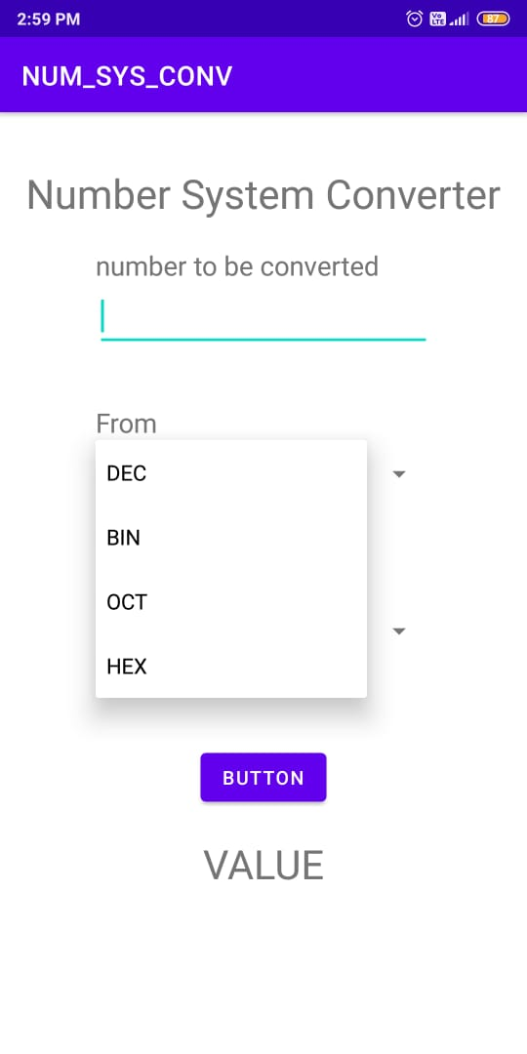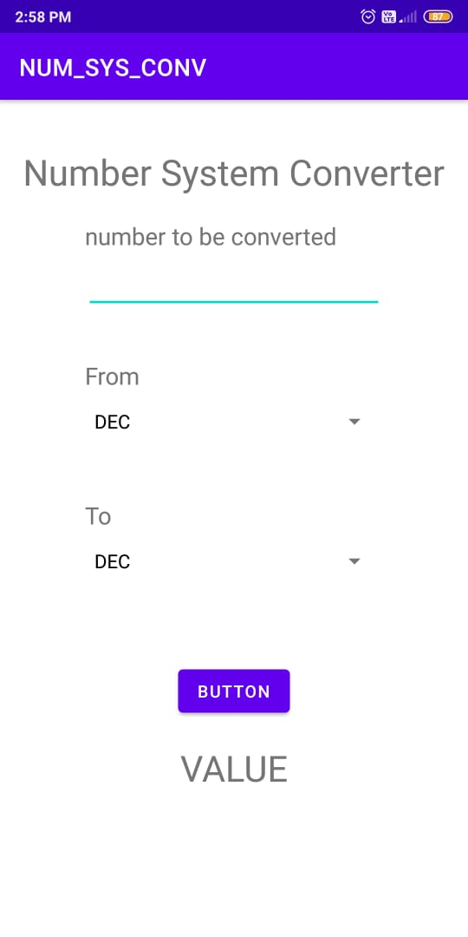

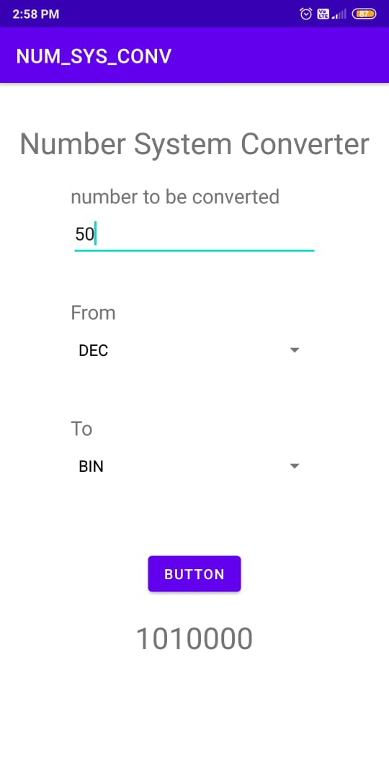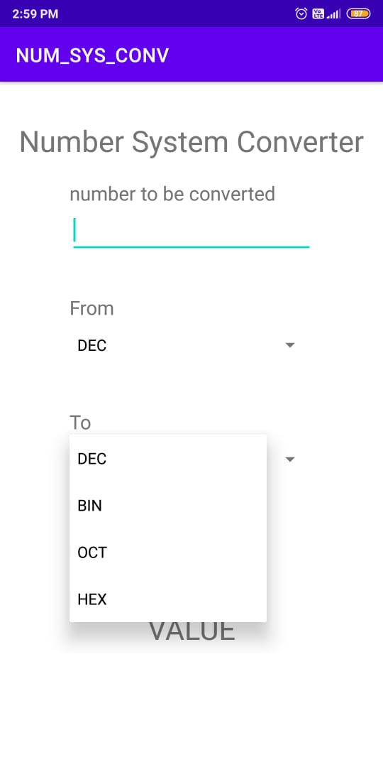

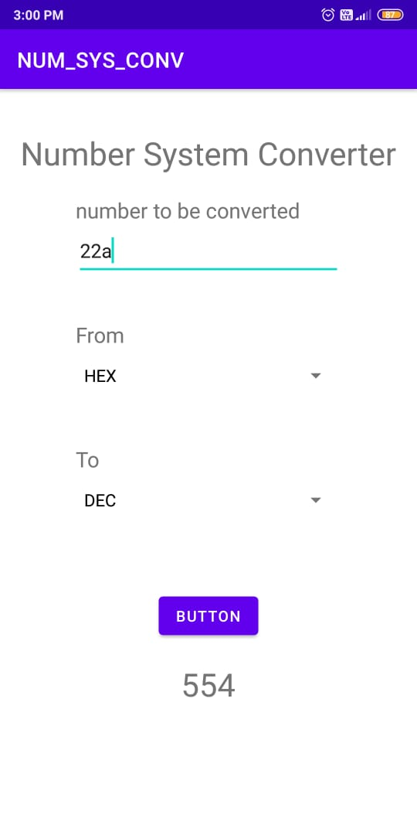

**Skill Developed**

* WE learnt how to make Application in android
* WE learnt how to use Android studio
* WE learnt new programs concept in java and android

**Area of future**

* We will add new function and data to make it easier for operating.
* Faults will be removed if found any.
* As soon as possible we try to perform arithmetic operations on it

**Conclusion**

Hence from this Micro-Project we Learnt about how to write and compile program And from this project we learnt different types of programming and their use in android studio.

**Reference**

|  |  |  |
| --- | --- | --- |
| Srno. | Reference | Remark |
| 1  2  3 | [tutorialspoint.com](http://www.tutorialspoint.com)  YouTube: Some coding and programming  Different application | Website  YouTube  Nirali,Techmax Pub. |