A

micro Project Report

On

**"Managerial Skills”**

IN FULFILMENT OF DIPLOMENT IN COMPUTER ENGINEERING OF

M**SBTE MUMBAI**

Submitted By

Sangita Madhukar Kamble(3348)

Ankita Parashuram Sutar(3349)

Tanishka Ranjeet Jadhav (3349)

Rupali Bandopant Dasare (3350)

**Program Name: Computer Engineering.**

**Course Name: Management**



**Department of Computer Engineering**

Shree Swami Vivekanand Shikshan Sanstha’s

**Dr. BAPUJI SALUNKHE INSTITUTE OF ENGINNERING AND TECHNOLOGY**

**KOLHAPUR**

**Academic year 2020-2021**



**Maharashtra State Board of Technical Education, Mumbai**

**CERTIFICATE**

This is to certify Mr. /Ms.………………………………………………………...

………………………………………………………...………………………….

………………………………………………………...…………………………. With Enrolment Nos.............................................................................................

Has successfully completed Micro Project of Course Name:…………………….

……………………………………………....Course. Code……………………..

For the academic year 2020-21 as prescribed in the curriculum.

**Subject Teacher HOD Principal**

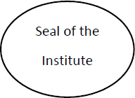

**INDEX**

|  |  |  |
| --- | --- | --- |
| **Sr. No.** | **Contents** | **Page No.** |
| 1 | Rationale | 2 |
| 2 | Aims/Benefits of the Micro-Project | 2 |
| 3 | Course Outcome Achieved | 2 |
| 4 | Literature Review | 3 |
| 5 | Actual Methodology Followed | 3 |
| 6 | Actual Resources Used | 4 |
| 7 | Outputs of the Micro-Project | 4 |
| 8 | Skill Developed / Learning outcome of this Micro-Project | 30 |
| 9 | Application of Micro-Project | 30 |

**Managerial Skills**

**1.0Rationale.**

In order to be successful in planning, organizing, leading, and controlling, managers must use a wide variety of skills. A skill is the ability to do something proficiently. Managerial skills fall into three basic categories: technical, human relations, and conceptual skills. The degree to which each type of skill is used depends upon the level of the manager’s position as seen in (Figure). Additionally, in an increasingly global marketplace, it pays for managers to develop a special set of skills to deal with global management issues.

* **Aims/Benefits of the Micro-Project.**

**Aim:-**

Managerial Skills

**Benefits:-**

* Explaining functions Of Management for the given Situation.
* Suggesting Suitable Managerial Skills for given situation with justification.
* Comparing features of given type of Planning.
* **Course outcomes achieved.**
* Use Basic Management Principles to execute Daily activities.
* Use principles of Planning and Organising For accomplishment of tasks.

**4.0Literature Review.**

|  |  |  |
| --- | --- | --- |
| **Sr. No**  **.** | **Title of**  **Book/Websit e** | **Author** |
| 1 | management and entrepreneurship | N. V. R. Naidu |
| 2 | Website | <https://corporatefinanceinstitute.com/resources/careers/soft-skills/management-skills/>  <https://www.entrepreneurshipinabox.com/202/managerial-skills/> |

* **Actual Methodology Followed.**
* **Information gathering:-**

Gathering information About Managerial Skills.

* **Gathering Required Resources:-**

After information gathering the resource that are required must be gathered. The resource gathered must help in effective study of Managerial Skills.

* **Information analysis:-**

After gathering required resource study following points like:

* What are Managerial Skills
* Types of Managerial Skills
* Examples of Managerial Skills

**Report preparation:-**

It include the study done on Managerial Skills.

**6.0 Resources Used.**

|  |  |  |  |
| --- | --- | --- | --- |
| **Sr.**  **No.** | **Names of resources** | **Specification** | **Qty** |
| **1** | Computer System | Any System with   * windows 7 or more * minimum storage 500 GB * Processor @2.93GHz core 2 duo | 1 |
| **2** | Operating System | Windows/ Ubantu | 1 |

**7.0Outputs of Micro-Projects.**

**What Are Management Skills?**

Management skills are applied to a broad array of functions in areas like production, finance, accounting, marketing, and human resources. Common components of management in different arenas include: selection, supervision, motivation and evaluation of staff, scheduling and planning of workflow, developing policies and procedures, measuring and documenting results for a group or department, solving problems, developing and monitoring budgets and expenditures, staying abreast of trends in the field, collaborating with other staff and departments, and leading and motivating employees**.**

**Types of Management Skills**

Most management skills are related to six fundamental functions: planning, organizing, coordinating, directing, leadership, and oversight**.**

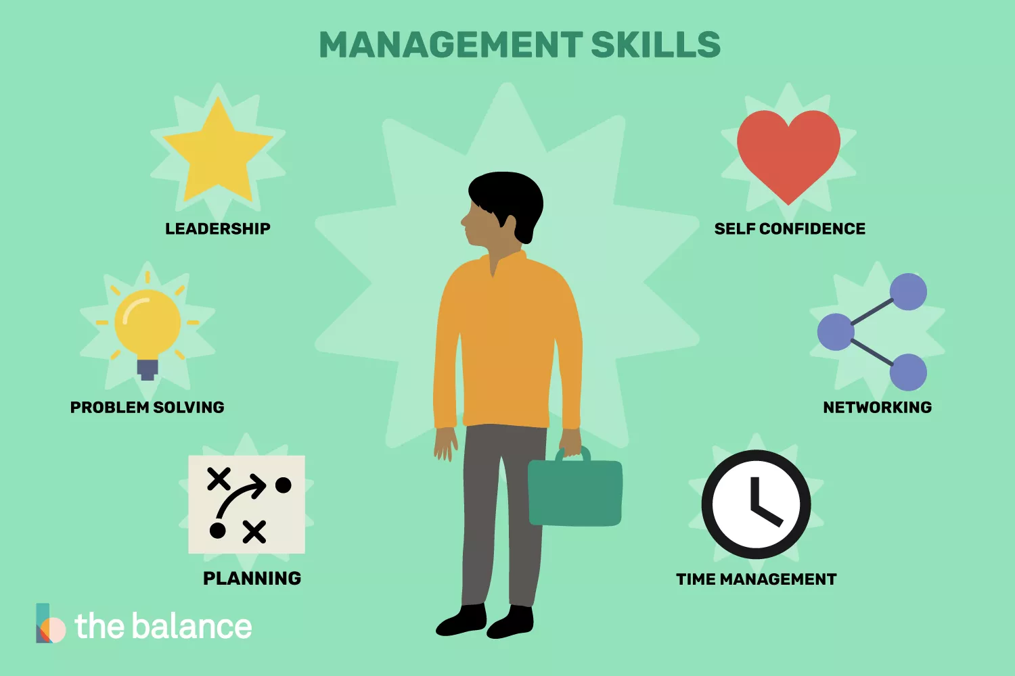

**Planning**

Individual managers may or may not be personally involved in drafting company policy and strategy, but even those who aren’t still must be able to plan. You might be given certain objectives and then be responsible for developing ways to meet those objectives. You may need to adjust or adapt someone else’s plan to new circumstances. In either case, you’ll have to understand what your resources are, develop time tables and budgets, and assign tasks and areas of responsibility**.**

Planning programs for professional societies is another way to develop and document planning abilities. Mastering planning software, like NetSuite OpenAir, and project management software, like Workfront, can prove that you're able to tap technology that's instrumental to sound planning. College students should take on leadership positions with campus organizations to hone their planning skills.

Analyzing Business Problems

Analyzing Expenditures

Critical Thinking

Devising Plans for New Business

Development, Entrepreneurialism

Identifying the Interests and Preferences of Stakeholders

Microsoft Office,

Proposing Solutions to Business Problems

Problem Solving

Research, Qualitative Skills

Strategic Planning

Strategic Thinking

Tapping Information Technology to Facilitate Decision Making

Writing Proposals for Business Initiatives or Projects, Vision

Project Management

Utilizing Planning Software

**Organizing**

Organizing generally means creating structures to support or accomplish a plan. This might involve creating a new system of who reports to whom, designing a new layout for the office, planning a conference or event, building a strategy and planning around how to move through a project, or determining how to move toward deadlines or how to measure milestones.

Aspects of organization could also mean helping leaders under your guidance to manage their subordinates well.

Identify processes, procedures, or events related to your department that could be improved, and demonstrate that you can re-design processes to create greater efficiency or enhance quality. Document procedures in a manual or spreadsheet for future use.

Accuracy

Administrative

Analytical Ability

Assessing Factors Impacting Productivity

Business Storytelling

Framing Communication Toward Specific Audiences

Innovation

Logical Thinking

Logistics

Negotiating

Networking

Persuasion

Presentation

Public Speaking

Suggesting Ways to Enhance Productivity

Technical Knowledge

Technology

Time Management

**Leadership**

The best managers are typically inspirational and effective leaders. They set the tone for their areas by demonstrating—through their actions—norms for staff behavior.

Clear communication of goals and expectations is also vital. Good leaders seek input from all stakeholders and recognize the contributions of other team members, and they give credit where credit is due. Good leaders draw consensus on group plans whenever feasible, and they delegate strategically to the best-qualified staff.

Develop leadership skills by volunteering to run point on projects. College students should volunteer to take on a leadership role with group projects, sports teams, and student organizations.

Delegation

Presentation

Humility

Networking

Confidence

High Energy

Clear Communication

Writing

Budgeting

Motivating Others

Problem Solving

Persuasion

Evaluating Talent

Supervision

Charisma

Integrity

Passion for Work

Networking

**Coordinating**

Managers must know what is happening, what needs to happen, and who and what are available to accomplish assigned tasks. If someone is miscommunicating, if someone needs help, or if a problem is being overlooked or a resource underutilized, a manager needs to notice and correct the issue. Coordinating is the skill that lets the organization act as a unified whole. Coordination across departments and functions is also essential to a well-run organization that presents a unified face to constituents.

Develop a solid team orientation by close communication and cooperation with co-workers. Seek out opportunities to collaborate with other staff and departments.

**Adaptability**

Adapting to Changing Business Conditions

Building Productive Relationships

Collaboration

Communication

Drawing Consensus

Diplomacy

Emotional Intelligence

Empathy

Facilitating Group Discussions

Flexibility

Honesty

Influencing

Listening

Nonverbal Communication

Patience

Punctuality

Relationship Building

Scheduling

Screening Applicants for Jobs, Staffing

Tactfulness

Teaching

Team Building

Team Manager

Team Player

Teamwork

Time Management

**Management Skills List**

The following is a comprehensive list of management skills to use in resumes, job applications, cover letters, and during job interviews.

Accuracy

Achieving Goals

Adaptability

Administrative

Analytical Ability

Assertiveness

Budget Management

Business Management

Business Storytelling

Collaboration

Communication

Conflict Management

Conflict Resolution

Coordination

Critical Thinking

Decision Making

Delegation

Development

Diplomacy

Discipline

Division of Work

Dynamic

Emotional Intelligence

Empathy

Empowerment

Energetic

Engagement

Execution

Facilitating

Finance

Financial Management

Flexibility

Focus

Genuine

Goal-oriented

Goal Setting

Hiring

Honesty

Influencing

Innovation

Interpersonal

Leadership

Legal

Listening

Logical Thinking

Logistics

Microsoft Office

Motivation

Negotiating

Networking

Nonverbal Communication

Obstacle Removal

Organizing

Patience

Persuasion

Planning

Presentation

Productivity

Problem Solving

Professionalism

Product Management

Project Management

Process Management

Public Speaking

Punctuality

Research

Responsibility

Qualitative Skills

Sales

Scheduling

Staffing

Strategic Planning

Strategic Thinking

Success

Tactfulness

Teaching

Team Building

Team Manager

Team Player

Teamwork

Technical Knowledge

Technology

Time Management

Training

Uncertainty Removal

Writing

Verbal Communication

Vision

**Examples of Management Skills-**

There is a wide range of skills that management should possess to run an organization effectively and efficiently. The following are six essential management skills that any manager ought to possess for them to perform their duties:

1. Planning

Planning is a vital aspect within an organization. It refers to one’s ability to organize activities in line with set guidelines while still remaining within the limits of the available resources such as time, money, and labor. It is also the process of formulating a set of actions or one or more strategies to pursue and achieve certain goals or objectives with the available resources.

The planning process includes identifying and setting achievable goals, developing necessary strategies, and outlining the tasks and schedules on how to achieve the set goals. Without a good plan, little can be achieved.

2. Communication

Possessing great communication skills is crucial for a manager. It can determine how well information is shared throughout a team, ensuring that the group acts as a unified workforce. How well a manager communicates with the rest of his/her team also determines how well outlined procedures can be followed, how well the tasks and activities can be completed, and thus, how successful an organization will be.

Communication involves the flow of information within the organization, whether formal or informal, verbal or written, vertical or horizontal, and it facilitates smooth functioning of the organization. Clearly established communication channels in an organization allow the manager to collaborate with the team, prevent conflicts, and resolve issues as they arise. A manager with good communication skills can relate well with the employees and thus, be able to achieve the company’s set goals and objectives easily.

3. Decision-making

Another vital management skill is decision-making. Managers make numerous decisions, whether knowingly or not, and making decisions is a key component in a manager’s success. Making proper and right decisions results in the success of the organization, while poor or bad decisions may lead to failure or poor performance.

For the organization to run effectively and smoothly, clear and right decisions should be made. A manager must be accountable for every decision that they make and also be willing to take responsibility for the results of their decisions. A good manager needs to possess great decision-making skills, as it often dictates his/her success in achieving organizational objectives.

4. Delegation

Delegation is another key management skill. Delegation is the act of passing on work-related tasks and/or authorities to other employees or subordinates. It involves the process of allowing your tasks or those of your employees to be reassigned or reallocated to other employees depending on current workloads. A manager with good delegation skills is able to effectively and efficiently reassign tasks and give authority to the right employees. When delegation is carried out effectively, it helps facilitate efficient task completion.

Delegation helps the manager to avoid wastage of time, optimizes productivity, and ensures responsibility and accountability on the part of employees. Every manager must have good delegation abilities to achieve optimal results and accomplish the required productivity results.

5. Problem-solving

Problem-solving is another essential skill. A good manager must have the ability to tackle and solve the frequent problems that can arise in a typical workday. Problem-solving in management involves identifying a certain problem or situation and then finding the best way to handle the problem and get the best solution. It is the ability to sort things out even when the prevailing conditions are not right. When it is clear that a manager has great problem-solving skills, it differentiates him/her from the rest of the team and gives subordinates confidence in his/her managerial skills.

6. Motivating

The ability to motivate is another important skill in an organization. Motivation helps bring forth a desired behavior or response from the employees or certain stakeholders. There are numerous motivation tactics that managers can use, and choosing the right ones can depend on characteristics such as company and team culture, team personalities, and more. There are two primary types of motivation that a manager can use. These are intrinsic and extrinsic motivation.

Bottom Line

Management skills are a collection of abilities that include things such as business planning, decision-making, problem-solving, communication, delegation, and time management. While different roles and organizations require the use of various skill sets, management skills help a professional stand out and excel no matter what their level. In top management, these skills are essential to run an organization well and achieve desired business objectives.

**8.0 Skills developed/ learning outcomes of the Micro-Project.**

After this micro project we are able to identify managerial skills. We are able to understand efficiency of managerial skills.

**9.0 Application of Micro-Project.**

* Negotiation
* Strategic thinking
* Project management
* Time management
* Adaptability
* Communication