**Project PLAN**

**On**

**Optimal Scheduling of Automated Diagnostic Self-Tests in an MRI Scanner System**

**SUBMITTED BY**

**BHARATKUMAR M 1MS12CS017**



**M. S. Ramaiah Institute of Technology**

**(Autonomous Institute, Affiliated to VTU)**

**BANGALORE-560054**

**Department of Computer Science & Engineering**

|  |  |  |
| --- | --- | --- |
| **Sameer N. Navaratna**  **Software Architect**  **MR Serviceability**  **PIC ADI Magnetic Resonance 2**  **Philips Innovation Campus**  **Bangalore** | **&** | **Mrs. A. Parkavi**  **Assistant Professor**  **Department of Computer Science & Engineering** |

***Under the guidance of***

1. **Process Model :**

Agile model believes that every project needs to be handled differently and the existing methods need to be tailored to best suit the project requirements. In agile the tasks are divided to time boxes (small time frames) to deliver specific features for a release.

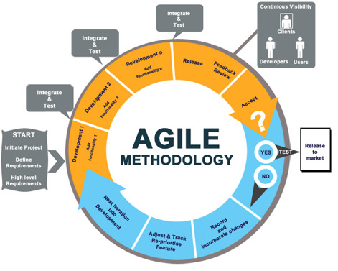

1. **Gantt Chart :**

Gantt Chart provides the specific idea about project plan for any kind of project and a better understanding of the schedule of any project. Gantt charts illustrate the start and finish dates of the terminal elements and summary elements of a [project](https://en.wikipedia.org/wiki/Project). Terminal elements and summary elements comprise the [work breakdown structure](https://en.wikipedia.org/wiki/Work_breakdown_structure) of the project. Gantt charts also show the [dependency](https://en.wikipedia.org/wiki/Dependency_(project_management)) (i.e., precedence network) relationships between activities. The following Gantt Chart illustrates the project plan for the project titled “Optimal Scheduling of Automated Diagnostic Self-Tests in an MRI Scanner System.”

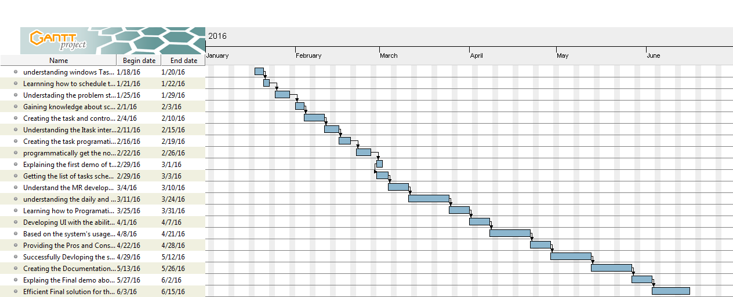

1. **Risk Identification (Top 5 Risk) with Risk Mitigation Steps :**

1)      Availability of Test System with MR Environment.

Mitigation: Due to Other Program priorities there is not dedicated test system available.

Simulate the MR Application software using VMWare.

Owner: mentor

2)      Requirement for workflow of MR scheduling mechanism is not frozen.

Mitigation: Collect the inputs from architects, developer and research users to have clarity on the need and understand the workflow for current way of Scheduling.

Owner: Mentor

3)      Authorization to schedule the Self-tests is not public.

Mitigation: Interact with Serviceability team to get the required authorization either permanently or temporarily and able to schedule the Self-tests.

Owner: Mentor

4)      Improper Scheduling of self-tests may affect the performance of MR scanning.

Mitigation: Identify different approaches for scheduling and come up with most efficient programmatic method to schedule these self-tests.

Owner: Self

5)      Performance of Scheduling mechanism is dependent on isolation of process, which is constrained by current MR software architecture.  
Feasibility study need to be done to identify the isolated processes performing the self-tests,

List need to be generated for the processes which are isolated from other processes in MR Environment.

Owner: Self