**Movie-Review System**

**Action Plan**

1. Provide movie review based on user ratings (ex:- 2.5/5)
   1. Decide the rating system – *, % etc.
2. Categorize the movies based on genres
   1. Action
   2. Drama
   3. Horror
   4. Crime
   5. Thriller
   6. Romance
   7. Animated
   8. Sci-fi
3. Include critics reviews
   1. Decide the rating system – *, % etc.
4. Games/quizzes – includes prizes
5. Movie trends over the years – Graph representation

**Tools**

Angular 2

Bootstrap 4.1.1

**Pages**

Home

Movies

News

Community

**Home**

1. Title of Website - (yet to decide)
2. Menu grid - (yet to decide) – bootstrap Fixed Navigation Bar
3. Search bar - (just a placeholder)
4. Login/Signup options - (no implementation yet)
5. Help menu - (just a placeholder)
6. Latest movie grids with ratings - (sample movies for now)

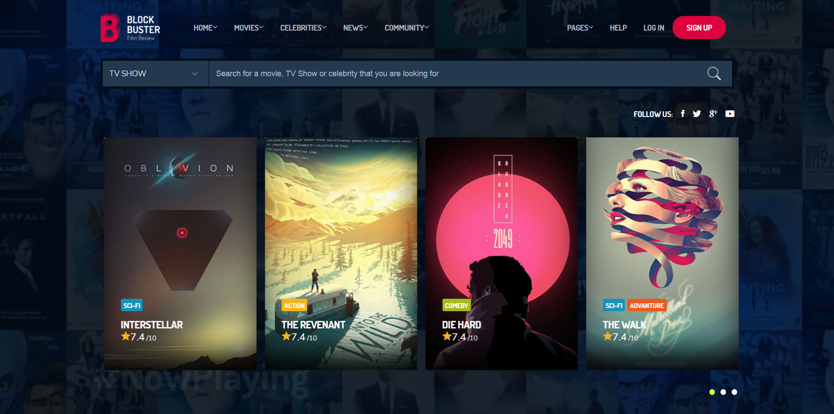

* For next iteration we take up the further pages