
SMART PHARMA SYSTEM
PROJECT REPORT FOR
CSE23CL302 – COMPUTER AIDED SOFTWARE ENGINEERING (CASE) TOOLS
LABORATORY
Submitted by
BHARATRAJ-E0323054
YOKESHNANDHA-E0323041
In partial fulfillment for the award of the degree of
BACHELOR OF TECHNOLOGY
in
COMPUTER SCIENCE AND ENGINEERING
(Artificial Intelligence and DATA ANALYTICS)
Sri Ramachandra Faculty of Engineering and Technology, Sri Ramachandra Institute of Higher Education and Research, Porur, Chennai -600116
JUNE, 2026

SMART PHARMA SYSTEM
PROJECT REPORT FOR
CSE23CL302 – COMPUTER AIDED SOFTWARE ENGINEERING (CASE) TOOLS
LABORATORY
Submitted by
BHARATRAJ-E0323054
YOKESHNANDHA-E0323041
In partial fulfillment for the award of the degree of
BACHELOR OF TECHNOLOGY
in
COMPUTER SCIENCE AND ENGINEERING
(Artificial Intelligence and DATA ANALYTICS)
Sri Ramachandra Faculty of Engineering and Technology, Sri Ramachandra Institute of Higher Education and Research, Porur, Chennai -600116
JUNE, 2026



BONAFIDE CERTIFICATE
Certified that this project report titled SMART PHARMA SYSTEM is the bonafide record of work done by BHARATRAJ-E0323054 AND YOKESHNANDHA-E0323041 who carried out the project work under my supervision.
Signature of the Supervisor

Yamini k
Assistant Professor,
Deoartmen of Cybersercurity and Internet of Things
Sri Ramachandra Faculty of Engineering and Technology,
SRIHER, Porur, Chennai-600 116.

INTERNAL EXAMINER

EXTERNAL EXAMINER
TABLE OF CONTENTS

CHAPTER NO. |  | PAGE  NO.
 | ABSTRACT | 5
1 | PROBLEM DEFINITION | 6
2 | REQUIREMENTS ENGINEERING | 9
3 | DESIGN METHODOLOGY | 15
4 | CODING PRACTICES AND PLATFORMS | 26
5 | TESTING | 32
6 | DEPLOYMENT CHECK LIST | 38
7 | RESULTS | 40
 | APPENDIX | 41

ABSTRACT
Smart Pharma System is a comprehensive web-based pharmaceutical production and management platform developed to automate and streamline the operational activities of pharmaceutical packaging industries. The system integrates inventory management, employee attendance tracking, salary calculation, task management, QR code and barcode scanning, audit logging, and reporting functionalities into a single centralized application.
The primary objective of the system is to eliminate manual record keeping, reduce operational errors, improve workforce productivity, and provide real-time monitoring of manufacturing activities. The platform enables administrators and managers to efficiently manage inventory items such as foils and cylinders, assign and monitor tasks, track employee attendance, calculate wages automatically, and generate analytical reports for decision-making.
The application is developed using React.js for the frontend, Node.js and Express.js for the backend, and MongoDB as the database. Security mechanisms such as JWT authentication, password encryption, role-based access control, and audit logging ensure data protection and system reliability.
The Smart Pharma System improves operational efficiency, transparency, accountability, and resource utilization within pharmaceutical manufacturing environments while providing a scalable foundation for future enhancements such as AI-based production forecasting and predictive analytics.

CHAPTER 1
PROBLEM DEFINITION

1.1 Introduction
The pharmaceutical packaging industry plays a critical role in ensuring the quality, safety, and traceability of medicines before they reach consumers. Effective management of inventory, workforce, production tasks, and operational records is essential for maintaining productivity and regulatory compliance. However, many pharmaceutical companies still rely on manual processes, spreadsheets, and disconnected software systems for managing day-to-day operations.
These traditional methods often lead to data inconsistencies, inventory mismatches, delayed task execution, attendance errors, and difficulties in generating accurate reports. Such challenges can negatively impact productivity, operational efficiency, and decision-making processes.
The Smart Pharma System has been developed to address these challenges by providing a centralized digital platform that integrates inventory management, employee management, attendance tracking, salary calculation, task management, QR/barcode-based tracking, and audit reporting functionalities.

1.2 Problem Statement
In pharmaceutical packaging industries, operational activities such as inventory control, employee attendance monitoring, task assignment, and production tracking are frequently managed through manual processes or independent software applications. This creates several issues including:
- Lack of centralized data management.
- Difficulty in tracking inventory movement.
- Inaccurate attendance and salary calculations.
- Poor visibility into employee performance.
- Delayed task monitoring and reporting.
- Increased chances of human errors.
- Limited accountability and audit tracking.
- Time-consuming report generation.
These limitations reduce operational efficiency and make it difficult for management to monitor organizational performance effectively.

1.3 Existing System
The existing system in many pharmaceutical organizations relies on manual documentation, spreadsheets, and separate software tools for managing operational activities.

Limitations of Existing System
- Manual inventory tracking.
- Paper-based attendance records.
- Separate systems for payroll and task management.
- High risk of data duplication and errors.
- Lack of real-time monitoring.
- No centralized reporting mechanism.
- Limited security and audit capabilities.
- Difficulty in maintaining historical records.

1.4 Proposed System
The Smart Pharma System is a centralized web application designed to automate and integrate various pharmaceutical operational processes into a single platform.
The system provides:
- User authentication and role-based access control.
- Inventory management for foils and cylinders.
- QR code and barcode generation and scanning.
- Employee attendance tracking.
- Automatic salary calculation.
- Task assignment and monitoring.
- Audit logging for compliance tracking.
- Dashboard analytics and reporting.
- Secure data management and storage.
By automating routine processes and providing real-time visibility into organizational activities, the system enhances productivity, accuracy, and decision-making.

1.5 Objectives of the System
The major objectives of the Smart Pharma System are:
- To automate pharmaceutical operational activities.
- To improve inventory tracking and management.
- To provide accurate attendance monitoring.
- To automate salary and wage calculations.
- To enable efficient task allocation and monitoring.
- To maintain audit logs for accountability.
- To generate real-time analytical reports.
- To improve productivity and operational efficiency.
- To reduce manual errors and paperwork.
- To ensure data security and reliability.

1.6 Scope of the Project
The scope of the Smart Pharma System includes:
- Employee Management
- Attendance Management
- Inventory Management
- Task Management
- Salary Processing
- QR/Barcode Tracking
- Audit Logging
- Reporting and Analytics
- User Authentication and Authorization
The system is designed for pharmaceutical packaging industries and can be expanded in the future to support advanced production monitoring, AI-based forecasting, and enterprise resource planning functionalities.

1.7 Benefits of the Proposed System
The proposed system offers the following benefits:
- Centralized operational management.
- Faster and more accurate data processing.
- Improved inventory visibility.
- Reduced administrative workload.
- Enhanced employee accountability.
- Secure data storage and access control.
- Automated report generation.
- Better decision-making through analytics.
- Scalability for future organizational growth.

1.8 Conclusion
The Smart Pharma System addresses the operational challenges faced by pharmaceutical packaging industries by integrating multiple management functions into a unified platform. Through automation, centralized data management, and real-time monitoring capabilities, the system improves efficiency, transparency, and organizational productivity while reducing operational costs and human errors.

CHAPTER 2
REQUIREMENTS ENGINEERING
2.1 Requirements Engineering Life Cycle
Requirements Engineering is a systematic process used to identify, document, analyze, validate, and manage software requirements throughout the project lifecycle. It ensures that the developed system satisfies user expectations and business objectives.
The Requirements Engineering Life Cycle for the Smart Pharma System consists of the following phases:

Requirement Elicitation
Information is gathered from stakeholders such as administrators, managers, supervisors, and employees through interviews, discussions, observations, and document analysis.

Requirement Analysis
The collected requirements are analyzed to identify conflicts, dependencies, priorities, and feasibility.

Requirement Specification
All requirements are documented in a structured format known as the Software Requirements Specification (SRS).

Requirement Validation
Requirements are reviewed and validated with stakeholders to ensure correctness, completeness, consistency, and feasibility.

Requirement Management
Requirements are continuously monitored and updated throughout the software development lifecycle.
2.2 Categorizing Different Types of Requirements
2.2.1 Functional Requirements
Functional requirements describe the specific functionalities that the system must perform.

User Management
- User Registration
- User Login
- Password Encryption
- Role-Based Access Control

Inventory Management
- Add Inventory Items
- Update Inventory Records
- Delete Inventory Records
- Generate QR Codes
- Generate Barcodes

Attendance Management
- Employee Check-In
- Employee Check-Out
- Attendance History Tracking

Salary Management
- Salary Rate Configuration
- Automatic Salary Calculation
- Salary Report Generation

Task Management
- Create Tasks
- Assign Tasks
- Update Task Status
- Complete Tasks

Reporting Module
- Attendance Reports
- Salary Reports
- Inventory Reports
- Audit Reports

Audit Management
- Log User Activities
- Monitor System Events
- Track Changes
2.2.2 Non-Functional Requirements
Non-functional requirements define the quality attributes of the system.

Performance Requirements
- API response time should be less than 3 seconds.
- Dashboard data should load efficiently.

Security Requirements
- JWT-based Authentication.
- Password Encryption using bcrypt.
- Role-Based Access Control.

Reliability Requirements
- Data backup mechanisms.
- Error handling and recovery.

Scalability Requirements
- Support increasing numbers of users and inventory records.

Availability Requirements
- System availability of at least 99%.

Maintainability Requirements
- Modular code architecture.
- Proper documentation and logging.

Usability Requirements
- User-friendly interface.
- Responsive design for different devices.
2.2.3 Domain Requirements
Domain requirements are specific to the pharmaceutical packaging industry.
- Pharmaceutical inventory tracking.
- Foil management.
- Cylinder management.
- QR code validation.
- Barcode-based inventory identification.
- Production task monitoring.
- Employee attendance tracking.
- Salary computation based on working hours.
- Audit trail maintenance.
- Compliance reporting.

2.3 Requirements Traceability Matrix
The Requirements Traceability Matrix (RTM) helps track each requirement throughout development and testing.

Tab 2.1 Requirements Traceability Matrix

Requirement ID | Requirement Description | Design Module | Test Case | Status
FR-001 | User Registration | Authentication | TC-01 | Completed
FR-002 | User Login | Authentication | TC-02 | Completed
FR-003 | Inventory Management | Inventory | TC-03 | Completed
FR-004 | QR Code Generation | Inventory | TC-04 | Completed
FR-005 | Attendance Tracking | Attendance | TC-05 | Completed
FR-006 | Salary Calculation | Salary | TC-06 | Completed
FR-007 | Task Assignment | Task Management | TC-07 | Completed
FR-008 | Report Generation | Reporting | TC-08 | Completed
NFR-001 | Secure Authentication | Security | TC-09 | Completed
NFR-002 | System Performance | Performance | TC-10 | Completed

2.4 Hardware Requirements
The following hardware specifications are required for developing and deploying the Smart Pharma System.

Hardware Component | Minimum Requirement | Recommended Requirement
Processor | Intel Core i3 | Intel Core i5/i7
RAM | 8 GB | 16 GB
Storage | 256 GB HDD | 512 GB SSD
Display | 1366 × 768 | 1920 × 1080
Internet | 10 Mbps | 50 Mbps
QR Scanner | Optional | Recommended
Barcode Scanner | Optional | Recommended

2.5 Software Requirements
The software tools used for developing the Smart Pharma System are listed below.
Category | Software / Tool | Version | Purpose
Operating System | Windows | 10/11 | Development Platform
Frontend | React.js | 18.x | User Interface Development
Backend | Node.js | 18.x | Server Runtime
Framework | Express.js | 4.x | API Development
Database | MongoDB | 6.x | Data Storage
Authentication | JWT | Latest | User Authentication
Encryption | bcrypt | Latest | Password Security
Testing Tool | Postman | Latest | API Testing
IDE | Visual Studio Code | Latest | Development Environment
Version Control | Git & GitHub | Latest | Source Code Management
Logging | Winston | Latest | Activity Logging
Package Manager | npm | Latest | Dependency Management

Tab 2.3 Software Requirements

CHAPTER 3
DESIGN ENGINEERING
3.1 Design Diagrams (UML Diagrams)
3.1.1 Use Case Diagram
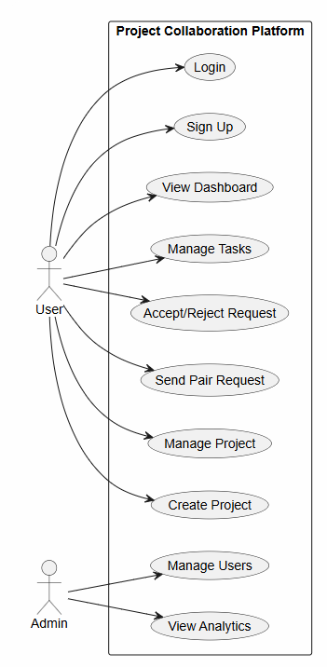

Fig 3.1 Use Case Diagram

3.1.2 Class Diagram
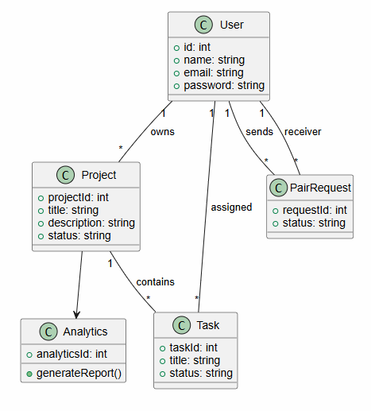

Fig 3.2 Class Diagram

3.1.3 Sequence Diagram
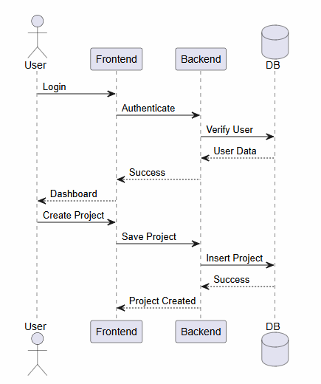

Fig 3.3 Sequence Diagram

3.1.4 Activity Diagram
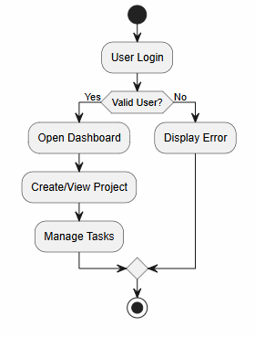
Fig 3.4 Activity Diagram

3.1.5 State Diagram — PairRequest
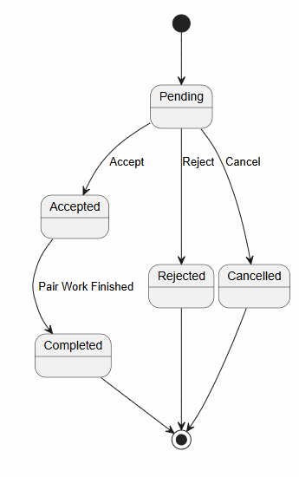

Fig 3.5 State Diagram — PairRequest

3.1.6 State Diagram — Project
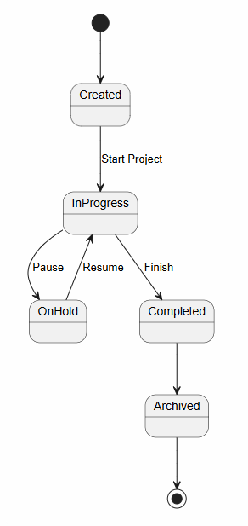

Fig 3.6 State Diagram — Project

3.1.7 ER Diagram
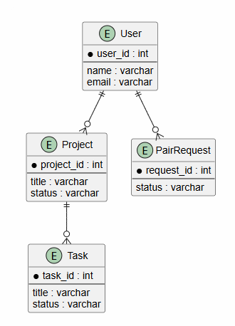

Fig 3.7 ER Diagram

3.1.8 Component / Dependency Diagram
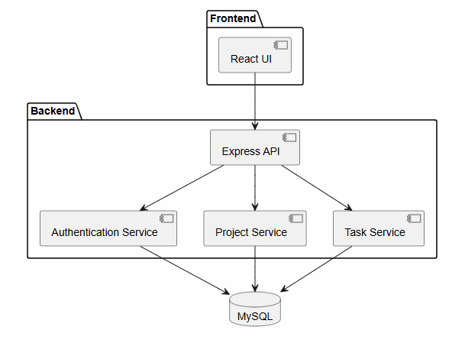
Fig 3.8 Component / Dependency Diagram

3.2 Cohesion and Coupling
Cohesion and Coupling are important software design principles used to improve system maintainability, scalability, and reliability. The Smart Pharma System is designed with high cohesion and low coupling to ensure better software quality.

3.2.1 Cohesion (High Cohesion)
Cohesion refers to the degree to which the elements within a module belong together. A highly cohesive module performs a single well-defined task and contains closely related functionalities.
The Smart Pharma System follows the principle of High Cohesion by dividing the application into specialized modules.

Authentication Module
Responsibilities:
- User Registration
- User Login
- Password Management
- JWT Authentication

Inventory Module
Responsibilities:
- Foil Management
- Cylinder Management
- QR Code Generation
- Barcode Generation

Attendance Module
Responsibilities:
- Check-In
- Check-Out
- Attendance Tracking
- Working Hours Calculation

Salary Module
Responsibilities:
- Salary Calculation
- Earnings Tracking
- Payroll Reporting

Task Management Module
Responsibilities:
- Task Creation
- Task Assignment
- Task Status Updates
- Task Completion Tracking

Reporting Module
Responsibilities:
- Attendance Reports
- Inventory Reports
- Salary Reports
- Audit Reports

Benefits of High Cohesion
- Easy maintenance
- Improved readability
- Better reusability
- Reduced complexity
- Easier testing and debugging

3.2.2 Coupling (Low Coupling)
Coupling refers to the degree of dependency between software modules. Low Coupling means modules interact with each other through well-defined interfaces while remaining independent.
The Smart Pharma System follows Low Coupling architecture through REST APIs and service-based communication.

Examples of Low Coupling

Authentication and Inventory
The Inventory Module only verifies authentication tokens and does not directly access authentication logic.

Attendance and Salary
Salary calculations use attendance data through service calls without tightly connecting both modules.

Reporting Module
The Reporting Module collects data from multiple modules without modifying their internal functionality.

Benefits of Low Coupling
- Easy module replacement
- Better scalability
- Independent development
- Simplified maintenance
- Reduced risk of system-wide failures

3.3 Design Pattern
The Smart Pharma System adopts the Model-View-Controller (MVC) Design Pattern.

Model Layer
The Model layer manages data and business entities.
Examples:
- User Model
- Attendance Model
- Task Model
- Inventory Model
- Audit Log Model

View Layer
The View layer provides the user interface using React.js.
Examples:
- Login Page
- Dashboard
- Inventory Page
- Attendance Page
- Reports Page

Controller Layer
The Controller layer processes user requests and communicates with the database.
Examples:
- Authentication Controller
- Inventory Controller
- Attendance Controller
- Salary Controller
- Report Controller

Advantages of MVC Pattern
- Separation of concerns
- Better code organization
- Easier maintenance
- Improved scalability
- Enhanced testability
Additional patterns used include:
- Service Layer Pattern
- Repository Pattern
- Middleware Pattern
- Dependency Injection Concepts

3.4 Usage of Appropriate Architectural Styles
The Smart Pharma System follows a Three-Tier Client-Server Architecture.

Presentation Layer
The Presentation Layer is responsible for user interaction and interface rendering.
Technologies:
- React.js
- HTML5
- CSS3
- JavaScript
Functions:
- User Interface
- Dashboard Visualization
- Form Handling
- Report Display

Business Logic Layer
The Business Logic Layer processes application rules and workflows.
Technologies:
- Node.js
- Express.js
Functions:
- Authentication
- Inventory Processing
- Attendance Processing
- Salary Calculation
- Report Generation

Data Layer
The Data Layer stores and manages application data.
Technologies:
- MongoDB
- Mongoose ODM
Functions:
- Data Storage
- Data Retrieval
- Data Validation
- Database Operations

Architectural Benefits
- Scalability
- Security
- Flexibility
- Maintainability
- High Performance
- Easy Deployment

3.5 Interface Design
The Smart Pharma System provides a simple, responsive, and user-friendly interface that enables users to perform daily operations efficiently.

Login Interface
Features:
- Username Field
- Password Field
- Login Button
- Forgot Password Option
Purpose:
Provides secure authentication and access control.

Dashboard Interface
Features:
- Employee Statistics
- Inventory Summary
- Attendance Summary
- Task Overview
- Report Widgets
Purpose:
Provides a centralized overview of system activities.

Inventory Management Interface
Features:
- Add Inventory
- Edit Inventory
- Delete Inventory
- QR Code Generation
- Barcode Generation
Purpose:
Manages pharmaceutical inventory records efficiently.

Attendance Management Interface
Features:
- Employee Check-In
- Employee Check-Out
- Attendance History
- Working Hour Tracking
Purpose:
Monitors employee attendance and productivity.

Salary Management Interface
Features:
- Salary Configuration
- Salary Calculation
- Payroll Reports
Purpose:
Automates payroll processing.

Task Management Interface
Features:
- Create Task
- Assign Task
- Update Status
- View Progress
Purpose:
Improves workflow management and employee coordination.

Reporting Interface
Features:
- Attendance Reports
- Salary Reports
- Inventory Reports
- Audit Logs
Purpose:
Supports management decision-making through analytical reports.

Interface Design Principles
- Simplicity
- Consistency
- Responsiveness
- Accessibility
- Security
- User Friendliness
The interface design ensures that users can perform their tasks efficiently while maintaining a professional and organized user experience.
CHAPTER 4

CODING PRACTICES
Coding practices play a significant role in developing reliable, maintainable, scalable, and secure software systems. The Smart Pharma System follows industry-standard coding practices, including static code analysis, dynamic code analysis, logging mechanisms, runtime monitoring, validation techniques, and security controls to ensure software quality.

4.1 Static Code Analysis
Static Code Analysis is the process of examining source code without executing the application. It helps identify coding errors, security vulnerabilities, code smells, and maintainability issues during development.
Benefits include:
- Early defect detection
- Improved code quality
- Consistent coding standards
- Enhanced maintainability
- Reduced debugging effort
The Smart Pharma System utilizes various static analysis tools to maintain high-quality code.

4.1.1 ESLint (Frontend)
ESLint is a static code analysis tool used to identify problematic patterns and coding errors in JavaScript and React applications.

Purpose
The frontend of the Smart Pharma System is developed using React.js. ESLint is used to enforce coding standards and improve code consistency across the project.

Features
- Detects syntax errors
- Enforces coding conventions
- Prevents unused variables
- Identifies potential bugs
- Maintains code readability

Example Checks
- Missing semicolons
- Undefined variables
- Duplicate declarations
- Unused imports
- Improper React Hook usage

Benefits
- Improved code quality
- Better maintainability
- Reduced runtime errors
- Consistent coding practices

4.1.2 express-validator (Backend)
express-validator is a middleware library used for validating and sanitizing user input in Express.js applications.

Purpose
The Smart Pharma System uses express-validator to ensure that incoming API requests contain valid and secure data before processing.

Validation Examples
- Email validation
- Password validation
- Required field validation
- Numeric input validation
- Data sanitization

Example
User Registration API validates:
- Username
- Email Address
- Password Length
- User Role

Benefits
- Prevents invalid data entry
- Enhances security
- Reduces server-side errors
- Protects against malicious inputs

4.2 Dynamic Code Analysis
Dynamic Code Analysis involves monitoring the application while it is running. It helps detect runtime errors, performance issues, security vulnerabilities, and system behavior under different conditions.
The Smart Pharma System uses several runtime monitoring mechanisms to improve reliability and performance.

4.2.1 Winston Logger
Winston is a powerful logging library used for recording application activities and runtime events.

Purpose
The Smart Pharma System uses Winston Logger to track:
- User activities
- API requests
- System errors
- Security events
- Audit logs

Logged Information
- Login attempts
- Inventory updates
- Attendance modifications
- Task assignments
- Error messages

Benefits
- Easy debugging
- Error tracking
- Performance monitoring
- Security auditing

4.2.2 Health Check Endpoint
A Health Check Endpoint is used to verify whether the application and its services are functioning correctly.

Endpoint Example
/api/health

Checks Performed
- Server Status
- Database Connectivity
- API Availability
- Memory Usage
- System Uptime

Sample Response
Status: Healthy
Database: Connected
Server: Running

Benefits
- Continuous monitoring
- Quick fault detection
- Deployment verification
- System reliability assurance

4.2.3 Postman API Testing
Postman is used to test and validate REST APIs during development and deployment.

Purpose
The Smart Pharma System uses Postman to verify:
- API functionality
- Response validation
- Authentication workflows
- Error handling

APIs Tested
- Login API
- Registration API
- Inventory API
- Attendance API
- Salary API
- Reporting API

Benefits
- Automated testing
- Faster debugging
- API verification
- Reduced integration errors

4.2.4 Sequelize Query Logging
Sequelize Query Logging records database queries executed by the application during runtime.

Purpose
Query logging helps developers monitor database interactions and identify performance bottlenecks.

Information Logged
- SELECT queries
- INSERT queries
- UPDATE queries
- DELETE queries
- Query execution time

Benefits
- Database performance optimization
- Slow query detection
- Easier debugging
- Improved transparency

Note
If MongoDB and Mongoose are used instead of Sequelize, similar query monitoring can be implemented using Mongoose debugging features.

4.2.5 Rate Limiting (Runtime Protection)
Rate Limiting restricts the number of requests that a user can send to the server within a specified time period.

Purpose
Protects the Smart Pharma System from:
- Brute force attacks
- DDoS attacks
- API abuse
- Excessive resource consumption

Example Configuration
- Maximum Requests: 100
- Time Window: 15 Minutes

Benefits
- Enhanced security
- Improved server stability
- Protection against abuse
- Better resource utilization

4.2.6 Sequelize Transaction Monitoring
Transaction Monitoring ensures database operations execute reliably and maintain data consistency.

Purpose
The Smart Pharma System monitors critical transactions such as:
- Inventory Updates
- Salary Calculations
- Attendance Processing
- Task Assignments

Monitoring Features
- Transaction Start
- Transaction Commit
- Transaction Rollback
- Error Detection

Benefits
- Data consistency
- Error recovery
- Reliable operations
- Improved database integrity

Note
For MongoDB-based implementations, transaction monitoring can be performed using MongoDB Sessions and Mongoose Transactions.

.

CHAPTER 5

TESTING
Testing is an essential phase of software development that ensures the Smart Pharma System functions correctly, meets user requirements, and operates reliably under different conditions.

5.1 Debugging Techniques
The following debugging techniques were used during development:

Console Logging
Used to monitor variable values and execution flow.

Browser Developer Tools
Used for frontend debugging, network monitoring, and performance analysis.

Postman Testing
Used to verify API responses and backend functionality.

Error Logging
Winston Logger was used to record application errors and runtime events.

Database Query Inspection
Database operations were monitored to identify incorrect queries and data inconsistencies.

Breakpoint Debugging
Visual Studio Code debugger was used to inspect code execution step-by-step.

5.2 Unit Testing
Unit testing verifies individual functions and modules independently.

Tab 5.2 Unit Testing
Module | Function Tested | Input | Expected Output | Result
Authentication | User Login | Valid Username & Password | Successful Login | Pass
Authentication | User Login | Invalid Credentials | Authentication Error | Pass
Authentication | User Registration | Valid User Data | User Created | Pass
Inventory | Add Foil | Valid Foil Details | Foil Added Successfully | Pass
Inventory | Update Foil | Updated Data | Foil Updated | Pass
Inventory | Delete Foil | Foil ID | Foil Deleted | Pass
Attendance | Check-In | Employee ID | Attendance Recorded | Pass
Attendance | Check-Out | Employee ID | Check-Out Recorded | Pass
Salary | Salary Calculation | Attendance Hours | Correct Salary Generated | Pass
Task Management | Create Task | Task Details | Task Created | Pass
Task Management | Assign Task | Employee ID | Task Assigned | Pass
Reports | Generate Report | Date Range | Report Generated | Pass
QR Module | QR Generation | Inventory Data | QR Code Generated | Pass
Barcode Module | Barcode Generation | Cylinder Data | Barcode Generated | Pass
Audit Log | Activity Logging | User Action | Log Created | Pass

5.3 Integration Testing
Integration testing verifies the interactin between multiple modules.

Tab 5.3
Modules Integrated | Scenario Tested | Expected Outcome | Result
Authentication + Dashboard | Login and Dashboard Access | Dashboard Loaded Successfully | Pass
Authentication + Inventory | Authorized Inventory Access | Inventory Displayed | Pass
Inventory + QR Module | Generate QR After Inventory Entry | QR Created Successfully | Pass
Inventory + Barcode Module | Generate Barcode for Cylinder | Barcode Generated | Pass
Attendance + Salary | Calculate Salary from Attendance | Correct Salary Generated | Pass
Task + Employee Module | Assign Task to Employee | Task Assigned Successfully | Pass
Reports + Database | Generate Attendance Report | Report Generated | Pass
Audit Log + Authentication | Record Login Activity | Log Created | Pass
Dashboard + Reports | Display Report Statistics | Analytics Displayed | Pass
Inventory + Audit Log | Inventory Update Tracking | Audit Record Generated | Pass

5.4 System Testing
System testing evaluates the complete Smart Pharma System as a whole.

Tab 5.4 System Testing
Test Scenario | Expected Result | Actual Result | Status
User Registration | New User Created Successfully | User Created Successfully | Pass
User Login | Access Granted | Access Granted | Pass
Inventory Creation | Inventory Stored in Database | Inventory Stored Successfully | Pass
QR Code Generation | QR Code Generated | QR Code Generated | Pass
Barcode Generation | Barcode Generated | Barcode Generated | Pass
Attendance Check-In | Attendance Recorded | Attendance Recorded | Pass
Attendance Check-Out | Working Hours Calculated | Working Hours Calculated | Pass
Salary Calculation | Salary Generated Correctly | Salary Generated Correctly | Pass
Task Assignment | Task Assigned Successfully | Task Assigned Successfully | Pass
Report Generation | Reports Displayed | Reports Displayed | Pass
Audit Logging | Activity Logged | Activity Logged | Pass

5.5 Bug Report
The following bugs were identified and resolved during development.

Tab 5.4 Bug Report
Bug ID | Module | Bug Description | Severity | Steps to Reproduce | Resolution | Status
BUG-001 | Authentication | Invalid JWT Token Error | High | Login with expired token | Token Refresh Logic Added | Closed
BUG-002 | Inventory | Duplicate Inventory Entry | Medium | Add same inventory twice | Duplicate Validation Added | Closed
BUG-003 | Attendance | Check-Out Time Not Recorded | High | Employee Check-Out | Fixed Database Update Logic | Closed
BUG-004 | Salary | Incorrect Salary Calculation | High | Calculate Salary | Corrected Formula Logic | Closed
BUG-005 | Dashboard | Statistics Not Refreshing | Medium | Update Inventory | Added Auto Refresh API | Closed
BUG-006 | Reports | Report Export Failure | Medium | Export PDF Report | Fixed Export Service | Closed
BUG-007 | QR Module | QR Scan Validation Error | Medium | Scan Invalid QR | Improved Validation Logic | Closed
BUG-008 | Barcode Module | Barcode Not Rendering | Low | Generate Barcode | Updated Barcode Library | Closed
BUG-009 | Audit Log | Missing User Activity Logs | Medium | Perform User Action | Fixed Logging Middleware | Closed
BUG-010 | API Gateway | Slow API Response | Medium | Multiple Requests | Query Optimization Applied | Closed

CHAPTER 6

DEPLOYMENT CHECKLIST

Tab 6.1 Deployment Checklist
S.No | Deployment Activity | Status
1 | Install Node.js Environment | Completed
2 | Install MongoDB Database | Completed
3 | Configure Environment Variables | Completed
4 | Install Backend Dependencies | Completed
5 | Install Frontend Dependencies | Completed
6 | Configure JWT Secrets | Completed
7 | Configure Database Connection | Completed
8 | Build React Application | Completed
9 | Execute Unit Testing | Completed
10 | Execute Integration Testing | Completed
11 | Execute System Testing | Completed
12 | Verify API Endpoints | Completed
13 | Enable Logging Services | Completed
14 | Configure Security Settings | Completed
15 | Deploy Backend Server | Completed
16 | Deploy Frontend Application | Completed
17 | Verify Production Environment | Completed
18 | Monitor Application Health | Completed

CHAPTER 7

RESULT
The Smart Pharma System was successfully developed and tested to automate pharmaceutical inventory management, employee attendance tracking, salary calculation, task management, QR/barcode processing, audit logging, and reporting activities.
The system achieved the following outcomes:
- Successful user authentication and authorization.
- Efficient inventory management of foils and cylinders.
- Accurate attendance tracking and salary computation.
- Automated QR code and barcode generation.
- Effective task assignment and monitoring.
- Comprehensive audit logging and reporting.
- Real-time dashboard analytics.
- Secure and scalable architecture.
The testing results confirmed that all major functionalities performed as expected with minimal errors. The system improved operational efficiency, reduced manual work, enhanced data accuracy, and provided better decision-making support through centralized management and analytical reporting.
Therefore, the Smart Pharma System successfully meets the objectives defined during the requirements engineering phase and provides a reliable solution for pharmaceutical production and workforce management.

APPENDIX
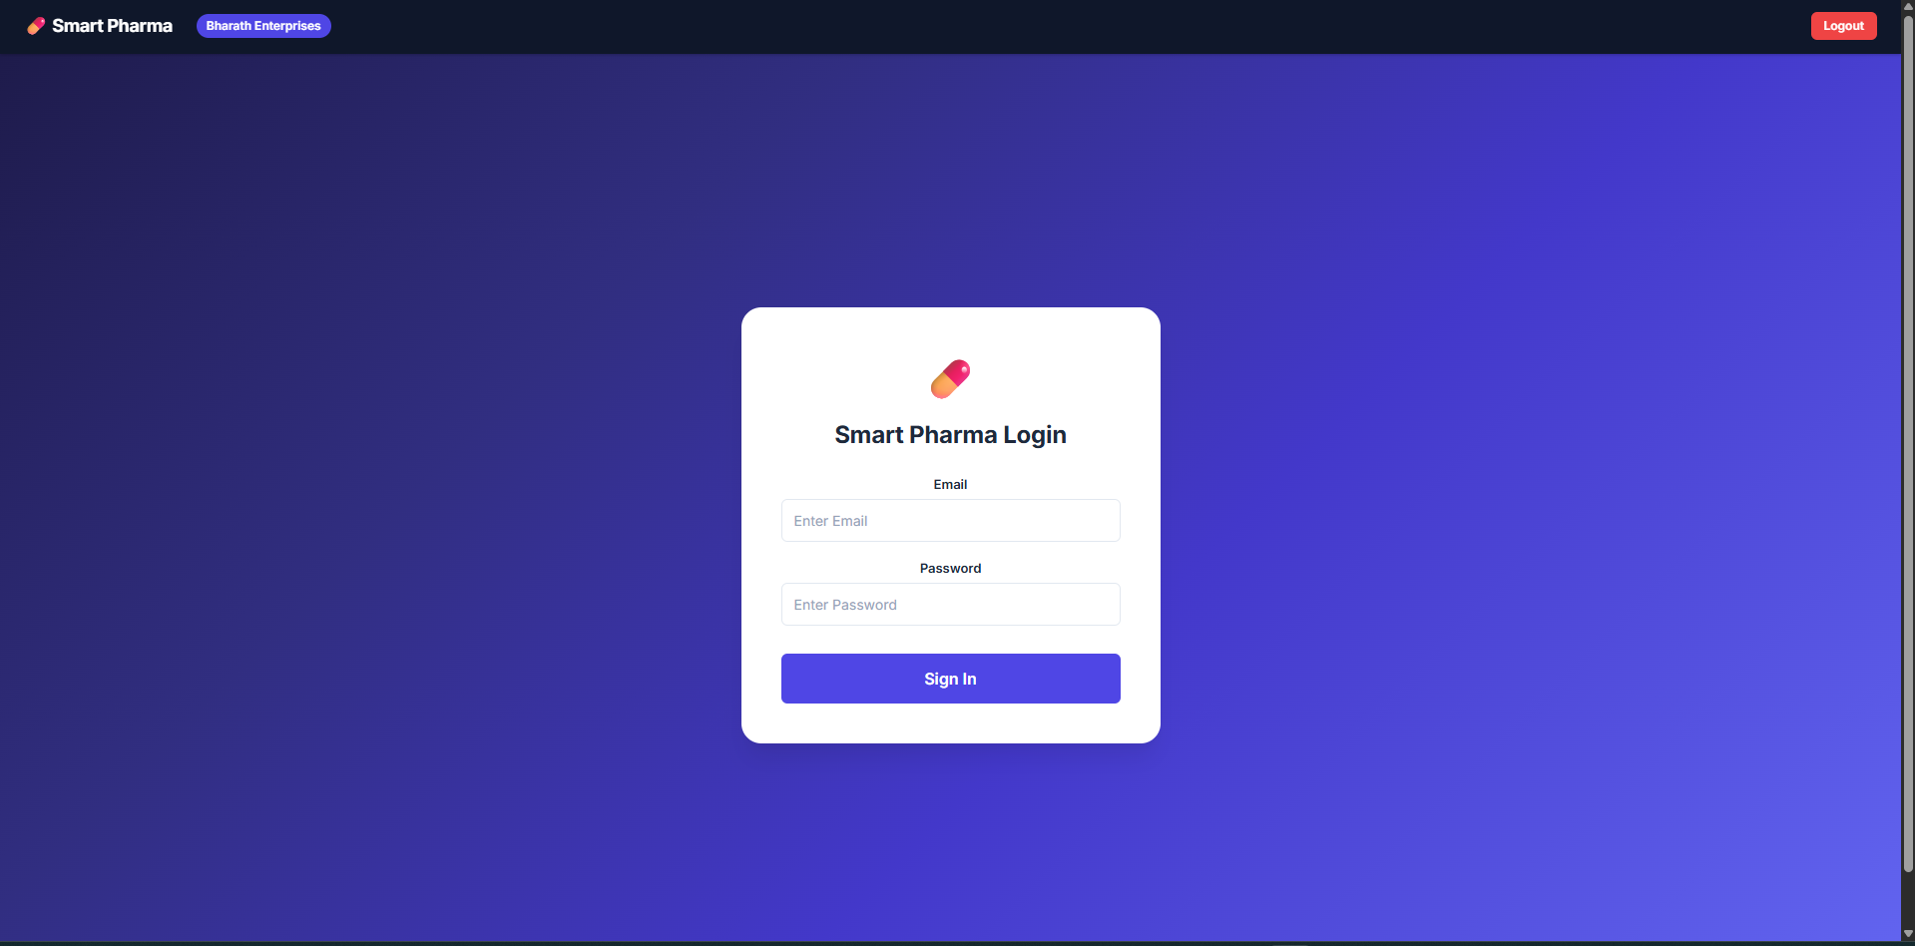
Fig 7.1 signup page
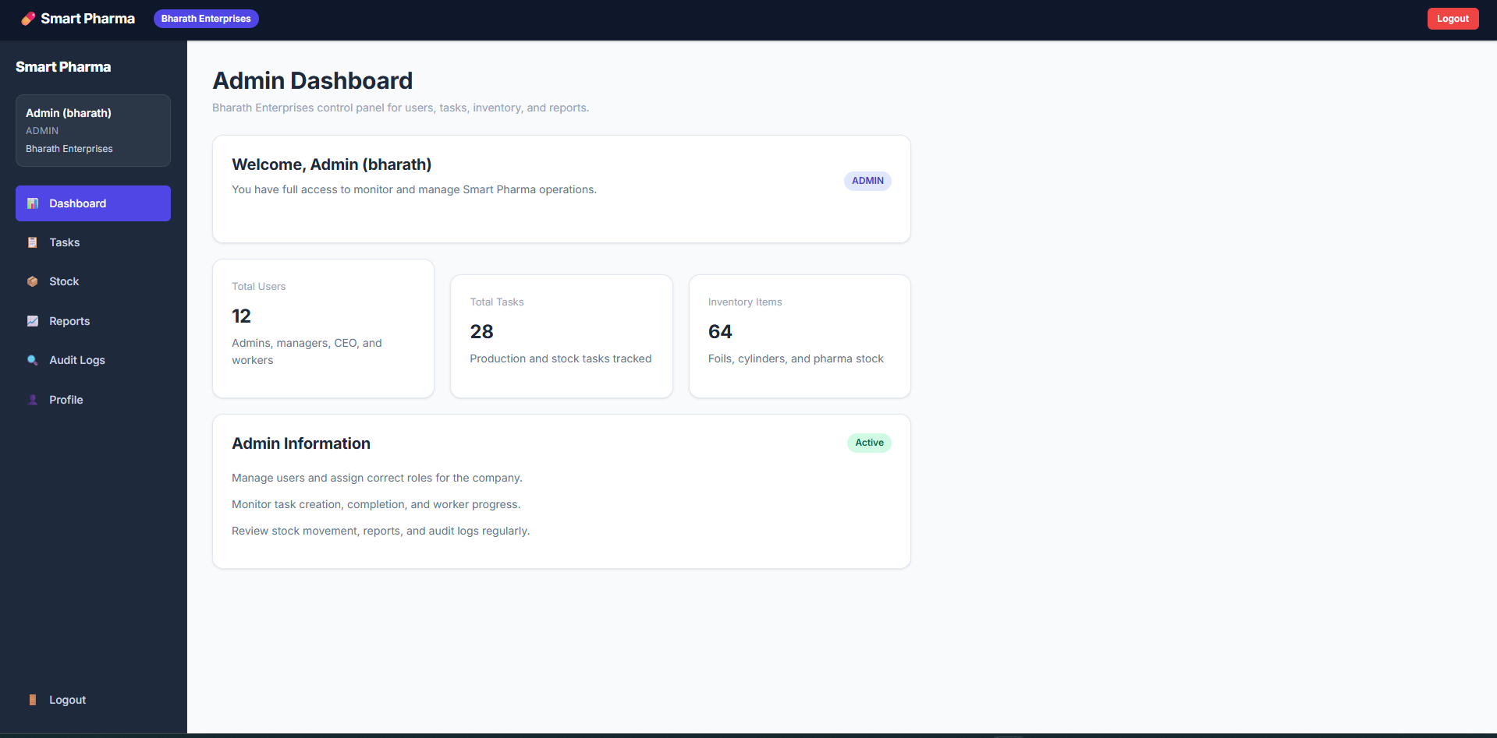
Fig 7.2 Admin Dashboard
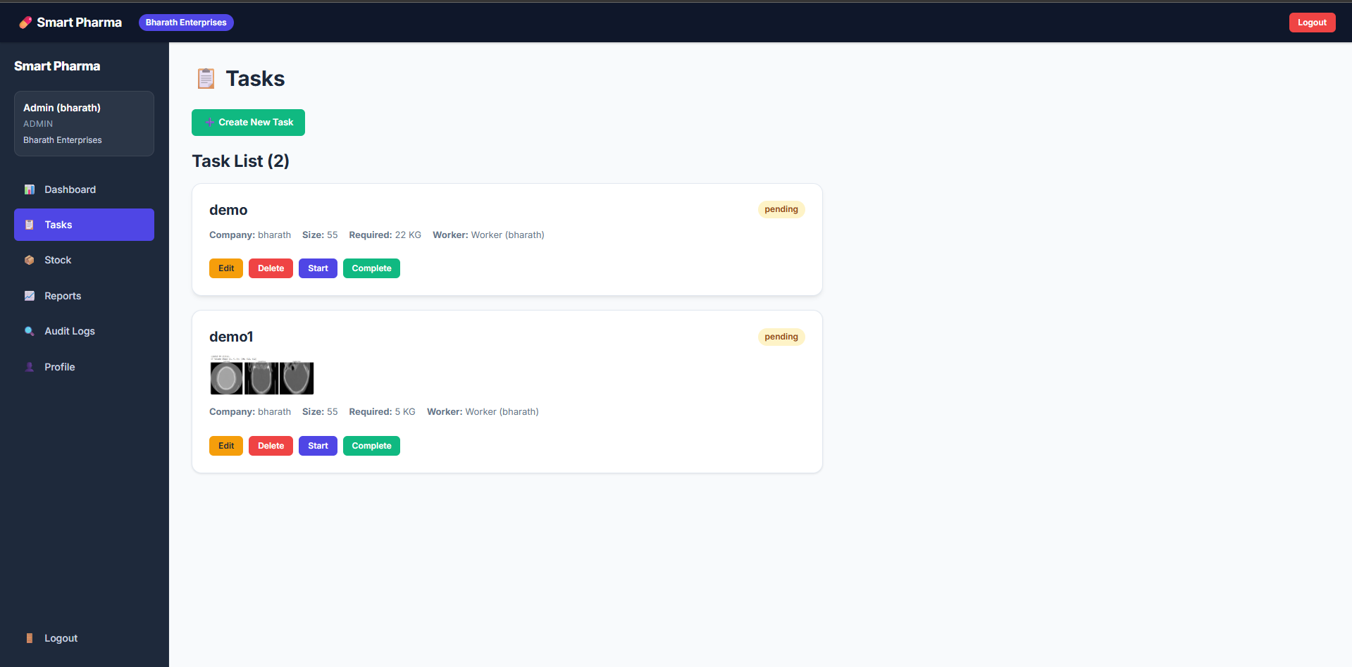
Fig 7.3 task manager
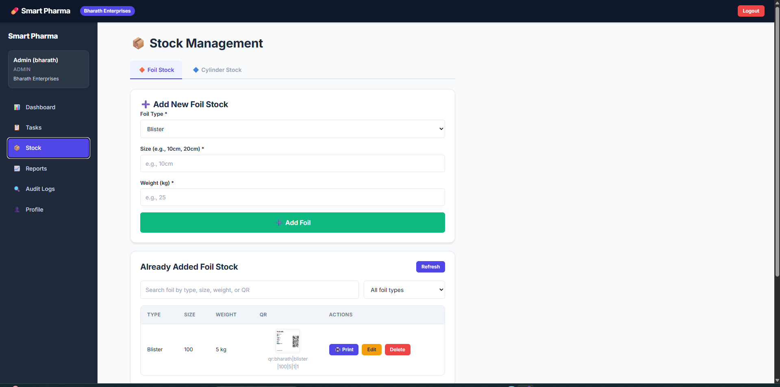
Fig 7.4 Stock management
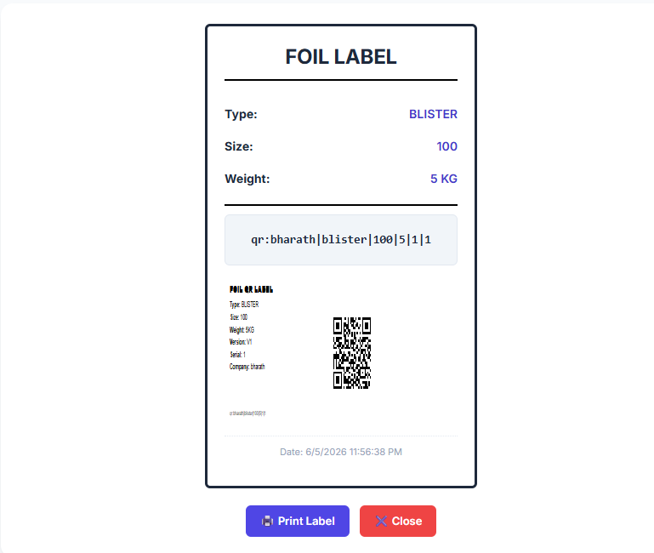
Fig 7.5 bar code
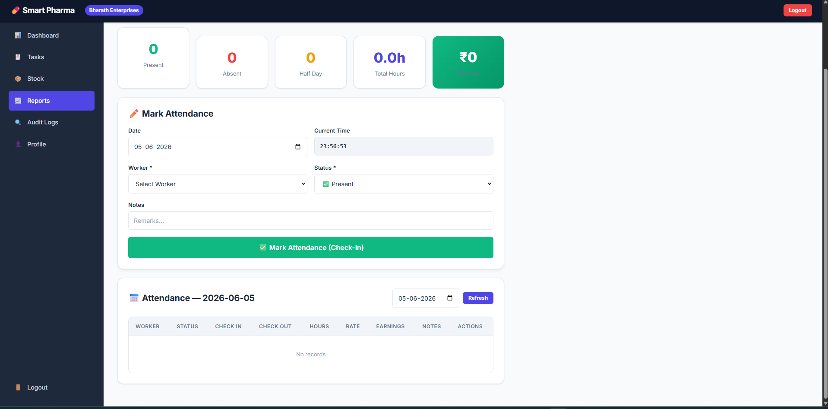
Fig 7.6 Attendance report
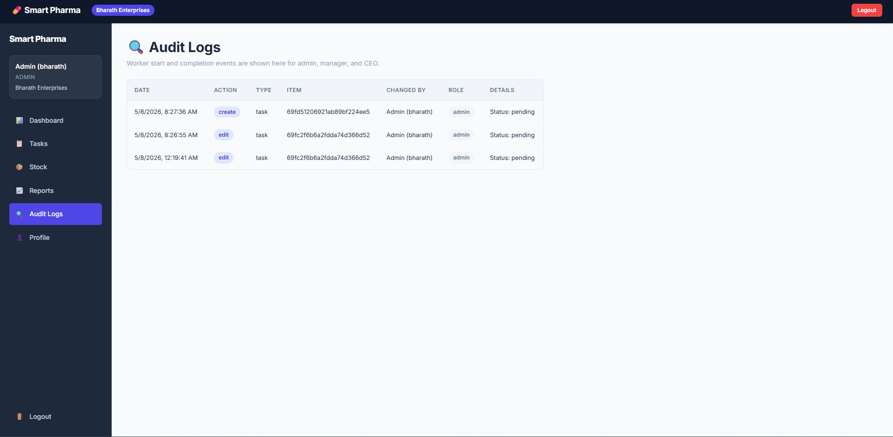
Fig 7.7 Audit logs
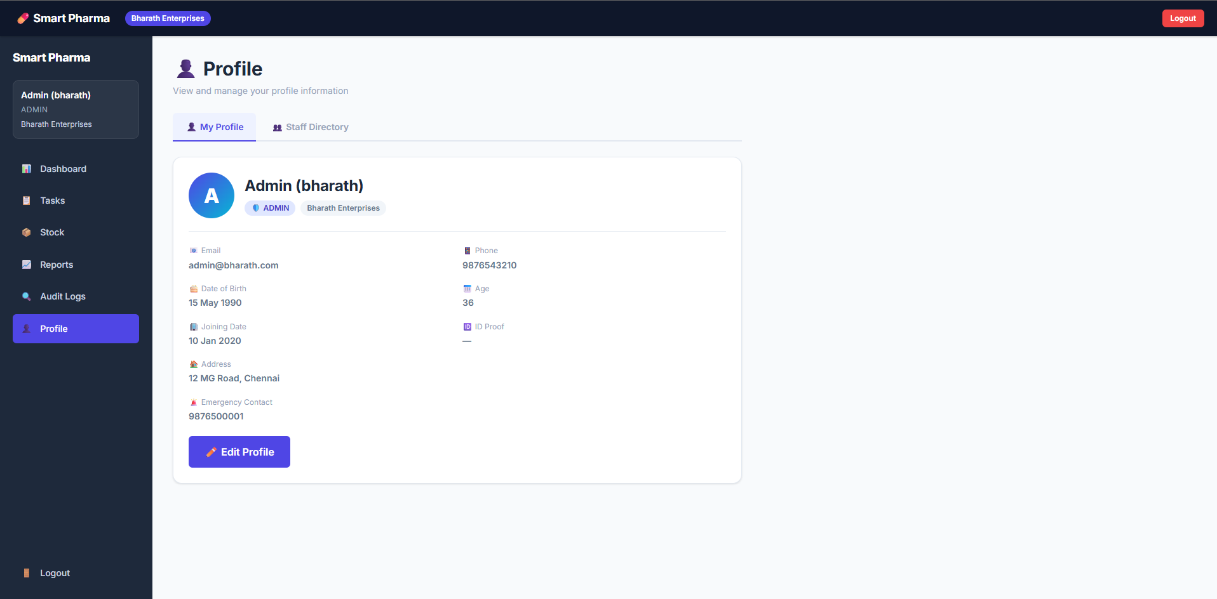
Fig 7.8 Profile settings

