Use Case Specification

DMT/RM01/TMP

|  |  |
| --- | --- |
| Project Code | PRJ_ARS_007 |
| Project Name | FlyWithMe Airline Reservation System |

|  |  |  |
| --- | --- | --- |
| Prepared/Modified by | Role | Date of Preparation |
| Team 1 | Test Team | 02/01/2018 |
| Reviewed by | Role | Date of Review |
| Naveen | Test Engineer | 06/01/2018 |
| Approved by | Role | Date of Approval |
| Praveen M.P. | Test Engineer | 07/01/2018 |
| Circulation List |  | Version Number of the template:1.1 |
| Version Number | v1.1 |  |

<<Customer>> REVIEW HISTORY

<<Customer comments on the Use case along with the signed off is tracked here>>

|  |  |  |  |  |  |  |
| --- | --- | --- | --- | --- | --- | --- |
| Version | 1.1 |  |  |  |  |  |
| Date | 02/01/2018 |  |  |  |  |  |
| Reviewed by | Team 1 |  |  |  |  |  |
| Reviewed UI Specification doc | Yes |  |  |  |  |  |
| All Open Queries/issues closed | Yes |  |  |  |  |  |
| Agreement on Assumptions | Agreed |  |  |  |  |  |
| Sign Off | <<Signature>> |  |  |  |  |  |

Disclaimer:

The scope of the project ‘FlyWithMe Airline Reservation System’ is restricted to the contents of this signed off use case.

TABLE OF CONTENTS

1. Use Case Name: AirLine Admin Login 5

2. Actor(s) 5

3. Preconditions 5

4. Flow of Events 5

4.1 Basic Flow 5

4.2 Alternative Flows 5

Alternate Flow 1 5

Alternate Flow 2 6

4.3 Exception Flows 6

Exception Flow 1: Unsuccessful login 6

Exception Flow 2: HTTP session not created 6

Exception Flow 3: User id is excedding the limit 6

Exception Flow 4: Password is below the limit 6

Exception Flow 5: Database Connectivity 7

Exception Flow 6: Network Failure 7

5. Post Conditions 7

6. Special Requirements 7

7. Performance 7

8. Availability 7

9. Security 8

10. Extension Points 8

11. Business Rules 8

12. Diagrams 9

13. Scenarios 10

14. Issues 10

15. UI Specifications 10

16. Inter System Dependencies 10

17. Assumptions 10

1. Use Case Name: AirLine Admin Login

**Use Case ID:**  UC.ARS_Admin_01

**Brief Description:** This Use Case describes the process by which the Authority login to Airline Reservation System Portal. The Admin can directly login to the application using the credentials given to him.

This use case describes the process by which admin can log into the Airline Reservation System Portal.

1. Actor(s)

* Admin

1. Preconditions

* Administrator is an employee of Fly High Company
* Administrator has access to Airline Reservation System Portal
* Administrator has a valid username and password

1. Flow of Events

4.1 Basic Flow

**Name:** Administrator login to Airline Reservation System Portal.

1. Administrator visits the Airline Reservation System Portal URL link <http://ndafile:8081/AirlineReservationSystem/> using any standard browser.
2. Administrator enters username and password and clicks on the login button.
3. The system validates the username and password combination with the database.
4. On successful login, the admin home page is displayed.
5. Admin clicks on Update Flight Details radio button and clicks Submit button.
6. Admin enters the valid inputs in the given input fields of Flight Details.
7. Clicks on Update button.
8. Success message is displayed.
9. Admin clicks Back button.
10. Admin clicks on View Passenger's List.
11. Passenger's list page is displayed.
12. Admin clicks on LogOut button.

* 1. Alternative Flows

Alternate Flow 1

1. Administrator is navigated to the home page.
2. Administrator enters username and password and clicks on the login button.
3. The system validates the username and password link with the database.
4. On successful login, the admin home page is displayed on the console.
5. Admin clicks on View Passenger's list radio button and clicks Submit button.
6. Passenger's List page is displayed.
7. Admin Clicks on LogOut button.

Alternate Flow 2

1. Administrator visits the Airline Reservation System Portal URL <http://ndafile:8081/AirlineReservationSystem/> using any standard browser.
2. Administrator enters username and password and clicks on the login button.
3. The system validates the username and password combination link with the database.
4. On successful login, the admin home page is displayed.
5. Admin clicks on Update Flight Details radio button and clicks Submit button.
6. Admin enters the valid inputs.
7. Admin clicks Reset button. details entered is resetted.
8. Admin clicks LogOut button.

* 1. Exception Flows

Exception Flow 1: Unsuccessful login

1. Administrator visits the Airline Reservation System Portal URL <http://ndafile:8081/AirlineReservationSystem/> using any standard browser.
2. Administrator enters username and password and clicks on the login button for validation .
3. The system validates the username and password combination link with the database.
4. If the authentication is unsuccessful, a login failure message is displayed on the console.

Exception Flow 2: HTTP session not created

1. Administrator is navigated to the home page.
2. Administrator enters username and password and clicks on the login button to validate.
3. The system validates the username and password combination with the database.
4. On successful login, the admin home page is displayed on the console.
5. On Successful login, the username and role fields are not stored in the HTTP session.

Exception Flow 3: User id is excedding the limit

1. Administrator visits the Airline Reservation System Portal URL <http://ndafile:8081/AirlineReservationSystem/> using any standard browser.
2. Administrator enters username more than 5 characters
3. Administrator enters password and clicks on the Login button.
4. The system validates the username and password.
5. Administrator geting error message for invalid Username.

Exception Flow 4: Password is below the limit

1. Administrator visits the Airline Reservation System Portal URL <http://ndafile:8081/AirlineReservationSystem/> using any standard browser.
2. Administrator enters username.
3. Administrator enters password below 5 characters.
4. Clicks on the Login button.
5. The system validates the username and password.
6. Administrator geting error message for invalid password.

Exception Flow 5: Database Connectivity

1. Administrator visits the Airline Reservation System Portal URL <http://ndafile:8081/AirlineReservationSystem/> using any standard browser.
2. Administrator enters username and password and clicks on the login button.
3. The system validates the username and password combination with the database.
4. System displays error message regarding database connectivity.

Exception Flow 6: Network Failure

1. Administrator visits the Airline Reservation System Portal URL <http://ndafile:8081/AirlineReservationSystem/> using any standard browser.
2. The system displays error message regarding network failure.

1. Post Conditions

| Flow Name | Post Condition |
| --- | --- |
| Administrator visits the Airline Reservation System Portal URL <http://ndafile:8081/AirlineReservationSystem/> using any standard browser. | Airline Reservation System home page should display |
| Administrator successful Login to application | Administrator should navigate to the Admin home page. |
| Administrator unsuccessful login | The application should display Error message to the Administrator for invalid username or password |
| Exceeding Username Limit | The application should display error message on invalid userid |
| Password below the limit | The application should display error message on invalid password |
| Database Connectivity | The application should display error message for Database connectivity |
| Network failure | The application should display error message for Network failure |

1. Special Requirements

1. Performance

* On kiosks operating with a PSTN connection, users shall have greater than 50Kbps connection speed.
* Application should response within 6 sec. for all the request by the user.

1. Availability

* Application should be available for 24*7 to Adminstrator and Applicants.

1. Security

* On each page in the Airline Reservation System Portal URL link <http://ndafile:8081/AirlineReservationSystem/> web application checks for a valid user login by checking the value of a session variable.
* Users cannot directly access any web page of the application by simply entering the URL of that page on the address bar of the browser.

User Interface

* 1. The letters on Menus shall be bold and strong.
  2. The active links should be displayed in red color.
  3. The visited links should be displayed in purpule color.
  4. The unvisited links should be displayed in blue.
  5. The logout and back button should be available on every page of the application.
  6. Look, feel and color of application should be proper.
  7. In case of Field level validation error messages should be displayed in red color.

1. Extension Points

Extension in Alternate Flow 1:

* If the customer has entered wrong user credentials :
* The system prompts the user to re-enter the credentials
* User enters the username and password
* The system validates the username and password combination with the database.
* On successful login, the admin home page is displayed.

(Extension in Alternate Flow 1:

In step 7, if the user has entered wrong user credentials :

1. The system prompts the user to re-enter the credentials.
2. User enters the username and password.
3. The system takes user to the Step 3 of Basic Flow.

Extension in Alternate Flow x:

In step y, if the user has entered inappropriate source and destination places in the search option :

1. The system displays error message saying no flights are available.
2. User either backs out of this use case, or retries after entering correct data.)

1. Business Rules

| Business Rule Name | Business Rule Description | System action (if BR fails) |
| --- | --- | --- |
| BR_01 | Administrator should be valid. | User got popup to re-enter the credentials. |
| BR_02 | Administartor should be able to update or modify flight details. | Display notification message “Flight details cannot be updated.” |
| BR_03 | Administrator should be able to few the Passenger’s list. | Display message “Passengers’ List cannot be viewed.” |

1. Diagrams

Use Case Diagram

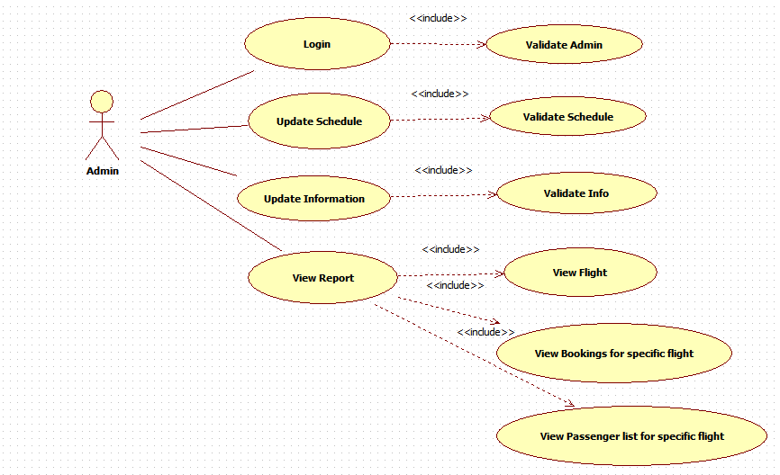

1. Scenarios

Success Scenarios

* Successful Adminisatration login
* Successful Update flight schedule in the portal
* Successful Update flight information in the portal
* Successfully HTTP session got created

Failure Scenarios

* Adminisatration login authentication fails
* HTTP session not created
* Administrator not able to Update flight schedule or Update flight information in portal.

1. Issues

* What if the HTTP session not created.
* What if the user is able to access the page of the application by simply entering the URL of that page on the address bar of the browser.

1. UI Specifications

<http://ndafile:8081/AirlineReservationSystem/>

1. Inter System Dependencies

**Module:** Executive

Use case name: Executive flight-occupancy details

**Impact**: If Executive has not updated passenger details the admin will not be able to see the passenger details.

1. Assumptions

* Application is valid and up running.
* Application is launcing in all the browser.
* Administrator should have valid username and password.

( more e.g

1. The User should be authenticate.
2. User should know the valid URL of Airline Reservation System Portal.
3. User should have Google chrome browser for best view of site.)

REVISION HISTORY OF THE WORK PRODUCT

<to be maintained by projects>

|  |  |  |  |  |  |
| --- | --- | --- | --- | --- | --- |
| # | Date | Version # | Section Changed | Details of changes made | Approved By |
| 1 |  |  |  |  |  |
| 2 |  |  |  |  |  |