**Assignment 2**

1)Write a program that checks if a given year is a leap year or not using both if-else and switch-case.

**Solution-**

**import** java.util.Scanner;

**public** **class** Leap_Year {

**public** **static** **void** main(String[] args) {

Scanner scanner = **new** Scanner(System.***in***);

System.***out***.print("Enter a year: ");

**int** year = scanner.nextInt();

**int** remainder = year % 4;

**switch** (remainder) {

**case** 0:

**if** (year % 100 == 0) {

**if** (year % 400 == 0) {

System.***out***.println(year + " is a leap year");

} **else** {

System.***out***.println(year + " is not a leap year");

}

} **else** {

System.***out***.println(year + " is a leap year");

}

**break**;

**default**:

System.***out***.println(year + " is not a leap year");

}

}

}

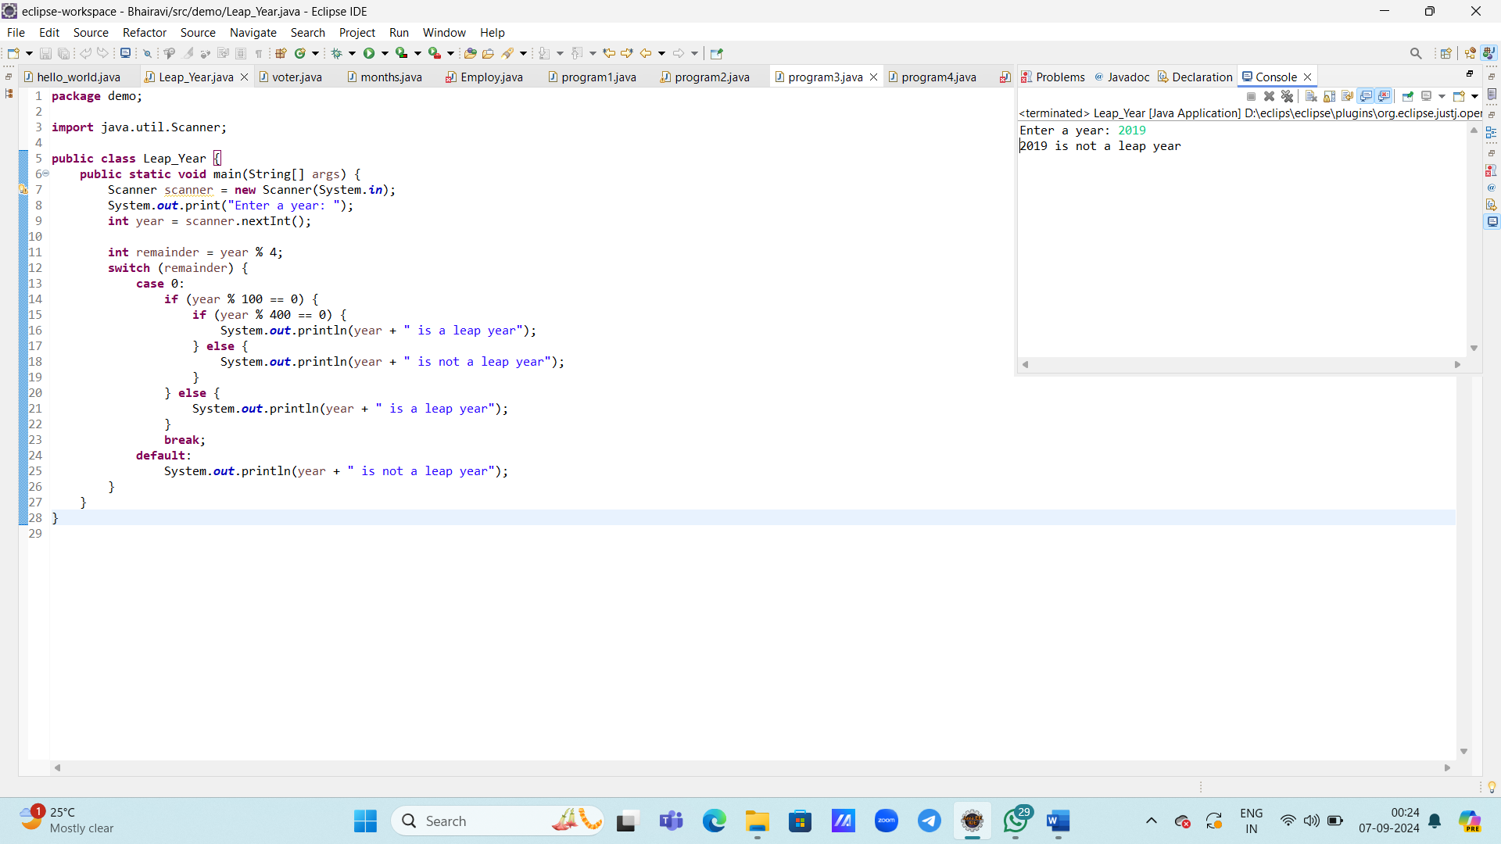

3) Write a program that checks if a person is eligible to vote based on their age.

**Solution-**

package demo;

import java.util.Scanner;

public class voter {

public static void main(String[] args) {

Scanner scanner = new Scanner(System.*in*);

System.*out*.print("Enter your age: ");

int age = scanner.nextInt();

if (age >= 18){

System.*out*.println("Eligible for voting.");

}else {

System.*out*.println("Not eligible.");

}

}

}

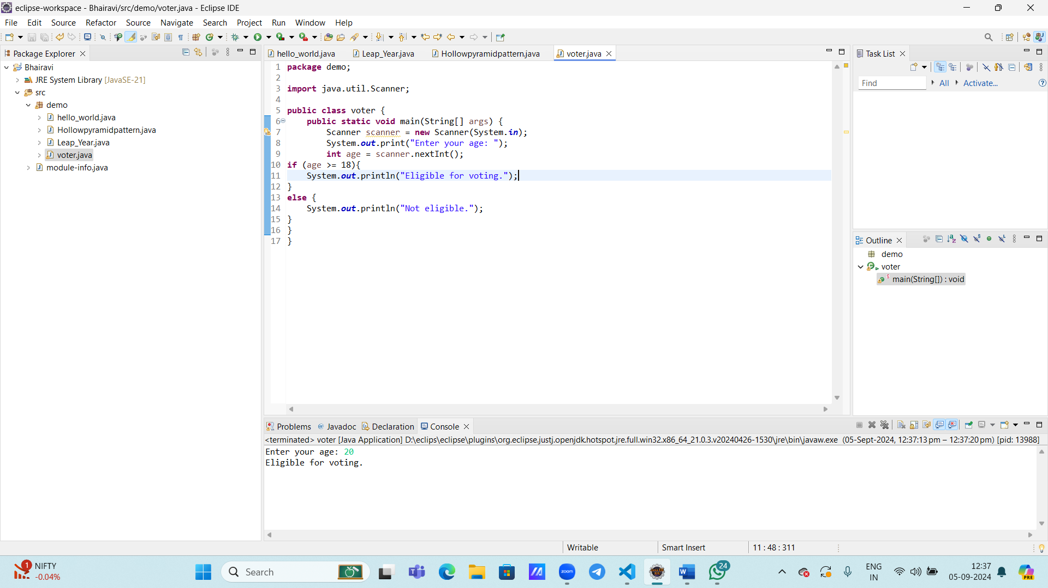

4) Write a program that takes a month (1-12) and prints the corresponding season (Winter, Spring, Summer, Autumn) using a switch case

**Solution-**

package demo;

import java.util.Scanner;

public class months {

public static void main(String[] args) {

Scanner scanner = new

Scanner(System.*in*);

System.*out*.println("Enter month (1-12):");

int month = scanner.nextInt();

switch (month) {

case 1:

case 2:

case 12:

System.*out*.println("Winter");

break;

case 3:

case 4:

case 5:

System.*out*.println("Spring");

break;

case 6:

case 7:

case 8:

System.*out*.println("Summer");

break;

case 9:

case 10:

case 11:

System.*out*.println("Autumn");

break;

}

}

}

