Autonomous CI/CD Pipeline Optimizer
MVP Report with Real Swagger UI Screenshots
Document Objective
This report provides a detailed functional and operational summary of the MVP and includes evidence screenshots captured from the real Swagger UI execution flow at /docs.

1. MVP Scope
- Backend platform validates CI/CD signals, computes run risk, and exposes governance-ready APIs.
- Core output surfaces include health, status, runs, assessments, queue metrics, KPIs, and audit logs.
- Role-based controls protect sensitive operational and governance endpoints.

2. Functional Coverage
- Health and Diagnostics: /health, /status/checks, /status-ui
- Ingestion and Scoring: /ingest/events, /ingest/source-event, /score/run/{run_id}
- Operations and Analytics: /queue/status, /runs, /assessments, /kpis
- Governance: /audit-logs

3. Real Swagger UI Evidence
All screenshots below were captured from the live Swagger UI endpoint at http://127.0.0.1:8000/docs using executed requests.
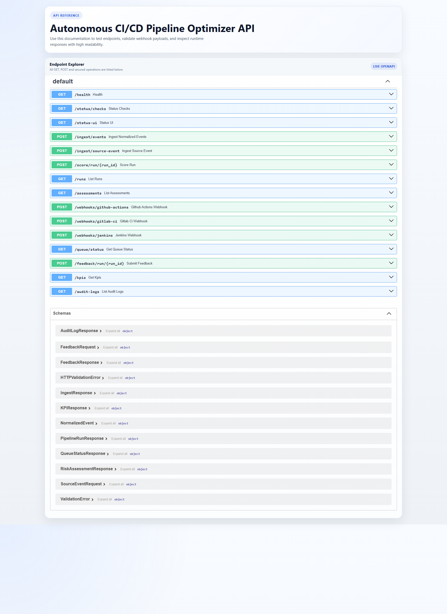
Figure 1. Swagger UI landing page (real browser capture)
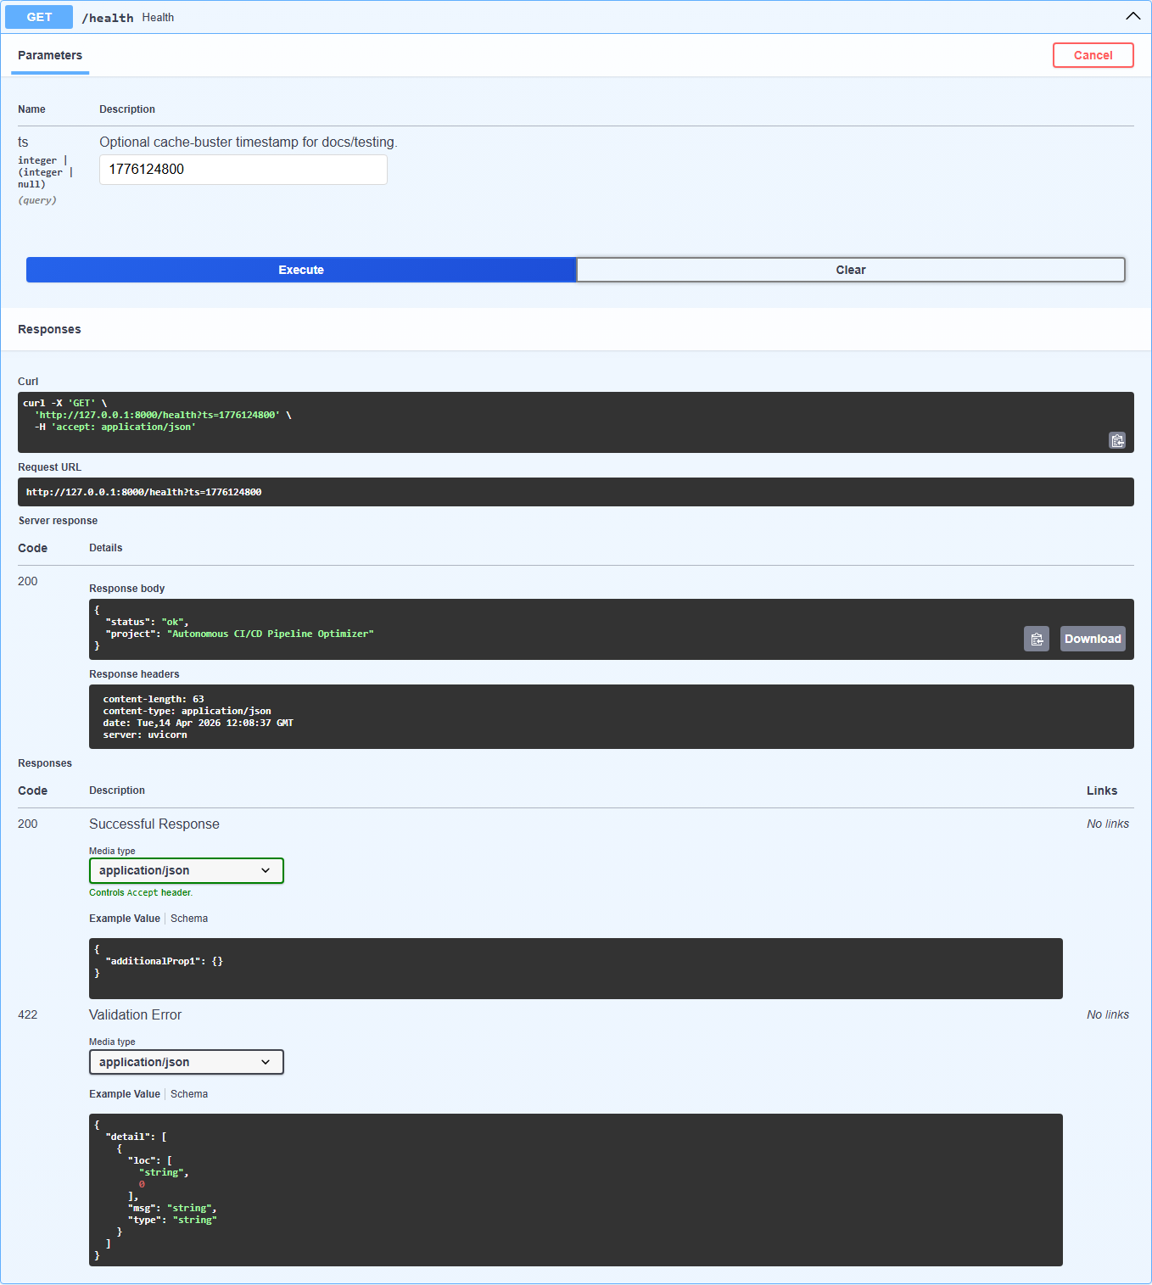
Figure 2. Health Endpoint (200)
Observation: Executed from Swagger UI with ts=1776124800; response shows service health payload.
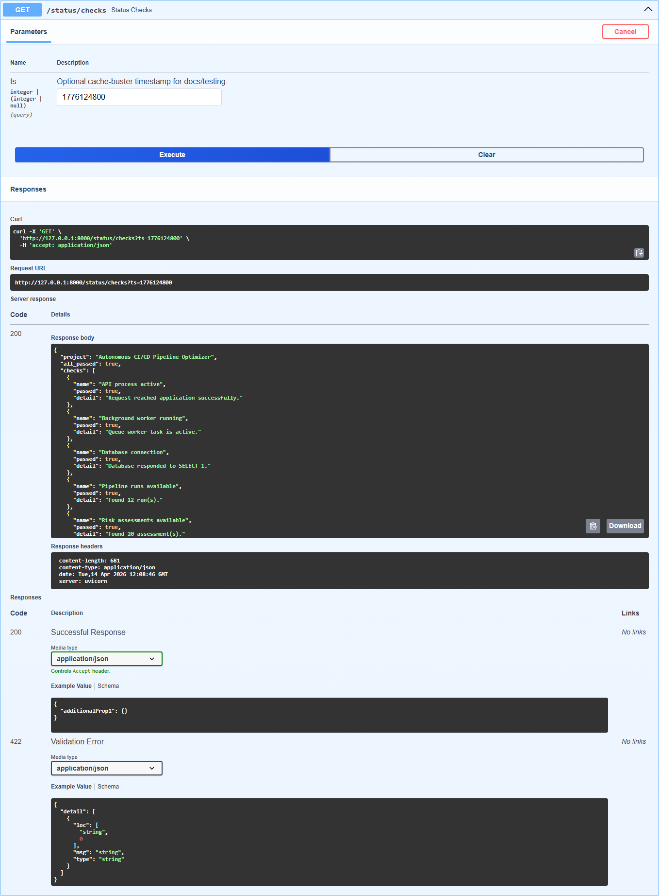
Figure 3. Status Checks (200)
Observation: Executed from Swagger UI with ts=1776124800; output includes all_passed summary and check details.
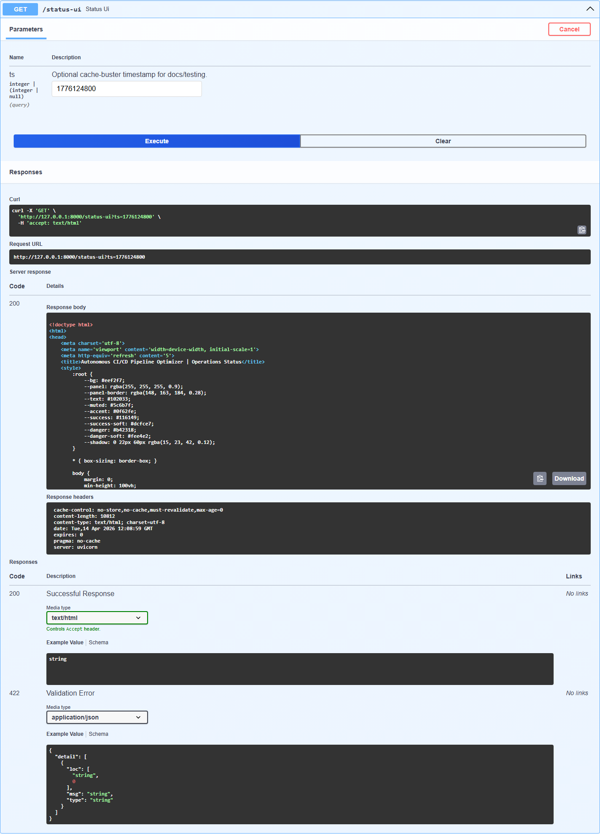
Figure 4. Status UI Endpoint (200)
Observation: Executed from Swagger UI with ts=1776124800; response contains rendered dashboard HTML payload.
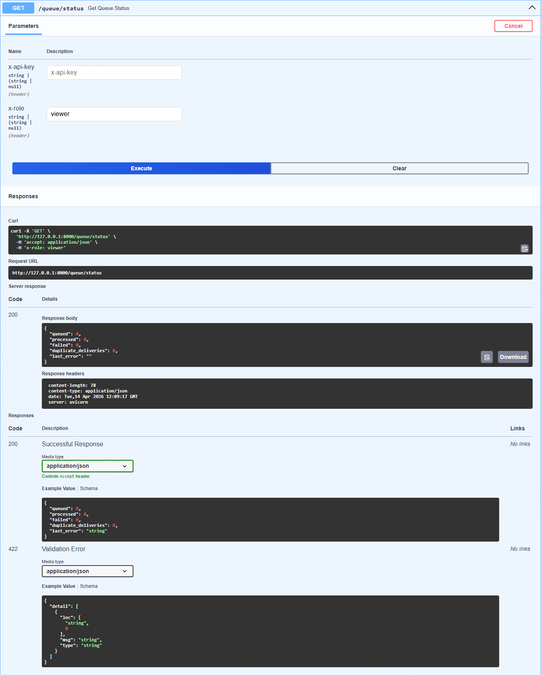
Figure 5. Queue Status (200)
Observation: Executed with x-role=viewer; output confirms queue metrics endpoint is working.
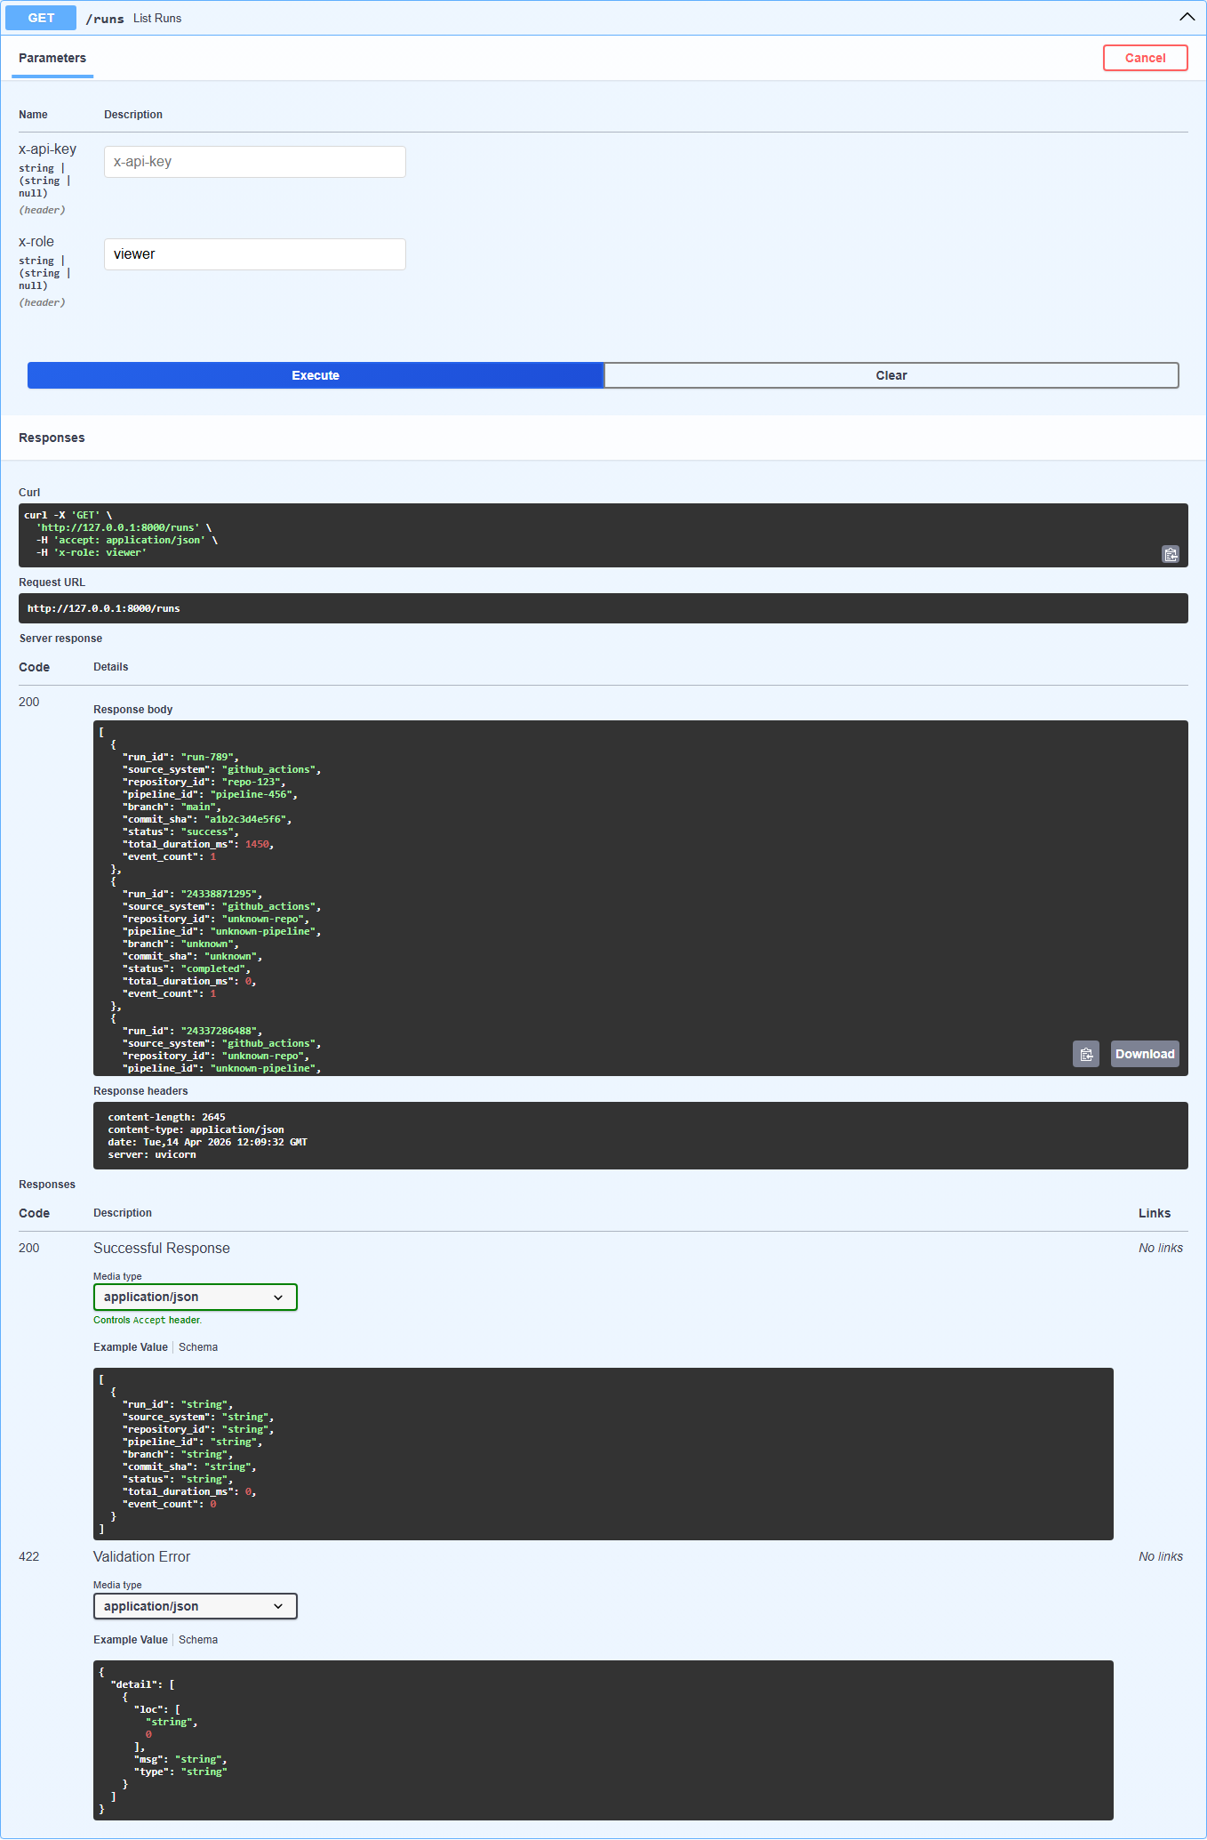
Figure 6. Runs Listing (200)
Observation: Executed with x-role=viewer; output returns pipeline runs dataset.
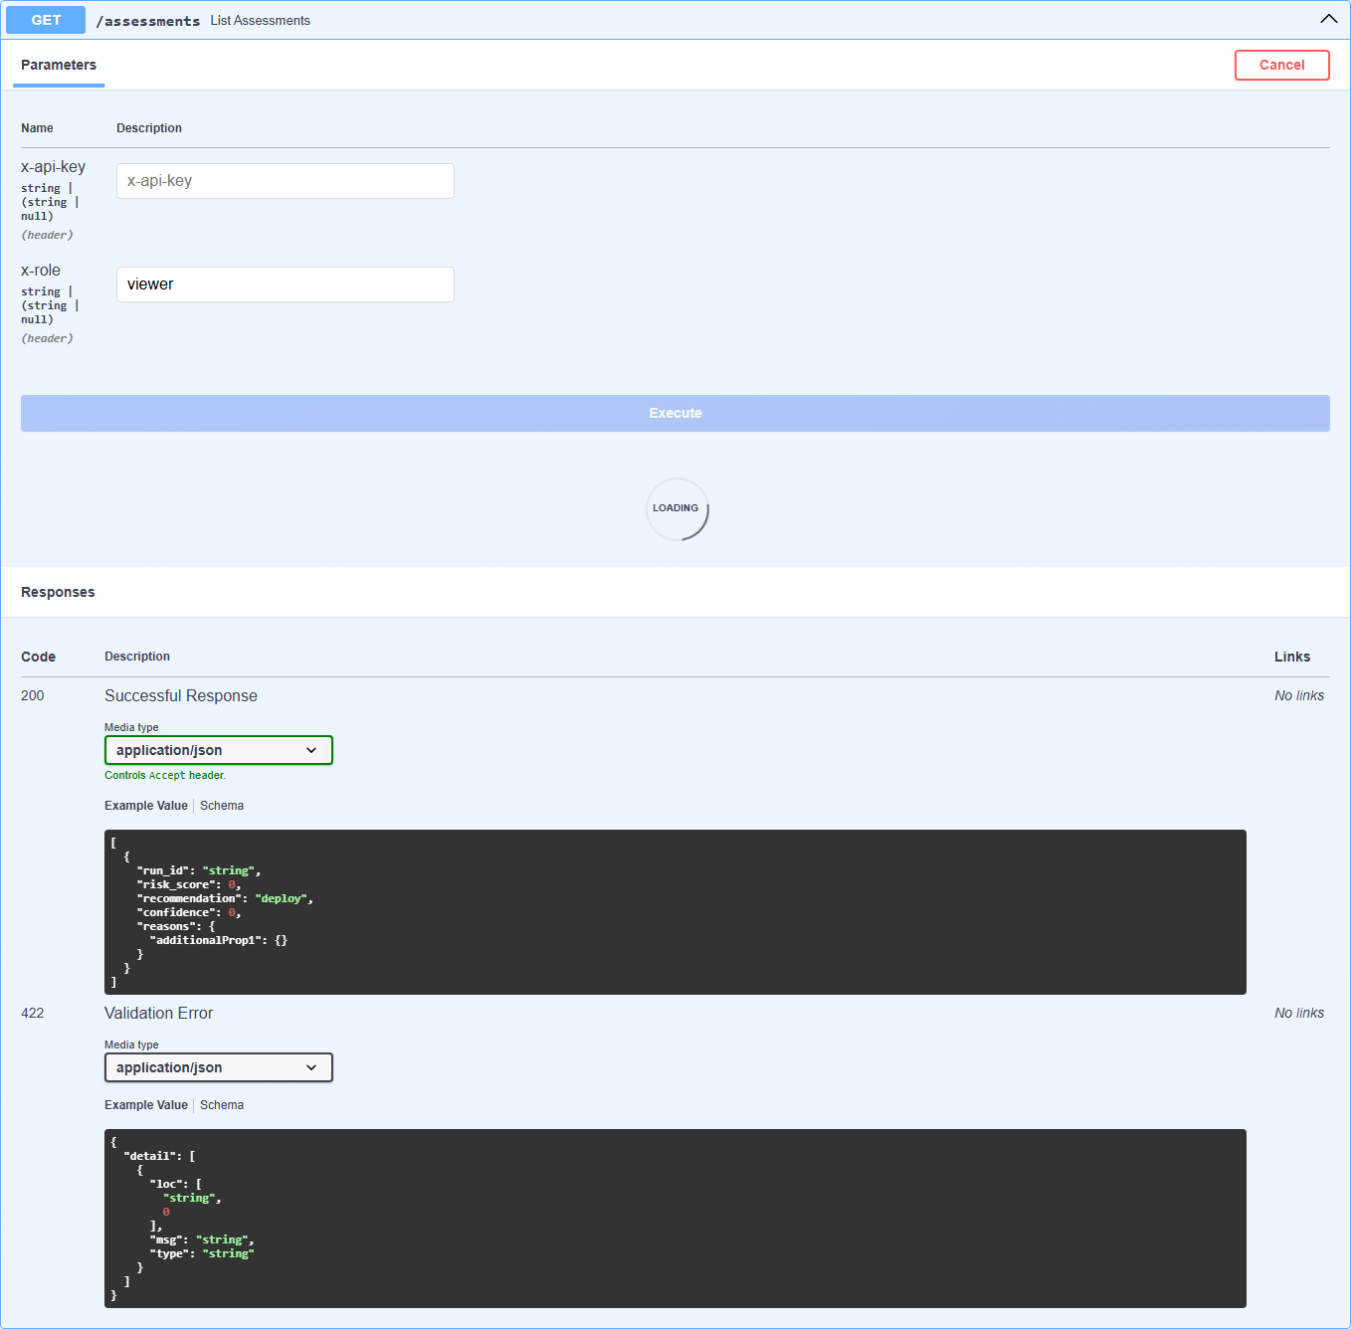
Figure 7. Risk Assessments (200)
Observation: Executed with x-role=viewer; output includes risk_score, recommendation, confidence.
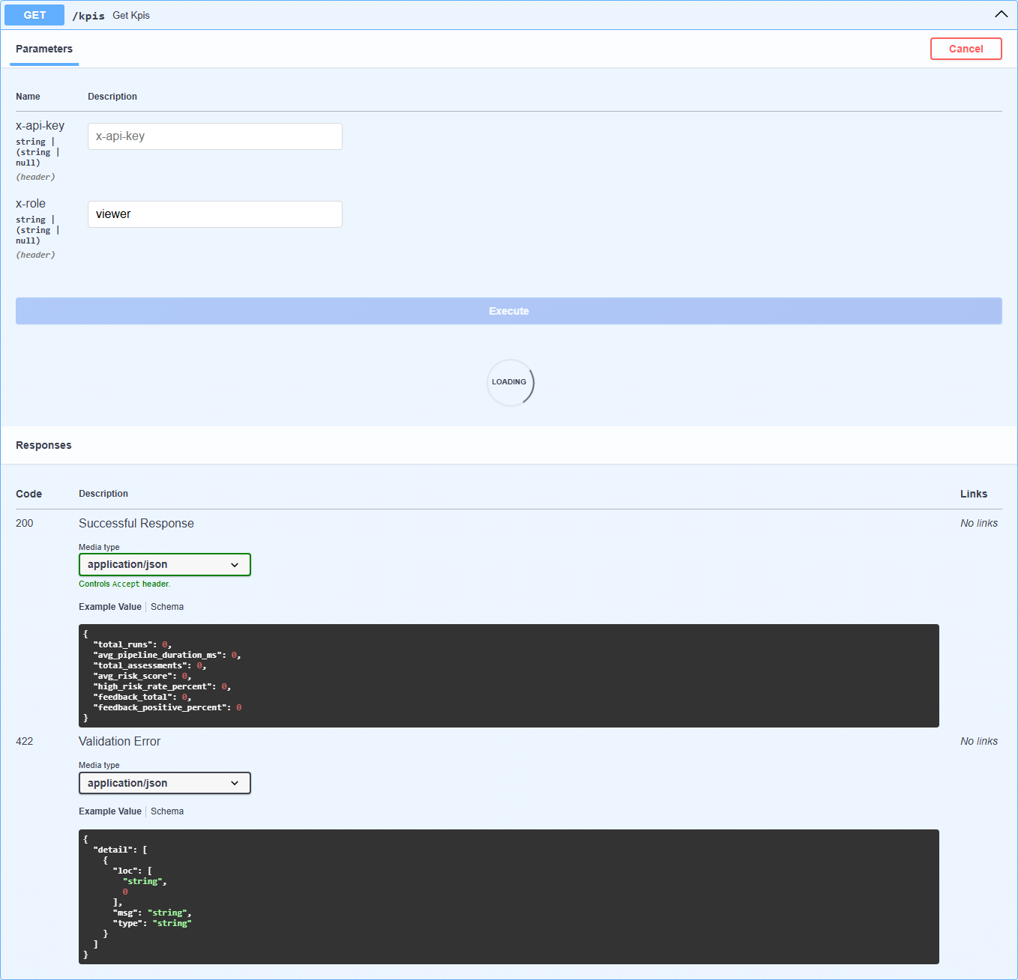
Figure 8. KPI Summary (200)
Observation: Executed with x-role=viewer; output shows total runs, average risk, and feedback metrics.
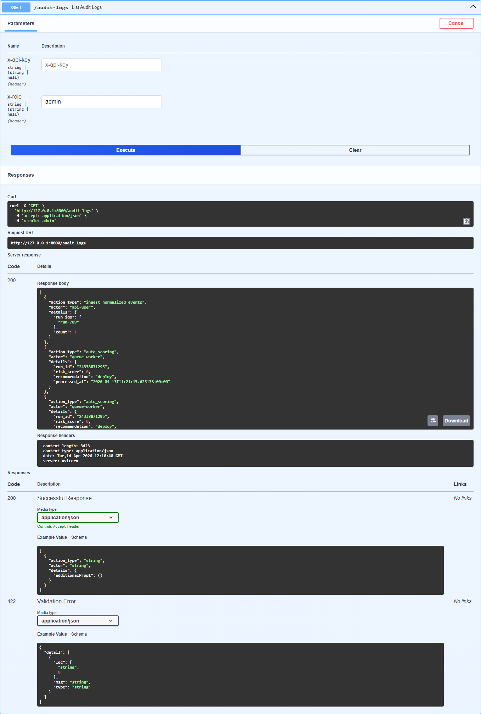
Figure 9. Audit Logs (200)
Observation: Executed with x-role=admin; output demonstrates governance and traceability records.
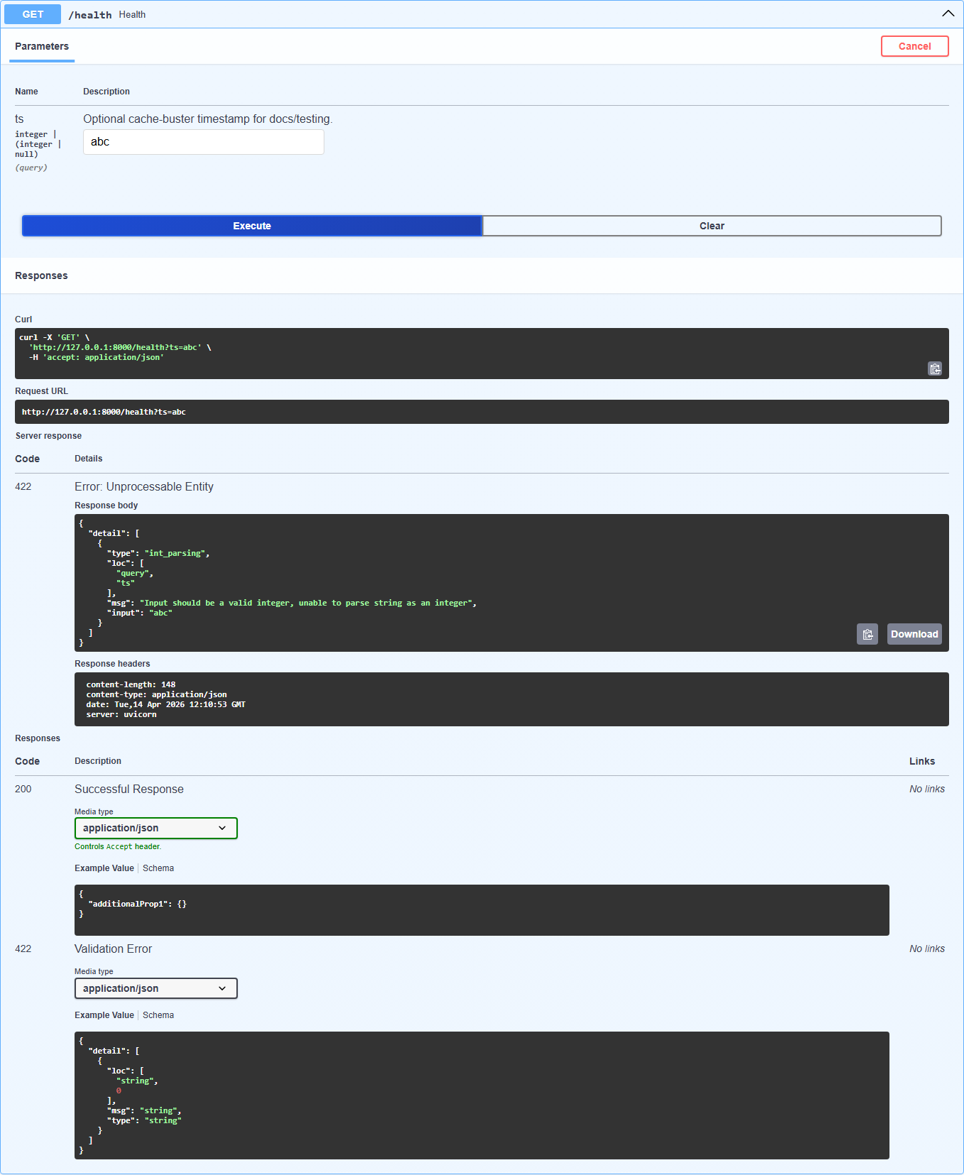
Figure 10. Health Validation Path (422)
Observation: Executed with ts=abc; output confirms expected FastAPI validation behavior.

4. Summary
The MVP is functionally demonstrable end-to-end, with validated outputs visible directly through Swagger UI and consistent role-based behavior across operational endpoints.

