Autonomous CI/CD Pipeline Optimizer
Detailed MVP Report (Real Swagger UI Evidence)

1. Executive Summary
Autonomous CI/CD Pipeline Optimizer is an API-first MVP that converts CI/CD telemetry into deployment decision intelligence. The platform ingests pipeline events, normalizes source payloads, computes deterministic risk scores, and provides actionable recommendations such as deploy, canary, delay, or block. The MVP focuses on reducing release friction, improving reliability visibility, and enabling governance-friendly operations.

2. Business Problem Statement
Enterprise release pipelines face four recurring operational issues:
- Reactive decision making after failures rather than preventive risk controls.
- CI/CD data fragmentation across GitHub Actions.
- Lack of a unified pre-release risk signal for release managers.
- Weak auditability for why deployment decisions were made.
This MVP addresses these by standardizing data, surfacing risk transparently, and recording action evidence.

3. Project Objectives and Success Criteria
Primary objectives of the MVP:
- Reduce delivery instability by exposing risk earlier in the release cycle.
- Improve operator confidence with explainable recommendation logic.
- Enable measurable reliability monitoring through KPI endpoints.
- Preserve governance with role-based controls and audit logging.
Success indicators include stable endpoint behavior, reliable role enforcement, and usable evidence for demo and review workflows.

4. Scope of MVP
In-scope capabilities for this report:
- Telemetry ingestion and normalization from supported CI sources.
- Risk scoring and release recommendation generation.
- Operational endpoints for runs, assessments, queue metrics, KPIs, and audit logs.
- Swagger-driven interactive validation for functional demonstration.

5. High-Level Solution Overview
Operational flow in this MVP:
- Step 1: Receive CI/CD event payloads from connectors or direct ingestion APIs.
- Step 2: Normalize source data into a canonical event schema.
- Step 3: Persist run and event data for traceable processing.
- Step 4: Compute deterministic risk score and recommendation.
- Step 5: Expose results through status, reporting, KPI, and governance APIs.

6. System Architecture
The design follows layered architecture for maintainability and control:
- Connector Layer: GitHub Actions.
- Ingestion Layer: API/webhook collectors and queue processing.
- Processing Layer: normalization, dedupe, persistence, scoring.
- Governance Layer: RBAC checks, audit trail, secure headers.
- Experience Layer: Swagger UI, status dashboard, output APIs.

7. Core Data Model
Core entities implemented in the MVP:
- PipelineRun: run-level summary including source, repo, status, and duration.
- PipelineEvent: normalized stage/job event details with metadata.
- RiskAssessment: score, recommendation, confidence, reason codes.
- RecommendationFeedback: human feedback for recommendation quality.
- AuditLog: immutable-style action history for governance traceability.

8. Security and Governance Controls
Security controls verified in this MVP include:
- Role-based access using x-role header (viewer/operator/admin pathways).
- Optional API key enforcement when configured.
- Webhook signature validation for trusted event ingestion.
- Audit-log endpoint protection and role-sensitive access behavior.
These controls ensure that data visibility and actions are policy-bound and reviewable.

9. API Surface and Functional Coverage
Health and status endpoints:
- GET /health
- GET /status/checks
- GET /status-ui
Operational and analytics endpoints:
- GET /queue/status
- GET /runs
- GET /assessments
- GET /kpis
- GET /audit-logs
Ingestion and scoring endpoints:
- POST /ingest/events
- POST /ingest/source-event
- POST /score/run/{run_id}

10. Real Swagger UI Output Evidence

All figures below are captured from live Swagger UI execution at http://127.0.0.1:8000/docs.
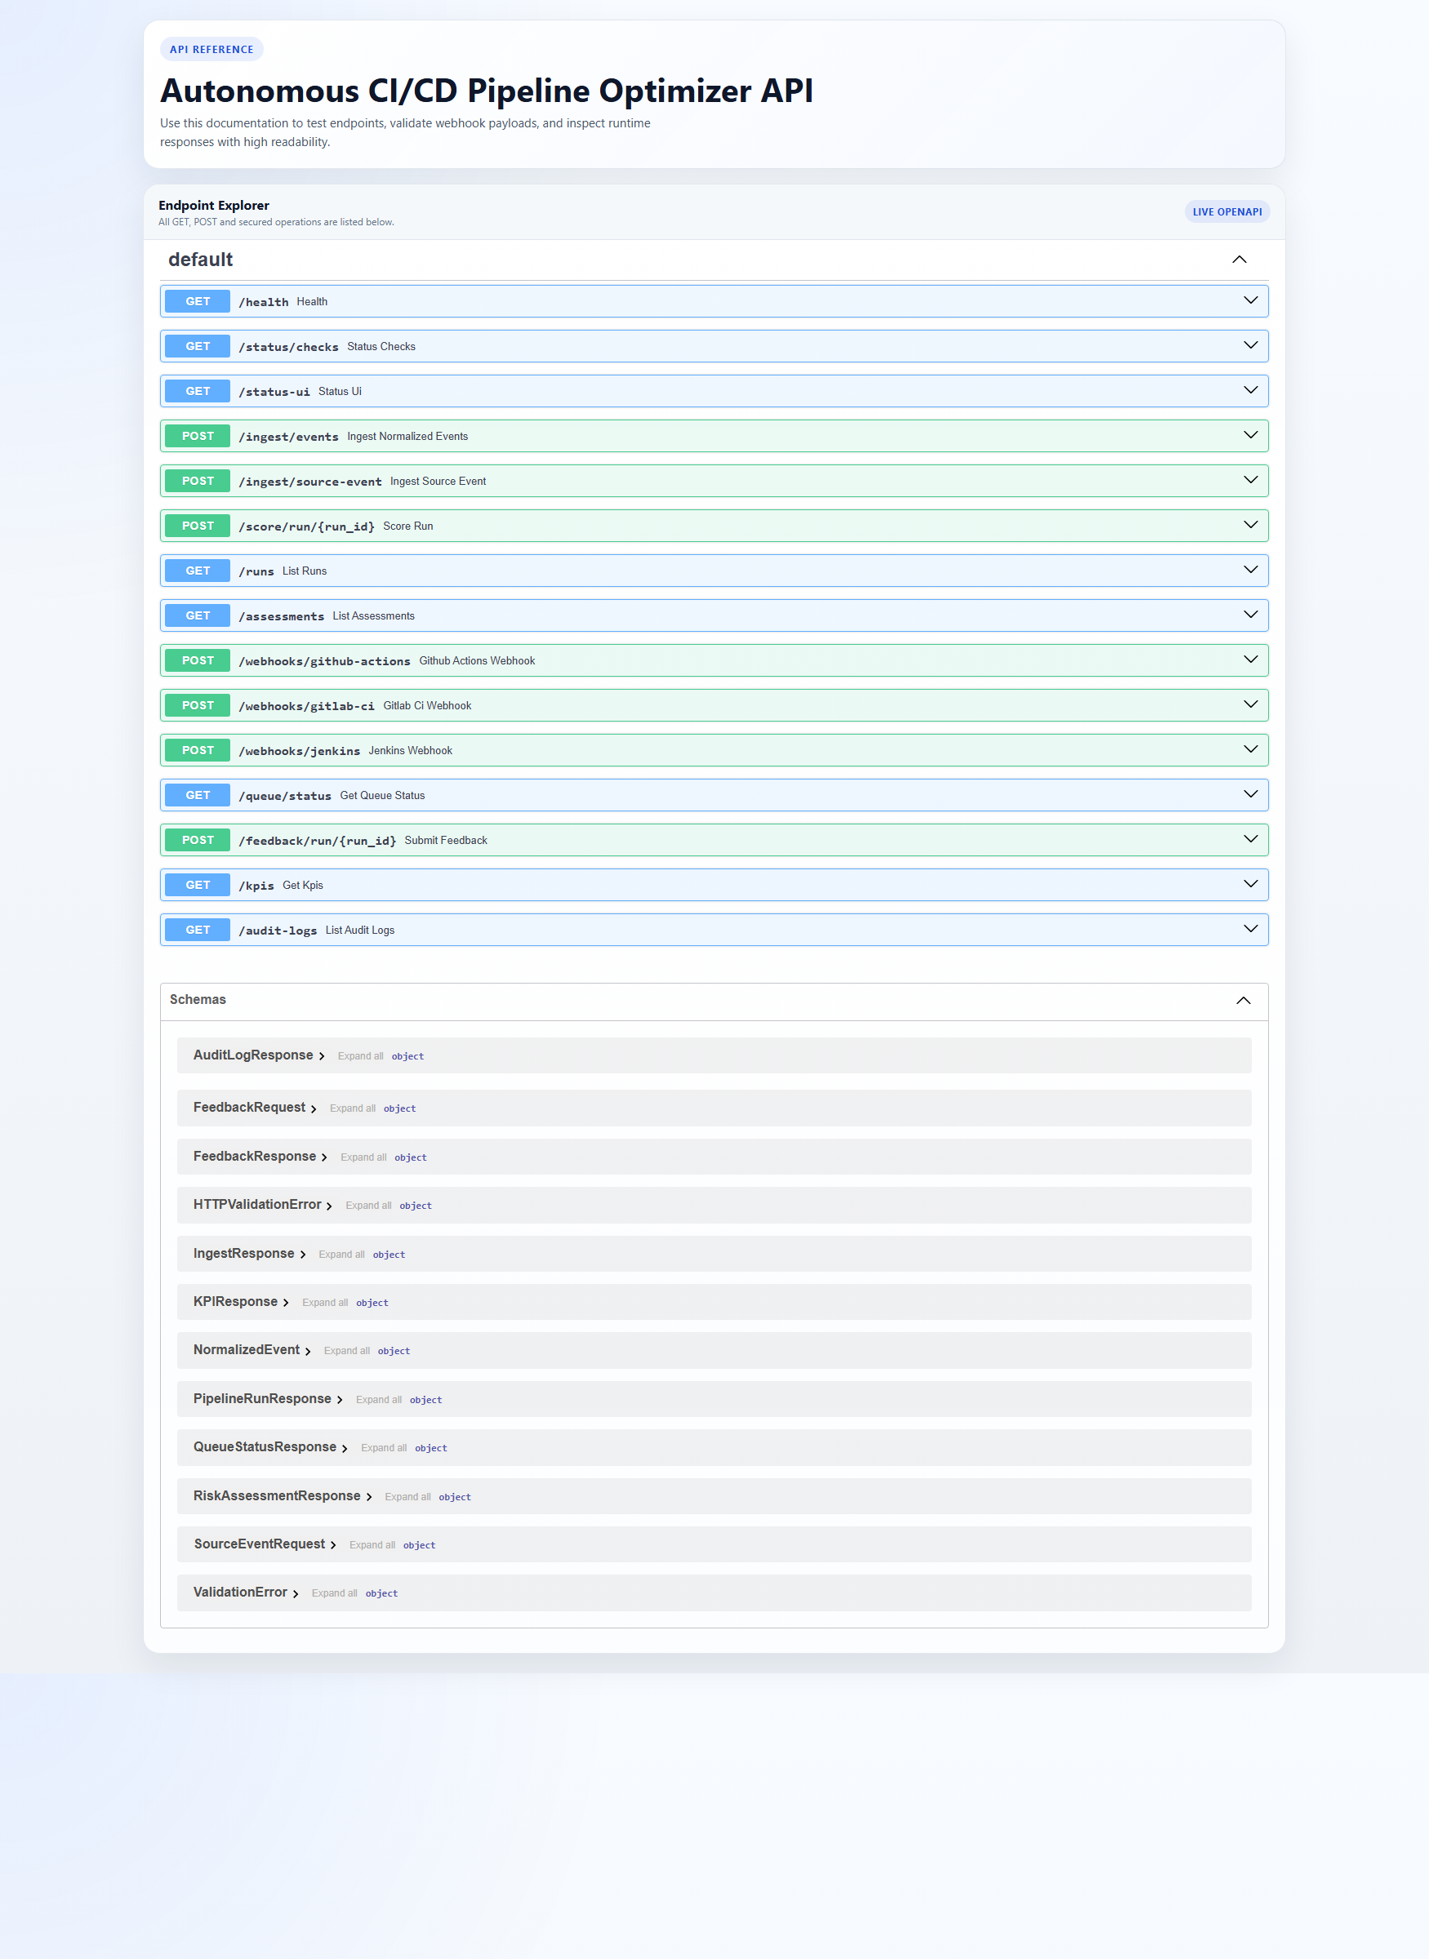
Figure 1. Real Swagger UI landing page
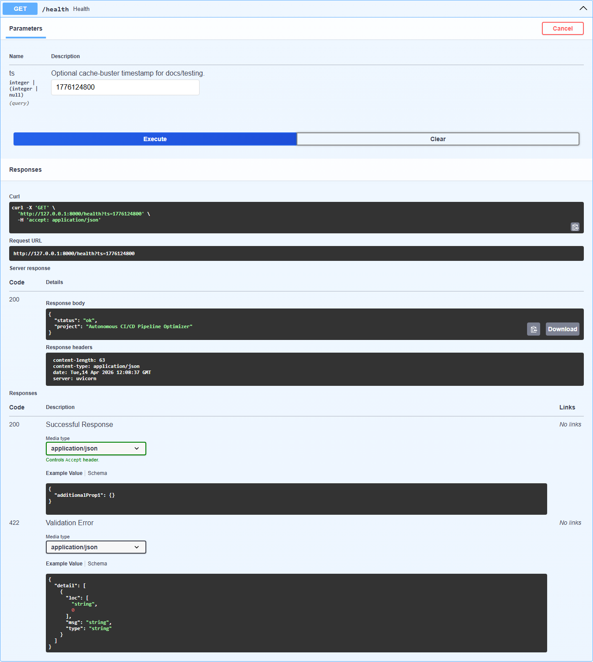
Figure 2. GET /health executed with 200 response
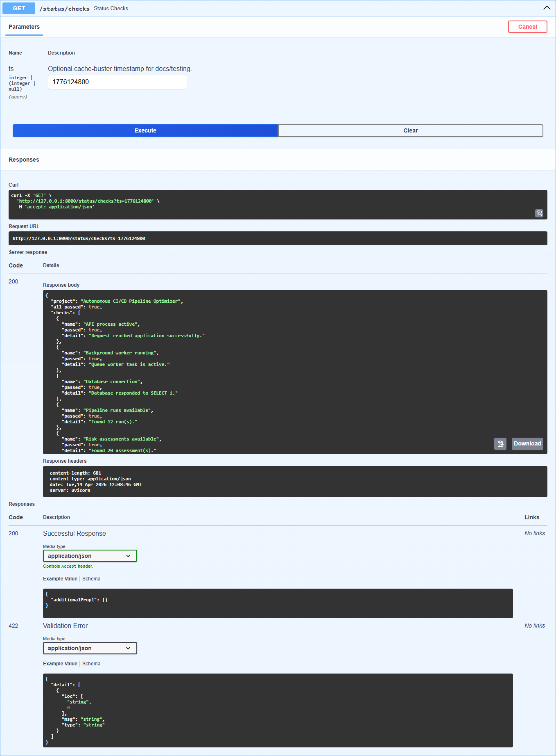
Figure 3. GET /status/checks executed with status summary
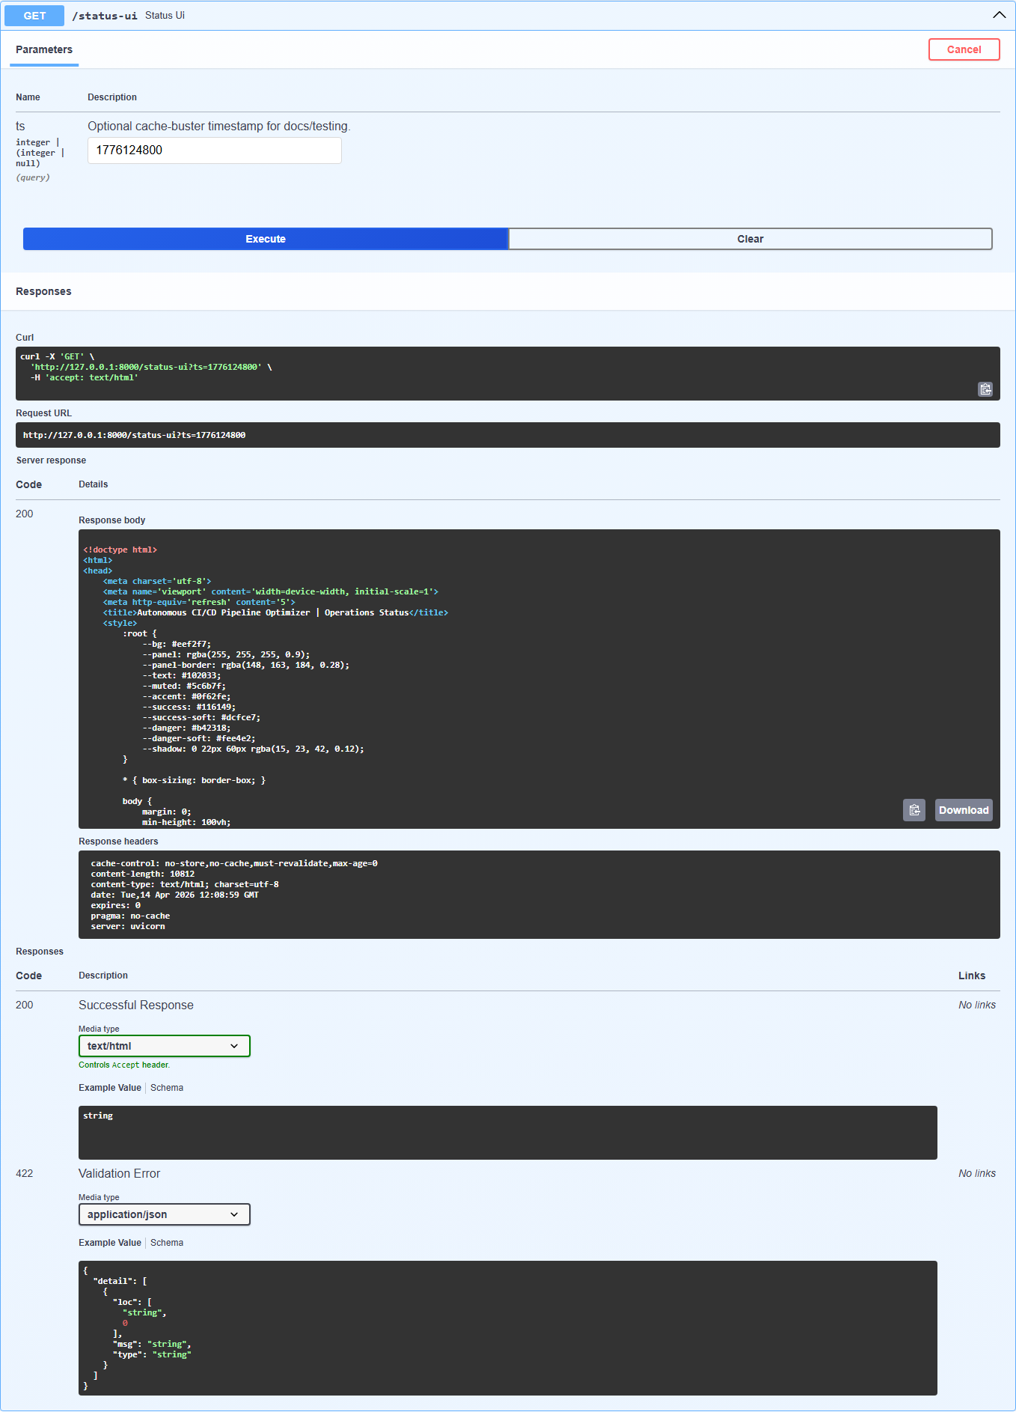
Figure 4. GET /status-ui executed with dashboard HTML response
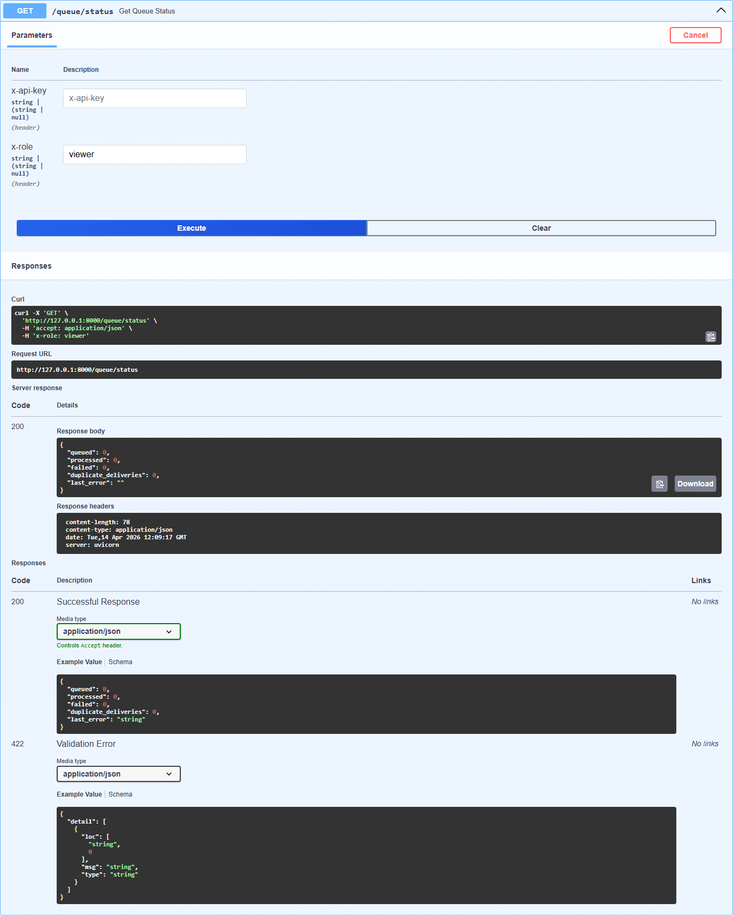
Figure 5. GET /queue/status executed with x-role=viewer
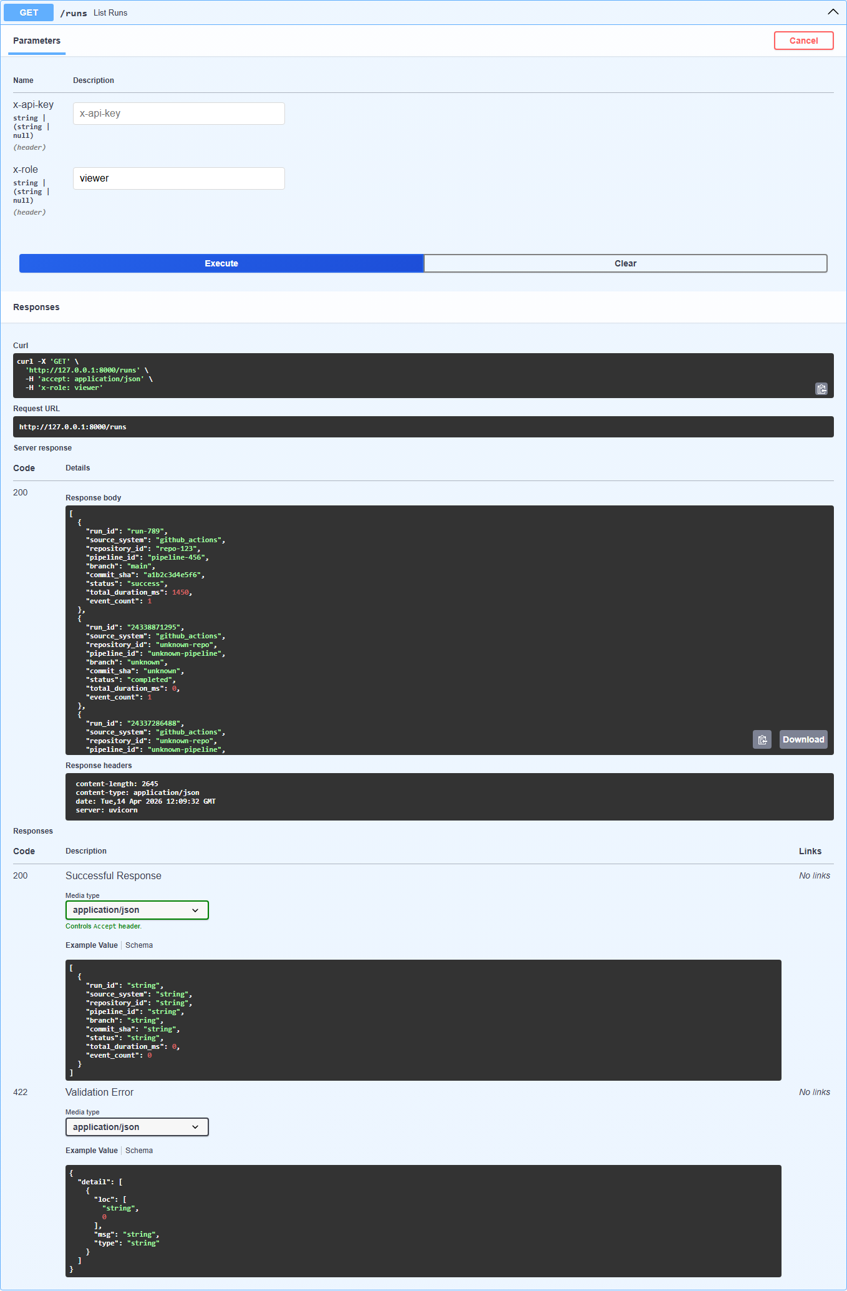
Figure 6. GET /runs executed with x-role=viewer
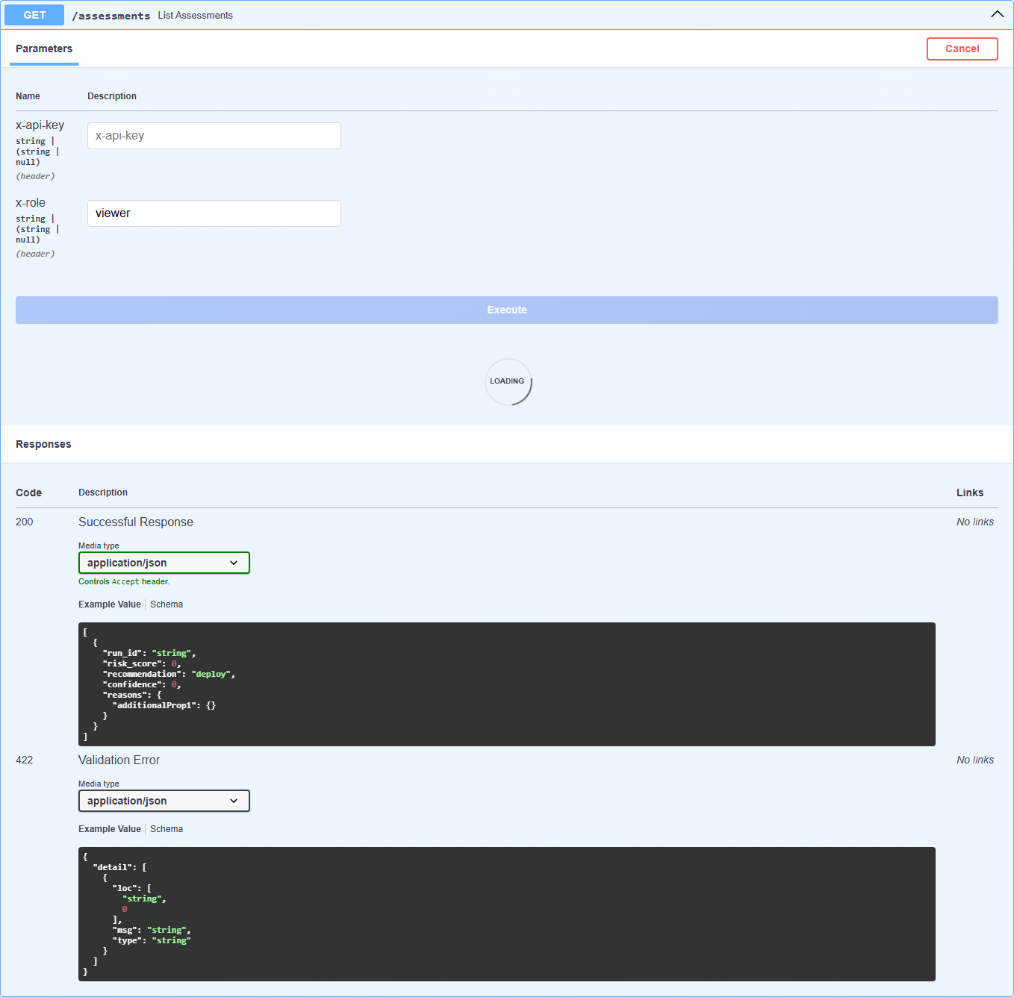
Figure 7. GET /assessments executed with x-role=viewer
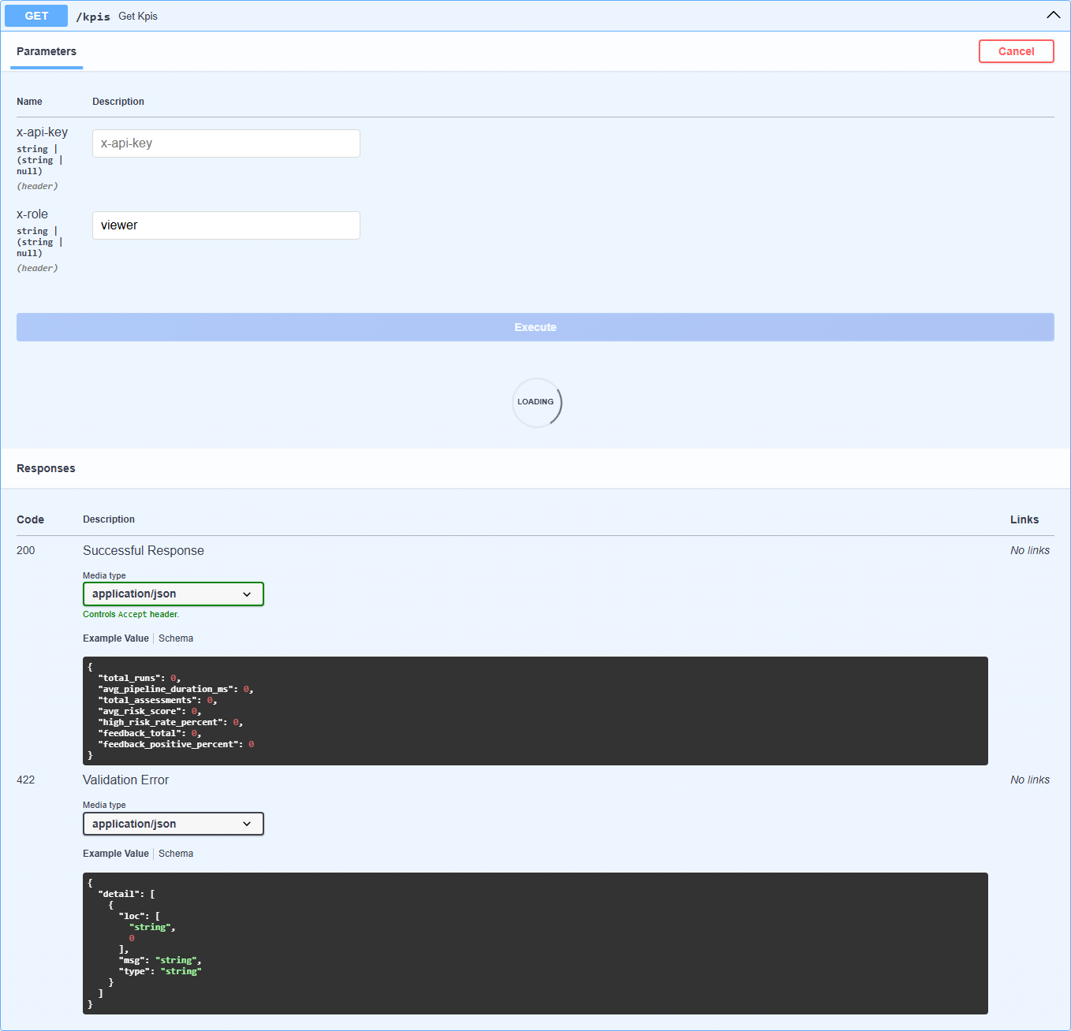
Figure 8. GET /kpis executed with x-role=viewer
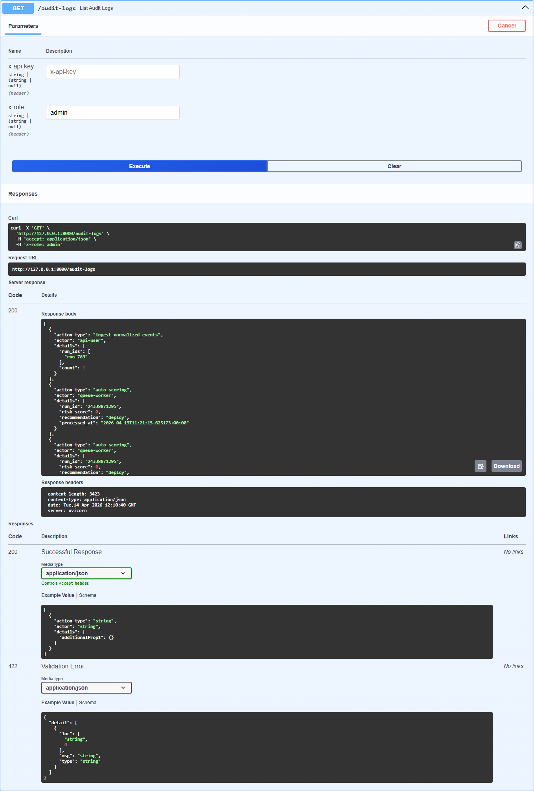
Figure 9. GET /audit-logs executed with x-role=admin
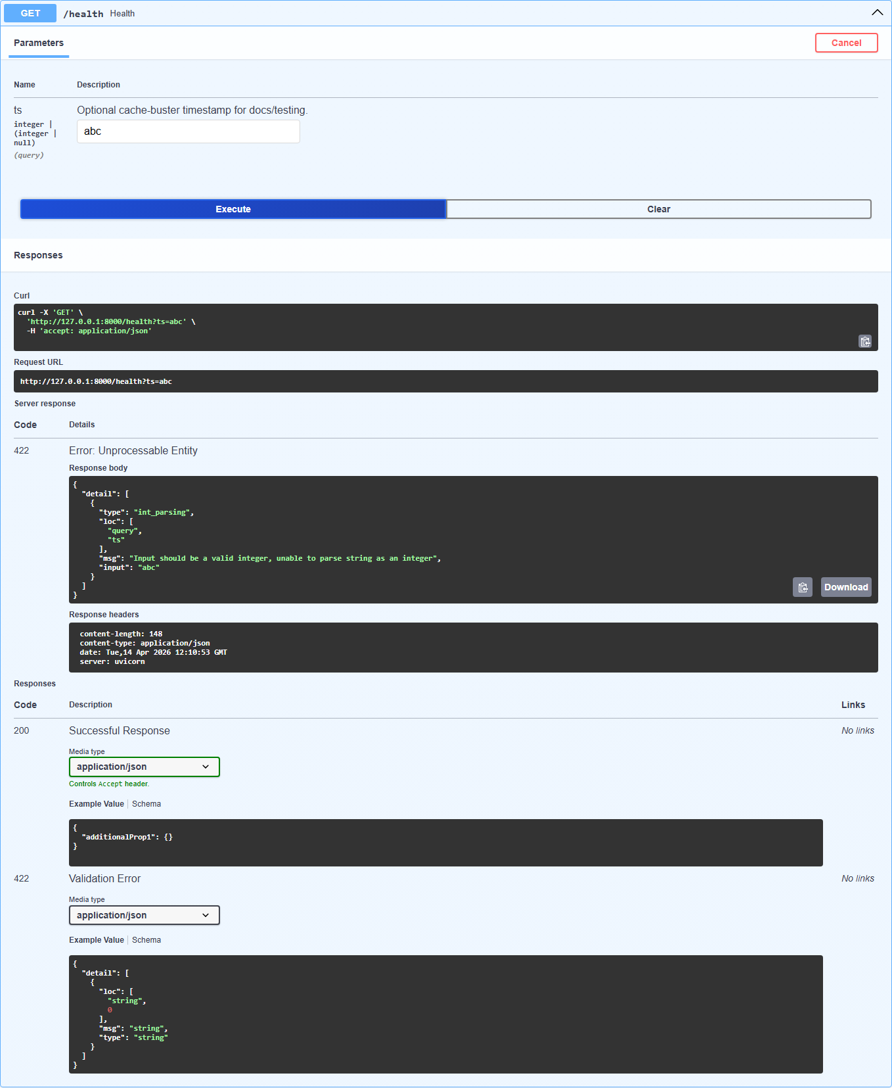
Figure 10. GET /health with invalid ts showing 422 validation response

11. Demo Walkthrough Script
Recommended sequence for live demo:
- Open /docs and show endpoint categories and request models.
- Execute GET /health with ts=1776124800 and explain success payload.
- Execute GET /status/checks and show all_passed indicator.
- Execute GET /queue/status with x-role=viewer and explain queue metrics.
- Execute GET /runs and GET /assessments to show scoring outcomes.
- Execute GET /kpis for manager-level metrics.
- Execute GET /audit-logs with x-role=admin for governance proof.
- Execute invalid GET /health?ts=abc and explain expected 422 validation behavior.

12. Conclusion
The MVP demonstrates a production-oriented foundation for CI/CD risk intelligence with validated API behavior, real interactive Swagger evidence, role-aware security controls, and manager-friendly operational reporting. The implementation is suitable for pilot reviews, technical walkthroughs, and stakeholder presentations.

