Autonomous CI/CD Pipeline Optimizer

1. Summary
Autonomous CI/CD Pipeline Optimizer is an API-first MVP that turns raw CI/CD telemetry into actionable release intelligence.
It ingests events from supported CI sources, normalizes the data into a canonical schema, computes a risk score, and produces a deployment recommendation such as deploy, canary, delay, or block.
The main objective is to reduce release risk, improve deployment confidence, and give engineering teams a transparent decision-support layer for CI/CD operations.

2. Business Problem
Enterprise delivery pipelines often face the following issues:
- release decisions are made reactively after failures occur
- CI/CD data is fragmented across different tools
- teams do not always have a single pre-release risk view
- manual go/no-go decisions increase delivery friction
- governance and auditability are often incomplete
This project addresses these gaps by creating a consistent, explainable, and secure workflow for CI/CD event analysis and release risk assessment.

3. Project Objective and Scope

Purpose
Reduce release friction and delivery instability by creating a platform that highlights CI/CD risk and recommends safe next actions.

Objectives
- reduce pipeline duration
- reduce change failure rate
- reduce rollback frequency
- improve MTTD and MTTR
- deliver measurable ROI through engineering time savings

In Scope
- GitHub Actions, GitLab CI, and Jenkins ingestion
- pipeline optimization insights
- release risk radar
- failure prediction
- dashboard and ChatOps delivery
- PR-based remediation suggestions

Out of Scope for Initial Release
- fully autonomous code commits without human review
- replacing existing CI/CD platforms
- deep code-level static analysis as a primary focus
- multi-cloud cost optimization and chaos engineering automation

4. Solution Overview
The platform follows a simple operational flow:
1. Receive CI/CD events from a supported source.
2. Validate and normalize the payload.
3. Persist event and run data.
4. Compute a risk score.
5. Generate a recommendation.
6. Expose results through APIs, dashboard views, KPIs, and audit logs.
This makes the system useful as both a release-control layer and an operations visibility surface.

5. High-Level Architecture
The system is organized into layered components.

A. Input Layer
Receives pipeline events from:
- GitHub Actions
- GitLab CI
- Jenkins
- direct API payloads

B. Normalization Layer
Source-specific mappers convert incoming payloads into one canonical event model.

C. Processing Layer
Handles:
- ingestion
- deduplication
- persistence
- scoring
- audit logging
- queue processing

D. Output Layer
Exposes:
- health endpoints
- status dashboard
- runs and assessments
- KPIs
- queue status
- audit logs
- feedback endpoints

6. Core Data Model and Inputs
The platform is built around five key entities.

PipelineRun
Stores run-level summary data such as:
- run ID
- source system
- repository ID
- pipeline ID
- status
- total duration
- event count

PipelineEvent
Stores normalized CI/CD event records with detailed fields such as:
- stage name
- event type
- duration
- status
- branch
- commit SHA
- retry count
- metadata

RiskAssessment
Stores scoring output:
- run ID
- risk score
- recommendation
- confidence
- reasons

RecommendationFeedback
Stores user feedback on recommendation quality:
- vote
- comment
- actor

AuditLog
Stores action trail for governance and traceability.

7. Supported Event Sources and Integration Inputs
The MVP currently supports three CI providers:
- GitHub Actions
- GitLab CI
- Jenkins
Each source has a dedicated mapper so that source-specific payload structures can be converted into a unified internal schema.
The canonical input schema includes fields such as:
- source_system
- tenant_id
- repository_id / project_id
- pipeline_id
- run_id
- job_id
- stage_name
- event_type
- event_ts_utc
- duration_ms
- status
- branch
- commit_sha
- actor
- environment
- retry_count
- failure_signature
- log_excerpt_hash
- metadata_version

8. Ingestion and Processing Flow
The end-to-end flow works as follows:
1. A payload arrives through a supported endpoint.
2. The system validates the input.
3. If needed, a source mapper converts it to normalized events.
4. Duplicate events are detected and skipped.
5. Events are stored in the database.
6. Run aggregates are updated.
7. The scoring engine evaluates risk.
8. The result is persisted as a risk assessment.
9. An audit log entry is written.
10. The result becomes visible through API and dashboard endpoints.

9. Risk Scoring Logic
The scoring engine is deterministic and rule-based.

Inputs Considered
- failed event count
- retry count
- maximum stage duration
- total run duration

Score Range
- 0 to 100

Recommendation Thresholds
- 0 to 49: deploy
- 50 to 69: canary
- 70 to 84: delay
- 85 to 100: block

Confidence Output
A confidence value is also calculated so the result is not only a score, but also a signal of how reliable that score is.
This approach is explainable, testable, and easy to tune during early-stage adoption.

10. Security, Governance, and Reliability
The system includes multiple controls:

Role-Based Access Control
Protected endpoints require an `X-Role` header.
Supported roles are:
- viewer
- operator
- admin

Optional API Key Enforcement
If `APP_API_KEY` is configured, requests must include a matching `X-API-Key` header.

Webhook Security
GitHub Actions webhooks are protected using HMAC-SHA256 verification through the `X-Hub-Signature-256` header.

Duplicate Delivery Protection
Webhook delivery IDs are tracked to prevent repeated processing of the same request.

Queue Metrics
- queued
- processed
- failed
- duplicate_deliveries
- last_error
These controls help ensure that only trusted and valid traffic is accepted and that background processing remains observable.

11. Main API Surface and Operational Outputs

Health and Status
- `GET /health`
- `GET /status/checks`
- `GET /status-ui`

Ingestion and Scoring
- `POST /ingest/events`
- `POST /ingest/source-event`
- `POST /score/run/{run_id}`
- `POST /webhooks/github-actions`
- `POST /webhooks/gitlab-ci`
- `POST /webhooks/jenkins`

Observability and Governance
- `GET /queue/status`
- `GET /runs`
- `GET /assessments`
- `GET /kpis`
- `GET /audit-logs`

Feedback
- `POST /feedback/run/{run_id}`
The verified runtime outputs include:
- `/health` returning 200 for valid calls
- `/status-ui` showing overall PASS/FAIL and last updated details
- Swagger documentation available at `/docs`

Swagger Endpoint Outputs
For a manager-facing brief, the best practice is to show representative outputs by category rather than a screenshot for every endpoint.

Health and Validation
- `GET /health?ts=1776124800` returns `200` with:
`{"status":"ok","project":"Autonomous CI/CD Pipeline Optimizer"}`
- `GET /status/checks?ts=1776124800` returns `200` with an all-pass JSON summary.
- `GET /health?ts=abc` returns `422`, which is expected validation behavior for an invalid integer query parameter.

Status and Operations
- `GET /status-ui?ts=1776124800` returns `200` and renders the dashboard with `OVERALL PASS` and `Last updated:` details.
- `GET /queue/status` returns current queue metrics such as queued, processed, failed, and duplicate deliveries.
- `GET /runs` returns pipeline run records.
- `GET /assessments` returns risk score and recommendation records.
- `GET /kpis` returns project-level KPI summaries.
- `GET /audit-logs` returns governance events when called with an admin role.

12. Current Limitations and Production Roadmap

Current MVP Limitations
- queue stats are in-memory and reset after restart
- SQLite is suitable for MVP use, but not production scale
- scoring is rule-based rather than ML-adaptive
- deep historical analytics are still basic

Production Roadmap
- migrate to a managed relational database
- move queue processing to Redis, RabbitMQ, or a similar broker
- introduce multi-worker processing and retry policies
- add profile-based thresholds per team or repository
- expand historical analytics and trend reporting
- introduce model-assisted scoring after enough labeled feedback is available

Final Summary
Autonomous CI/CD Pipeline Optimizer is a secure, explainable, API-first CI/CD decision-support platform that helps teams reduce release risk, improve pipeline reliability, and make faster deployment decisions using normalized telemetry, scoring, dashboards, KPIs, and auditable recommendations.

Screenshot Evidence
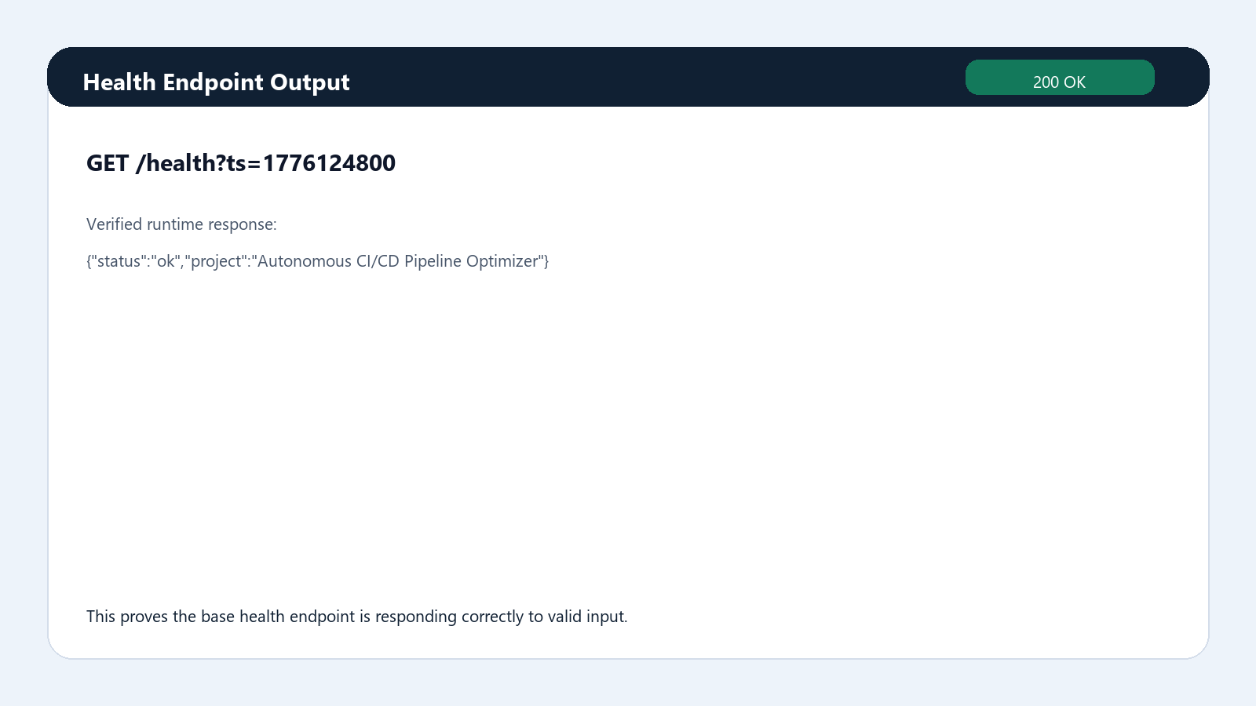
Figure 1. Health endpoint success response
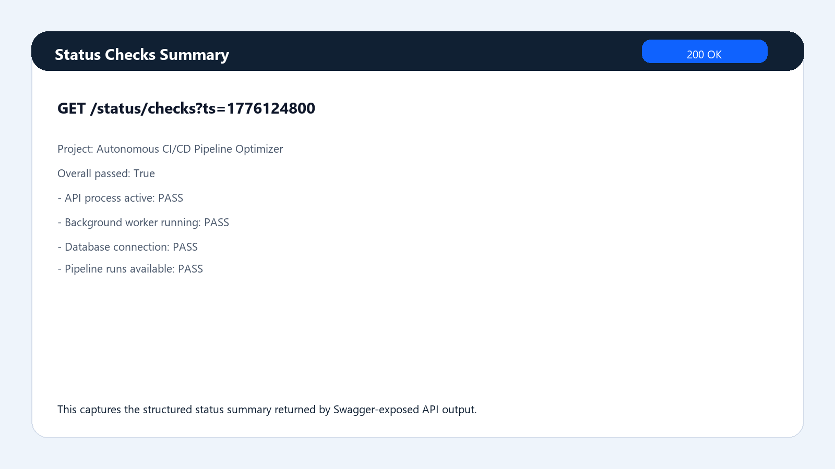
Figure 2. Status checks summary response
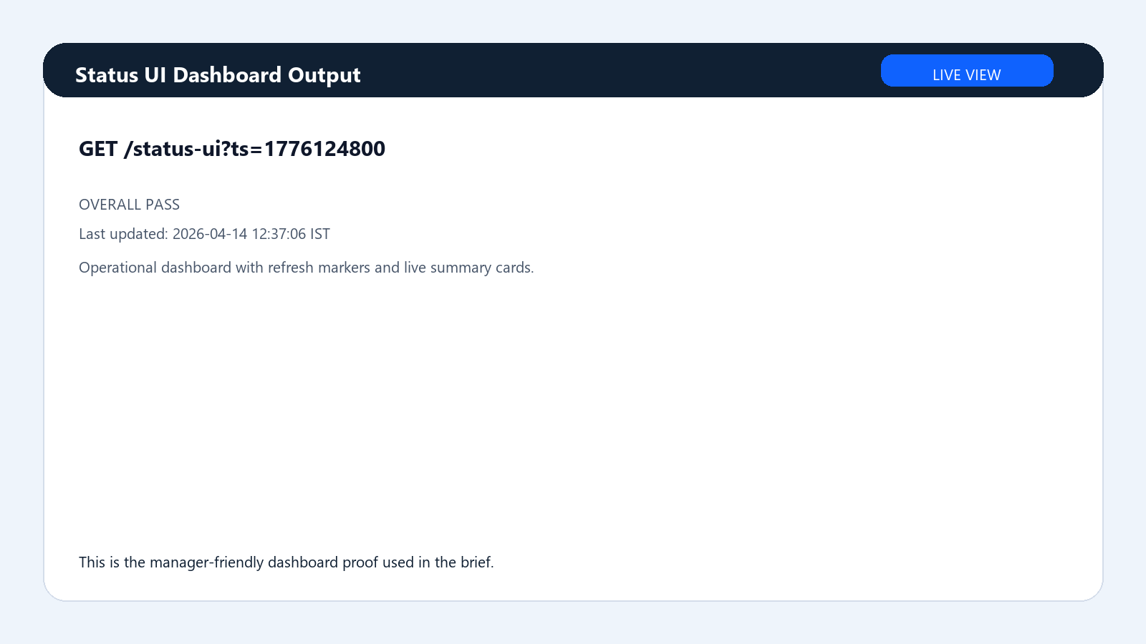
Figure 3. Status UI dashboard output
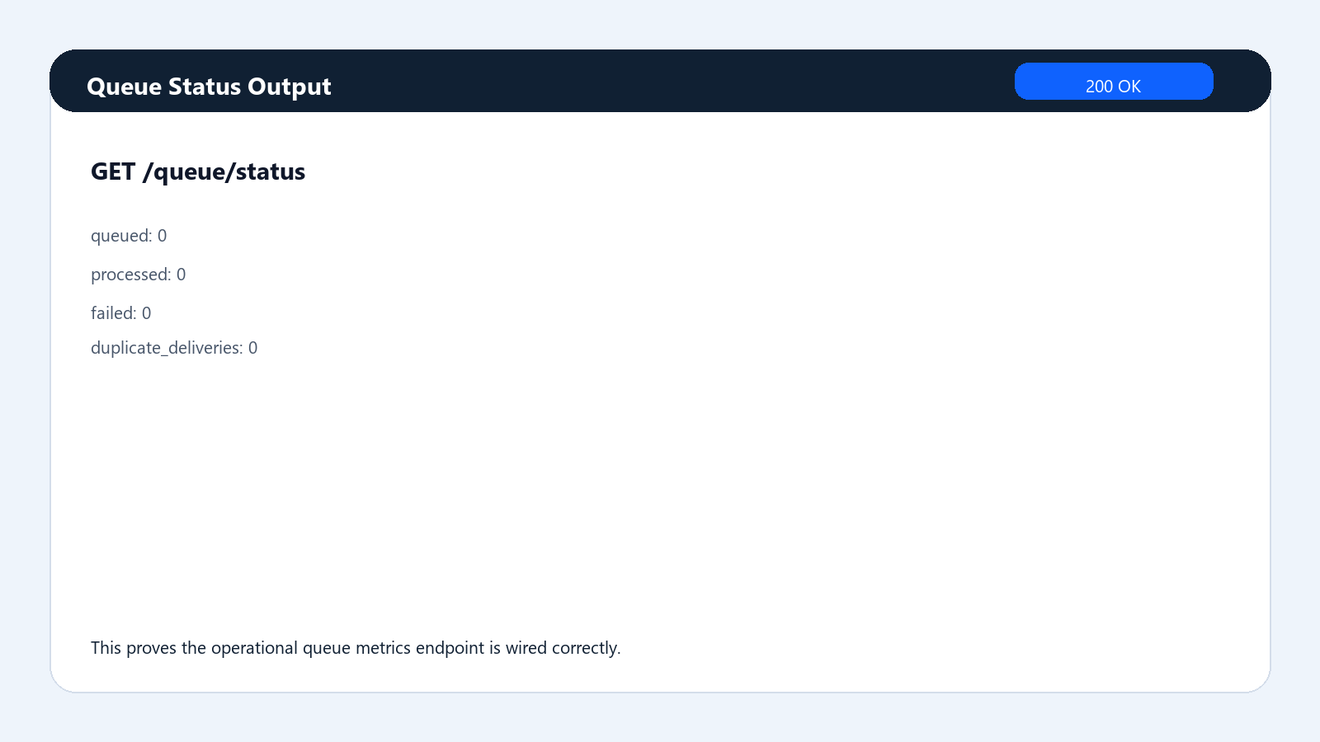
Figure 4. Queue status output
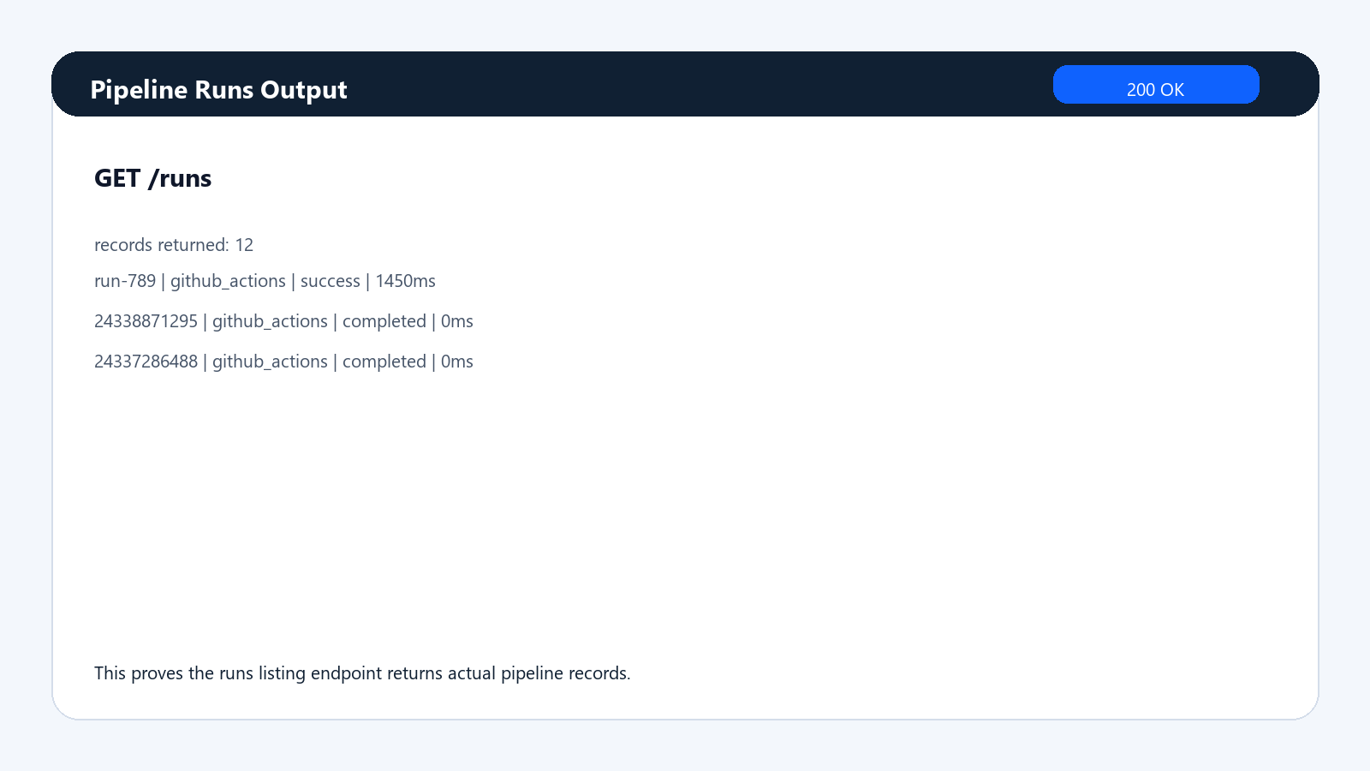
Figure 5. Pipeline runs output
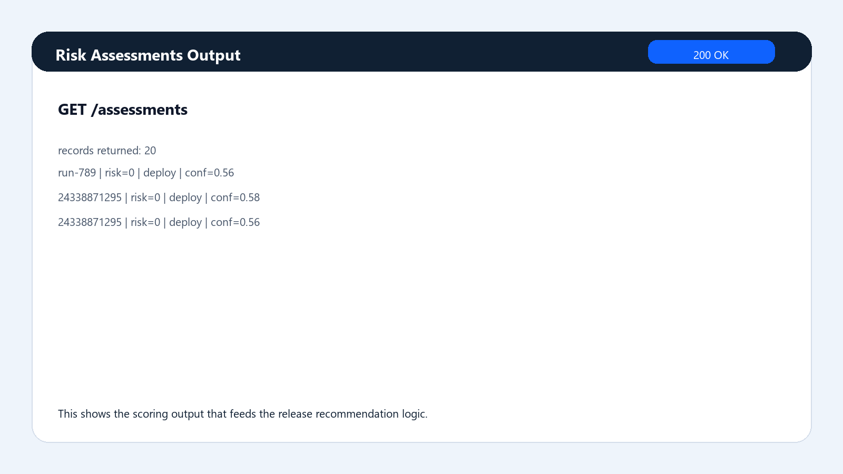
Figure 6. Risk assessments output
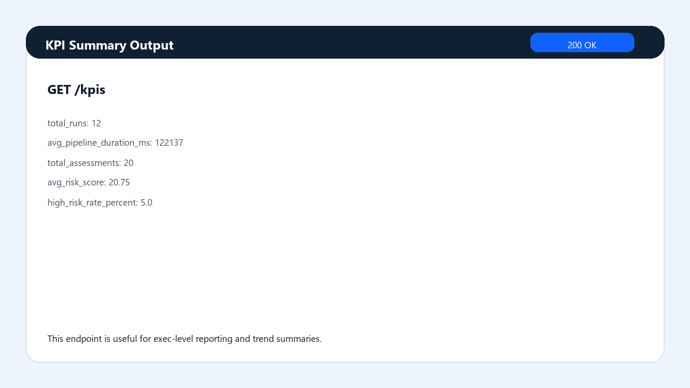
Figure 7. KPI summary output
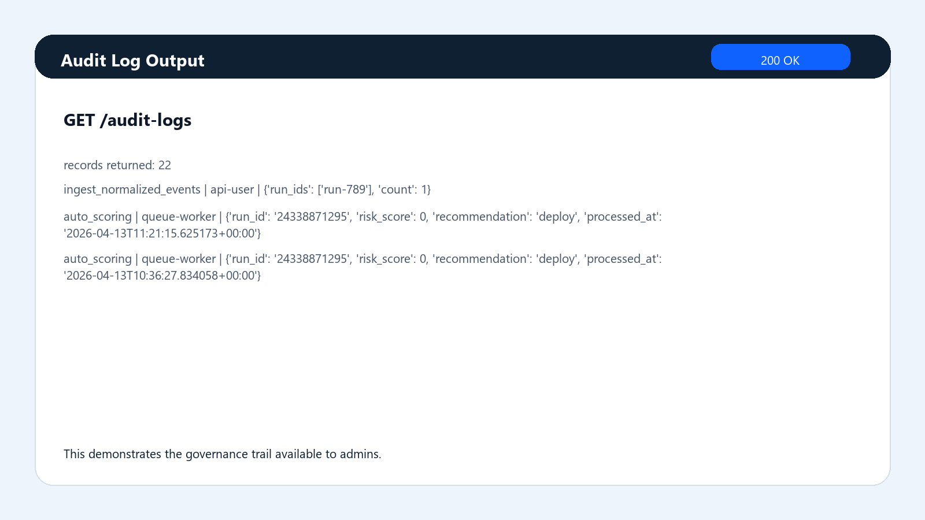
Figure 8. Audit log output
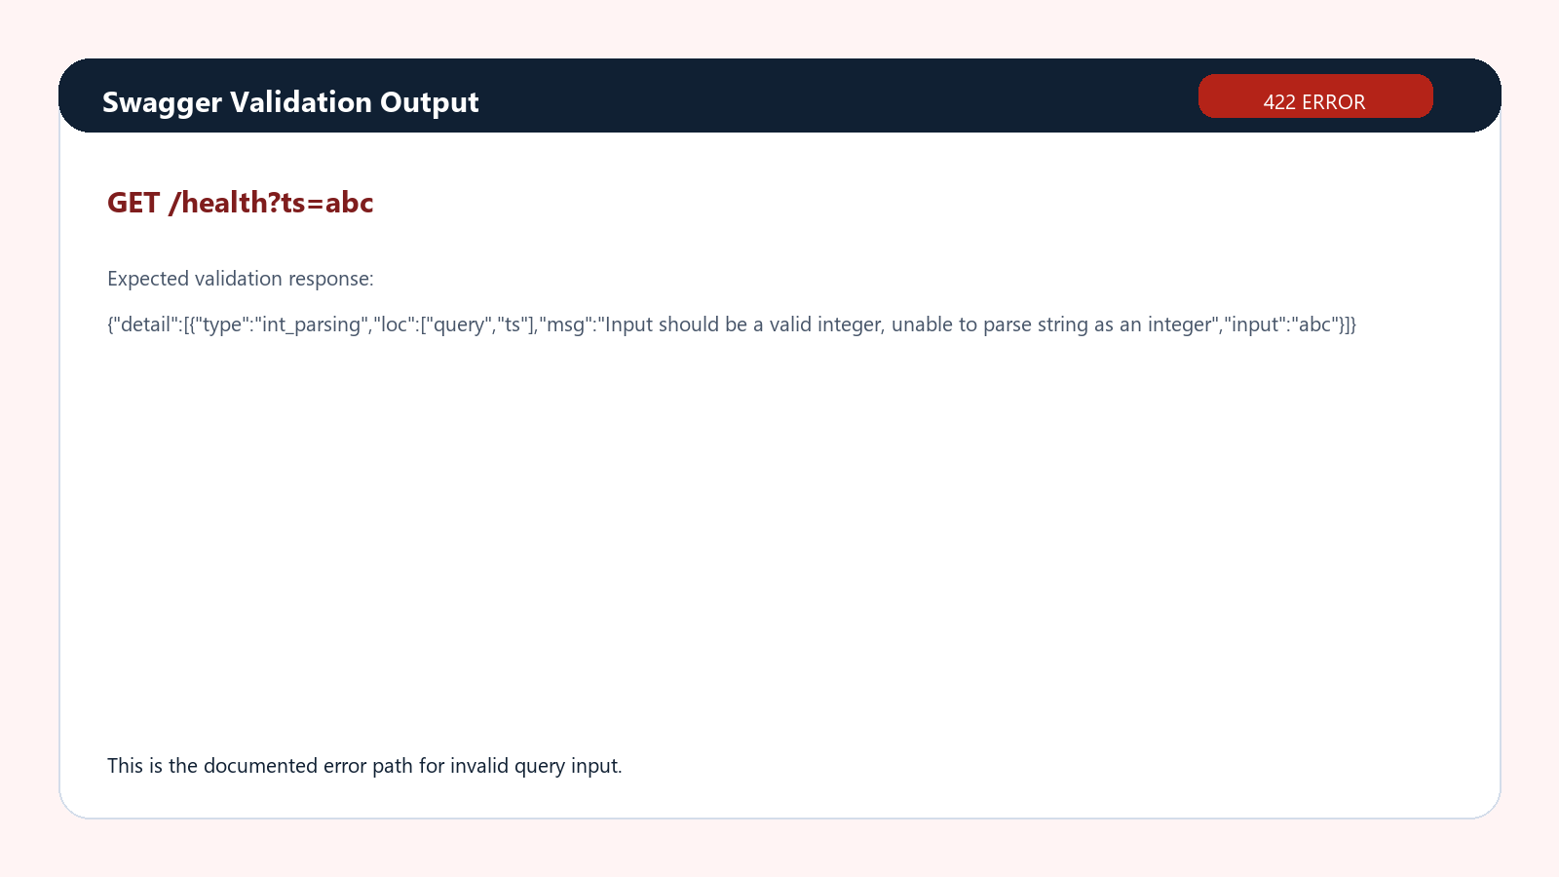
Figure 9. Swagger validation response for invalid input

