19YOLO: An Ensemble Model for SAR Ship Detection
Aishwary Bhatt(12311075), Y. K. Madhava Sai(12311103), Abhishek Kumar(12311061) and Aditya Bhardwaj(12311093)

Abstract— Monitoring maritime areas and border regions is often difficult due to limited visibility and operational risks. SAR images furnish essential data for detecting ships, managing traffic, and preventing illegal activities. Small vessels are much more common than large ones, which makes accurate detection challenging; many methods fail to recognize smaller ships and produce false positives. To improve performance, we propose 19YOLO, an ensemble that combines YOLOv8 and YOLOv11. The outputs of the two models are joined with Weighted Box Fusion to improve detection across all ship sizes. The model was trained and tested on the SARScope dataset and compared with existing approaches on same and different datasets. Evaluation on the SARScope dataset confirms that 19YOLO performs well across different ship sizes, with an F1 score of 88.52% and a mean average precision (mAP@0.5) of 88.20%.

I. INTRODUCTION
The latest improvements in remote sensing tools, particularly with Synthetic Aperture Radar (SAR) imaging, have greatly broadened how we see our planet - helping many fields at once through better data from above apps used in defence and everyday life. One key area includes spotting ships become a big deal because it matters so much for sea monitoring, ship scouting, shore protection, or watching for crimes at sea. So, spotting vessels using radar reports stands out as a top tool at sea domain awareness - ocean monitoring.
As worldwide sea commerce grows fast while ships keep moving across oceans along huge shorelines, particularly in places such as India that have more than 200 working harbours, keeping sea travel smooth while supporting reliable shipping activity is now a big problem. Things like unlawful catching of fish, illegal boat moves, trafficking using sea routes, crossing boundaries without permission breaking through also calls for strong, automatic vessel spotting systems.
To tackle these issues, this study aims at creating a group of smart systems (19YOLO) built by linking YOLOv8 and YOLOv11 to help spot ships using SAR. This method aims at method tries to boost accuracy while improving trust in results tricky ocean spots using what’s best from each model using Weighted Boxes Fusion (WBF), which gives better at spotting things big and small, so it works well in everyday situations keeping an eye on ships worldwide while making sea travel safer here and there.

II. Dataset Description
In this work, the SARScope dataset is used - a dedicated SAR-based ship detection dataset, which has been curated for small and multi-scale ship recognition. The dataset is kind of a summation of the widely used SSDD dataset and HRSID dataset. The SSDD dataset is a smaller dataset (over 1000 SAR images) which can be used for research purposes while HRSID dataset is a large dataset (more than 5000 SAR images) which can be used for real world testing. So, SARScope has the qualities of both the datasets making it suitable for real world applications and research purposes.
It includes high-resolution Synthetic Aperture Radar images acquired over varied maritime environments, including both open seas and coastal areas, where ships come in various sizes, shapes, and orientations. The dataset is having 6735 SAR images with annotated bounding boxes for each target ship transformable to YOLO format. Each image is having 640 × 640 pixel images containing ships of varied sizes, which ensures detection on multi-scale ships. The dataset contains training, validation, and testing subsets. From figures 1 to 4, it can also be seen that the statistical distribution of ship sizes is heavily dominated by small ships, with the median of the bounding box area covering less than 3% of the total image area. Such strong scale imbalance poses a challenge for detection because smaller ships may lose distinguishable features on existing models. In addition, several complex backgrounds, including coastal clutter, tidal interference, and near-shore reflections are also included in the dataset, further increasing the difficulty of discriminating ships. These characteristics make the SARScope dataset suitable for evaluating ensemble-based deep learning models, like the proposed 19YOLO model for efficient multi-scale ship detection in real-world maritime scenarios. Sample images:
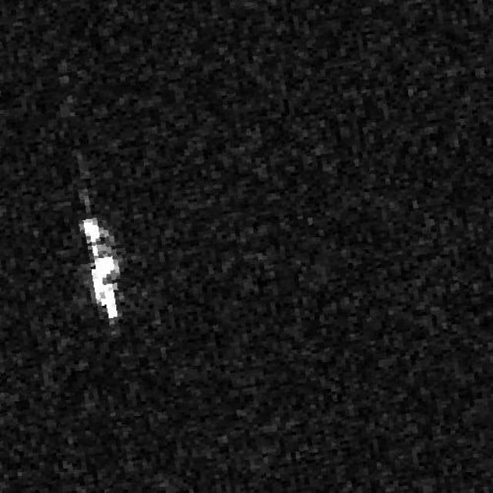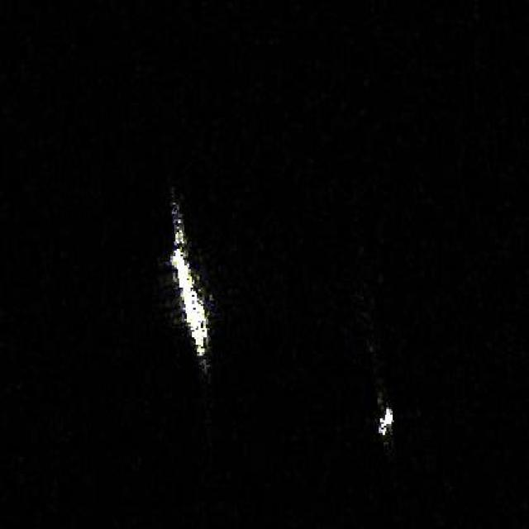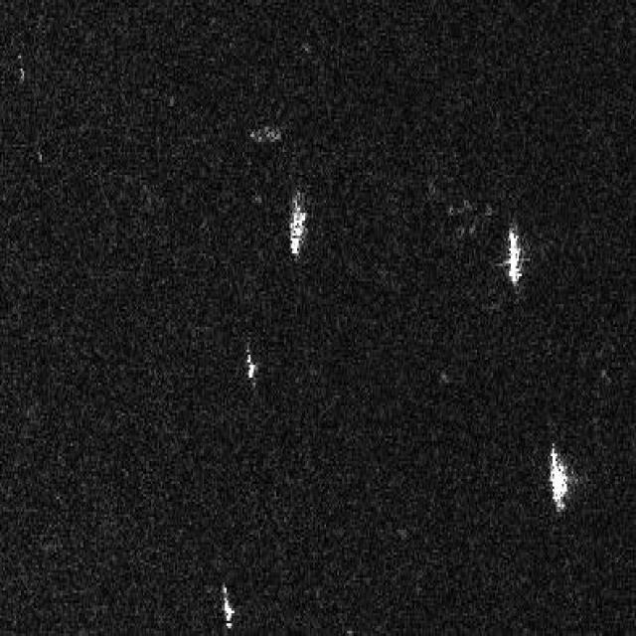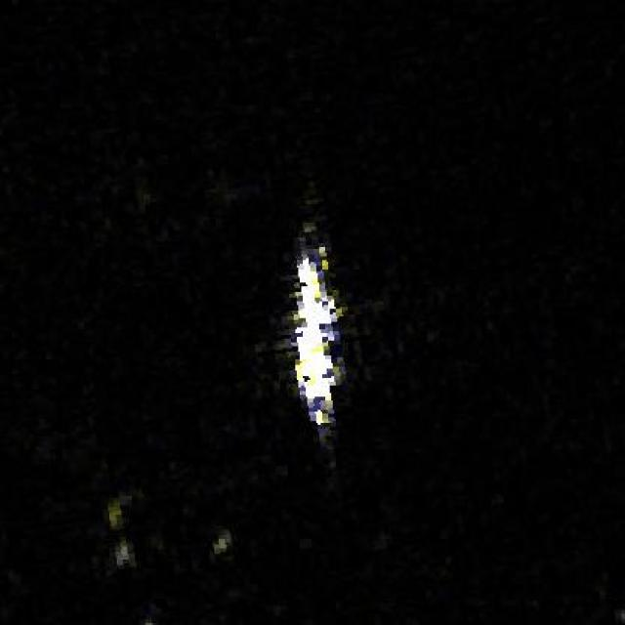
Fig. 1 - 4

III. Proposed Methodology
The proposed methodology puts forward 19YOLO, a ship detection model based on ensemble technique, designed to increase detection performance and robustness in Synthetic Aperture Radar (SAR) images. The framework joins the goodness of two object detection models, YOLOv8 and YOLOv11, for optimising feature extraction and fuses their predictions through a Weighted Box Fusion (WBF) function. The overall workflow of can be understood using Fig.5.
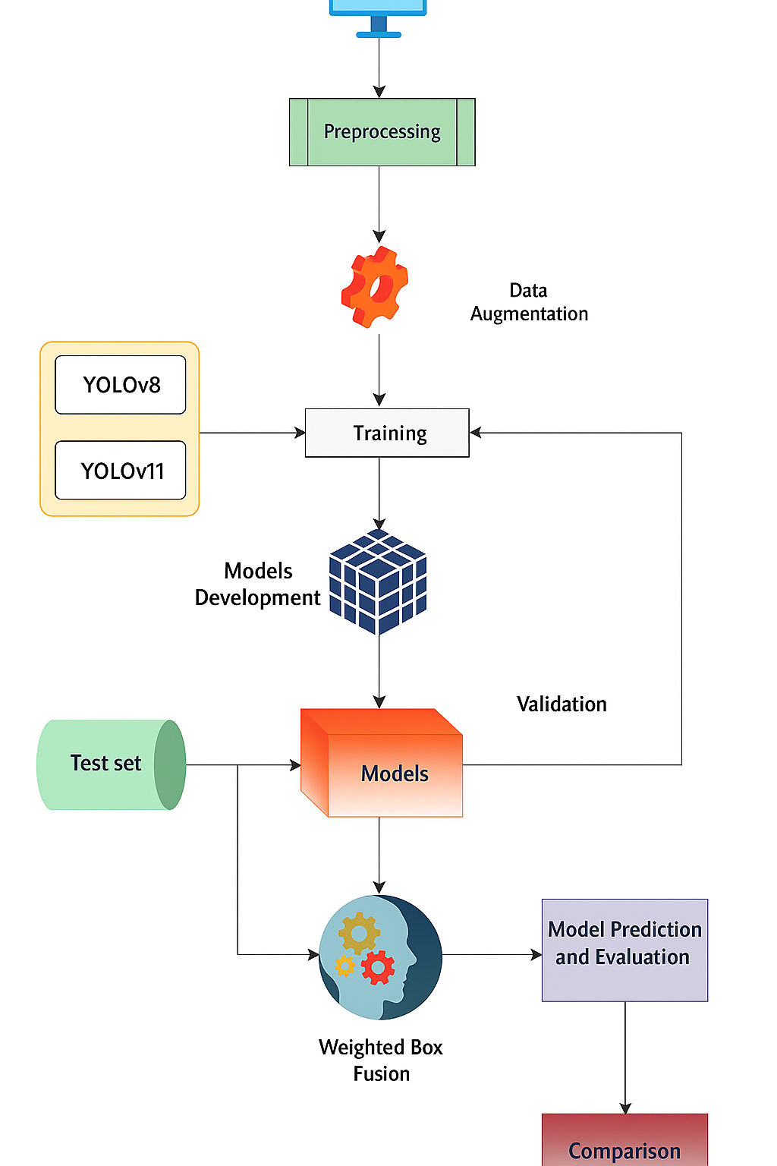
Fig. 5

1. Preprocessing and Feature Extraction
The SAR images are pre-processed to standardize input images to improve performance across both detectors. Each input image I∈RH×W is normalized using the following equation:
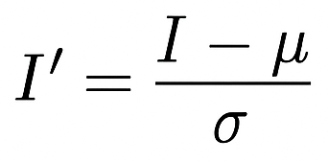

where μ and σ denote the mean and standard deviation of values of image intensity, respectively.
The normalized images are then processed independently by YOLOv8 and YOLOv11 models. YOLOv8 gives strong generalization for smaller-scale ships because of its lightweight design and refined feature pyramid, while YOLOv11 gives deep contextual awareness and better detection for medium and large targets. Each model predicts a set of bounding boxes as
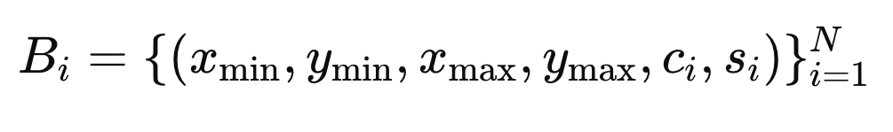
where (xmin, ymin, xmax, ymax) represent coordinates of the bounding box, ci denotes class label, and si ∈ [0,1] is the confidence score.

2. Weighted Box Fusion (WBF)
Conventionally used Non-Maximum Suppression (NMS) generally suppresses overlapping predictions, discarding valuable information, especially for small or closely packed ships. To overcome this, 19YOLO uses the Weighted Box Fusion (WBF) algorithm to join predictions from both the models.
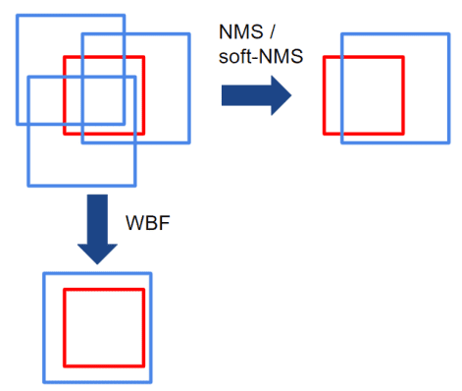
Fig. 6

For a given set of overlapping bounding boxes (IoU ≥ tiou), the fused box coordinates are calculated as weighted averages of the predictions, with model confidence scores being weights:
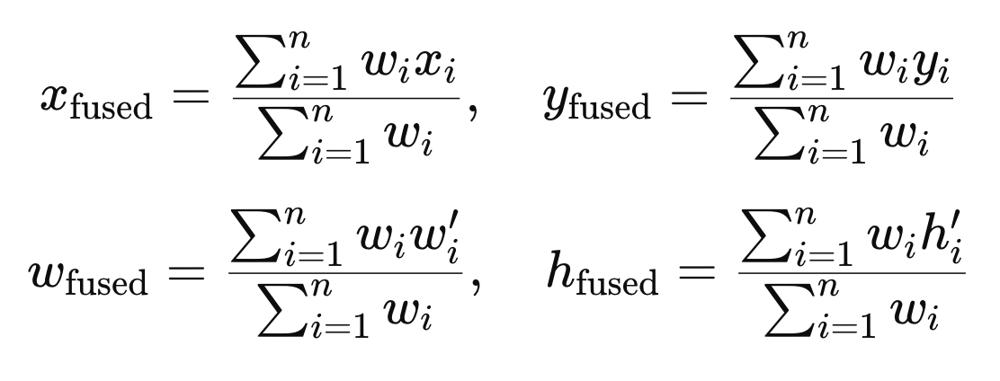

where wi = si denotes the confidence of ith bounding box, and n is the number of overlapping bounding boxes across the models.
The final fused confidence score is given as:
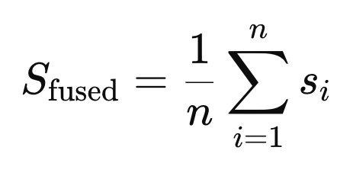
The resulting ensemble predictions for all images are represented as:
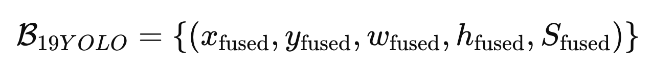

This methodology retains all relevant detections and increases localisation accuracy by accounting for each model’s confidence.

IV. Experiments

1. Evaluation metrics
Now, we are going to define the evaluation metrics to evaluate performance of 19YOLO. These are widely used comparison metrics for object detection:
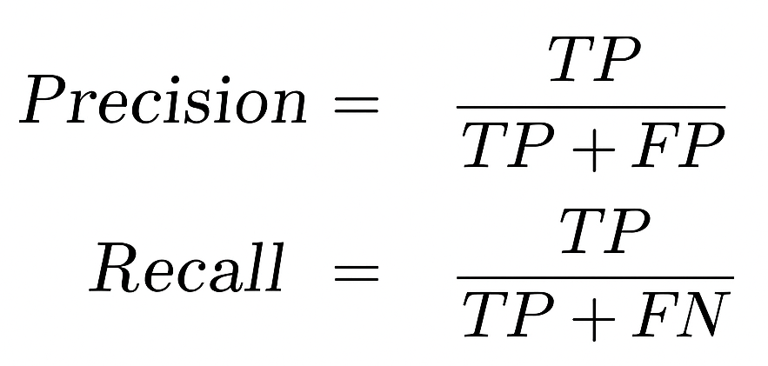

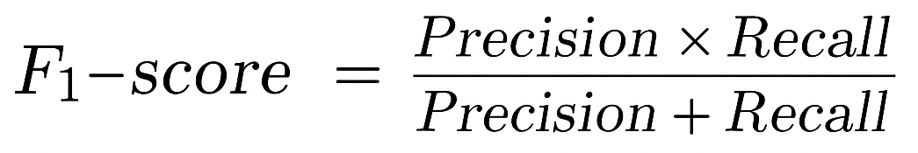

Intersection over Union (IoU):
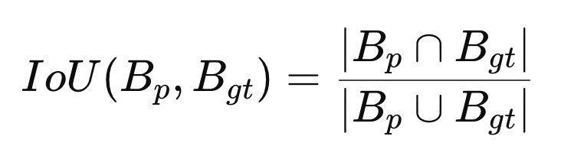
IOU threshold is 0.2, i. e., correct when IoU ≥ 0.2. The mean Average Precision (mAP@0.5) is integration of the precision-recall curve:
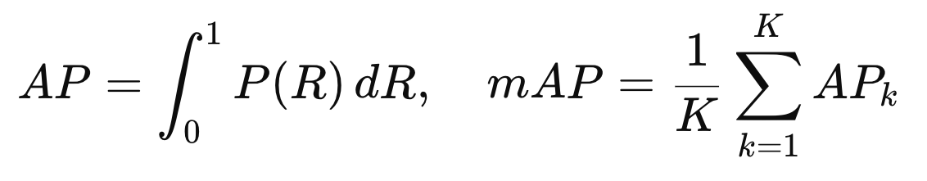

where P(R) is precision as f(recall).

2. Visualisation
To check the quality of ship detection using 19YOLO, we visualised the detection results on test data consisting of 672 images. The final ensembled predictions are visualised by bounding the ships using red-coloured bounding boxes. The results show effective detection of ships using 19YOLO, much better than the solo models. Also, small ships, that are not efficiently detected in conventional models, were detected with very good confidence scores, highlighting the effectiveness of employed weighted box fusion. These visualizations suggest it to be suitable for real world applications.. Some visualisations are:

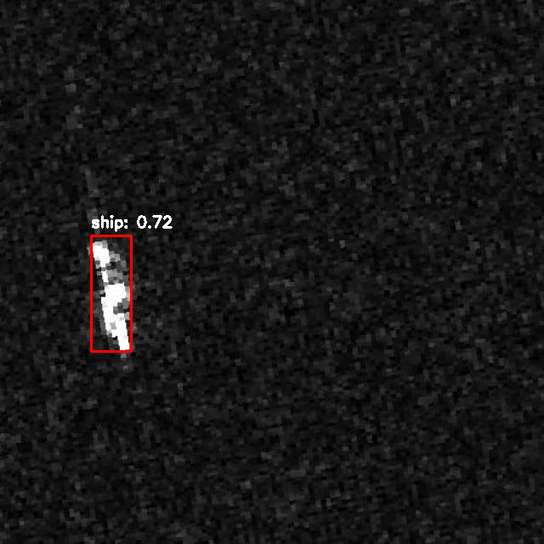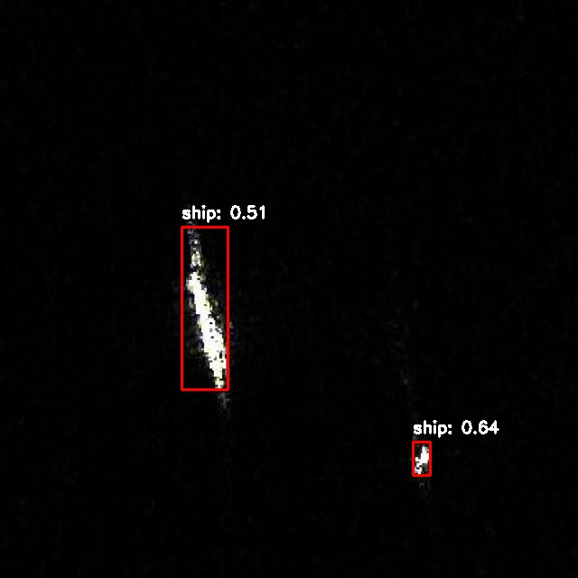
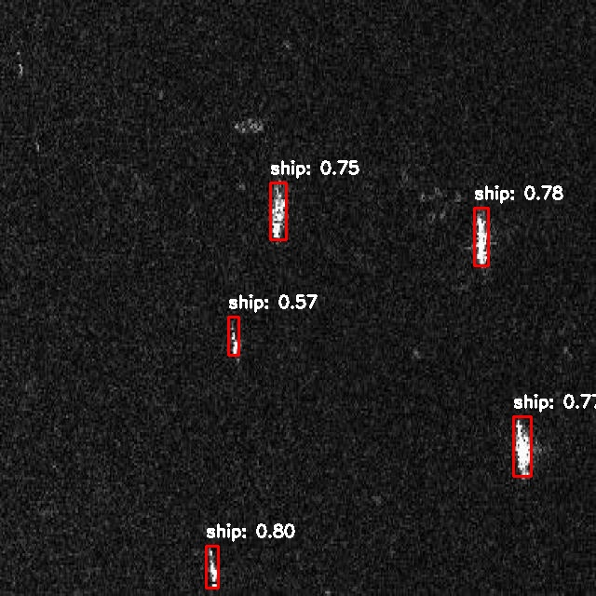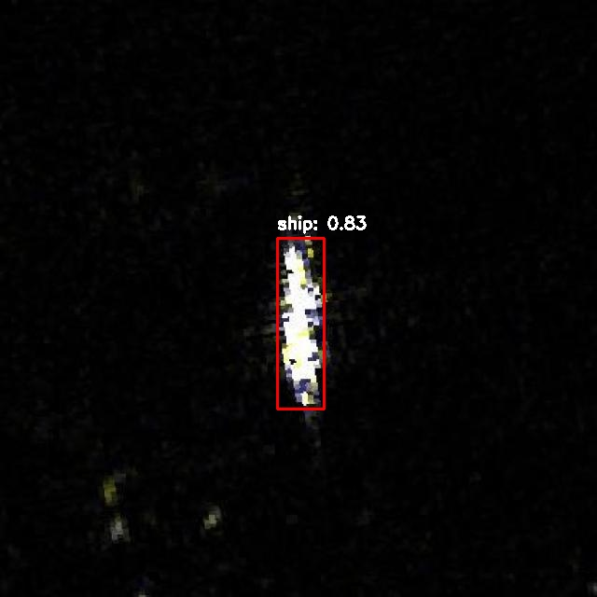
Fig. 7 - 10

3. Results and Analysis
The evaluation of performance of the proposed 19YOLO ensemble model conducted on the SARScope dataset, which is having both small area and large area SAR images of ships, both on and off the coast. The dataset is very diverse with varied maritime surroundings. The dataset is well aligned with testing the performance for real world application. The 19YOLO model, fusing outputs from YOLOv8 and YOLOv11 using Weighted Boxes Fusion (WBF), demonstrated improved results and extraordinary balance between f1-score and mAP@0.5, being trained and tested on such a large and diverse dataset. The ensembled model fused bounding boxes from both models effectively, by adaptive confidence weights being assigned to overlapping boxes, improving the final predictions. This approach helped reducing false positives while detecting ships in congested images.
19YOLO achieved an F1-score of 88.52%, and a mean Average Precision (mAP@0.5) of 88.20%, which surpassed the performance of solo YOLOv8 and YOLOv11 models, and also shows better results and balance between F1-score and mAP@0.5 than other existing models. Exceptional balance between F1-score and mAP@0.5 suggest it to be good to find objects with good overlap along with good balance between precision and recall.
19YOLO produced compact and accurate bounding boxes, in diverse backgrounds. The results show that the proposed ensemble model offers efficient real world applications like coast monitoring, security and surveillance.

4.Comparison and Validation
To check how good the new 19YOLO combo works in actual SAR ship spotting tasks, its outcomes got stacked against several common detection systems. Testing happened across two stages:
1.⁠ ⁠Models built using the same SARScope data.
2.⁠ ⁠Models tested on different SAR plus optical data - just to check if 19YOLO keeps working well when domains shift.
4.1 Comparison on the SARScope Dataset
On the SARScope data, 19YOLO got tested against YOLOv8, YOLOv11, along with a slim version of Faster R-CNN. According to Table 1, 19YOLO stays ahead in nearly every key measure. Its F1-score is up to 88.52%. YOLOv11 holds up well overall - hitting good marks in F1-score and mAP@0.5 - yet loses ground when scenes get messy, missing small boats that fade into noisy backgrounds. In contrast, YOLOv8 does worse; its recall dips far below others, showing it can't catch dim or blurry ships easily. Faster R-CNN manages steady performance across areas but doesn’t match the group effort, particularly on accuracy-driven scores. The better results from 19YOLO in SARScope show what happens when different YOLO backbones are merged - this setup cuts down false alarms sparked by speckle noise while boosting how consistently objects get spotted.
4.2 Cross-Dataset Comparison
To check how well it works overall, 19YOLO got tested against models using different SAR data - like Gaofen-3 or Sentinel-1 - alongside optical ones built on COCO instead of Pascal VOC. You’ll find these outcomes listed in Table 2. Models built using ship-focused SAR data - take YOLOv5 on Gaofen-3 or SSD with Sentinel-1 - they work well within that setting; still, their accuracy slips when tested on SARScope visuals because of the largeness and diverseness of the data. Tools such as RetinaNet and YOLOv7, good at spotting objects in regular photos, lose grip once faced with SAR’s unique signal patterns instead of normal light-based details. In contrast, 19YOLO keeps steady results, high F1-score and mAP at the same time, SARScope being different from training data. That means 19YOLO isn't just tuned for SAR ship spotting; it handles shifts in brightness, graininess, or boat sizes pretty well.

Table 1. Performance Comparison of Models Trained on the SARScope Dataset
Model | F1-Score (%) | mAP@0.5 (%)
YOLOv8 | 80.05 | 65.00
YOLOv11 | 87.28 | 67.50
19YOLO | 88.52 | 88.20

Table 2. Comparison with Models Trained on Different Datasets
Model | Dataset | F1-Score (%) | mAP@0.5 (%)
YOLOv5s | HRSID | 89.6 | 62.3
Lite-YOLOv5 | LS-SSDD-v1.0 | 74.1 | _
Standard Faster R-CNN | SSDD | 86.5 | 87.10
CFS-YOLO | HRSID | 95.1 | 68.4
19YOLO (Proposed) | SARScope | 88.52 | 88.20

V. Conclusion and Future Scope

The proposed 19YOLO model has shown very good performance for ship detection using images from the SARScope dataset, effectively overcoming challenges of multi-scale ship detection with diverse and noisy backgrounds by summing the strengths of YOLOv8 and YOLOv11 using a weighted box fusion (WBF) mechanism and optimizing the performance of ship detection with a generalized IoU loss, 19YOLO achieved notable improvements in precision, recall, F1-score, and mean Average Precision (mAP) compared to solo and existing ensemble models on such a large and diverse dataset. The results advocate its usability in real world maritime monitoring because of the robustness and adaptability of 19YOLO in detecting small, large and congested SAR ship images, even with poor background.
For future work, it is recommended to explore multi-modal fusion by combining SAR data with optical images to enhance feature discrimination and reduce false positives. The application of this model can go beyond ship detection, to other domains like vehicle detection, and testing on large datasets can further improve the results.

REFERENCES
- Weighted Boxes Fusion in Object Detection: A Comparison with Non-Maximum Suppression https://learnopencv.com/weighted-boxes-fusion/
- G. Cheng et al., “SPNet: Siamese-prototype network for few-shot remote sensing image scene classification,” IEEE Trans. Geosci. Remote Sens., vol. 60, Jul. 2022, Art. no. 5608011.
- E. Liu, Y. Zheng, B. Pan, X. Xu, and Z. Shi, “DCL-Net: Augmenting the capability of classification and localization for remote sensing object detection,” IEEE Trans. Geosci. Remote Sens., vol. 59, no. 9, pp. 7933–7944, Sep. 2021.
- X.Qian,S.Lin,G.Cheng,X.Yao,H.Ren,andW.Wang,“Objectdetection in remote sensing images based on improved bounding box regression and multi-level features fusion,” Remote Sens., vol. 12, no. 1, Jan. 2020, Art. no. 143.
- L. Shi, L. Kuang, X. Xu, B. Pan, and Z. Shi, “CANet: Centerness-aware network for object detection in remote sensing images,” IEEE Trans. Geosci. Remote Sens., vol. 60, Apr. 2022, Art. no. 5603613.
- X. Yao, H. Shen, X. Feng, G. Cheng, and J. Han, “R²IPoints: Pursuing rotation-insensitive point representation for aerial object detection,” IEEE Trans. Geosci. Remote Sens., vol. 60, May 2022, Art. no. 5623512.
- J. Zhang, R. Huang, Y. Li, and B. Pan, “Oriented ship detection based on intersecting circle and deformable RoI in remote sensing images,” Remote Sens., vol. 14, no. 19, Jan. 2022, Art. no. 4749.
- P. F. Felzenszwalb, R. B. Girshick, D. McAllester, and D. Ramanan, “Object detection with discriminatively trained part based models,” IEEE Trans. Pattern Anal. Mach. Intell., vol. 32, no. 9, pp. 1627–1645, Sep. 2010.
- R.Solovyev,W.Wang,andT.Gabruseva,“Weightedboxesfusion:Ensembling boxes from different object detection models,” Image Vis. Comput., vol. 107, Mar. 2021, Art. no. 104117.
- Z. Liu, J. Hu, L. Weng, and Y. Yang, “Rotated region based CNN for ship detection,” in Proc. IEEE Int. Conf. Image Process., 2017, pp. 900–904.
- S. Ren, K. He, R. Girshick, and J. Sun, “Faster R-CNN: Towards real-time objectdetectionwithregionproposalnetworks,”IEEETrans.PatternAnal. Mach. Intell., vol. 39, no. 6, pp. 1137–1149, Jun. 2017.
- Z. Zhang, W. Guo, S. Zhu, and W. Yu, “Toward arbitrary-oriented ship detectionwithrotatedregionproposalanddiscriminationnetworks,”IEEE Geosci. Remote Sens. Lett., vol. 15, no. 11, pp. 1745–1749, Nov. 2018.
- X. Yang et al., “Automatic ship detection in remote sensing images from Google earth of complex scenes based on multiscale rotation dense feature pyramid networks,” Remote Sens., vol. 10, no. 1, 2018, Art. no. 132.
- S. M. Azimi, E. Vig, R. Bahmanyar, M. Körner, and P. Reinartz, “Towards multi-class object detection in unconstrained remote sensing imagery,” in Proc. Asian Conf. Comput. Vis., 2018, pp. 150–165.
- J.Ding,N.Xue,Y.Long,G.-S.Xia,andQ.Lu,“LearningROItransformer for oriented object detection in aerial images,” in Proc. IEEE/CVF Conf. Comput. Vis. Pattern Recognit., Piscataway, NJ, USA, 2019, pp. 2849– 2858.
- J. Han, J. Ding, N. Xue, and G.-S. Xia, “Redet: A rotation-equivariant detector for aerial object detection,” in Proc. IEEE/CVF Conf. Comput. Vis. Pattern Recognit., 2021, pp. 2786–2795.
- M. Weiler and G. Cesa, “General E (2)-equivariant steerable CNNs,” in Proc. Adv. Neural Inf. Process. Syst., 2019, pp. 14334–14345.
- X. Xie, G. Cheng, J. Wang, X. Yao, and J. Han, “Oriented R-CNN for object detection,” in Proc. IEEE/CVF Int. Conf. Comput. Vis., 2021, pp. 3520–3529.
- G.-S. Xia et al., “DOTA: A large-scale dataset for object detection in aerial images,” in Proc. IEEE Conf. Comput. Vis. Pattern Recognit., 2018, pp. 3974–3983.
- K. He, X. Zhang, S. Ren, and J. Sun, “Deep residual learning for image recognition,” in Proc. IEEE Conf. Comput. Vis. Pattern Recognit., Piscataway, NJ, USA, Dec. 2016, pp. 770–778.
- A. Vaswani et al., “Attention is all you need,” in Proc. 29th Int. Conf.
- Neural Inf. Process. Syst., 2017, pp. 1982–1990.
- A. Dosovitskiy et al., “An image is worth 16x16 words: Transformers for image recognition at scale,” in Proc. Int. Conf. Learn. Representations, 2021.
- H. Touvron, M. Cord, M. Douze, F. Massa, A. Sablayrolles, and H. Jegou, “Training data-efficient image transformers & distillation through attention,” in Proc. 38th Int. Conf. Mach. Learn., Jul. 2021, pp. 10347–10357.
- X. Chu et al., “Conditional positional encodings for vision transformers,” in Proc. Int. Conf. Learn. Representations, 2023.
- L. Yuan et al., “Tokens-to-Token ViT: Training vision transformers from scratch on ImageNet,” in Proc. IEEE/CVF Int. Conf. Comput. Vis., 2021.
- W. Wang et al., “Pyramid vision transformer: A versatile backbone for dense prediction without convolutions,” in Proc. IEEE/CVF Int. Conf.
Comput. Vis., 2021, pp. 548–558.
- Z. Liu et al., “Swin transformer: Hierarchical vision transformer using shifted windows,” in Proc. IEEE/CVF Int. Conf. Comput. Vis., 2021, pp. 10012–10022.
- C.Guo,G.Pleiss,Y.Sun,andK.Q.Weinberger,“Oncalibrationofmodern neural networks,” in Proc. Int. Conf. Mach. Learn., 2017, pp. 1321–1330.
- J. Platt, “Probabilistic outputs for support vector machines and comparisons to regularized likelihood methods,” Adv. Large Margin Classifiers, vol. 10, no. 3, pp. 61–74, 1999.
- J. Wenger, H. Kjellström, and R. Triebel, “Non-parametric calibration for classification,” in Proc. Int. Conf. Artif. Intell. Statist., 2020, pp. 178–190.
- J. Zhang, B. Kailkhura, and T. Y.-J. Han, “Mix-n-match: Ensemble and compositional methods for uncertainty calibration in deep learning,” in Proc. Int. Conf. Mach. Learn., 2020, pp. 11117–11128.
- P. Izmailov, W. J. Maddox, P. Kirichenko, T. Garipov, D. Vetrov, and A. G. Wilson, “Subspace inference for bayesian deep learning,” in Proc. Int. Conf. Uncertainty Artif. Intell., 2020, pp. 1169–1179.
- G. Pereyra, G. Tucker, J. Chorowski, L. Kaiser, and G. Hinton, “Regularizing neural networks by penalizing confident output distributions,” in Proc. Int. Conf. Learn. Representations, 2017.
- A. Rosenfeld and M. Thurston, “Edge and curve detection for visual scene analysis,” IEEE Trans. Comput., vol. 100, no. 5, pp. 562–569, May 1971.
- N. Bodla, B. Singh, R. Chellappa, and L. S. Davis, “Soft-NMS improving object detection with one line of code,” in Proc. IEEE Int. Conf. Comput. Vis., 2017, pp. 5561–5569.
- C.LiandH.Lang,“AnorientedSARshipdetectorwithmixedconvolution channelattentionmoduleandgeometricnonmaximumsuppression,”IEEE J. Sel. Topics Appl. Earth Observ. Remote Sens., vol. 15, pp. 8074–8084, 2010.
- “FAIR1M: A benchmark dataset for fine-grained object recognition in high-resolution remote sensing imagery,” ISPRS J. Photogrammetry Remote Sens., vol. 184, pp. 116–130, Feb. 2022.
- M. Everingham, L. Van Gool, C. K. Williams, J. Winn, and A. Zisserman, “The pascal visual object classes (VOC) challenge,” Int. J. Comput. Vis., vol. 88, no. 2, pp. 303–338, 2010.
- T.-Y. Lin, P. Dollar, R. Girshick, K. He, B. Hariharan, and S. Belongie, “Feature pyramid networks for object detection,” in Proc. IEEE Conf. Comput. Vis. Pattern Recognit., 2017, pp. 2117–2125.
- T. Hastie, R. Tibshirani, J. H. Friedman, and J. H. Friedman, The Elements of Statistical Learning: Data Mining, Inference, and Prediction. Berlin, Germany: Springer, 2009.

