Springboard Data Science Career Track

*Guided Capstone - Big Mountain Resort (Unit 6)*

Big Mountain Resort, located in Montana is a large ski resort that brings in approximately 350,000 visitors each season. The resort offers many features that do not reflect its current price which is at a premium when compared to other similar resorts. The initial dataset, “ski_data”, contained 330 resorts with specific features such as, “vertical drop”, “number of runs”, “skiable area”, etc. However, the most important features given were the prices for weekday and weekend tickets. Further examination showed us that Big Mountain Resort is charging $81.00 for both weekday and weekend tickets, whereas other resorts' ticket prices vary.

Given the context, the goal of this analysis was to see how Big Mountain Resort can potentially and competitively increase their ticket valuation based on their current standing within the ski resort market segment nationally. With the data provided, we can recommend a feasible solution that allows Big Mountain Resort to increase their ticket price and stay relatively low considering operating costs. That being said, there is much-supporting evidence that reveals to us that the resort has not capitalized on its most valued features or facilities. With our developed model, we can see a significant increase in revenue generated proceeding with an increase in vertical drop along with a new chair lift installation.

To reach this goal and build a predictable model we did not only rely on the original data source, “ski_data”, we also pulled supplemental information from Wikipedia that contained population data from each state. After examining the summary statistics for each state and its features, we concluded that our best approach was to focus on resorts that shared similar features despite where they were located.

Based on both data sources and after some basic exploratory analysis we began building the model by viewing the performance of the mean prices. The performance using the mean of prices was not as insightful as other detailed models like a linear model but it provided a nice baseline to compare other results too. The linear model targeted eight features [vertical_drop, Snow Making_ac, total_chairs, fastQuads, Runs, LongestRun_mi, trams, and SkiableTerrain_ac] as they were deemed best fit. Then the next model, a random forest regressor model targeted four features (Figure 1) as best fit [fastQuads, Runs, Snow Making_ac, and vertical_drop]. Through better cross-validation results as well as a lower mean absolute error, the random forest model was chosen to be the most accurate moving forward.

**Figure 1**

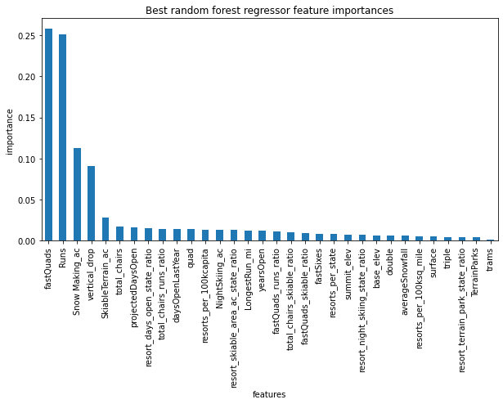

As a result of the random forest model, it showed us that a ticket price of $95.87 was a more accurate ticket valuation regarding the utilization of four best-fit features. Given that newfound information, we proposed four different scenarios for Big Mountain Resort to further increase revenue. Out of the four scenarios which considered both revenue increasing and cost-cutting actions, the one that seemed most feasible was for the resort to increase their vertical drop by 150ft. The vertical drop is relatively high when compared to other resorts but there are still other resorts with higher vertical drops (Figure 2). By combining that information with the fact that Big Mountain is ranked one of the highest in snowmaking (Figure 2.1) and near the middle of most runs (Figure 2.2), you can see how each feature can be utilized in a synergistic way to make the resort more competitive with pricing.

**Figure 2**

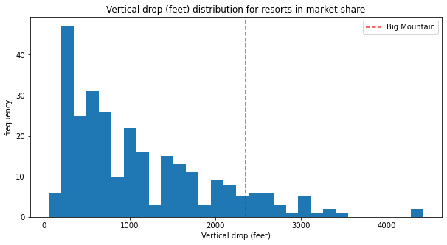

**Figure 2.1**

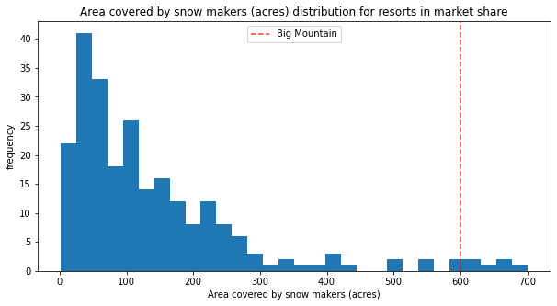

**Figure 2.2**

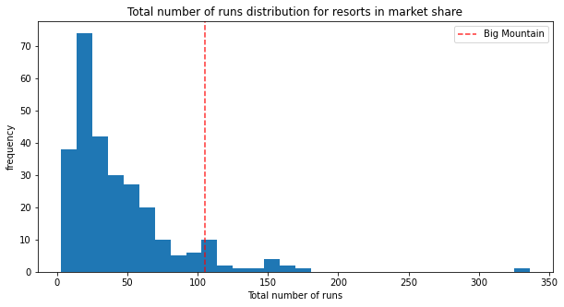

By increasing their vertical drop by 150ft it would allow Big Mountain to add an additional run, thus potentially increasing ticket value by $8.61. However, by adding this additional run they would be required to install a new chair lift which would then increase operating costs by roughly $1.5 million. The cost-cutting scenario proposed considered the closing of the ten least used runs. This is not recommended as the model suggested that the more runs that were closed, the less revenue generated, thus a lower ticket price (Figure 3).

**Figure 3**

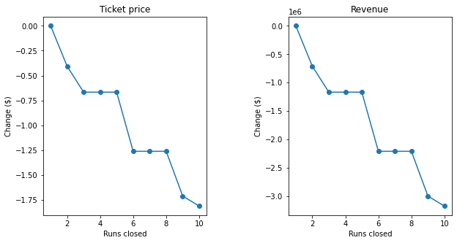

Overall, the increase of the vertical drop by 150ft along with adding a new run will allow the ticket price to be $89.61. At that price, Big Mountain Resort can expect a revenue of $15,065,471 for the season considering the average ticket sales are for five days per visitor.