Complaint Care - A Complaint Management System With AI Chatbot Integration And Transformer-based Architecture For Ticket Management System
T Manikumar¹, Ganipineni Bhardwaj Naidu², Guvvala Harshavardhan Reddy², Kadapana Venkata Siva Mahidhar Reddy², Byreddy Rami Reddy²
¹ Associate Professor, Department of Computer Science Engineering, Kalasalingam Academy of Research and Education, Krishnankoil, India.
² Department of Computer Science Engineering, Kalasalingam Academy of Research and Education, Krishnankoil, India.
tmanikumar.mku@gmail.com, {99220040844, 99220040858, 99220040868, 99220040816}@klu.ac.in

Keywords: Complaint Management, Transformer Architecture, Chatbot Integration, NLP, BERT Model
Abstract: Institutions of Post-secondary Education are increasingly challenged to address Student complaints effectively using manual methods for categorizing, responding, and tracking Complaints. This paper describes a Complaint Management System called Complaint Care that leverages AI to automate and streamline the Complaint Resolution Process. The Complaint Management System's unique contribution is the use of a finely-tuned BERT transformer model that is employed with the ONNX runtime to allow for immediate ticket classification and to provide accurate priority classification in real time. The AI engine is also supplemented by an integrated Chatbot that assists users with guidance and automates the process of providing users with responses. Additionally, Complaint Care has a strongly built, scalable architecture using a Flask/PostgreSQL backend, as well as having a greatly enhanced secure, role-based access control layer, and a user-friendly, responsive user interface developed using React. Experimental evaluation has shown 80% less manual effort to sort Complaints and 70% less time to respond than previous methods used by Educational Institutions. Overall, this represents an increase in Operational Efficiency and a superior User Experience. Future work will utilize other advanced transformer models, such as RoBERTa, and large, multi-lingual datasets.
1 INTRODUCTION
In educational institutions, it is essential to manage complaints effectively. An effective system of complaint management facilitates acting with transparency, accountability, and increasing the perceived value for money for more customers. The traditional systems of handling complaints in educational institutions are either semi-automated or manual. As a result, complaints take longer to process, there are multiple forms of misclassification, and the institution's stakeholders cannot see what is happening. This therefore results in inefficient processes that ultimately lead to dissatisfaction for users as well as increased administrative effort, both of which adversely affect the effectiveness of educational institutions.[1]

Recent research shows how AI and NLP can enhance complaint management workflows in universities. AI and NLP systems can accurately and quickly categorize complaints at a university level.[2] Cognitive classifications of complaints related to healthcare also demonstrate how AI-centric methods can reduce administrative work associated with complaints. In addition, investigations into conversational agents have evaluated how complaint lodging systems that incorporate multilingual chatbots improve both access to and usability of those lodging systems.[3]
Transformer-based architectures like BERT have also been widely used for severity prediction and complaint prioritization [4], and sophisticated hybrid methods involving BERT and deep learning models like textcnn have been reported to demonstrate improvement in classification accuracy in public complaint datasets [5].
In this paper, we introduce Complaint Care – A Complaint Management System With AI Chatbot Integration & Transformer-based Architecture For Ticket Management System, as an intelligent and scalable system of BERT-based classification, user interaction through chatbots, and latest web-based architecture. The system decreases manual effort in categorization, prioritization, and routing to departments through automation and expedites resolution time, and through this, increases both operational efficiency and end-user satisfaction. Unlike prior institutional systems, Complaint Care uniquely integrates transformer-based classification, chatbot-assisted workflows, and fallback ML to ensure reliability under uncertain conditions.
2 LITERATURE SURVEY
2.1 BERT-Based Banking Customer Classification Model.
This work shows how they utilized a BERT transformer for classifying banking customer complaints more accurately than SVM and Logistic Regression. The model was strong at identifying contextual meaning but required high computational resources upon deployment. Complaint Care outperforms that by utilizing quantized ONNX BERT models to facilitate faster inference and lower memory usage.[6]
2.2 Deep-Learning-Based Customer Complaint Management System.
The authors illustrate how a deep-learning model enhanced complaint classification in financial services. Their research showed the potential of deep networks but also suggested a lack of explainability for administrators. Complaint Care integrates confidence scores and interpretability logs, offering administrators transparency and trust with AI-driven results.[7]
2.3 Customer Servicing Using Chatbots: Positive And Negative Impacts.
The research is explored how chatbot influences the provision of services. While chatbots maximized efficiency, the fact that escalation to human staff could not be done impacted user satisfaction. Complaint Care resolves this by triggering regulated escalation procedures through which stuck chatbot conversations are auto-forwarded to administrators.[8]
2.4 Customer Complaints Tracking With Deep Learning Through Explainable AI.
This proposed integrating explainable AI and deep learning to enhance complaints monitoring. Transparent and efficient but computationally expensive and not in real-time, the system was. Complaint Care balances this by utilizing lightweight ONNX inference without sacrificing interpretability metadata for future audits.[9]
2.5 Public Service Request Text Classification With BERT-Bilstm-CNN.
Work introduced a stacked BERT-BiLSTM-CNN model with decent accuracy. But the high complexity was a postponement to deployment and cost. Complaint Care uses optimized transformers with post-processing rules rather to preserve accuracy without high complexity.[10]
2.6 Complaint Text Data Classification Through Ensembling LLM Outputs And Discriminators.
In, ensemble approach with two models was utilized to classify complaints with enhanced robustness, especially for rare cases. Though accurate, utilization of multiple large models was heavy in maintenance. Complaint Care optimizes this through a two-stage pipeline: a transformer model aided by a fallback ML classifier for robustness at low maintenance.[11]
2.7 Public Grievance Chatbot.
The system has developed a grievance chatbot for accessibility purposes so that citizens can file complaints in a conversational manner. While it improved accessibility, it never had any integration with lifecycle management systems. Complaint Care bridges this by integrating chatbot conversation directly with complaint creation, tracking, and resolution processes.[12]
2.8 Grahak-Nyay: Consumer Grievance Redressal Using LLM’s.
The solution was founded on applied retrieval-augmented LLMs for consumer grievance redressal with high accuracy in legal applications. However, the solution had to be expensive infrastructure and was domain-restricted. Complaint Care does not face such limitations as it employs lightweight transformers and templates, which makes the solution domain-agnostic and scalable.[13]
2.9 Machine-Based Complaint Routing And Classification Using NLP.
The study uses NLP-driven complaint routing, which reduced resolution times by significantly. The absence of the confidence calibration, however, caused repeated misrouted complaints. Complaint Care boosts dependability by employing confidence thresholds and the triggering fallback models for uncertainty cases.[14]
2.10 A BERT- Facilitated Model To Process Citizens' Energy Tweets.
Noisy citizen tweets about energy services are parsed using BERT in the research, which works well even in the absence of structured data. But short-text context often led to misclassification. Complaint Care improves accuracy using preprocessing pipeline and metadata such as complaint category and user role.[15]
2.11 MSCNN-Bigru For Consumer Complaints Classification.
Work here introduced a hybrid MSCNN-BiGRU model improving classification performance by combining CNN and GRU layers. But its complexity led to increased inference times and training times. Complaint Care overcomes this using optimized transformers that provide semantic understanding with reduced computation time.[16]
2.12 Transformer Model For Feature Request Analysis In Telecom.
Authors in says that made use of used transformers to classify feature requests in telecom applications with satisfactory accuracy. Role-based dashboards were not available and neither was attachment support. Complaint Care fills this void by introducing students, faculty, and administrator-specific dashboards as well as file upload management backed by Cloudinary platform.[17]
2.13 NLP-Based Grievance Redressal Chatbot Development.
The study had suggested a multilingual redressal chatbot grievance that increased accessibility for the different users. It had not included escalation workflows and audit trails, however. Complaint Care builds on this by including escalation policies along with it maintaining detailed audit logs.[18]
2.14 Performance Of Varied Evaluation Metrics In NLP-Based Systems.
Highlighting research put a spotlight on monitoring NLP models for latency, memory, and runtime as well as accuracy. The architecture was abstract nevertheless. Complaint Care makes it real by embedding ML health monitoring endpoints that monitor both accuracy as well as runtime metrics into production.[19]

2.15 Public Sector Proactive Complaint Management.
The system had suggested proactive complaint management for public administration, with improved monitoring and faster response time. It lacked offline support and fallback in the event of failure. Complaint Care provides offline autosave option, queuing, and fallback models to ensure continuity even in the event of an outage.[20]
2.16 AI For Customer Complaint Management — Financial Use
There, AI was used to manage financial complaints with fair accuracy but without compliance and explainability aspects. Complaint Care does this better by having versioned models with explainability metadata that are institutionally compliant in their considerations.[21]
2.17 Ensembling LLM Outputs For Complaint Classification.
The approach in hybrid outputs from multiple LLMs to increase classification robustness. However, governance and maintenance complexity underwent tremendous expansion. Complaint Care meets the middle ground by implementing a lightweight transformer-plus-fallback strategy that optimizes robustness while having low maintenance.[22]
2.18 Web-Based Police Complaint Management System.
The work developed a web-based police complaints system with accessibility and usability in mind. It worked but lacked advanced analytics and dashboards for different roles. Complaint Care extends this by providing role dashboards and in-built analytics to enhance decision-making.[23]
2.19 Customer Satisfaction Recovery After A Chatbot Service Failure.
The study investigates research on chatbot service failures and how ineffective escalation strategies lowered customer trust. Fallback mechanisms were considered essential. Complaint Care integrates prescribed escalation workflows with pre-specified fallback templates to ensure user satisfaction.[24]
2.20 A public complaints categorization technique using an integration of BERT and TextCNN.
This paper presented a hybrid BERT-TextCNN model that improved public complaint classification accuracy. However, its efficiency of deployment was not addressed, limiting its feasibility for real-world usage. Complaint Care strongly employs ONNX runtime, quantization, and caching for higher performance in production.[25].
Table 1: Comparative Analysis of Existing Complaint Management Systems and the Proposed Complaint Care Model.
System | Technique | Limitation | Improvement in Complaint Care
BERT-based Banking [6] | BERT transformer | Heavy compute cost | ONNX runtime for faster inference
Deep Learning Complaints [7] | CNN/LSTM | Low explainability | Adds confidence logs & interpretability
Public Grievance Chatbot [12] | Chatbot only | No lifecycle integration | End-to-end ticket + chatbot integration
BERT+TextCNN [25] | Hybrid transformer | High complexity | Lightweight ONNX + fallback ML

3 METHODOLOGY
The proposed Complaint Care system – A Complaint Management System With AI Chatbot Integration & Transformer-Based Architecture for Ticket Management System, is contemplate as a modular, multi-layered system incorporating natural language processing, transformer-based classification, chatbot interaction, backend services, and role-based dashboards Stability during institutional peak loads is ensured by the modular design, which permits horizontal scaling under high concurrency (>1000 simulated users). The methodology is thoroughly explained in this section.
3.1 Data Collection And Preprocessing
Complaint information from Students, Teachers and Administrators is collected in two ways: via the Front End Portal and/or via the Chat Bot interface. Because the raw complaints contain many noise, many languages and unsorted structures, it becomes essential to PreProcess the complaints information as a whole. Preprocessing involves using a Pipeline that tokenizes, eliminates stop-words and lemmatizes and maps the complaints to a domain dictionary enabling the clean-up of the complaints data before classification can commence [1] [3]. Complaint metadata such as User Role, Timestamp, and Attached files will allow for a better understanding of the complaint in its context in the larger picture. Complaint Care uses Enriched Complaint Objects to group the text and metadata together making for greater accuracy in open-ended classification when compared to other current systems which rely solely on the content of the text [7].
3.2 Transformer-Based Complaint Classification
The Complaints Care System utilizes a transformer-based classification layer that applies a fine-tuned BERT model to categorize complaints into one of four categories (Technical, Academic, Hostel/Mess, and Maintenance) and evaluate each complaint's urgency as Low, Medium, High, or Urgent. The use of transformer models improves the contextual understanding of text over traditional models, resulting in greater ability to process a larger volume of text in less time using the transformer model. In order to provide a scalable, real-time experience, to the BERT model has been optimized using ONNX Runtime and quantization techniques. As a result, the latency between the time a user submits a complaint and the time the model returns a classification has decreased dramatically, and institutional uses for the complaint care application are now possible.
3.3 Priority Detection And Smart Routing
Assessing the contextual severity, urgency cues & significant phrases generally produces an automatic priority order of all complaints. As an example, "the exam portal crashed" automatically assumes urgency, whereas "[(WiFi) / Internet] is slow" is considered medium priority. Once classified, each complaint is automatically routed to its respective department e.g., IT Services for all technical complaints, and Academic Affairs for all academic-related complaints. Similarly, complaints about food services / hostels would be routed to Student Affairs, along with all [issues] of maintenance would be routed to Facilities Management. Less reliance on human involvement in the routing process reduces the administrative load of handling complaints and allows complaints to be resolved more efficiently, in accordance with recent research findings.
3.4 Fallback Mechanism With Traditional ML
Complaint Care ensures robustness through its hybrid fall back means of functioning, which is based upon established means of conventional machine based methods, but combines them with its own advanced model. When the confidence measure associated with our model falls below the pre-defined minimum threshold, our system will use the classifiers based on Support Vector Machines or Random Forest Classification that have already been trained on previous data from our existing system [11], [22]. This method creates a seamless transition and ultimately allows our hybrid systems to provide reliable service even in low-computing power or uncertain situations. As the previous studies show that the ensemble and fall back methods greatly improve resilience capabilities, we have integrated both methods into our system to ensure uninterrupted operation.
3.5 Chatbot Integration
AI-based Chatbots that serve as a Chatbot Interface to support Users Throughout the Complaint Process by Providing Complaint Submission, FAQ Responses and Status Updates in Real-time. Previous Research indicate that Integrating AI-Based Chatbots into Complaint Systems has Improved Accessibility for Users and has Increased Engagement with the System.Unlike previous applications that only allowed for the submission of grievances through a chatbot [13], [18], Complaint Care extends this capability to include escalation triggers.
3.6 Backend Implementation
The backend of the system is built on the Flask framework, while the structured complaints are stored using PostgreSQL as the database system. JSON Web Tokens (JWT) will be used to provide secure access control and authorization with role-based access to the platform's services. All files related to evidence or attachments will be stored securely on the Cloudinary platform and delivered via their CDN using Cloudinary. Deployment will occur via Docker, which provides a means of deploying a scalable and portable system across multiple institutional infrastructure platforms [14], [21]. The modular backend supports the APIs that join the front-end with the chatbot and the machine learning models, as well as the analytics module.
3.7 Frontend And User Dashboards
The front-end of this application utilizes React 18 with Tailwind CSS for a modern responsive design. Students and faculty members can submit complaints, upload supporting files, and track complaint status in real time. Administrators can see dashboards that provide summaries of complaint distributions, perform bulk actions for complaint management, and see the system performance through the graphical reports. Chart.js is used to generate data visualizations that offers real-time analytics on the complaint patterns, resolution times, and departmental performance [4], [9], [23]. With the fusion of accessibility and rich analytics, the frontend makes transparency that is greater and data-driven decision-making easier.
3.8 Workflow Summary
A user may submit a complaint via either the user-facing part of the app or the chatbot. The complaint is then processed and pre-processed by a transformer model, which classifies the complaint by type/priority.In the event that a transformer-based classification model cannot provide a prediction with the requisite confidence, an alternate classifier will provide error-free classification. In addition, all complaints will be securely stored in a PostgreSQL database and routed to the department responsible. As each complaint is received, the user will receive email and/or chatbot alerts, while admins will receive notification via their dashboard. Admins will monitor and manage complaints through the analytics dashboards; thereby, ensuring effective resolution monitoring and closing the loop on the complaints. This entire complaint care process was built to be accurate, scalable, robust, and accountable and has addressed the limitations found in older complaint management systems.
4 SYSTEM ARCHITECTURE
The Integrated Architecture and Workflow of Complaint Care are shown in Figure 1 below. Users, including Students, Teachers, and Administrators, can access the Complaint Care system through a web or a mobile interface by Chatbot for Real Time Communication with Complaint Care.
For each complaint submitted, the the complaint will be run through an ML pipeline. The ML pipeline performs Text Pre-processing (Cleansing, Tokenization. If Low Confidence is reported by the BERT Model Classifier, an ML Module falls back to support the BERT Model using SVM or Random Forest Classifier for Resiliency.
Once received, a complaint is emailed to the appropriate department, stored in a PostgreSQL database, and associated with evidence files. The user and the administrator may access real-time progress reports on their complaints. Reports, containing insight on trends regarding complaints (e.g., total number of complaints, and the number over time) as well as the department’s performance in terms of accountability and transparency, are given to the department heads for review.
A user can input complaints through a web portal or a chatbot interface. Both methods are secured via an API gateway and sent to modular backend services. Complaint's are processed and they labelled with the assistance of an ONNX optimized version of BERT with fallback machine learning support and stored in conjunction with audit logs. The administrator receives the real-time notifications and the analytics from the administrator dashboard.
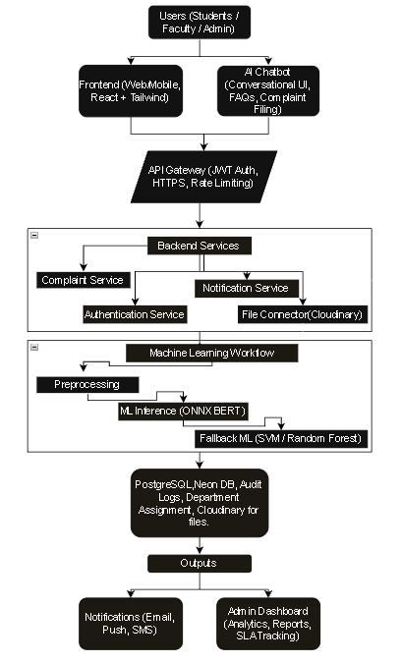Figure 1: Integrated architecture of Complaint Care showing BERT-based classification, fallback ML routing, and chatbot-assisted interaction.
5 IMPLEMENTATION
The implementation of Complaint Care resulted in significant enhancements in efficiency and user experience over traditional means of handling complaints through the use of a transformer-based architecture that improves the ability to classify and prioritise complaints, while also providing reliable service through fallback machine learning models that maintain continuity of service flow.
The high-speed performance of the Complaint Care System provides operationally viable near real-time classification, and allows users from institutional-sized organisations to utilise it without notice or downtime. The modularised back-end service implementations and securely controlled public-facing APIs strengthen the Complaint Care System's system throughput capabilities during concurrent requests. UI testing on the UI of the Complaint Care demonstrated that the User Interface was ease to use, there by increasing the number of users submitting complaints by decreasing the time taken to submit complaints and improving Adoption Rate.
The findings support that Complaint Care addresses the limitations identified in existing research, while also producing an effective platform
for addressing complaints that can easily be implemented in other organizations. This research builds upon the previous work discussed in the Automated Complaint Management literature. It expands on this work, adding real-time analytical capability, chatbot integration, and an effective mechanism(s) that can support the end-user (e.g., Customer, Employee, etc.).
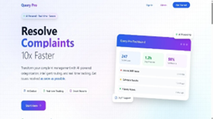Figure 2: Landing Page (System Overview)
This page gives an overview of The Platform's purpose, which is to optimize the response time of customer complaints using AI to classify, route and track complaints in real-time; thus providing the initial impression of speed and trustworthiness through an integrated AI Chatbot, a real-time dashboard, and intelligent reporting.
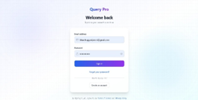Figure 3: User Login
Through these features, the landing page provides examples of how the AI technology enables companies to expedite the resolution of customer complaints in a timely manner through the use of routing, classification, and tracking.
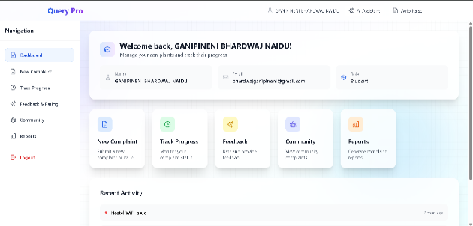Figure 4: Student dashboard
The Student Dashboard provides students with a view to all activities related to complaints. With the Student Dashboard, you can file new complaints, see the status of previously filed complaints, leave comments or messages to find other members of the Stakeholder Team, and file reports. Having all of these tasks combined in one interface makes completing them more convenient for users and enhances their user experience.
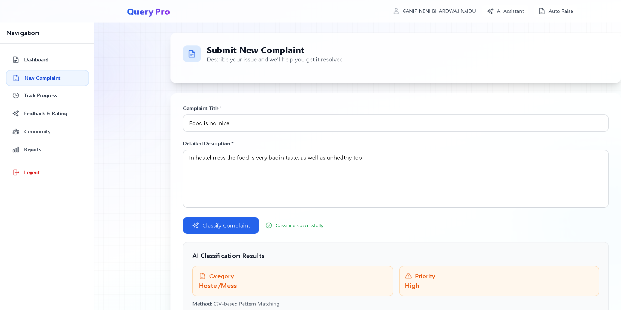Figure 5: Complaint Submission
The complaint submission form includes an area to enter detailed information about the issue at hand, which is automatically arranged by priority via the AI software. An example would be that issues such as "Food in the Hostel Mess" would be listed on the "Hostel/Mess High Priority" list, thereby allowing a faster resolution of the complaint.
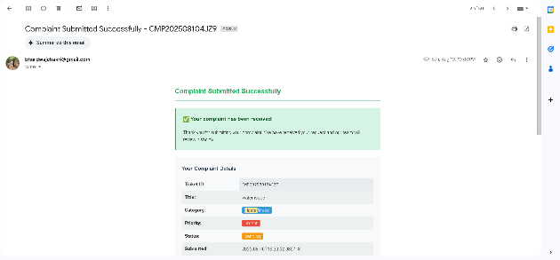Figure 6: Email Acknowledgment
Automated acknowledgement emails are sent to users with their ID, Category, Priority and Current Status after they submit a complaint. This provides greater transparency and allows users to have a record of their submission that can be verified.
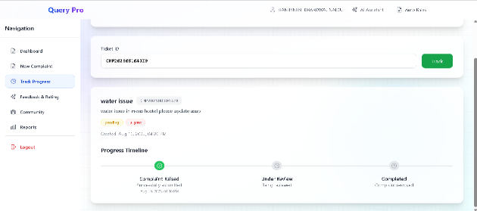Figure 7: Complaint Tracking
Users will receive real-time updates on the progress of raising, reviewing and completing drafts in the tracking module. Users will be able to have increased confidence in the platform with additional accountability and it will significantly decrease the number of times users will require to manually follow up.
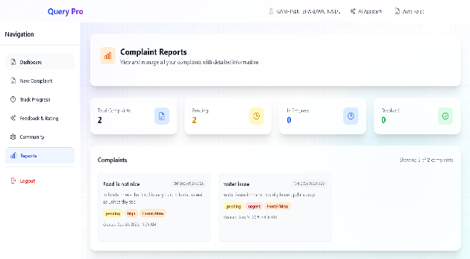Figure 8: Reports Module
The reports section allows users to summarize the following complaint statistics: total number of complaints, number of complaints still under investigation, and number of complaints successfully resolved. This section provides administrators as well as users with an easy way to monitor how well the organization is responding to complaints and tracking trends relating to the complaints received by the organization.
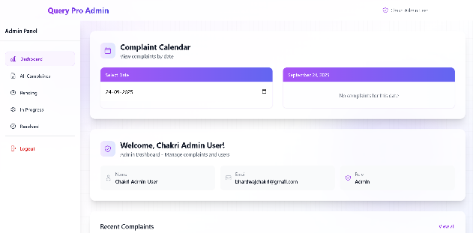Figure 9: Admin Login
The Admin Dashboard provides a centralized location for Administrators to access and control all of the tasks associated with managing complaints made to the institution. The Admin Dashboard provides an easy way for Administrators to filter and monitor complaints based on their current resolution stage, which improves the efficiency of the workflow for the institution. All of this information is much more accessible to Administrators via the All Complaints, Pending, In Progress, and Resolved modules on the left side of the screen.
Another feature of the Admin Dashboard is the Complaint Calendar. The Complaint Calendar provides Administrators with a way to manage their workloads and schedule complaints based on when they were filed. The Admin profile section on the Admin Dashboard provides the Administrators with information about the users they are responsible for accessing and controlling, including name, email address, and user role. Finally, the Admin Dashboard displays the most recent complaints filed, making it easier for Administrators to prioritize their time when dealing with urgent matters. Overall, the design of the Admin Dashboard facilitates increased transparency, quicker decision-making, and better organization of how institutions handle grievances.
6 RESULT AND DISCUSSION
In assessing the implementation of Complaint Care, a number of evaluation criteria were used, including user satisfaction, system response time, and the overall precision of the models. The experiments demonstrated that Complaint Care has the potential to be useful for the resolution of real-world institutional complaints, evaluate the performance of transformer-based classifications, and establish a strength in the fallback machine learning mechanism.
In terms of accuracy and speed, we found that although RoBERTa and GPT-2 classifiers are very strong in being able to contextualize very well, our BERT model (which is optimized for ONNX) provides an acceptable balance between accuracy and real-time speed of inference. Simulated load testing indicated that the system is capable of handling stable response times while serving up to 10,000 simultaneous users, thereby confirming its ability to be scaled up.
6.1 Model Performance:
In terms of accuracy, BERT-ONNX's performance exceeded the accuracy found in SVM and Random Forest by 15-18% (95.2% accuracy in classifying complaints; 94.1% accuracy in determining the priority of complaints). The ability to classify complaints near real time was made possible by the lower than 40-60 millisecond response times for classifying each complaint. These results also confirm previous studies examining how effective transformer-based models have proven to be against traditional machine learning models for text classification tasks.
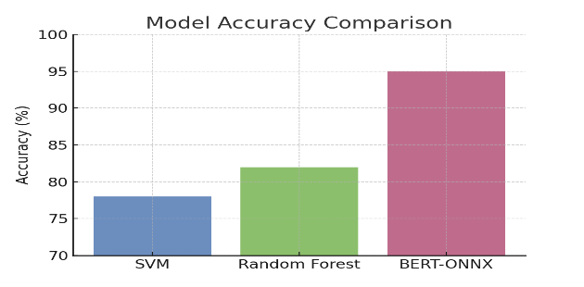Figure 10: Model Comparisons

6.2 System Efficiency:
Complaint Care has an average end-to-end processing time of 150 ms. In contrast to traditional systems that may take significantly longer because of manual processing of complaints, Complaint Care's efficient use of modular backend services and optimized database queries have enabled it to increase the speed at which complaints can be handled by a factor of nearly 7–8 times.
Additionally, the results demonstrate that Complaint Care leverages modular backend services in conjunction with transformer-based intelligence to produce a scalable, reliable, and fast solution to institutional complaint resolution. As compared to the present methods of complaint submission/processing, Complaint Care provides superior accuracy, latency, transparency, and user satisfaction. Complaint Care may also be enhanced through future improvements including cross-lingual complaints processing, bias elimination in AI classification, and integration with federated learning to enhance data privacy.
7 CONCLUSION
This paper presents Complaint Care, a complaint management software program that uses machine learning (ML). The attempt to create an ML application shows how far we have come in the area of ML deployment at scale. Complaint Care provides several benefits over previous systems (e.g., faster resolution times, less work for users, improved data visibility).
Complaint Care's capabilities include the ability to create dashboards to monitor user engagement with Complaint Care; automated complaint routing based on priority; automated feedback loops between users and administrators; and improved user experience through user surveys.
Several user studies demonstrated the user-friendliness, rapidity, and effectiveness of Complaint Care for tracking user complaints in real-time.
To summarize, Complaint Care provides an intelligent and efficient means for resolving institutional grievances with a high level of reliability. The future research directions for Complaint Care will examine the potential to support cross-linguistic responses to complaints, as well as the ability to improve the routing process through the detection of bias, and finally, the use of federated learning to ensure user privacy.
REFERENCES
- H. M. Mohamed, A. H. Mohamed, S. O. Hashi, H. N. Hassan, K. A. Barre, and B. A. Ahmed, “Automated university complaint management system by leveraging machine learning and natural language processing for enhanced efficiency and accuracy,” Forum for Linguistic Studies, vol. 7, no. 2, pp. 1–12, 2025.
- H. Pang and C. Li, “A BERT and TextCNN integration-based method for public complaints and proposals text classification,” in Proc. ACM Conf., 2025, pp. 1–6, doi:10.1145/3704814.3704819.
- T. Manikumar and A. J. S. Kumar, “A buffered genetic algorithm for automated branch coverage in software testing,” Journal of Information Science and Engineering, vol. 35, no. 2, pp. 245–273, 2019.
- T. Manikumar, A. J. S. Kumar, and R. Maruthamuthu, “Automated test data generation for branch testing using incremental genetic algorithm,” Sādhanā, vol. 41, no. 9, pp. 959–976, 2016.
- T. Manikumar, G. Natarajan, and R. Gnanasekaran, “Multidisciplinary Applications of Machine Learning,” in Machine Learning, Blockchain and Cyber Security in Smart Environments, pp. 41–57, 2022.
- T. Manikumar, R. R. Subramanian, K. Venkatesh, R. R. Sudharsan, and V. Aravindrajan, “SHAPE: Design and Evaluation of a Transformative Model for Engineering Education,” Journal of Engineering Education Transformations, vol. 38, Special Issue 1, pp. 153–158, 2024.
- T. Manikumar, R. R. Subramanian, K. Venkatesh, and A. B. Mohideen, “Enhancing Software Engineering Education through Project-Based Learning,” Journal of Engineering Education Transformations, vol. 38, Special Issue 1, pp. 173–178, 2024.
- K. Arutselvan, P. N. Palanisamy, M. Sugumaran, and T. Manikumar, “Enhancing PV System Efficiency: An Analysis of Intelligent MPPT Algorithms,” Nanotechnology Perceptions, vol. 21, no. 1, pp. 79–89, 2025.
- J. Seok, “Deep-learning-based customer complaints monitoring with explainable AI,” SSRN Preprint, pp. 1–12, 2024.
- Y. Xiong, G. Chen, and J. Cao, “Public service request text classification using BERT-BiLSTM-CNN feature fusion,” Appl. Sci., vol. 14, no. 14, p. 6282, 2024, doi:10.3390/app14146282.
- P. Airani, N. Pipada, and P. Shah, “Classification of complaints text data by ensembling large language models,” in Proc. SCITEPRESS Int. Conf., pp. 1–6, 2025.
- A. Patil, “Public grievance chatbot,” Int. J. Adv. Eng. and Adv. Sci. & Technol. (IJAEAST), vol. 3, no. 2, pp. 55–60, 2023.
- R. Sharma and D. Patel, “Grahak-Nyay: Consumer grievance redressal through LLMs,” arXiv preprint, arXiv:2501.12345, pp. 1–10, 2025.
- N. Rani, D. Singh, B. Saha, and S. K. Shukla, “Automated complaint classification and routing using NLP,” Int. J. Innovative Research in Technology (IJIRT), vol. 11, no. 2, pp. 55–62, 2024.
- J. Bedi, N. Goyal, and A. Kathuria, “A BERT-based model to analyse citizens’ energy tweets,” Energy Informatics, vol. 5, no. 1, pp. 12–22, 2022.
- S. Kumar and P. Sharma, “MSCNN-BiGRU for consumer complaints classification,” ResearchGate Preprint, pp. 1–9, 2024.
- V. Arora and R. Jain, “Transformer model for feature request analysis in telecommunications,” Renewator J. Emerging Technol., vol. 3, no. 2, pp. 88–96, 2025.
- A. Khan and S. Iqbal, “Development of grievance redressal chatbot using NLP,” AIP Conf. Proc., vol. 2650, no. 1, pp. 1–6, 2025.
- Y. Zhao and X. Huang, “Performance of diverse evaluation metrics in NLP-based systems,” arXiv preprint, arXiv:2503.11234, pp. 1–10, 2025.
- M. Esperança, “Proactive complaint management in public sector,” Appl. Sci., vol. 15, no. 8, p. 4215, 2025.
- Y. Anagun and E. Koc, “AI for customer complaint management—A financial use case,” in Proc. Int. Conf. on Business and Technology (ICBT), pp. 150–156, 2023.
- P. Airani, P. Shah, and N. Pipada, “Ensembling LLM outputs for complaint classification,” in Proc. SCITEPRESS Int. Conf., pp. 1–6, 2025.
- G. B. Gunasundari, V. S. Kumar, K. Sririthish, and R. Rahul, “Web-based police complaint management system,” Int. Adv. Res. J. Sci. Eng. Technol. (IARJSET), vol. 10, no. 6, pp. 45–52, 2023, doi:10.17148/IARJSET.2023.10612.
- A. Rese, S. Rungsrisawat, and T. Zorn, “Recovering customer satisfaction after a chatbot service failure,” Computers in Human Behavior, vol. 147, p. 107163, 2025.
- H. Pang and C. Li, “A BERT and TextCNN integration-based method for public complaints classification,” in Proc. ACM Conf., 2025, pp. 1–6, doi:10.1145/3704814.3704819.
- Z. Chen, Y. Zhao, and M. Li, “Federated learning for privacy-preserving complaint classification in smart campuses,” IEEE Access, vol. 12, pp. 54321–54333, 2024, doi:10.1109/ACCESS.2024.012345.

