**Open Source Graphics & Animation Tools**



**Quantum Computer**

**Submitted to**

**Dr. Durgansh Sharma**

**Professor, Cybernetics SCS, UPES**

**Submitted By**

Name: Varun Tandon

Roll No: 65

SAP ID: 500068131

B. Tech CSE (OSSOS) Department of Cybernetics

COMPUTER SCIENCE & ENGINEERING

**MID TERM FILE**

**ABSTRACT INFORMATION:**Number of Layers Used:6(Including text layers)

Font used in text: SAUCER BB

Kerning in text: 0.1

Leading in text: 0.1

Tracking in text: 0.2

Text Size: 91

Text Colour: White,BLUE RED USING DIFFERENT FILTER

Text Opacity: 100%

GIMP PROJECT STEPS:

Step 1 : Download your favourite picture of Messi ,Open the image in gimp 2.10 as a layer and usin a new layer fill the respective bg color and using texture of stripes with desirerd spacing apply on this layer.



Step 2: Create different layers above the image for different types like color ,text ,texture,etc .select the created layer and select it.

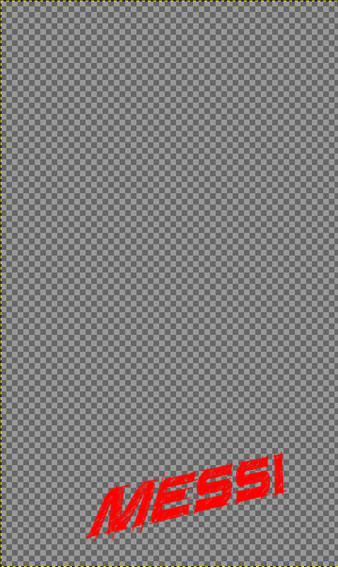

4 : Neatly trace the outline of the character by zooming it to 400% and fill the respected color using free selection and bucket fill tools.

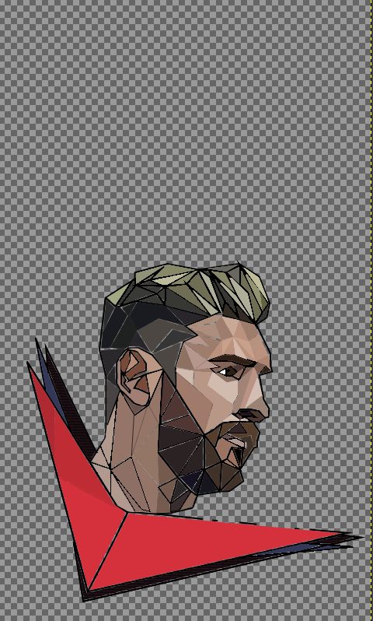

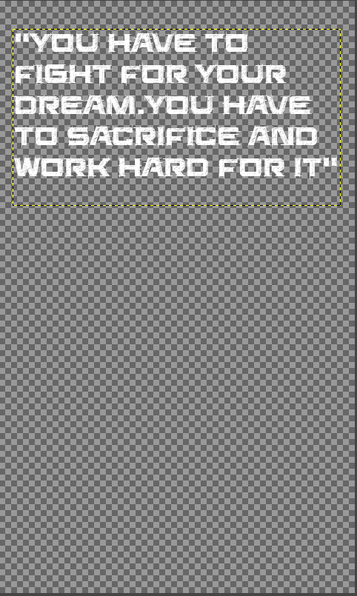Step 5:on another layer using text box write MESSI using the font of saucer bb and font size of 91

Step 6:using transformation tool and perspective tool change it accordingly.

Step 5:on another layer wirte the quote with the same font

Step 5 : save it and export the image.thats it.done

**FINAL OUTCOME:**

