Customer Shopping Behavior Analysis

Project Overview

Objective
The objective of this project was to analyze customer shopping behavior and identify patterns in purchasing activity, product preferences, seasonal trends, and customer demographics. The project demonstrates a complete data analytics workflow, from data preparation to dashboard development and business insight generation.

Tools Used
- Python (Pandas)
- SQL
- Power BI
- GitHub

Dataset
Source: Kaggle Customer Shopping Trends Dataset
The dataset contains approximately 3,900 customer purchase records, including:
- Customer Demographics
- Product Categories
- Purchase Amounts
- Seasons
- Subscription Status
- Payment Methods
- Shipping Preferences
- Purchase Frequency

Data Preparation and Analysis
Data Cleaning (Python) The dataset was cleaned and prepared using Python to ensure accuracy and consistency.

Key Activities
- Checked for missing values
- Validated data types
- Removed duplicates
- Standardized column names
- Verified data quality
The cleaned dataset was then used for SQL analysis and Power BI reporting.

- Used df.info() and to check structure and df.describe() for summary statistical.

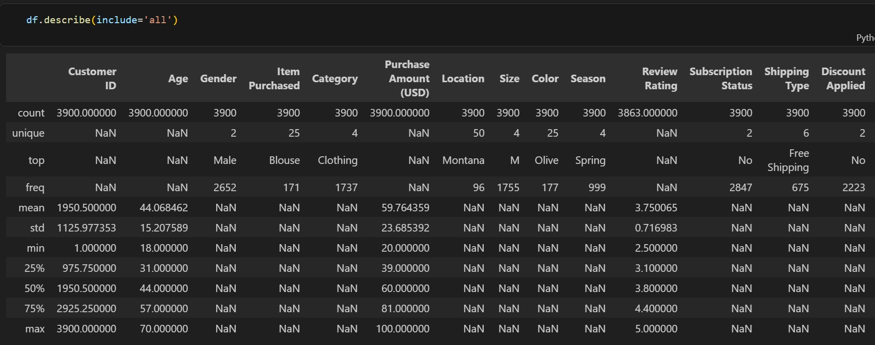

- Checked for null values and imputed missing values in the Review Rating column using the median rating of each product category.
- Renamed columns for better readability and documentation.
- Created age_group column by binning customer ages and also created purchase_frequency_days
column from purchase data.
- Verified if discount_applied and promo_code_used were redundant; dropped promo_code_used.
- Connected Python to MySQL and loaded the cleaned DataFrame into the database for SQL analysis.

SQL Analysis
SQL was used to explore customer behavior and answer business questions such as:
- Revenue by Gender – Compared total revenue generated by male vs. female customers.
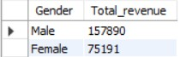
- High-Spending Discount Users – Identified customers who used discounts but still spent above the average purchase amount.
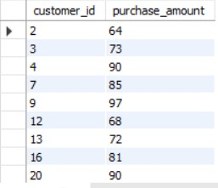
- Top 5 Products by Rating – Found products with the highest average review ratings.
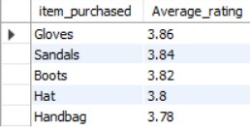
- Shipping Type Comparison – Compared average purchase amounts between Standard and Express shipping.
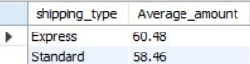
- Subscribers vs. Non-Subscribers – Compared average spend and total revenue across subscription status.
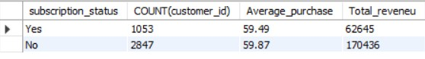

- Discount-Dependent Products – Identified 5 products with the highest percentage of discounted purchases.
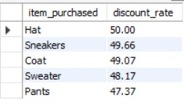
- Customer Segmentation – Classified customers into New, Returning, and Loyal segments based on purchase history.
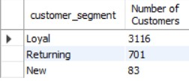
- Top 3 Products per Category – Listed the most purchased products within each category.
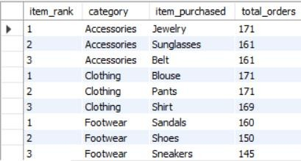
- Repeat Buyers & Subscriptions – Checked whether customers with >5 purchases are more likely to subscribe.
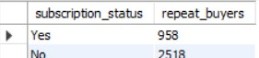
- Revenue by Age Group – Calculated total revenue contribution of each age group.
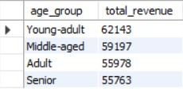

The analysis provided the foundation for dashboard development and insight generation.

Dashboard Development
An interactive Power BI dashboard was developed to visualize business performance and customer behavior.

Overview Page
The Overview page provides a high-level summary through: KPIs
- Customer Count
- Total Revenue
- Average Order Value

Visualizations
- Revenue by Product Category
- Subscription Status Distribution
- Top Product Categories

Detailed Analysis Page
The Detailed Analysis page focuses on customer-level insights:
- Revenue by Gender
- Revenue by Age Group
- Payment Method Analysis
- Shipping Preference Analysis
- Purchase Frequency Analysis

DAX Measures
- Customer Count
- DISTINCTCOUNT(Customer_ID)
- Total Revenue
- SUM(Purchase_Amount_USD)
- Average Order Value
- DIVIDE([Total Revenue], [Customer Count], 0)


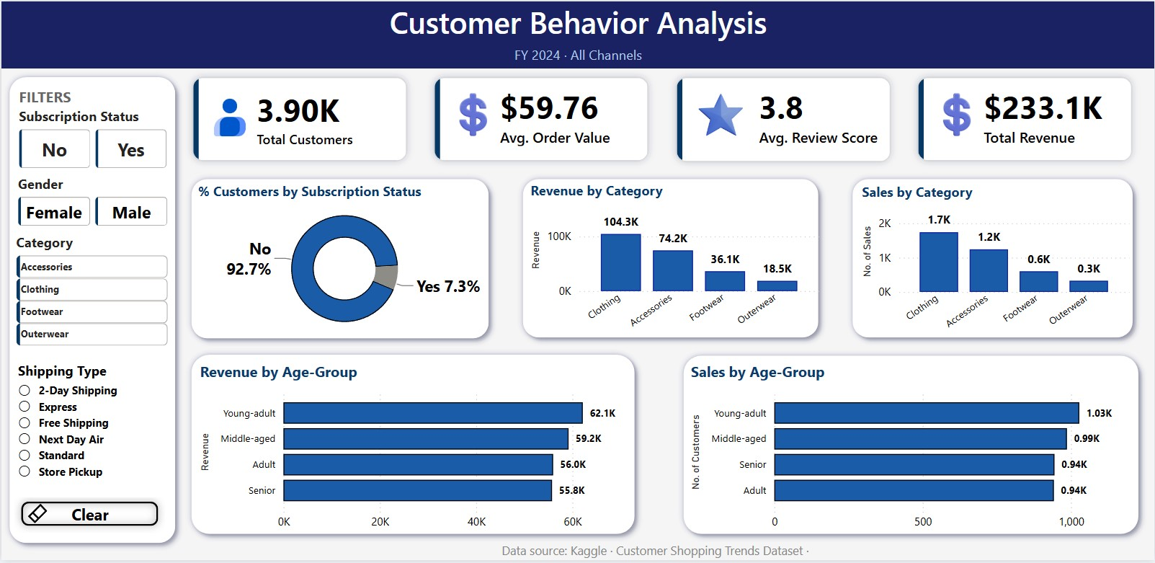
Dashboard Screenshots

Key Insights and Recommendations

Key Insights

Product Performance
Certain product categories generated significantly higher revenue, indicating stronger customer demand.
Seasonal Trends
Sales varied across seasons, suggesting opportunities for seasonal promotions and inventory planning.

Customer Behavior
Repeat customers contributed substantially to overall revenue, highlighting the importance of customer retention.

Subscription Analysis
Customer purchasing patterns differed based on subscription status, indicating opportunities for loyalty programs.

Geographic Insights
Revenue distribution varied across locations, suggesting the potential for region-specific marketing strategies.

Business Recommendations
- Increase focus on high-performing product categories.
- Develop customer retention and loyalty initiatives.
- Align marketing campaigns with peak sales seasons.
- Encourage subscription adoption through targeted incentives.
- Use regional insights to improve marketing effectiveness.

Conclusion
This project demonstrates the practical application of Python, SQL, and Power BI to transform raw data into actionable business insights. Through data cleaning, exploratory analysis, and dashboard development, the project provides a clear understanding of customer shopping behavior and supports data-driven decision-making.

