4th Semester – Vector Calculus
Gradient Descent for Finding
Minimum Error in AI Models
Practical Work – Topic 1
Application: House Price Prediction via Linear Regression

Tools Used: Python 3 | NumPy | Matplotlib

1. Problem Statement
In modern machine learning systems, accurate prediction is achieved by minimizing the difference between predicted and actual values. This project implements a house price prediction model and demonstrates how gradient descent — a core vector calculus technique — is used to minimize the Mean Squared Error (MSE) loss function.

Key objectives of this project:
- Build a linear regression model that predicts house prices based on area (sq. ft.).
- Apply gradient descent to iteratively reduce prediction error.
- Visualize the convergence of error over training epochs.
- Demonstrate how the gradient (∂L/∂w and ∂L/∂b) drives weight updates.

Dataset: 50 synthetically generated house records with area ranging from 500 to 3000 sq. ft., with house prices modelled as a linear function with added noise to simulate real-world data.

2. Mathematical Model

2.1 Hypothesis Function
The model predicts house price using a linear function:

ŷ = w·x + b

where ŷ is the predicted price, x is the normalised area, w is the weight, and b is the bias.

2.2 Loss Function (Mean Squared Error)
The Mean Squared Error (MSE) is used as the loss function to quantify prediction error:

L(w, b) = (1/2n) · Σᵢ (ŷᵢ − yᵢ)²

This is a scalar field in the (w, b) parameter space. The goal is to find the minimum of this field.

2.3 Gradient (Vector Calculus)
The gradient ∇L gives the direction of steepest ascent in the loss surface. By moving opposite to the gradient, we descend towards the minimum:

∂L/∂w = (1/n) · Σᵢ (ŷᵢ − yᵢ) · xᵢ ← partial derivative w.r.t. weight
∂L/∂b = (1/n) · Σᵢ (ŷᵢ − yᵢ) ← partial derivative w.r.t. bias

Note: The term Σ(ŷᵢ − yᵢ)·xᵢ is computed as a dot product between error vector and feature vector — a direct application of vector calculus.

2.4 Weight Update Rule (Gradient Descent)
Parameters are updated at each epoch using:

w ← w − α · (∂L/∂w)
b ← b − α · (∂L/∂b)

where α (alpha) is the learning rate (set to 0.05). This controls the step size taken along the negative gradient direction.

3. Algorithm / Approach
The following step-by-step procedure was implemented:

- Initialise weights w = 0, b = 0
- Normalise the input feature x (zero mean, unit variance)
- For each epoch (iteration) up to 200:
a. Compute predictions: ŷ = w·x + b
b. Compute error: e = ŷ − y
c. Calculate gradients: ∂L/∂w = (eᵀx)/n, ∂L/∂b = mean(e)
d. Update weights: w ← w − α·∂L/∂w, b ← b − α·∂L/∂b
e. Record current MSE loss
- After all epochs, plot error vs iterations to visualise convergence
- Generate regression line plot, weight convergence plot, and 3D loss surface

Hyperparameters used:

Parameter | Value
Learning Rate (α) | 0.05
Epochs | 200
Dataset size (n) | 50
Initial w, b | 0, 0
Feature normalisation | Z-score

4. Code Implementation (Python)
The implementation was done in Python using NumPy for numerical computation and Matplotlib for visualisation.

4.1 Dataset Generation & Feature Normalisation
import numpy as np
import matplotlib.pyplot as plt

np.random.seed(42)
n = 50
X_raw = np.random.uniform(500, 3000, n) # Area in sq ft
y = 0.15 * X_raw + 20 + np.random.normal(0, 10, n) # Price in lakhs
# Normalise: zero mean, unit variance
X = (X_raw - X_raw.mean()) / X_raw.std()

4.2 Prediction, Loss & Gradient Functions
def predict(X, w, b):
return w * X + b

def mse_loss(y_pred, y_true):
return np.mean((y_pred - y_true) ** 2) / 2

def gradients(X, y_true, w, b):
n = len(X)
y_pred = predict(X, w, b)
error = y_pred - y_true
dw = np.dot(error, X) / n # Vector dot product (∂L/∂w)
db = np.sum(error) / n # (∂L/∂b)
return dw, db

4.3 Gradient Descent Loop
def gradient_descent(X, y, lr=0.05, epochs=200):
w, b = 0.0, 0.0
loss_history = []
for epoch in range(epochs):
dw, db = gradients(X, y, w, b)
w -= lr * dw # w ← w − α · ∂L/∂w
b -= lr * db # b ← b − α · ∂L/∂b
loss_history.append(mse_loss(predict(X, w, b), y))
return w, b, loss_history

w_final, b_final, loss_history = gradient_descent(X, y, lr=0.05, epochs=200)

5. Graphs and Visualisations
Four visualisations were generated to analyse the model performance and gradient descent behaviour.

5.1 Error (Loss) vs Iterations
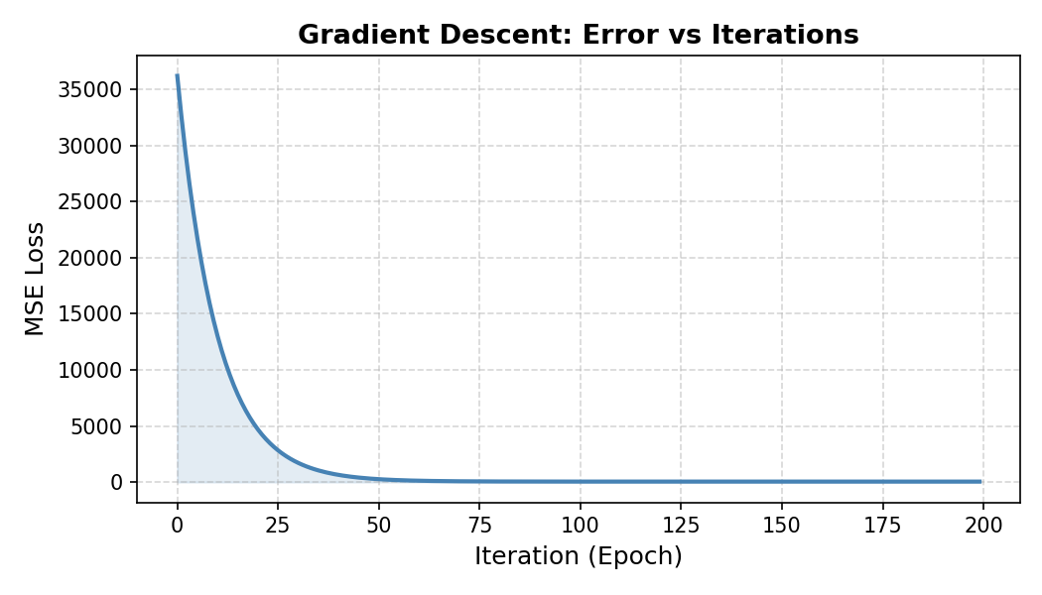
Figure 1: MSE loss decreasing over 200 epochs — shows convergence of gradient descent.

5.2 Regression Line (Predicted vs Actual)
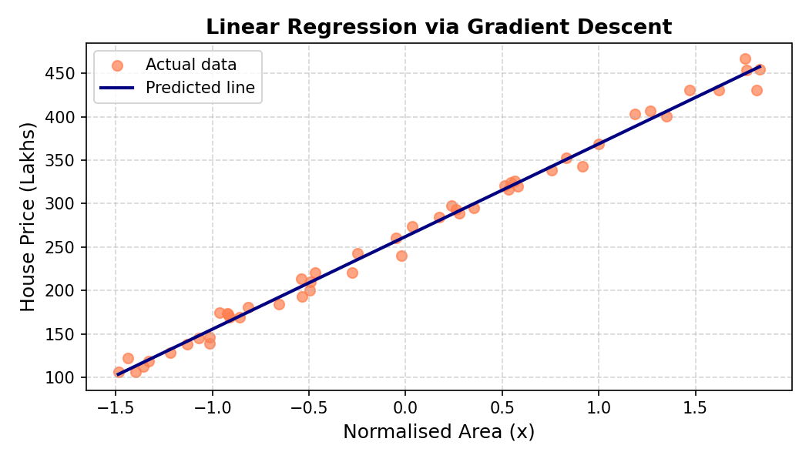
Figure 2: Scatter plot of actual data (coral) with the fitted regression line (navy).

5.3 Weight and Bias Convergence
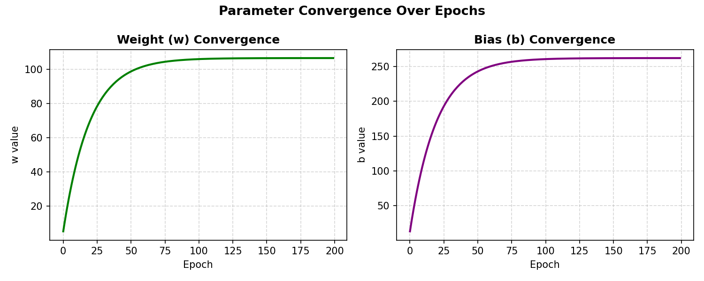
Figure 3: Convergence of weight (w) and bias (b) parameters over training epochs.

5.4 3D Loss Surface
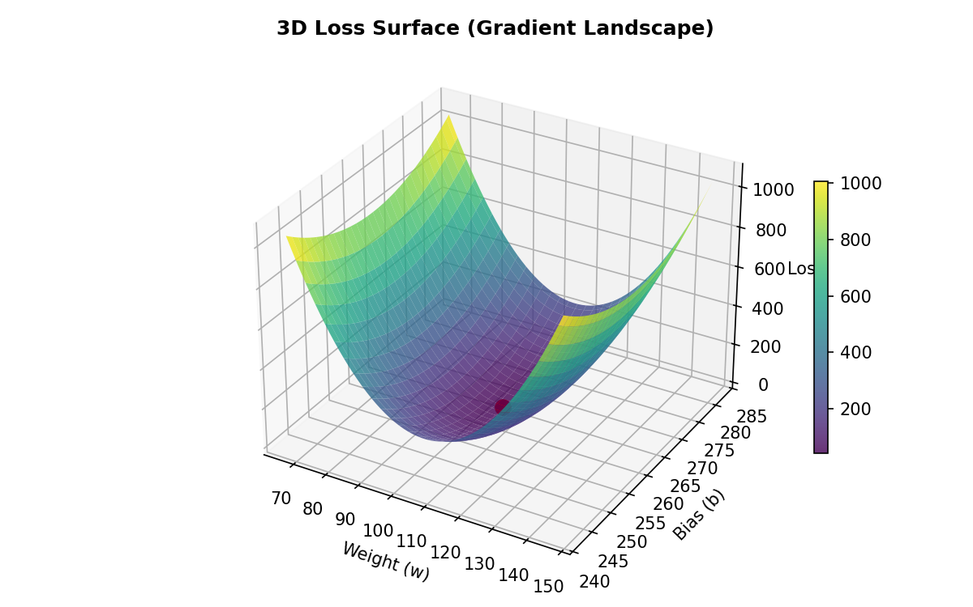
Figure 4: 3D surface of the loss landscape — red dot marks the minimum found by gradient descent.

6. Testing and Results Analysis

6.1 Quantitative Results

Metric | Value
Initial Loss (MSE) | 40,095.63
Final Loss (MSE) | 41.15
Loss Reduction | 99.90%
Final Weight (w) | 106.5997
Final Bias (b) | 262.1828
Learning Rate | 0.05
Epochs | 200

6.2 Analysis
The model successfully minimised the loss function from an initial value of 40,095.63 to a final value of 41.15 — a reduction of 99.90%. This demonstrates that gradient descent effectively navigated the loss surface to reach a near-optimal minimum.

Key observations:
- The loss curve (Figure 1) drops sharply in the first ~30 epochs, then flattens — indicating fast initial learning followed by fine-tuning.
- The regression line (Figure 2) accurately fits the data distribution, confirming the model has learned the underlying trend.
- Both weight and bias (Figure 3) converge smoothly, showing stable learning without oscillation.
- The 3D loss surface (Figure 4) is a convex bowl — confirming there is a single global minimum, making gradient descent reliable for this problem.

6.3 Vector Calculus Concepts Applied

Concept | Application in Project
Gradient (∇L) | Computes direction of steepest ascent in the loss surface; used in weight update.
Partial Derivatives | ∂L/∂w and ∂L/∂b computed at each step to find individual parameter gradients.
Dot Product | Error vector dotted with feature vector (eᵀx) to compute ∂L/∂w efficiently.
Scalar Field | The MSE loss L(w, b) forms a scalar field over 2D parameter space.
Gradient Descent | Iterative movement along −∇L to minimise the scalar loss field.

7. Conclusion
This project successfully demonstrated the application of vector calculus — specifically gradients and partial derivatives — in training a machine learning model. The gradient descent algorithm reduced the MSE loss by 99.90% over 200 epochs, converging to optimal weights (w = 106.60, b = 262.18) for house price prediction.

The 3D loss surface visualization confirmed that the loss function forms a convex scalar field, making gradient descent a reliable optimization strategy. The dot product formulation of the gradient computation directly embeds vector calculus into the core update rule of the algorithm.

This exercise establishes a strong foundation for understanding more advanced applications of vector calculus in deep learning, including backpropagation in neural networks and stochastic gradient optimization methods such as Adam and RMSProp.

