<https://sqliteonline.com/>

SUB : DBMS

PRACTICAL NUMBER : 2

AIM : To Study DDL-Create and DML-Insert Commands

Create table job

( Emp_Id integer(30),

First_Name varchar(20),

Last_Name varchar(20),

Email varchar(25),

Phone_No varchar(25),

Age varchar(25),

Salary integer(30),

City varchar(25)

);

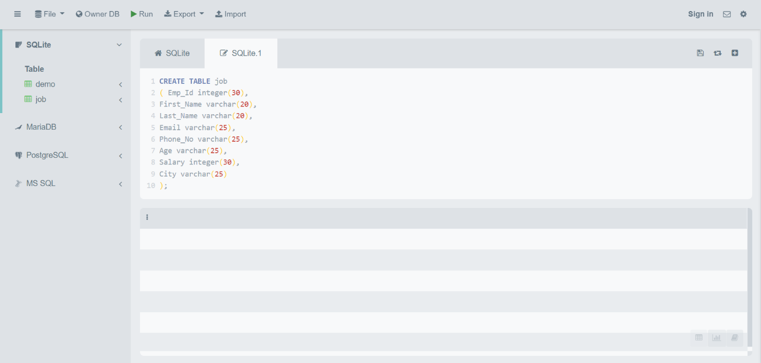

INSERT INTO Job

VALUES("EMID1","Bhargav","Savaliya","bhargav@test.com",9988776655,18,50000,"Surat");

INSERT INTO Job

VALUES("EMID2","Princy","Savaliya","princy@test.com",8877665544,18,40000,"Amreli");

INSERT INTO Job

VALUES("EMID3","Keval","Savaliya","keval@test.com",7766554433,18,30000,"Surat");

INSERT INTO Job

VALUES("EMID4","Vaidik","Ramani","vaidik@test.com",6655443322,18,25000,"Amreli");

INSERT INTO Job

VALUES("EMID5","Hit","Savani","hit@test.com",6677889900,18,45000,"Bhavnagar");

INSERT INTO Job

VALUES("EMID6","Yashvi","Senjaliya","yashvi@test.com",9089786765,18,45000,"Rajkot");

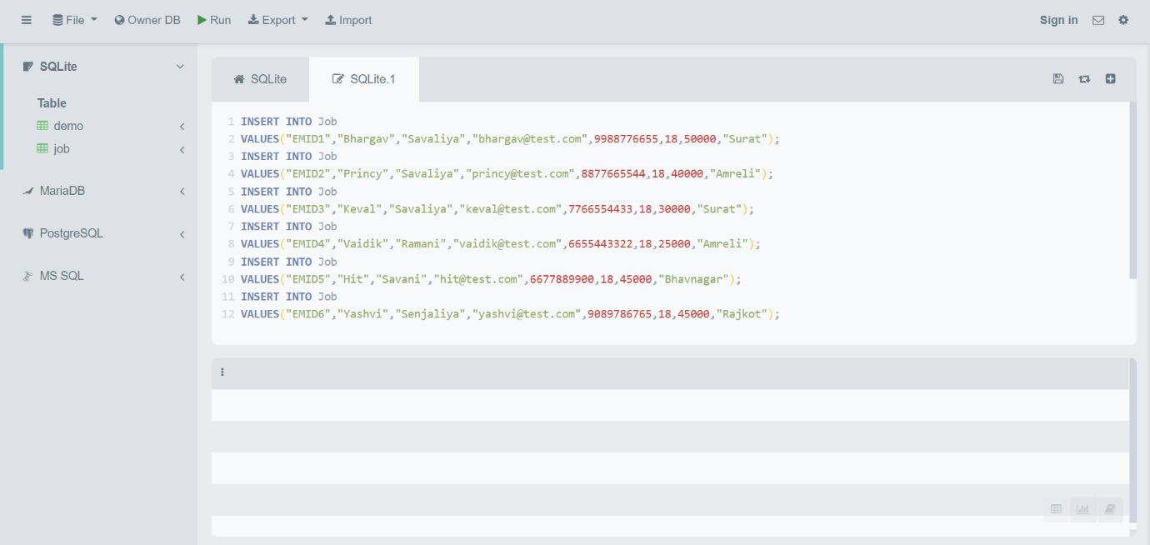

SELECT*FROM JOB;

