SUB : DBMS

PRACTICAL NUMBER : 2

AIM : Create the Below Given Table and Insert the Data Accordingly.

Note : Create table same as practical 1

SELECT * FROM job;

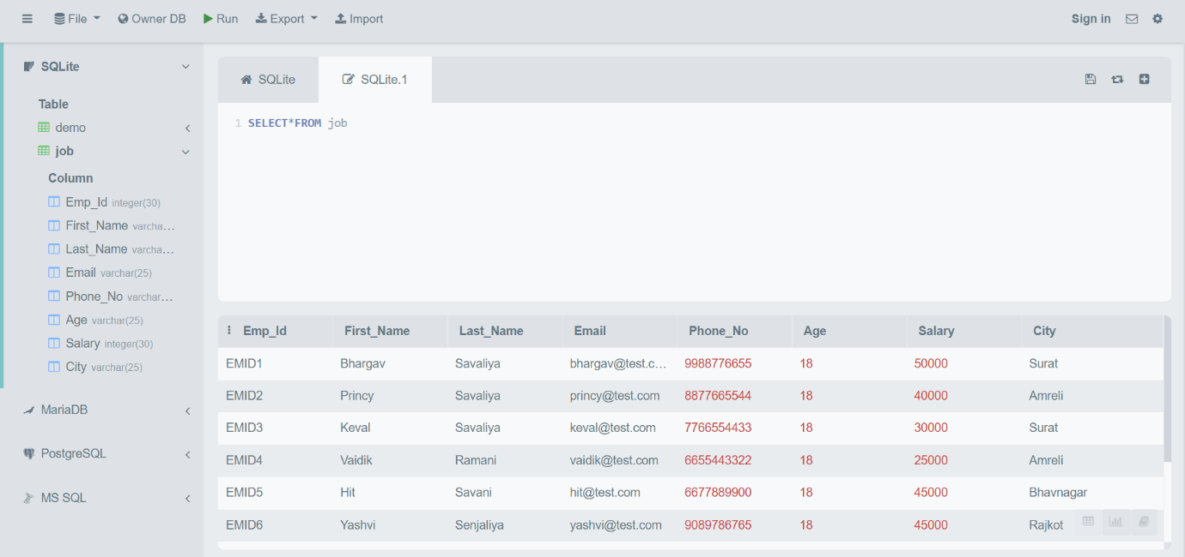

select * from job where First_Name like "B%";

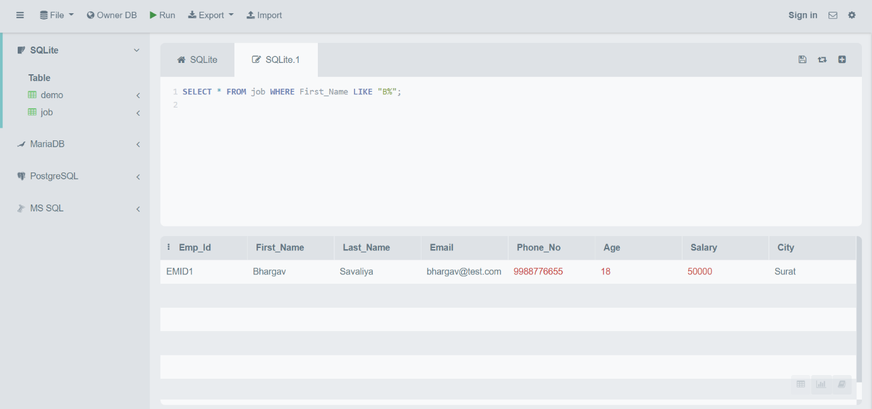

select * from job where Last_Name like "_e%";

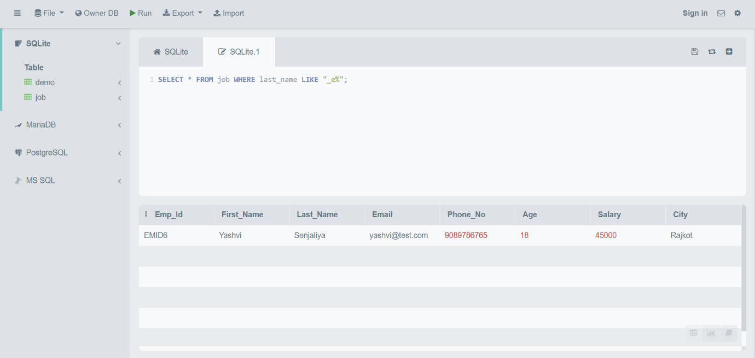

select * from job where First_Name like "%v%";

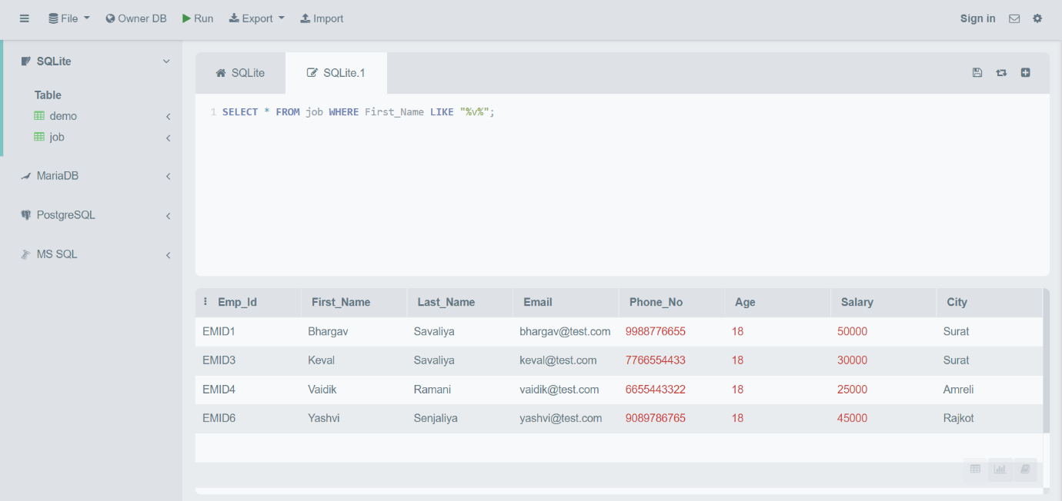

select * from job where First_Name like "%y";

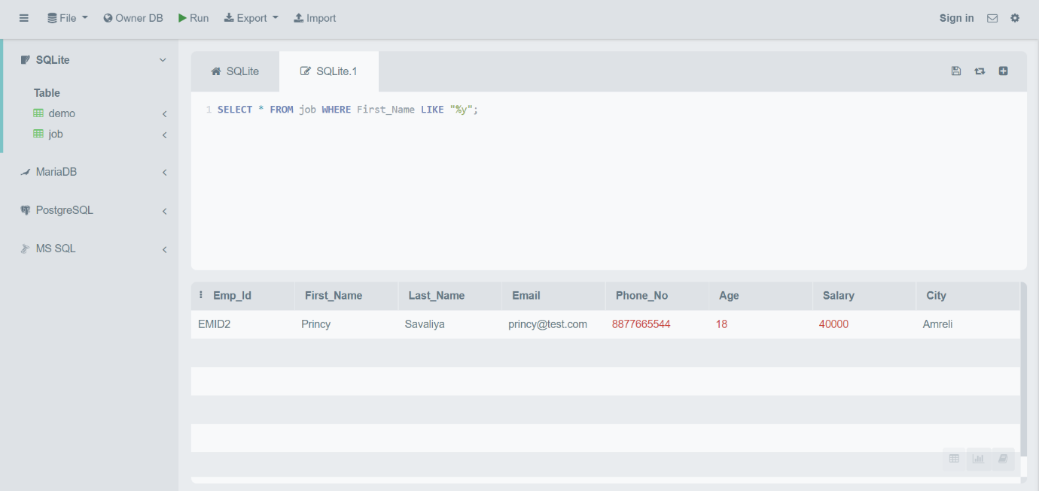

select * from job where First_Name like "___";

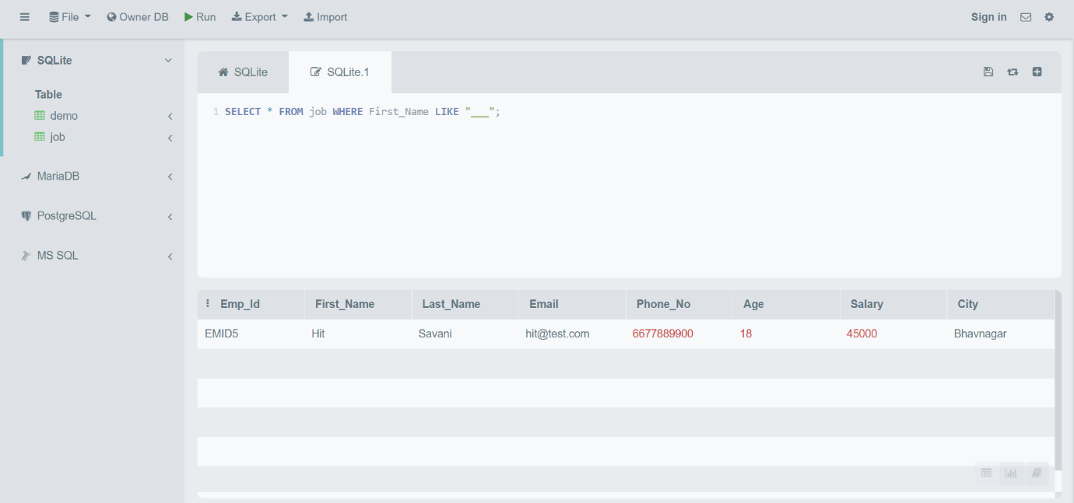

select * from job where salary between 25000 and 40000;

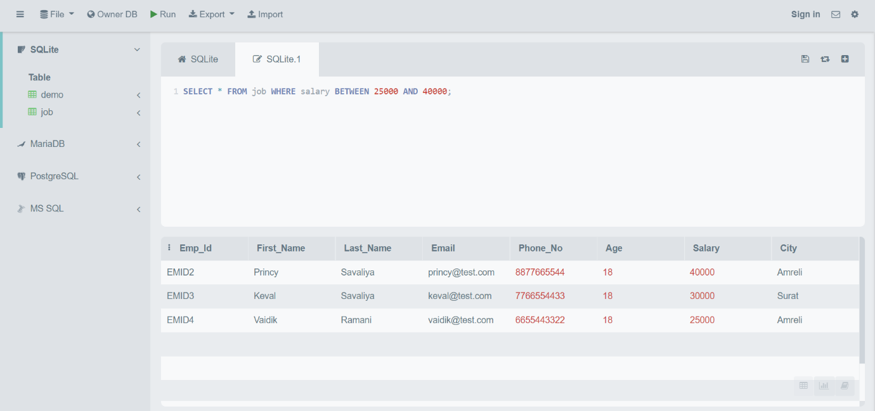

select * from job where salary>40000 and salary<50000

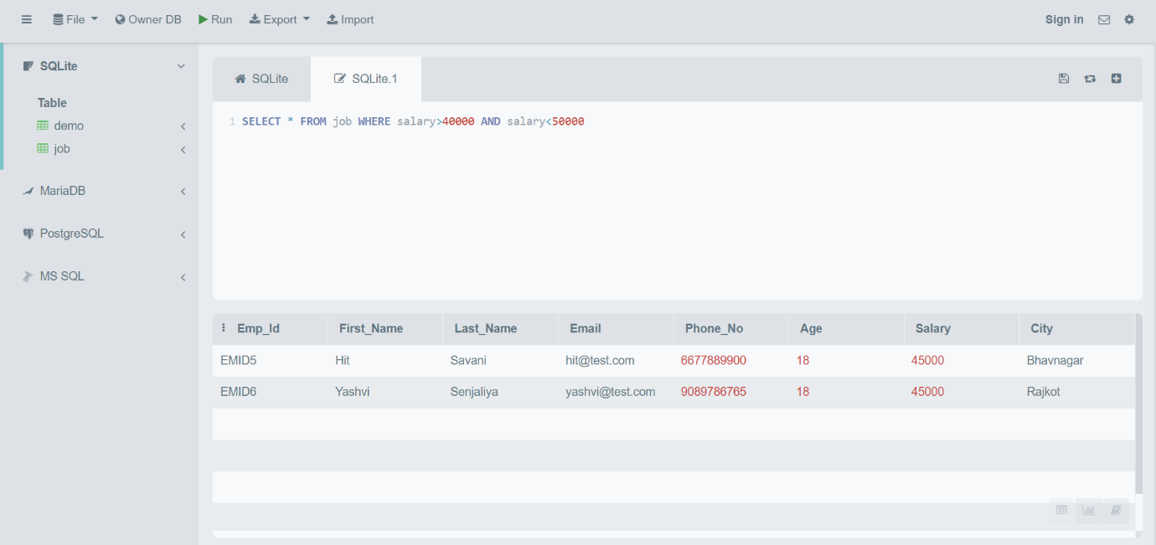

select * from job where salary>=40000 and salary<=50000

