SUB : DBMS

PRACTICAL NUMBER : 3

AIM : To Perform Various Data Manipulation Commands, Aggregate Functions and Sorting Concept on All Created Tables.

SELECT * FROM job;

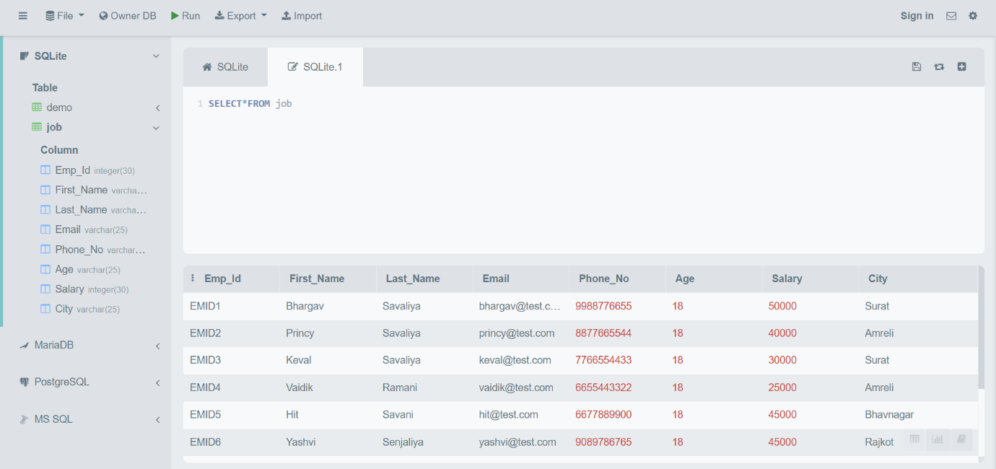

SELECT AVG(AGE) FROM job;

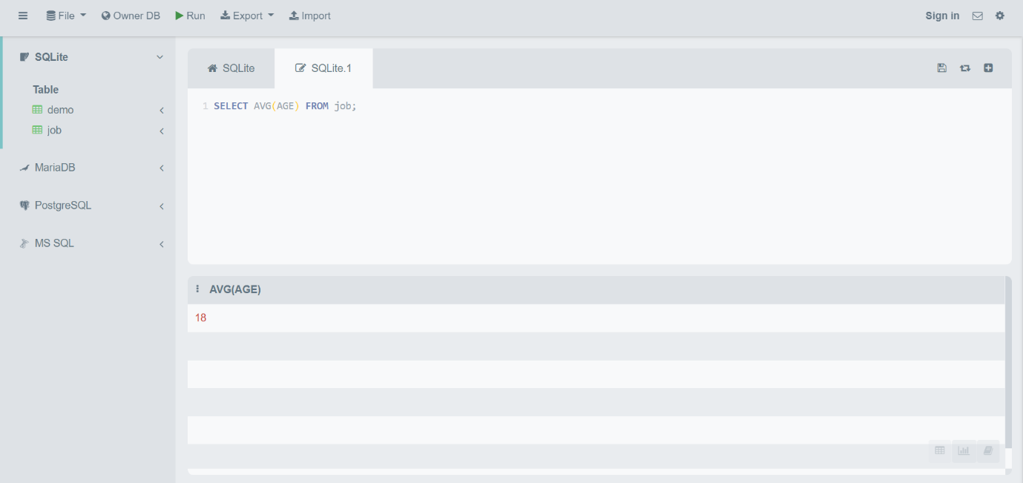

SELECT SUM(Salary) FROM job;

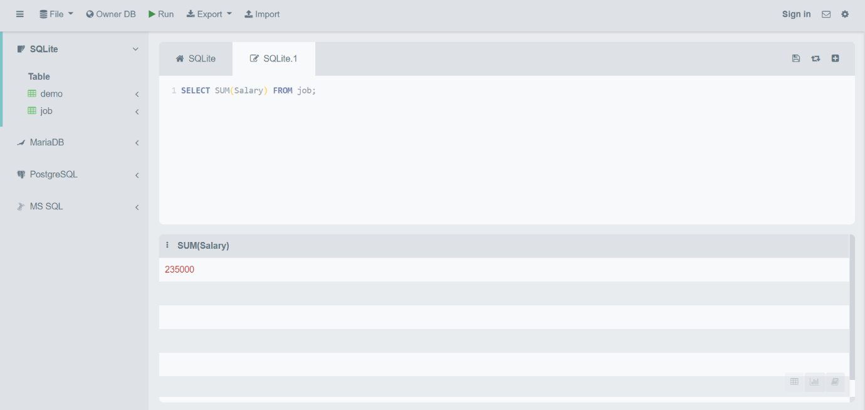

SELECT COUNT(*) FROM job;

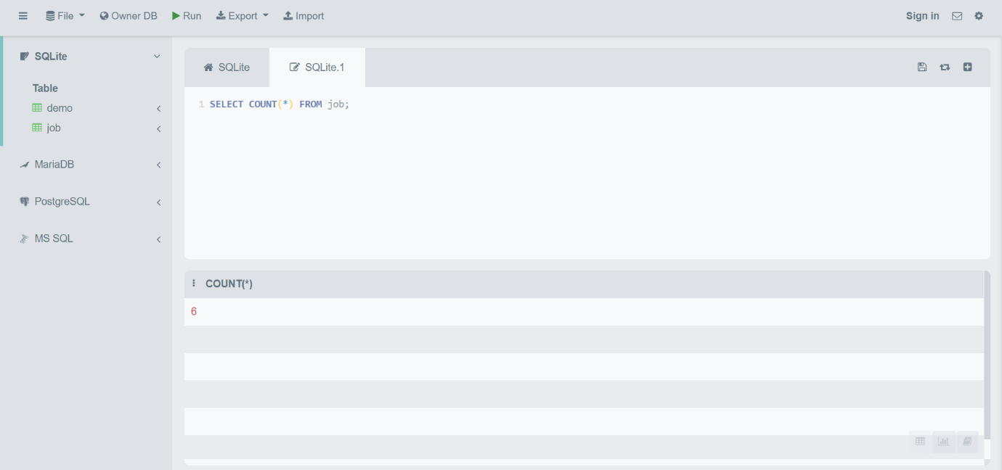

SELECT SUM(Salary)/COUNT(Emp_Id) FROM job;

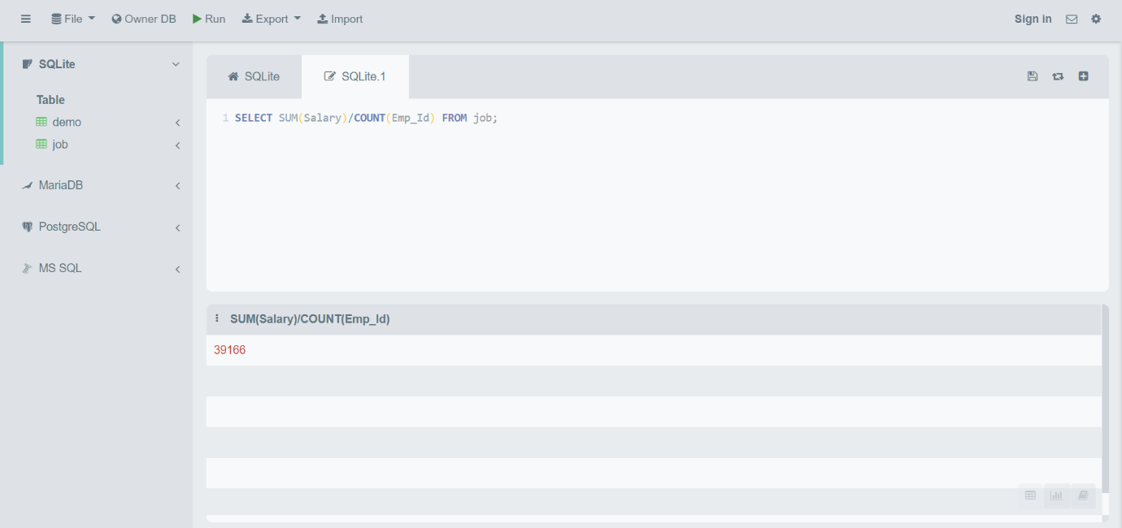

SELECT FIRST_NAME , SALARY , SALARY+10000 NEW_SALARY FROM job;

