SUB : DBMS

PRACTICAL NUMBER :

AIM :

SELECT \* FROM JOB;

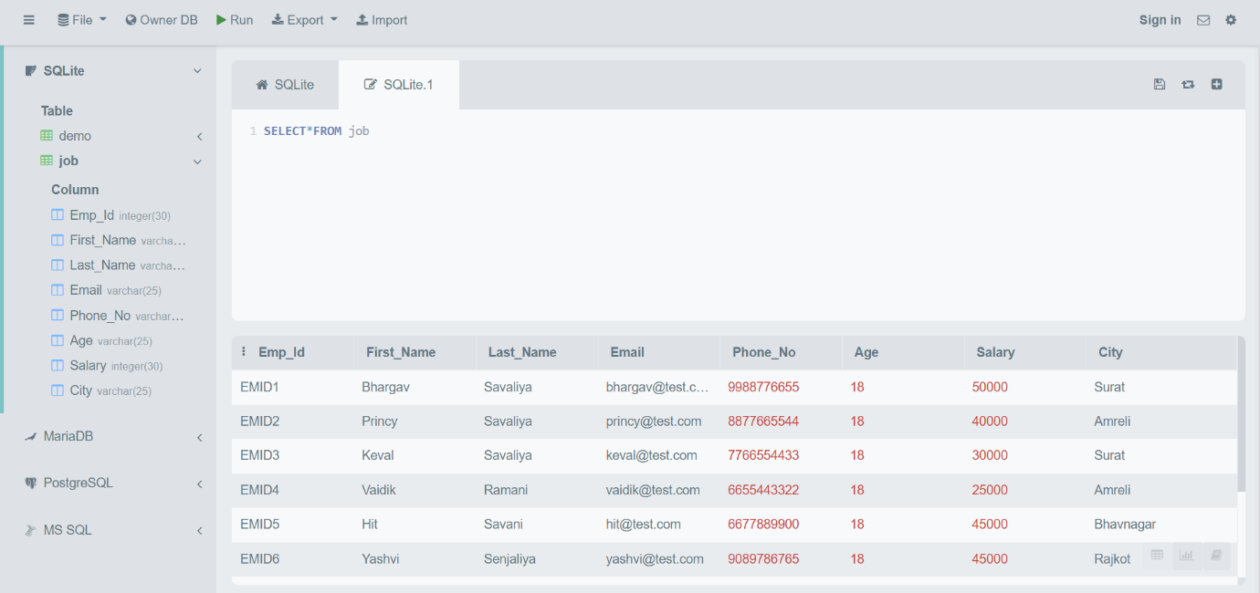

ALTER TABLE JOB ADD REMARK VARCHAR(50);

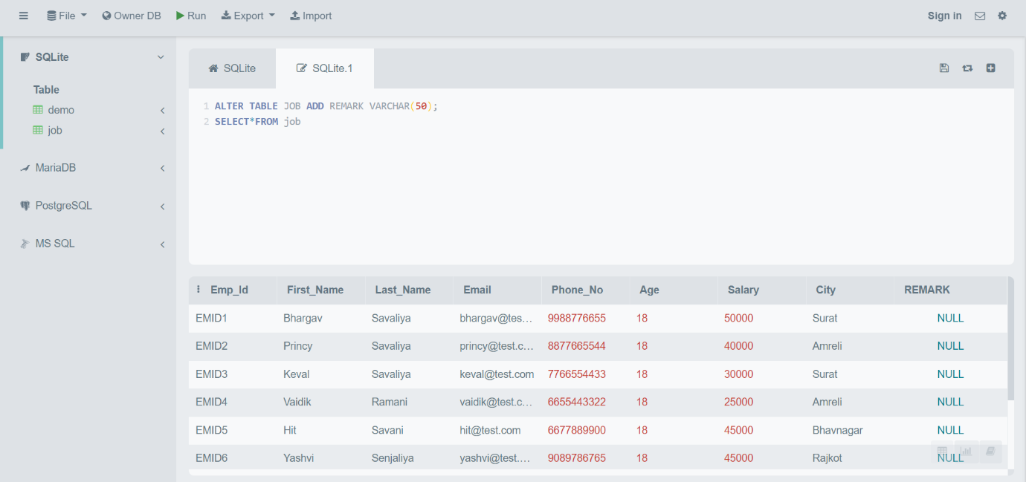

ALTER TABLE JOB DROP REMARK;

