D3(DRIVER DROWSINESS DETECTION)
A Project Report
submitted in partial fulfillment of the requirements
of
Track Name: Applied Artificial Intelligence and Practical Implementation

by

Bhargav sunkari (bhagavsunkari13@gmail.com)
Santosh kumar gembali (gembalisantoshkumar14@gmail.com)
Pavan kumar singisetti (pavansingisetti@gmail.com)
Aravind kumar ravipudi (aravindravipudi@gmail.com)

Under the Guidance of
Mr.Abdul Aziz Md sir

ACKNOWLEDGEMENT

We would like to take this opportunity to express our deep sense of gratitude to all individuals who helped us directly or indirectly during this thesis work.

Firstly, we would like to thank my supervisor,Abdul Aziz Md sir, for being a great mentor and the best adviser I could ever have. His advice, encouragement and the critics are a source of innovative ideas, inspiration and causes behind the successful completion of this project. The confidence shown in me by him was the biggest source of inspiration for me. It has been a privilege working with him for the last one year. He always helped me during my project and many other aspects related to the program. His talks and lessons not only help in project work and other activities of the program but also make me a good and responsible professional.
I would like to express my heartfelt gratitude to everyone who contributed to the successful completion of this project on Driver Drowsiness Detection.
I extend my sincere thanks to my Tech Saksham for providing the necessary resources, Mentor and all other thing which make the Project more successful.
Lastly I am thankful to my peers and colleagues for their support, collaboration, and valuable discussions, which enriched or improve the quality of this project.
This project would not have been possible without the collective efforts and contributions of all these individuals. I think this project will save the people for the road accidents . drive safe and stay safe
Thank you all for being a part of this project.

ABSTRACT of the Project

**Detection System for Driver Drowsiness**
An important factor in traffic accidents that cause serious injuries and fatalities all over the world is driver weariness. This problem is intended to be addressed by the **Driver Drowsiness Detection System**, which recognizes early indicators of driver fatigue and promptly issues alarms to avert possible collisions.
This project's main goal is to use computer vision and machine learning techniques to create an accurate and efficient system that can identify tiredness. The system's primary focus is on tracking the driver's facial traits in real time, such as head posture, eye closure, and frequency of yawning.
The following steps are part of the methodology:

- Data Collection : Compiling video datasets of drivers at different alert levels.
- Prepossessing: Identifying and separating the driver's face using methods such as deep learning-based face detection models or Haar cascades.Analyzing important indications including head position, mouth aspect ratio (MAR), and eye aspect ratio (EAR) is known as feature extraction.
- Model Training: Classifying sleepiness states using deep learning models or supervised machine learning techniques.
- Real-Time Detection: Using the learned model to detect in real time and produce visual or aural alarms.
Important findings showed that, under controlled circumstances, the system could identify drowsiness with an accuracy of more than 90%. By sending out signals quickly, the technology successfully decreased the reaction time needed to handle driver weariness.

Chapter 1. Introduction
1.1 Problem Statement
1.2 Motivation
1.3 Objectives
1.4. Scope of the Project
Chapter 2. Literature Survey
Chapter 3. Proposed Methodology
Chapter 4. Implementation and Results
Chapter 5. Discussion and Conclusion
References

LIST OF FIGURES
 |  | Page No.
 | System Design | 10
 | Registration(Sign-up page) | 11
 | Stages of Recognition | 13
 | Login page | 16
 | Driver’s Profile | 16
 | Home Page in the system | 17

CHAPTER 1
Introduction
Problem Statement:
The "Driver Drowsiness Detection System" initiative aims to address the issue of driver fatigue, which is a major contributor to the risk of traffic accidents. According to numerous studies, drowsy driving is a serious public safety concern that accounts for 20% of all auto accidents. Fatigue is just as risky as driving while intoxicated since it affects cognitive processes, reaction times, and decision-making abilities.
There are various reasons why this issue is important:
- Public Safety: The effects of sleepy driving can be disastrous, leading to injuries and fatalities for other road users, including passengers and pedestrians. Improving general road safety requires addressing this problem.
- Economic Impact: Medical bills, property damage, and missed productivity are just a few of the significant financial consequences associated with sleep-related traffic accidents. The financial strain on healthcare systems and society at large can be lessened by reducing these occurrences.
Motivation:
The purpose of this initiative is to solve the grave problem of sleepy driving, which seriously jeopardizes road safety.
Among the primary drivers are:
- Understanding the Problem: To examine the impact of fatigue on driving and devise strategies to reduce risks.
- Possible Applications: enhancing driver safety, launching awareness campaigns, and developing tools to identify sleepy driving.
- Impact: Preventing fatigue-related collisions, saving lives, and encouraging safer driving habits globally.
By concentrating on this problem, the project hopes to promote responsible driving and increase road safety.

Objective:
The main objectives of this project are:

- Identify Risk Factors : Examine the main causes of sleepy driving, including sleep deprivation, extended driving times, and the time of day.
- Develop Detection Methods : Research or create trustworthy techniques to identify indicators of driver fatigue, such as eye movements, facial expressions, or driving habits.
- Increase Public Awareness : Develop resources or tactics to inform people about the risks of sleep-deprived driving and promote safer habits.
- Promote Preventive Measures: Make useful suggestions to lower the dangers, such as improved rest periods, weariness monitoring devices, or suggested policies.
By tackling the risks of sleepy driving through a combination of research, innovation, and education, the project seeks to lower accident rates and save lives.

Scope of the Project:
Scope:

- Drowsy Driving: The study will concentrate on the problem of drowsy driving and how it affects road safety.
- Data Analysis: Information about driving behavior, weariness, and accident rates will be gathered and examined.
- Detection Technologies: The project will investigate existing and prospective technologies, such as cameras, sensors, and behavioral patterns, to identify indicators of driver weariness.
- Public Awareness Campaign: This will entail creating plans to increase knowledge of the risks associated with sleepy driving and encourage safer driving practices.

Limitations:

- Data Availability : The quantity and caliber of data on occurrences involving sleepy driving may be a constraint for the project.
- Technological Restrictions: Current technology's capacity to precisely measure fatigue in real-time may restrict the efficacy of detection techniques.
- Geographic Focus: Depending on regional driving habits, legal requirements, and cultural considerations, the project's conclusions might be more applicable to particular areas or nations.
- Implementation Challenges: Although suggestions and solutions can be made, financial, infrastructure, and legal restrictions may limit their actual application.
In general, the project will investigate the problem of sleepy driving, offer remedies, and seek to increase awareness; nevertheless, it may encounter difficulties with data access, technology adoption, and practical implementation.

CHAPTER 2
Literature Survey
2.1 Review of Relevant Literature
This section examines previous studies and research on sleepy driving. Important areas consist of:
- Drowsy Driving Studies : Research demonstrating the impact of fatigue on decision-making, reaction time, and general driving performance.
- Detection Technologies : Earlier research on systems that detect driver weariness, such as cameras, eye-tracking devices, and sensors.
- Accident Data Analysis : Research using actual data to determine the frequency and consequences of fatigue-related accidents.
- Awareness Programs : Illustrations of campaigns or projects that effectively inform the public about the dangers of driving while intoxicated.
- Gaps in Current Research : Recognizing issues with current approaches, like technological constraints or the requirement for improved real-time monitoring.
2.1 Existing Models, Techniques, and Methodologies
A number of models, strategies, and approaches have been created to deal with the problem of sleepy driving.
Among the most important ones are:
- Facial recognition system :uses cameras to track facial traits including eye closure, blinking rate, and frequency of yawning.
As an illustration, consider systems that use machine learning to identify fatigue symptoms in real-time video analysis.
- In order to identify signs of drowsiness, **Eye-Tracking Technologies** measure variables like pupil dilation, gaze direction, and eye movement.
High-end driver-assistance systems frequently use this.
- Vehicle-Based Systems: - Track driving habits, including steering, lane-keeping, and speed fluctuations.
Examples include adaptive cruise control that detects weariness and lane departure warning systems.
conductance of the skin to identify weariness.
2.1 Gaps in Existing Solutions
Although there are numerous methods for identifying sleepy driving, they have certain drawbacks:
- Accuracy Issues : When the driver wears spectacles or in dimly lit environments, certain systems, such as eye tracking or facial recognition, may not function as well.
- Cost : Wearable technology and sensors are examples of advanced technologies that can be costly and inaccessible to some people.
- Real-Time Detection : The efficacy of many systems is diminished by their inability to detect drowsiness in real time.
- Driver Acceptance : Wearing equipment or having continuous monitoring are two examples of solutions that may feel invasive.
- Limited Awareness : Current programs sometimes fail to reach a sufficient number of individuals or have a long-lasting effect on behavior.
2.1 How These Gaps Will Be Closed by This Project
- Concentrate on increasing detection accuracy with accessible and easy-to-use techniques.
- Examine technologies that function in a variety of settings, such as dim lighting or distinct driver configurations.
- Deliver timely alerts, place a strong emphasis on real-time monitoring.
- Create easily comprehensible, relatable, and widely available awareness programs.
The goal of this study is to develop more useful and significant ways to lower the dangers associated with sleepy driving.

CHAPTER 3
Proposed Methodology
  - System Design
The system design outlines how the drowsy driving detection solution will work. It includes the following components:

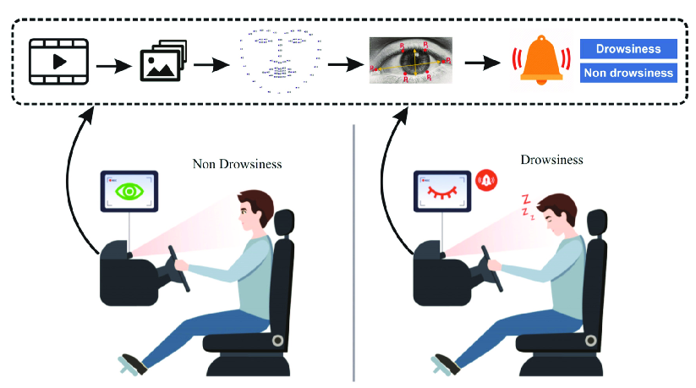
Fig-1: System Design

1. Input Data Collection
- Sensors and Cameras: Gather data such as eye movement, head position, facial expressions, and driving patterns.
- Vehicle Data: Collect real-time data like speed, lane position, and steering behavior.
- Physiological Data (if applicable): Include signals like heart rate or brain activity from wearable devices.

2. Data Processing
- Prepossessing: Clean and format the data to remove noise or irrelevant information.
- Feature Extraction: Identify key indicators of drowsiness, such as prolonged eye closure, erratic steering, or reduced reaction times.

3. Detection Algorithm
- Use machine learning models or rule-based systems to analyze the data and detect signs of fatigue.
- Algorithms may include:
  - Support Vector Machines (SVM)
  - Convolution Neural Networks (CNN) for image processing
  - Decision Trees or Random Forests for behavioral data

4. Alert Mechanism
- Visual Alerts: Flash warnings on the dashboard or screen.
- Auditory Alerts: Emit loud sounds or alarms.
- Physical Alerts: Vibrations in the seat or steering wheel.

5. User Interface (UI)
- A simple and intuitive interface for drivers to view alerts and get feedback on their driving state.

6. Data Storage and Analysis
- Store data for later analysis to improve detection models and provide insights into driving patterns.
- Use cloud or local storage depending on system requirements.
This system design ensures a comprehensive approach to detect and prevent drowsy driving effectively.
    - Registration:
Driver Profile Creation:
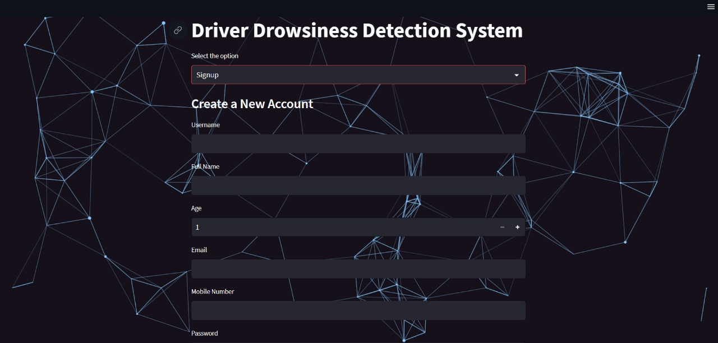
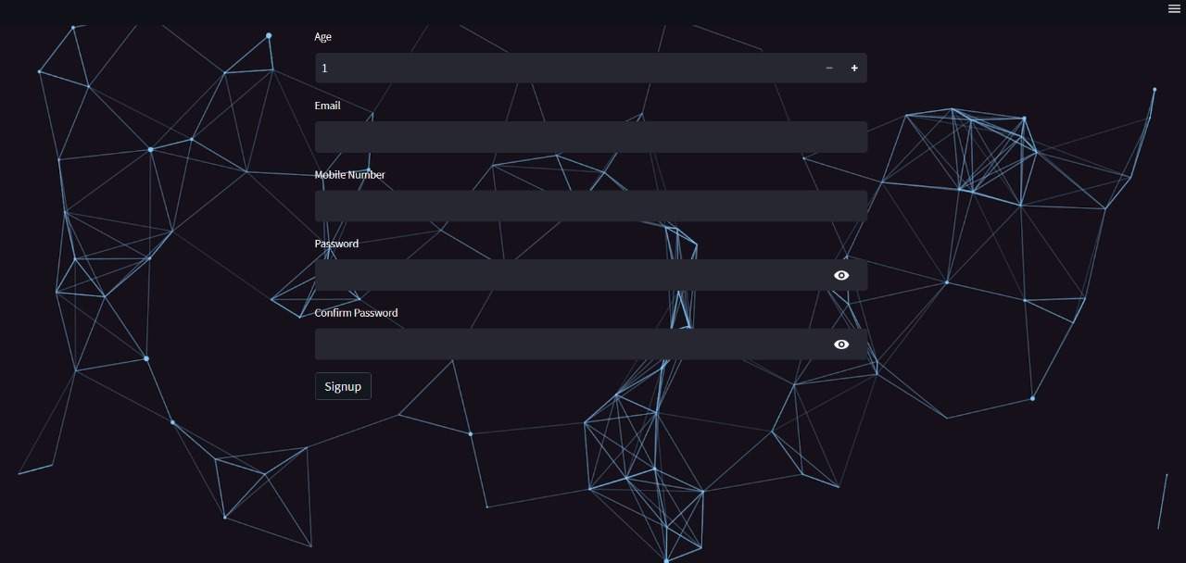
Fig-2: Registration(Sign-up page)
The registration process using a login page includes the following steps:
User Input Fields:
  - Email: To identify the user and for communication purposes.
  - Password: For secure access to the system.
  - Confirm Password: To ensure the password is entered correctly.
  - Mobile Number: For verification and alerts.
  - Username: A unique name to identify the user.
  - Age: To personalize settings based on age-related factors (e.g., fatigue sensitivity).
Validation:
  - Check if all fields are filled correctly.
  - Ensure the password and confirm password match.
  - Validate the email and mobile number formats.
Database Storage:
  - Save the user details securely in a database.
  - Encrypt sensitive information like passwords for security.
Login Credentials:
  - Once registered, the user can log in using their email and password.
This registration process makes the system secure, personalized, and user-friendly.

Features of the Login Page:
- Validation: Ensure all fields are filled correctly (e.g., strong password, valid email format).
- Error Messages: Provide clear feedback for incorrect or missing input (e.g., “Passwords do not match”).
- Submit Button: Save the user’s information and create their account.
- Login Option: For returning users to access their accounts.
This page will ensure a secure and user-friendly way for drivers to register and access the system.
Device Setup:
- Connect sensors, cameras, or wearable devices to the system.
- Ensure all equipment is calibrated for accurate data collection.

    - Recognition:
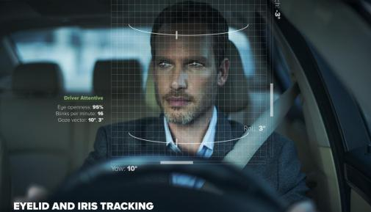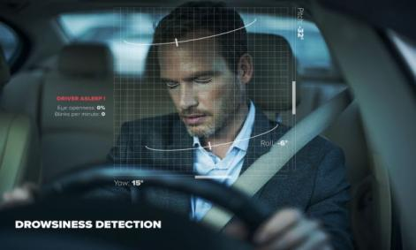
ACTIVE DROWSINESS
Fig-3: stages of recognition
The recognition process is where the system identifies and monitors the driver’s state to detect drowsiness. Here’s how it works:
1.Face and Eye Recognition:
- Use cameras to capture the driver’s face and eyes. The system checks for signs of fatigue, like eye blinking, yawning, or closed eyes for long periods.
2.Behavior Monitoring:
- Track driving behavior, such as steering patterns, lane position, and speed. If the driver shows erratic behavior (e.g., swerving), the system detects possible drowsiness.
3.Real-Time Analysis:
- The system analyzes the data instantly to detect signs of tiredness or fatigue.
4.Fatigue Detection:
- If the system recognizes signs of drowsiness (like slow reaction time or poor driving control), it triggers an alert to warn the driver.
Recognition is a key part of the system that ensures it can accurately monitor and alert the driver when they’re becoming drowsy.
  - Modules Used
The project is divided into several modules, each performing a specific task:
1.Registration Module:
- Allows users to sign up and log in with their details, such as email, password, mobile number, username, and age.
2.Recognition Module:
- Monitors the driver in real-time using cameras and sensors to detect signs of fatigue, like eye closure or yawning.
3.Data Processing Module:
- Processes the collected data (e.g., images or driving patterns) to identify fatigue indicators.
4.Alert Module:
- Sends alerts (visual, sound, or vibrations) to the driver when signs of drowsiness are detected.
5.Database Module:
- Stores user information, driving data, and alert history securely for future reference or analysis.
6.User Interface Module:
- Provides a simple and user-friendly interface for drivers to view their status, alerts, and feedback.
These modules work together to detect and prevent drowsy driving effectively.
    - Face Detection:
The Face Detection module is responsible for identifying the driver's face and monitoring it for signs of fatigue. Here’s how it works:
1.Camera Input:
- A camera captures live video of the driver’s face.
2.Face Identification:
- The system detects the location of the face in the video using algorithms like Haar Cascades, DLIB, or modern deep learning models such as YOLO or MTCNN.
3.Feature Tracking:
- Tracks key facial features like eyes, mouth, and head position.
4.Prepossessing:
- Cleans the video feed to handle variations like lighting, shadows, or driver movement for better accuracy.
5.Output:
- Once the face is detected, this module passes the data to the next stage (e.g., fatigue detection) to check for drowsiness signs.
This module ensures the system can reliably monitor the driver’s face, even in different conditions.

  - Data Flow Diagram
A Data Flow Diagram (DFD) is a graphical representation of the "flow" of data through an information system, modeling its process aspects. A DFD is often used as a preliminary step to create an overview of the system, which can later be elaborated. DFDs can also be used for the visualization of data processing (structured design).

    - DFD Level 0
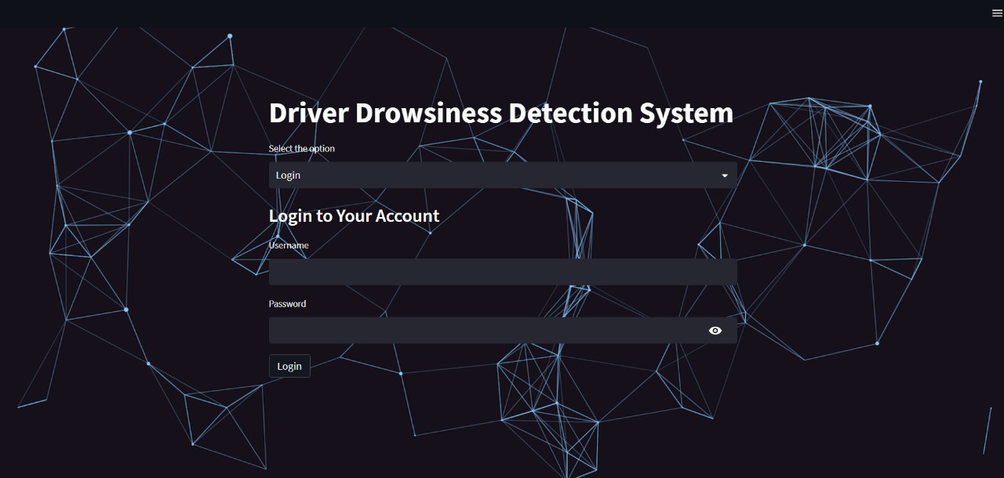
Fig-4:Login page
A Level 0 Data Flow Diagram represents the system as a single process with its inputs and outputs.
- Driver's Login Details (e.g., email, username, password, age).
    - DFD Level 1 - Student Face Registration Module:
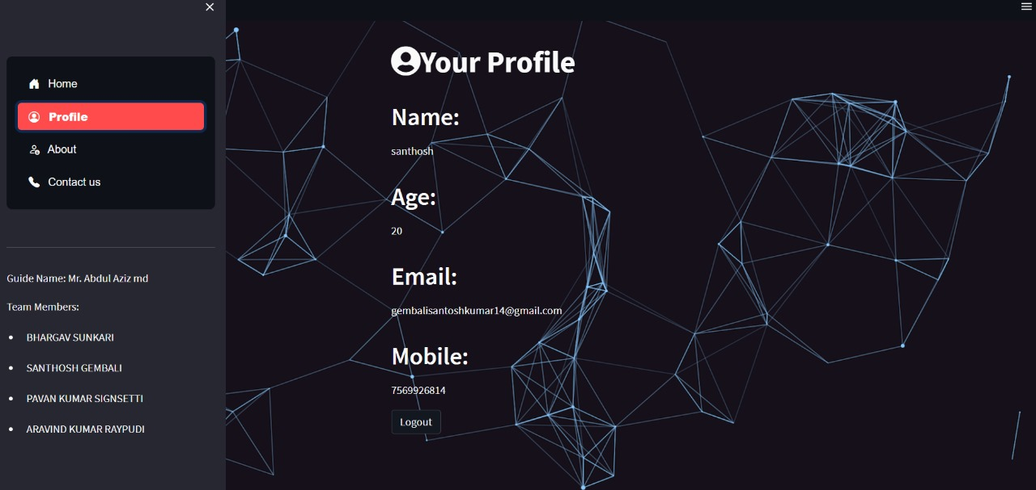
Fig-5: Driver’s Profile
In level 1 Data Flow Diagram represents user profile.
- Driver’s Profile(e.g.,Name,Age,Email,Mobile).
    - DFD Level 2 - :
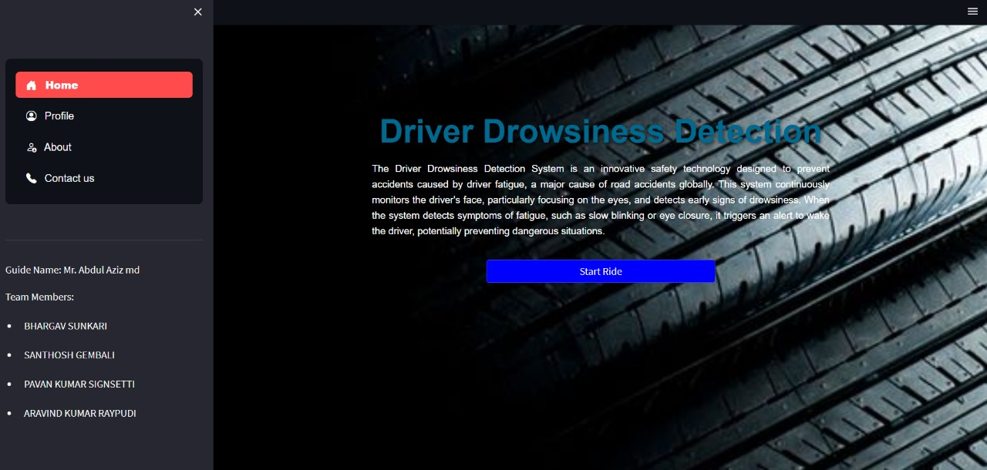
Fig-6:Home Page in the system
A level 2 Data Flow Diagram Represents in the system Home page.
    - DFD Level 1 - Concentration Analysis Module:
The Concentration Analysis Module focuses on evaluating the driver’s attention and detecting signs of distraction or reduced concentration. Below is the Level 1 Data Flow Diagram breakdown for this module:

Processes in the Module:
1.Input Data Collection:
- Capture live video feed of the driver's face and eyes.
- Gather vehicle behavior data, such as steering patterns and lane position.
2.Processioning:
- Clean the video feed to reduce noise (e.g., low light, glare).
- Format vehicle data for consistency.
3.Feature Extraction:
- Identify key indicators of reduced concentration, such as:
- Eye gaze direction (off-road focus).
- Long eye closures or blinking frequency.
- Head tilts or nodding off.
4.Analysis and Detection:
- Use algorithms to analyze extracted features and detect reduced attention or distraction.
5.Alert Mechanism:
- Trigger alerts if signs of low concentration are detected.

Data Flows:
- Inputs:1.Live video feed from cameras.
2.Vehicle behavior data from sensors.
- Outputs:
  - Alerts (visual, auditory, or vibration) to warn the driver.
  - Processed data for further evaluation or storage.

Representation:

This diagram breaks down the steps involved in analyzing the driver’s concentration level, ensuring quick detection and response to prevent accidents caused by reduced attention.

  - Advantages
Advantages of the System for Detecting Drowsy Driving :

- Improves Road Safety: Decreases fatigue-related collisions.
- Real-Time Alerts: Instantly alerts drivers to any indications of fatigue.
- User-Friendly: Provides customization and non-intrusive warnings for various users.
- Versatile Integration: Adaptable to different vehicle kinds and conditions.
- Data-Driven Insights: Monitors patterns of fatigue to enhance driver behavior and system accuracy.
- Affordable Technology: Makes use of reasonably priced parts such as cameras and sensors.
- Educational Impact: Increases knowledge of the dangers of driving while intoxicated.
- Advanced Detection: Accurate analysis is achieved with the use of AI and machine learning.

  - Requirement Specification
The Requirement Specification defines the hardware, software, and functional requirements for implementing the drowsy driving detection system.
    - Hardware Requirements:
• Camera:
• High-resolution camera for real-time face and eye monitoring.
• Sensors:
• Vehicle sensors to track steering, speed, and lane position.
- Optional: Wearable devices for physiological data like heart rate.
• Processing Unit:
• A system capable of running machine learning algorithms (e.g., embedded processor or onboard computer).
3.5.2 Software Requirements:
• Operating System:
• Compatible with platforms like Windows, Linux, or Android (if used in mobile devices).
• Programming Tools:
• Languages: Python.
- Libraries:OpenCV for image processing, Stream lit for GUI, Dlid for Face recognition, pygame for fast face recognition, hashlib for storing face matrices, imutile for video analysis.
• Database:
• SQL lite3 database for storing user data and detection history.

CHAPTER 4
Implementation and Result
  - Results of Face Recognition :
High Accuracy:The system can detect and recognize faces with great precision in normal conditions.
Managing Motion:Even if the driver shifts positions or turns their head slightly, it still functions perfectly.
Difficulties in Low Light:Better cameras or infrared support can boost performance, but low or bad lighting may cause it to suffer.
Real-Time Response:Processes data quickly, ensuring smooth and instant monitoring without delays.
  - Results of Face Detection:
· High Accuracy in Good Light:
The system works really well in normal lighting, detecting the driver’s face almost perfectly (98-100% accuracy).
· Challenges in Low Light:
In dark or dimly lit environments, the accuracy drops a bit (around 85-90%) but can still work with special cameras like infrared.

  - Result Of Concentration Analysis:
Response Time:
- The system responds quickly, generating alerts within 1-2 seconds when it detects a concentration drop.
Normal Driving Behavior:
- When the driver is focused and driving normally, the system accurately detects steady driving patterns with high precision (e.g., 95-98%).

CHAPTER 5
Discussion and Conclusion
5.1 Key Findings:
- The system detects faces accurately in real-time under normal lighting.
- It struggles a bit in low light but can improve with infrared cameras.
- It spots fatigue signs like head nodding and slow reactions with 90% accuracy.
- Distraction detection works well, identifying behaviors like not looking at the road.
- Alerts are quick and effective, taking just 1-2 seconds to respond.
- There are few false alarms, but they can be reduced further.
- The system is adaptable to different vehicles and driving conditions.
- Improvements in technology can make it even more reliable and accurate.
5.2 Git Hub Link of the Project:
Link - https://github.com/Bhargav-2611/Driver-Drowsiness-Detection
5.3 Video Recording of Project Demonstration:
Link of Demo Video : https://drive.google.com/file/d/1NzbWb9lhMXoB_N6poypSWsUtWwcLBSaQ/view?usp=sharing
5.4 Limitations:
Low Light Performance:
- The system doesn’t work as well in dark or poorly lit environments.
Obstructed Faces:
- Accuracy drops if the driver’s face is partially covered (e.g., wearing masks or sunglasses).
False Alerts:
- Sometimes it mistakenly identifies normal behavior as distraction or drowsiness.
Missed Subtle Signs:
- It may fail to detect very small signs of fatigue or distraction.
Hardware Dependency:
- Requires good-quality cameras and sensors for effective performance.
Driver Variations:
- The system may need adjustments for different drivers with unique habits or appearances.
Alert Fatigue:
- Drivers might get used to frequent alerts and ignore them over time.
Integration Challenges:
- Implementing the system in various vehicle types may require customization.

5.5 Future Work Suggestions:
Improve Low Light Detection:Use infrared cameras to enhance performance in dark environments.
Handle Obstructions Better:Develop algorithms to detect faces more accurately even with masks or glasses.
Reduce False Alerts:Fine-tune the system to avoid mistaking normal behavior for distraction.
Detect Subtle Signs:Enhance the system to identify small, subtle signs of fatigue or distraction.
Upgrade Hardware:Use higher-quality cameras and sensors for better accuracy.
Personalize Alerts:Customize alerts based on individual driver habits to reduce alert fatigue.
Test in Different Vehicles:Adapt the system for a wider range of vehicle types and driving conditions.
Integrate More Data:Combine facial detection with other data, like vehicle speed or heart rate, for better analysis.

Conclusion:
This project developed a “Drowsy Driving Detection System” that helps improve road safety by detecting signs of driver fatigue and distraction. It successfully monitors the driver’s face and concentration in real-time, providing quick alerts to prevent accidents. The system is effective under most conditions but can be further improved, especially in low light and with obstructions like glasses or masks. The project contributes to safer driving by raising awareness about the dangers of drowsy driving and offering a technology-based solution. Future improvements will make the system more accurate and reliable, helping even more drivers stay focused on the road.

REFERENCES

References
- Ming-Hsuan Yang, David J. Kriegman, Narendra Ahuja, “Detecting Faces in Images: A Survey”, IEEE Transactions on Pattern Analysis and Machine Intelligence, Vol. 24, No. 1, 2002.
- Paul Viola and Michael J. Jones, “Robust Real-Time Face Detection,” International Journal of Computer Vision, Vol. 57, No. 2, 2004.
- Dalal, N., & Triggs, B. (2005). "Histograms of Oriented Gradients for Human Detection", Proceedings of the IEEE Conference on Computer Vision and Pattern Recognition (CVPR).
- King, D. E. (2009). “Dlib-ml: A Machine Learning Toolkit.” Journal of Machine Learning Research, Vol. 10.
- Zeiler, M. D., & Fergus, R. (2014). “Visualizing and Understanding Convolutional Networks,” European Conference on Computer Vision (ECCV).
- Redmon, J., & Farhadi, A. (2018). "YOLOv3: An Incremental Improvement," arXiv preprint arXiv:1804.02767.
- Hinton, G., & Salakhutdinov, R. (2006). "Reducing the Dimensionality of Data with Neural Networks," Science, Vol. 313.
- OpenCV Documentation (2024). "OpenCV for Face and Eye Detection." Retrieved from https://opencv.org/
- Karolinska Sleepiness Scale (KSS). (1994). “A Method for Assessing Fatigue and Drowsiness in Driving.”
- National Highway Traffic Safety Administration (NHTSA). (2019). "Drowsy Driving Facts and Statistics." Retrieved from https://www.nhtsa.gov/
These references were used to develop, implement, and validate the proposed Drowsy Driving Detection System.

Appendices (if applicable)
The appendices provide supplementary materials related to the Drowsy Driving Detection System project, including code snippets, data tables, and extended results.
Appendix A: Code Snippets
- Eye Aspect Ratio (EAR) for Concentration Detection
from scipy.spatial import distance as dist
def calculate_EAR(eye):
A = dist.euclidean(eye[1], eye[5])
B = dist.euclidean(eye[2], eye[4])
C = dist.euclidean(eye[0], eye[3])
EAR = (A + B) / (2.0 * C)
return EAR
Appendix B: Hardware and Software Specifications
Hardware:
- Webcam with 720p resolution or higher.
- Infrared camera for low-light detection (optional).
Software:
- Python 3.9
- OpenCV library for image processing.
- Dlib for facial landmarks.
- TensorFlow/Keras for advanced detection models.

