PRACTICAL: 10

**AIM: INTRODUCTION TO MICROSOFT AZURE**

**MICROSOFT AZURE:** Microsoft Azure, formerly known as Windows Azure, is Microsoft's public cloud computing platform. It provides a range of cloud services, including compute, analytics, storage and networking. Users can pick and choose from these services to develop and scale new applications, or run existing applications in the public cloud.

- Some facts about Azure which we should know about:

- It was launched on February 1, 2010, significantly later than its main competitor, AWS.

- It’s free to start and follows a pay-per-use model, which means you pay only for the services you opt for.

- Interestingly, 80 percent of the Fortune 500 companies use Azure services for their cloud computing needs.

- Azure supports multiple programming languages, including Java, Node Js, and C#.

- Azure has the number of data centres around the world. There are 42 Azure data centres spread around the globe, which is the highest number of data centres for any cloud platform.



**SERVICES OF AZURE:** Azure provides more than 200 services which are divided into 18 categories. Some are given below:

**Networking:**

Azure CDN

Azure CDN (Content Delivery Network) is for delivering content to users. It uses a high bandwidth, and content can be transferred to any person around the globe.

**Express Route**

This service lets you connect your on-premise network to the Microsoft cloud or any other services that you want, through a private connection.

**Virtual network**

The virtual network allows you to have any of the Azure services communicate with one another privately and securely.

Azure DNS

This service allows you to host your DNS domains or system domains on Azure.

**Compute Services:**

Virtual Machine

This service enables you to create a virtual machine in Windows, Linux or any other configuration in seconds.

Cloud Service

This service lets you create scalable applications within the cloud. Once the application is deployed, everything, including

provisioning, load balancing, and health monitoring, is taken care of by Azure.

Functions (for Applications and Websites)

The best part about this service is that you need not worry about hardware requirements while developing applications or making websites because Azure takes care of that. All you need to do is provide the code. With functions, you can create applications in any programming language.

Mobile Services

Azure Mobile Services provides a scalable cloud backend for building Windows Store, Windows Phone, Apple iOS, Android, and HTML/JavaScript applications. Store data in the cloud, authenticate users, and send push notifications to your application within minutes.

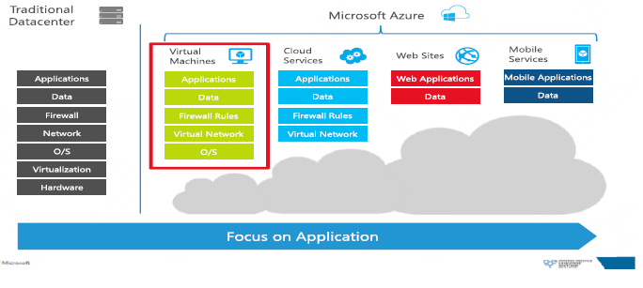

**Storage:**

Disk Storage

This service allows you to choose from either HDD (Hard Disk Drive) or SSD (Solid State Drive) as your storage option along with your virtual machine.

Blob Storage

This service is optimized to store a massive amount of unstructured data, including text and even binary data.

File Storage

This is a managed file storage service that can be accessed via industry SMB (server message block) protocol.

Queue Storage

With queue storage, you can provide stable message queuing for a large workload. This service can be accessed from anywhere in this world.

➢ **USES OF AZURE :** Some of its uses are given below:

• Application development: You can create any web application in Azure.

• Testing: After developing an application successfully on the platform, you can test it.

• Application hosting: Once the testing is done, Azure can help you host the application.

• Create virtual machines : You can create virtual machines in any configuration you want with the help of Azure.

• Integrate and sync features: Azure lets you integrate and sync virtual devices and directories.

• Collect and store metrics: Azure lets you collect and store metrics, which can help you find what works.

• Virtual hard drives: These are extensions of the virtual machines; they provide a huge amount of data storage