Name : Bhargav Valani

Enno : 19BEIT30007

5TH IT

Practical 4 SOA

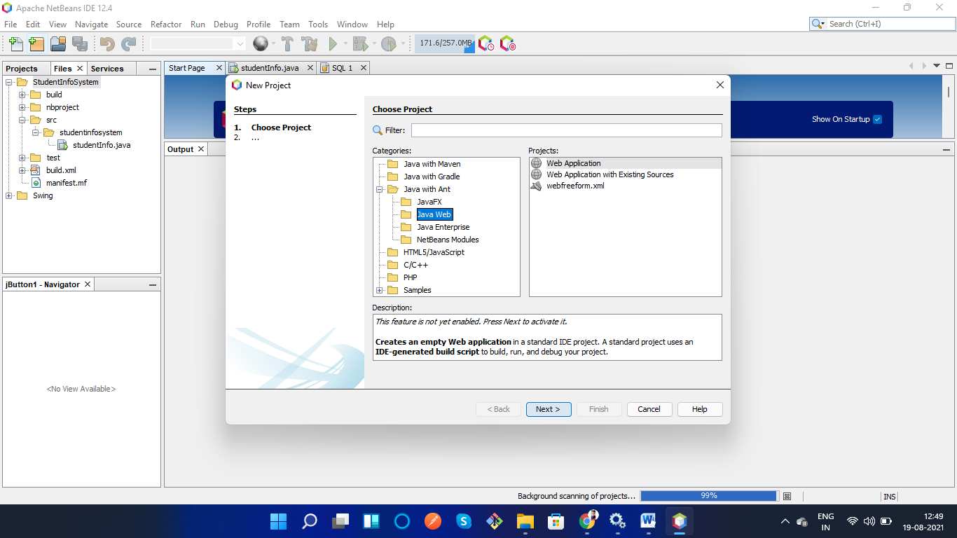

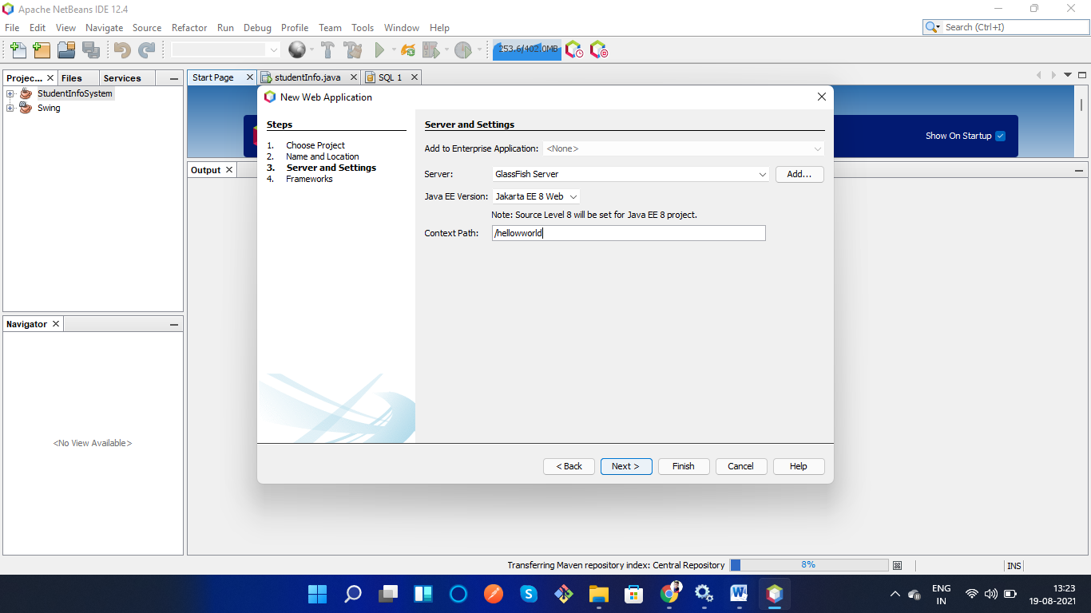

**index.html**

<html>

 <head>

 <title>First Web Application</title>

 <meta charset="UTF-8">

 <meta name="viewport" content="width=device-width, initial scale=1.0">

 </head>

 <body>

 <div>Hello World</div>

 </body>

</html>

OUTput

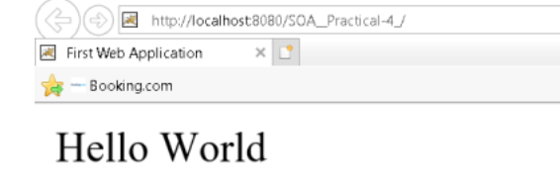

19BEIT30007