En no : **19BEIT30007** Name **: Valani Bhargav Chandrakant Bhai** **5TH IT**

**PRACTICAL-6**

**AIM:** Create a web service:

1. Create a Hello Web Services using netbeans:

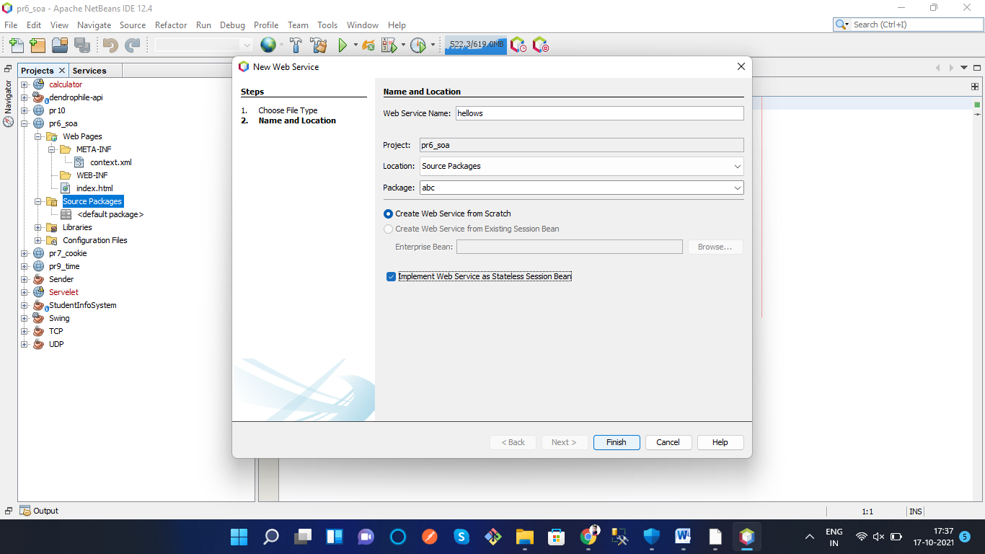

package abc;

import javax.jws.WebService;

import javax.jws.WebMethod;

import javax.jws.WebParam;

import javax.ejb.Stateless;

/**

*

* @author Bhargav

*/

@WebService(serviceName = "hellows")

@Stateless()

public class hellows {

/**

* This is a sample web service operation

*/

@WebMethod(operationName = "hello")

public String hello(@WebParam(name = "name") String txt) {

return "Hello " + txt + " !";

}

}

OUTPUT

