**19BEIT30007 Valani Bhargav Chandrakant Bhai 5th IT**

**Practical -7**

Aim : Create Calculator web service using netbeans.

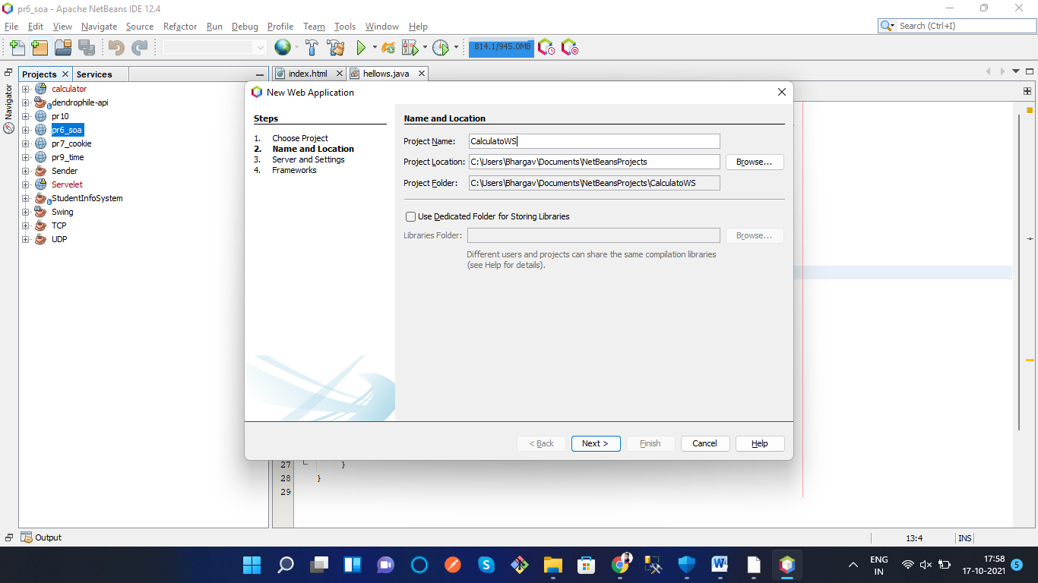

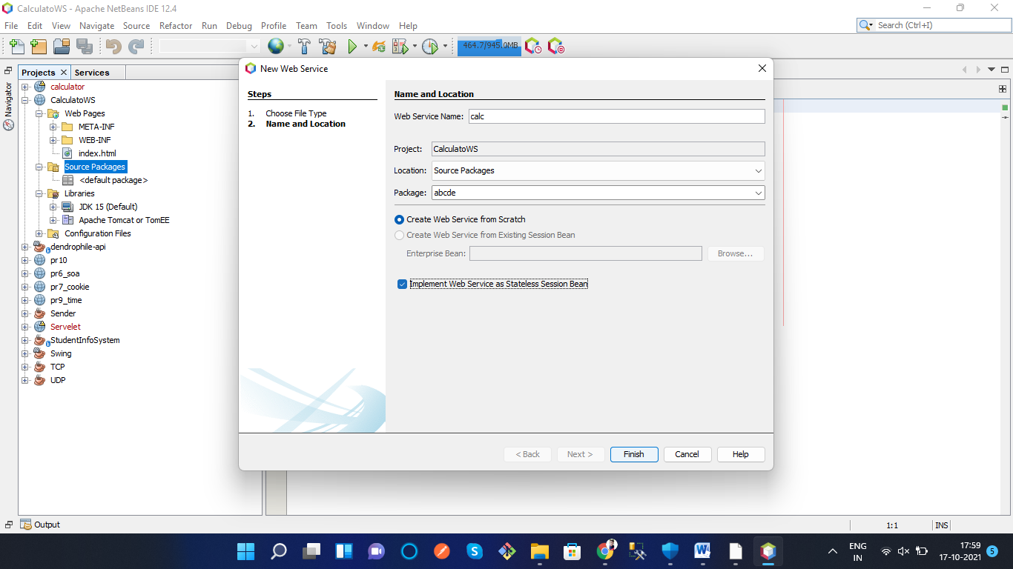

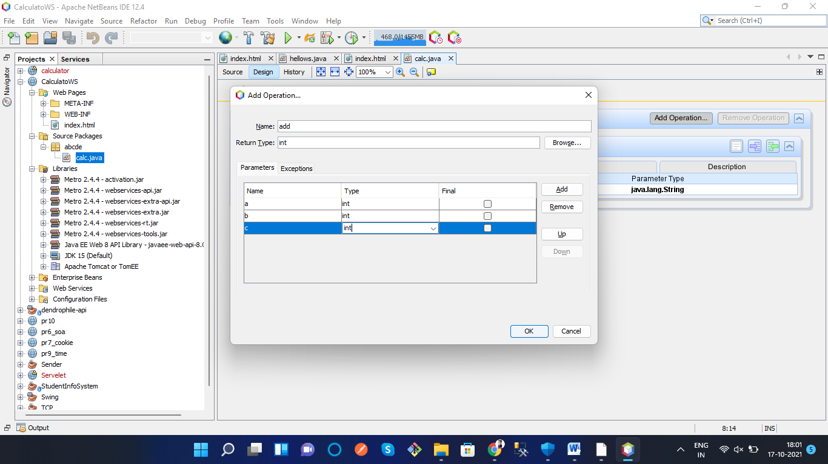

package abcde;

import javax.jws.WebService;

import javax.jws.WebMethod;

import javax.jws.WebParam;

import javax.ejb.Stateless;

@WebService(serviceName = "calc")

@Stateless()

public class CalculatorWS {

@WebMethod(operationName = "Add")

public int Add(@WebParam(name = "a") int a, @WebParam(name = "b") int b, @WebParam(name = "c") int c) {

int d = a+b+c;

return d;

}

}

@WebMethod(operationName = "Sub")

public int Sub(@WebParam(name = "p") int p, @WebParam(name = "q") int q) {

int r = p-q;

return r;

}

@WebMethod(operationName = "Mul")

public int Mul(@WebParam(name = "i") int i, @WebParam(name = "j") int j) {

int k = i*j;

return k;

}

@WebMethod(operationName = "Div")

public int Div(@WebParam(name = "x") int x, @WebParam(name = "y") int y) {

int z = x/y;

return z;

}

}

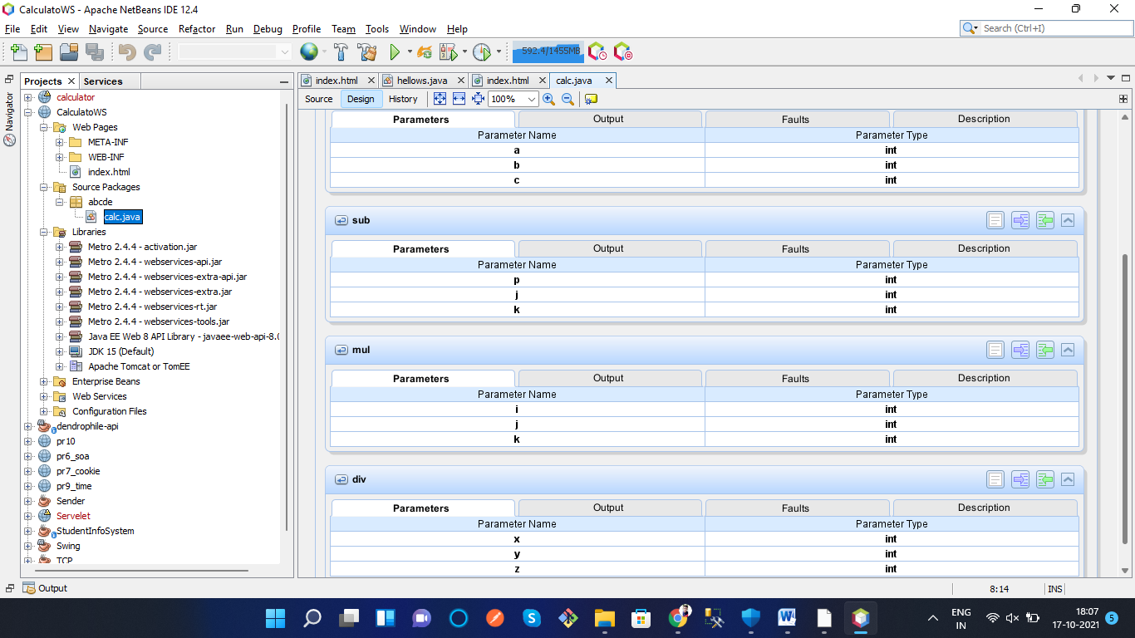

Add

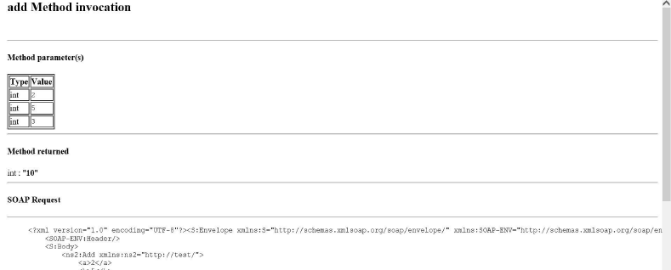

Sub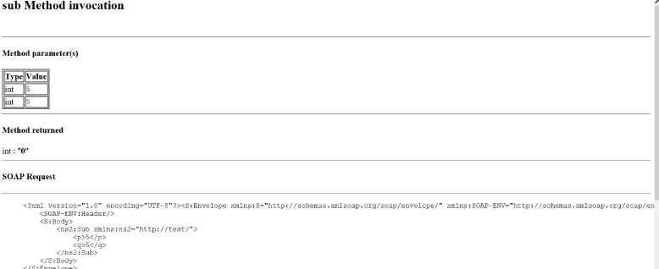

MUL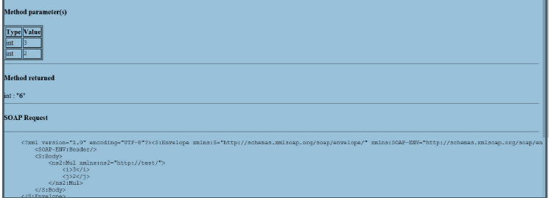

Div