Practical : 8

Aim :

**AIM: To create Restful Web Services**

The code for creating the RESTFUL Web Service is as follows:

package abcdef;

import javax.ws.rs.core.Context;

import javax.ws.rs.core.UriInfo;

import javax.ws.rs.PathParam;

import javax.ws.rs.Consumes;

import javax.ws.rs.Produces;

import javax.ws.rs.GET;

import javax.ws.rs.Path;

import javax.ws.rs.PUT;

@Path("helloWorld")

public class HelloWorld {

@Context

private UriInfo context;

public HelloWorld() {

}

@GET

@Produces("text/html")

public String getHtml() {

return "<html><body><h1>Hello, World!!</h1></body></html>";

}

@PUT

@Consumes("text/html")

public void putHtml(String content) {

}

}

The output for the RESTFUL Web Service is as follows:

1. In the following snapshot, your “HELLOWORLDAPPLICATION” name is shown. Then click on “helloworld” i.e. your restful web service.

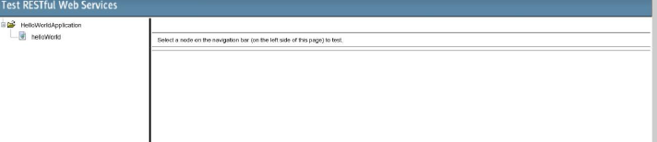

1. After clicking on the “helloworld” you’ll get two methods i.e. GET method and PUT method. But we have to select the GET method and then click on the “TEST” button.

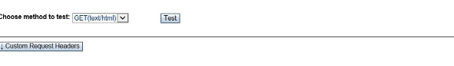

3. After clicking on the “TEST” button you’ll get the output as below:

