PRACTICAL : 9

AIM: INTRODUCTION TO AMAZON WEB SERVICES(AWS)

**AMAZON WEB SERVICES(AWS):** Amazon Web Services (AWS) is the world’s most comprehensive and broadly adopted cloud platform.

It offers over 175 fully featured services from data centers globally.

It has millions of customers connected with AWS It includes the fastest-growing start-ups , largest enterprises, and leading government agencies.

These agencies are using AWS to lower costs, become

more agile, and innovate faster.

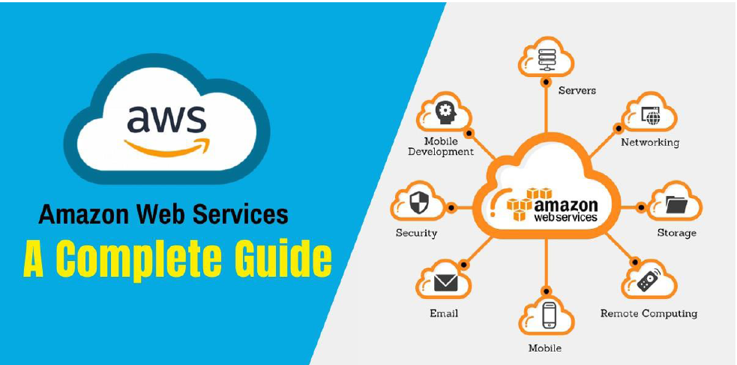

Functionality of AWS:

AWS has significantly more services, and more features within those services, than any other cloud provider.

It develops from infrastructure technologies like compute, storage, and databases–to emerging technologies, such as machine learning and artificial intelligence, data lakes and analytics, and Internet of Things. This makes it faster, easier, and more cost effective to move your existing applications to the cloud and build nearly anything you can imagine.

AWS also has the deepest functionality within those services. For example, AWS offers the widest variety of databases that are purpose-built for different types of applications so you can choose the right tool for the job to get the best cost and performance.

**FEATURES OF AWS:**

Largest community of customers and partners:

AWS has the largest and most dynamic community, with millions of active customers and tens of thousands of partners globally. Customers across virtually every industry and of every size, including startups, enterprises, and public sector organizations, are running every imaginable use case on AWS.

Most secure

AWS is architected to be the most flexible and secure cloud computing environment available today. Its core

infrastructure is built to satisfy the security requirements for the military, global banks, and other high-sensitivity organizations. This is backed by a deep set of cloud security tools, with 230 security, compliance, and governance services and features.

Fastest pace of innovation

With AWS, we can leverage the latest technologies to experiment and innovate more quickly. They are continually accelerating their pace of innovation to invent entirely new technologies , we can use to transform our business. For example, in 2014, AWS pioneered the serverless computing space with the launch of AWS Lambda, which lets developers run their code without provisioning or managing servers. And AWS built Amazon SageMaker, a fully managed machine learning service that empowers everyday developers and scientists to use machine learning, without any previous

experience.

Most proven operational expertise

AWS has unmatched experience, maturity, reliability, security, and performance that you can depend upon for your most important applications. For over 14 years, AWS has been delivering cloud services to millions of customers around the world running a wide variety of use cases. AWS has the most operational experience, at greater scale, of any cloud provider.

**SOME USES OF AWS:**

Adobe uses AWS to provide multi-terabyte operating environments for its customers by integrating its system with AWS Cloud. Adobe can focus on deploying and operating its own software instead of trying to deploy and manage the infrastructure.

Airbnb, the online vacation rental marketplace for property owners and travelers to connect, maintains a huge infrastructure in AWS, using nearly all the available services.

Autodesk develops software for the engineering, design, and entertainment industries. Using services like Amazon RDS and Amazon S3, Autodesk can focus on developing its machine learning tools instead of spending that time on managing the infrastructure

BMW uses AWS for its new connected-car application, collecting sensor data from BMW 7-series cars to give drivers dynamically updated map information.

Canon's imaging products division benefits from faster deployment times, lower cost, and global reach by using AWS to deliver cloud-based services such as mobile print and office imaging products.

The world's largest cable company and the United States’ leading provider of internet service, Comcast, uses AWS in a hybrid environment.

Docker is a company helping to redefine the way developers build, ship, and run applications making use of containers. The Amazon EC2 container service helps them do it and many more.

**FEATURES OR APPLICATIONS OF AWS:**

Security and durability - AWS encrypt the data, offering end-to-end privacy and storage.

Flexibility - There is great flexibility in AWS, allowing developers to select the OS language and database.

Ease of Use - AWS is easy to use. Developers can swiftly deploy and host applications, build new applications or migrate existing applications.

Scalability - Applications can be easily scaled up or down depending on user requirements.

Cost savings - Companies only pay for the computing power, storage and resources used, with no long-term commitments.