NovaCart E-Commerce Pvt. Ltd.
Analysis of Customer Buying Patterns Across Different Age Group Strata
Complete Project Report
Subject: Data Management and Reporting
Submitted To: [Your Ma'am's Name]
Submitted By: [Your Name / Roll No.]
Date: August 2026

Table of Contents
- 1. Introduction
- 2. Objectives of the Project
- 3. Database Design
- 4. Methodology
- 5. Data Analysis and Key Findings
- 6. Summary of Insights
- 7. Recommendation System
- 8. Data Warehouse Concepts
- 9. Ethical Considerations
- 10. Sustainability Perspective
- 11. Conclusion

1. Introduction
NovaCart E-Commerce Pvt. Ltd. wants to understand how student customers shop on their platform. Different students may buy different things, spend different amounts of money, and use different payment or delivery methods. This project studies these buying patterns using a small database of student purchase records.
The company Insight Analytics Consulting Pvt. Ltd. (this project) was given the task of collecting purchase data, building a database, running SQL queries on it, and preparing a report. The final goal is to give NovaCart useful information that can help them plan better marketing, improve product recommendations, and keep customers happy.
2. Objectives of the Project
The main objectives of this project are:
- To collect and organize student purchase data from NovaCart.
- To design a relational database using ER (Entity-Relationship) modeling.
- To write SQL queries that answer real business questions.
- To find out which product categories and brands are most popular.
- To study spending habits across different age groups.
- To check how payment method and delivery choice affect sales.
- To measure customer satisfaction through product ratings.
- To turn the SQL results into simple, easy-to-read business insights.
3. Database Design
The database has five tables. Each table stores one type of information, and the tables are linked together using primary keys and foreign keys. This is called a relational database design.
3.1 Tables Used
Table Name | What It Stores | Key Columns
STUDENT | Details of each student customer | student_id (PK), age, gender, college_year
PRODUCT_CATEGORY | List of product categories | category_id (PK), category_name
PRODUCT | Details of each product | product_id (PK), brand, category_id (FK), price
PURCHASE | Every purchase made by a student | purchase_id (PK), student_id (FK), product_id (FK)
REVIEW | Rating and comment for each purchase | review_id (PK), purchase_id (FK), product_rating

3.2 How the Tables Are Connected
The relationships between the tables are shown below:
- One STUDENT can make many PURCHASES (1 : M).
- One PRODUCT_CATEGORY can have many PRODUCTS (1 : M).
- One PRODUCT can appear in many PURCHASES (1 : M).
- One PURCHASE can have many REVIEWS linked to it (1 : M).

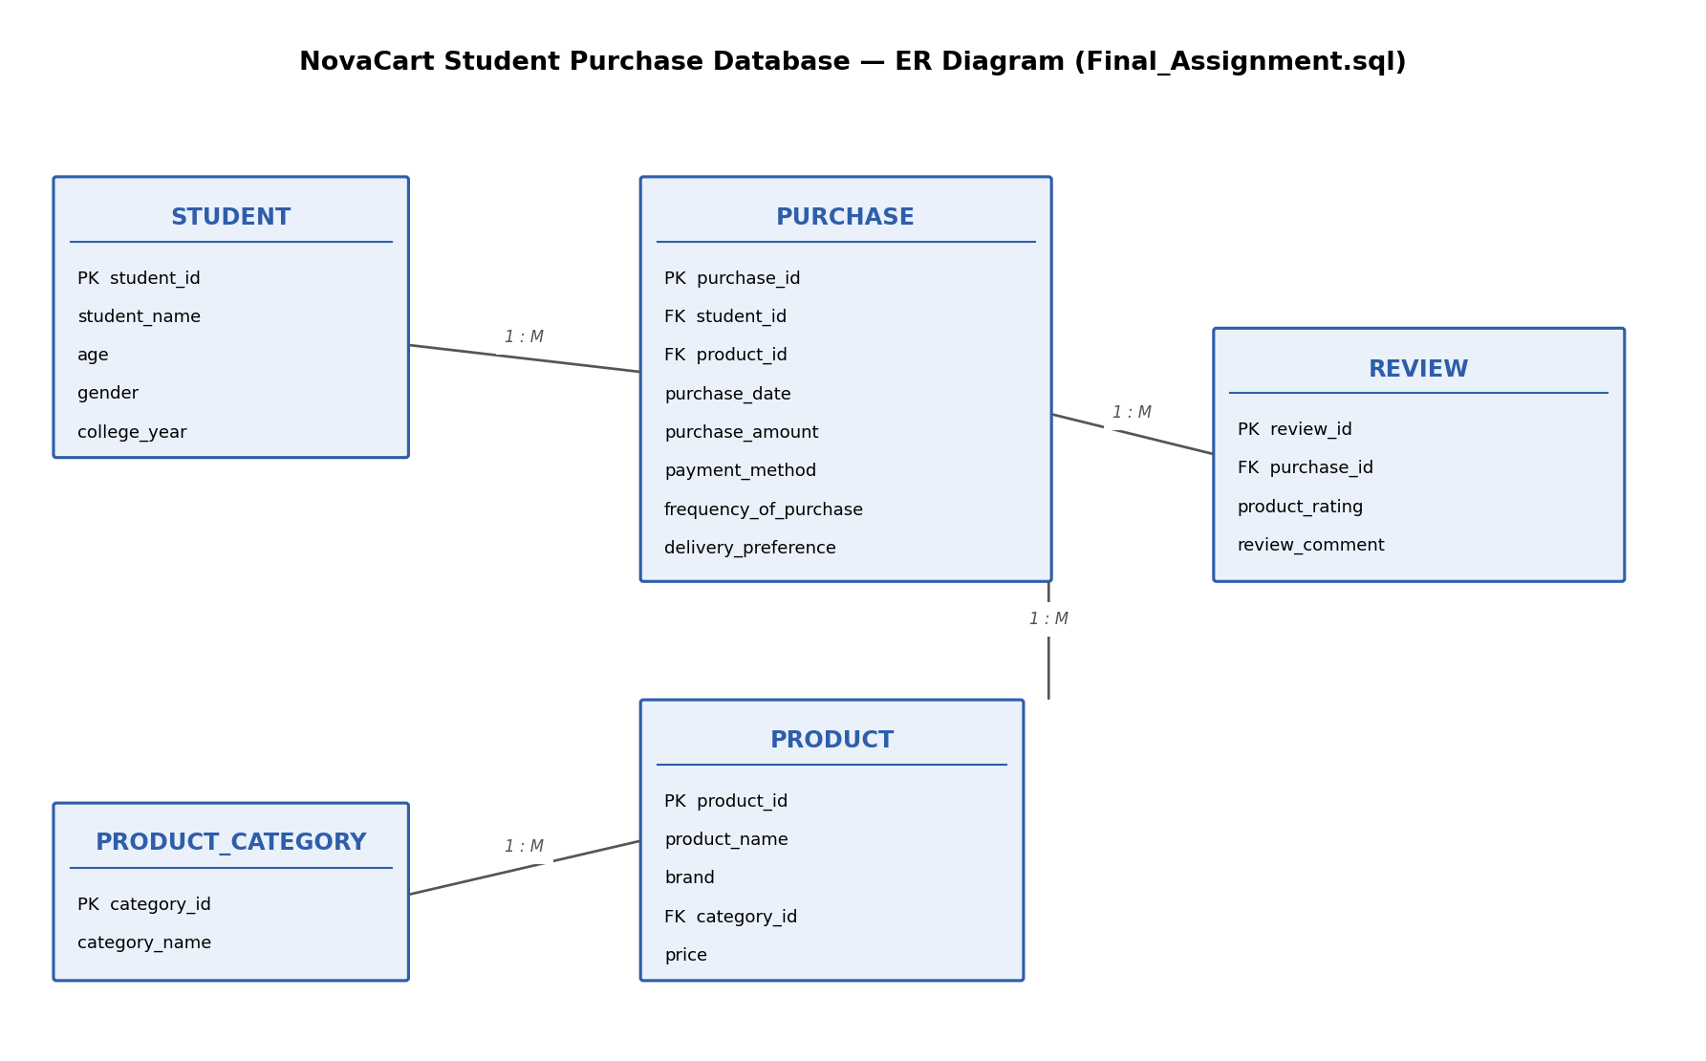
Figure 1: ER Diagram of the NovaCart Student Purchase Database

4. Methodology
The project was completed in the following simple steps: first, the database tables were created using SQL CREATE TABLE statements. Second, sample purchase data for 25 students, 30 products, 60 purchases and 60 reviews was entered into the tables. Third, SQL SELECT queries were written using JOIN, GROUP BY, COUNT, SUM and AVG to answer 21 business questions about student buying behaviour. Finally, the results of these queries were studied and turned into the findings shown in the next section.
The dataset covers purchases made between January 2026 and August 2026, across seven product categories: Electronics, Clothing, Books, Beauty, Home & Kitchen, Sports and Grocery.
5. Data Analysis and Key Findings
5.1 Most Popular Product Categories
Electronics and Clothing are the two most-purchased categories, with 13 purchases each, followed by Beauty (11 purchases). Grocery is the least-purchased category with only 3 purchases.
Category | Total Purchases
Electronics | 13
Clothing | 13
Beauty | 11
Home & Kitchen | 8
Books | 7
Sports | 5
Grocery | 3

5.2 Spending by Age Group
Students aged 22-23 spend the most, both in total (about Rs. 37,381) and on average per purchase (about Rs. 1,967). Students in the 18-19 and 20-21 groups spend around Rs. 1,000 per purchase on average, which is much lower.
Age Group | Total Purchases | Total Spending (Rs.) | Average Spending (Rs.)
22-23 | 19 | 37,381 | 1,967
18-19 | 17 | 17,485 | 1,029
20-21 | 24 | 24,028 | 1,001

5.3 Payment Method Preferences
UPI is the most used payment method with 32 transactions, followed by Card with 24 transactions and Cash with only 4. However, Card transactions are worth more money on average (about Rs. 1,847 per transaction) compared to UPI (about Rs. 994) and Cash (about Rs. 687). This shows students use UPI often for small purchases, but prefer Card for bigger, costlier items.
5.4 Delivery Preference
Prime delivery is the most chosen option with 30 out of 60 purchases (50%), followed by Standard delivery (18 purchases) and Express delivery (12 purchases). Interestingly, Express delivery purchases have a high average value, showing students are willing to pay for faster delivery on costlier items.
5.5 Monthly Purchase Trend
August recorded the highest number of purchases (12) and the highest total sales (about Rs. 16,188) in the dataset. This may be linked to the start of a new college term or festive shopping season.
5.6 Product Ratings and Customer Satisfaction
Out of 60 reviews, the average product rating is 4.48 out of 5, with the lowest rating being 4 and the highest being 5. This means students are, overall, very satisfied with their purchases. Category-wise, Books received the highest average rating (4.86), followed by Sports (4.80) and Clothing (4.62).
5.7 Frequent Shoppers vs. Spending
Students who purchase Monthly spend the most on average (about Rs. 1,550 per purchase) and also give slightly higher ratings (4.56 average) compared to Weekly or Occasional shoppers. This suggests that students who shop in a planned, monthly way tend to make more satisfying purchase decisions.
5.8 Top Products and Top Customers
Nike Sports Shoes were bought most often (5 times), followed by Minimalist Sunscreen and JBL Wireless Headphones (4 times each). The highest-spending customer is Siddharth Rao, who spent about Rs. 6,998 across just 2 purchases, showing a preference for costlier products.

6. Summary of Insights
- Electronics and Clothing are the top-selling categories among students.
- Older students (22-23 years) spend noticeably more per purchase than younger students.
- UPI is preferred for everyday, low-value purchases; Card is preferred for high-value purchases.
- Half of all orders use Prime delivery, showing students value fast and reliable shipping.
- August is the peak shopping month in the dataset.
- Overall customer satisfaction is high, with an average rating of 4.48 out of 5.
- Monthly shoppers spend more per order and are slightly more satisfied than frequent (Weekly) shoppers.
These insights, based on the SQL analysis of the NovaCart student purchase database, give a clear and simple picture of how students shop online. They can help NovaCart plan age-based marketing, promote Prime delivery, and encourage more Card usage for high-value items through offers or cashback.

7. Recommendation System
7.1 What Is a Recommendation System?
A recommendation system is a tool used by e-commerce websites like NovaCart, Amazon, and Flipkart to suggest products to customers that they are likely to buy. Instead of showing the same products to every customer, the system looks at data such as past purchases, ratings, and browsing behaviour to give each customer suggestions that match their interest. This makes shopping easier for the customer and increases sales for the company.
7.2 Types of Recommendation Systems
There are three common types of recommendation systems used in e-commerce:
Popularity-Based Recommendation is the simplest type. It recommends the products that are bought or rated the most by all customers, without looking at individual preference. For example, Nike Sports Shoes (bought 5 times) and JBL Wireless Headphones (bought 4 times, average rating 5.0) could be shown to every student as 'Trending Products'.
Content-Based Recommendation looks at the type of products a customer already bought and suggests similar products from the same category or brand. For example, if a student buys JBL Wireless Headphones (Electronics category), the system can recommend other Electronics items such as the Boat Bluetooth Speaker or the Noise Smart Watch.
Collaborative Filtering Recommendation looks at what other, similar customers have bought. It finds students with similar purchase history and recommends the products those similar students liked. For example, if two students both bought Sunscreen SPF 50 and gave it a high rating, and one of them also bought a Face Wash, the system can recommend the Face Wash to the other student too.
7.3 How This Can Be Applied to the NovaCart Data
The STUDENT, PRODUCT, PURCHASE and REVIEW tables already contain the information needed to build a simple recommendation system. Each table plays a role:
Table | Role in Recommendation
PURCHASE | Shows what each student has already bought, and how often.
PRODUCT / PRODUCT_CATEGORY | Helps find similar products by category or brand.
REVIEW | Shows which products customers rated highly, so only good products are recommended.
STUDENT | Helps group students by age or year, so recommendations can be tailored to a segment.

Using the actual query results from this project, a basic recommendation logic can already be written in SQL. For example, to recommend the top-rated products within a category a student has already shown interest in, we can join PURCHASE, PRODUCT and REVIEW, filter by category, and sort by average rating. This is exactly what the highest-rated products and category satisfaction queries already calculate — this project's SQL analysis is, in a small way, the foundation of a recommendation system.
7.4 A Simple Recommendation Workflow for NovaCart
- Step 1: Look at the student's past purchases from the PURCHASE table.
- Step 2: Find the product categories and brands they buy most often.
- Step 3: Search the PRODUCT table for other items in the same category that the student has not yet bought.
- Step 4: Use the REVIEW table to keep only products with a good average rating (for example, 4 or above).
- Step 5: Show the top few matching products to the student as 'Recommended for You'.
7.5 Benefits of Adding a Recommendation System
- Helps students discover products they may actually want, saving their time.
- Increases the chance of repeat purchases and higher spending per student.
- Improves customer satisfaction, since only well-rated products are suggested.
- Gives NovaCart a competitive advantage, similar to large platforms like Amazon.

8. Data Warehouse Concepts
8.1 What Is a Data Warehouse?
A data warehouse is a large storage system that collects data from many different sources and keeps it organized in one place, mainly so that companies can study it and make business decisions. It is different from a normal database. A normal database, like the one built for this project, is used for day-to-day work, such as adding a new purchase or updating a student record. A data warehouse instead stores data over a long period of time and is used only for analysis and reporting, not for daily updates.
For NovaCart, a data warehouse would collect purchase data from every month and every year, so the company can study long-term shopping trends across thousands of students, instead of looking at only a small, recent set of records.
8.2 OLTP vs. OLAP
Databases are generally divided into two types depending on how they are used. This project's SQLite database is an example of OLTP, while a data warehouse works as OLAP.
Feature | OLTP (Normal Database) | OLAP (Data Warehouse)
Full Form | Online Transaction Processing | Online Analytical Processing
Purpose | Day-to-day operations (add, update, delete) | Long-term analysis and reporting
Data Used | Current, recent data | Historical data collected over months/years
Example in This Project | Adding a new PURCHASE record | Studying total sales trends over a full year
Speed Needed For | Fast, single-record updates | Fast, large summary queries

8.3 Key Data Warehouse Concepts
Fact Table: A fact table stores the measurable data, that is, the numbers a business wants to study, such as amounts, quantities, or counts. In this project, the PURCHASE table already acts like a fact table, because it stores purchase_amount, which is the main number NovaCart wants to analyse.
Dimension Tables: Dimension tables store the descriptive details that explain the facts, such as who, what, when, and where. In this project, STUDENT (who bought it), PRODUCT and PRODUCT_CATEGORY (what was bought), and the purchase_date column (when it was bought) all act as dimensions.
Star Schema: A star schema is a simple way of arranging a fact table in the middle, with dimension tables connected around it, so it looks like a star shape. If NovaCart's database was turned into a data warehouse, the PURCHASE table would sit at the centre as the fact table, and STUDENT, PRODUCT, PRODUCT_CATEGORY, and a new DATE dimension table would surround it, each connected through a key.
ETL Process: ETL stands for Extract, Transform, Load. It is the process used to move data into a data warehouse — extracting data from different sources, transforming it into a clean and consistent format, and loading it into the warehouse tables, ready for analysis.
8.4 How This Applies to the NovaCart Project
Current Table | Role in a Data Warehouse
PURCHASE | Fact table — stores purchase_amount, the main measurable value
STUDENT | Dimension table — describes who made the purchase
PRODUCT | Dimension table — describes what was purchased
PRODUCT_CATEGORY | Dimension table — groups products for category-level analysis
purchase_date column | Would become a separate DATE dimension table (day, month, year)

8.5 Benefits of a Data Warehouse for NovaCart
- Combines data from many years and many sources into one place for analysis.
- Makes it faster to run large summary reports without slowing down the main website database.
- Helps NovaCart study long-term trends, such as yearly growth in student spending.
- Supports better business decisions, such as planning stock or marketing campaigns in advance.

9. Ethical Considerations
This project uses personal information about students, such as their name, age, gender, and what they buy online. Even though the data used here is sample (synthetic) data created for learning purposes, a real version of this project would use actual student information. Because of this, it is important to think about how such data should be collected, stored, and used in a fair and responsible way.
9.1 Student Data Privacy and Confidentiality
Privacy means that a student's personal details should only be seen by people who genuinely need them, and confidentiality means that this information should not be shared with outside parties without permission. If this project used real students, their names and personal information should be protected, stored securely, and never shared publicly, printed in reports, or sent to third parties without the student's consent.
9.2 Ethical Use of Purchasing Behaviour Data
The PURCHASE and REVIEW tables show what each student buys, how much they spend, and what they think about the products. This information should only be used for fair purposes, such as improving products or services, not to unfairly target students, for example by charging different prices based on how much they usually spend.
9.3 Responsible Handling of Personal Shopping Information
Responsible handling means that data should be collected only with the knowledge of the student, stored safely so it cannot be accessed by unauthorized people, and used only for the reason it was collected.
- Collect only the data that is actually needed for the analysis.
- Give students the option to know what data is being collected about them.
- Store the database securely, with access limited to the people running the analysis.
- Delete or archive old data that is no longer needed for reporting.
9.4 Data Anonymization for Reporting Purposes
Anonymization means removing or hiding details that can identify a specific person, so that reports and dashboards show only overall patterns, not individual identities. For example, instead of showing 'Siddharth Rao spent Rs. 6,998', a public report could show 'The highest-spending student in the 22-23 age group spent Rs. 6,998', which gives the same business insight without naming the student.
All the tables and dashboards built in this project already show grouped or aggregated data (totals, averages, counts) rather than exposing any single student's full purchase history — a simple example of anonymization already being followed in this project.

10. Sustainability Perspective
Sustainability means using resources in a way that does not harm the environment and can continue safely for a long time. Online shopping affects the environment in several ways, both good and bad, so it is useful to study NovaCart's purchase data from this angle too.
10.1 Analysing Eco-Friendly Product Purchases
Some categories in the NovaCart dataset are more eco-friendly than others. For example, products like the Yoga Mat, Water Bottle, and Storage Box (reusable, long-lasting items) support sustainable habits, while items bought very often and thrown away quickly, such as fast-fashion Clothing items, generally have a higher environmental cost. If NovaCart tagged products as eco-friendly in the PRODUCT table, a simple SQL query using GROUP BY could show what percentage of student purchases are eco-friendly, and this percentage could be tracked over time.
10.2 Digital Purchasing Trends Reducing Physical Shopping
This project's data shows that all 60 purchases were made online and paid for using UPI, Card, or Cash on delivery, meaning students did not need to travel to a physical store for these purchases. Online shopping like this can reduce the number of individual car or bike trips to shops, lowering fuel use and traffic. However, it also increases the number of delivery vehicles on the road, so the environmental benefit depends on how deliveries are grouped and managed.
10.3 Evaluating Sustainable Consumption Patterns
The delivery_preference column also connects to sustainability. In the dataset, 30 out of 60 purchases (50%) chose Prime delivery, 18 chose Standard, and 12 chose Express. Express delivery is usually less eco-friendly because it often needs a dedicated, faster trip for a single order. Standard delivery allows the company to group many orders together in one delivery run, making it more fuel-efficient.
Delivery Type | Orders in Dataset | Sustainability Note
Prime | 30 | Fast but grouped efficiently; moderate impact
Standard | 18 | Most eco-friendly; orders can be combined
Express | 12 | Fastest but least eco-friendly; often single-trip delivery

10.4 Simple Recommendations for NovaCart
- Mark eco-friendly products clearly on the website so students can choose them easily.
- Offer a small reward or discount to students who choose Standard delivery instead of Express, when the order is not urgent.
- Use packaging that can be recycled or reused for all delivery types.
- Track and report the percentage of eco-friendly purchases every month, similar to the sales reports already built in this project.

11. Conclusion
This mini-project gave hands-on experience in database management, SQL, and business analytics using a real-world e-commerce scenario. A relational database with five connected tables (STUDENT, PRODUCT_CATEGORY, PRODUCT, PURCHASE, and REVIEW) was designed and built, and 21 SQL queries were written and run to study how students shop on NovaCart.
The analysis showed several clear patterns: Electronics and Clothing are the most popular categories, older students (22-23 years) spend more per purchase than younger students, UPI is used for frequent small purchases while Card is preferred for costlier items, and half of all orders choose Prime delivery. Overall customer satisfaction is high, with an average rating of 4.48 out of 5.
Beyond the SQL analysis, this project also explored how the same data could support a recommendation system, how it could grow into a full data warehouse for long-term analysis, and the ethical and sustainability responsibilities that come with handling student data. Together, these pieces show how raw transactional data can be turned into meaningful business insight, and how a company like NovaCart could use such insight to plan better marketing, improve customer experience, and grow responsibly.
Overall, this project builds a strong foundation in DBMS, SQL, business intelligence, and data-driven decision-making, all of which are directly useful in real-world data management and reporting roles.

