**1. Overview**

The Sales Data Analysis Tool is an interactive Python-based application designed to provide users with comprehensive insights into their sales data. Through the utilisation of data visualisation libraries such as Matplotlib and Seaborn, along with the ease of use of Tkinter for the graphical user interface, the application provides a user-friendly interface for examining trends in sales data and making informed decisions.

**1.1 Purpose**

The purpose of this tool is to enable users, especially those with minimal programming experience, to analyze their sales data effectively. Users can load data, view summary reports, and visualize sales performance across different products and time periods. The tool aims to streamline the data analysis process, making it easier to understand and interpret sales trends.

**1.2 Key Features**

**Data Loading**: Easily load sales data from Excel files.

**Data Cleaning**: Automatic data cleaning ensures that only valid data is used in analysis.

**Summary Reports:** Get instant insights with calculated metrics like total sales and average sales.

**Visualizations**: View data through bar charts, line charts, and pie charts.

Interactive GUI: Navigate through different views and options with a user-friendly interface.

**2. Project Structure**

**2.1 Code Organization**

The project is organized into several key functions and components, each responsible for a specific aspect of the application:

**1.Data Loading and Cleaning:** The `load_and_clean_data` function handles the initial data loading, conversion, and cleaning processes.

**2.Data Analysis:** The `analyze_data` function calculates basic metrics such as total and average sales, and groups sales data by product.

**3.Visualization Generation:** The `generate_visualizations` function creates the necessary visualizations based on the cleaned data.

**4.GUI Management:** The `show_gui` function initializes and manages the user interface, including handling user interactions and displaying the results.

**3. Data Loading and Cleaning**

**3.1 Loading the Data**

The data loading process is crucial as it sets the foundation for the analysis. The `load_and_clean_data` function reads an Excel file and performs initial transformations to ensure the data is in a usable format.

def load_and_clean_data(file_path):

df = pd.read_excel(file_path)

df['Order Date'] = pd.to_datetime(df['Order Date'])

df['Total Revenue'] = pd.to_numeric(df['Total Revenue'], errors='coerce')

df = df.dropna()

df['Total Revenue'] = df['Total Revenue'] / 1_000_000

return df

**3.2 Data Cleaning**

During data loading, several cleaning steps are applied:

Date Conversion: Ensures the 'Order Date' is in datetime format, which is essential for time-series analysis.

Revenue Conversion: Converts revenue figures into millions for easier readability and consistency across visualizations.

Handling Missing Data: Rows with missing values are removed to prevent errors during analysis.

**3.3 Error Handling**

The code also includes error handling mechanisms during the conversion of 'Total Revenue'. Any non-numeric values are coerced into NaNs, which are subsequently dropped. This step ensures that only valid numeric data is analyzed.

**4. Data Analysis**

**4.1 Total and Average Sales**

The analysis starts with the calculation of basic metrics like total sales and average sales. These metrics give a quick overview of the sales performance.

def analyze_data(df):

total_sales = df['Total Revenue'].sum()

avg_sales = df['Total Revenue'].mean()

sales_by_product = df.groupby('Item Type')['Total Revenue'].sum().reset_index()

return total_sales, avg_sales, sales_by_product

**4.2 Sales by Product**

Grouping the sales data by product type helps in identifying the top-performing products. This is particularly useful for understanding which products contribute the most to the overall revenue.

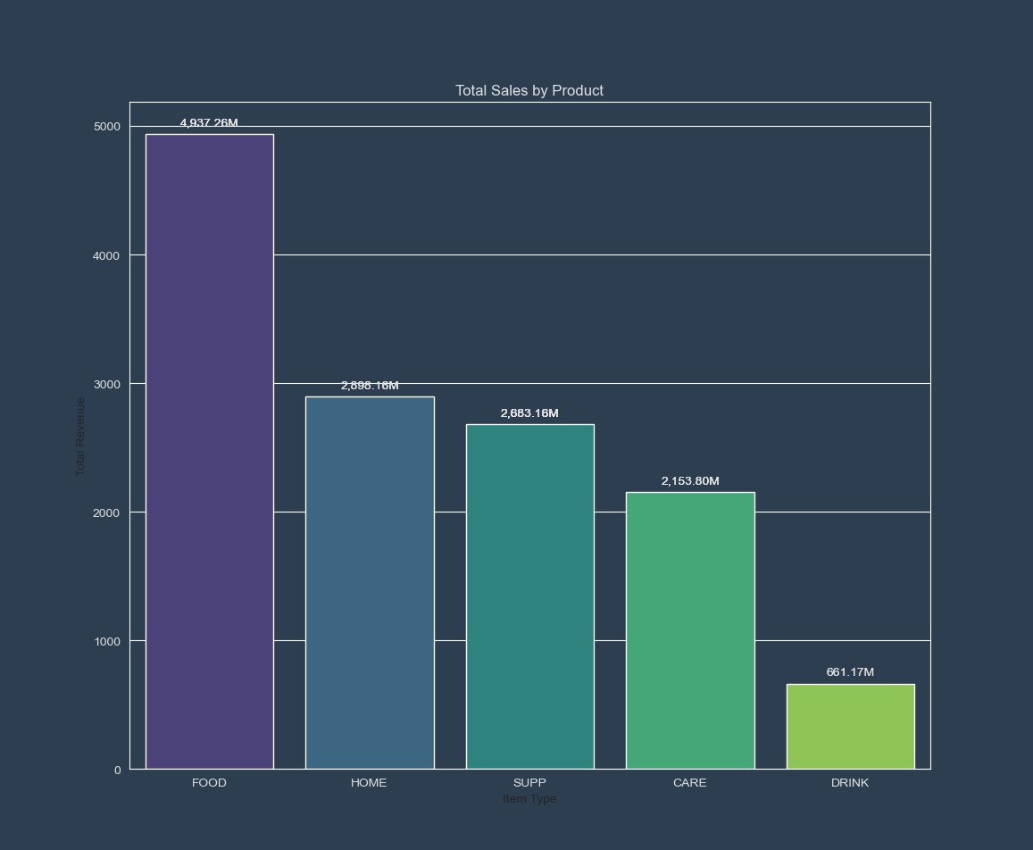

**5. Visualization Generation**

**5.1 Bar Chart: Total Sales by Product**

The bar chart provides a clear comparison of total sales across different products. Users can view this chart in either ascending or descending order.

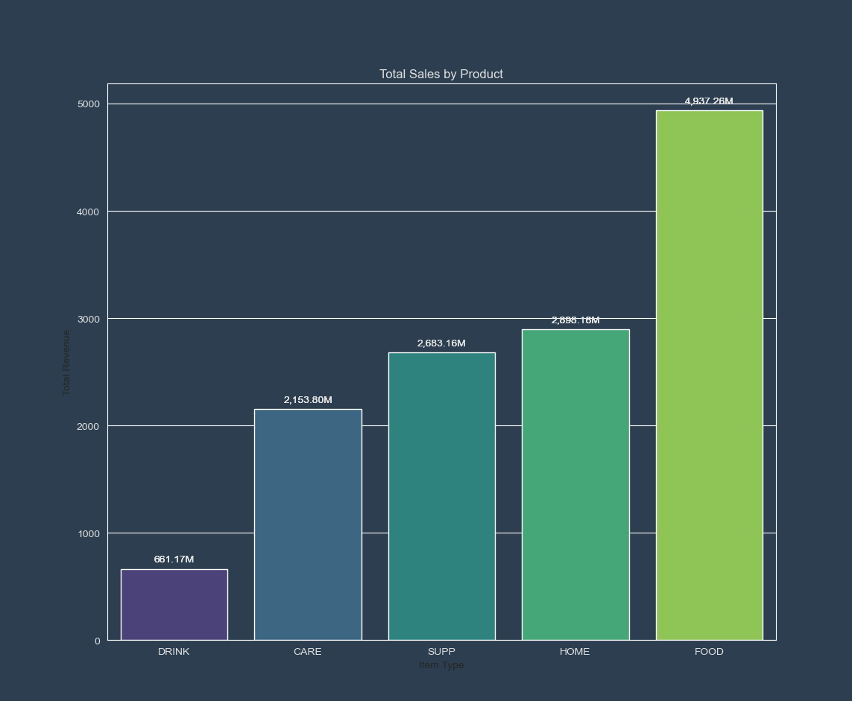

**5.2 Line Chart: Sales Over Time**

The line chart shows how total sales have evolved over time, aggregated by year. This visualization is key to understanding trends and identifying any seasonal patterns.

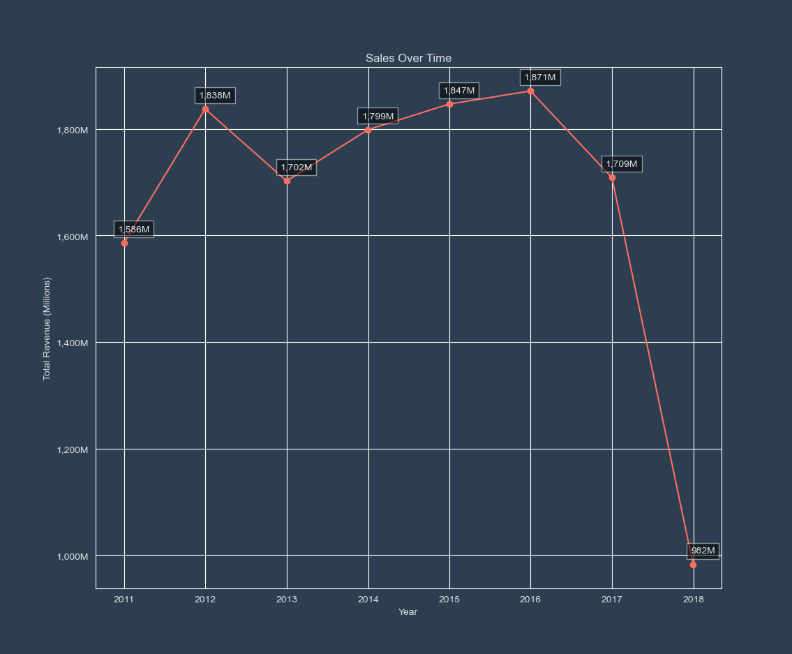

**5.3 Pie Chart: Sales Distribution by Product**

The pie chart illustrates the proportion of total sales accounted for by each product type, providing an immediate visual understanding of product performance.

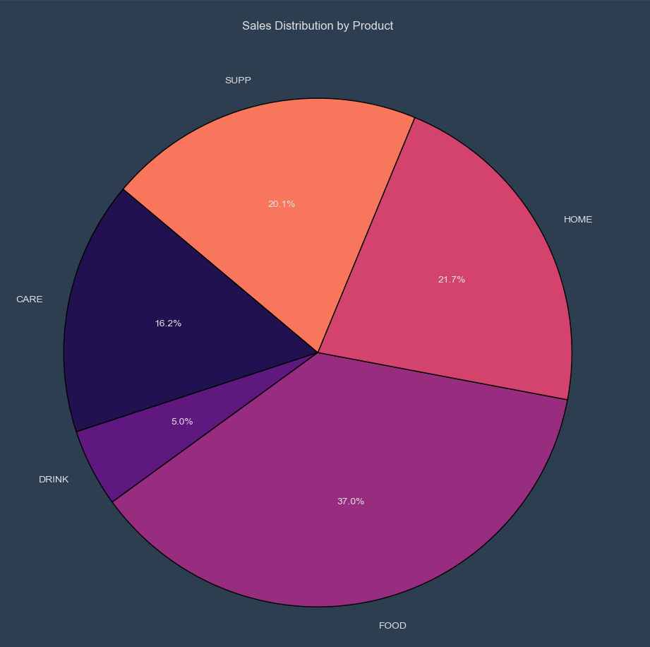

**5.4 Tooltip and Annotation**

Each visualization is enhanced with tooltips and annotations that provide additional information when users hover over data points. This interactivity helps users to quickly grasp the details of the data without cluttering the visualizations.

**6. Graphical User Interface (GUI) Features**

**6.1 Navigation and Interaction**

The GUI is designed to be user-friendly, allowing users to easily navigate between different visualizations and view summary reports. The main components include:

**Navigation Bar:** Buttons for switching between bar, line, and pie charts.

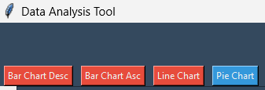

**Canvas Area:** Displays the selected visualization.

**Summary Report:** Provides a textual summary of the analysis, which is displayed in a scrollable text box.

**6.2 Summary Report**

The summary report is dynamically generated based on the data analysis results. It includes key metrics such as total sales, average sales, and sales by product.

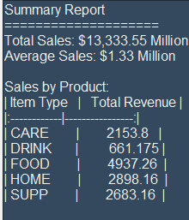

**7. Future Enhancements**

As robust and comprehensive as the Sales Data Analysis Tool is, there is always room for improvement. Here are some potential future enhancements that could be made to the tool:

**7.1 Additional Filters**

One possible enhancement is to introduce additional filtering options. Currently, the tool provides a high-level overview of the sales data, but adding filters (such as by region, customer segment, or time period) could allow users to perform more granular analyses. For instance, users could filter data by specific countries or product categories to analyze sales trends in those areas specifically.

**7.2 Export Functionality**

Another valuable addition would be the ability to export the generated reports and visualizations. Users could benefit from exporting these outputs to formats like PDF, Excel, or even images. This feature would enable users to share their findings with others easily or to include them in presentations and reports.

**7.3 Enhanced Visualization Features**

Currently, the tool provides basic but effective visualizations. Future versions could include more advanced visualization options, such as interactive charts, heatmaps, or geographical maps, to give users a more comprehensive view of their data. Additionally, allowing users to customize the visualizations (e.g., changing colors, adding more labels, etc.) could enhance user experience.

**7.4 Integration with Databases**

While the current tool works excellently with Excel files, integrating it with popular databases (like MySQL, PostgreSQL, etc.) could further extend its capabilities. Users would then be able to analyze real-time data directly from their databases, making the tool even more powerful for businesses with dynamic datasets.

**8. Flowchart**

The following flowchart illustrates the workflow of the Sales Data Analysis Tool, from data loading to visualization and user interaction:

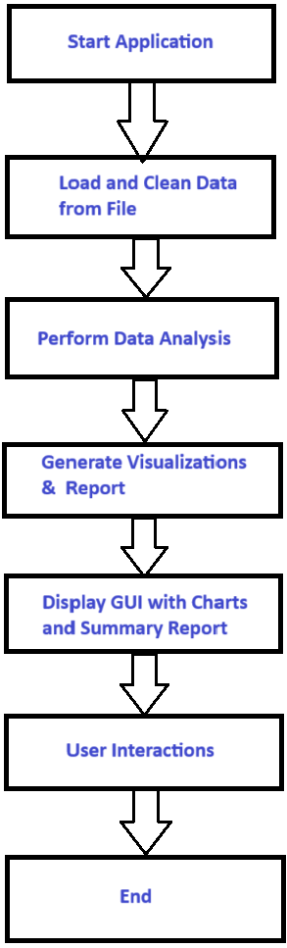

**9. Conclusion**

The Sales Data Analysis Tool provides a comprehensive and user-friendly way to explore sales data. By integrating data loading, cleaning, analysis, and visualization into a single application, users can quickly gain insights into their sales performance. The tool's interactive features and clear visualizations make it a valuable asset for decision-makers seeking to understand and act on their sales data.

**9.1 Key Takeaways**

**Simplicity:** The tool is easy to use, even for those with minimal technical expertise.

**Powerful Analysis:** It offers robust data analysis capabilities, allowing users to understand their data in-depth.

**Interactive Visualizations:** The interactive charts help users to engage with their data and discover insights.

**9.2 Future Development**

Ongoing development could include adding more data sources, enhancing the GUI, and expanding the analysis capabilities to cover more complex datasets.

**10. Conclusion**

**10.1 Summary of Features**

The Sales Data Analysis Tool is a powerful, user-friendly application designed to make data analysis accessible to everyone. By combining the strengths of Python's data manipulation libraries and the simplicity of Tkinter for GUI development, the tool offers a straightforward yet effective way to analyze sales data. Users can load data, view key metrics, and visualize their sales performance through various charts.

**10.2 Key Takeaways**

**Ease of Use:** The tool’s interface is intuitive, requiring no advanced technical knowledge to operate.

**Comprehensive Analysis:** Users can gain a deep understanding of their sales data through basic analysis and advanced visualizations.

**Scalability:** With potential future enhancements, the tool could evolve into an even more powerful data analysis platform.  
**10.3 Final Thoughts**

This tool represents a significant step forward in making data analysis more accessible. As businesses continue to rely on data-driven decisions, tools like this will become increasingly valuable. The Sales Data Analysis Tool is a solid foundation that, with further development, could support even more complex analysis needs, helping users make informed decisions that drive success.