4bit Parallel Adder
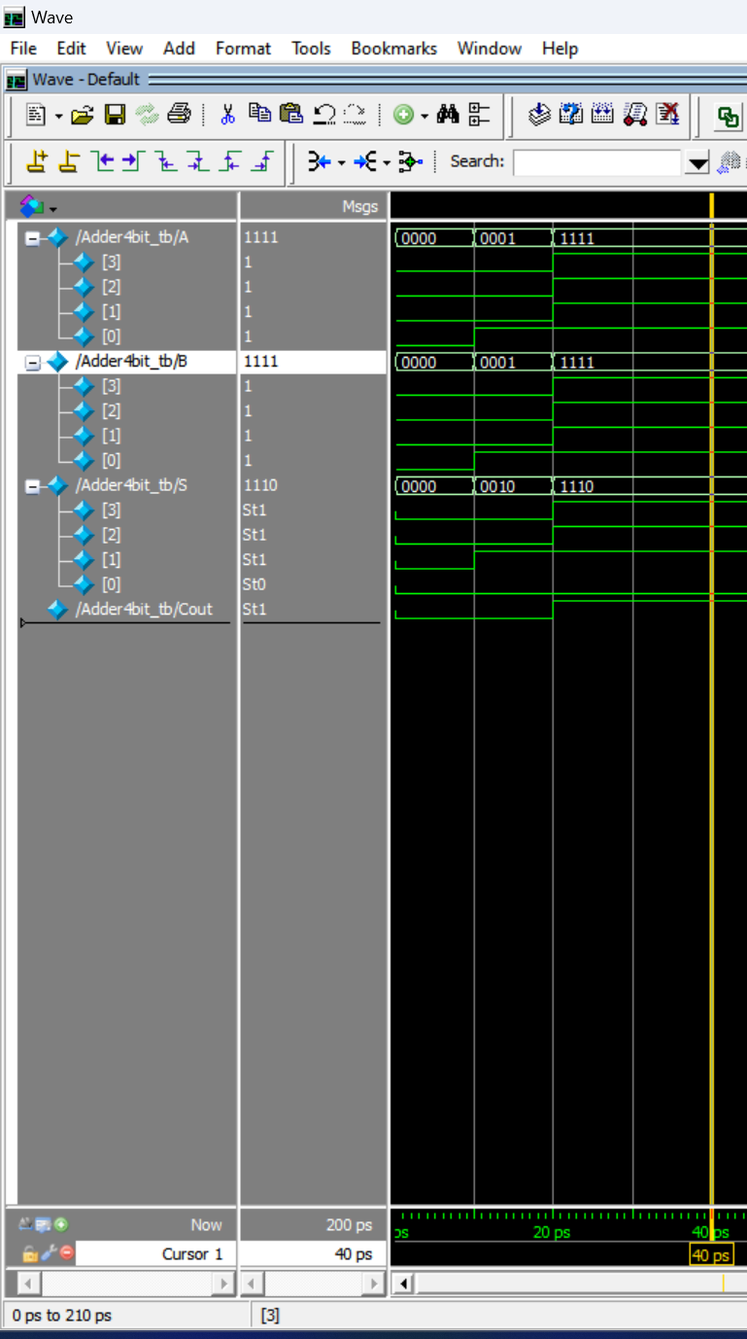
2x2 Multiplier
Title : 4 bit Parallel Adder
Reg.No : 23BEC1392
Date : 1 Sep 2024
Name: Bhargav Kulkarni

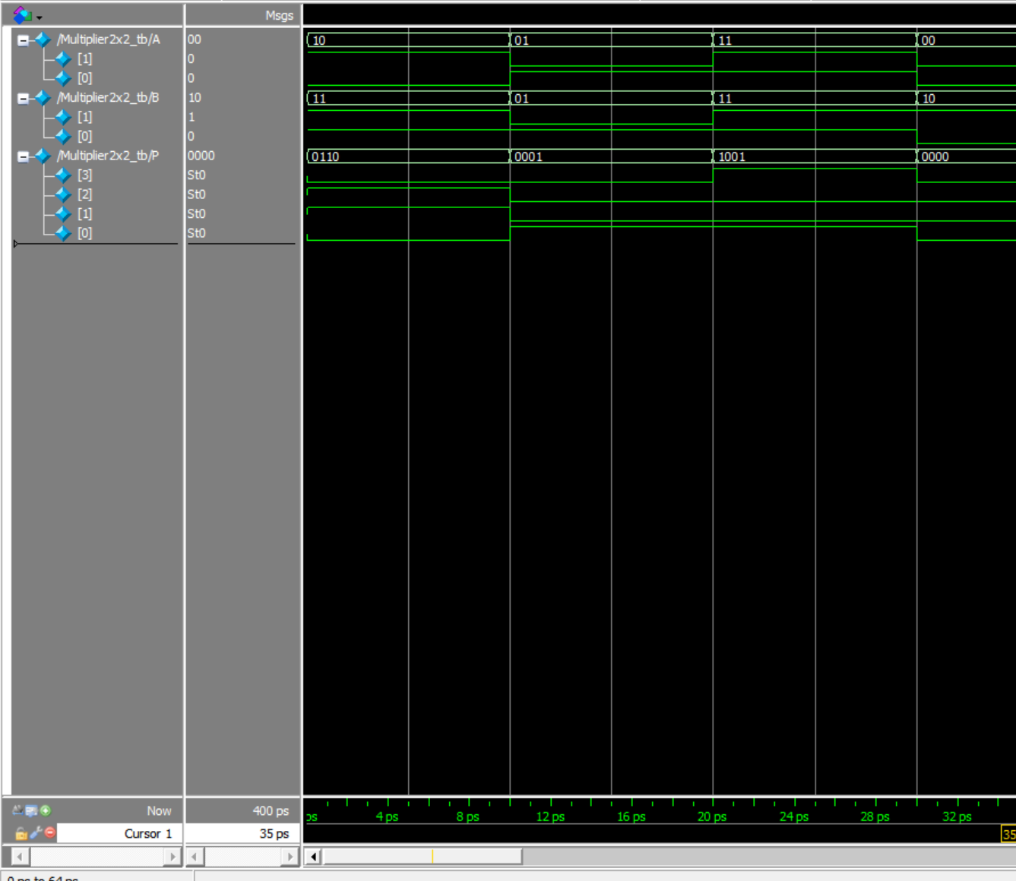
Title : 2X2 Multiplier
Reg.No : 23BEC1392
Name: Bhargav Kulkarni

