Lung Cancer Detection

In this project we are using CNN algorithm to detect Lung cancer from CT-SCAN images and to train CNN we have CT-SCAN images dataset and this dataset saved inside ‘Lung_Images_Dataset’ folder and below screen shots showing images from dataset

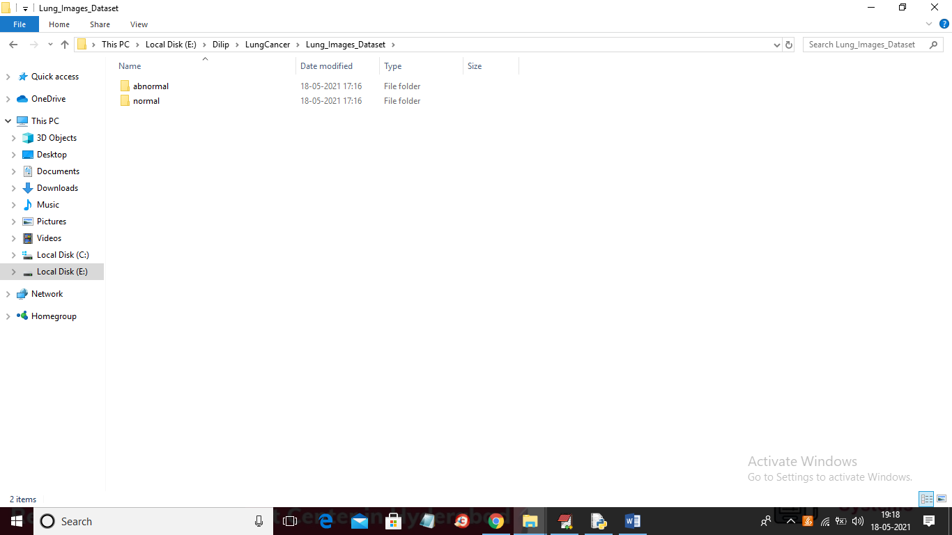

In above screen we have two folders where one folder contains NORMAL CT SCAN images and other folder contains ABNORMAL and you can go inside any folder to view those images



In above screen displaying few images from ABNORMAL folder and we used above images to train CNN algorithm and after training CNN we can upload test images and then CNN will predict whether CT_SCAN contains normal or abnormal tumour

SCREEN SHOTS

To run project double click on ‘run.bat’ file to get below screen

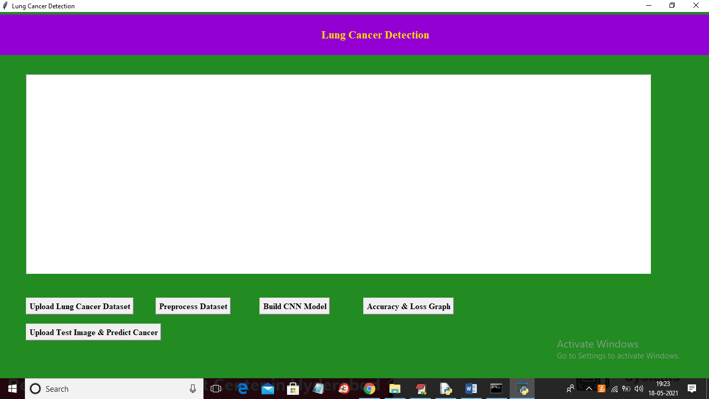

In above screen click on ‘Upload Lung Cancer Dataset’ button to upload CT-SCAN images

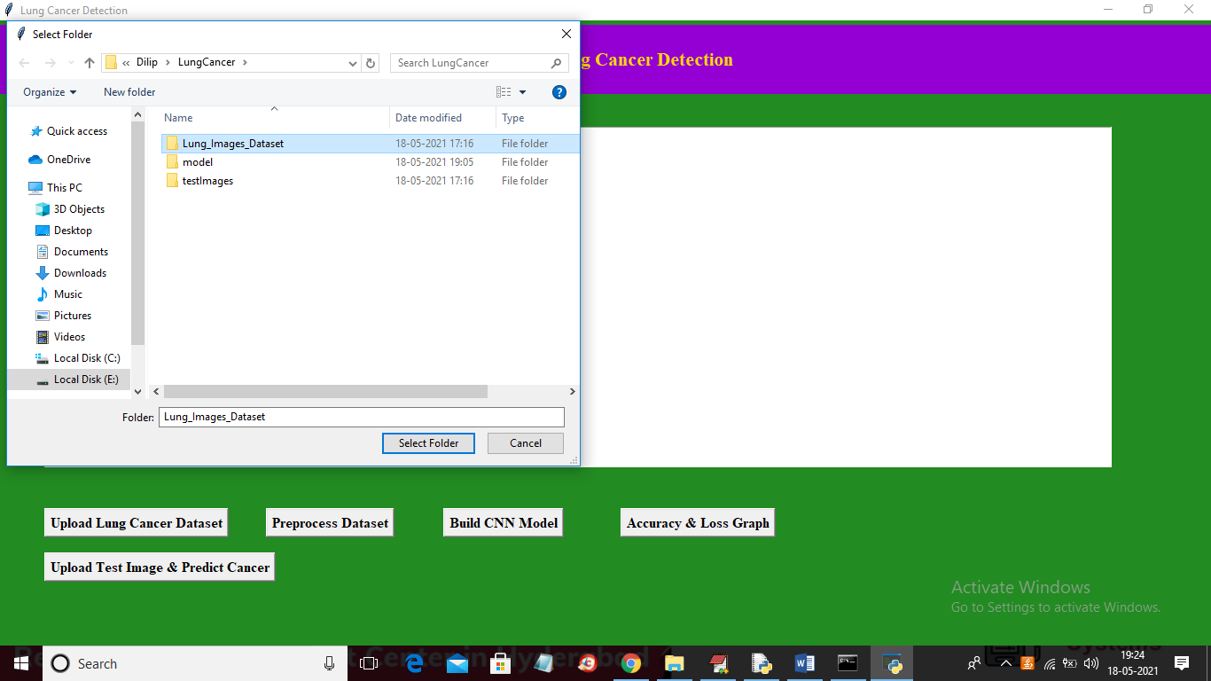

In above screen selecting and uploading ‘Lung_Image_Dataset’ folder and then click on ‘Select Folder’ button to load images and to get below screen

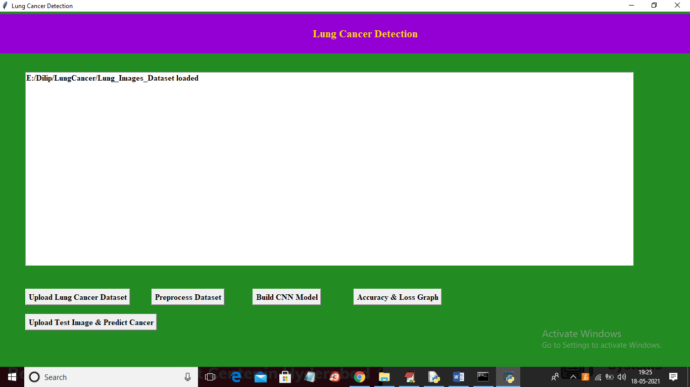

In above screen dataset loaded and now click on ‘Preprocess Dataset’ button to convert all images into colour format and resize them into equal sizes so CNN can accept those images

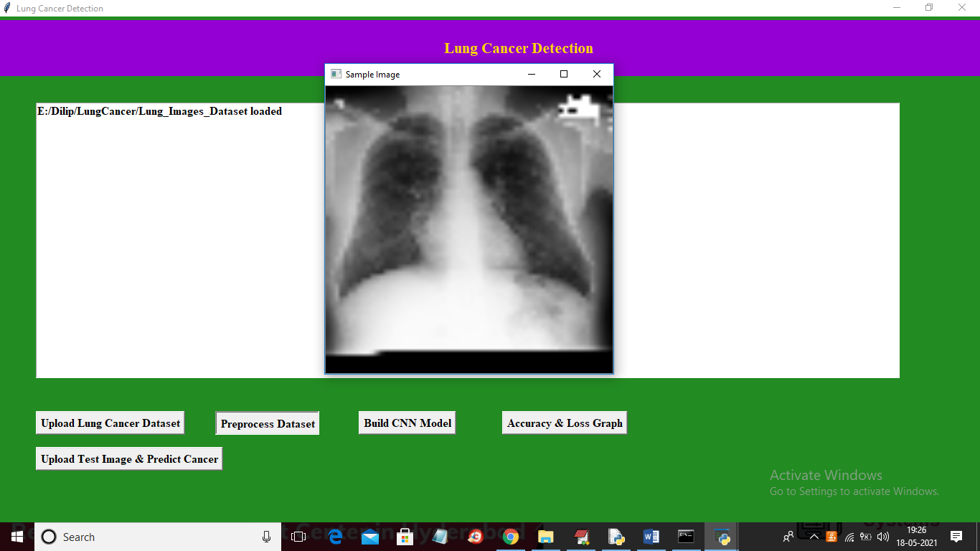

In above screen application process all images and then I am displaying one sample image to confirm all images loaded properly and now close above image to get below screen

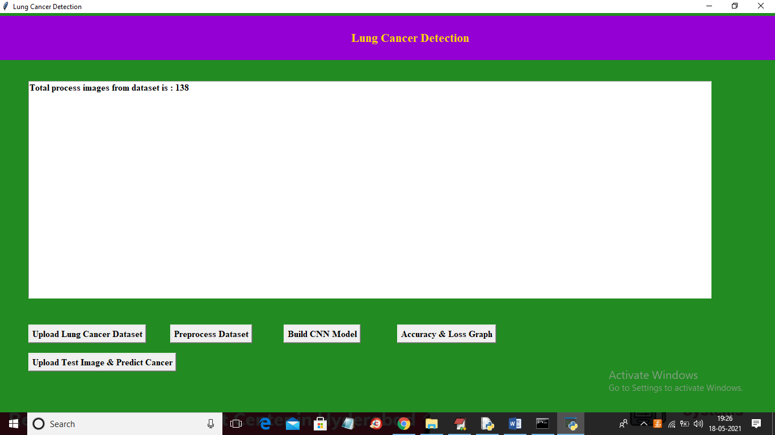

In above screen we can see dataset contains total 138 images and now click on ‘Build CNN Model’ button to train CNN algorithm on above images and then calculate prediction accuracy

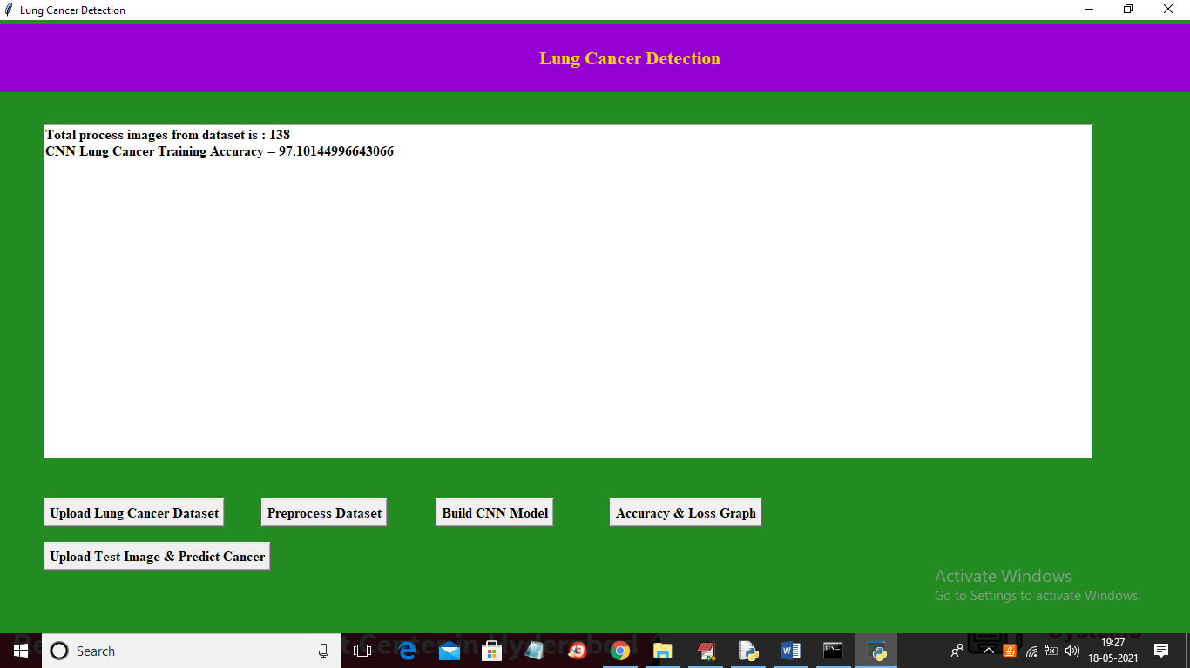

In above screen CNN model generated and we got its accuracy as 97% and in below screen we can see CNN architecture

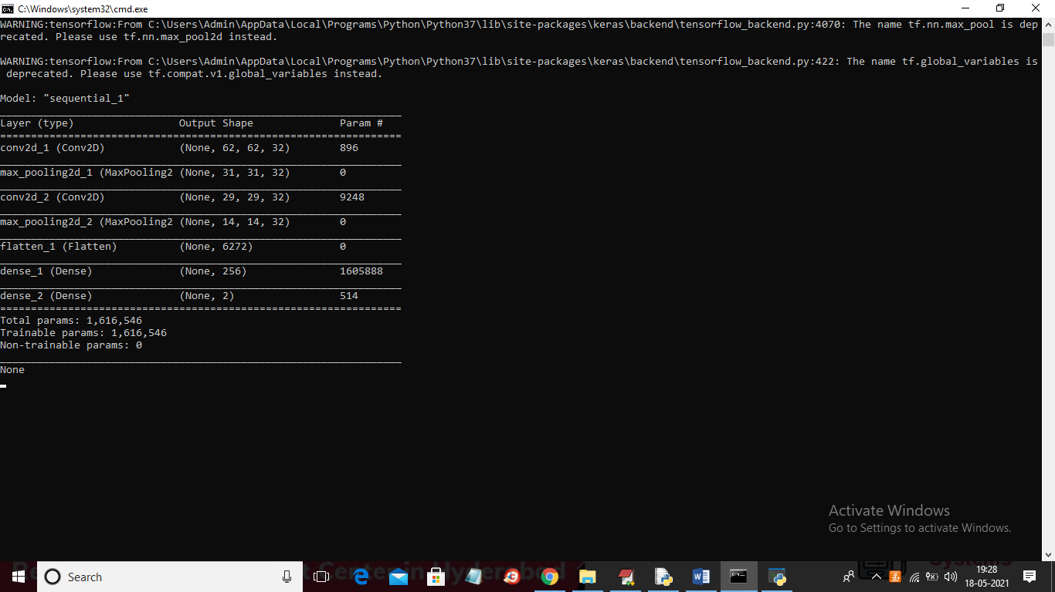

In above console to train CNN we created multiple layers where first layer process images of size 62 X 62 and second layer process 31 X 31 and goes on and now click on ‘Accuracy & Loss Graph’ button to get below graph

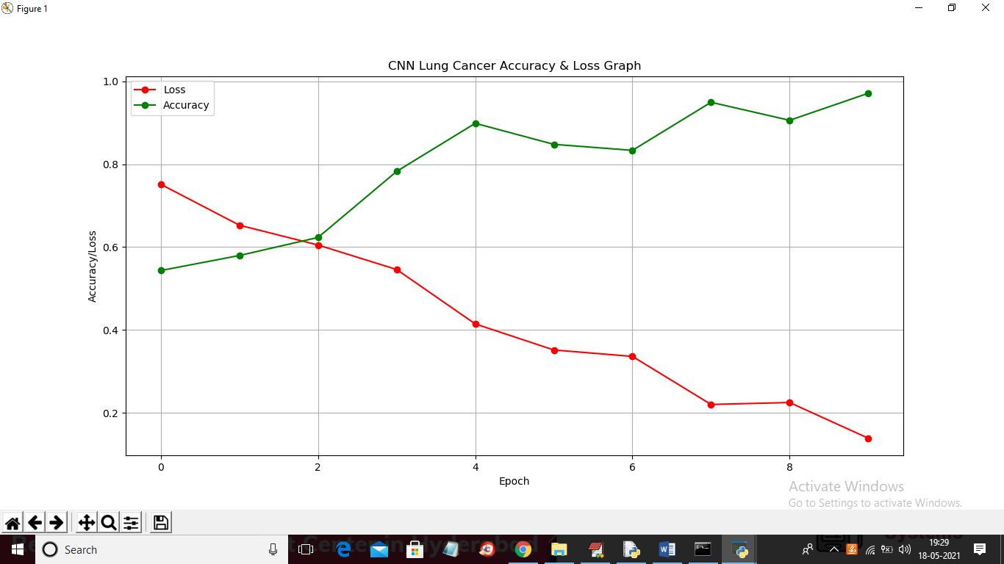

In above graph x-axis represents Epoch and Y-axis represents accuracy and loss values and in above graph we can see to train CNN we took 10 Epoch and at each increasing Epoch Loss values get decrease and accuracy gets increase and in above graph red line represents loss and green line represents accuracy. Now click on ‘Upload Test Image & Predict Cancer’ button to upload test image and then detect cancer

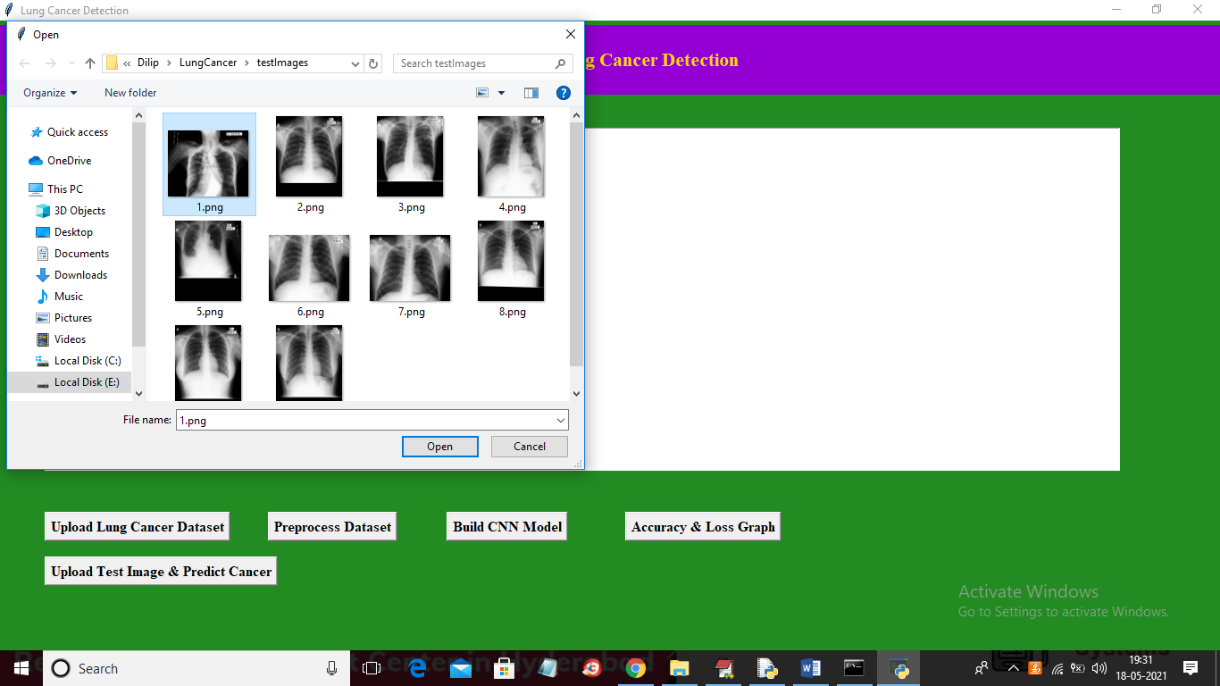

In above screen selecting and uploading ‘1.png’ file and then click on ‘Open’ button to get below result

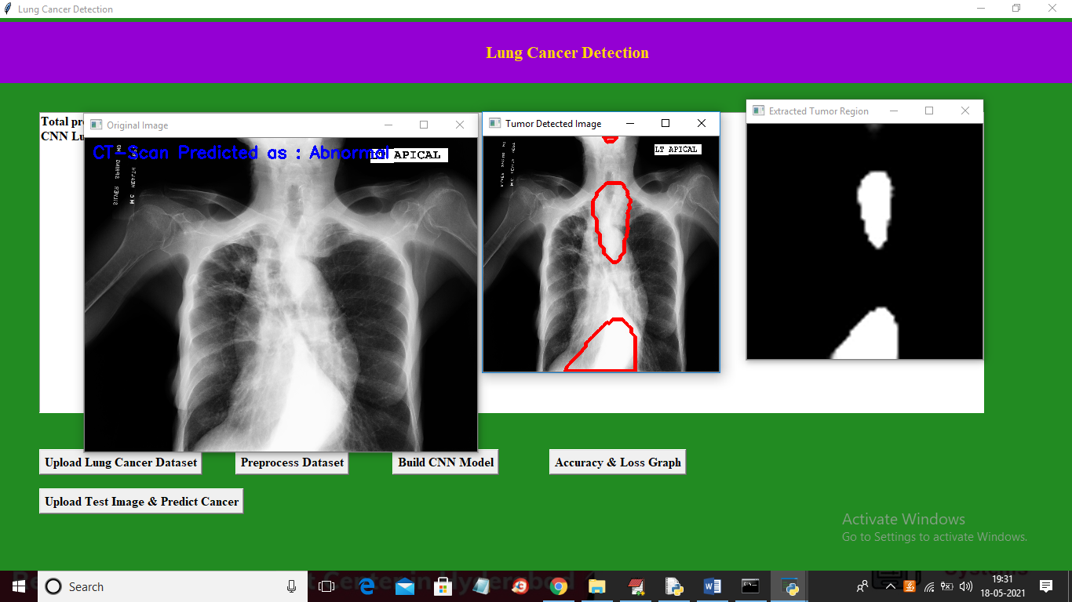

In above screen in first image in blue colour text we can see predicted result as CT-SCAN contains abnormality and in second image we are detecting places were abnormality detected and in third image we extracted all abnormality patches from original image and then displaying. Now test other image

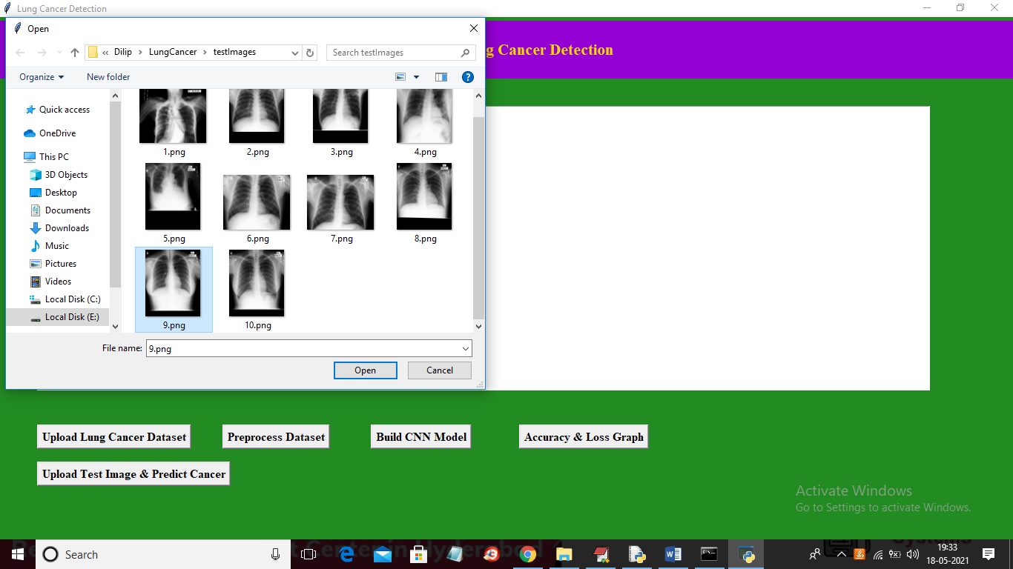

In above screen selecting and uploading ‘9.png’ file and then click on ‘Open’ button to get below result

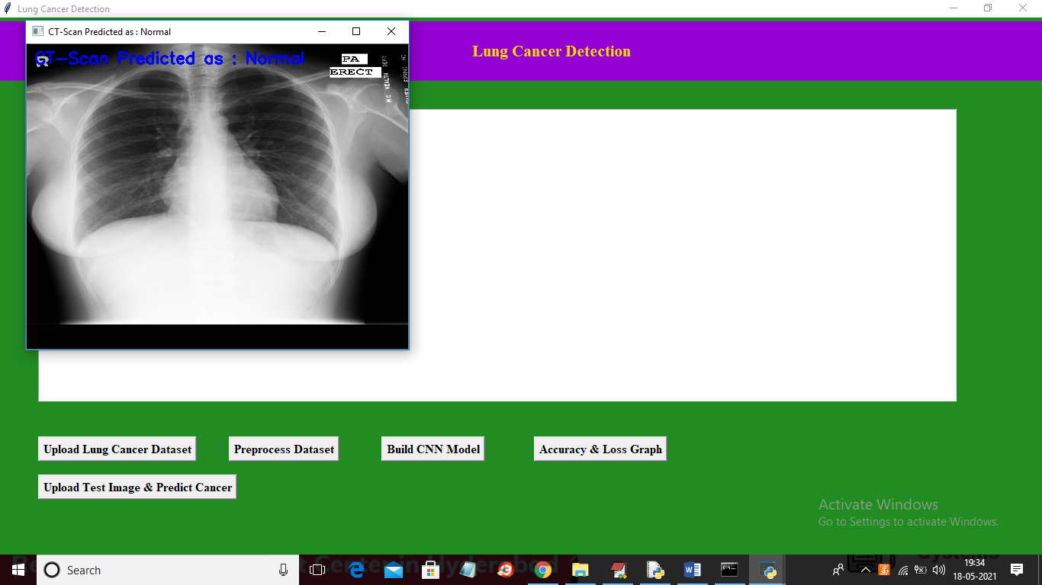

In above screen CT-SCAN is predicted as NORMAL. Similarly you can upload and test other images

