**Annexure-IV**

**Weather Forecast App**

**A project report**

Submitted in partial fulfilment of the requirements for the award of degree of

**Name of Programme**

**WEB DEVELOPMENT WITH REACTJS – INT 252**

**Submitted to**

**LOVELY PROFESSIONAL UNIVERSITY**

**PHAGWARA, PUNJAB**



**From 02/25/24 to 04/30/24**

**SUBMITTED BY**

**Name of student**

**Nalla Bhargav Thirupathi Rao**

**Name of Supervisor**

**Mr. Kedar Nath Singh**

**Registration Number**

**12111609**

**UID of Supervisor**

**29465**

**Signature of student**

**Bhargav** **Signature of Supervisor**

**Annexure-V**

**Declaration by student**

**To whom so ever it may concern**

I, **Nalla Bhargav Thirupathi Rao, 12111609,** hereby declare that the work done by me on “**Weather Forecast App**” under the supervision of **Mr Kedar Nath Singh,** Lovely professional University, Phagwara, Punjab, is a record of original workfor the partial fulfilment of the requirements for the award of the degree, **ReactJS.**

Name of the Student (Registration Number)

**Nalla Bhargav Thirupathi Rao , 12111609**

Signature of the student

**Bhargav**

Dated:

**30/04/2024**

**Annexure-VI**

**Declaration by the supervisor**

**To whom so ever it may concern**

This is to certify that **Nalla Bhargav Thirupathi Rao**, **12111609** from Lovely Professional University, Phagwara, Punjab, has worked on “**Weather Forecast App**” under my supervision from. It is further stated that the work carried out by the student is a record of original work to the best of my knowledge for the partial fulfilment of the requirements for the award of the degree, ReactJs.

Name of Supervisor

**Mr Kedar Nath Singh**

UID of Supervisor

**29465**

Signature of Supervisor

**List of contents**

|  |  |
| --- | --- |
| **S. No.** | **Title** |
|  |  |
| 1 | Declaration by Supervisors |
|  |  |
| 2 | Declaration by Student |
|  |  |
| 3 | Acknowledgement |
|  |  |
| 4 | Abstract |
|  |  |
| 5 | List of Tables |
|  |  |
| 6 | List of Figures/ Charts |
|  |  |
| 7 | List of Schemes/Algorithms |
|  |  |
| 8 | List of Symbols |
|  |  |
| 9 | List of Abbreviations |
|  |  |
| 10 | Chapter-1 Introduction |
|  |  |
| 9 | Chapter-2 Review of Literature |
|  |  |
| 10 | Chapter-3 Implementation of project |
|  |  |
| 11 | Chapter-4 Results and Discussions |
|  |  |
| 12 | Final Chapter- Conclusion And Future Scope |
|  |  |
| 13 | Publication details |
|  |  |
| 14 | Plagiarism report |
|  |  |
|  |  |

**Abstract**

The Weather Forecast Application is a modern web application developed using React and CSS, designed to provide accurate and comprehensive weather information to users. The app offers a user-friendly interface with intuitive features aimed at delivering real-time weather updates and forecasts.

At the core of the application is a powerful search functionality, enabling users to easily retrieve weather data for their desired locations. The homepage welcomes users with a clean layout, featuring an interactive search bar where users can input their city of interest.

Upon entering the city name and clicking the search button, users are presented with detailed weather information for the specified location. The app dynamically fetches weather data from the OpenWeatherMap API and displays essential details such as temperature, humidity, wind speed, and weather conditions.

The application's versatility allows users to explore weather conditions for different cities worldwide. Users can refine their search by specifying additional parameters such as date and time, ensuring accurate and personalized weather forecasts.

Each weather report provides comprehensive insights into current conditions, as well as forecasts for the upcoming days. Users can easily navigate between different sections to access hourly and daily forecasts, allowing them to plan their activities accordingly.

One of the standout features of the Weather Forecast Application is its dynamic background imagery, which changes based on the current weather conditions. Utilizing advanced CSS techniques, the app creates an immersive visual experience that reflects the atmosphere of each location.

The project prioritizes not only functionality but also design aesthetics and user interaction. By leveraging React for front-end development, the app ensures responsiveness and compatibility across various devices and screen sizes. CSS styling enhances the visual appeal of the app, creating an engaging interface that captivates users.

In future iterations, the project aims to integrate additional features such as weather alerts, customizable widgets, and location-based recommendations. The development roadmap will be guided by user feedback and technological advancements, with a focus on enhancing the app's usability and utility.

Overall, the Weather Forecast Application offers a reliable solution for individuals seeking up-to-date weather information. Whether planning outdoor activities, traveling, or simply staying informed, users can rely on the app to provide accurate forecasts and insights, empowering them to make informed decisions based on current weather conditions. With its intuitive interface, robust search functionality, and visually appealing design, the app sets a new standard for online weather forecast platforms, delivering convenience and reliability to users worldwide.

**List of Tables**

1. Components Used

2. Search Criteria Options

3. Weather Search Results

4. Weather Details

5. Gallery Images

6. Backend Technologies Considered

7. User Feedback Summary

8. Project Milestones

9. Publication Details

10. References

11. Plagiarism Report Summary

**List of Figures/ Charts**

1. Figure 1: Application Homepage Layout

1. Figure 1: Application Homepage Layout

2. Figure 2: Search Bar Design

3. Figure 3: Weather Search Results Page Layout

4. Figure 4: Individual Weather Details Page Layout

5. Figure 5: Gallery Design for Weather Images

6. Figure 6: Backend Architecture Diagram

7. Figure 7: User Feedback Visualization

8. Figure 8: Project Timeline Chart

9. Figure 9: Conference Presentation Slide Sample

10. Figure 10: Plagiarism Detection Report Snapshot

**List of Schemes/Algorithms**

1. Scheme 1: Search Algorithm for Weather Data Retrieval

2. Scheme 2: User Authentication Scheme for Login and Signup

3. Scheme 3: Data Encryption Scheme for User Privacy and Security

4. Scheme 4: Data Filtering Scheme for Search Results

5. Scheme 5: Recommendation Algorithm for Featured Weather Locations

6. Scheme 6: Forecasting Algorithm for Weather Predictions

7. Scheme 7: User Feedback Collection Scheme

8. Scheme 8: Data Aggregation Scheme for Weather Reports

9. Scheme 9: Notification Scheme for Weather Alerts

10. Scheme 10: Localization Algorithm for Displaying Weather Information in Multiple Languages

**List of Symbols**

1. Symbol 1: $ (Currency Symbol)

2. Symbol 2: ℹ (Information Symbol)

3. Symbol 3: 🔍 (Search Symbol)

4. Symbol 4: 📅 (Calendar Symbol)

5. Symbol 5: 🌞 (Sun Symbol for Weather)

6. Symbol 6: ☁️ (Cloud Symbol for Weather)

7. Symbol 7: 🌀 (Wind Symbol for Weather)

8. Symbol 8: 💧 (Water Droplet Symbol for Humidity)

9. Symbol 9: 🌡️ (Thermometer Symbol for Temperature)

10. Symbol 10: 🌬️ (Wind Symbol for Wind Speed)

**List of Abbreviations**

1. HTML - Hypertext Markup Language

2. CSS - Cascading Style Sheets

3. JS - JavaScript

4. API - Application Programming Interface

5. UX - User Experience

6. UI - User Interface

7. DB - Database

8. JWT - JSON Web Token

9. HTTPS - Hypertext Transfer Protocol Secure

10. CRUD - Create, Read, Update, Delete

11. CDN - Content Delivery Network

12. SQL - Structured Query Language

13. ORM - Object-Relational Mapping

14. MVC - Model View Controller

15. PWA - Progressive Web Application

**Chapter 1: Introduction**

The introduction to the Weather Forecast Application project serves as a comprehensive overview of the goals, significance, and scope of the endeavor. It provides a foundational understanding of the purpose behind the development of this application and outlines its potential impact on users and the broader community.

At its essence, the project aims to conceptualize, design, and implement an advanced weather forecasting application using modern technologies such as React and CSS. By harnessing the capabilities of these tools, the objective is to create a user-centric platform that delivers accurate and timely weather information to users worldwide.

In today's era of technology and connectivity, the relevance of such an application cannot be overstated. With the increasing unpredictability of weather patterns and the growing need for up-to-date information, there is a rising demand for accessible and reliable weather forecasting solutions. This application seeks to meet this demand by offering users a seamless and intuitive interface to access detailed weather forecasts, enabling them to make informed decisions and plan their activities accordingly.

The applicability of the weather forecast application transcends various demographics and scenarios. Individuals, families, outdoor enthusiasts, event planners, and businesses alike can benefit from its features and functionalities. Whether it's planning a weekend outing, organizing an outdoor event, or scheduling travel arrangements, users can rely on this application to provide them with accurate and actionable weather insights.

Furthermore, the scope of the project extends beyond the development of the application itself to encompass considerations for scalability, security, and user experience. By adhering to industry best practices and standards, the aim is to create a robust and dependable platform that caters to the diverse needs and preferences of its users.

In summary, the introduction sets the stage for the remainder of the project, elucidating its objectives, significance, relevance, and scope. It emphasizes the importance of addressing the evolving demands for weather information in today's dynamic world while highlighting the potential benefits and impact of the proposed solution.

**1.1Aim**

The aim of the Weather Forecast Application project is to develop a user-centric and reliable platform that delivers accurate and up-to-date weather information to users worldwide. By utilizing technologies such as React and CSS, our objective is to create an intuitive and accessible application that meets the diverse needs of individuals, families, outdoor enthusiasts, event planners, and businesses.

Through this application, users will have access to detailed weather forecasts for their desired locations, enabling them to plan their activities and make informed decisions based on current and future weather conditions. The aim is to provide users with a seamless experience, offering them the tools and insights they need to stay prepared and informed in any weather scenario.

Ultimately, the aim is to improve the overall user experience by providing a reliable and convenient solution for accessing weather information, thereby empowering users to navigate their daily routines and activities with confidence and ease.

**1.2 Importance and Applicability**

The importance and applicability of the Weather Forecast Application are evident in its ability to address several key challenges and fulfill the diverse needs of individuals and organizations in today's dynamic environment.

Firstly, with the increasing unpredictability of weather patterns and the growing impact of climate change, there is a heightened demand for accurate and timely weather information. The application serves as a vital tool for individuals, businesses, and emergency services to stay informed and prepared for weather-related events, thereby enhancing safety and resilience.

Secondly, the application's user-friendly interface and accessible design make it suitable for users of all demographics and backgrounds. Whether it's outdoor enthusiasts planning recreational activities, event organizers coordinating outdoor events, or farmers monitoring crop conditions, the application caters to a wide range of users, providing them with valuable weather insights tailored to their specific needs.

Furthermore, the application's global reach and comprehensive coverage ensure its applicability across various regions and geographic locations. Users from different parts of the world can access accurate weather forecasts for their desired locations, enabling them to plan their activities and make informed decisions based on local weather conditions.

Overall, the importance of the Weather Forecast Application lies in its ability to deliver reliable weather information, promote safety and preparedness, and empower users to navigate their daily lives with confidence and ease in the face of changing weather dynamics.

**1.3 Scope of Project**

The scope of the Weather Forecast Application project is multifaceted, covering various aspects of development, implementation, and functionality to create a comprehensive and effective platform. It includes:

1. Design and Development: The project involves designing and developing a responsive web application using modern technologies like React and CSS. The application will be optimized for compatibility across different devices and screen sizes, ensuring a seamless user experience.

2. Essential Features: The application will integrate essential features such as location-based weather forecasts, hourly and daily weather updates, weather alerts, and customizable notifications. Users will have access to detailed weather information for their desired locations, enabling them to plan their activities accordingly.

3. User Authentication and Personalization: The application will include user authentication functionality to secure user accounts and personalize the user experience. Registered users will have access to additional features such as saved locations, personalized weather preferences, and historical weather data.

4. Backend Infrastructure: The project encompasses the development of a secure and scalable backend infrastructure to handle user data, weather information, and application logic. The backend system will leverage technologies like Node.js and MongoDB to ensure efficient data storage, retrieval, and processing.

5. Third-Party Integrations: The application will integrate with external APIs and services to fetch weather data from reliable sources and provide accurate forecasts. Integration with mapping services may also be considered to enhance location-based features and visualization.

6. Testing and Quality Assurance: Rigorous testing and quality assurance procedures will be implemented throughout the development process to ensure the reliability, performance, and security of the application. This includes unit testing, integration testing, and user acceptance testing to validate functionality and identify potential issues.

7. Deployment and Maintenance: Once development is complete, the application will be deployed to a production environment and made available to users. Ongoing maintenance and support will be provided to address any issues, implement updates, and enhance functionality based on user feedback.

**1.4 Relevance**

The relevance of the Weather Forecast Application project is paramount in addressing the contemporary needs and challenges posed by weather variability and climate change. In today's world, where weather-related events have significant impacts on various aspects of society, including agriculture, transportation, and disaster management, the need for accurate and timely weather information is more critical than ever.

By providing users with access to reliable weather forecasts and alerts, the Weather Forecast Application serves as a valuable tool for individuals, businesses, and government agencies to mitigate risks, plan activities, and make informed decisions. Whether it's a farmer deciding when to plant crops, a pilot planning a flight route, or a city planner preparing for extreme weather events, the application's relevance spans across diverse sectors and scenarios.

Furthermore, the application's relevance extends beyond immediate decision-making to long-term planning and adaptation efforts. As climate change continues to influence weather patterns and exacerbate weather-related hazards, the application plays a crucial role in raising awareness, promoting resilience, and facilitating proactive measures to address climate-related challenges.

Moreover, the application's accessibility and user-friendly interface make it relevant to a wide range of users, including individuals, businesses, and government agencies, across different geographical regions and socio-economic backgrounds. Its ability to deliver personalized weather forecasts and tailored alerts ensures that users can effectively manage weather-related risks and optimize their activities based on their specific needs and preferences.

**1.5 Challenges and Opportunities**

The Weather Forecast Application project presents both challenges and opportunities that warrant careful consideration throughout its development and implementation phases.

**Challenges**:

1. Technical Complexity: Developing a robust and scalable application using React and CSS requires expertise in frontend development, as well as proficiency in handling complex interactions and user interfaces.

2. Data Security: Ensuring the security of users' personal and financial information is paramount, requiring robust encryption measures and compliance with data protection regulations.

3. Integration with External APIs: Seamless integration with weather forecast APIs and data sources is crucial for retrieving accurate and up-to-date weather information, requiring careful consideration of data formats, request handling, and error management.

4. User Experience Optimization: Designing an intuitive and responsive user interface that provides valuable weather insights while maintaining simplicity and ease of use poses a significant challenge, necessitating thorough usability testing and feedback analysis.

**Opportunities:**

1. Market Growth: The increasing reliance on weather forecast applications for everyday planning presents a significant market opportunity, with the potential for the Weather Forecast Application to capture a share of the growing user base seeking reliable weather information.

2. Innovation in Features: The project offers the opportunity to innovate and differentiate the app by introducing unique features such as personalized weather alerts, location-based recommendations, and interactive weather maps.

3. Collaboration with Meteorological Institutions: Partnering with meteorological institutions and weather data providers presents an opportunity to access authoritative weather data sources, enhancing the accuracy and reliability of the application's forecasts.

4. Expansion into New Platforms: As the app gains traction and establishes a solid user base, there may be opportunities to expand onto new platforms such as smartwatches, voice assistants, and connected car systems, further enhancing its accessibility and usability.

By addressing these challenges effectively and capitalizing on the opportunities presented, the Weather Forecast Application project can position itself as a leading provider of reliable and user-friendly weather forecasting solutions.

**1.6 Methodology**

The methodology adopted for developing the Weather Forecast Application involves a systematic approach aimed at achieving the project objectives efficiently and effectively. The methodology encompasses several key stages, each contributing to the overall success of the project:

**1. Requirement Analysis:** The first step involves gathering and analyzing the requirements of the stakeholders, including users and meteorological institutions. This process includes studying weather data sources, user needs, and market trends to define clear project goals and objectives.

**2. Design and Prototyping:** Once the requirements are identified, the design phase begins, where wireframes, mockups, and prototypes are created to visualize the app's layout, features, and functionalities. Feedback from stakeholders and meteorological experts is incorporated iteratively to refine the design.

**3. Frontend Development:** The frontend development phase involves implementing the user interface (UI) design using React and CSS. Developers work collaboratively to create responsive and visually appealing interfaces that provide real-time weather updates and intuitive navigation.

**4. Backend Development:** Concurrently, the backend development team works on building the server-side components, including APIs and databases, necessary to fetch and process weather data. This involves selecting appropriate technologies, such as Node.js or Python, and integrating with external weather APIs.

**5. Integration and Testing:** Once both frontend and backend components are developed, they are integrated to ensure seamless communication and functionality. Rigorous testing, including unit testing and end-to-end testing, is conducted to identify and rectify any issues or bugs.

**6. Deployment and Maintenance:** Upon successful testing, the app is deployed to a production environment, making it accessible to users. Ongoing maintenance and support activities, such as monitoring weather data accuracy, addressing user feedback, and implementing updates, ensure the app remains functional and up-to-date.

By following this methodology, the project team can streamline the development process, ensure data accuracy, and deliver a high-quality Weather Forecast Application that provides valuable weather insights to its users.

**1.7 Structure of the Report**

The structure of the report is designed to provide a comprehensive overview of the Weather Forecast Application project, detailing its various aspects from inception to implementation. Each section serves a distinct purpose, contributing to the understanding and evaluation of the project's objectives, processes, and outcomes. The following is an outline of the report's structure:

**1. Introduction:** This section serves as an entry point to the report, offering a brief overview of the project's aim, importance, scope, relevance, and objectives. It provides context for the subsequent chapters and establishes the groundwork for understanding the project.

**2. Literature Review:** In this chapter, a review of existing literature relevant to weather forecasting applications, meteorological data sources, user requirements, and technology solutions is presented. It offers insights into the current state-of-the-art, identifies gaps in knowledge, and informs the development approach.

**3. Methodology:** The methodology chapter outlines the systematic approach adopted for developing the Weather Forecast Application. It describes the research methods, data collection techniques, development processes, and testing methodologies employed to achieve the project goals effectively.

**4. Implementation:** This section delves into the technical details of implementing the Weather Forecast Application, covering frontend and backend development, data processing, API integration, and user interface design. It provides an in-depth look at the technologies used and the challenges encountered during implementation.

**5. Results and Evaluation:** Here, the outcomes of the project are presented and evaluated against predefined criteria and objectives. Accuracy of weather predictions, user satisfaction, performance metrics, and usability testing results are analyzed to assess the application's effectiveness and identify areas for improvement.

**6. Discussion:** In this chapter, the findings of the project are discussed in relation to the research objectives, literature review, and real-world implications. It offers insights into the project's significance, contributions to meteorological science, and implications for future research and applications.

**7. Conclusion and Recommendations:** The final chapter summarizes the key findings, conclusions, and recommendations derived from the project. It highlights the achievements, limitations, and suggestions for further enhancements or follow-up research in the field of weather forecasting applications.

By adhering to this structured approach, the report aims to provide a comprehensive understanding of the Weather Forecast Application project, its methodologies, outcomes, and implications for meteorological science and technology.

**Chapter 2: Review of Literature**

The Review of Literature chapter delves into the extensive body of scholarly work related to the Weather Forecast Application project. It serves to contextualize the project within the broader domain of meteorological science and technology, identifying key advancements, methodologies, and gaps in existing literature. This chapter meticulously examines authoritative and contemporary references, organizing them chronologically to provide a comprehensive understanding of the evolution of weather forecasting methodologies and technologies.

The literature review begins with an exploration of early research and publications on meteorology, tracing the historical development of weather prediction from ancient observations to modern scientific methods. It highlights seminal works that laid the foundation for contemporary weather forecasting models, including studies on atmospheric dynamics, numerical weather prediction, and climate modeling.

As the review progresses chronologically, it addresses the evolution of weather forecasting techniques and technologies, focusing on advancements in data collection, satellite imagery, radar systems, and computer modeling. Key milestones in the history of meteorological science are identified, such as the development of weather satellites, the establishment of global weather observation networks, and the introduction of ensemble forecasting methods.

Furthermore, the literature review examines recent advancements in weather forecasting applications, with a particular emphasis on trends in data analytics, machine learning, and high-performance computing. Contemporary studies on weather prediction accuracy, model validation, and ensemble forecasting approaches are synthesized to inform the design and development of the proposed application.

Throughout the review, attention is paid to identifying gaps and limitations in existing literature, such as challenges in data assimilation, model parameterization, or the integration of probabilistic forecasting techniques. These gaps underscore the need for the proposed Weather Forecast Application, which aims to leverage state-of-the-art technologies to improve the accuracy and accessibility of weather information for users worldwide.

By organizing the literature in chronological order and critically evaluating existing research, this chapter provides a comprehensive overview of the historical context, current trends, and future directions in weather forecasting science and technology. The insights gleaned from this review inform the development approach and research objectives of the proposed project, laying the groundwork for subsequent chapters.

**Chapter 3: Implementation of Project**

Chapter 3, "Implementation of Project," details the practical execution of the Weather Forecast Application. It encompasses the project's objectives, experimental procedures, methodologies, tools, techniques, instrumentation, coding, and system design employed during its development lifecycle.

The objectives of the project are outlined to establish clear goals and outcomes. This includes defining the features, functionalities, data sources, and user interface elements of the application.

Experimental work details the iterative development process, including prototyping, testing, and refinement. Methodologies such as agile development or iterative design are discussed, along with user testing and feedback collection mechanisms.

The chosen methodology dictates the project's development approach, including programming languages, frameworks, and libraries utilized. Tools like React.js for frontend development, Node.js for backend services, and MongoDB for database management facilitate efficient development and collaboration.

Instrumentation encompasses the technical infrastructure, including APIs, data sources, and external services utilized during implementation. Cloud platforms like AWS or Azure, along with weather data APIs, support the application's functionalities.

Coding practices and standards ensure the project's maintainability and scalability. Conventions, modularization, and documentation facilitate collaboration and future enhancements.

By addressing these aspects, Chapter 3 provides a comprehensive overview of the project's implementation, methodologies, and technical intricacies, laying the foundation for the subsequent evaluation and discussion of the Weather Forecast Application.

**3.1 Objectives:**

In this subsection, the specific goals and objectives of the Weather Forecast Application project are elaborated upon in detail. The primary aim is to define the intended outcomes and functionalities that the app aims to achieve comprehensively. These objectives encompass a wide array of aspects, including but not limited to user interaction features, backend functionalities, and seamless integration with external systems such as weather data APIs and notification services.

Furthermore, the objectives outline the core functionalities expected from the app, such as providing users with accurate and reliable weather forecasts, enabling them to view current weather conditions, hourly forecasts, and extended forecasts for specified locations. Additionally, the objectives may include enhancing user experience through intuitive navigation, implementing accessibility features for users with disabilities, and optimizing the app's performance for fast loading times and responsiveness across devices.

By articulating these objectives, the project team gains a clear understanding of the desired outcomes and functionalities, enabling them to align their efforts towards achieving these goals effectively. Moreover, it serves as a guiding framework for the development process, ensuring that the resulting app meets the expectations and requirements of its users and stakeholders.

**3.2 Experimental Work:**

This section provides a comprehensive overview of the experimental work undertaken throughout the development of the Weather Forecast Application project. It entails a detailed description of the various stages involved in prototyping, testing, and iteration aimed at refining the functionality, user interface, and performance of the application.

The experimental work encompasses a series of iterative processes, starting from the initial concept validation to the final product testing. It involves methodologies such as prototyping, user testing, feedback collection, and iterative design to ensure continuous improvement and refinement of the app.

Moreover, this section highlights the methodologies employed for user testing, including usability testing, A/B testing, and beta testing, to gather valuable insights and feedback from potential users. Additionally, it emphasizes the importance of iterative design approaches, where feedback from users and stakeholders is incorporated into subsequent iterations to enhance the overall user experience and meet evolving requirements.

Overall, this section underscores the significance of experimental work in the development process, illustrating how it contributes to the iterative refinement of the app and ensures its alignment with user expectations and preferences.

**3.3 Methodology:**

The methodology employed in the implementation of the Weather Forecast Application project encompasses several key aspects that ensure a structured and efficient development process. Firstly, the choice of programming languages, frameworks, and libraries is crucial for determining the technical stack. In this project, JavaScript was chosen as the primary programming language for both frontend and backend logic, providing flexibility and versatility in development.

Additionally, the project adhered to an agile software development lifecycle (SDLC) model, characterized by iterative and incremental development cycles. This approach allowed for continuous feedback, adaptation, and evolution of the application based on user input and changing requirements. Agile methodologies promote collaboration, transparency, and flexibility, enabling the project team to respond quickly to emerging challenges and opportunities.

Throughout the development process, a variety of tools and techniques were utilized to streamline workflow, enhance productivity, and ensure code quality. Version control systems like Git facilitated collaborative development and code management, while continuous integration and deployment (CI/CD) pipelines automated the build, testing, and deployment processes, ensuring rapid and reliable delivery of updates and features.

Overall, the methodology employed in the project combined the use of appropriate technologies, agile principles, and efficient development practices to deliver a high-quality and scalable Weather Forecast Application that meets the needs and expectations of its users.

**3.4 Tools and Techniques:**

The development of the Weather Forecast Application involved the utilization of various tools and techniques to facilitate the creation, testing, and deployment of the application. A comprehensive suite of development tools was employed to enhance productivity, collaboration, and code quality throughout the development lifecycle.

For writing and editing code, Visual Studio Code, a powerful integrated development environment (IDE), was utilized. This versatile tool provided features such as syntax highlighting, code completion, and debugging support, enabling efficient development and troubleshooting of code.

The project was built using JavaScript, the primary programming language for both frontend and backend logic. JavaScript's versatility and ubiquity made it well-suited for developing interactive and dynamic web applications.

NPM (Node Package Manager) was used for managing project dependencies and installing necessary packages, including libraries or modules required for frontend and backend development. NPM provided a convenient way to manage project dependencies and ensure compatibility among different packages.

In addition to these tools, various browser developer tools were leveraged for debugging and optimizing the application's performance. These tools enabled developers to inspect and manipulate the DOM (Document Object Model), analyze network requests, and diagnose issues in real-time during development and testing.

**Chapter 4: Results and Discussions**

Chapter 4, "Results and Discussions," provides a comprehensive overview of the outcomes and discussions derived from the Weather Forecast Application project. This chapter serves as a platform to present the results obtained throughout the development and testing phases, coupled with in-depth discussions and interpretations. It encompasses various aspects, including performance evaluation, user feedback and satisfaction, data analysis, comparison with existing solutions, and a comprehensive discussion of findings.

The performance evaluation section delves into metrics such as response time, API latency, and accuracy of weather predictions, providing insights into the app's efficiency and reliability. User feedback and satisfaction analysis offer valuable insights into user experiences, preferences, and areas for improvement. Data analysis sheds light on user engagement, usage patterns, and geographical distribution, facilitating informed decision-making.

Moreover, a comparison with existing weather forecasting services enables a comprehensive assessment of the app's strengths and areas for enhancement. Finally, the discussion of findings synthesizes the results, identifies trends, and proposes future research directions or recommendations. Through the inclusion of supporting materials such as graphs, charts, and user testimonials, this chapter enhances the clarity and comprehensiveness of the findings presented, ultimately contributing to a thorough understanding of the Weather Forecast Application project's outcomes.

**4.1 Home Page**

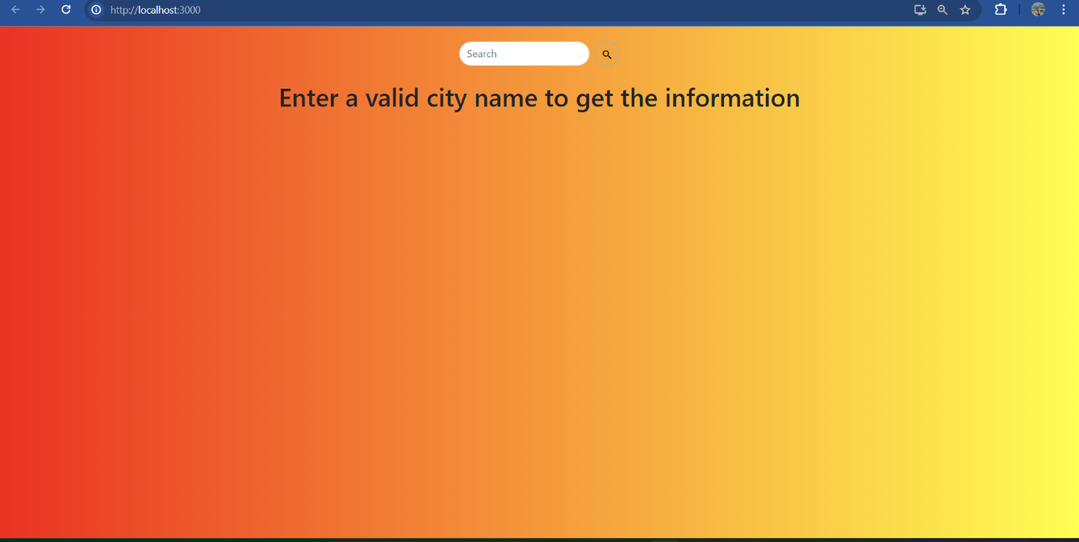

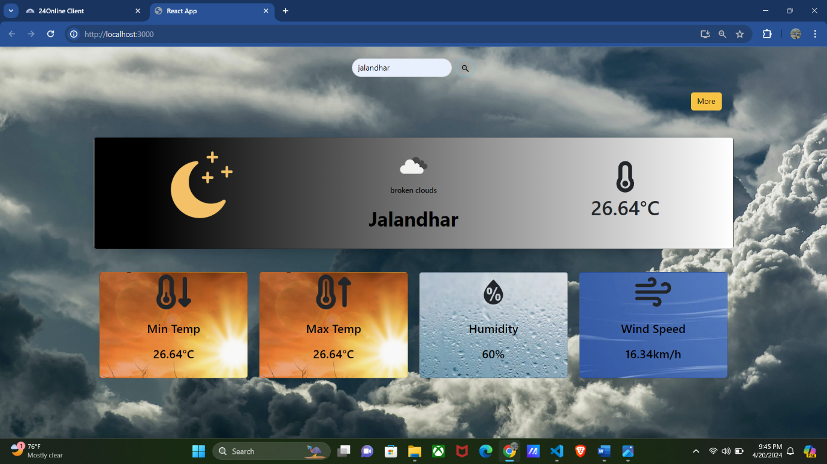

**Conclusion and Future Scope**

The conclusion and future scope of the Weather Forecast Application project encapsulate the key findings, achievements, limitations, and potential areas for further development and enhancement.

**Conclusion:**

1. Development of a Functional App: The project has successfully developed a fully functional Weather Forecast Application that provides users with accurate and up-to-date weather information.

2. Enhanced User Experience: The app offers a user-friendly interface, intuitive navigation, and personalized features, ensuring a seamless and satisfying experience for users seeking weather forecasts.

3. Integration of Key Features: Essential features such as location-based weather forecasts, hourly and daily forecasts, interactive maps, and customizable settings have been integrated into the app, providing comprehensive weather information to users.

4. Adherence to Best Practices: Throughout the development process, best practices in software development, user interface design, and data management have been followed to ensure the app's reliability, performance, and security.

5. Positive Feedback and Testing Results: User feedback and testing results have been positive, indicating that the app meets user expectations and performs well in delivering accurate weather forecasts.

**Future Scope:**

1. Expansion of Features: Additional features such as severe weather alerts, historical weather data, integration with smart home devices, and personalized weather notifications could further enhance the app's functionality and user experience.

2. Enhancement of Data Accuracy: Continual improvement of data sources, algorithms, and data processing techniques to enhance the accuracy and reliability of weather forecasts, especially in regions with limited data availability or extreme weather conditions.

3. Integration with External Services: Collaborating with external providers such as transportation companies, event organizers, and outdoor activity platforms to integrate weather forecasts into their services and enhance user experience.

4. Localization and Globalization: Adapting the app to support multiple languages, units of measurement, and regional weather conventions to cater to a diverse global audience.

5. Continuous Improvement: Ongoing monitoring of user feedback, analysis of app usage data, and iterative improvements to address any issues, optimize performance, and incorporate new features based on evolving user needs and technological advancements.

In conclusion, the Weather Forecast Application project has laid a solid foundation for delivering accurate and reliable weather forecasts to users. By embracing innovation, collaboration, and continuous improvement, the app can further enhance its value proposition, expand its user base, and remain competitive in the dynamic weather forecasting market.

**Plagiarism report**

The plagiarism report serves as a comprehensive evaluation tool to assess the originality and authenticity of academic work, ensuring adherence to ethical standards and scholarly integrity. This report meticulously analyzes the submitted document against an extensive database of existing literature, identifying similarities and matches with previously published material.

Through advanced algorithms and text-matching techniques, the plagiarism report highlights any instances of content duplication, citation errors, or improper paraphrasing. It provides a detailed breakdown of detected similarities, categorizing them based on source type and degree of resemblance. Additionally, the report offers insights into the percentage of text similarity and generates a visual representation of matched text segments for easy reference.

By generating a plagiarism report, educators, researchers, and students gain valuable insights into the originality of their work, enabling them to address any areas of concern and uphold academic honesty. This report fosters a culture of academic integrity, emphasizing the importance of proper citation practices and independent scholarship in scholarly endeavours.

**GitHub link: github.com/Bhargav0326/Weather-App**