Day-2 : 11/16/2021 Training
Team :
- Bhargav Mandadi
- Durga Phukan
- Amit yadav
- Pritam patra
- Ankit rawat

Entity Rationship Diagram :

An Entity Relationship (ER) Diagram is a type of flowchart that illustrates how “entities” such as people, objects or concepts relate to each other within a system.

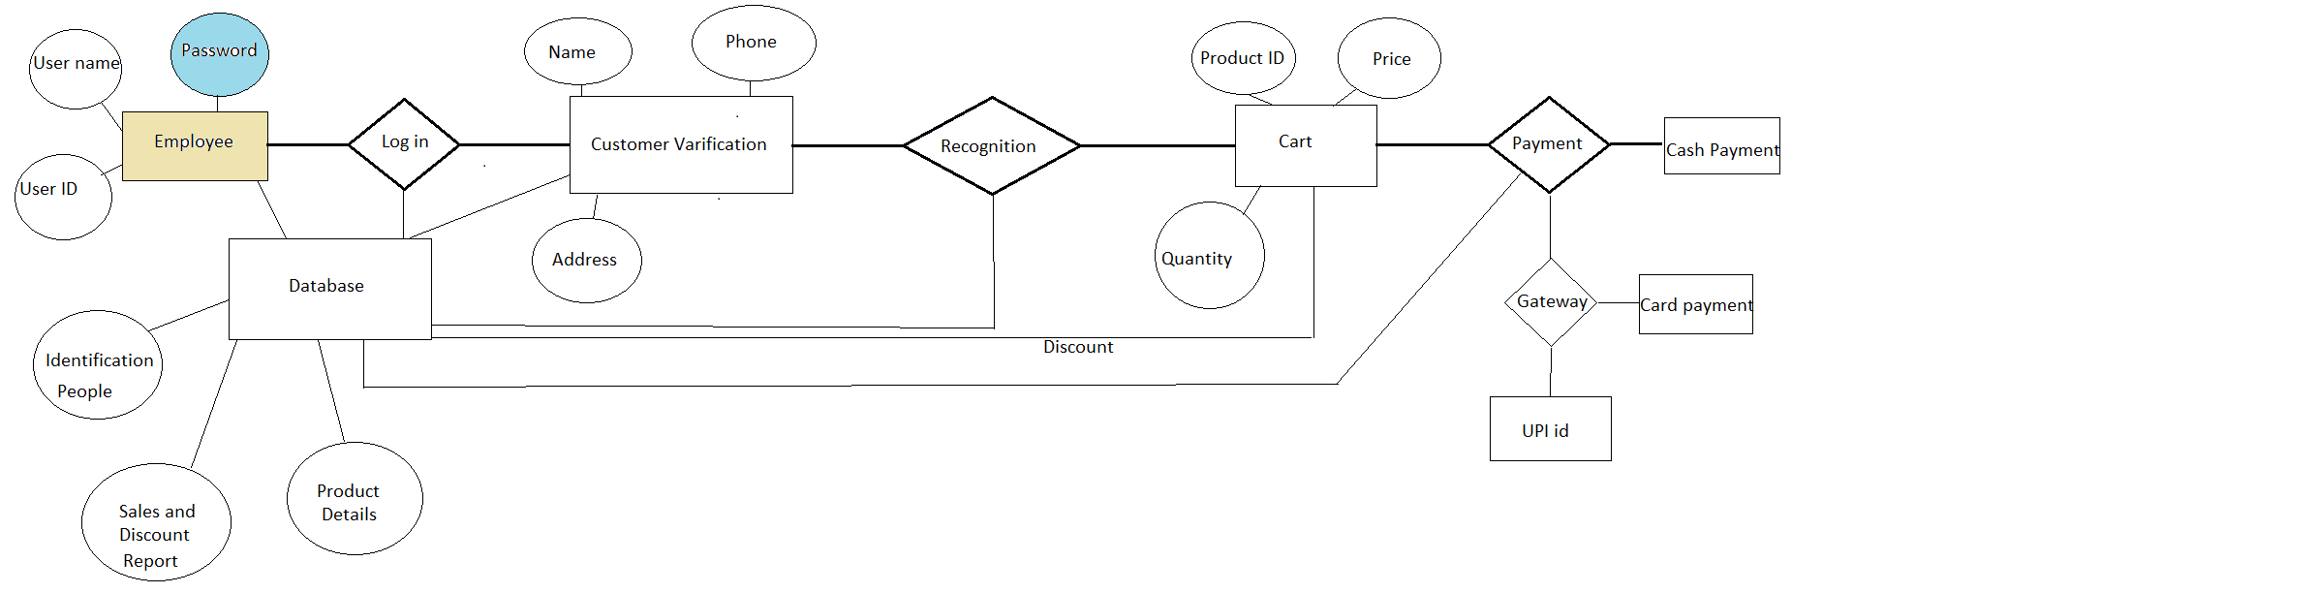

Data Flow Diagram :

A data flow diagram (DFD) illustrates how data is processed by a system in terms of inputs and outputs. As its name indicates its focus is on the flow of information, where data comes from, where it goes and how it gets stored.

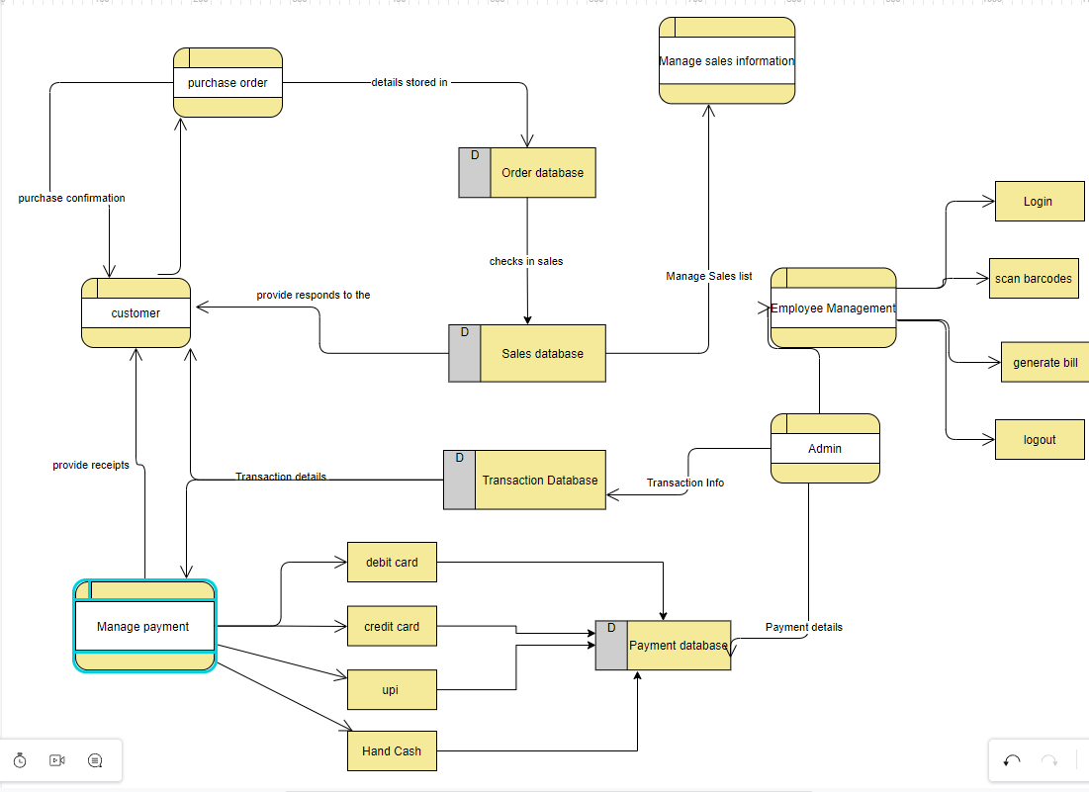

Activity Diagram:

An activity diagram shows business and software processes as a progression of actions. These actions can be carried out by people, software components or computers. Activity diagrams are used to describe business processes and use cases as well as to document the implementation of system processes.

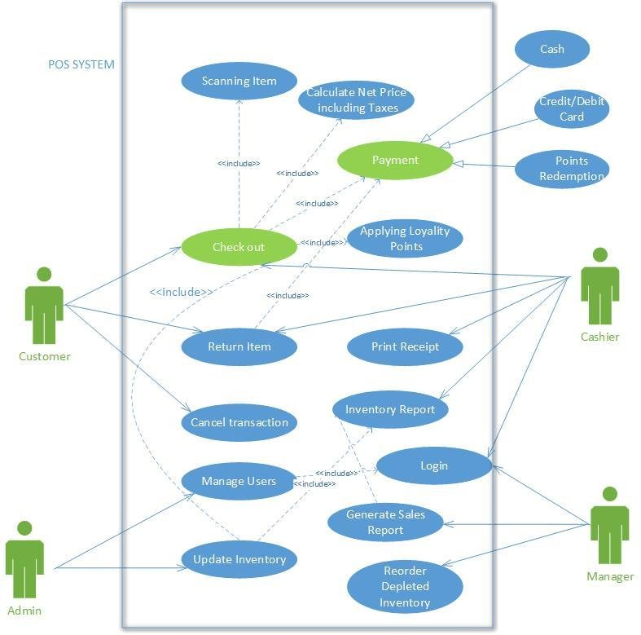

Testing

- Black box testing :

Black box testing is a type of testing the tester don’t known about any internal structre of the functionality . it is like a behavioural testing and the boundary value analysis.
Ex: whether it take valid inputs or not , syntax testing like varible declaration etc.

- White box testing:

White box testing is nothing but the tester should aware of the internal functionalities , White box testing involves looking at the structure of the code, it includes

- Loop testing
- Class testing
- Path testing etc.

- Regression testing:

This type of testing verify that the functionalit of previously tested are not changed even they add some other functionalities to it . The product or software works fine after adding the new functionality.

- Smoke testing:

Smoke testing is the one of the popular software testing services performed after software build to find the critical functionalities of the program are working fine . It verify whether the important features are working. It is a confirmation for QA team to process with further software testing.

- Alpha testing:
The focus of this testing is to done on an application towards the end of a development process when the product is almost in a usable state. This testing is used by highly skilled testers.

- Beta testing:

It’s performed by real users of the software application in a real enviroment. It’s a type of acceptance testing . When feed back is needed, is released to a limited number of the end-users of the product to obtain feedback on the product quality. Major advantage of the this testing is direct feedback from customers to increase better functionalities of the system.

- System testing:

It’s a tpe of software testing that is performed on a complete integrated system to evaluate the compliance of the system .
In this testing , integration testing passed components are taken as input. System testing detects defects within both the integrated units and the whole system.

- Stress testing:

The most prominent use of stress testing is to determine the limit, at which the system or software or hardware breaks. It’s also known as edurance testing.

- Performance testing:

The goal of performance testing is not to find bugs but to eliminate performance bottlenecks .

Speed -> whether the application responds quickly.

Scalability -> determines maximum user overload the software application can handle.

Stability -> determines if the application is stable under varying loads

