AWS LAB WEEK-2

Name: Bhargav Mandadi
Email: bhargav_mandadi@thbs.com

Task:-1 : S3 BUCKET CREATION

Click on the option create bucket to create the s3 bucket.

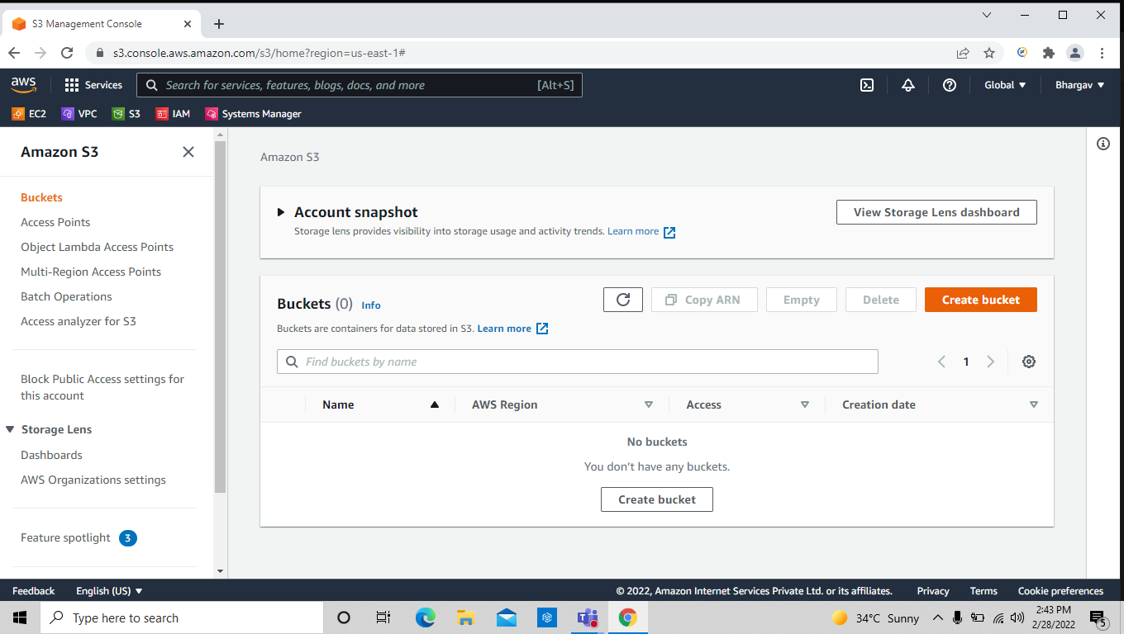
2) give the name of the bucket , it should be unique and this bucket has been created in global wise so it must be unique.

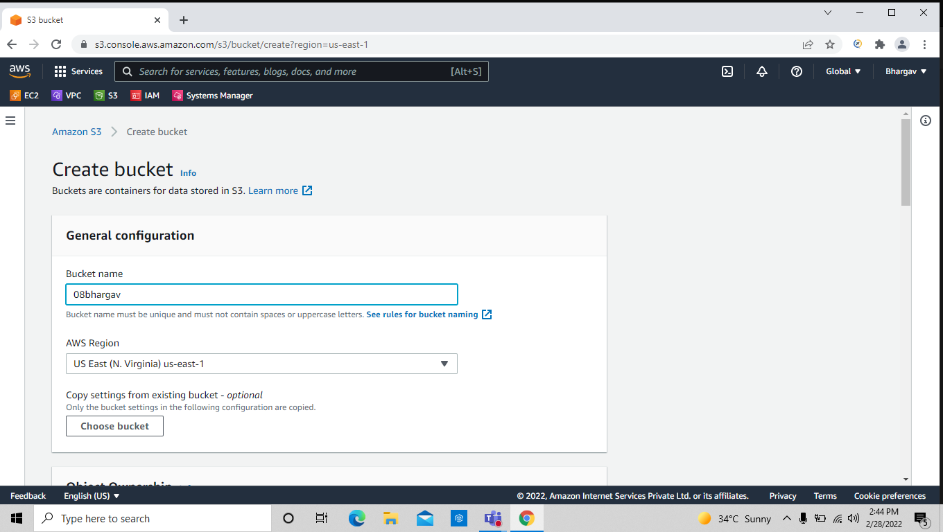
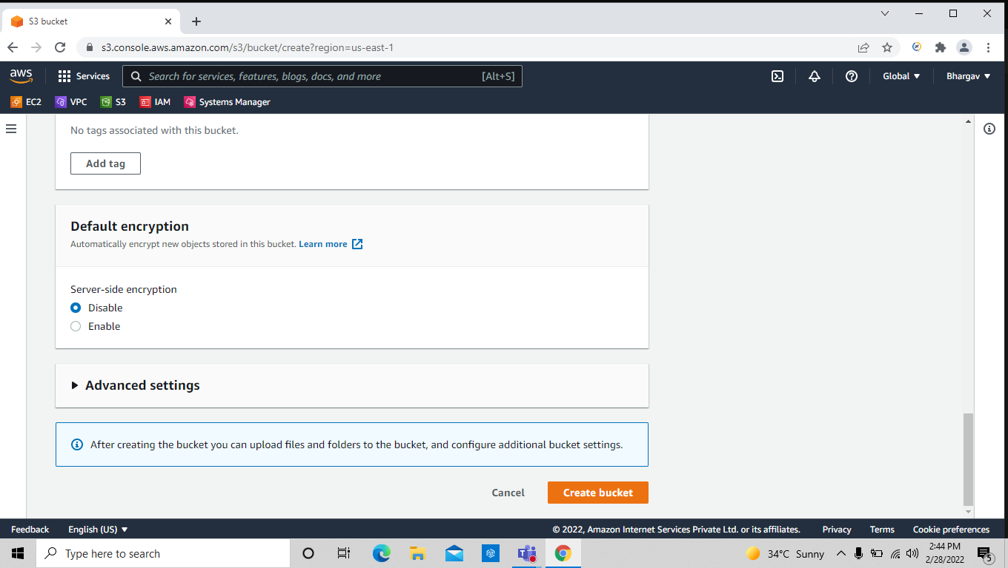

3) Delete the bucket

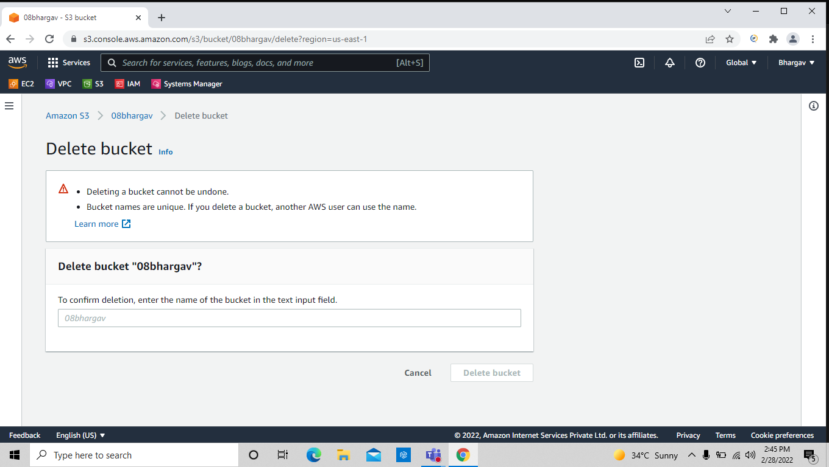
Task-2: Upload objects into the bucket

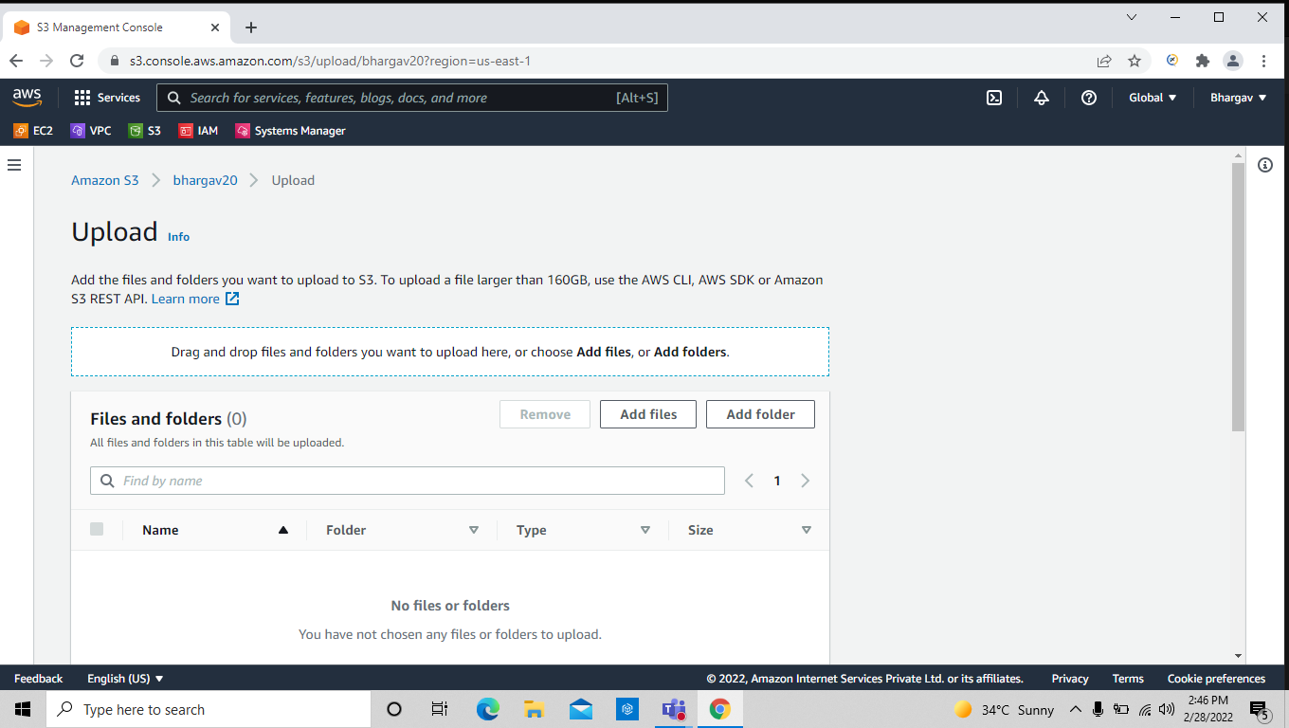

1) click on the upload then click on the add files to upload object .

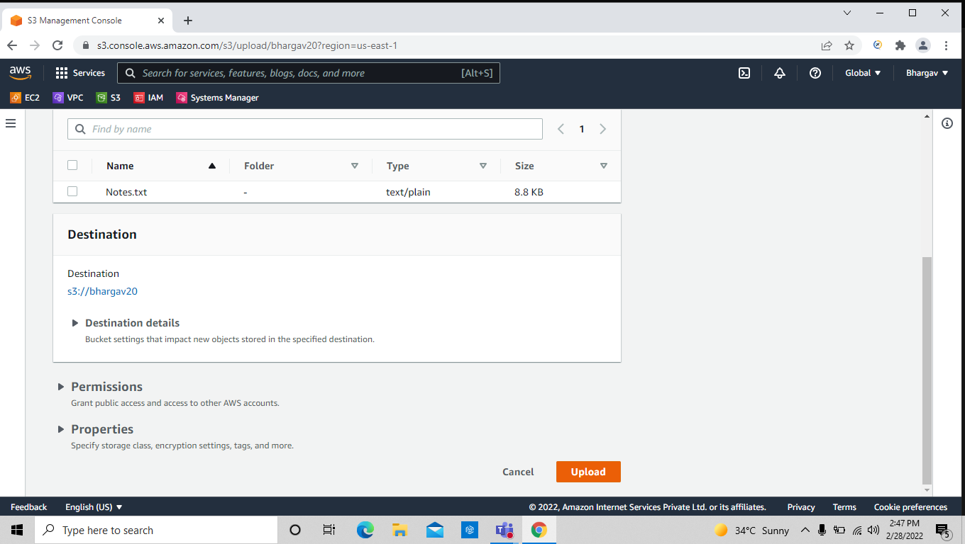
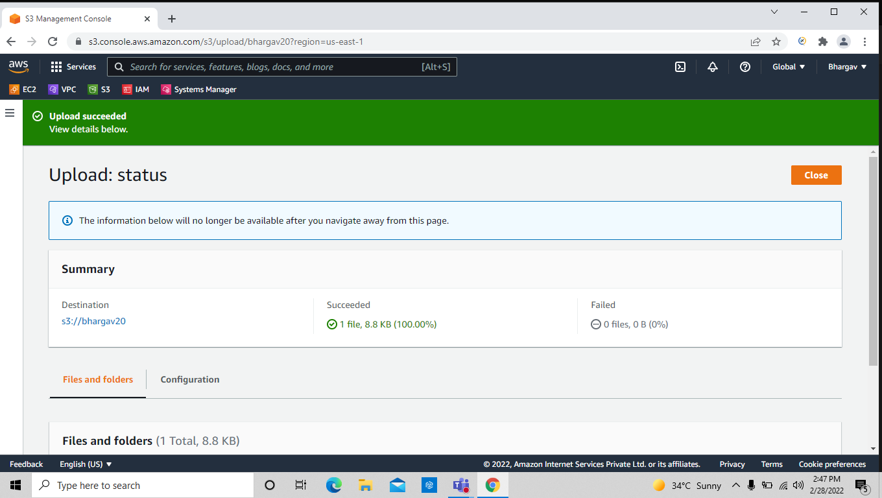

3) The above files are uploaded with out enabling the bucket versioning

Now we have to see the bucket versioning enabled .

Go to properties and enable the bucket versioning and then upload the file and click on show version & see the below files version id

by default if we hasn’t enable the versioning those files versions should be considered as null .

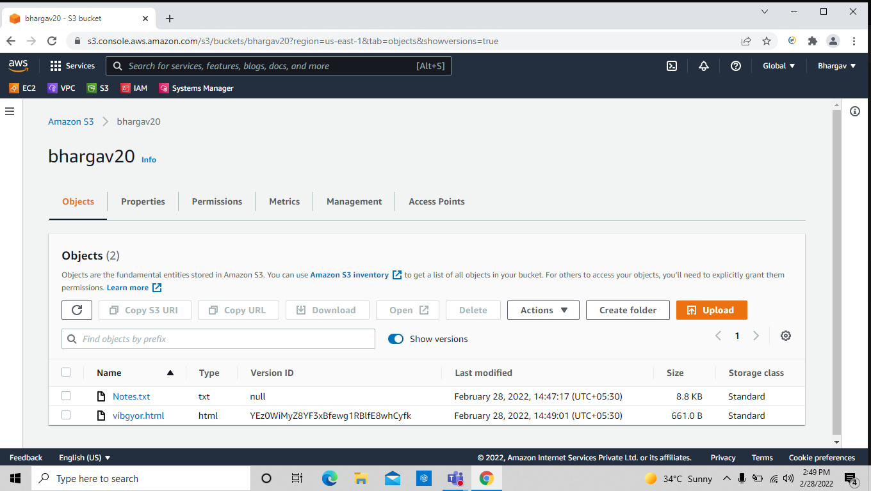

Task-4: Enabling encryption and uploading the object

by default it has been disabled just click on enabled.

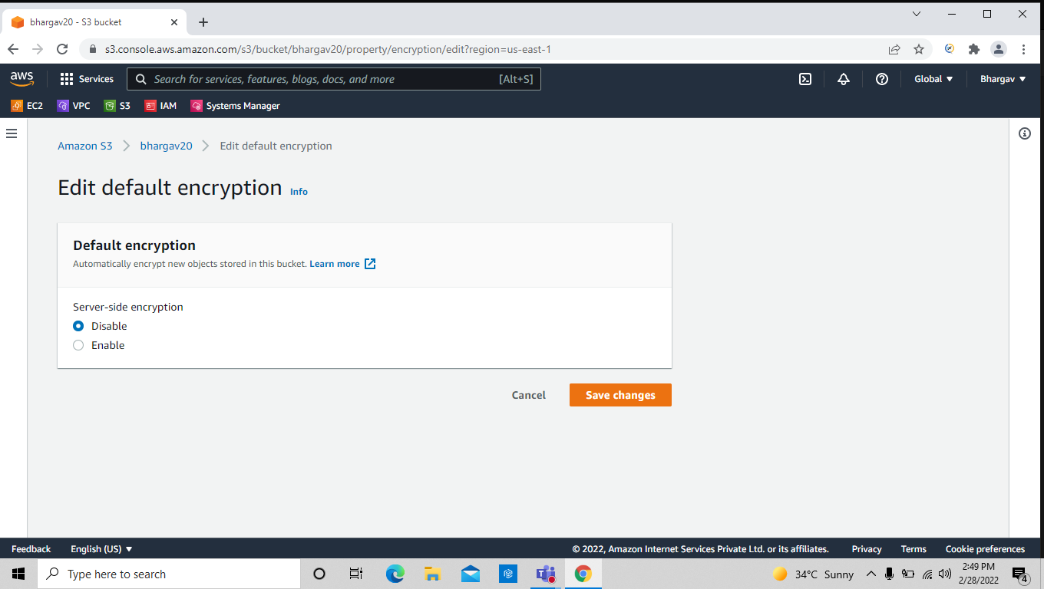

Task-5 : Creating the bucket policies to all users

go to the permission and click on policy generator to make a new policy

here we have been created a bucket policy as server-side-encryption

while the object has been uploaded then it checks the condition whether the object is encrypted or not if encrypted then the file has been uploaded successfully otherwise it won’t upload the object .

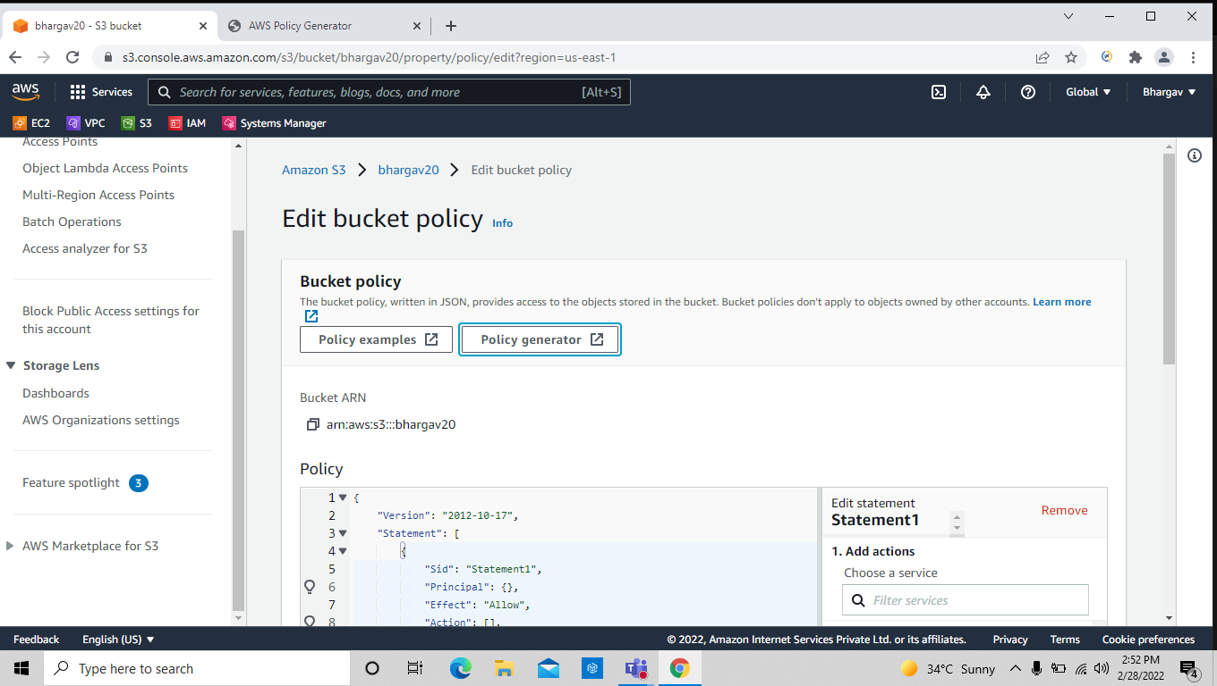
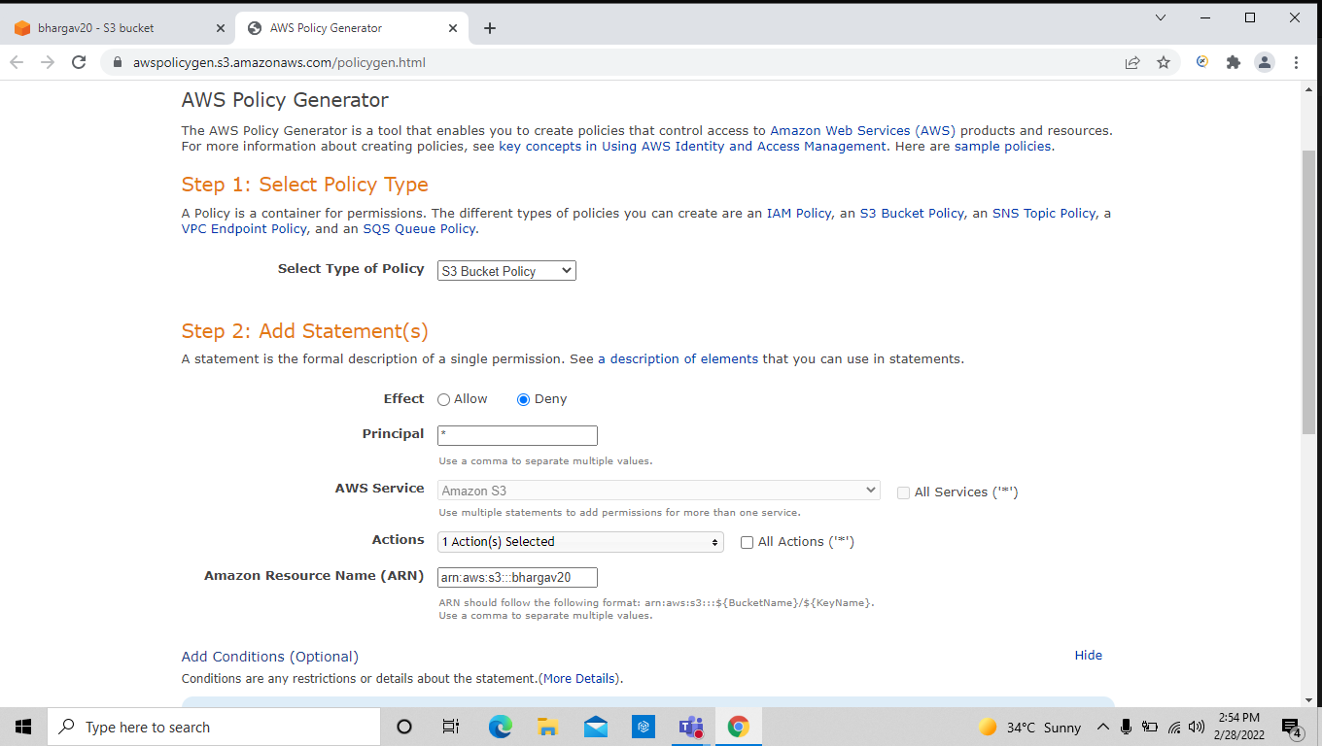

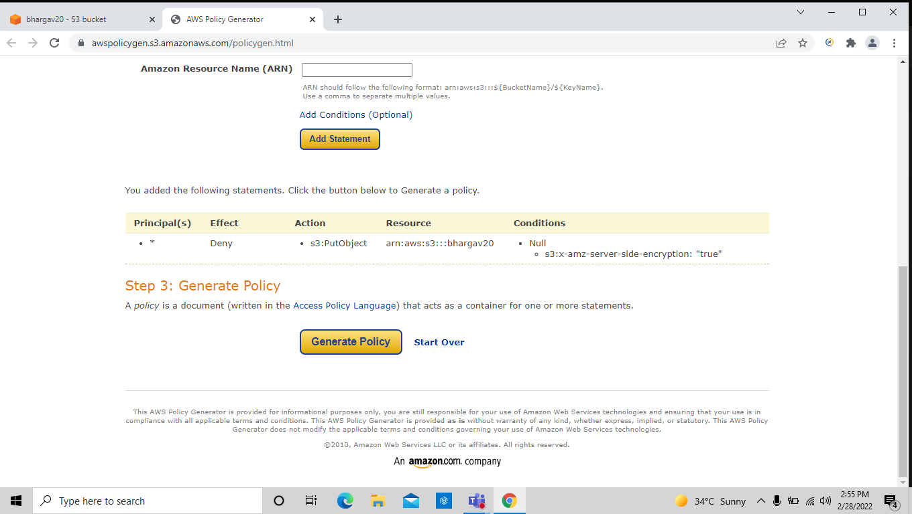
*) condition applying for server-side encryption

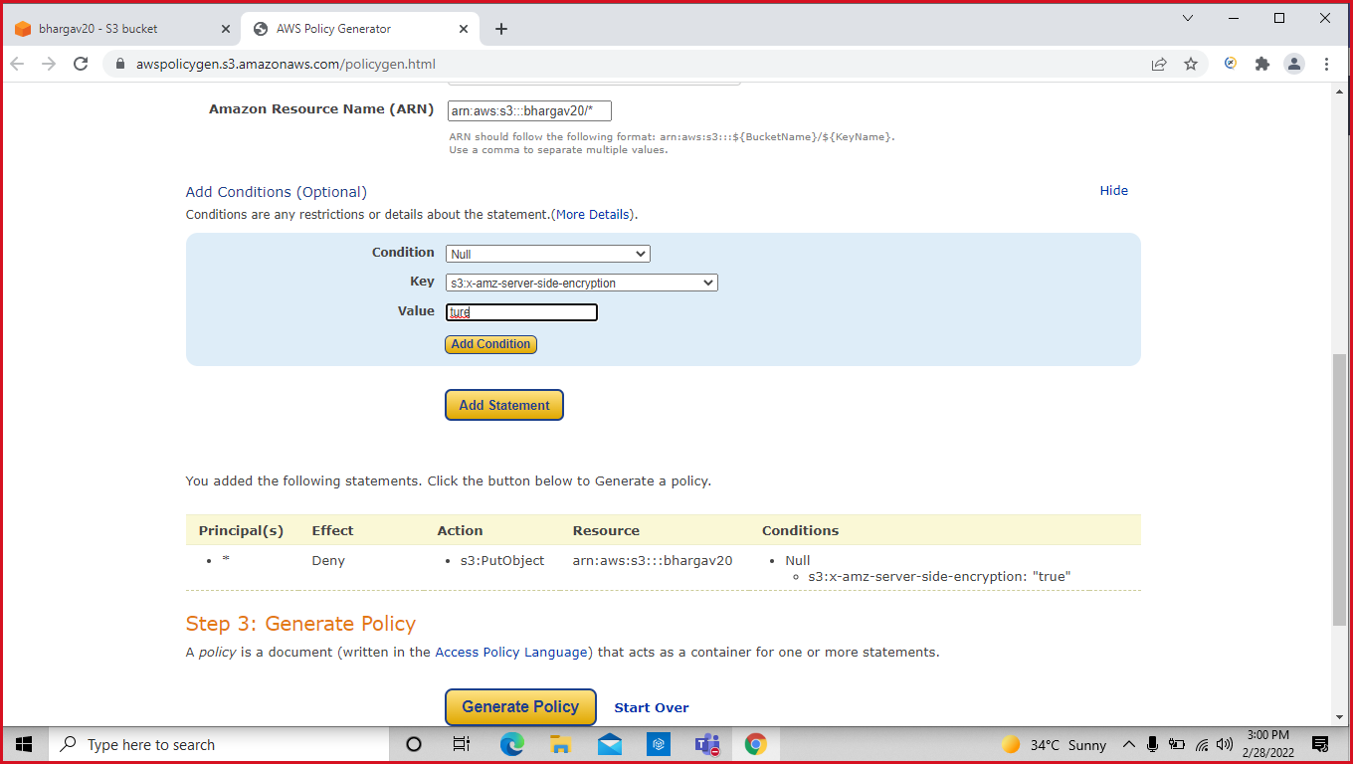

Here the file has been uploaded , because the encryption option enabled .

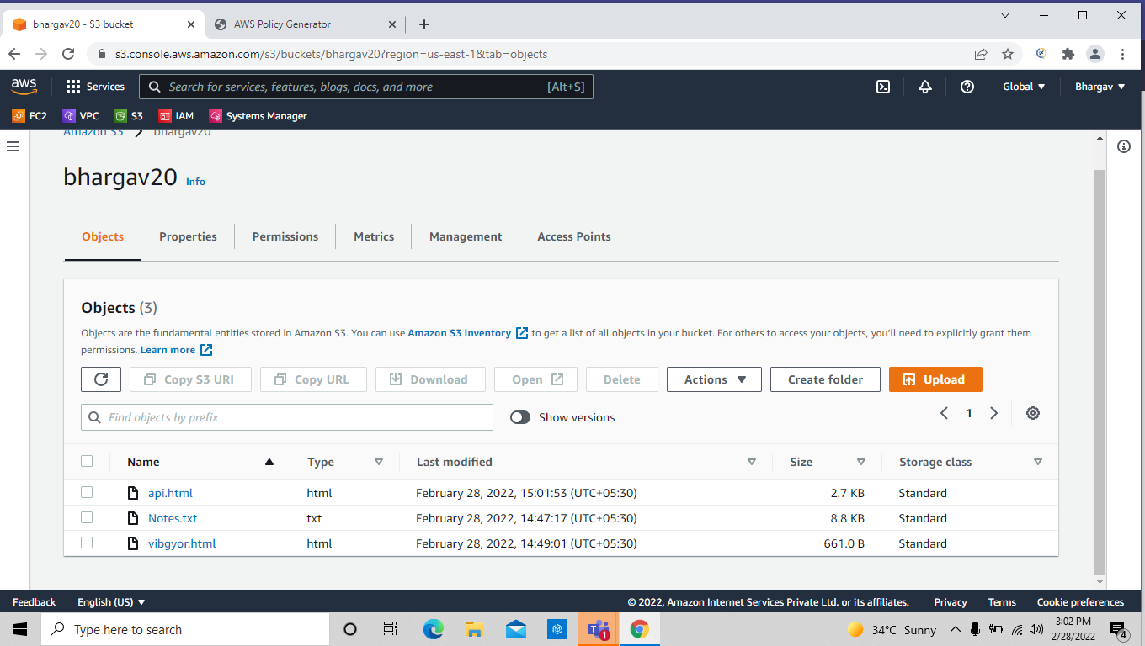
==> I have changed the encryption to disable then see what’s happens

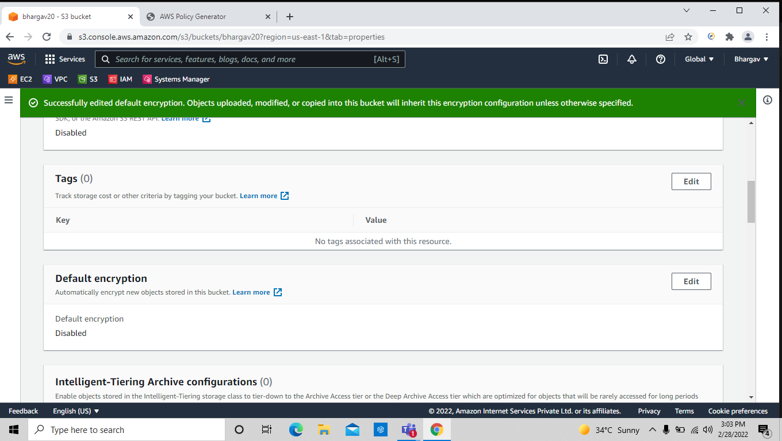

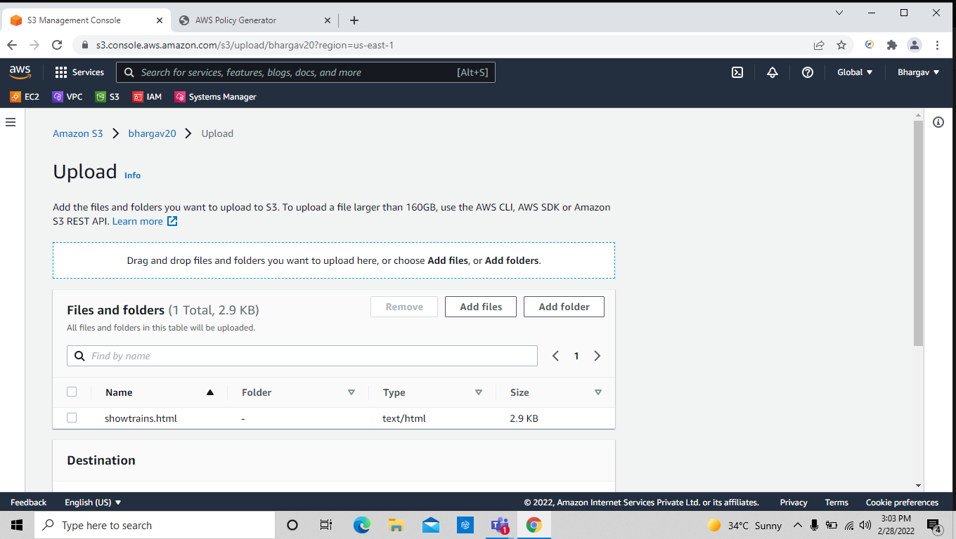
see the below picture object hasn’t allowed to upload , because it doesn’t have a server-side-encryption.

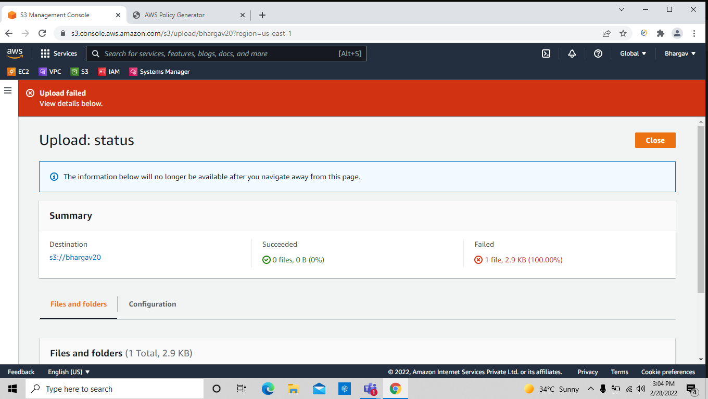

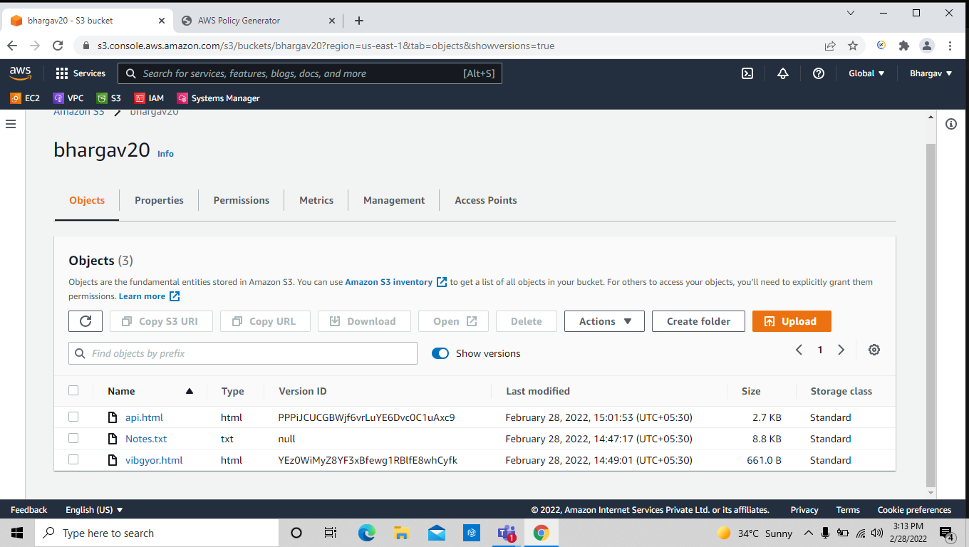
Task -6: Creating storage management .

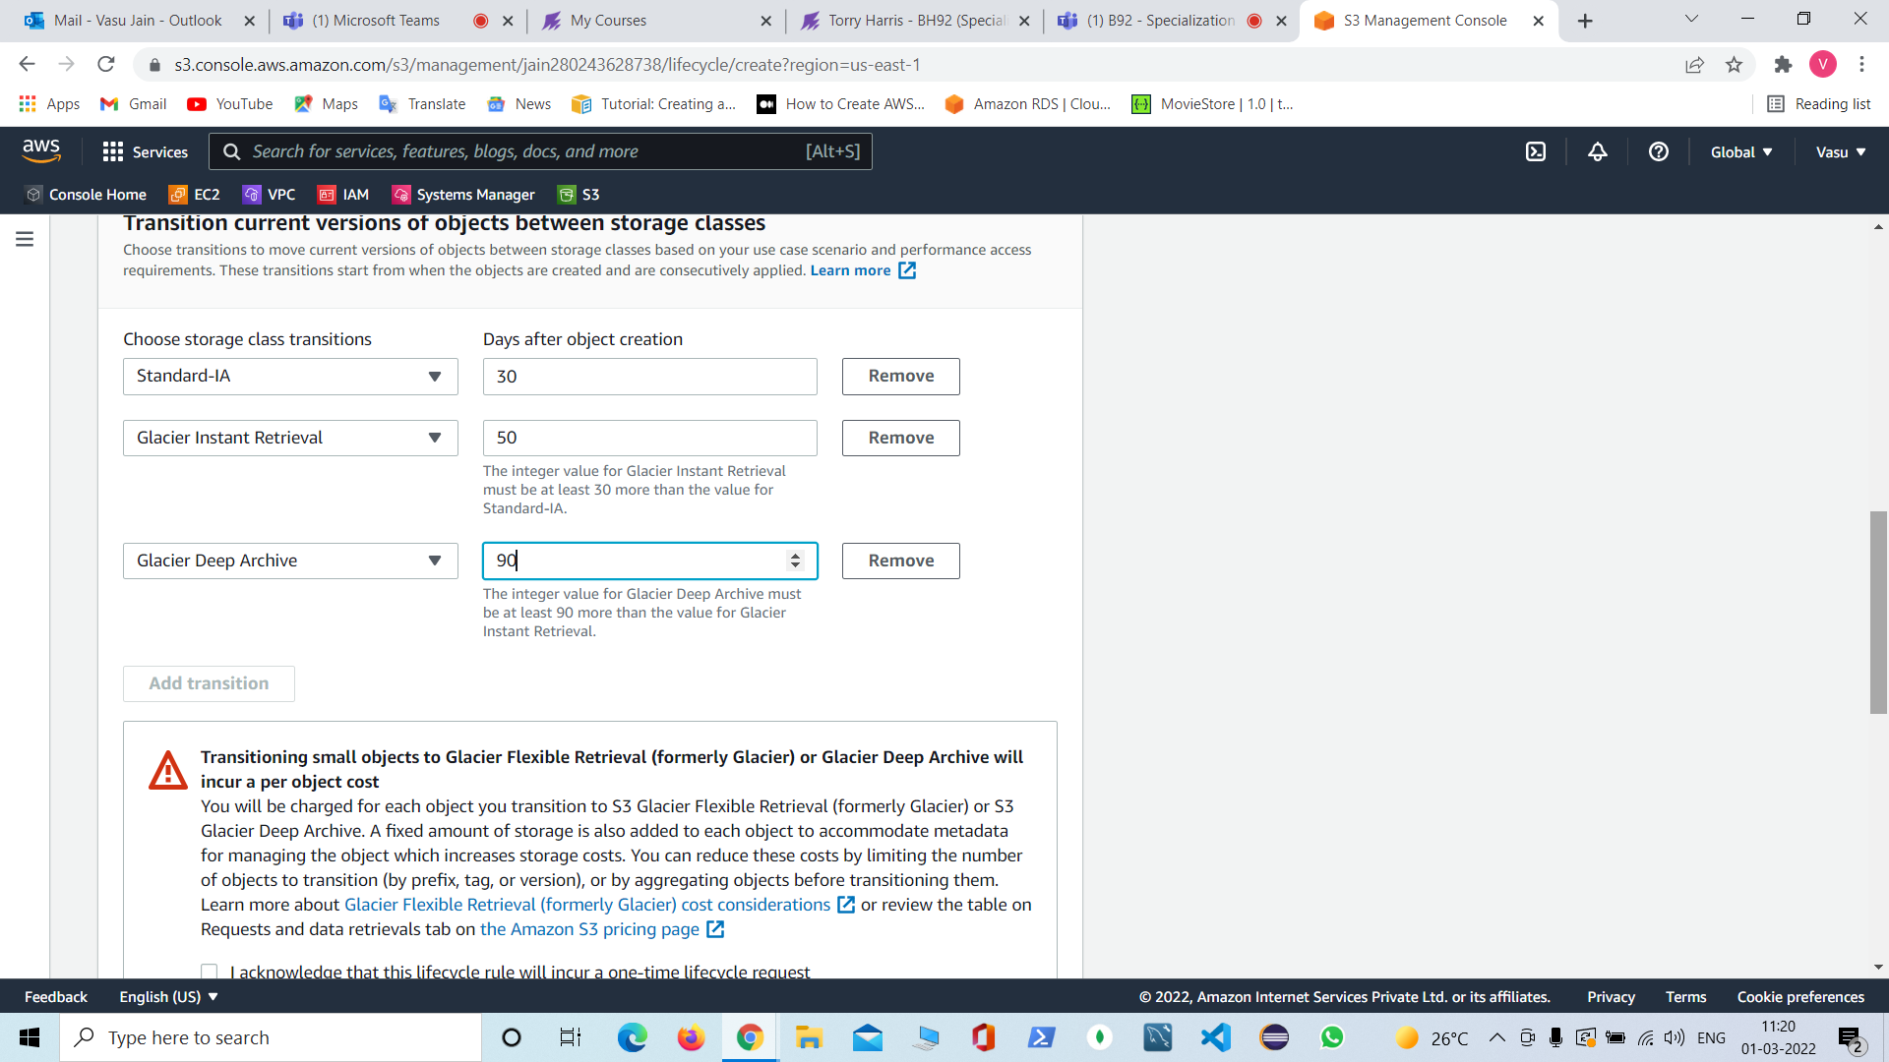

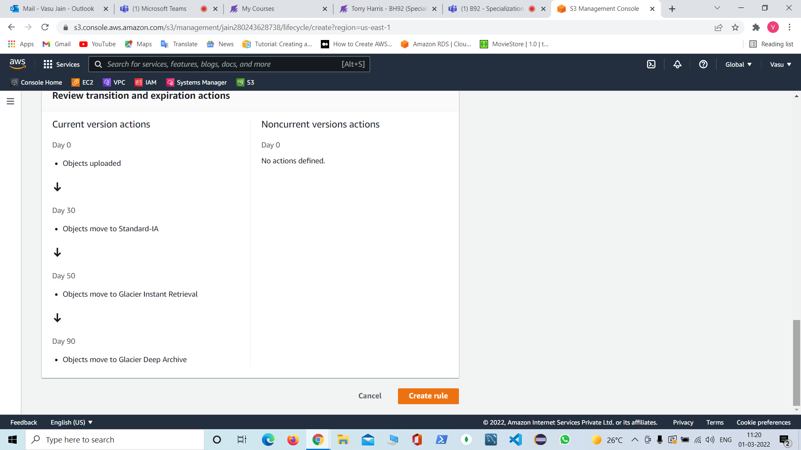

Task-7: Enabling the object lock for retention and access control and to the public

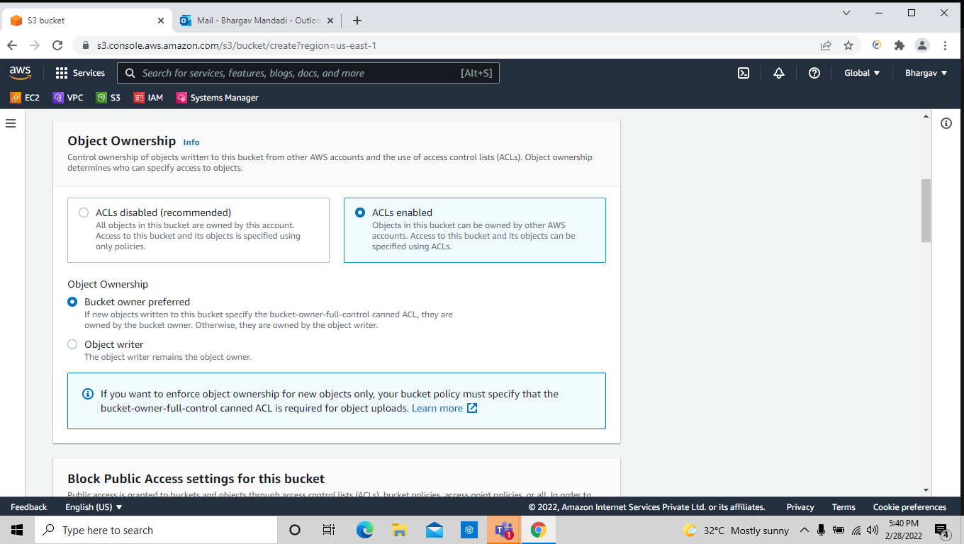

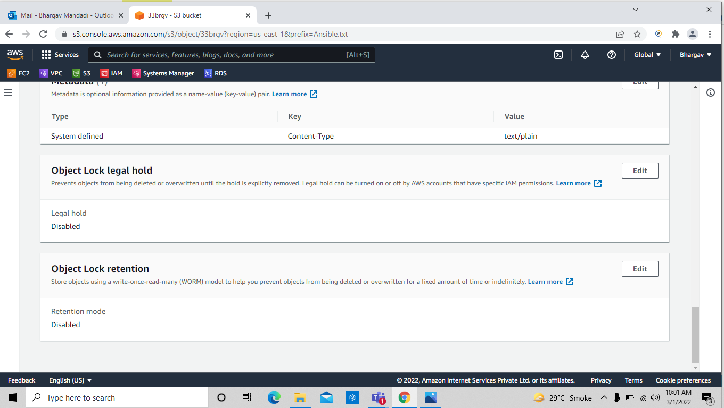
edit object lock retention to provide the object lock

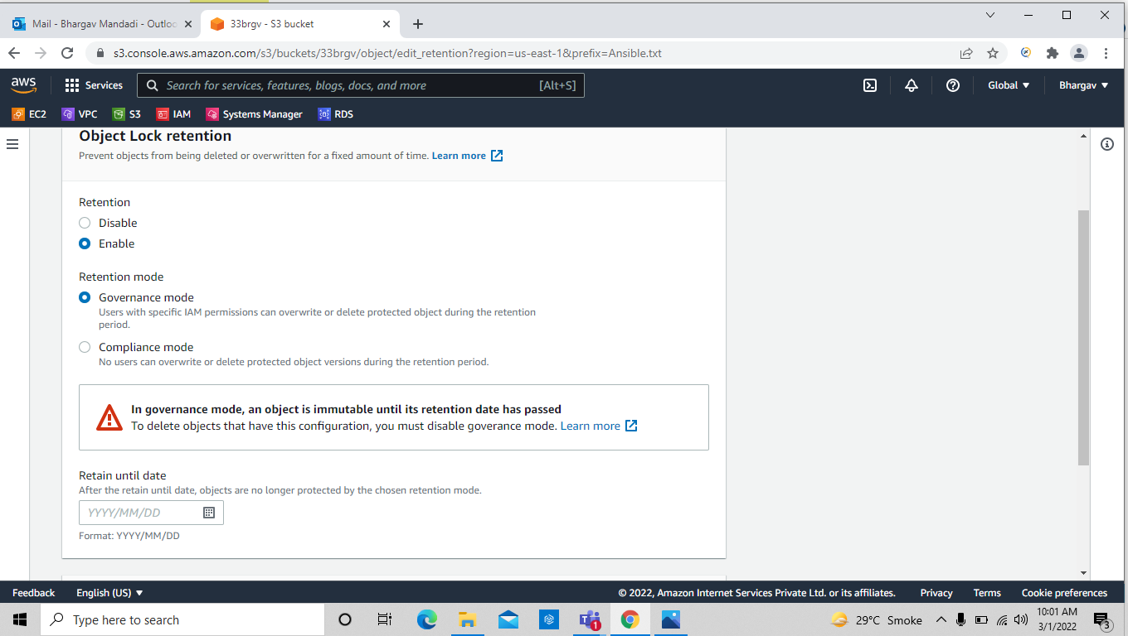

Task :-8 : allowing the public access we have already enabled the access control in the above ss ( acls) , un check the block all public access in the below screen shot

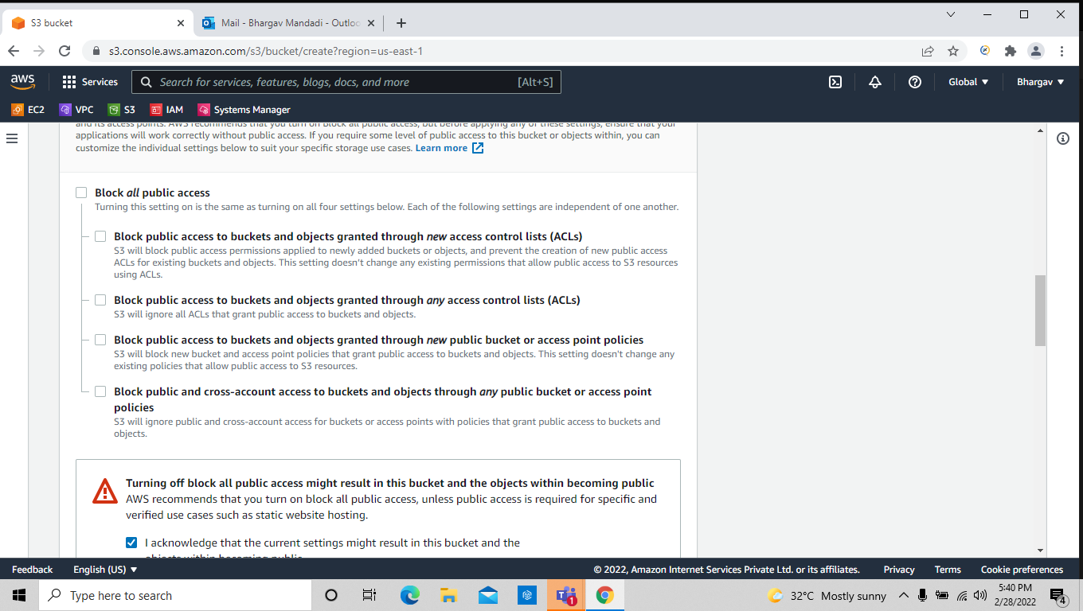
Then set the policy for the public access

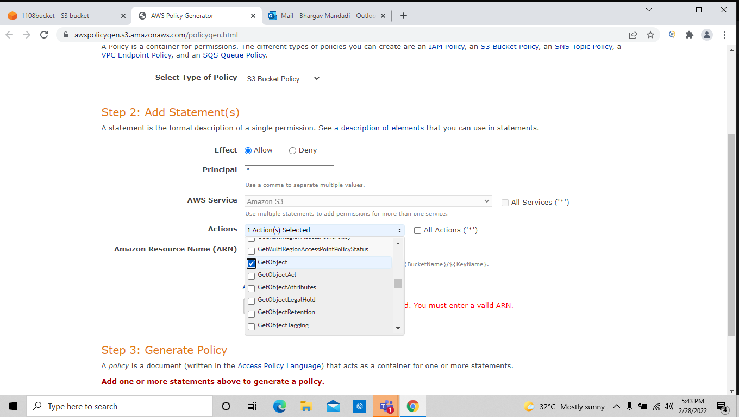

when the object has changed to public then it appears on the bucket with that bucket has publically accessible.

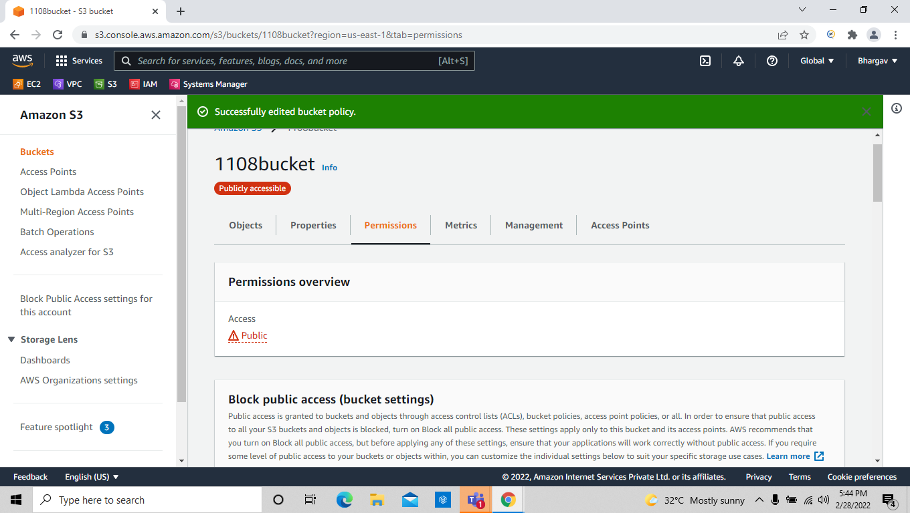
Then copy the object url and paste it on the browser and see whether it is accessible or not



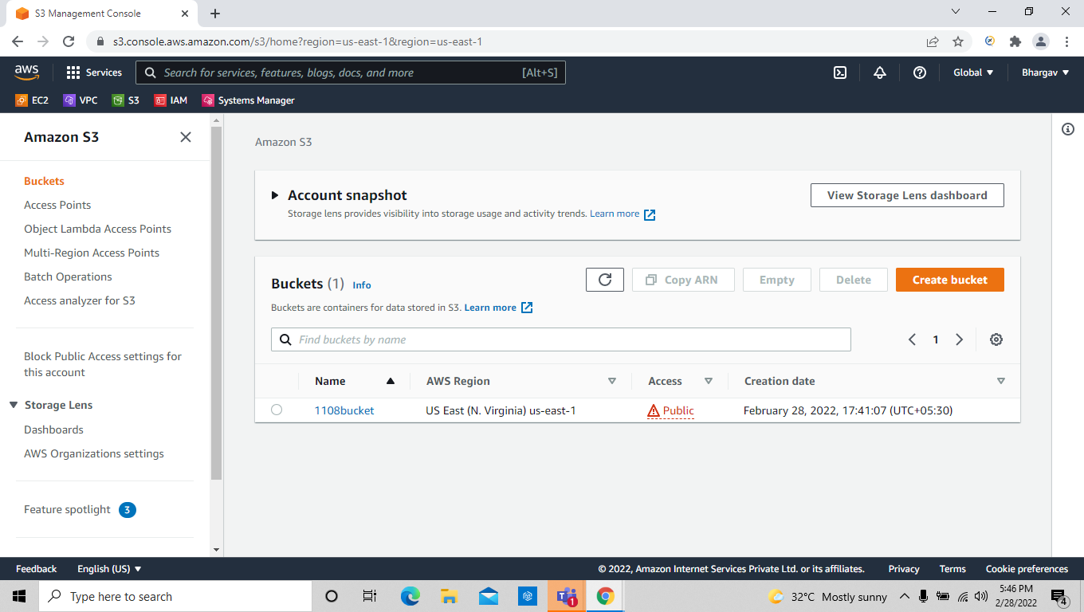

Task : -9: Static website hosting .

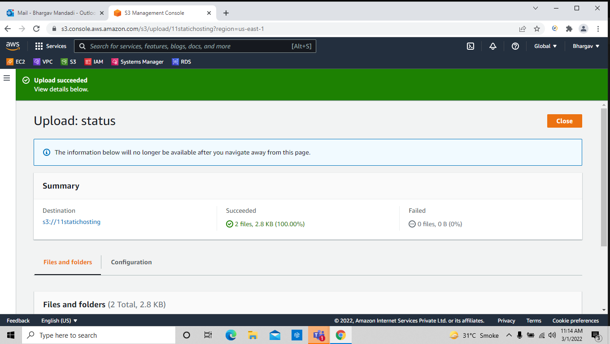
Uploaded 2 files webpage and error page .

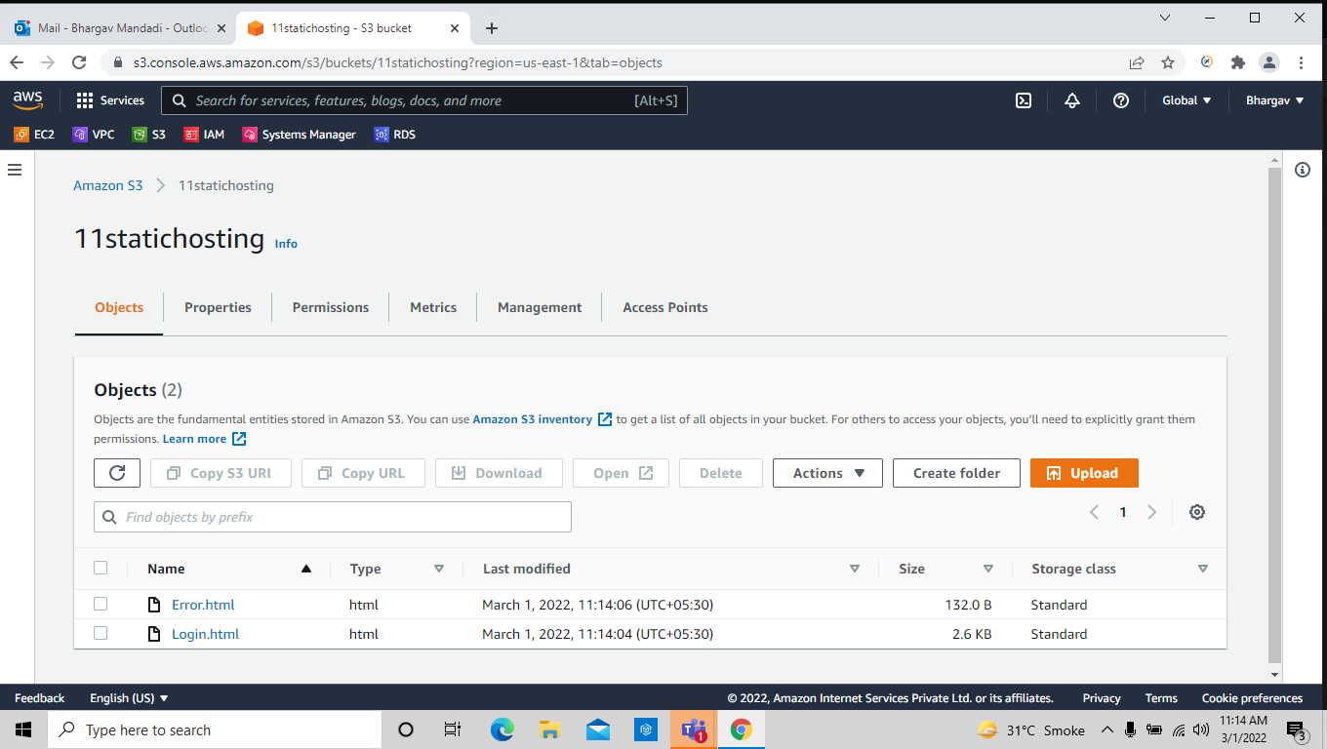
Go to properties and edit static website hosting and enable and give the index html and error message

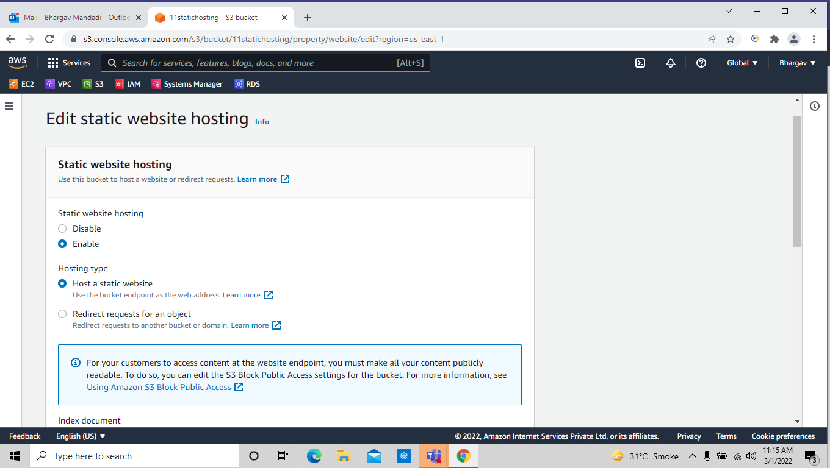

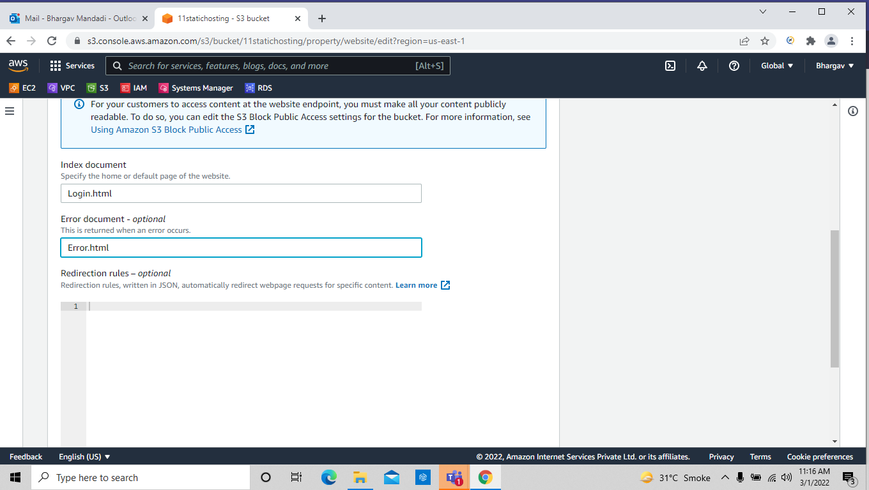

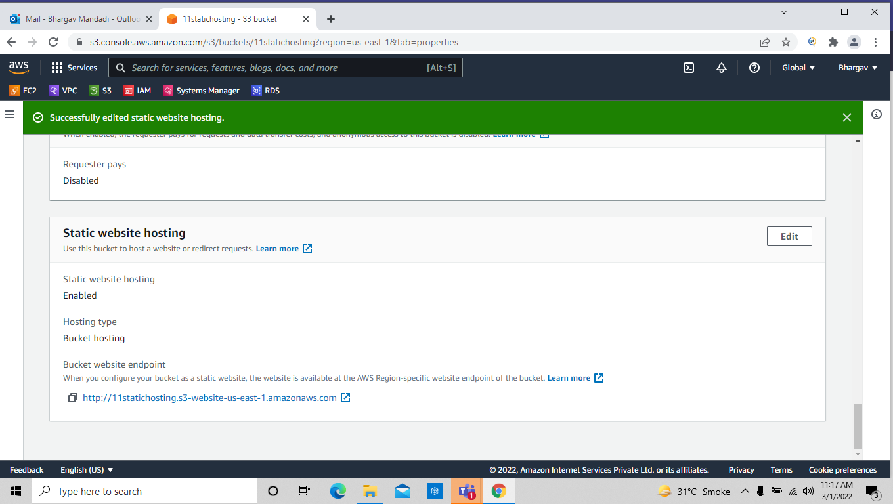
copy the bucket website endpoint to test the website

create the policy for public access

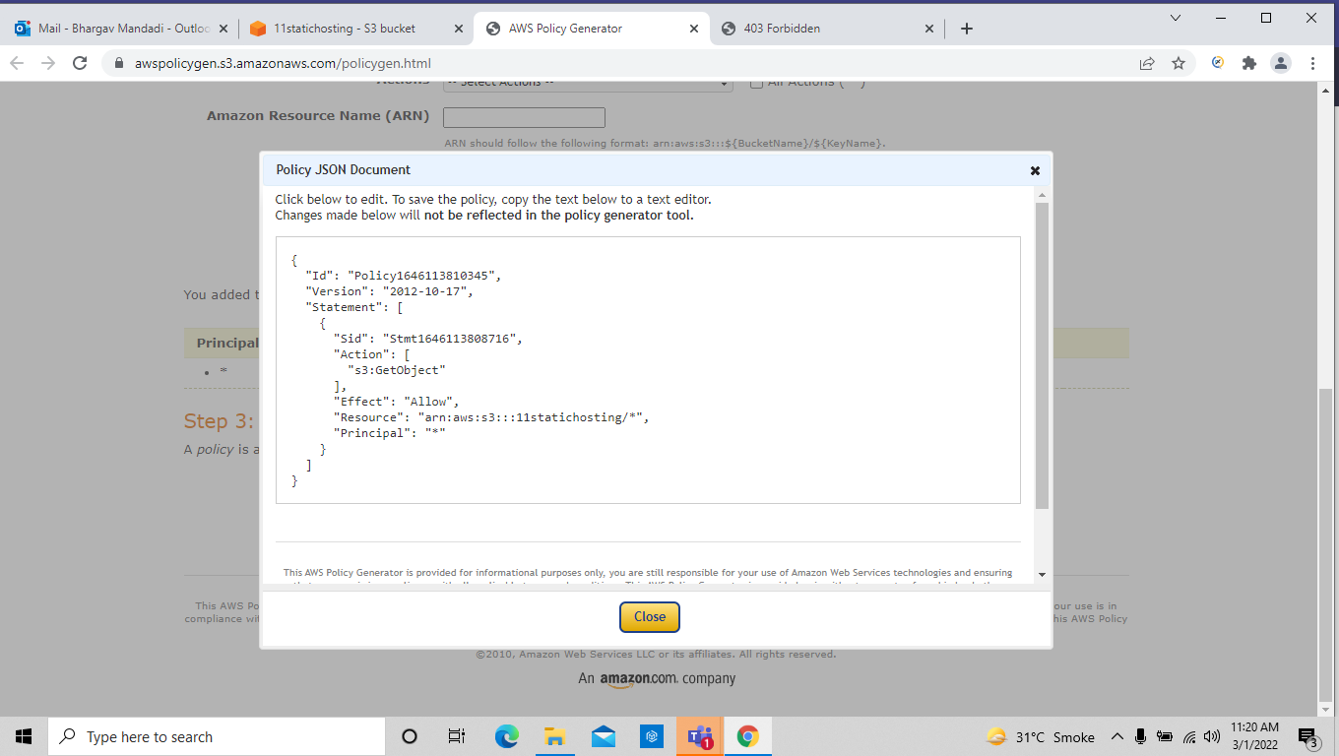
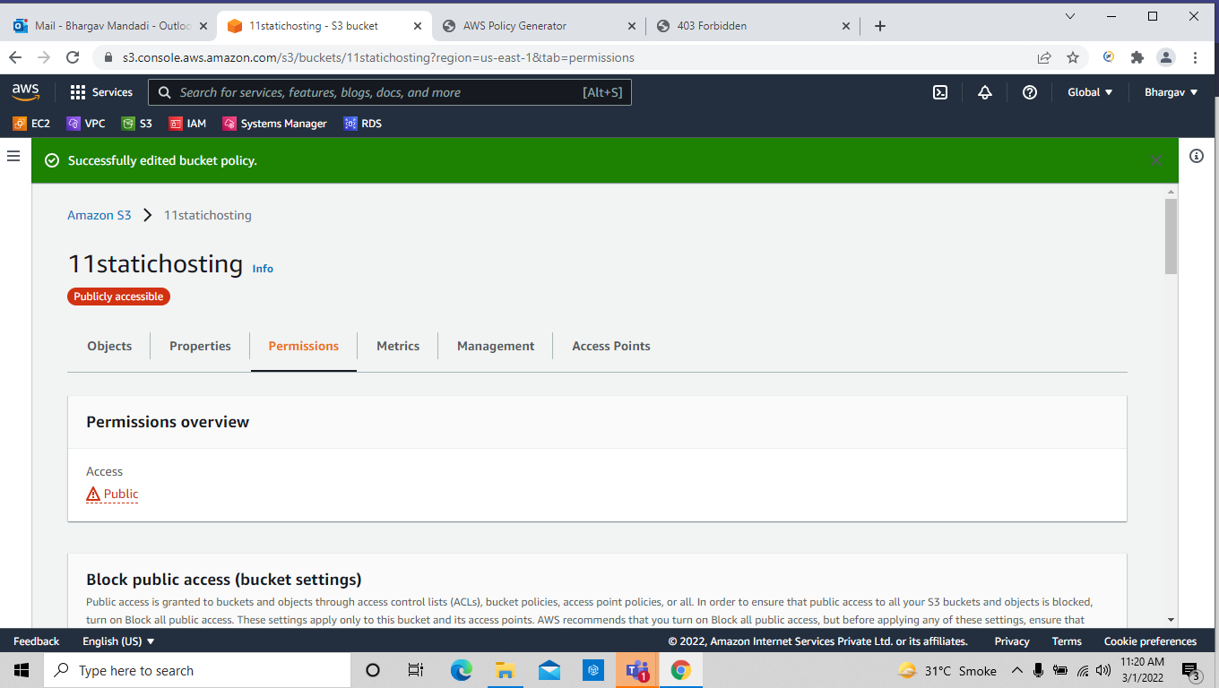

See this is the file I have uploaded and it’s working

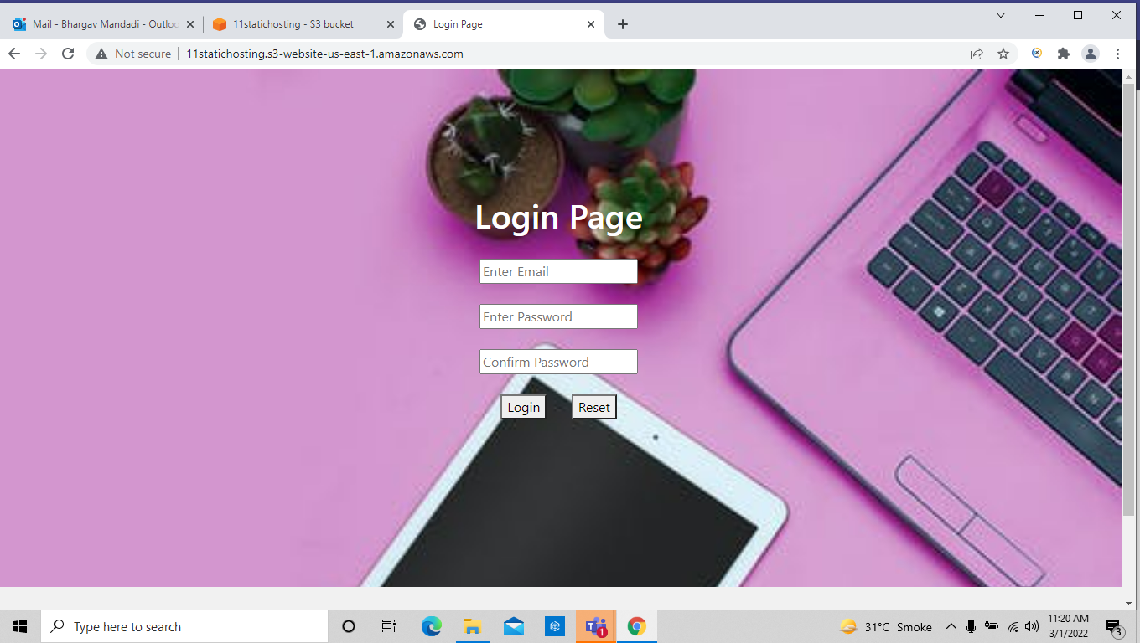
let me change my login file name to some other and then we could see the error message

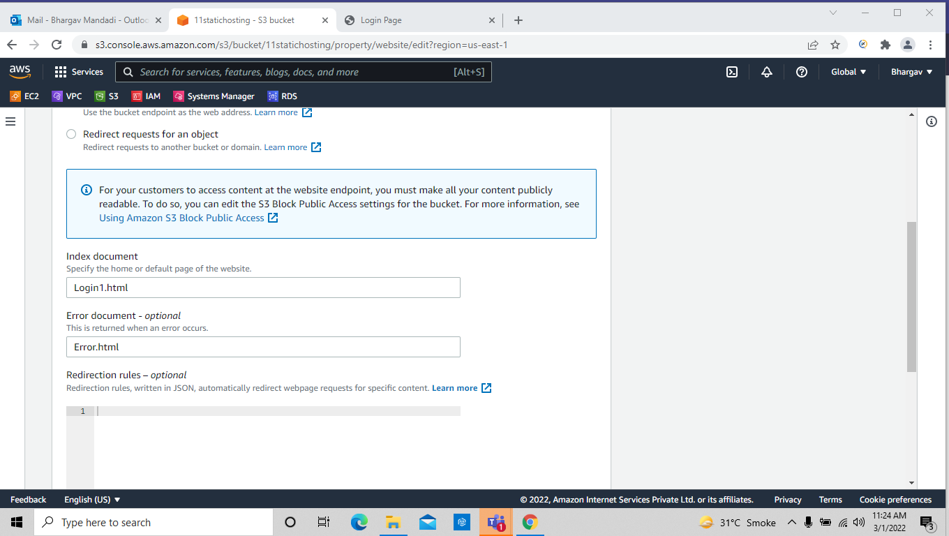

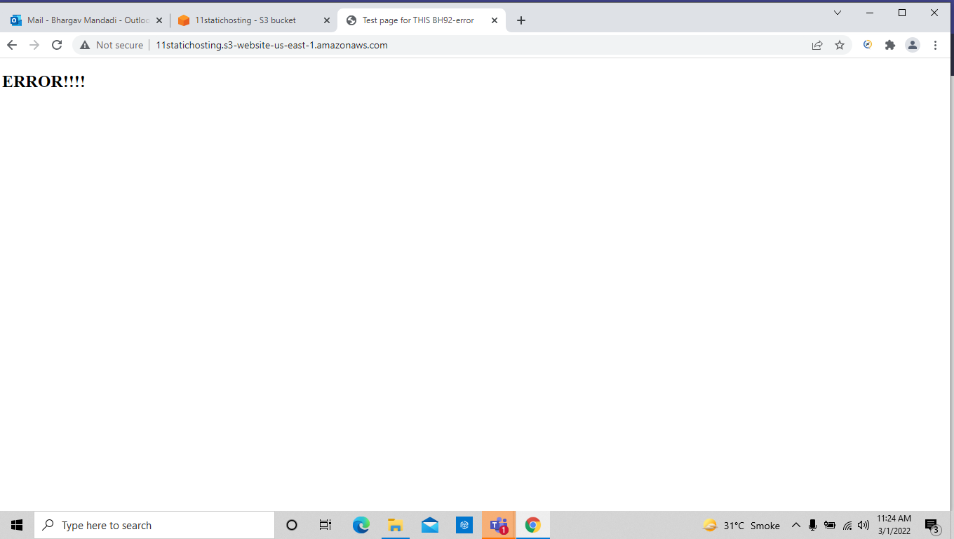

Task-10: Creating load balancer

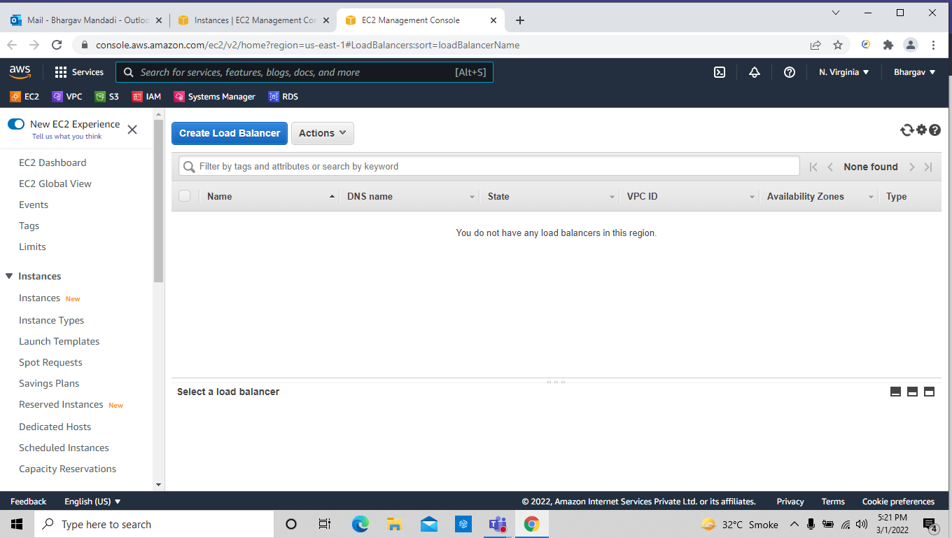

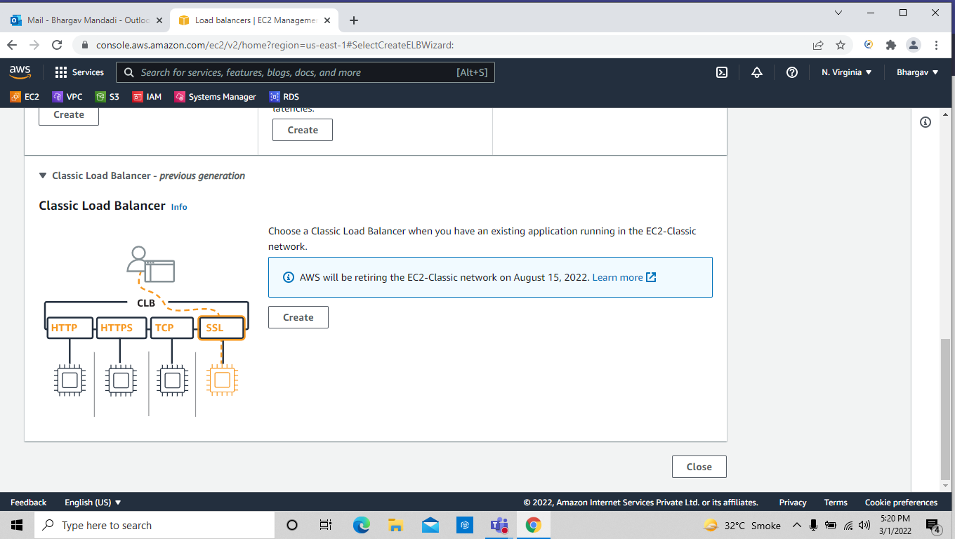
click on create

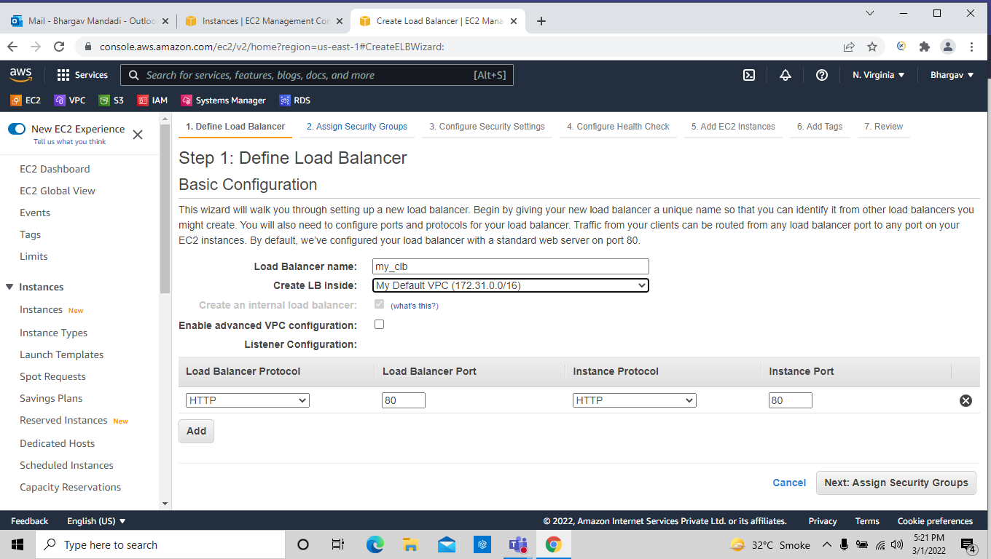

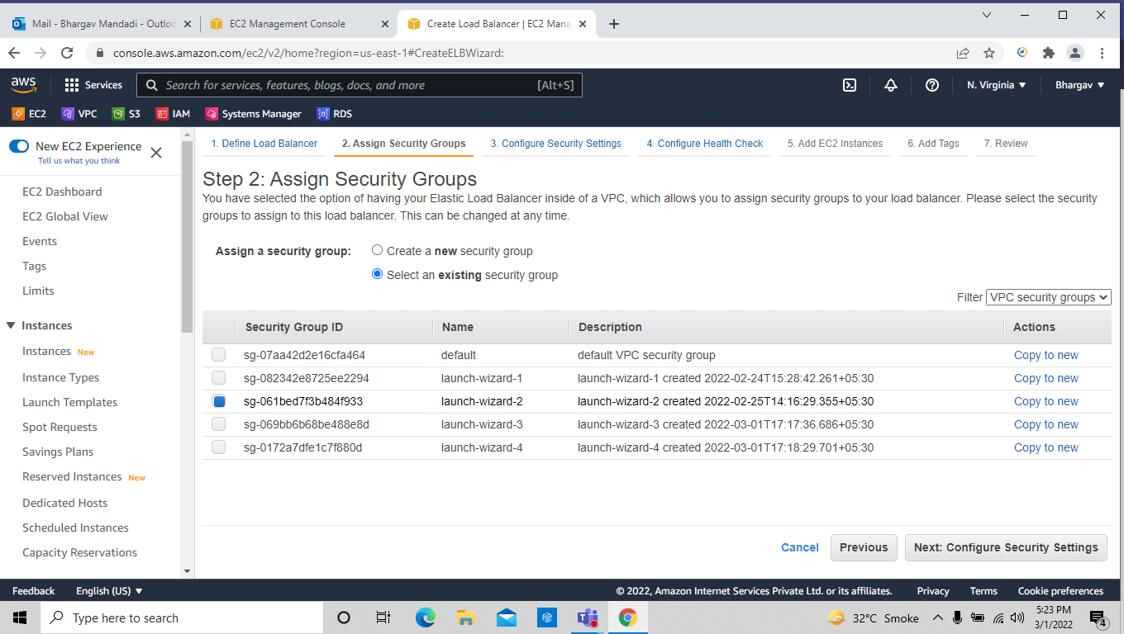
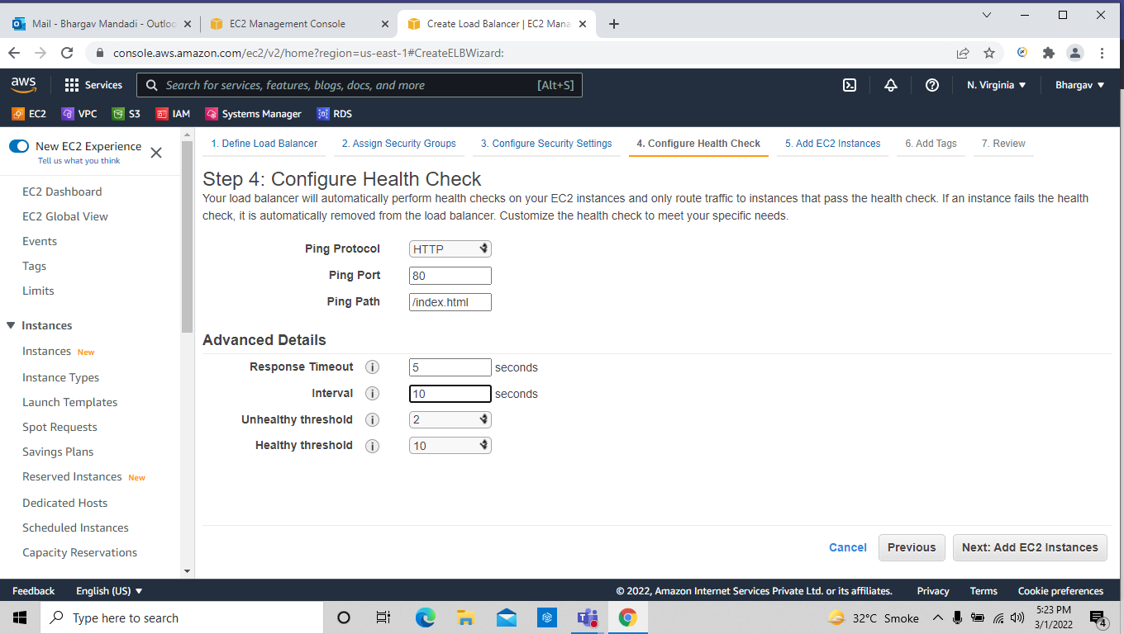

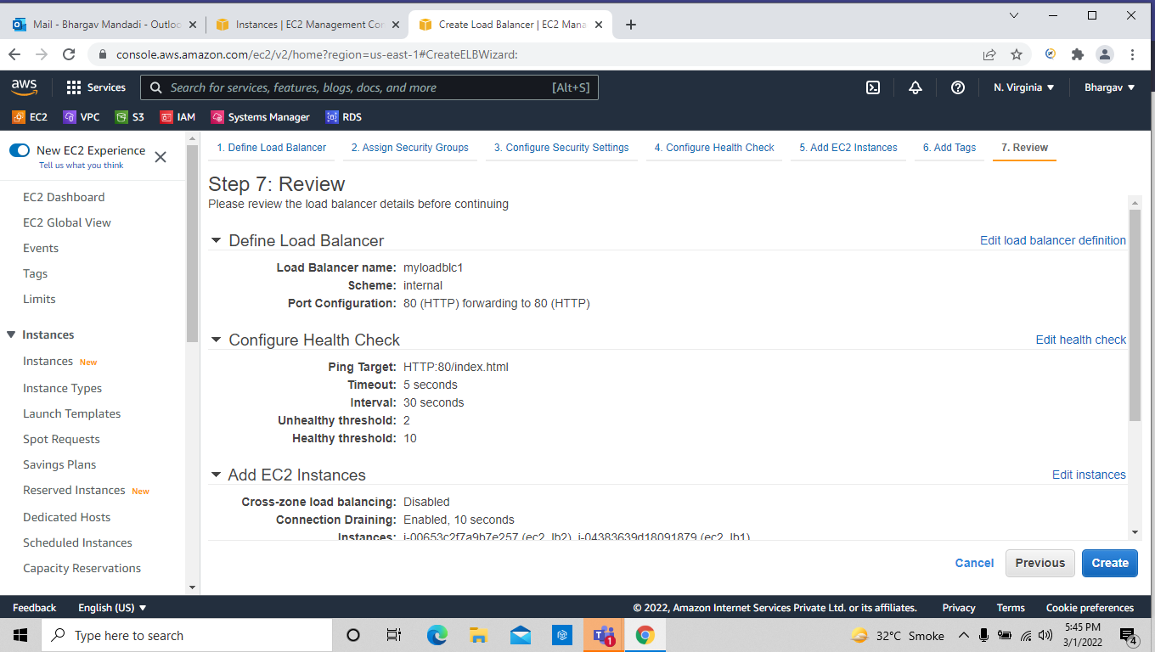

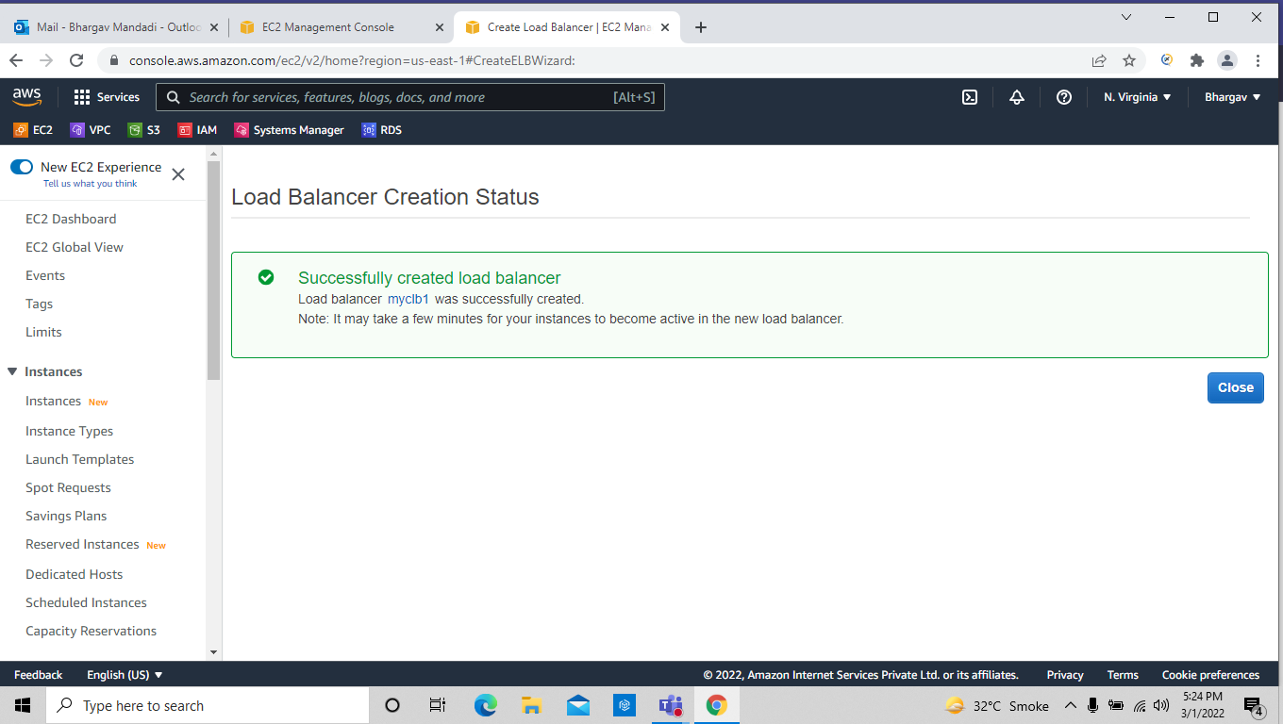
after creating the load balancer by deafult the service status as outofservice after some time it should be in service

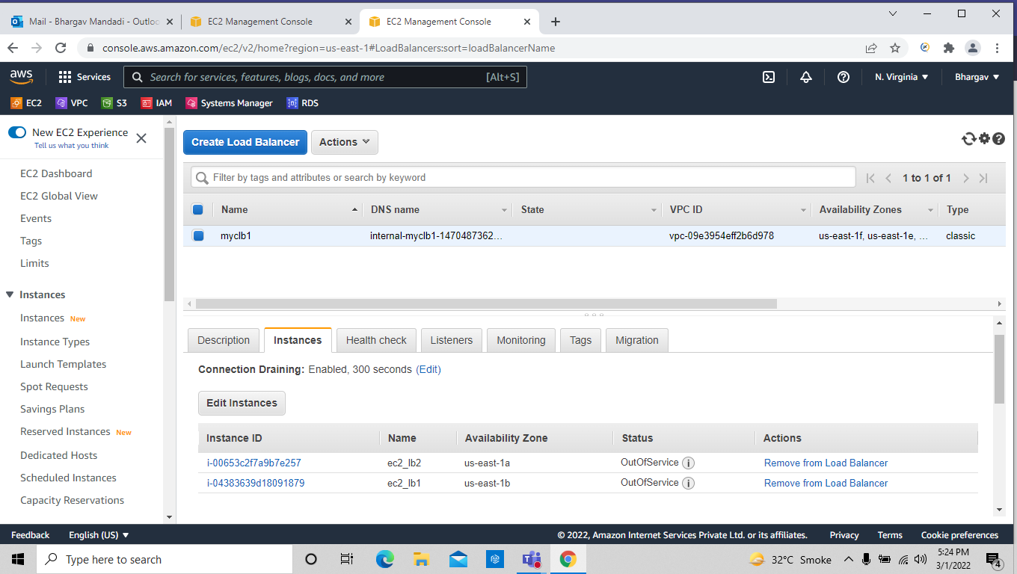
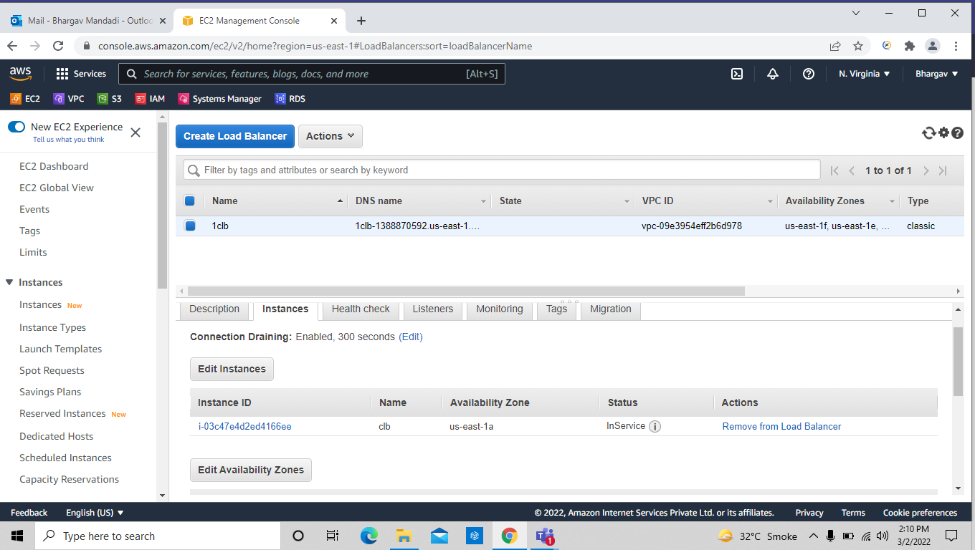

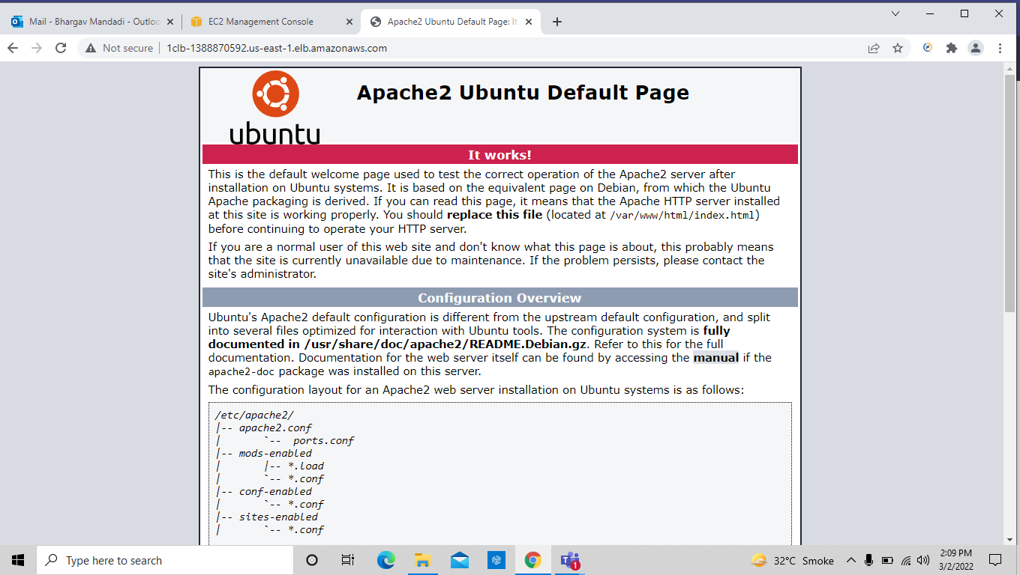
Task-11: application load balancer
we have to create 2instances and connect to terminal and then create an html file in both instances
==> sudo su
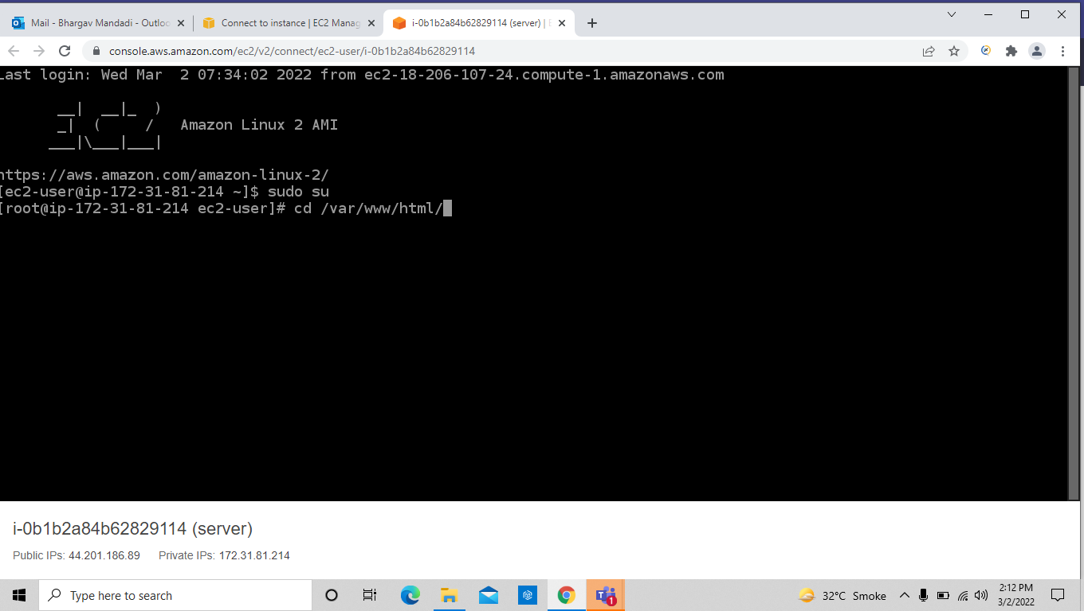
==> yum install httpd -y

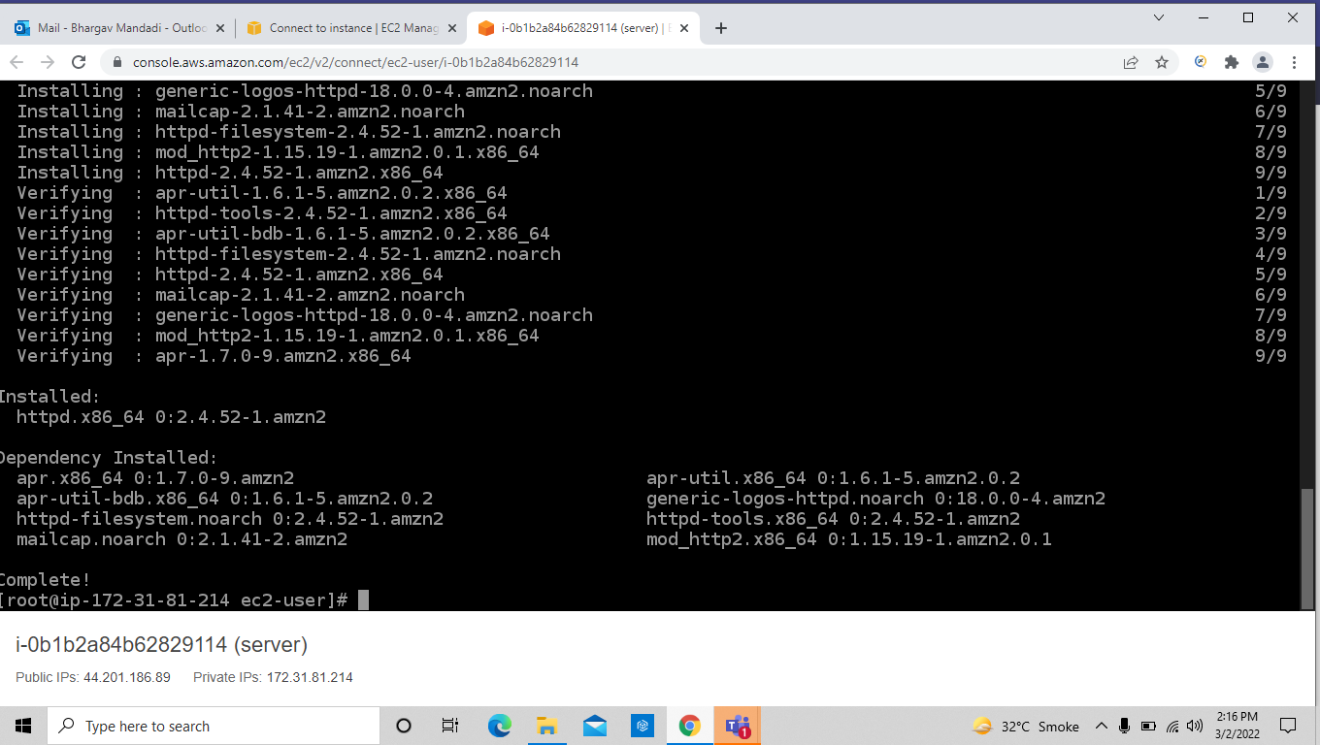
==> systemctl start httpd
==>systemctl enable httpd
==> cd /var/www/html/
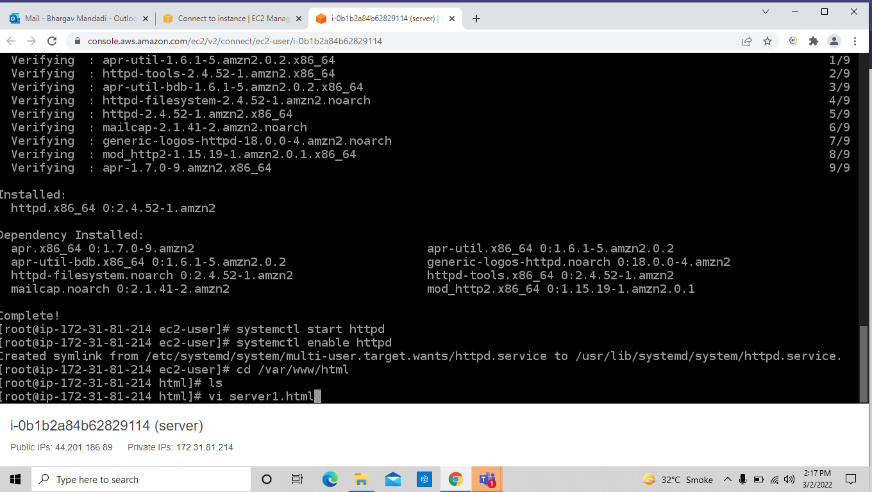
==> vi index.html press enter
then press I to insert mode and type the heading and the click
ESC +SHIFT+:wq! ( To save and exit )

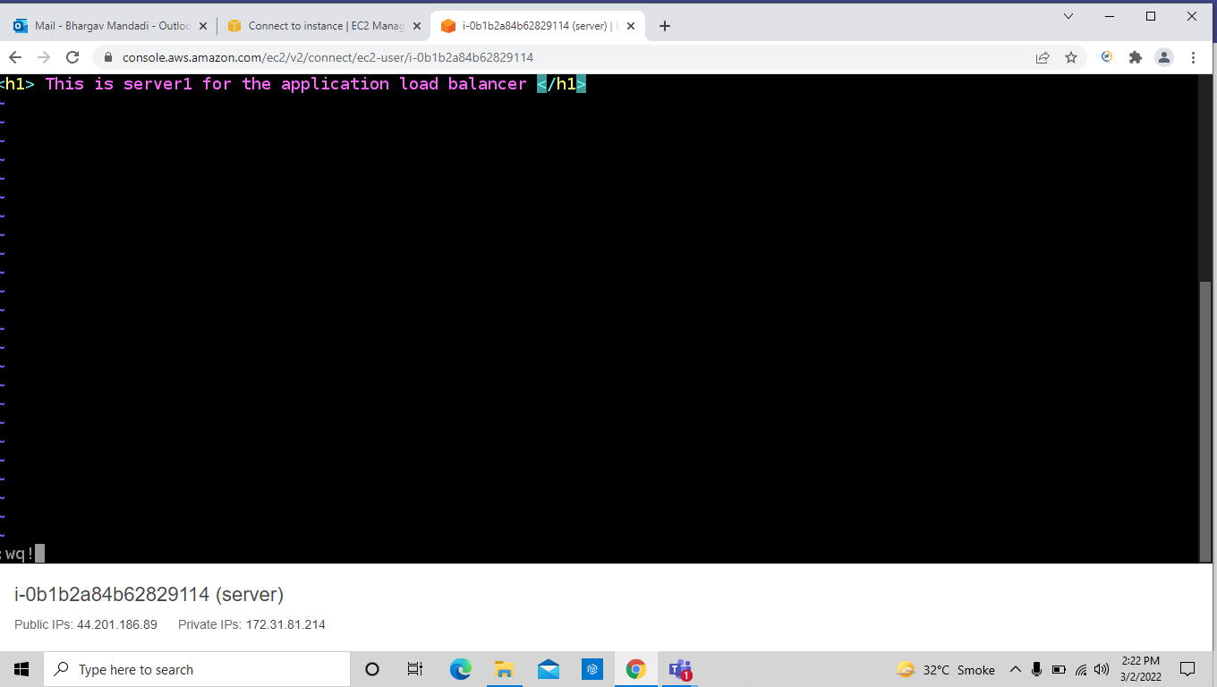
Do the above steps on the another machine as well,Then go to load balancing and create target group

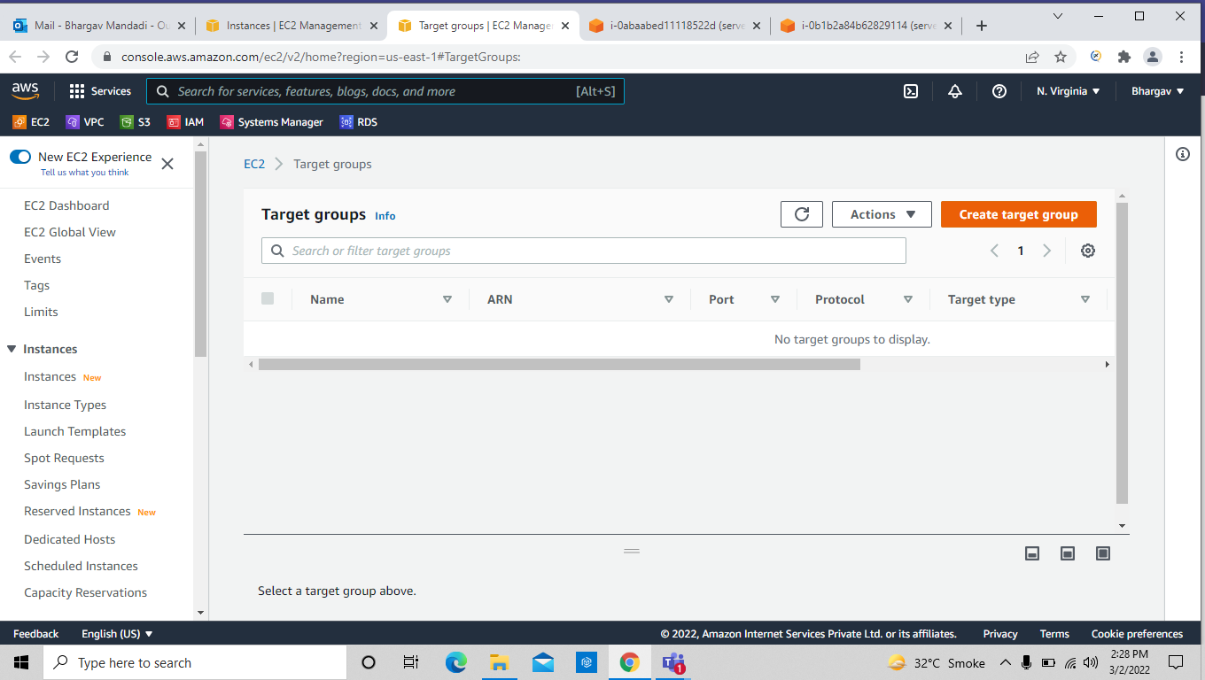

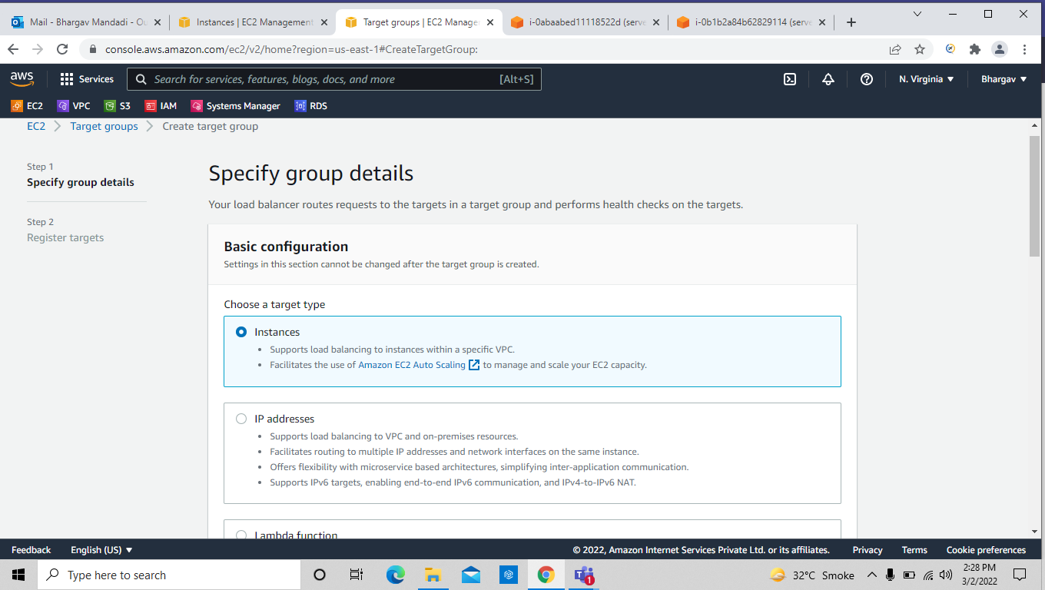
select the running instances

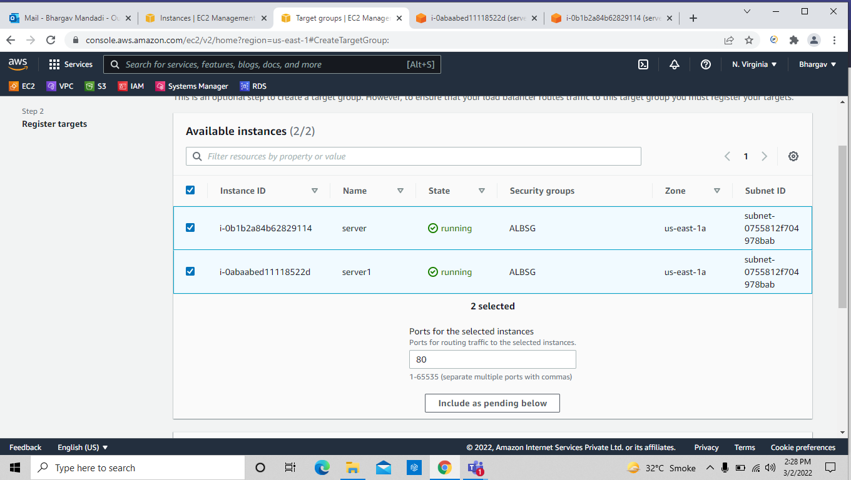

after selecting click on include as pending below

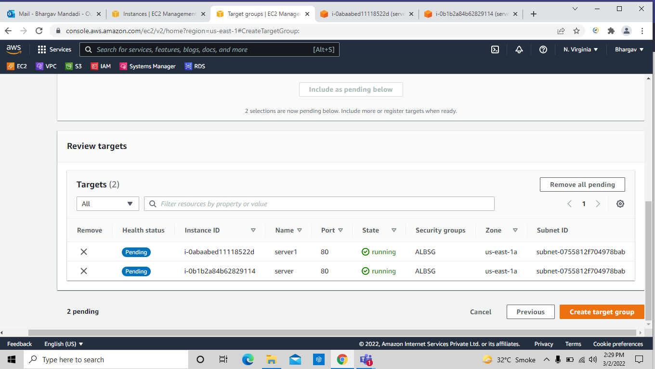
Then create the application load balancer

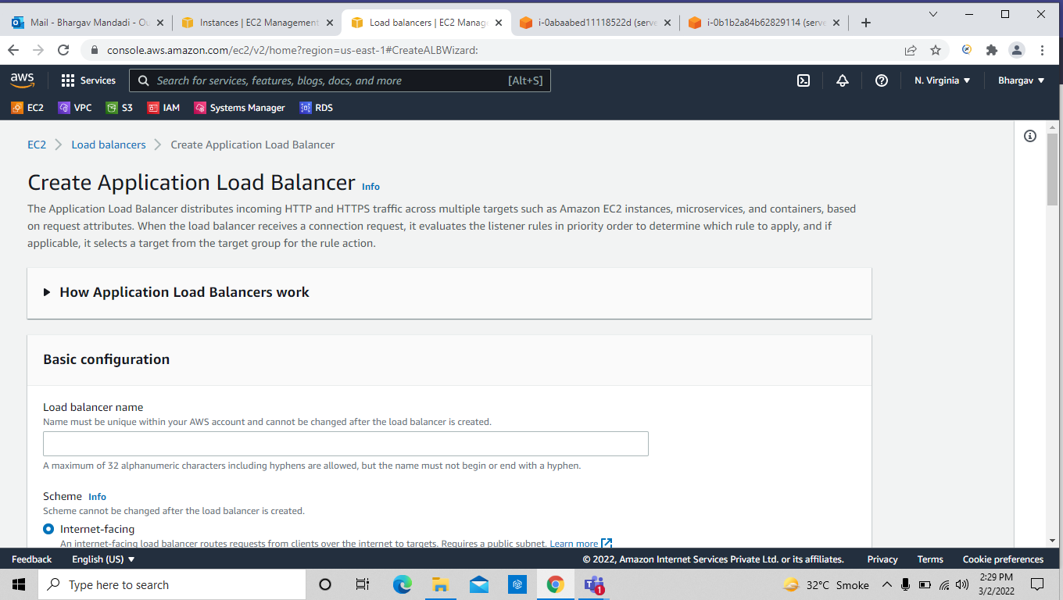

1=> Select the security group which you have been used for the creating instances
2=> select all the network mapping checkboxes
3=> choose listenrs as target group which you created earlier

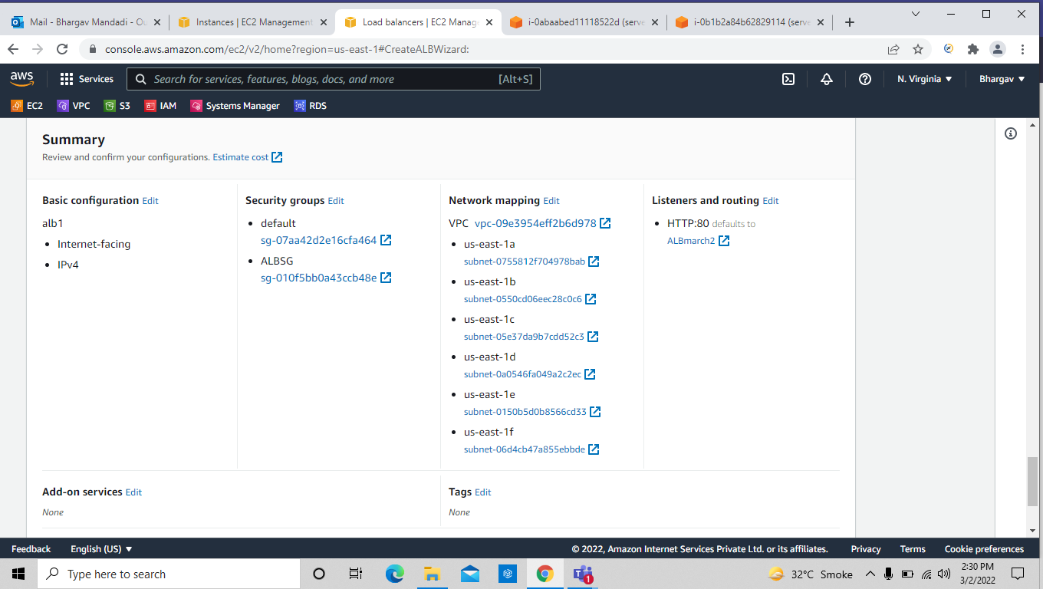
Then target group should changed to unhealthy then the service state in active
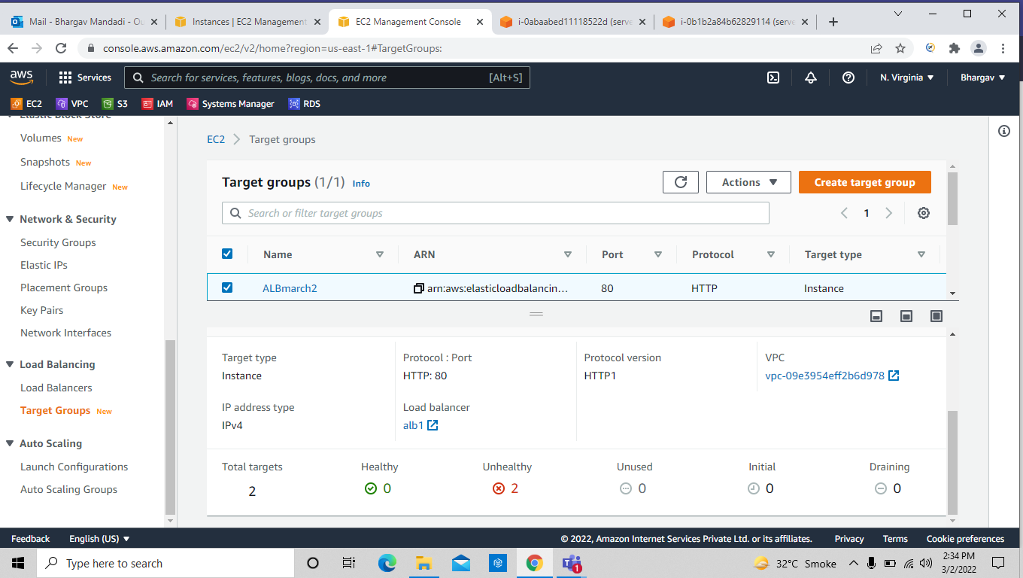

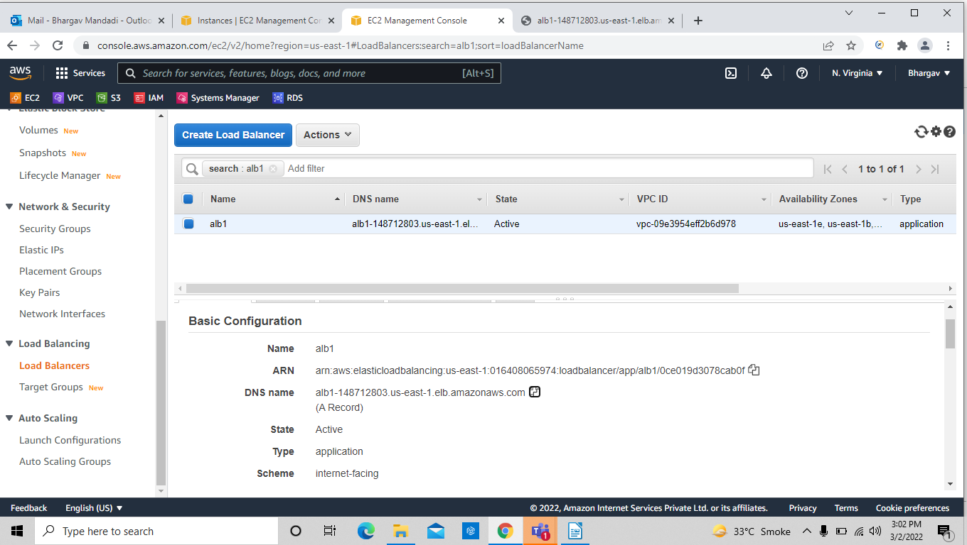
when the state comes to active then copy the dns address and paste over the chrome and see the result

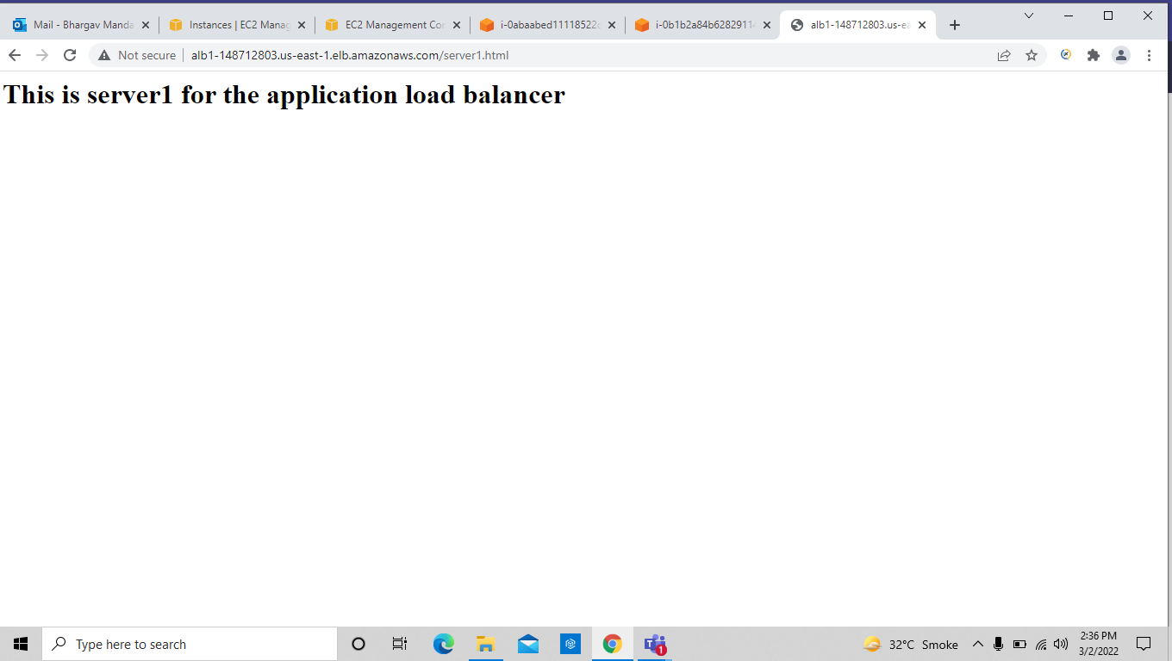

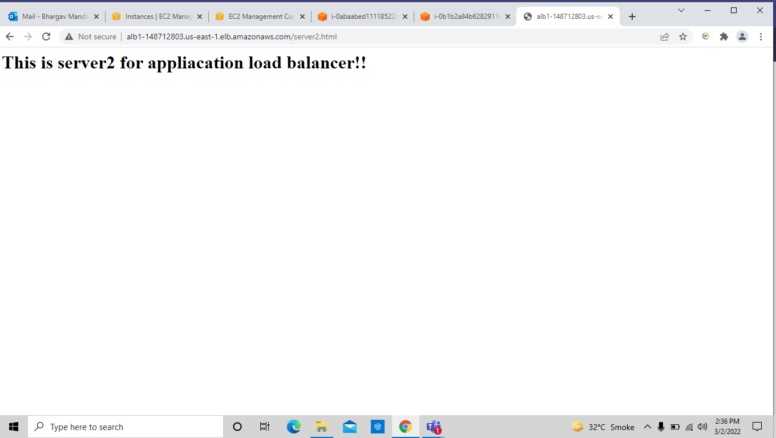

Task-12: Create 2 instaces for path based application load balancer
now connect to instances and make a new directory and inside make a file

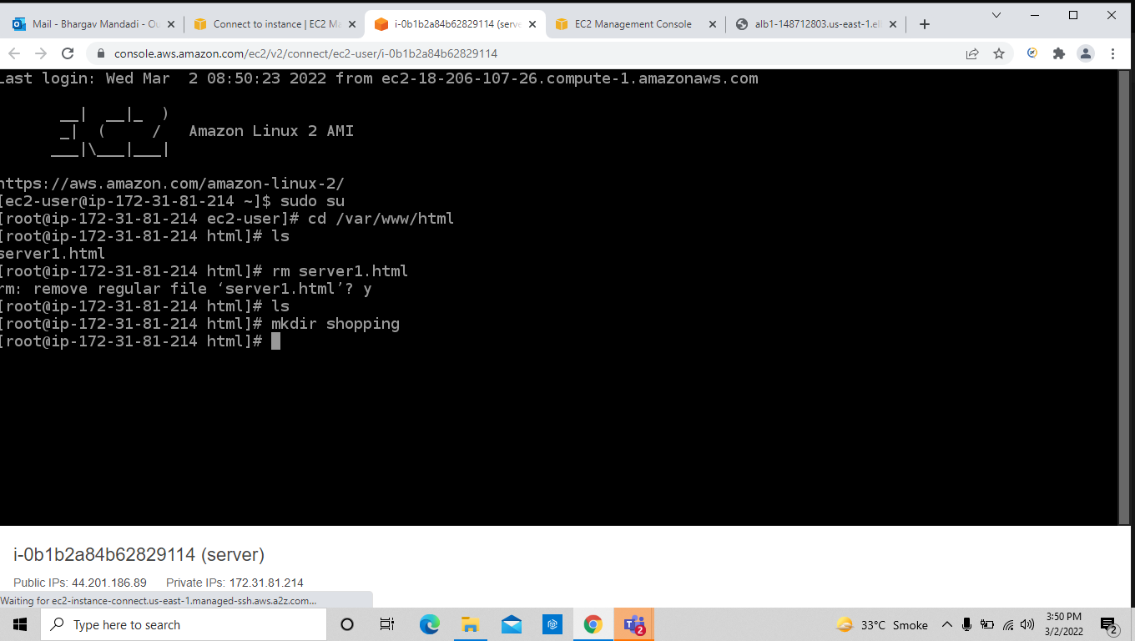

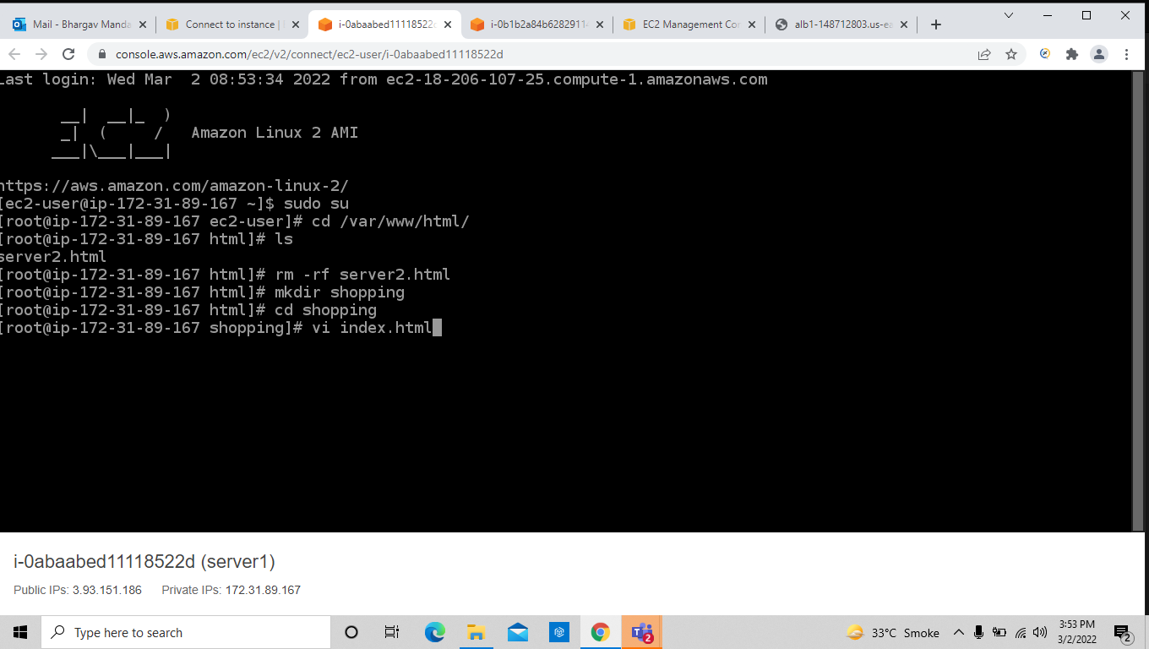
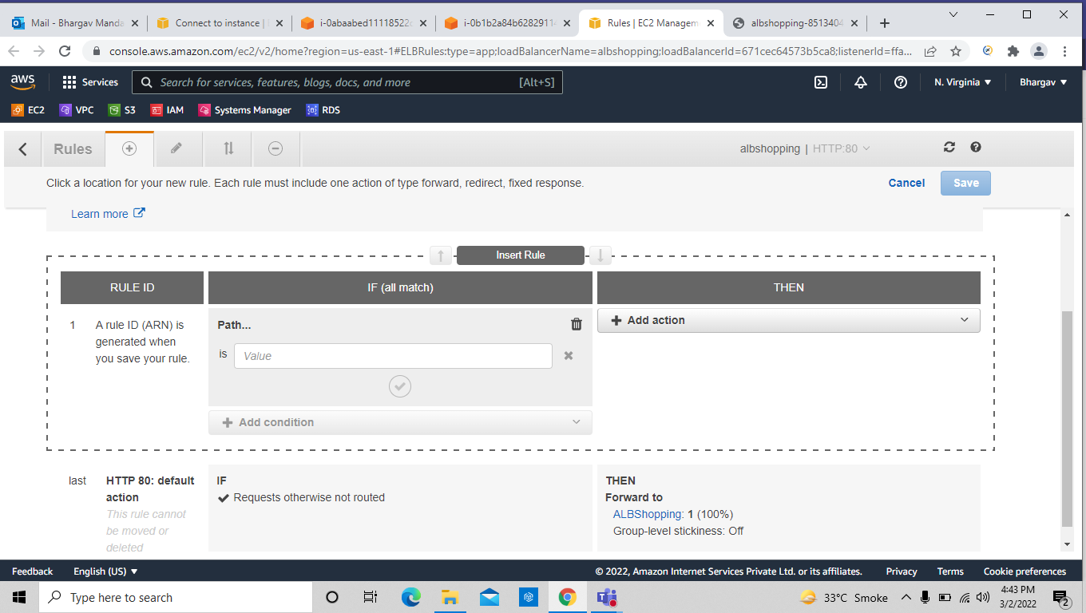

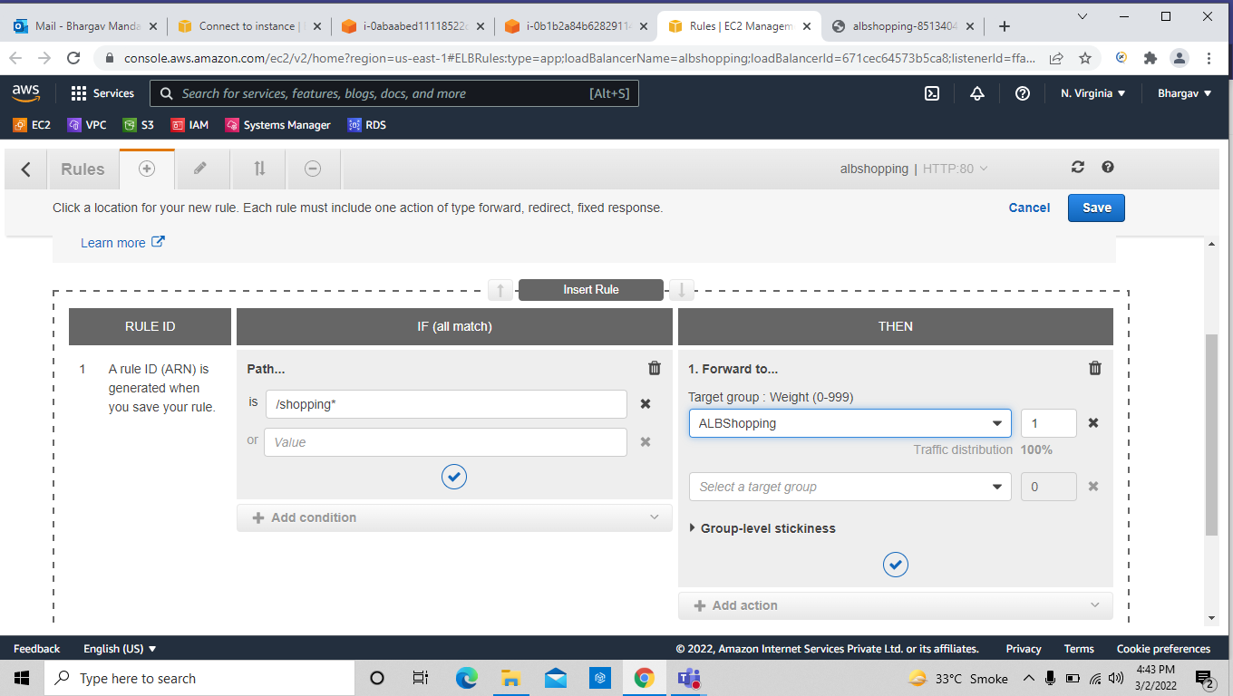

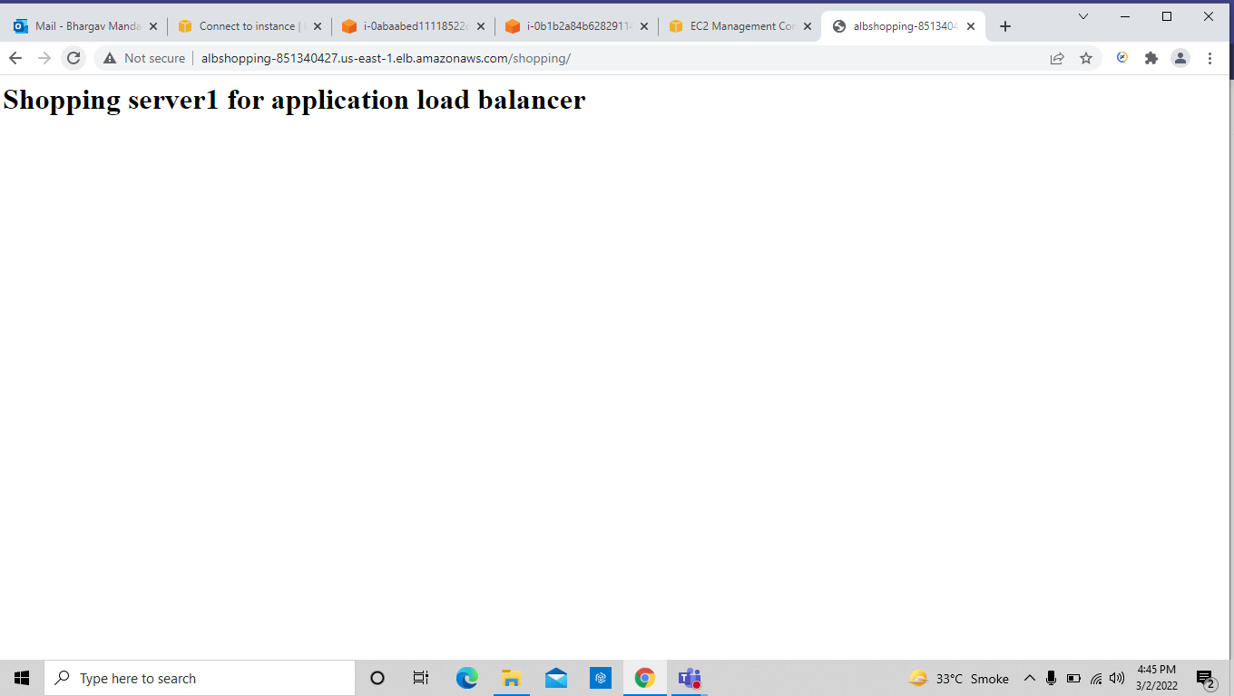

Task-13: Creating auto scaling group

create the instance and ami as well

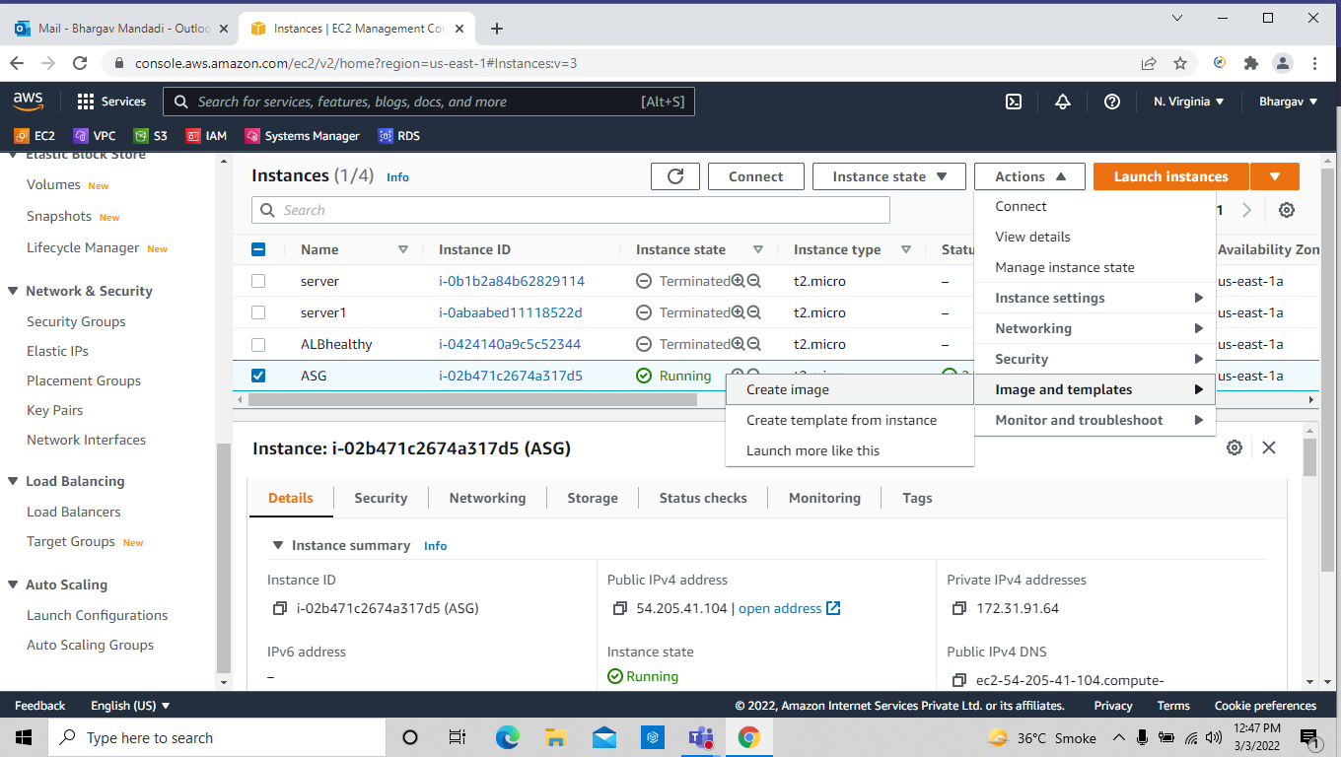
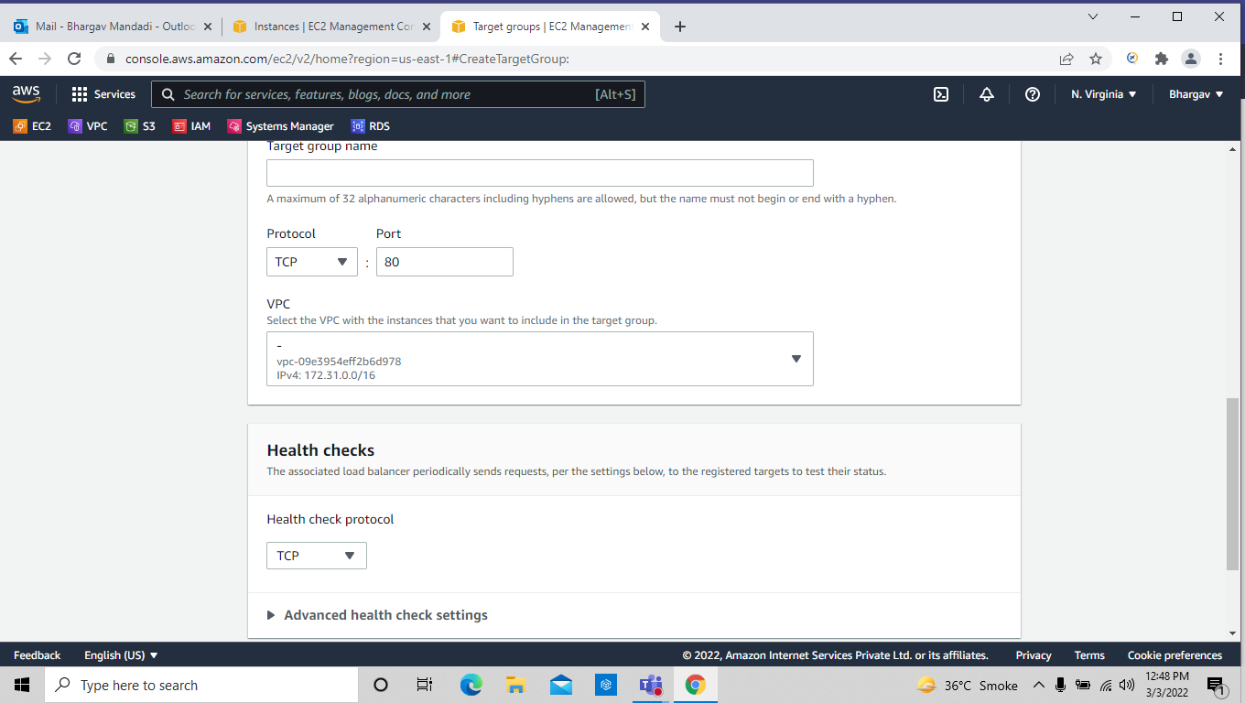

here we don’t need to create load balancer and target group we didn’t used in the auto scaling group , if you want create other leave it .

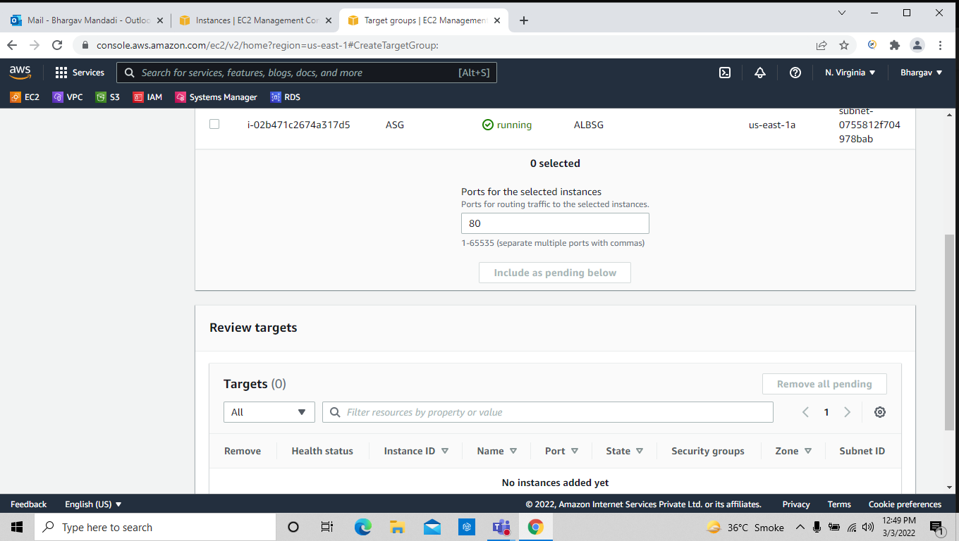
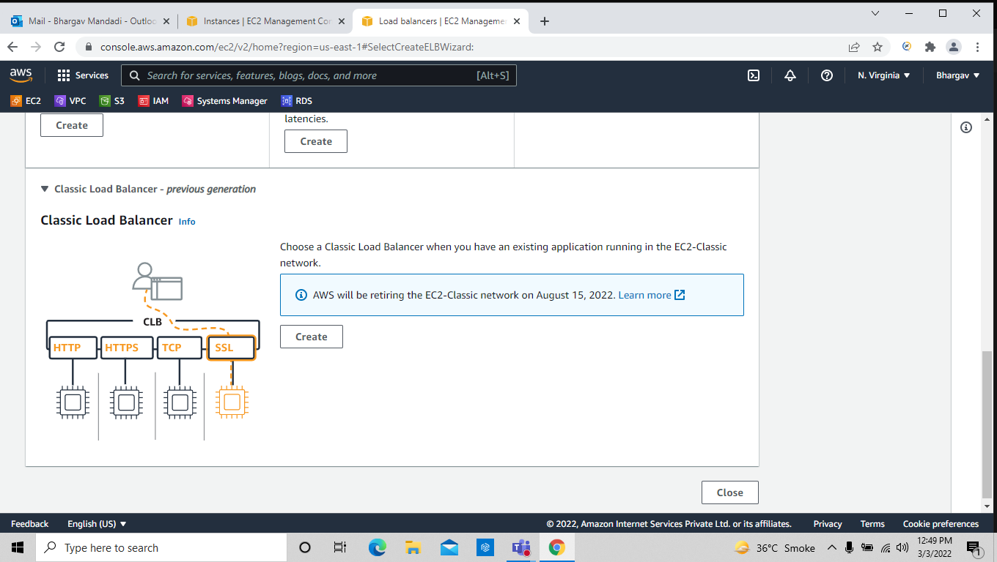

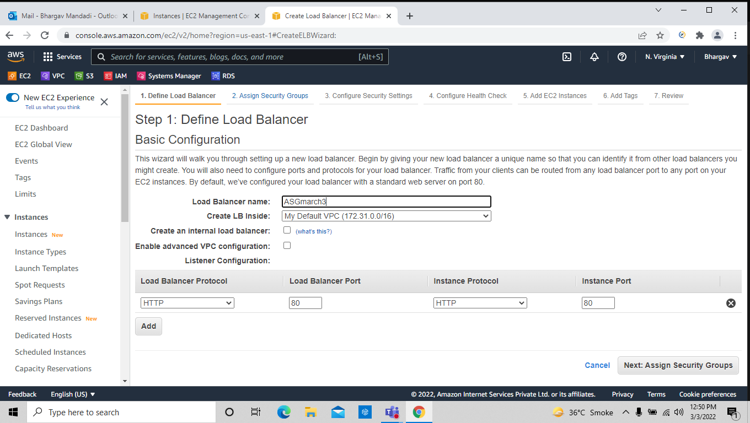
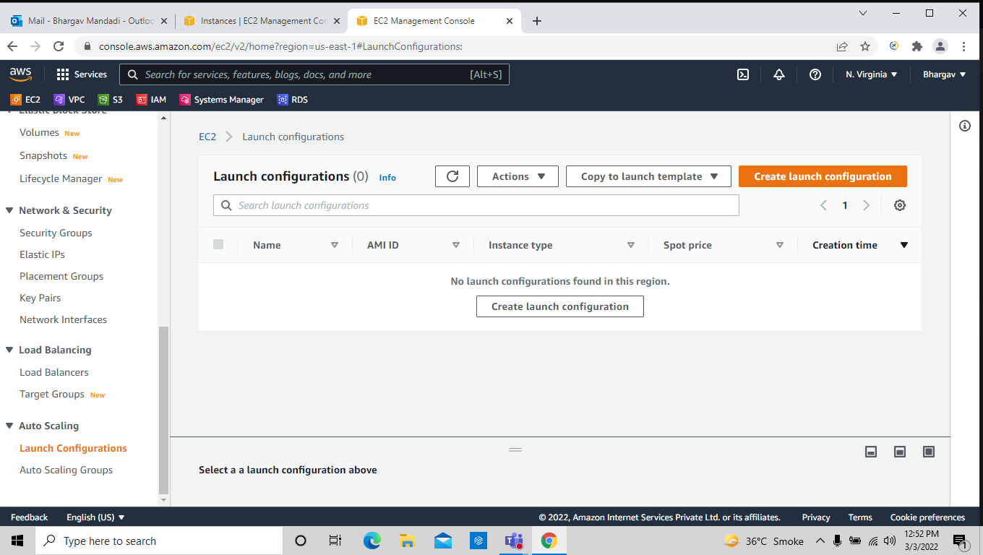

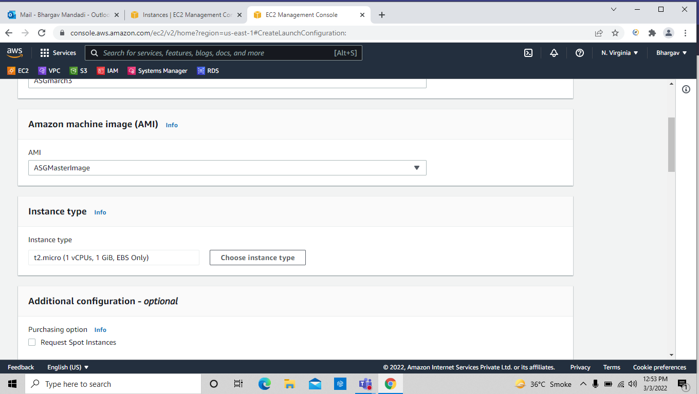
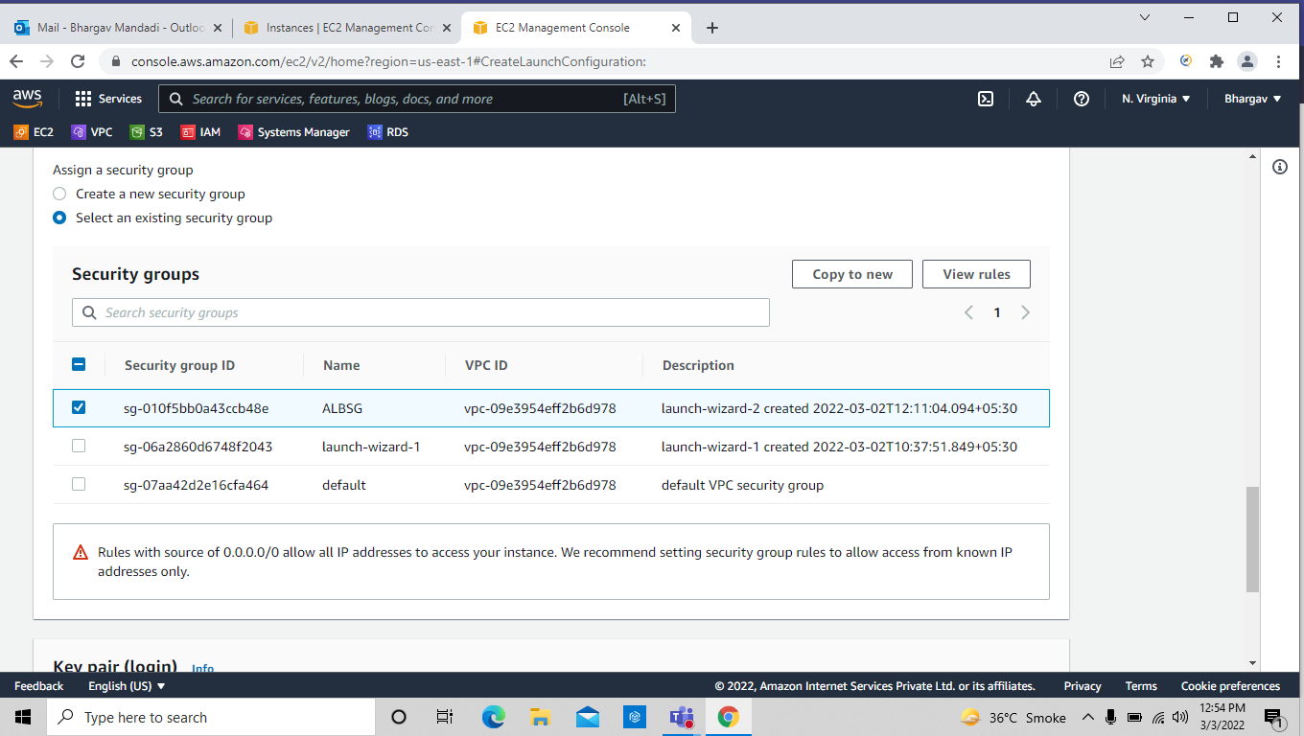

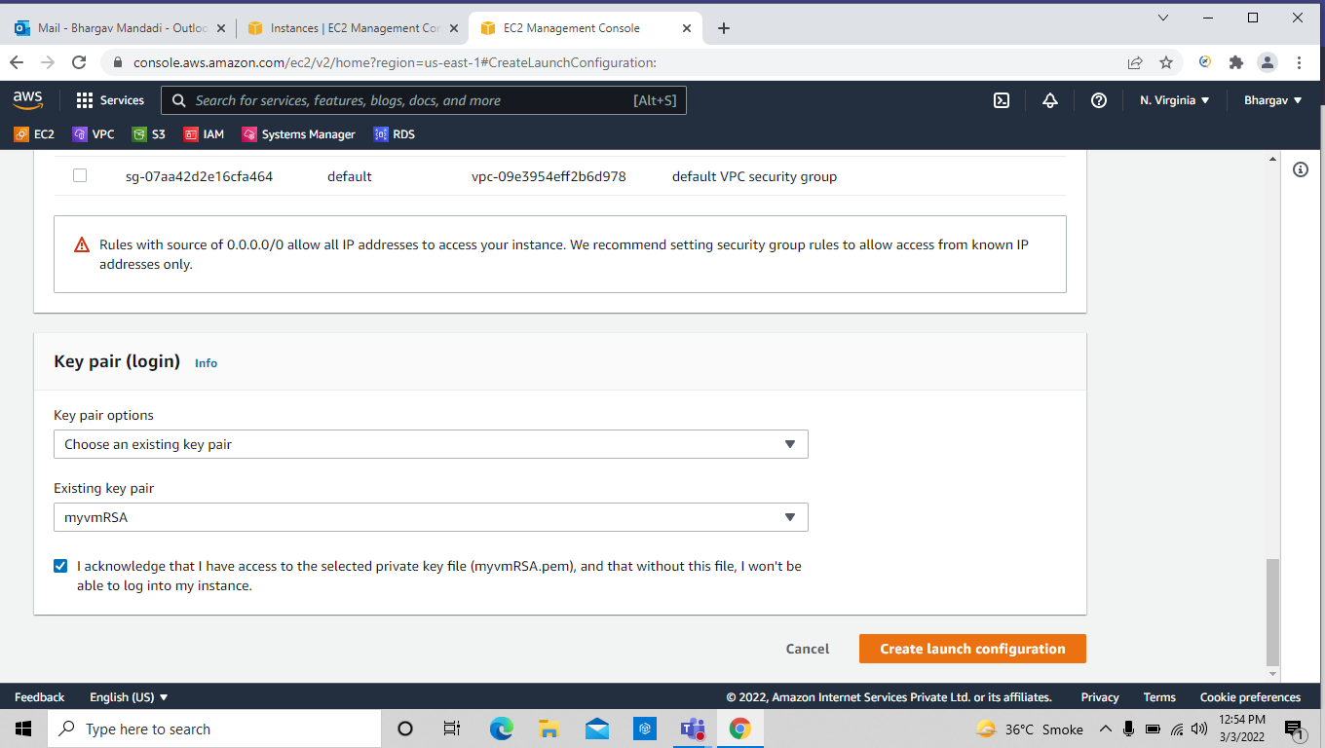
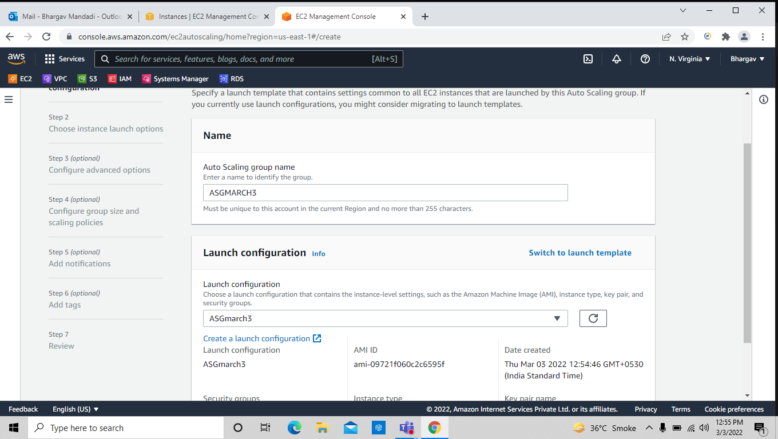

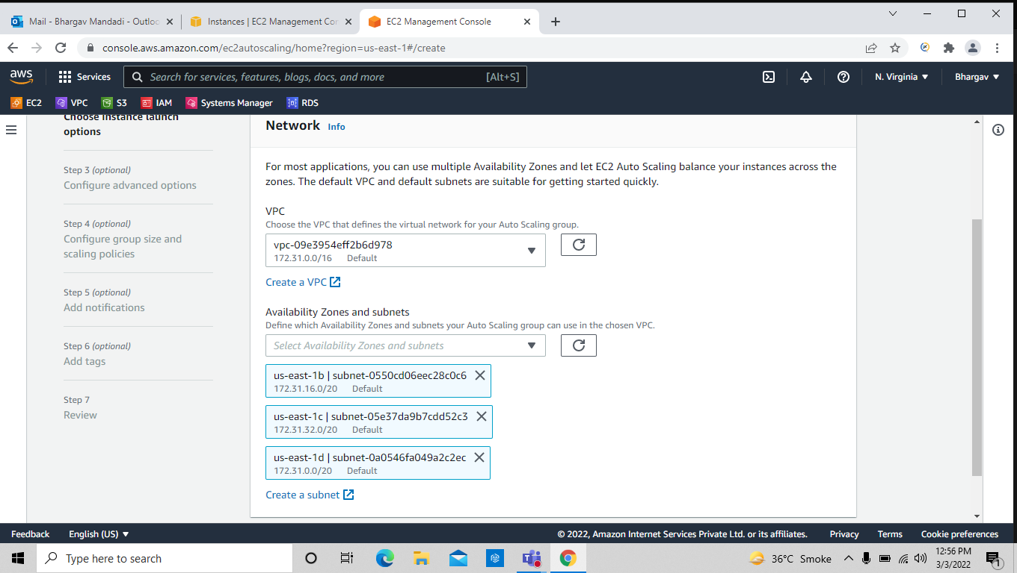
In below we have to select No load balancer

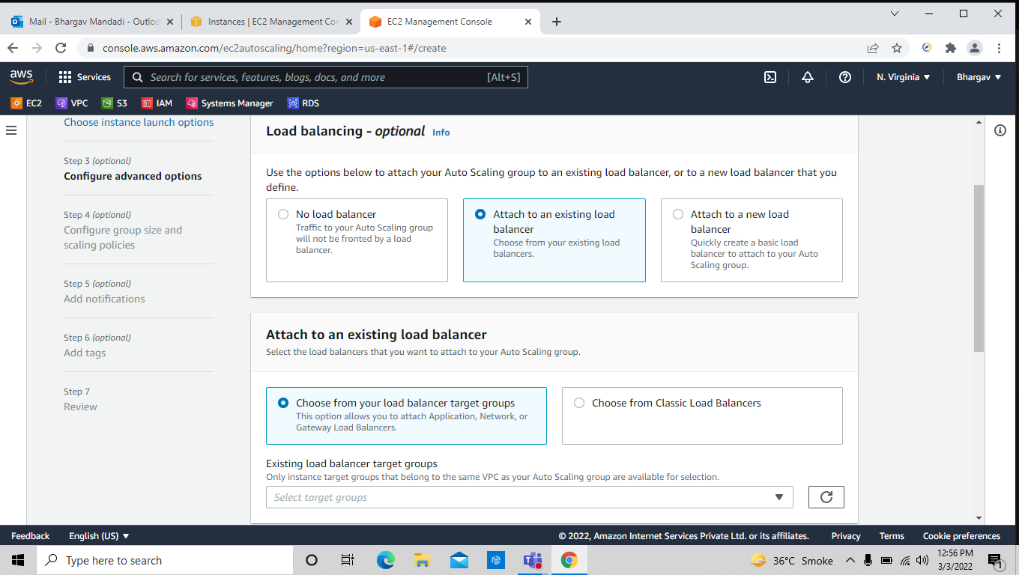

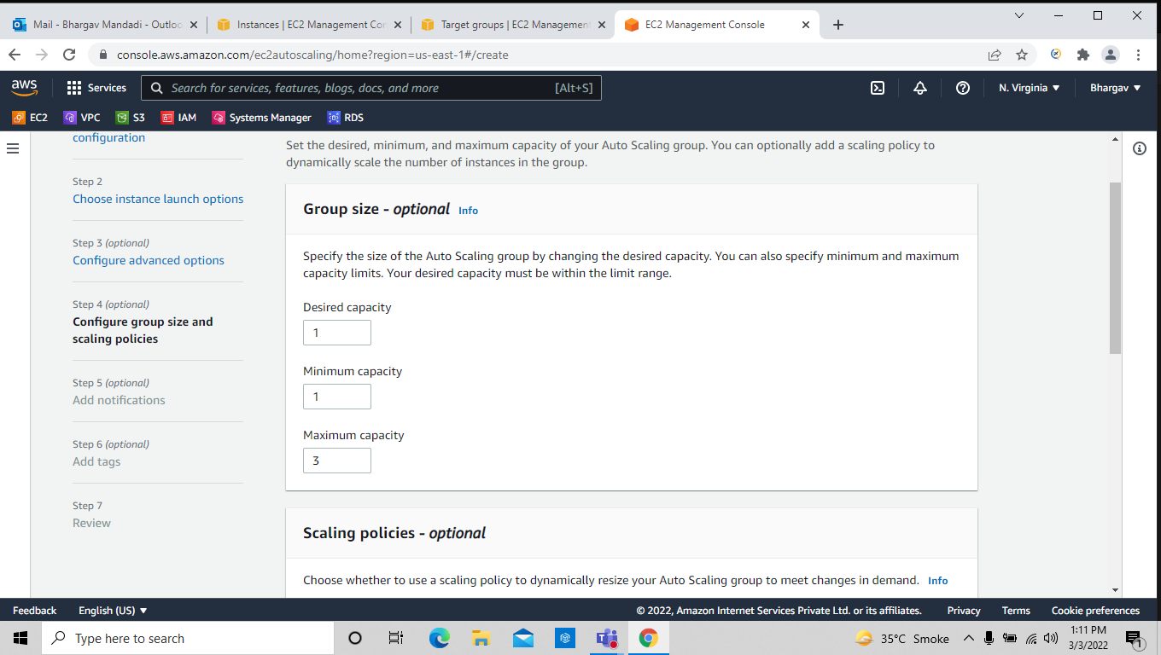
give the taget policay condition to auto scale the inastances

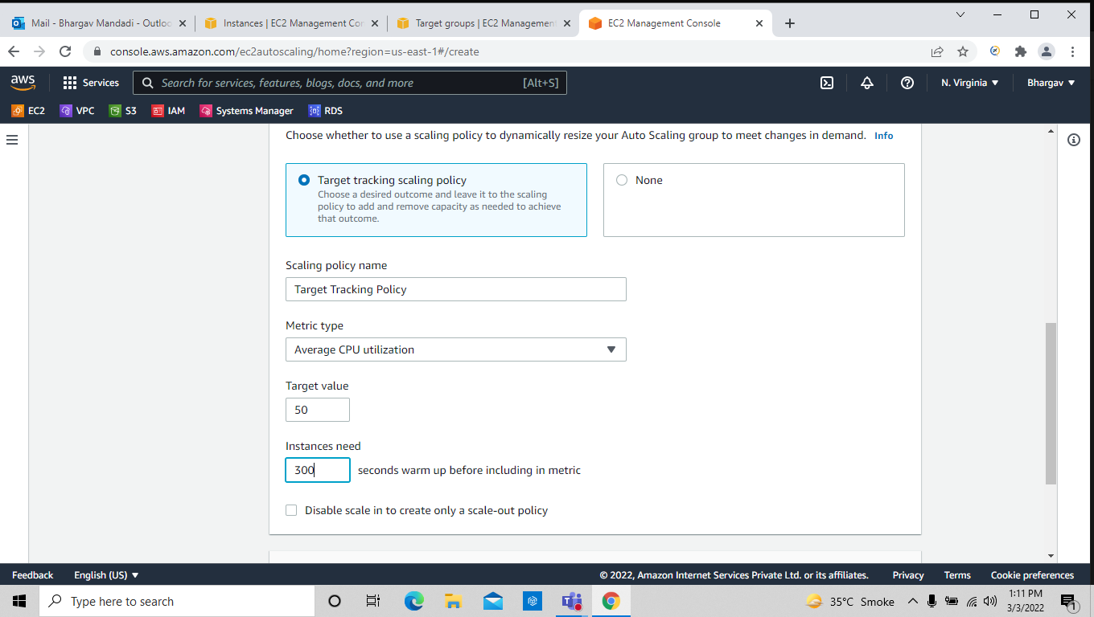

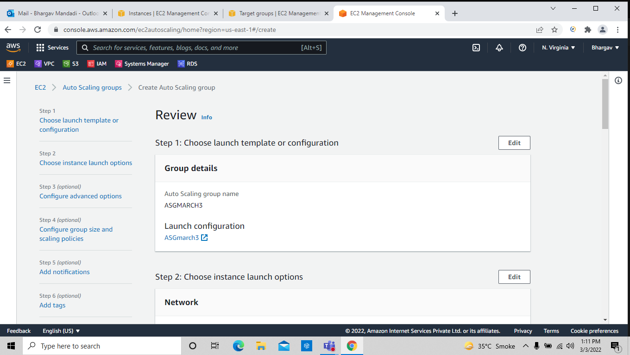

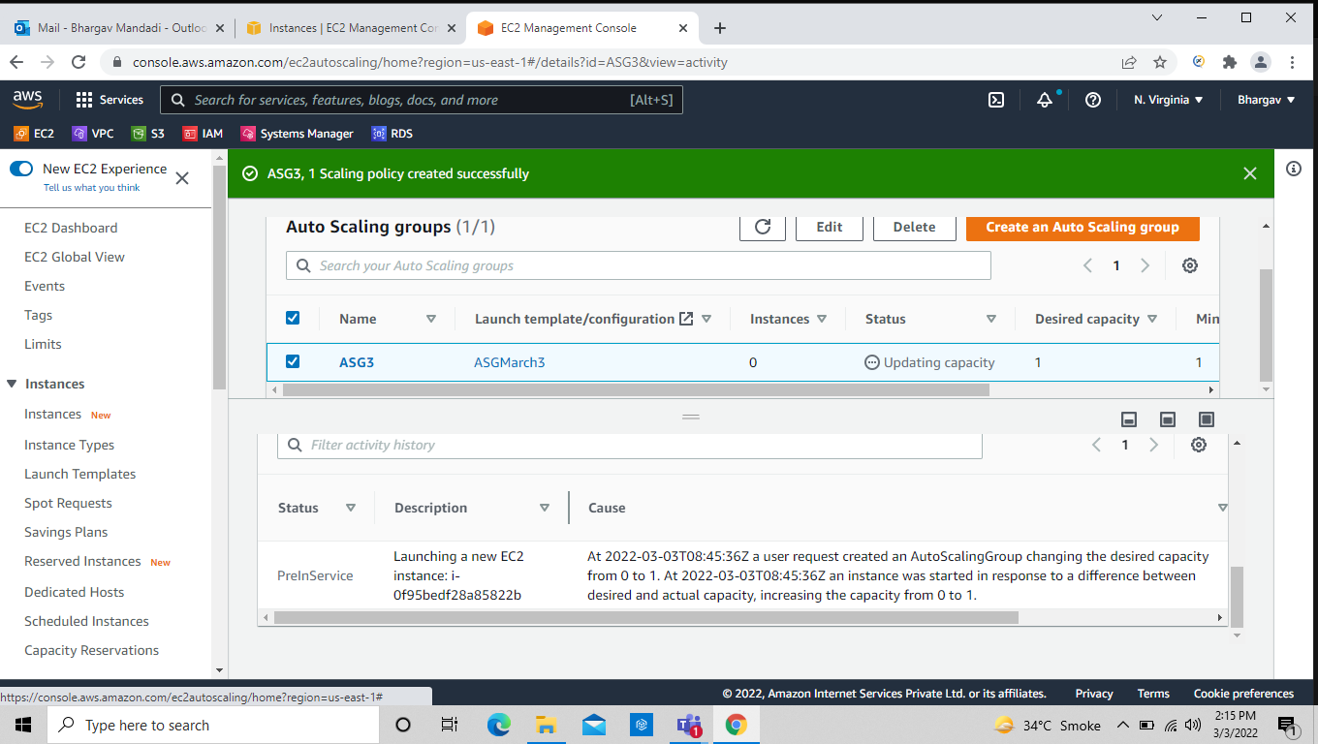
First the status should be in preinservice after some time it become successfully

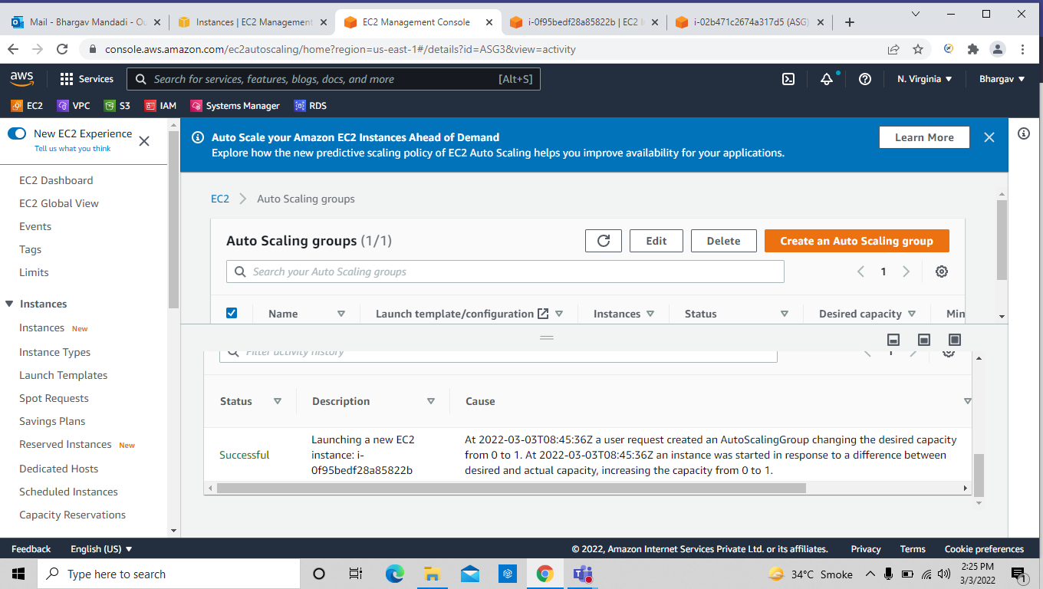

if the memory utilized 50percent then automatically one instance would be auto scaled

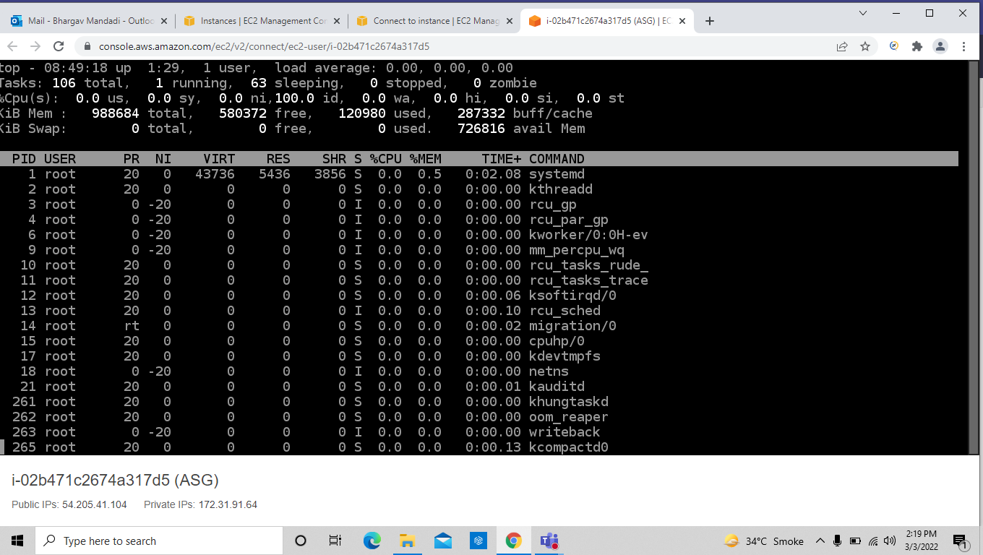

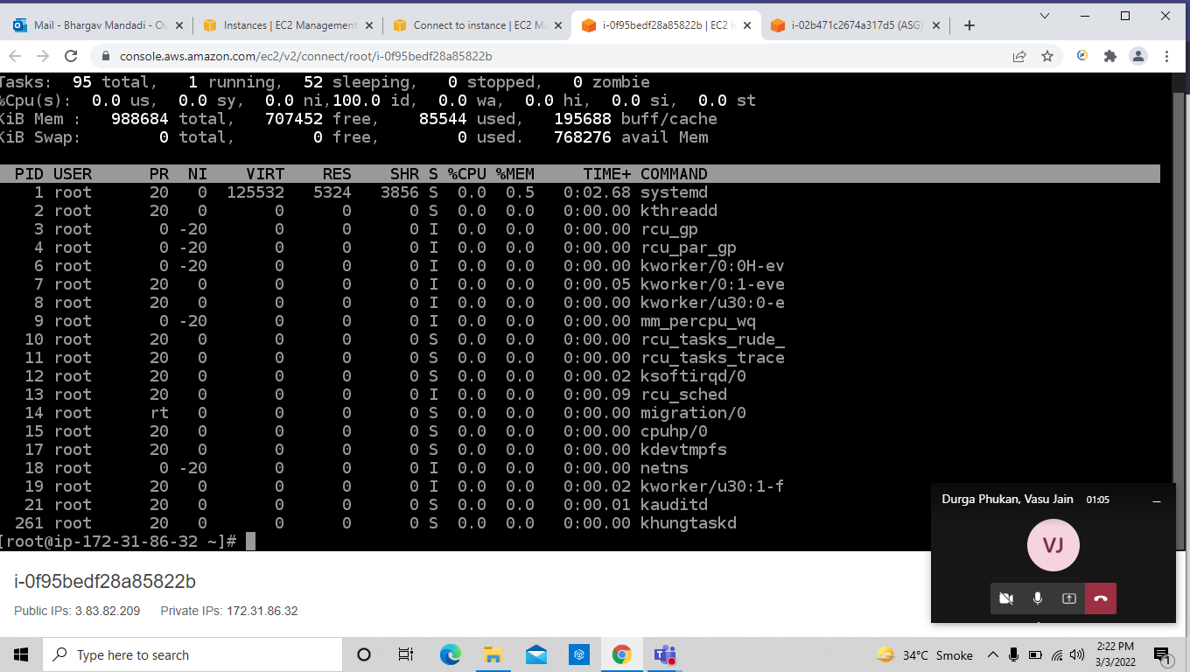
See the below screen shot when I utilized above 50% memory then new instance has been auto scaled .

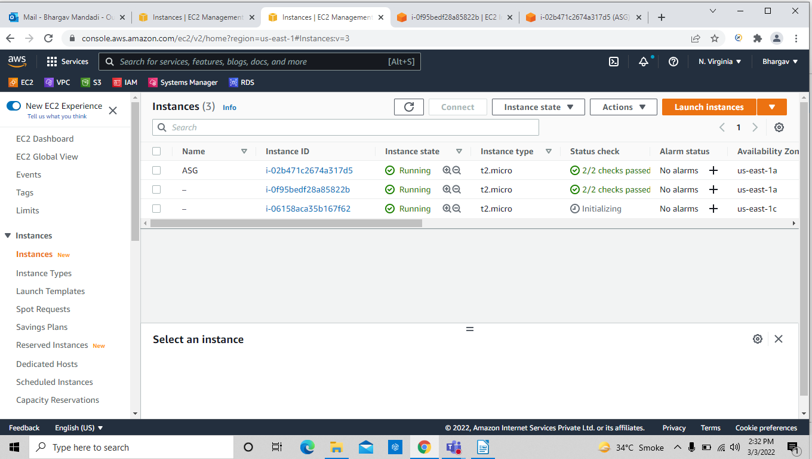

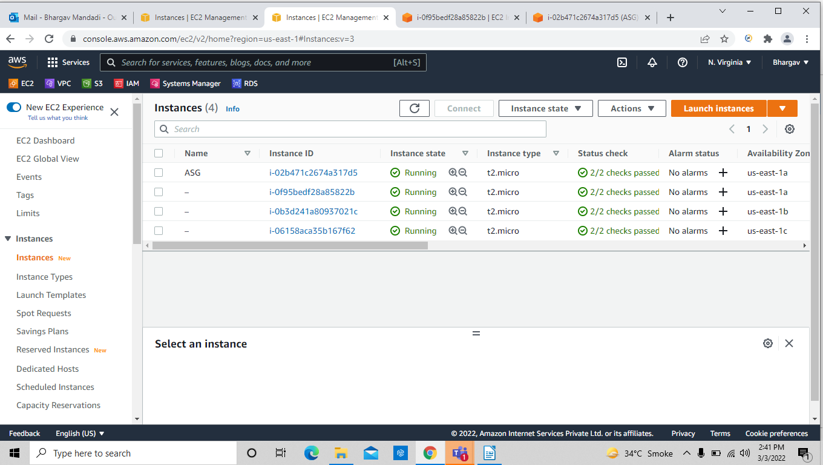
The above all the instaces were auto scaled.

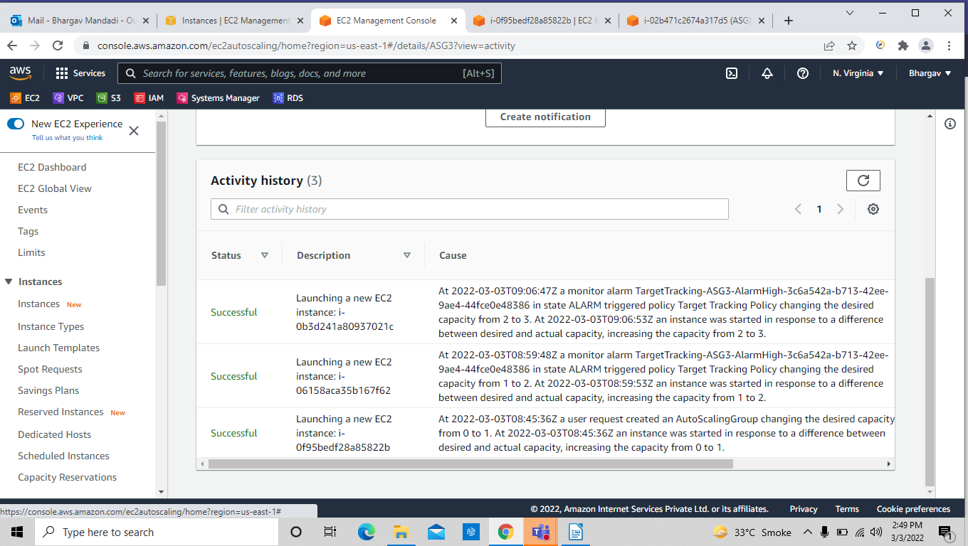
here we can see the activity of the autoscaling group

