Linux commands :

There are two types of users in Linux 1) Normal User and 2) super user (root)

--> current user contains ($) symbol
--> super user contains (#) symbol.

$whoami -> To show the user of the present shell.

$sudo -i -> To switch form the normal user to the super user by giving password.

Logout -> It’s used for logout from super user to go back to the normal user .

Exit -> It’s like logout command.

------------------------------------------------------------------------------------------------

$pwd --> Print Working Directory means it prints the user presently residing in.

$mkdir filename -> To make a new directoy

$cd -> change to the directory

$ls -> Show the list of files in the directory

Every linux directory must have two hidden files even though we created an empty directory .

$ ls -a --> To show all the files in the directory (hidden and normal files) .

--------------------------------------------------------------------------------------------------
( . ) - >Describes present directory .
( .. ) - >Describes parent directory.

$mkdir dir1 dir2 -> Create multiple directories by use space between the directories.

Without using Spcases how can we create multiple directories ?

$mkdir dir{1..10} --> use this command to create multiple dirctories whatever you want like 10,100,1000 etc.

Linux File System

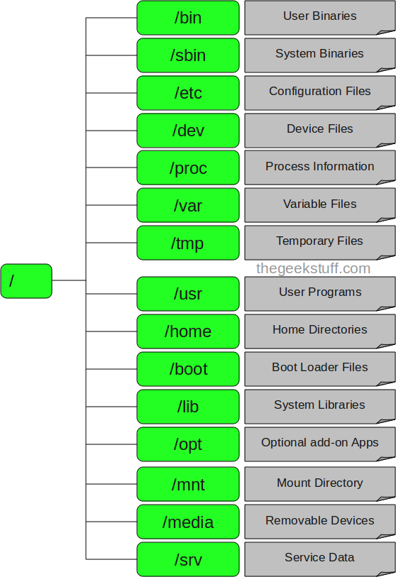

1) bin :

Bin contains the binaries , that is nothing but the applications and programs you can run .
It contains the executable files for the programs and applications you want to run .

Ex : rm , ls , cat etc

2) sbin :

It’s similar to bin , but it contains the executable files that only used by the super user ( root or system user) .

If you can use applications with sudo then it’s temporarly concedes you as a super user power .

3) etc :

It contains the configuration files , if not all system wide configuration files.

The files contains the name of your system and users and their passwords ,and the name of the machines on your network all the things are present in this directory.

4) dev:

This directory contains the device files . For example if you plug in a new webcam or usb into our machine , a new device data entry willl be stored automatically.

5) proc :

It contains the process information about your CPU and the kernel in your linux system are running.

6) usr :

It’s users home directory where the user can do a diffrent kind of activities . This directory again contains /bin directory because it would contain basic commands like rm , ls , mv these commands are pre installed.
So the user minimum to run and maintain the system .

7) tmp :

This directory contains the temporary files , usually placed there by applications we are running , You can also store your temporary files in the /temp directory .
You can interact with the /tmp directory without become a superuser .

8) var:

This directory contains things like log file .if any changes are there in the variables the also changes are done in the var directory frequently.

9) srv:

It contains the data about server files like html documents that we are running in the web server , whether the request are coming form the http server or www server or Ftr server like wisee.

10) boot :

This directory contains the bootable files for the system when the system was restarted , something interrupted etc.

11) lib :

This directory contains different system llibraries like if i want to run java programs we need some libraries right so those all libraries are contains in this lib directory.

12) media :

All the media related files are stored in this directory like images , videos etc.

--------------------------------------------------------------------

tty:

it is used to print the name of the terminal connected to the standard input .
It stands for “TeleTYPEwriter”.

Difference B/w Linux and windows file system?

Windows :

- windows follws FAT file system ( File allocation Table ) and it presently user file system is NTFS ( New technology File System)

- It doesn’t follow any order to store the files

- In windows we can’t save two files with the same name in the same folder .

- Limited no.of recovery tools are used in windows .

5) Windows files system was easily attacked by hackers.

6) Printers and CD-ROM’s are considered as devices .

Linux :

- Linux uses a tree like staructure to store the files it will start form the root (/)

- In Linux everything considered as a file , if it’s not a file then it’s a process.

- we have to create 2 files with the same name in the same directory .

- Large no.of recovery tools available for files in linux.

- Even printer and usb devices also considered as files .

- Linux can detect bugs and fix them easier because of it’s security .

