Cloud Project
by Bhargav Mandadi
bhargav_mandadi@thbs.com
batch-92

Task :- 1: Creating IAM user for the ec2 instance read only

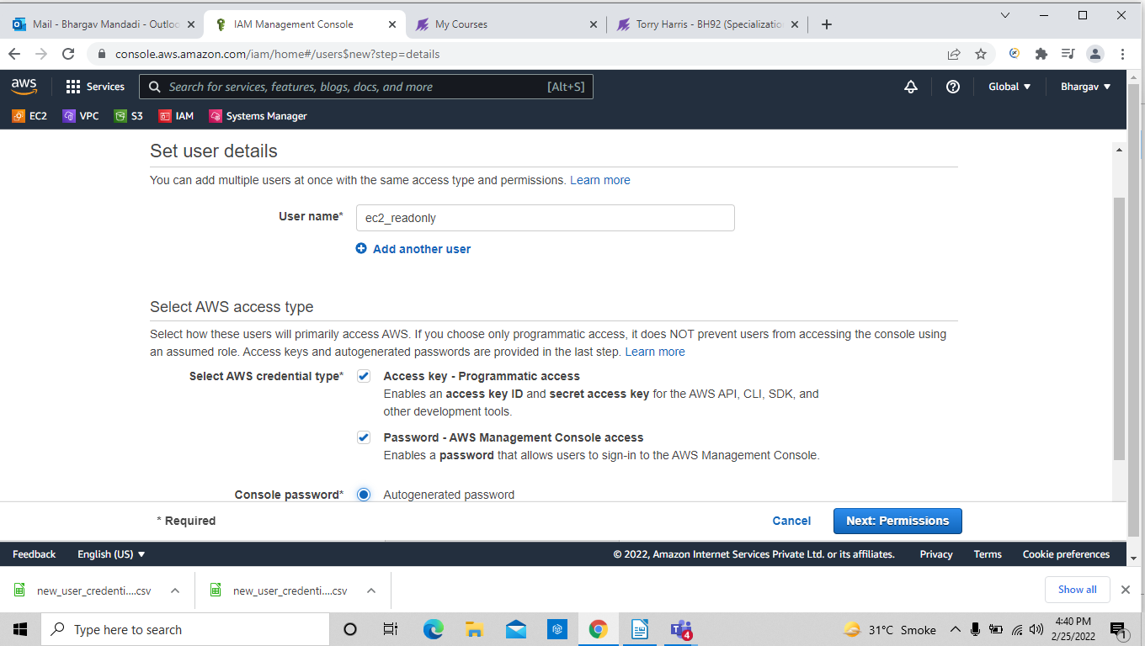
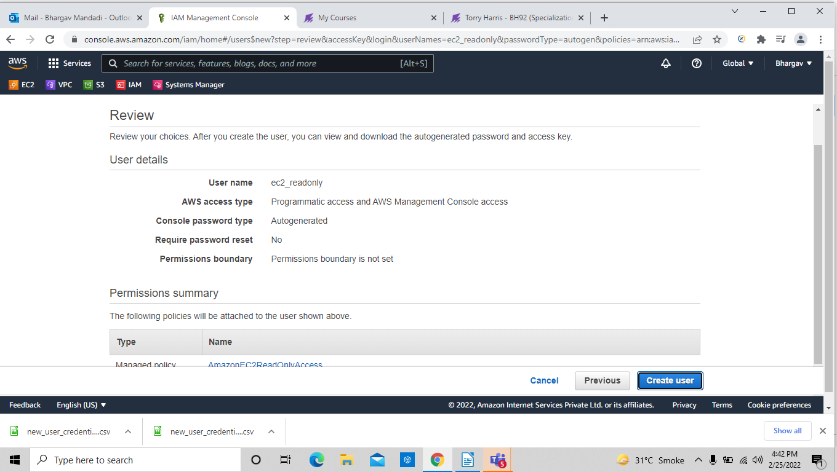

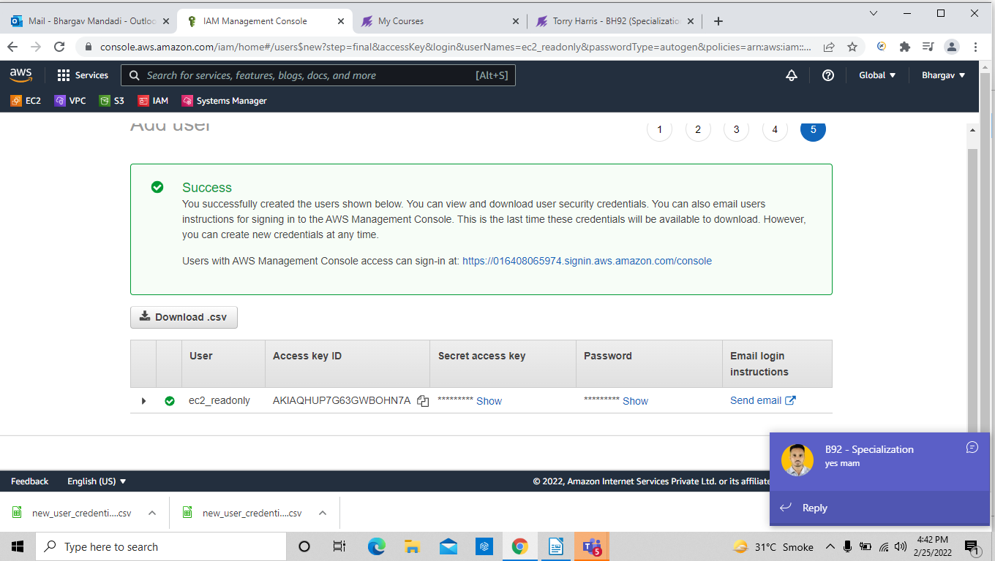

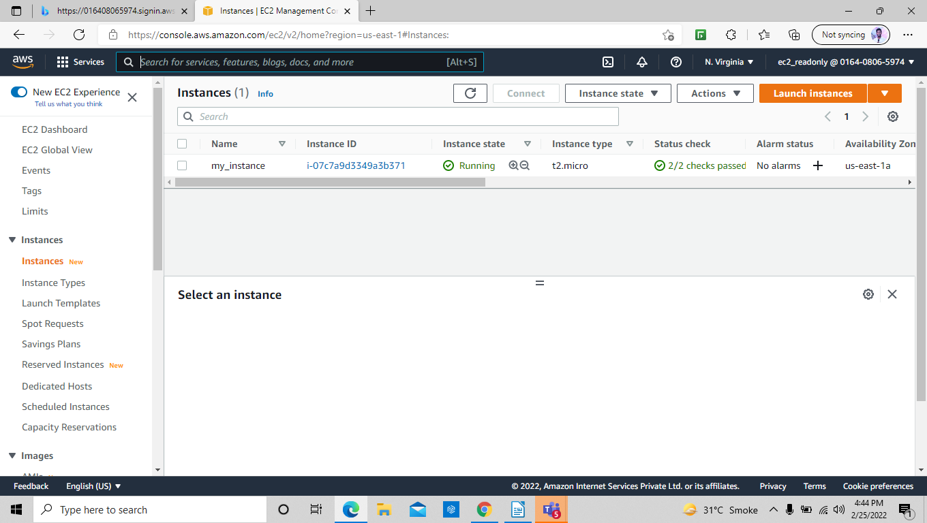

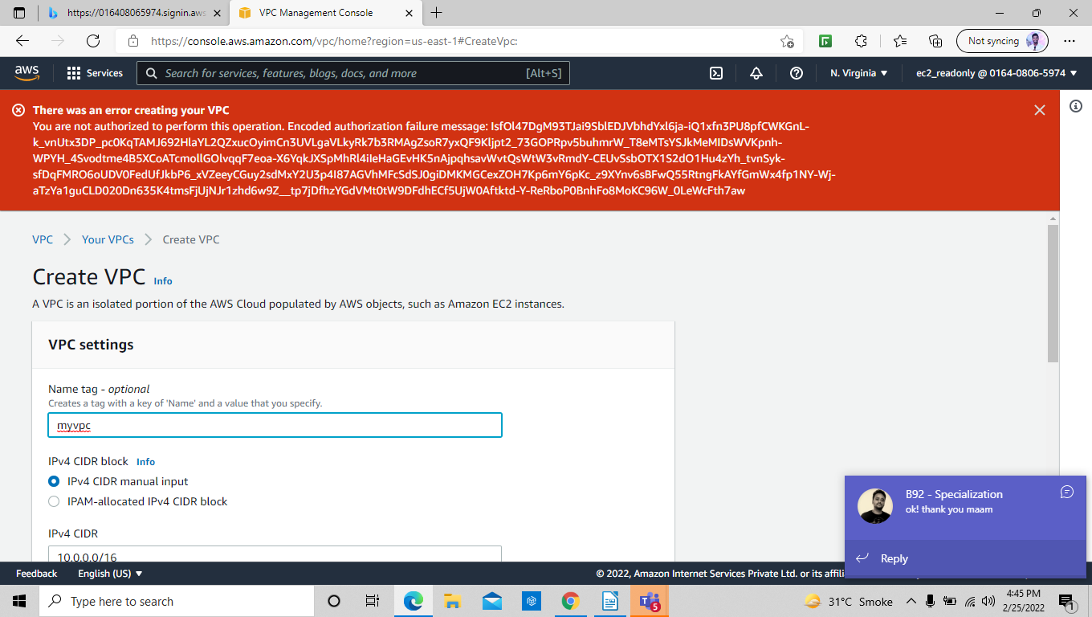

Task : 2 : crating IAM role for billing and try to access using iam user .

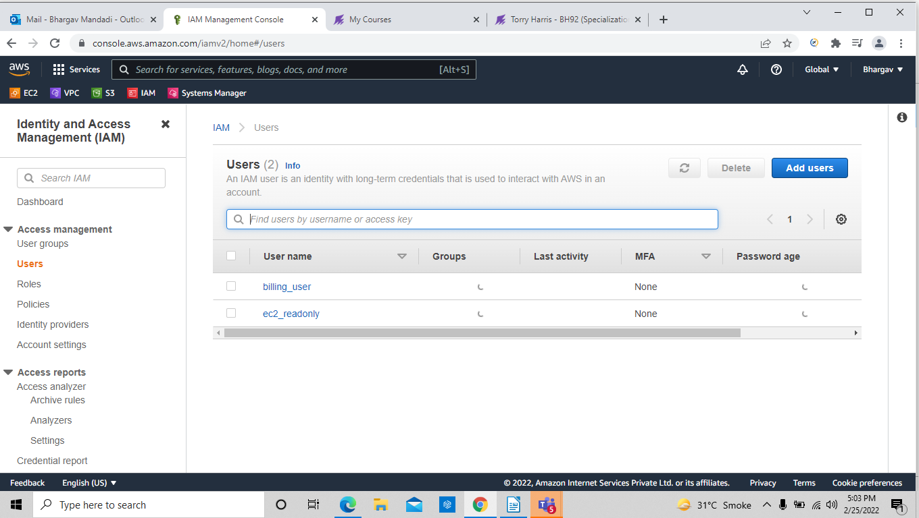

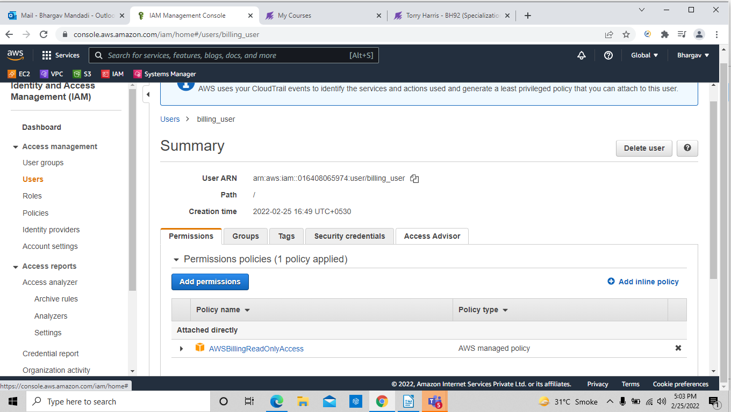
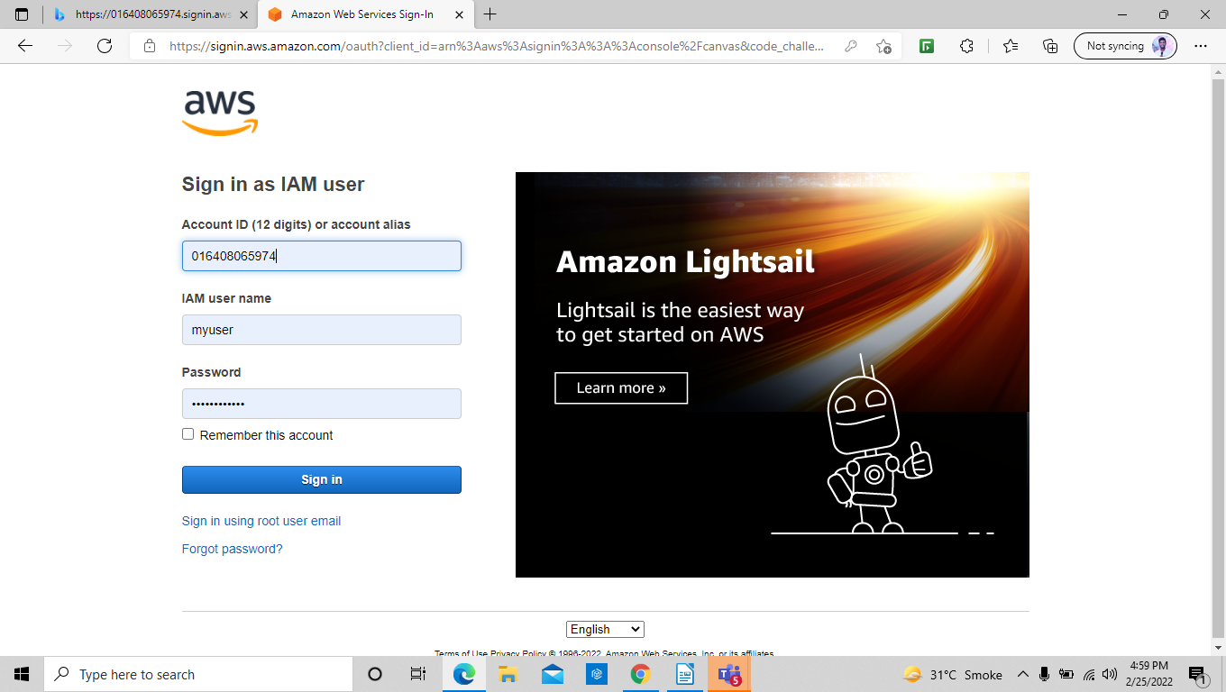

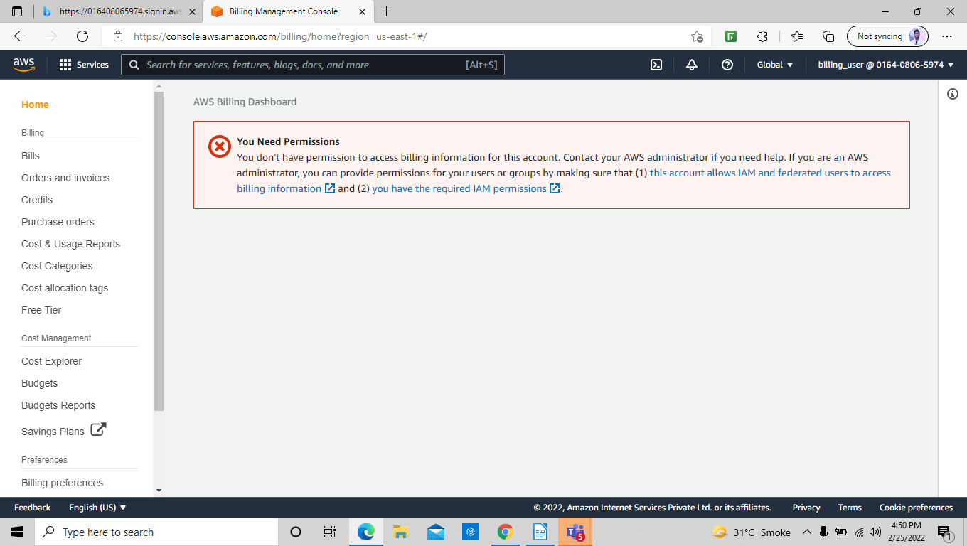
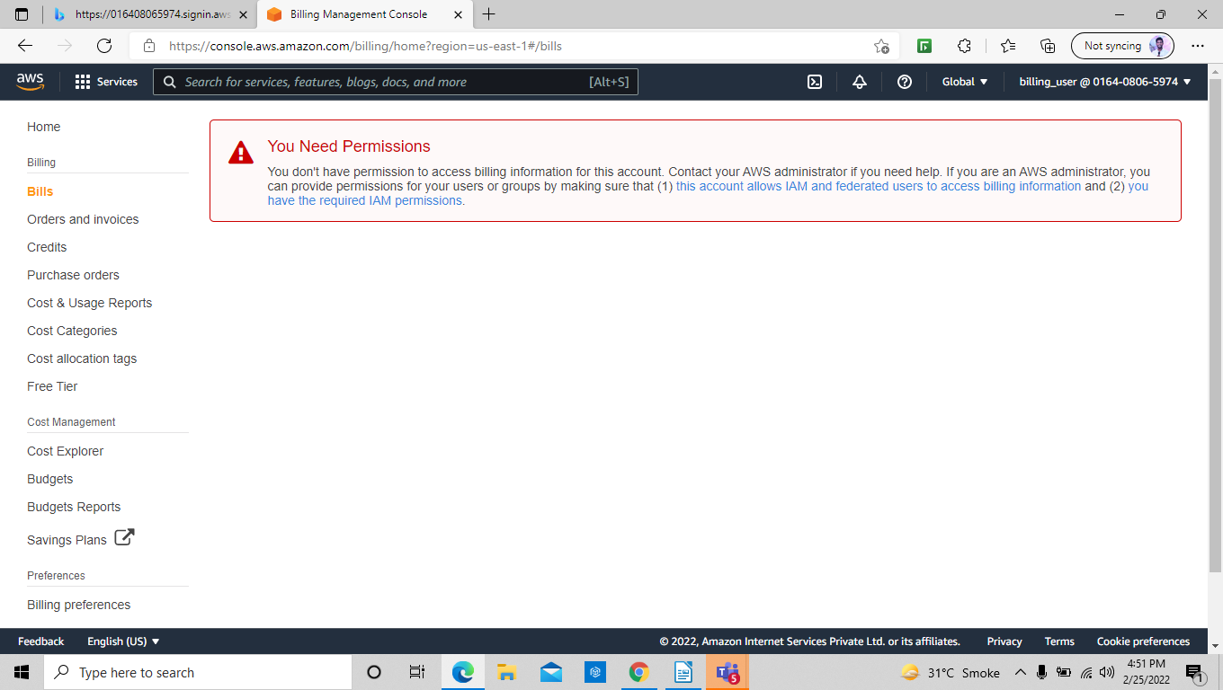

3. VPC creation:
We go to the create vpc and give it name and select the desired CIDR range .

After that we can see the vpc status as available.

Create sub-net:
Now we go to the create subnet and select the vpc and the subnet range and region and proceed.

In the screenshots we can see two subnets created with available status.

Create routes:
Now we go to the create route table and give a name and select the vpc.

We go the create route option and create two routes

Create internet gateway.
We go to the internet gateway and give a name and proceed.

After that we have to attach the internet gateway to the VPC.

Attach routes:
Now we go to the route table and edit route and connect the internet gateway.

We go to the sub-net association and select the desired available sub-net and save the association.

Create instance:
Now we go to the EC2 instance and create two instance and wait until the 2/2 status check.

Generate password:
We go to the public EC2 and RDP client and generate the password using the key pair and download the remote desktop.

Remote Desktop:
Now we open the remote desktop and give it password and log in.

We go to internet explorer and try to ping google.com.

Now we go to the RUN and type mstsc and give the ip address and password of the private EC2 instance and try to open the remote desktop in the previous remote desktop.

We can see the result below.

Now we terminate the EC2 instances to avoid the cost.

Deleted the VPC , SUB NET, INSTANCES, INTERNET GATEWAY.
First we go to the internet gateway and select and detach it form vpc and go to delete option and for confirmation type delete

We go to routes and edit and remove the sub-net association and go to delete and for confirmation type delete the routes.

We go to subnets also and delete the sub-nets and confirm it.

After removing the internet gateway we can delete the VPC also

Billing alert configured to your email address
We go to the billing section and can check the bills

We go to billing preferences and can give email and enable notification on our email.

Nat Gateway:
We create a nat gateway and allocate elastic ip for it
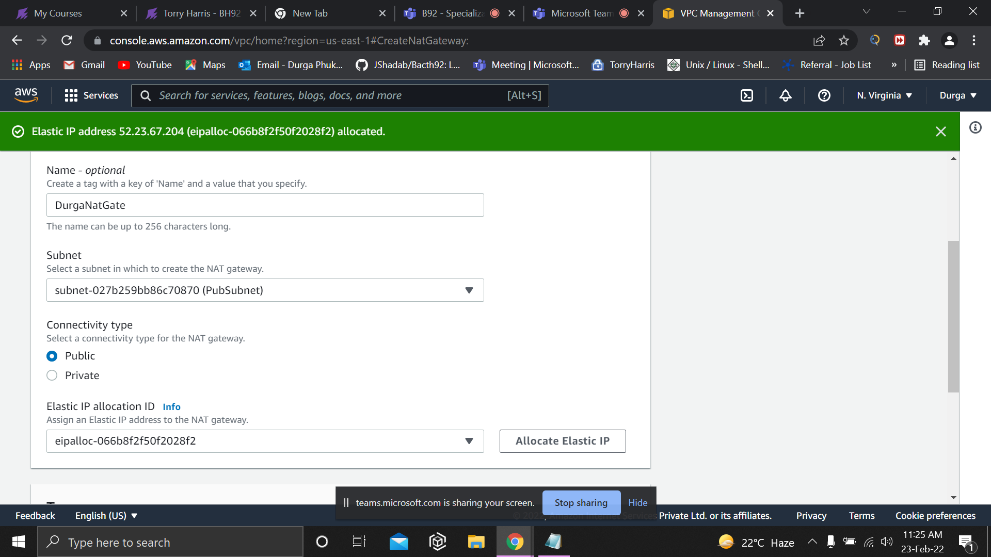
We go to the VPC and edit and enable the DNS host name.

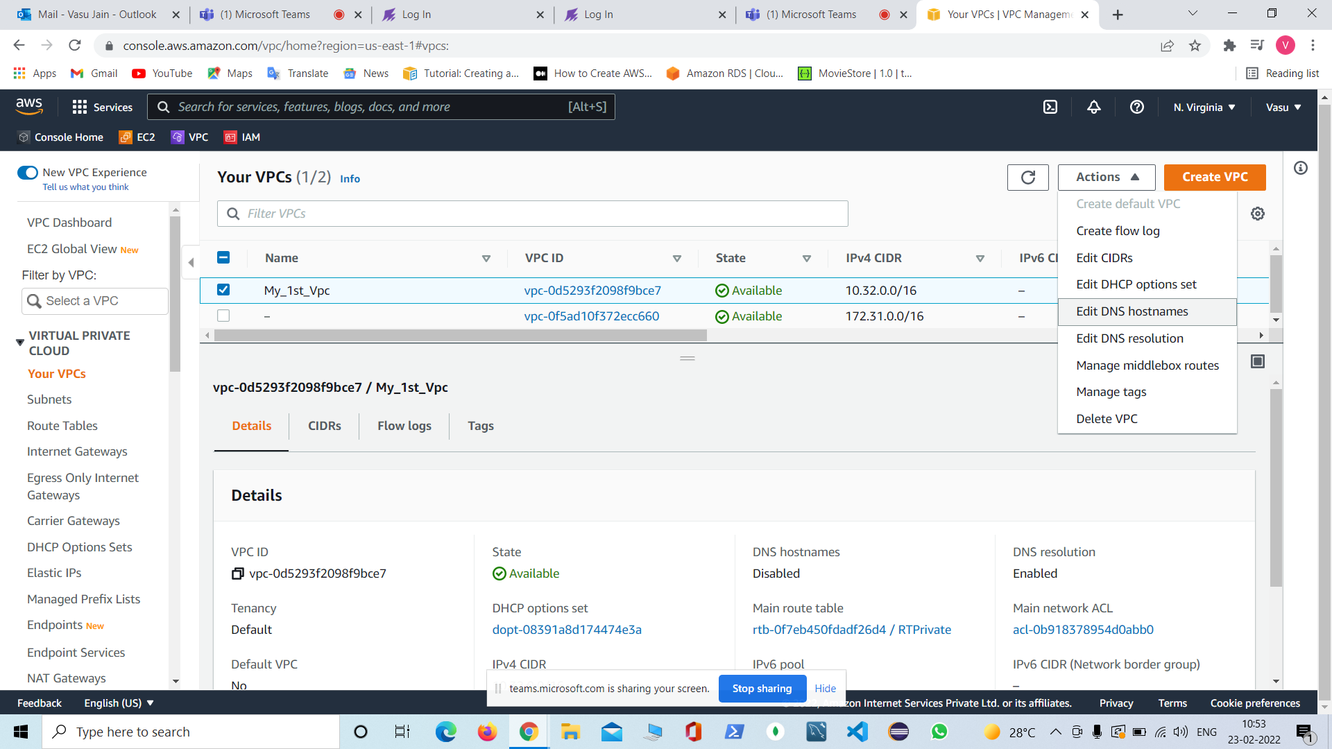

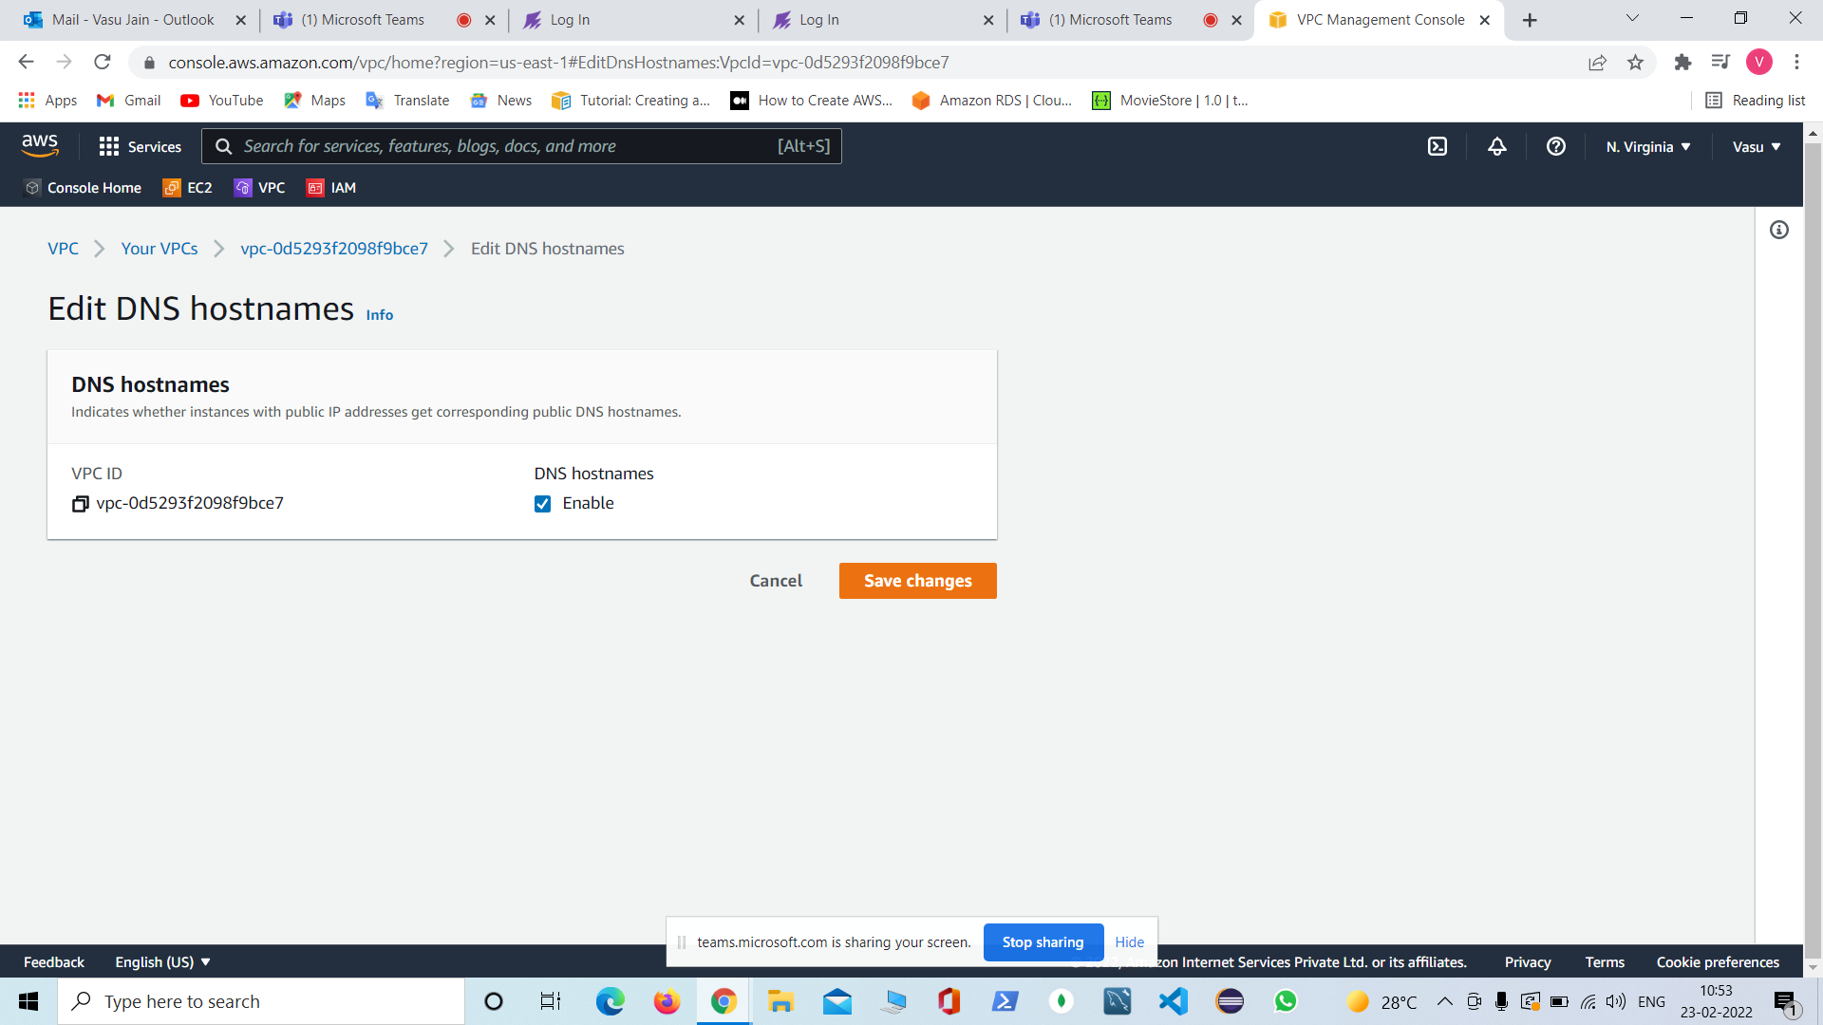

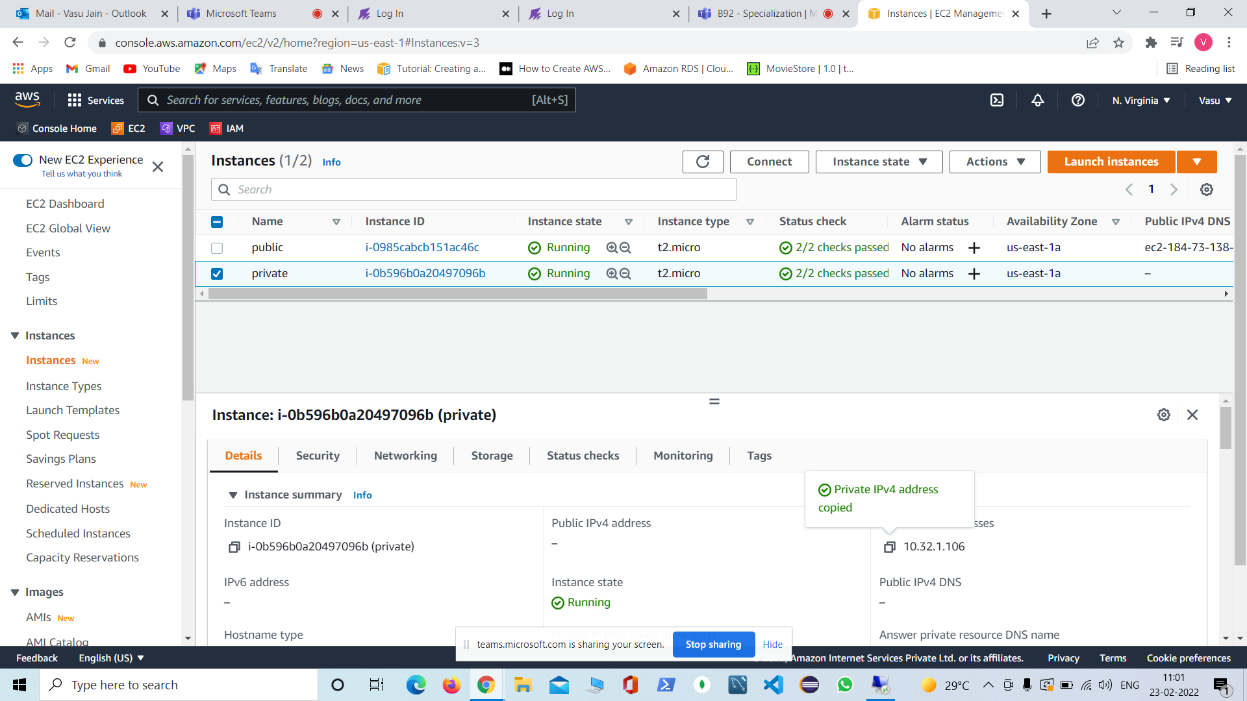

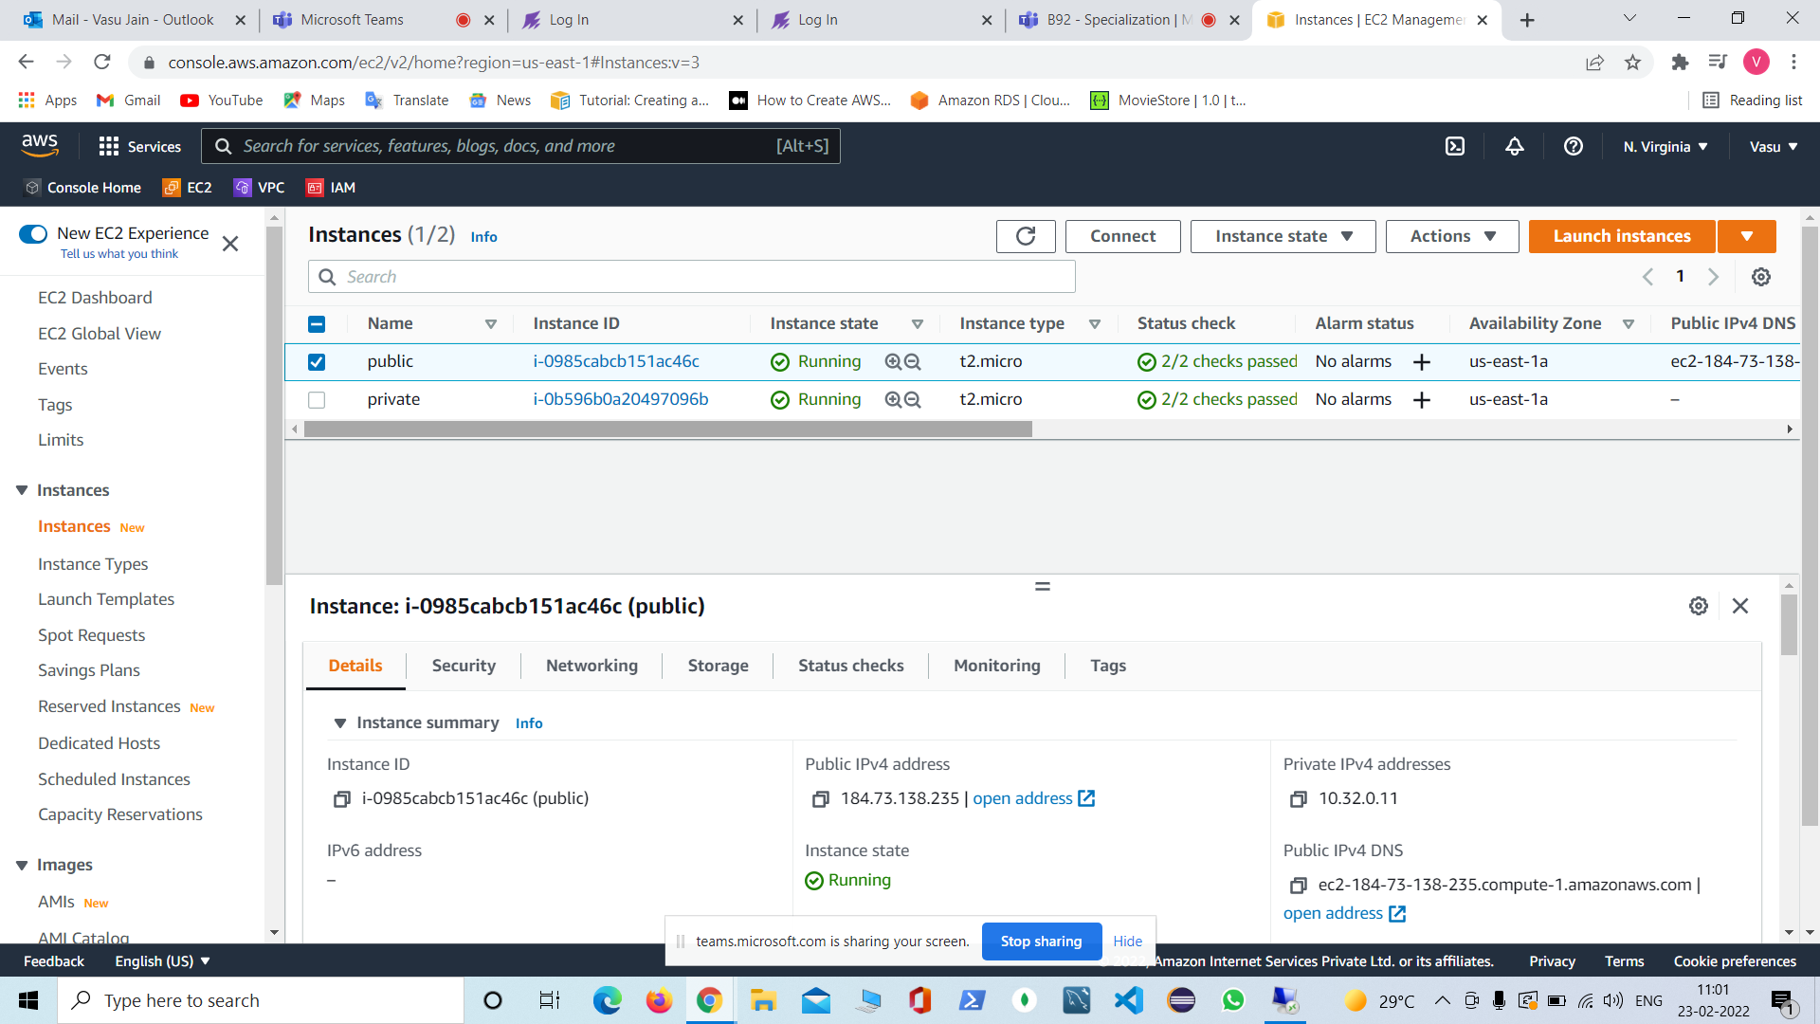

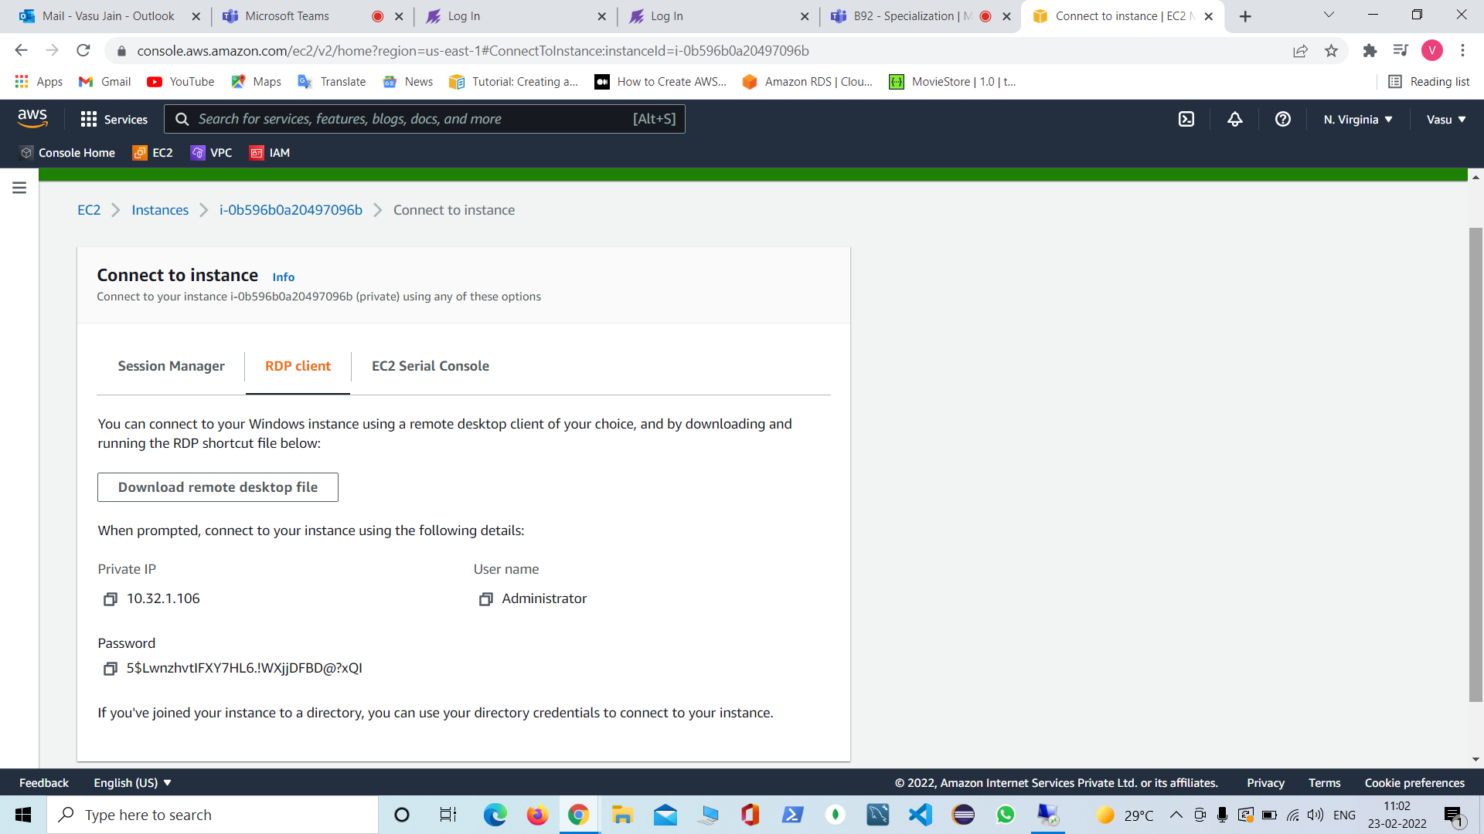

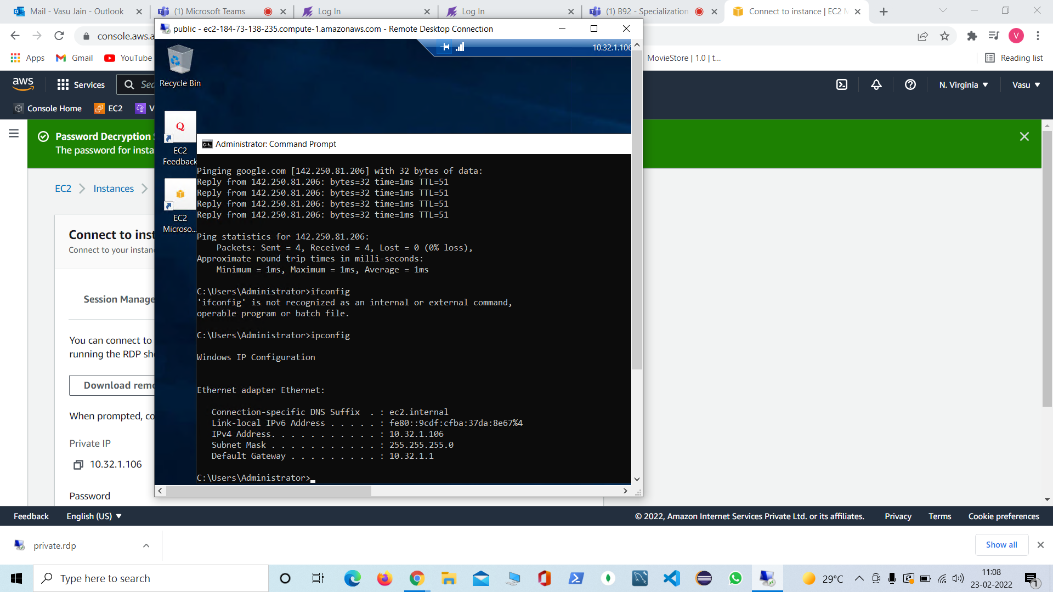

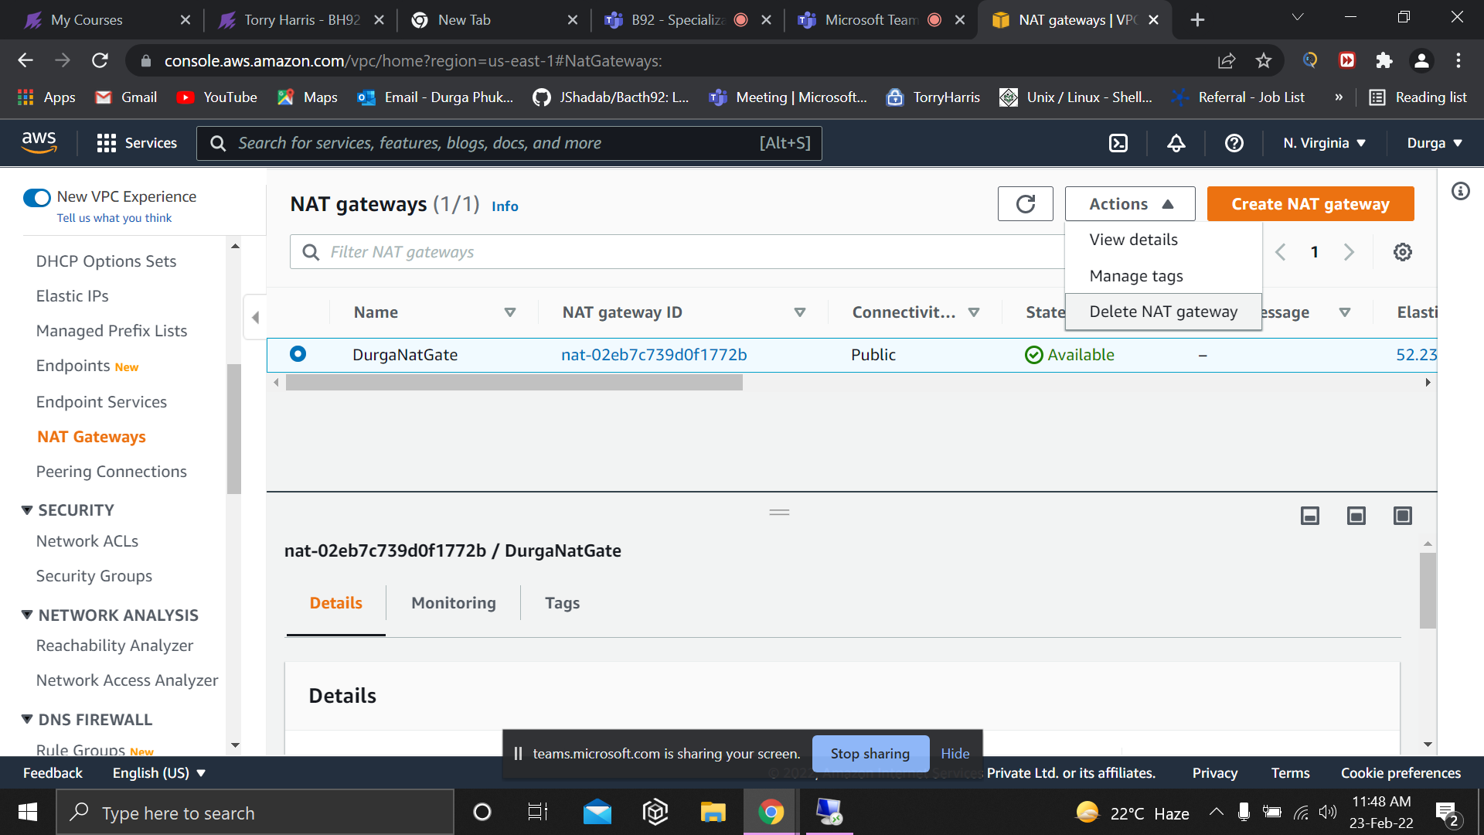

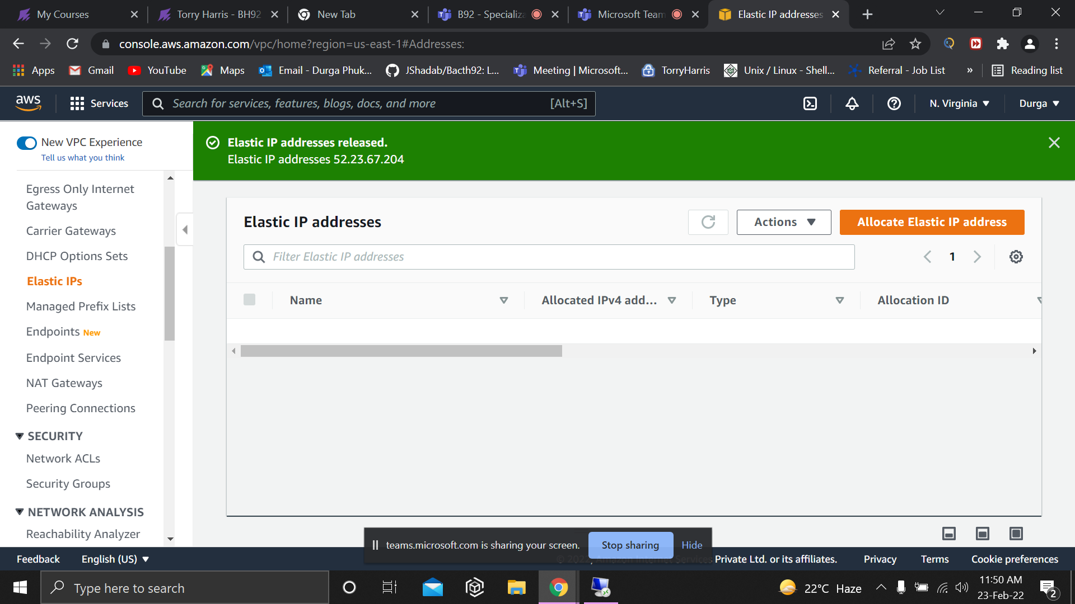

SSM creation:
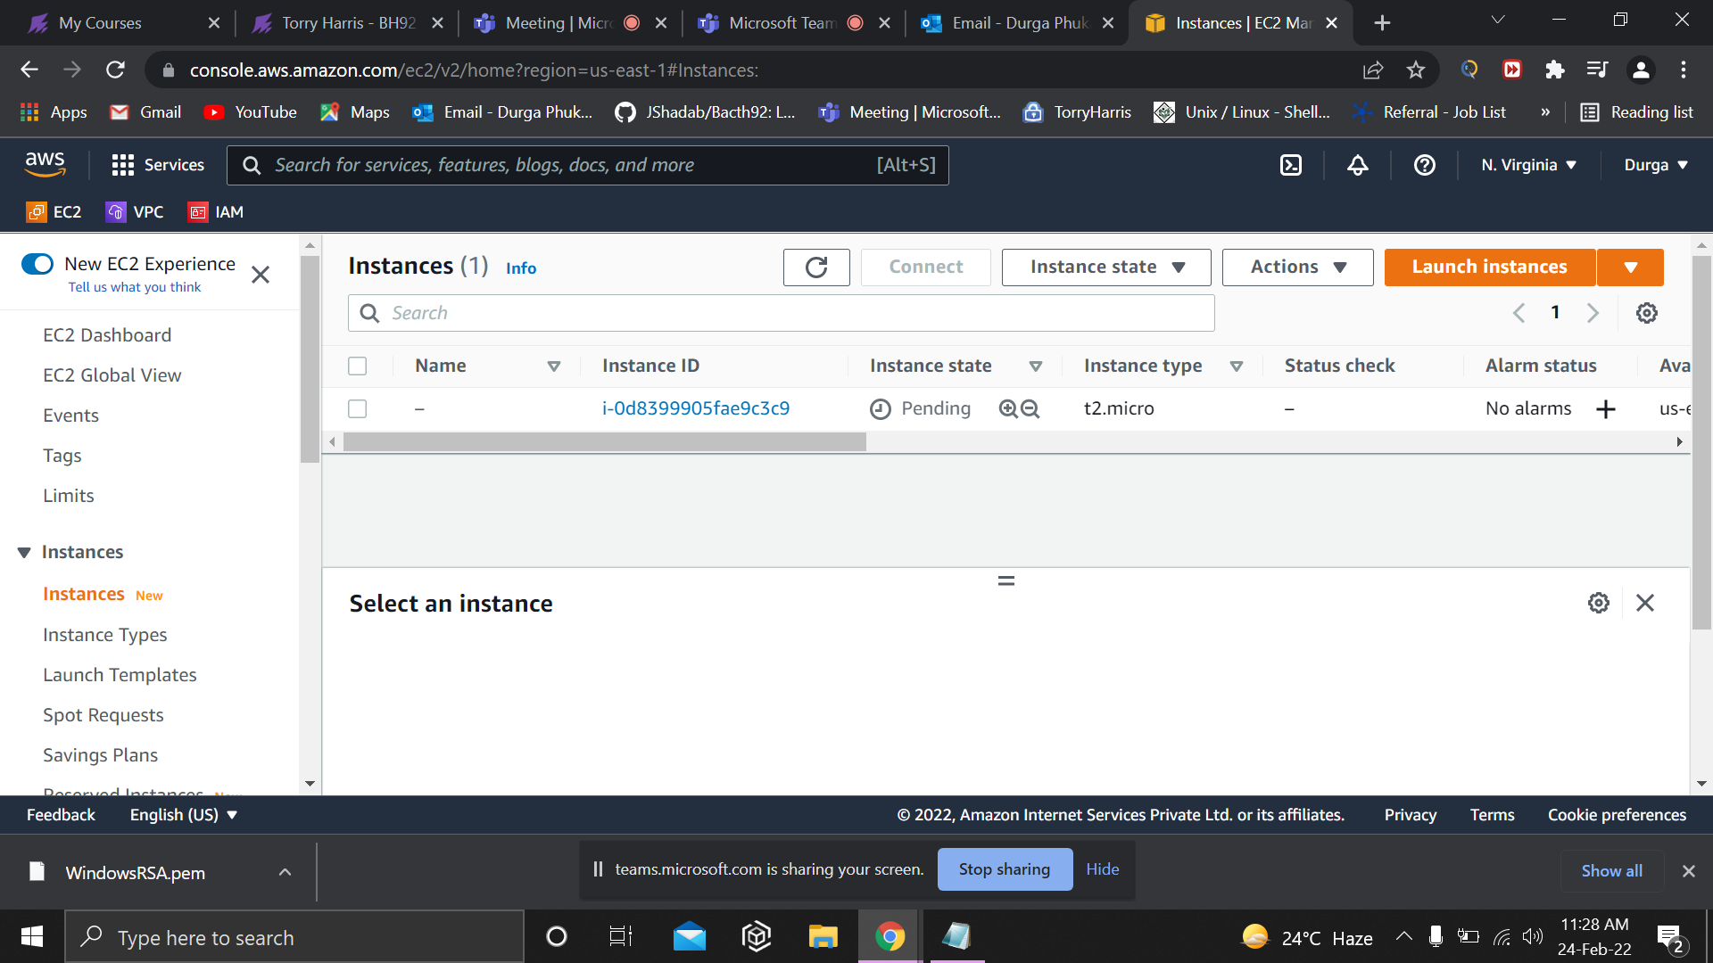
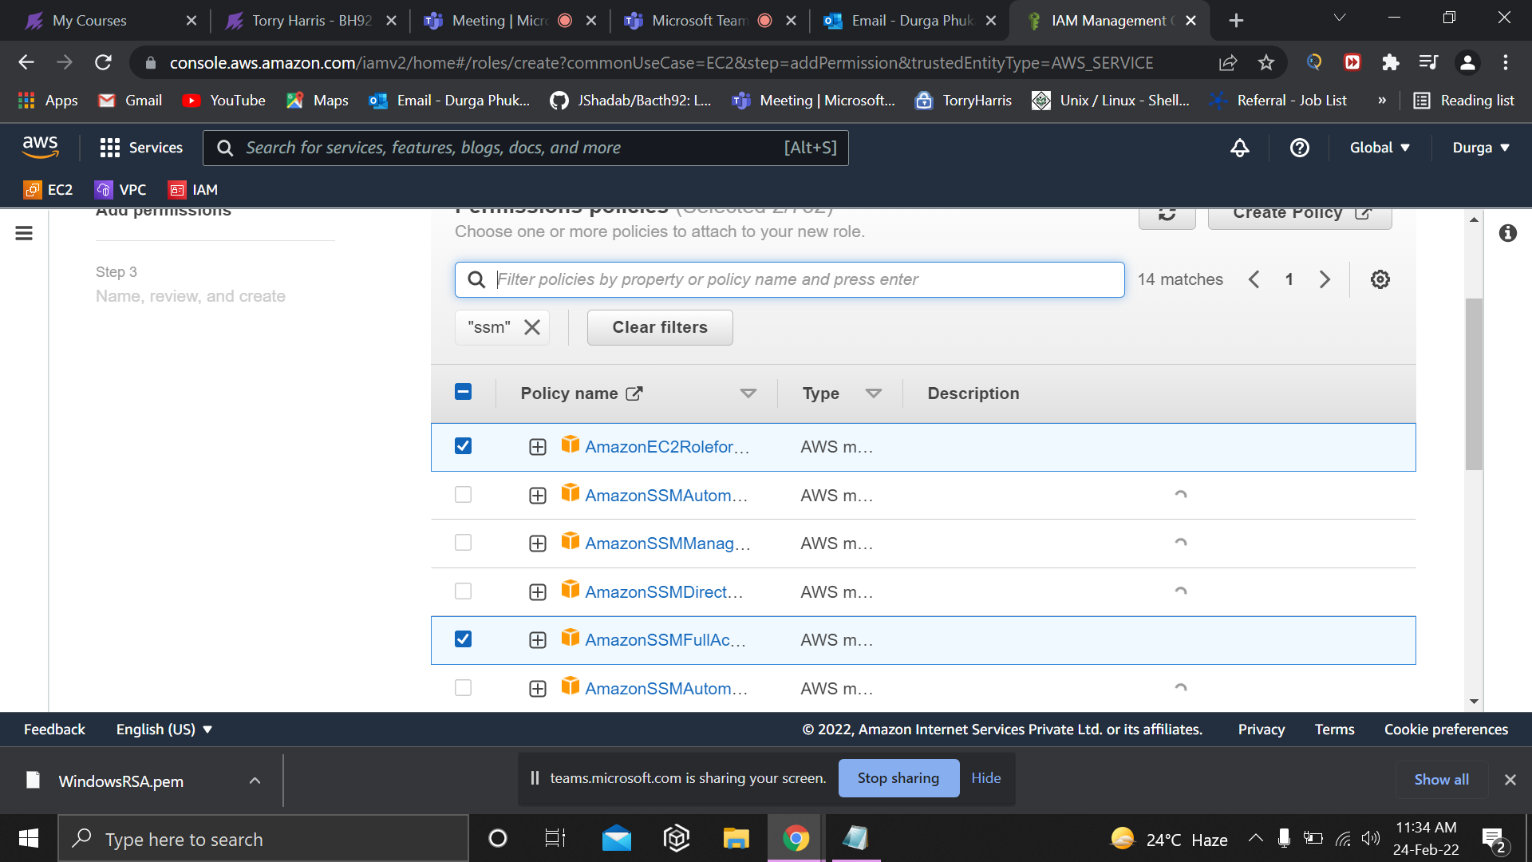

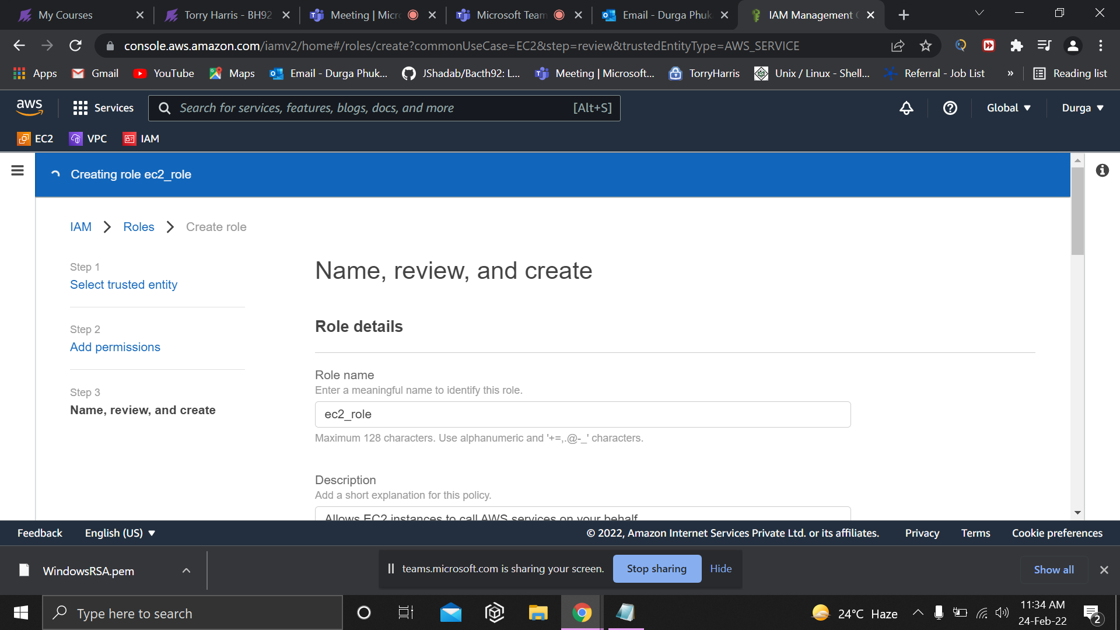
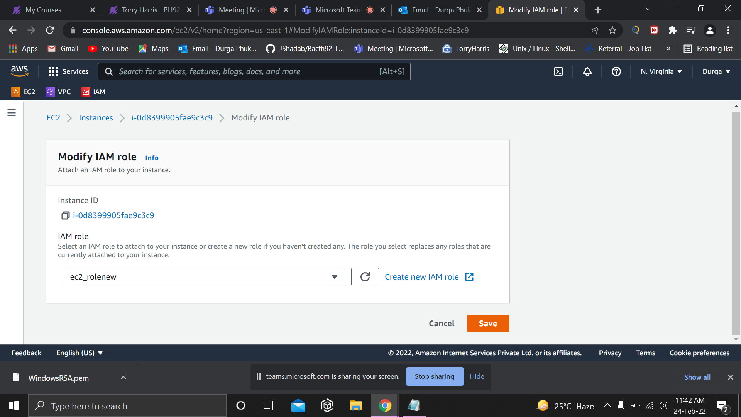

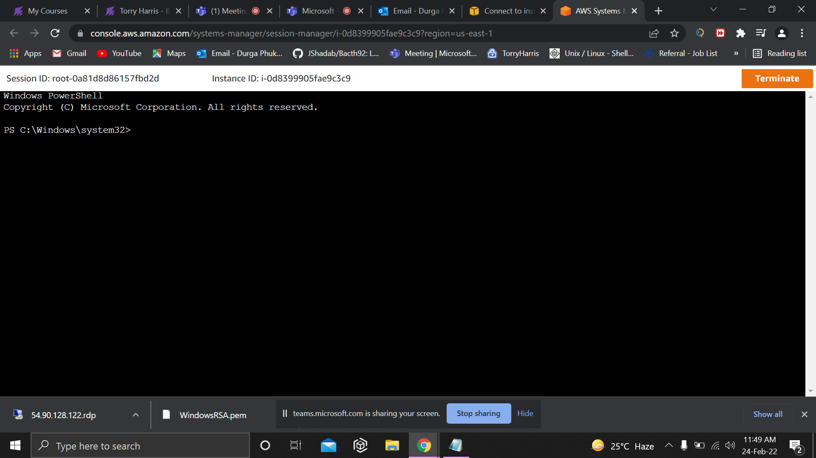

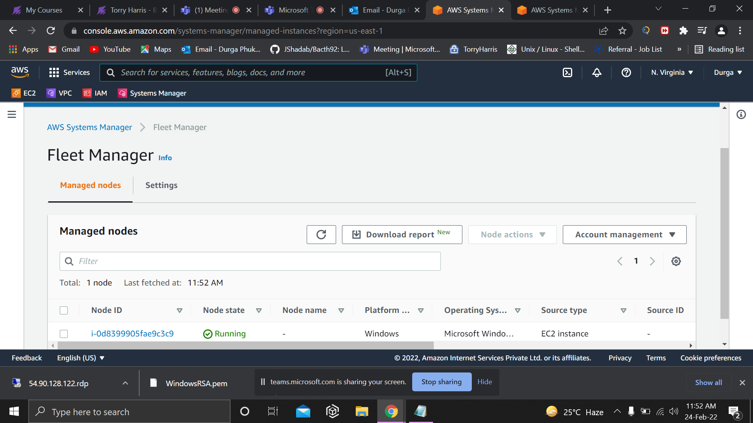

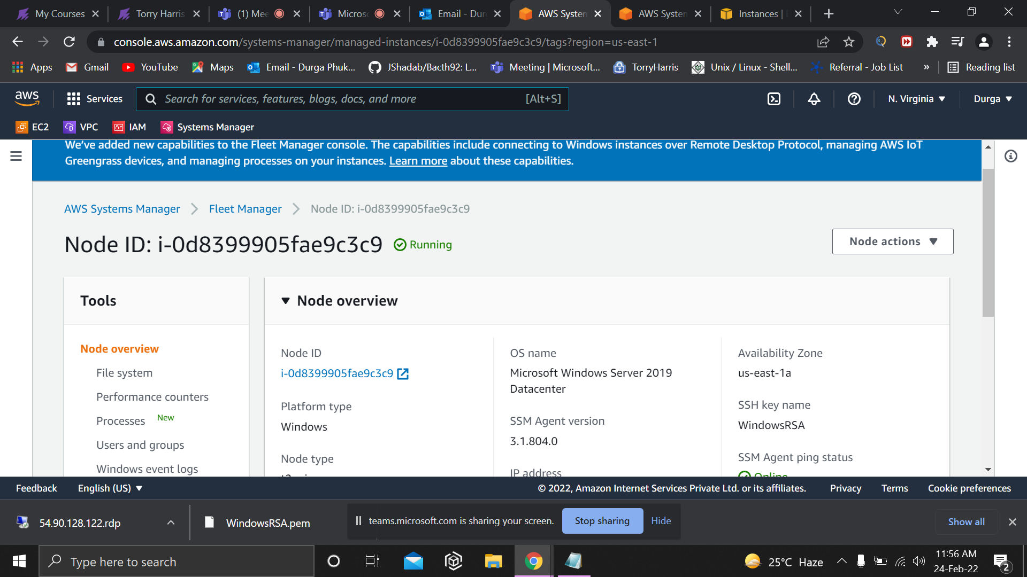

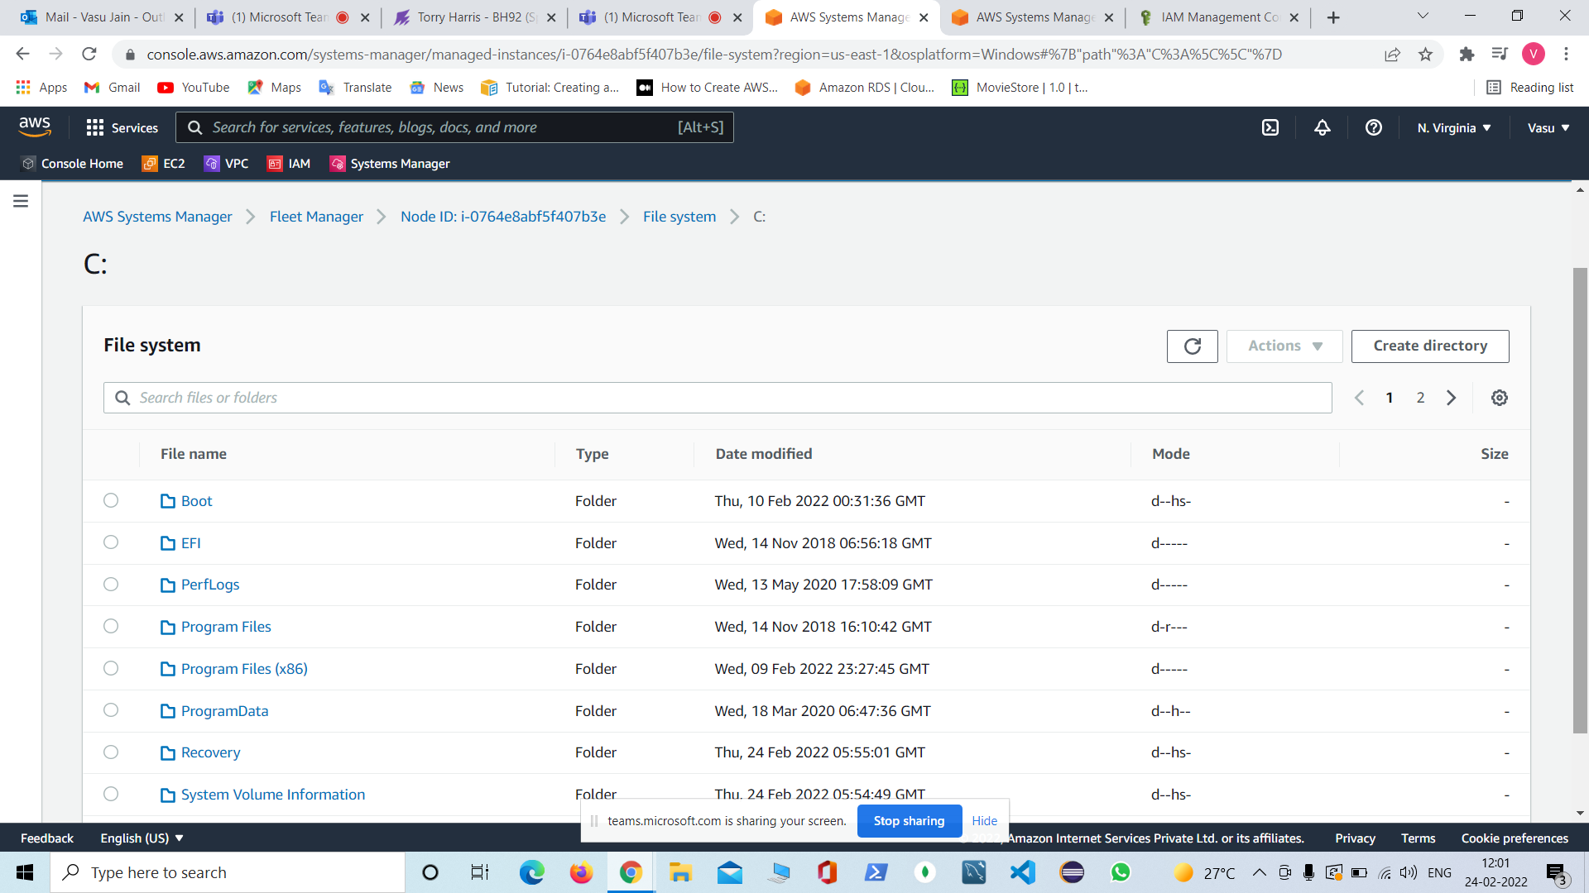

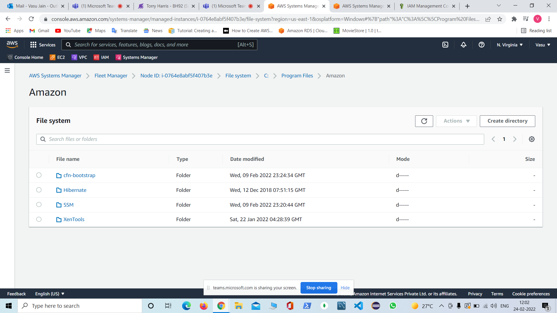

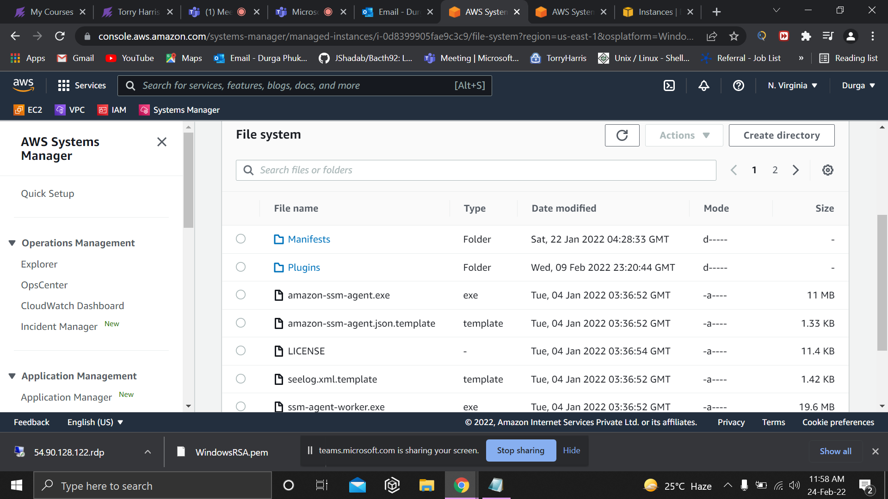

Peering Connections:
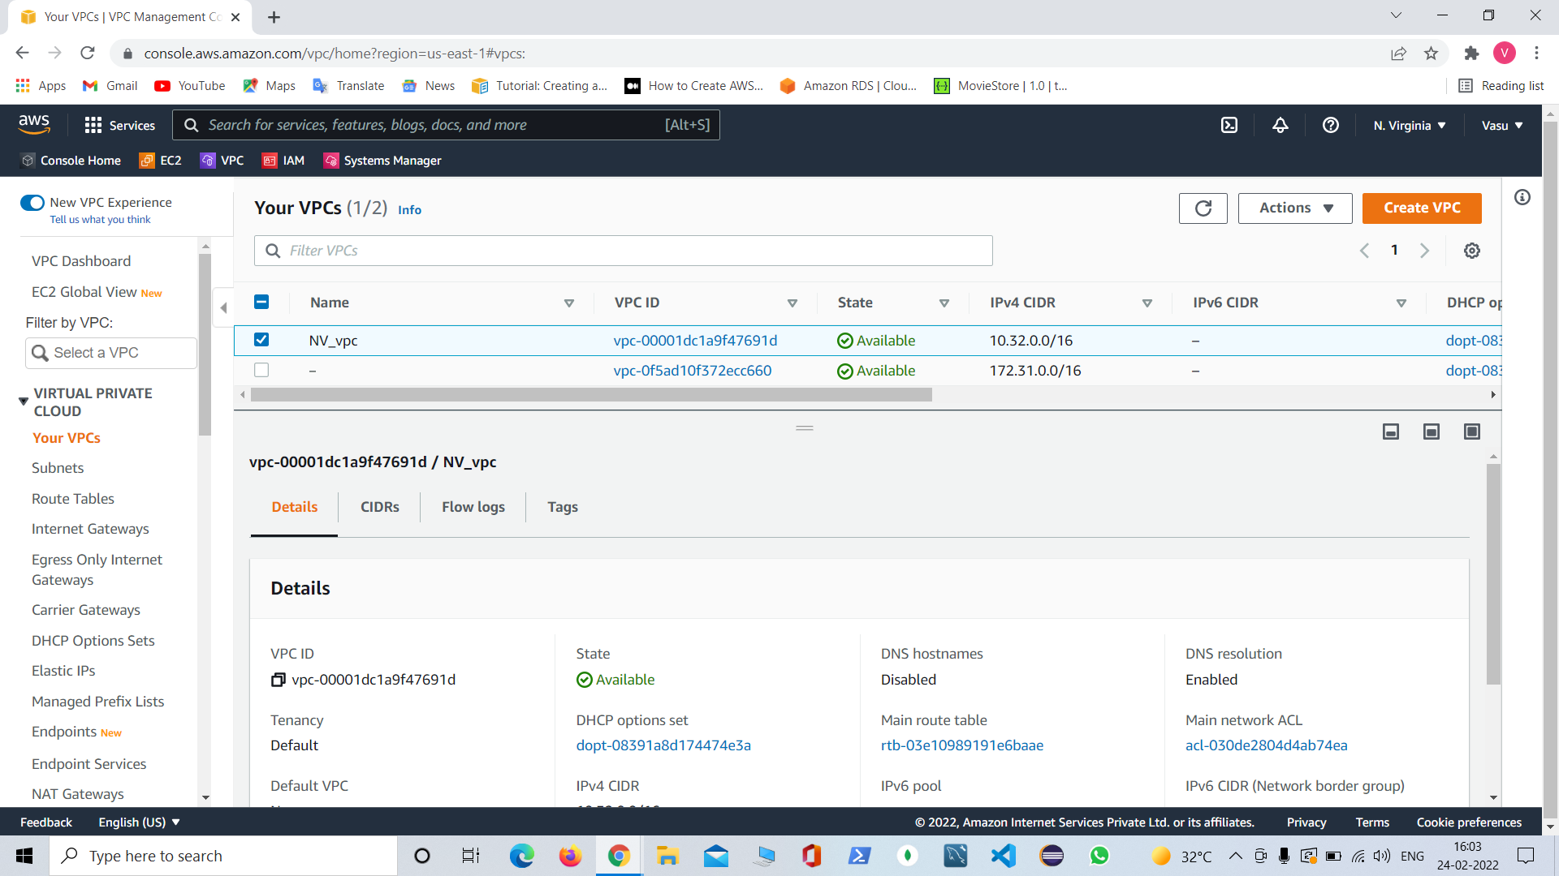

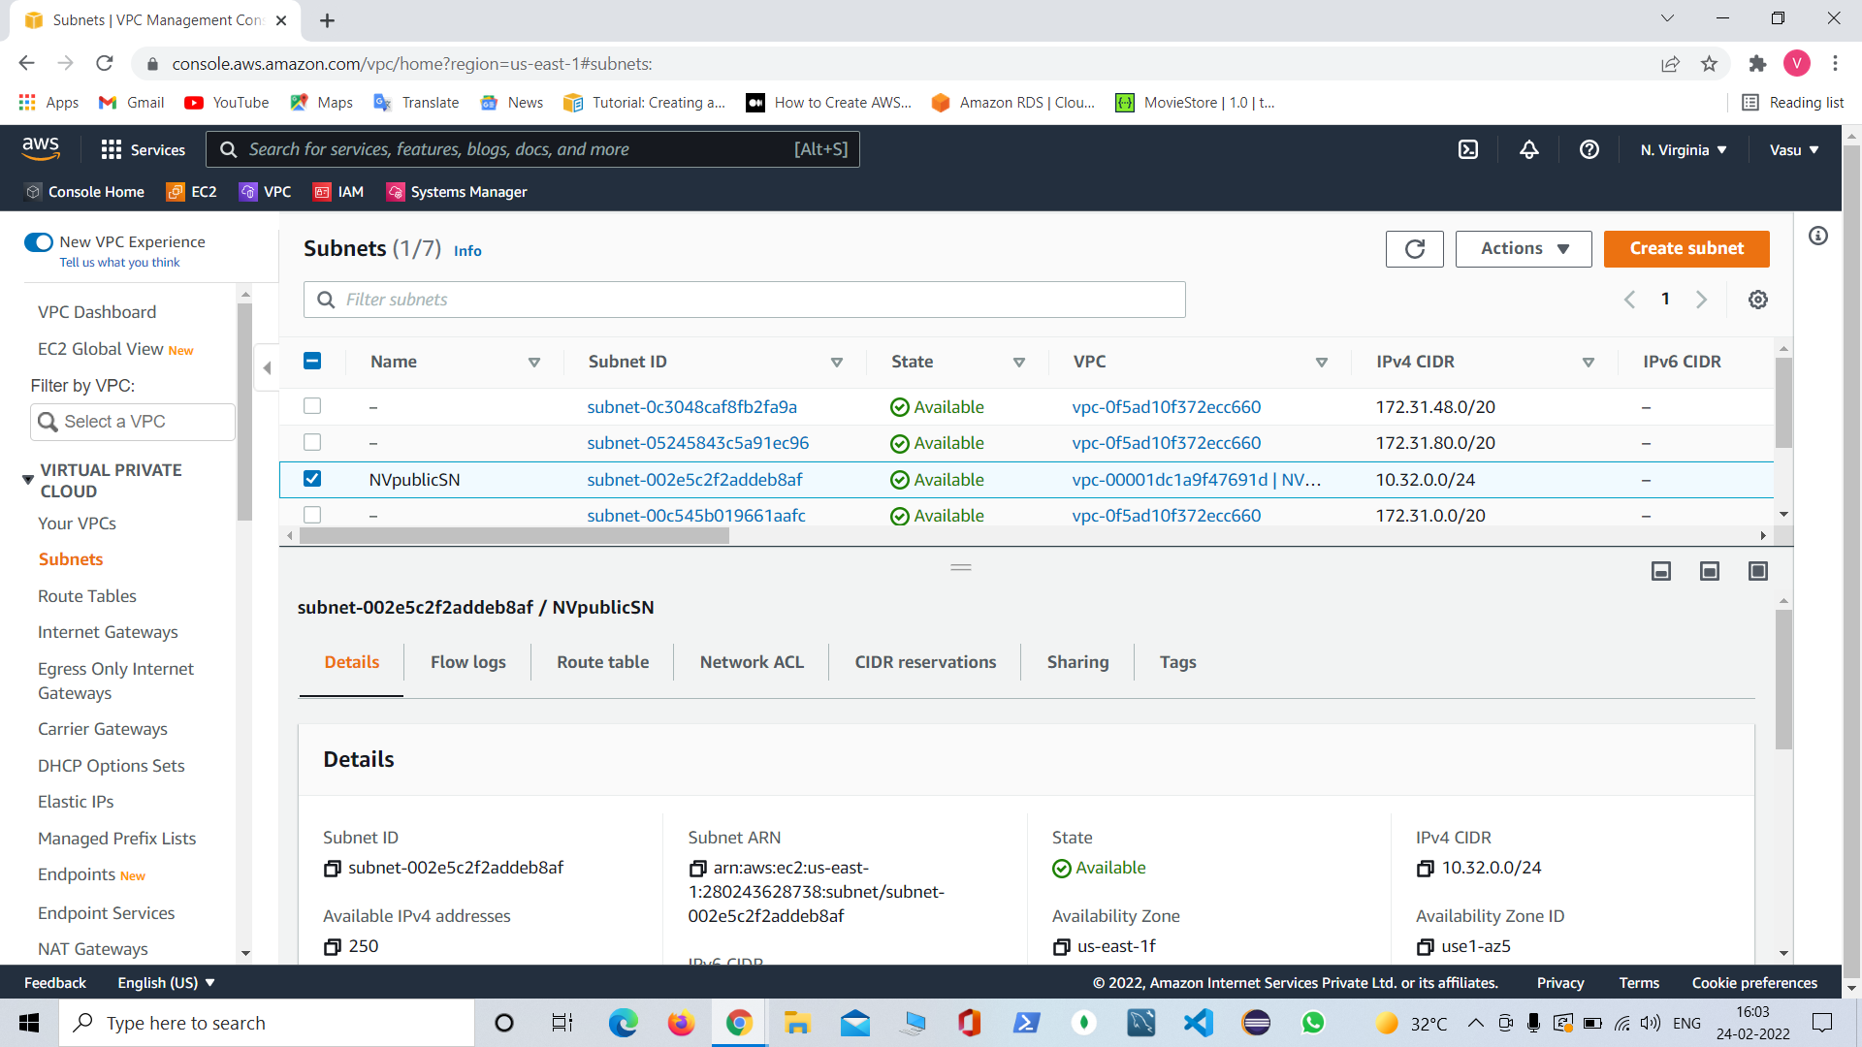
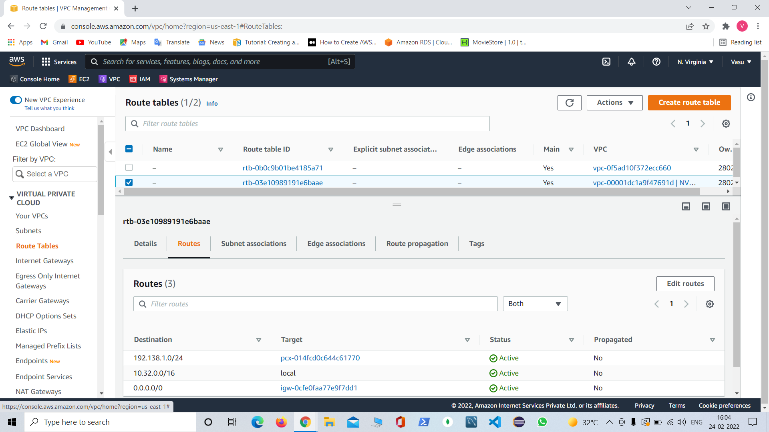

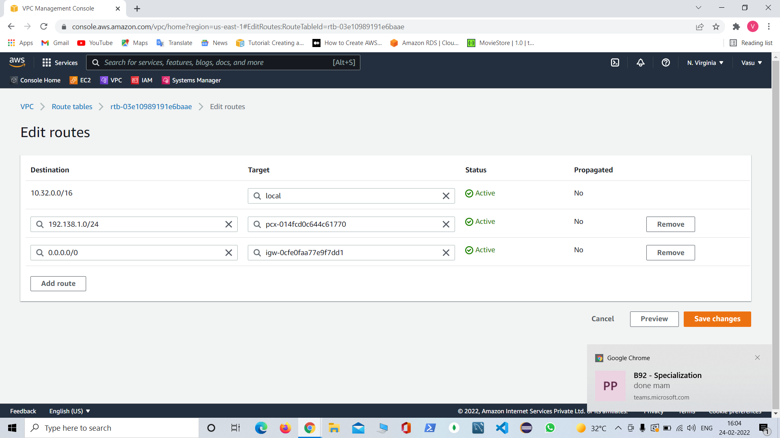

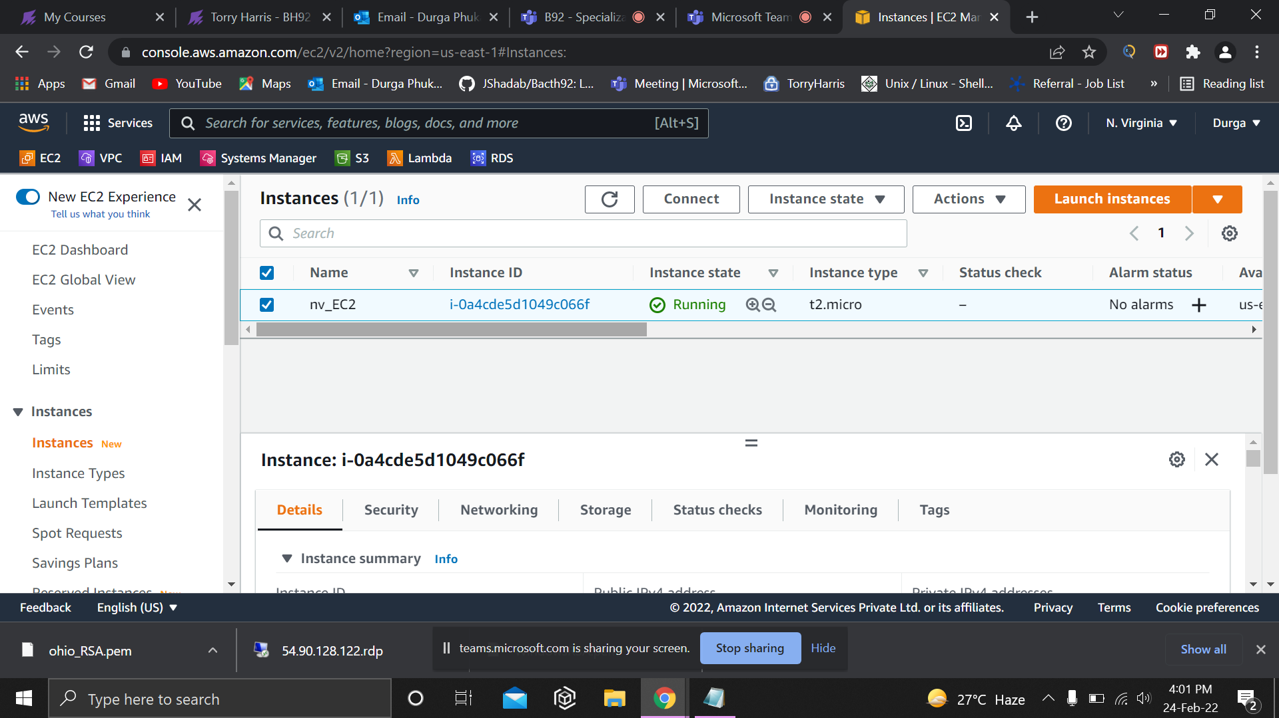
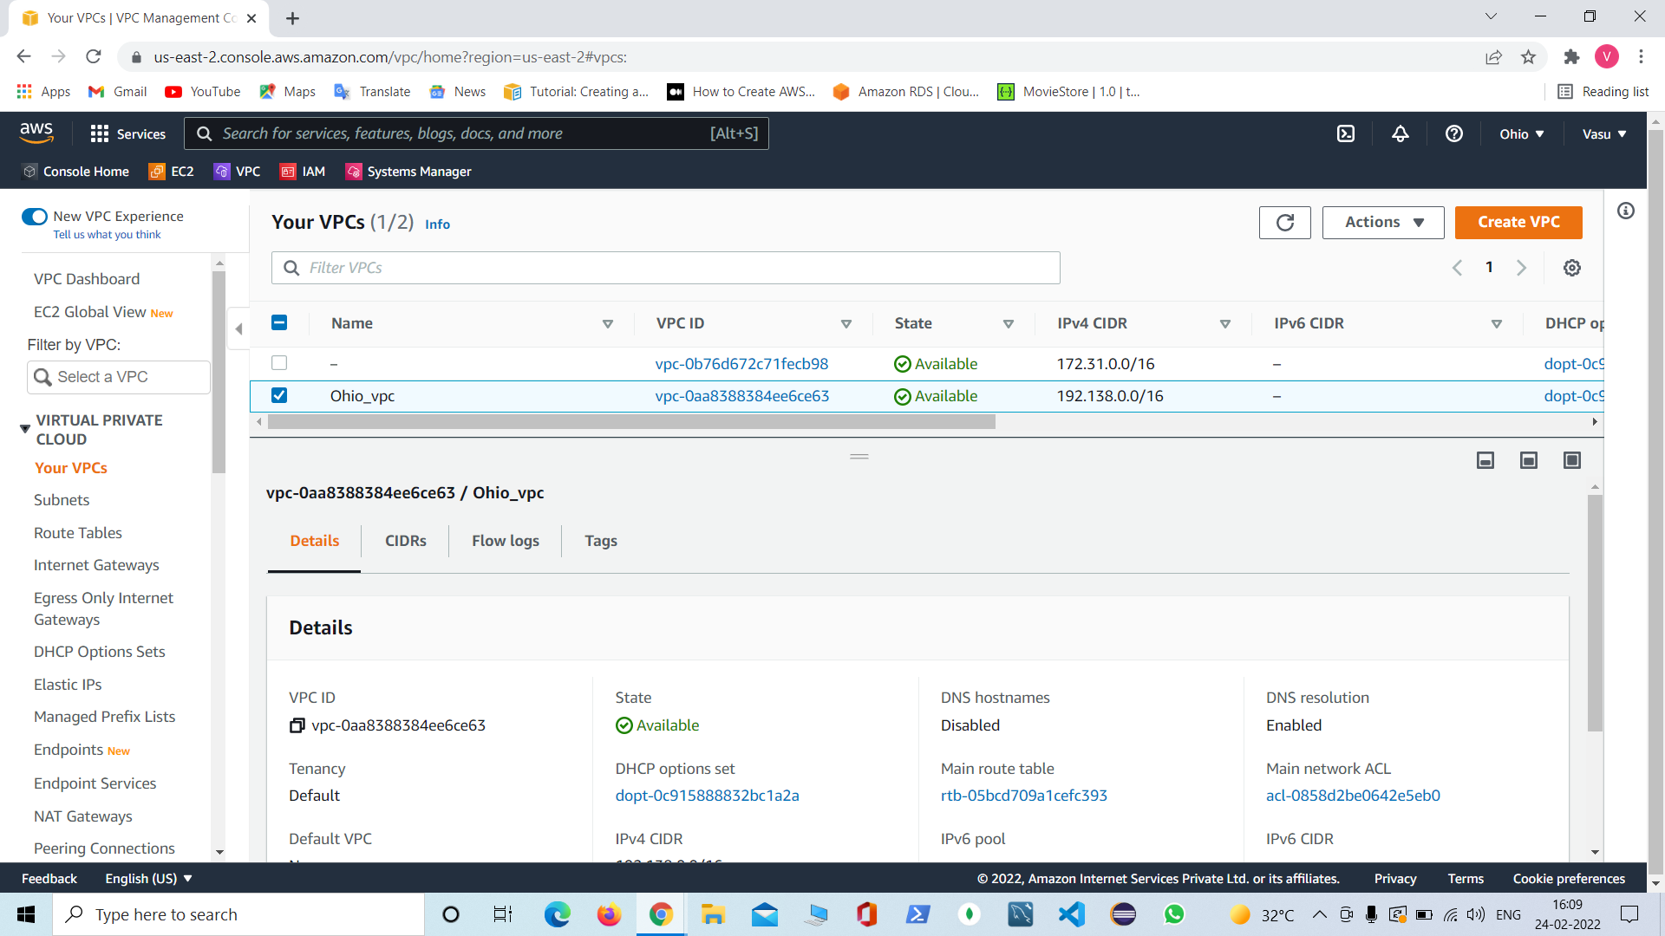

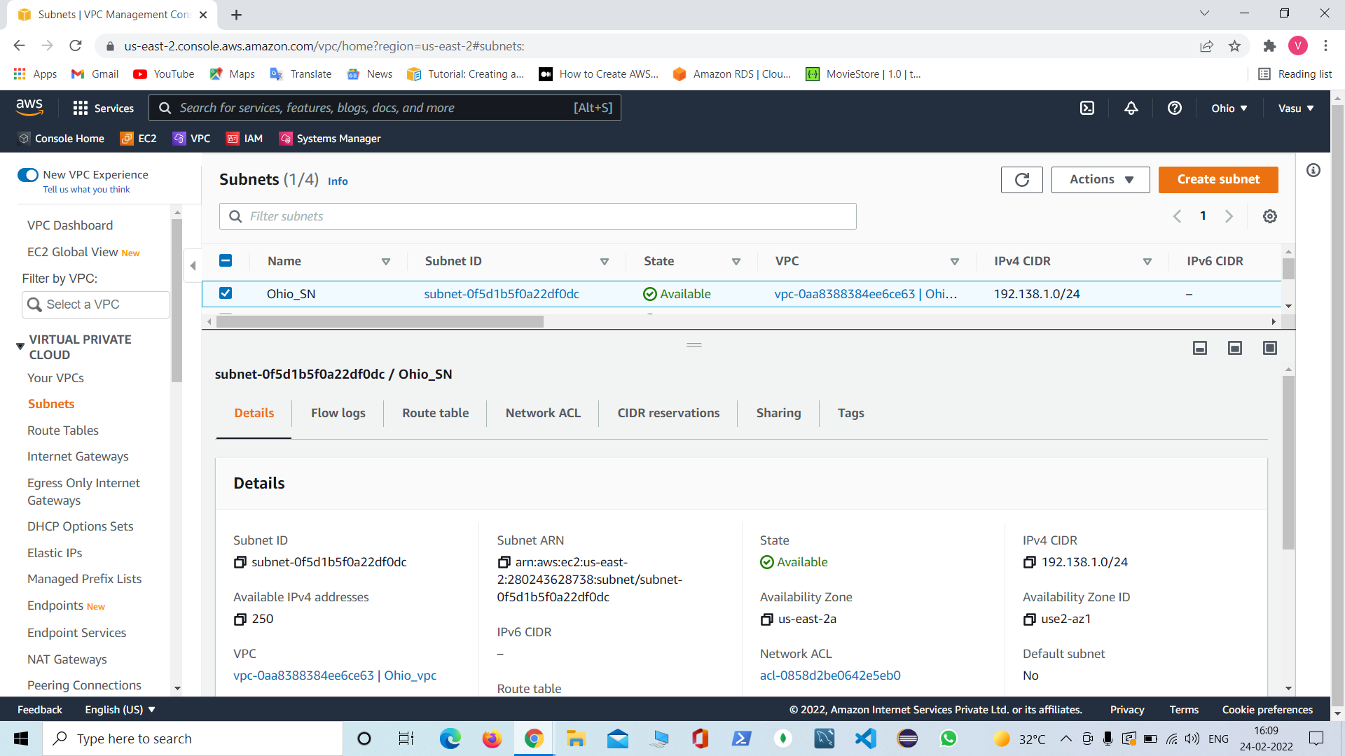

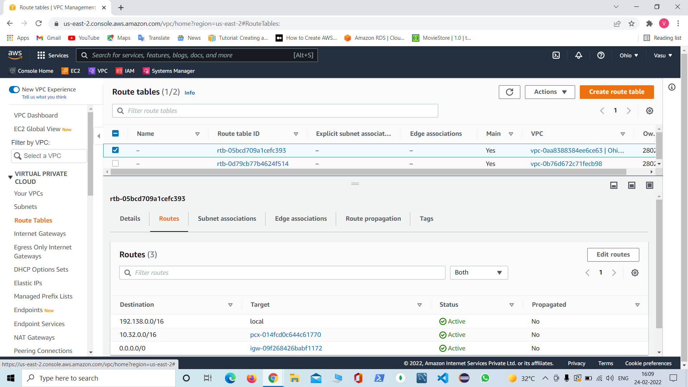

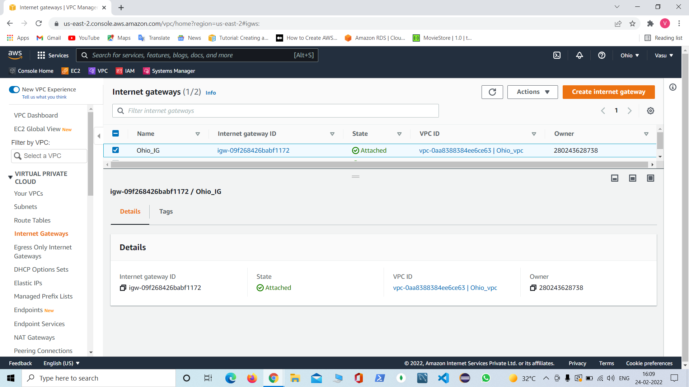

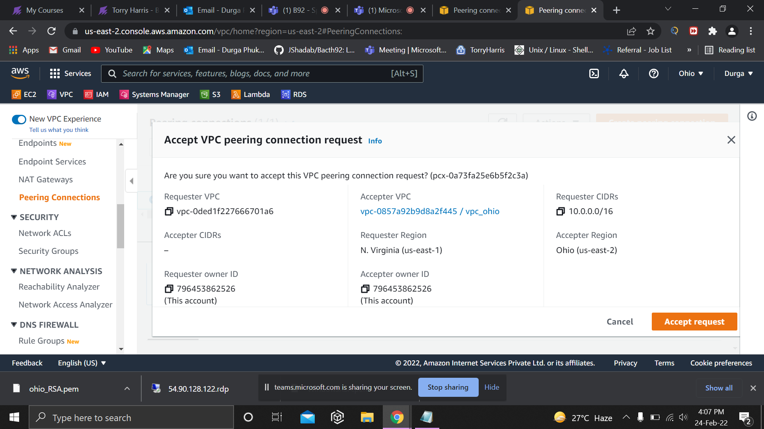

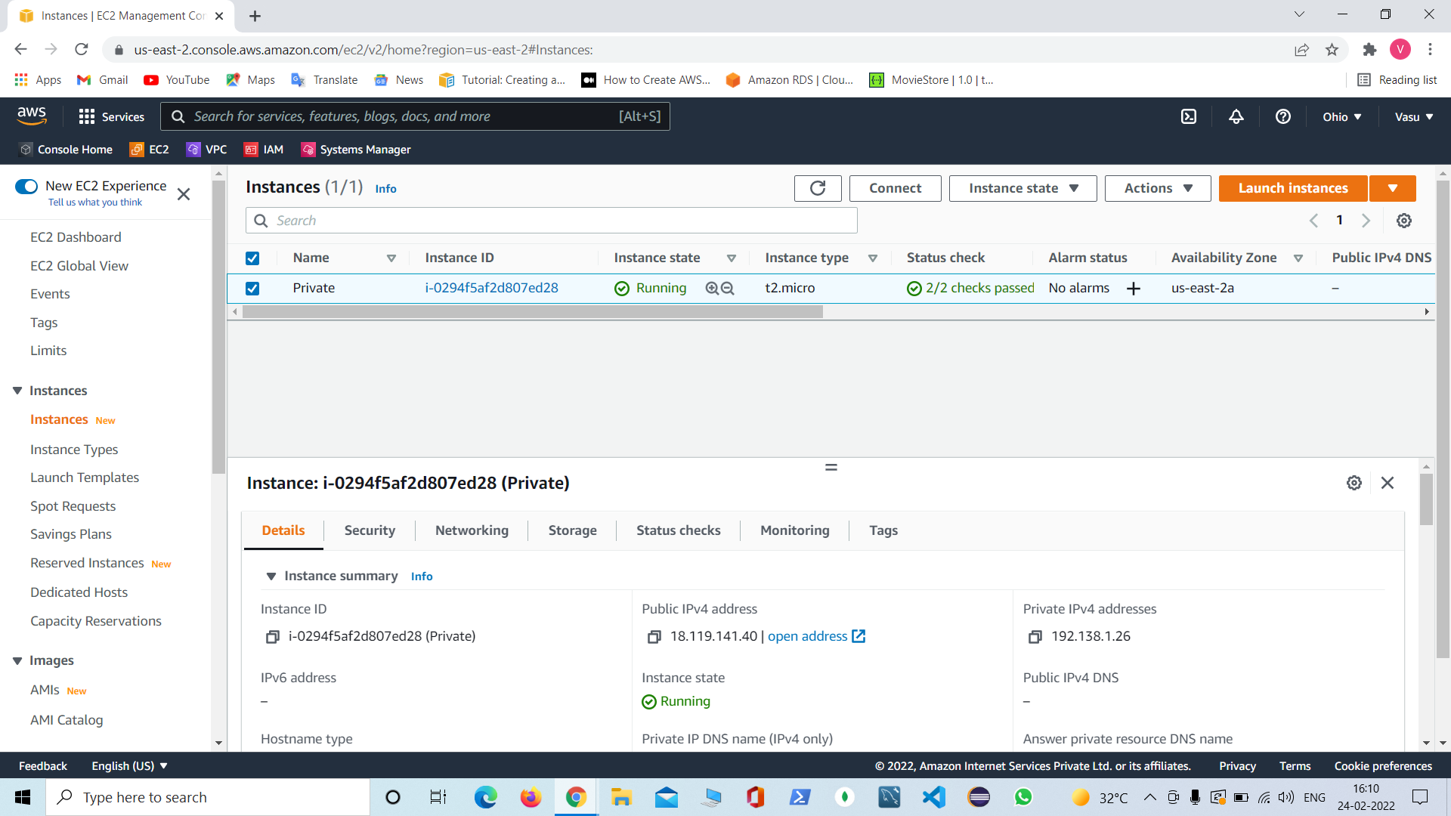

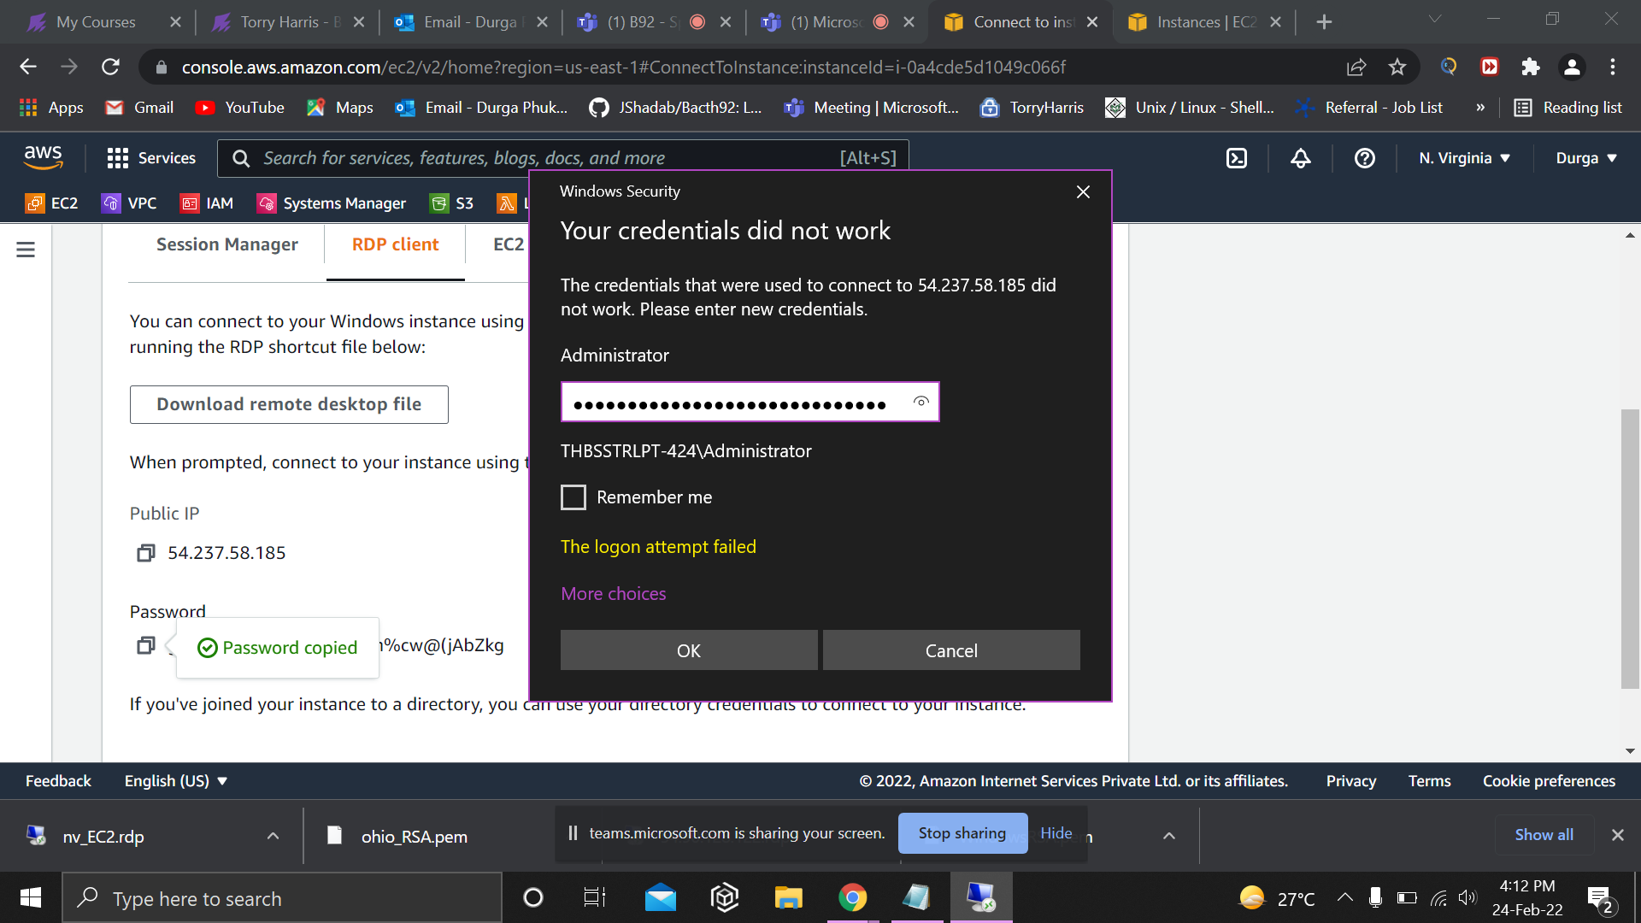

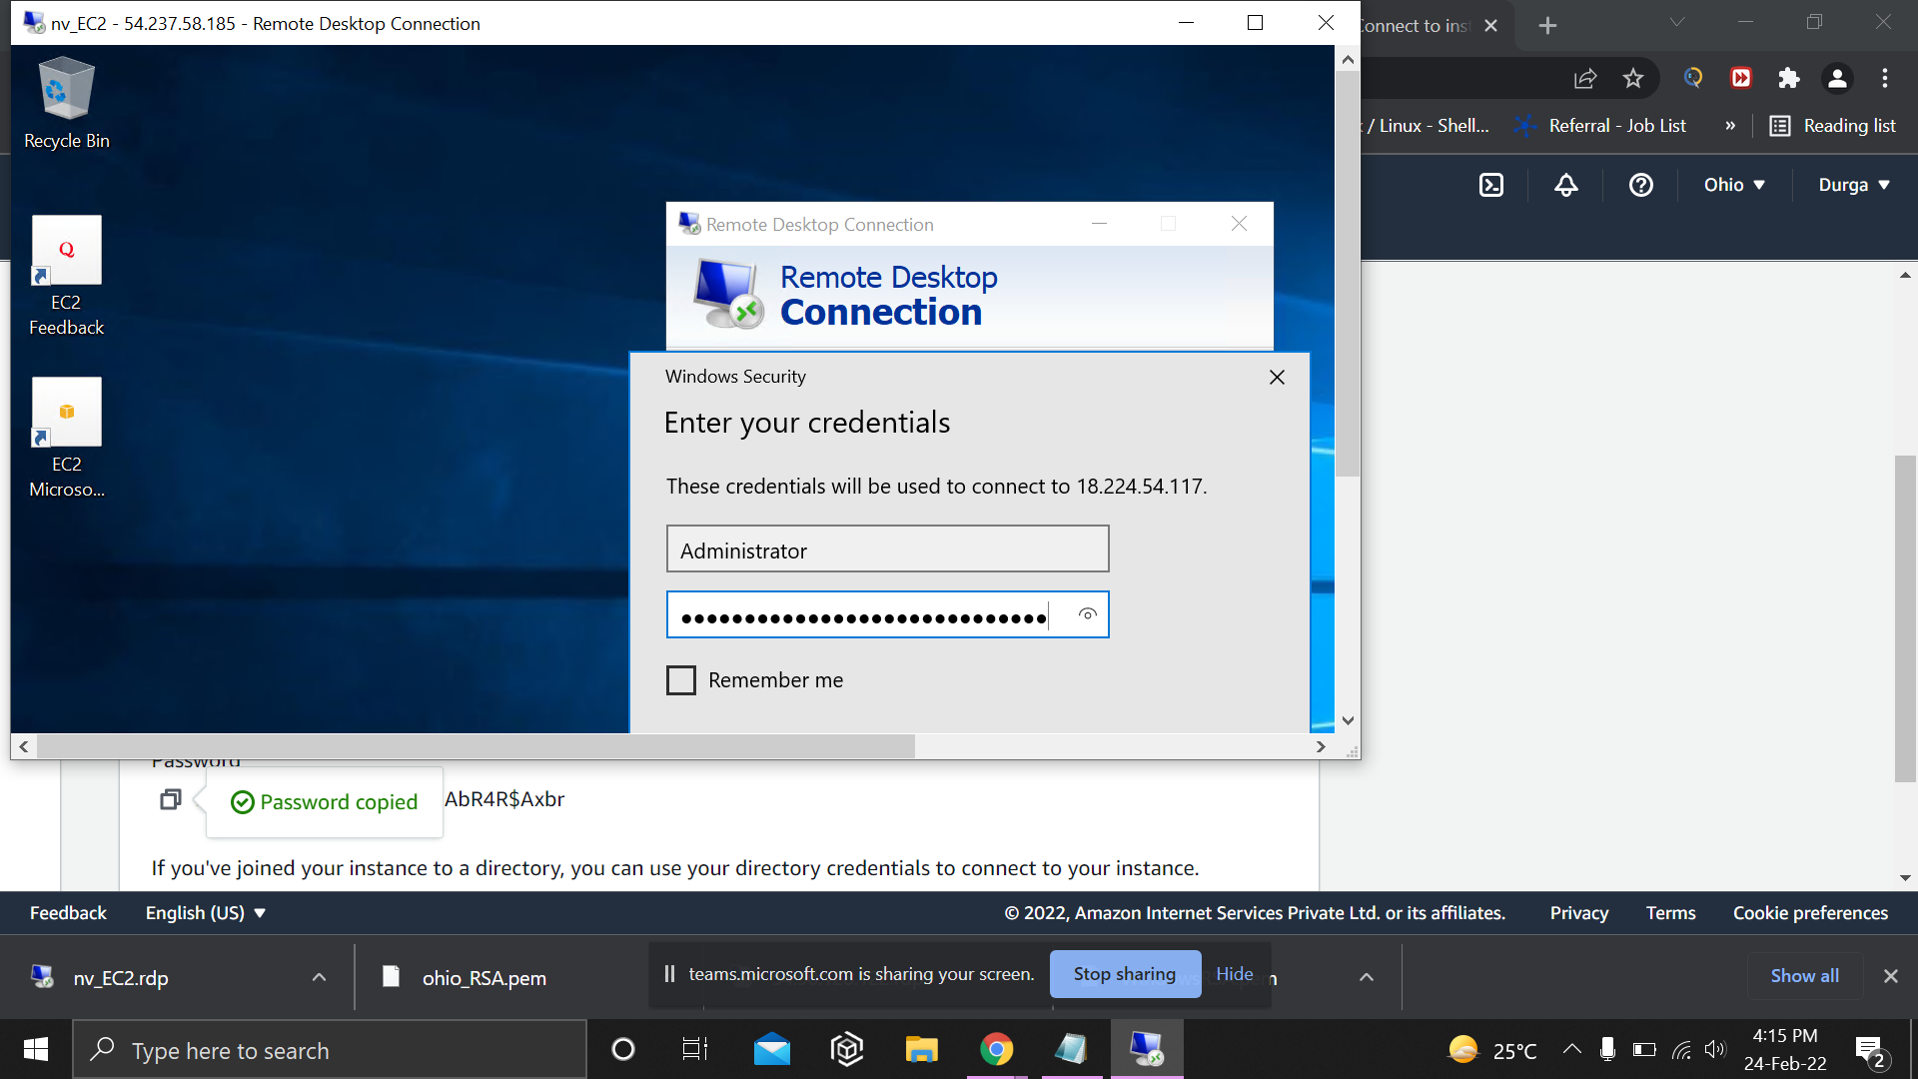
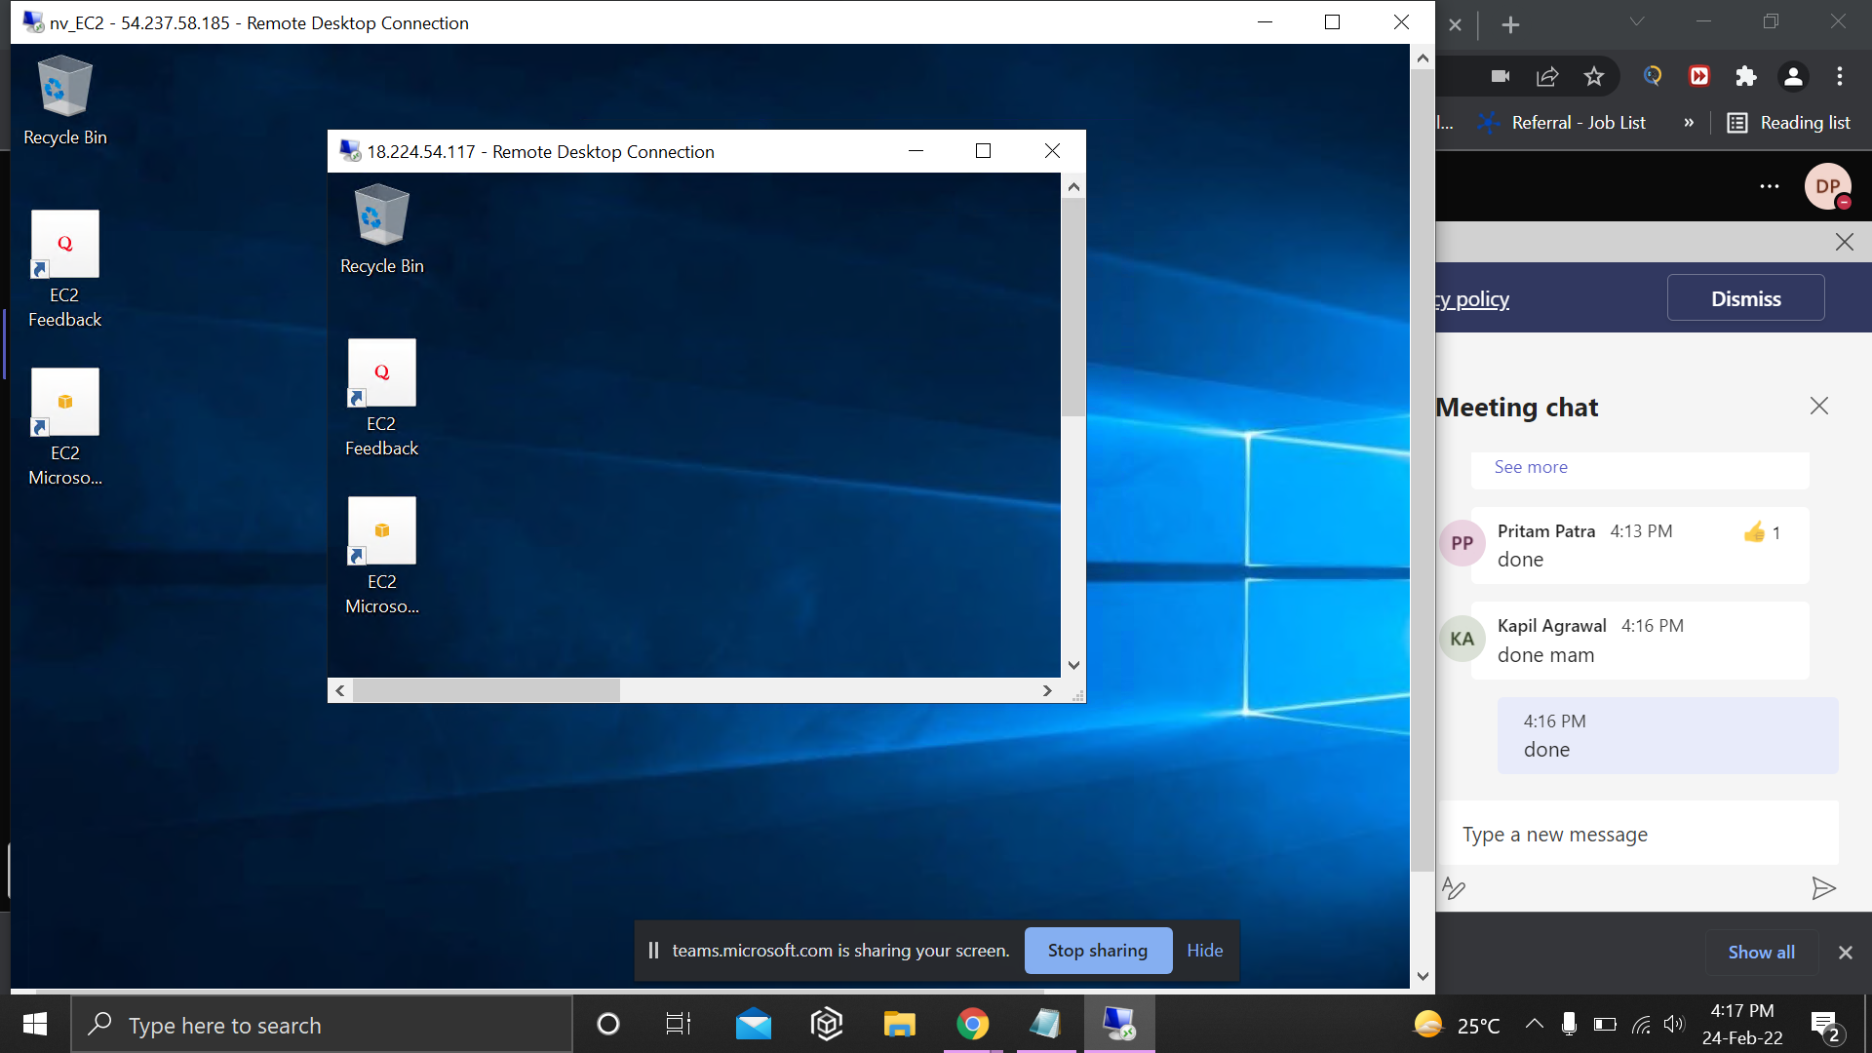

Ec2 rescue tool used to recover access to EC2 instance :



