Name: Bhargav Patel

Assessment: SQL Database

1. Write an SQL query to print all Worker details from the Worker table order by FIRST_NAME Ascending and DEPARTMENT Descending.

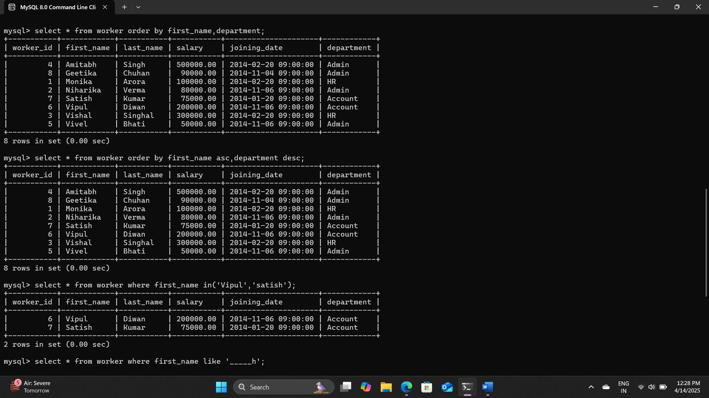

1. Write an SQL query to print details for Workers with the first names from the Worker table. “Vipul” and “Satish”

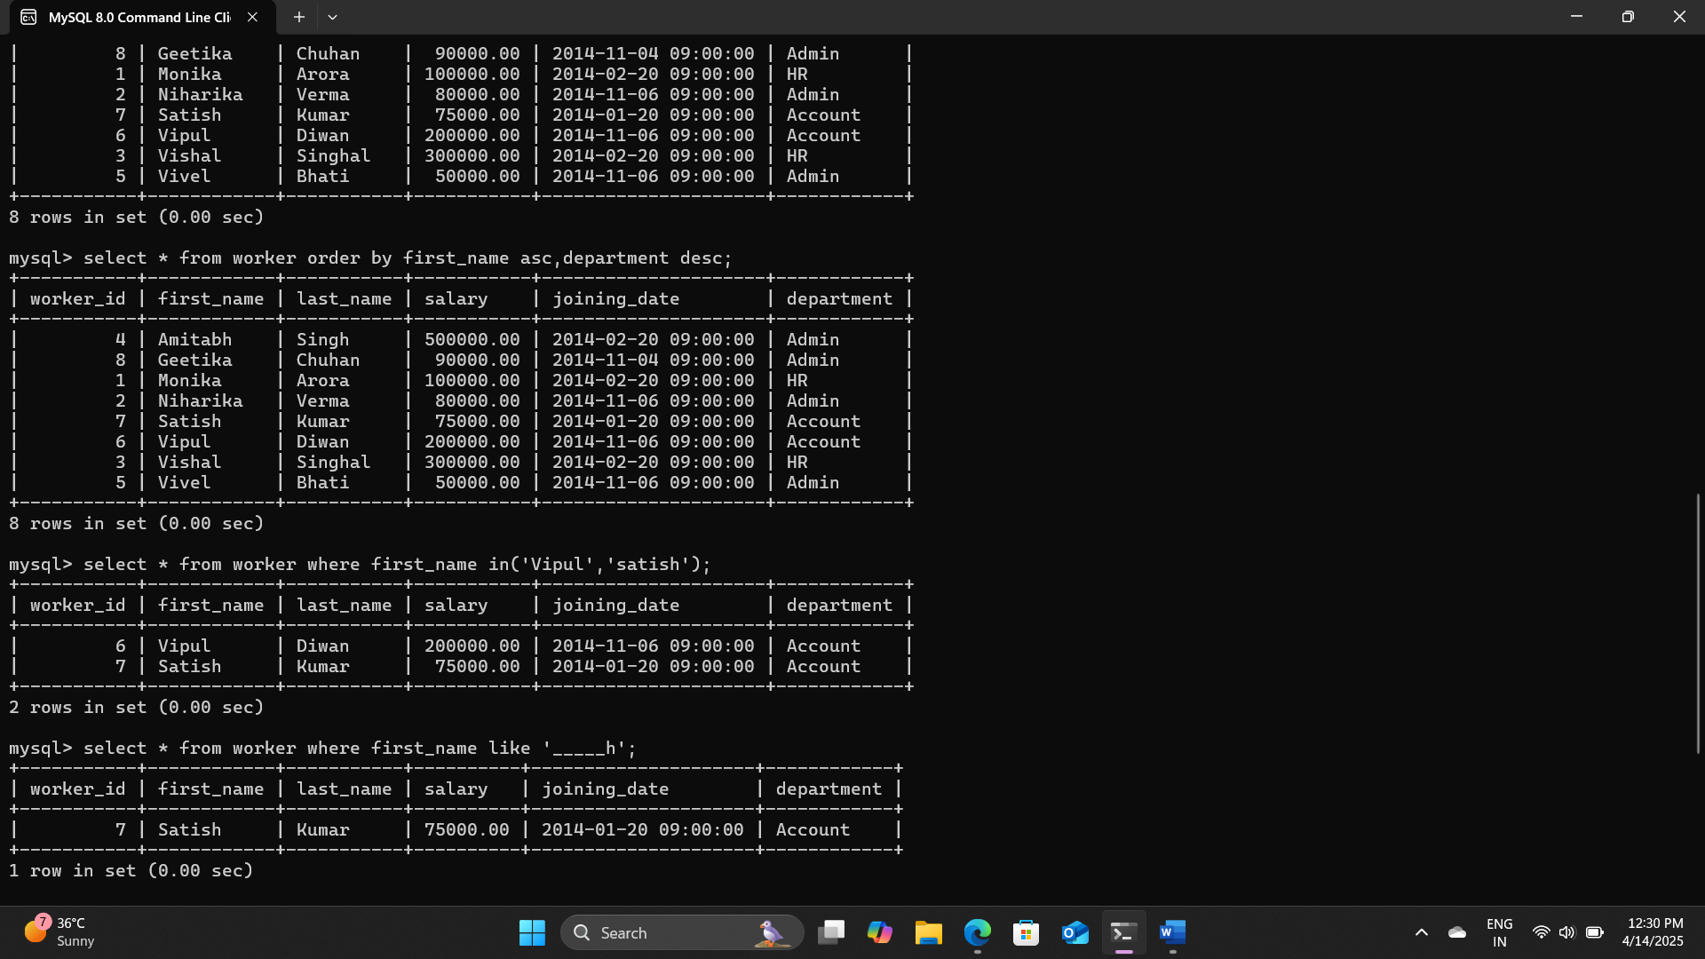

1. Write an SQL query to print details of the Workers whose FIRST_NAME ends with ‘h’ and contains six alphabets.

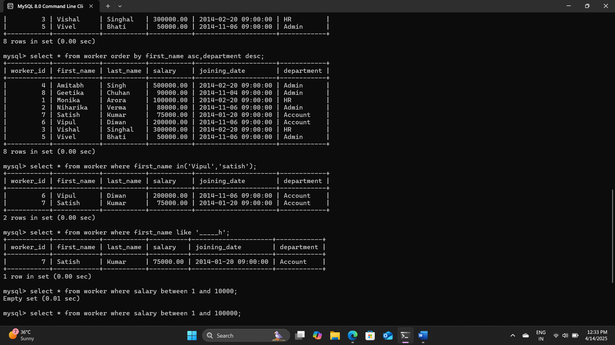

1. Write an SQL query to print details of the Workers whose SALARY lies between 1.

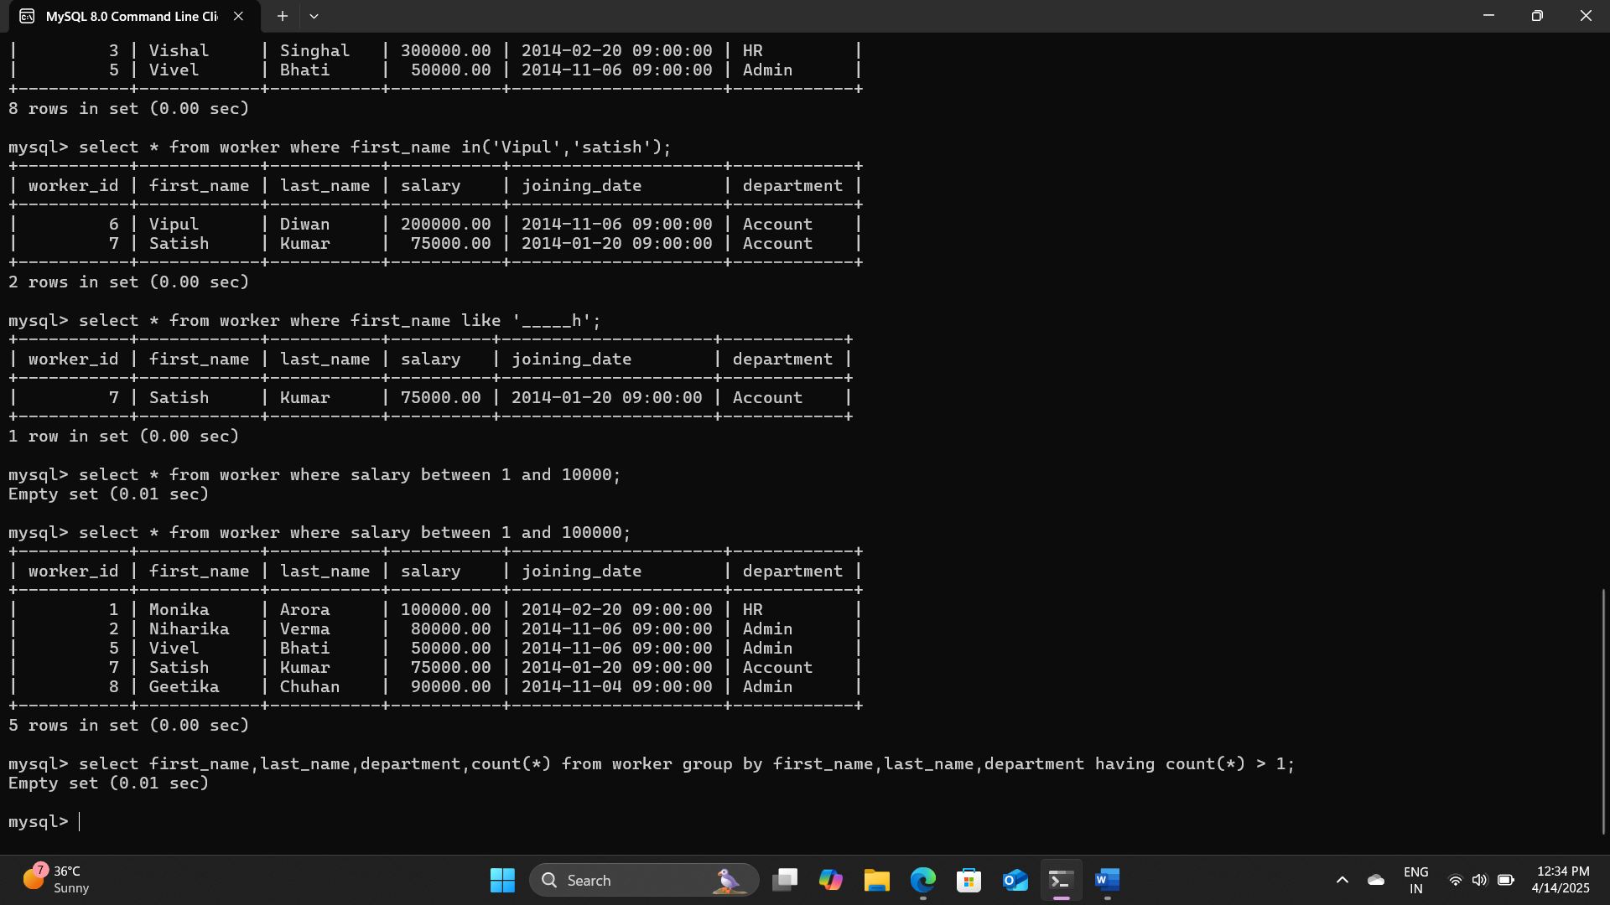

1. Write an SQL query to fetch duplicate records having matching data in some fields of a table.

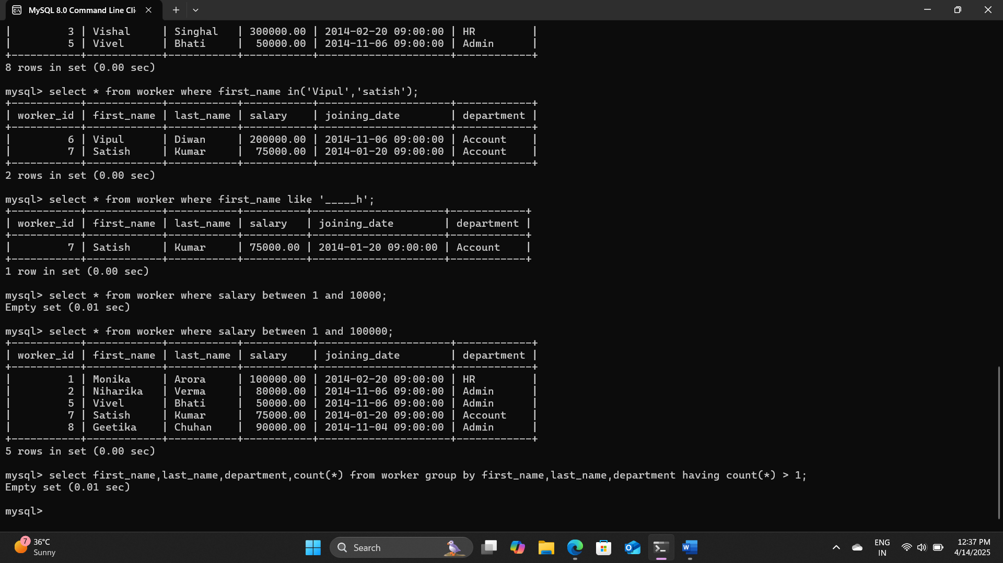

1. Write an SQL query to show the top 6 records of a table.

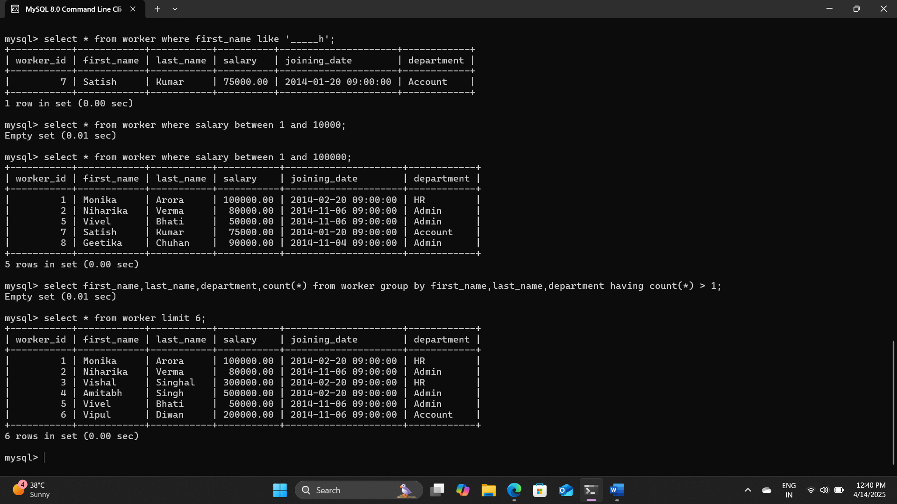

1. Write an SQL query to fetch the departments that have less than five people in them.

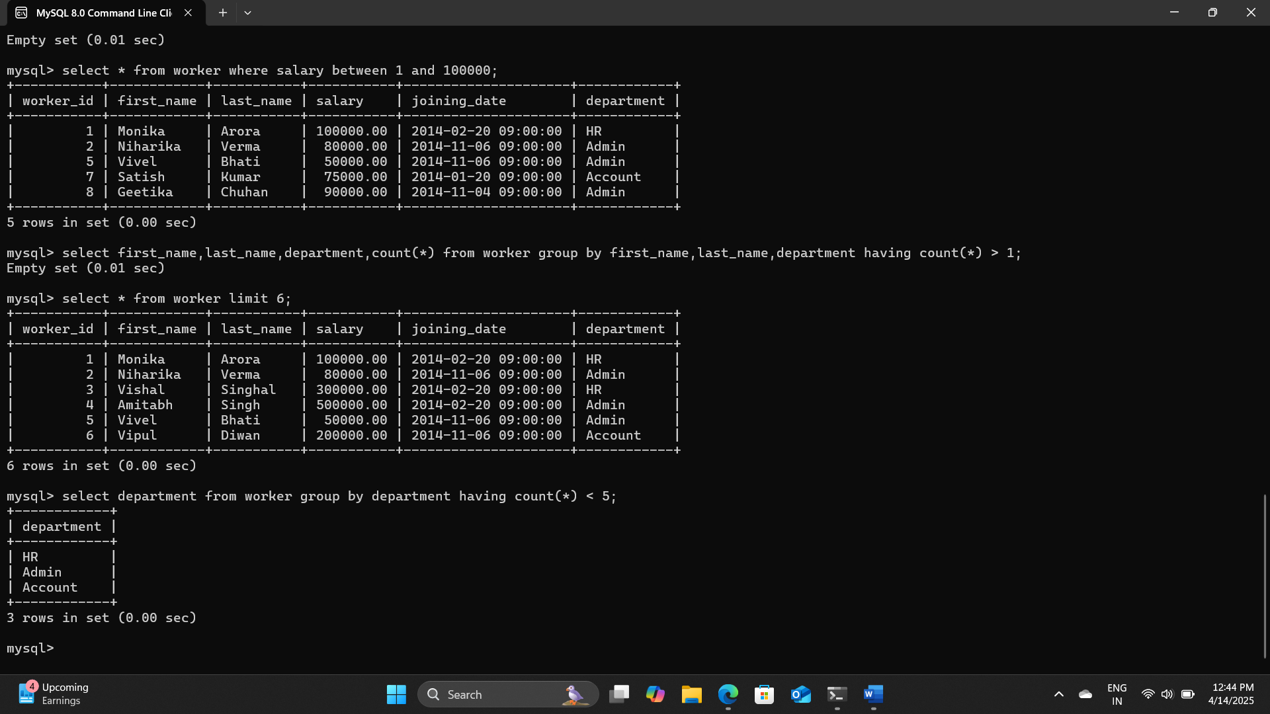

1. Write an SQL query to show all departments along with the number of people in there.

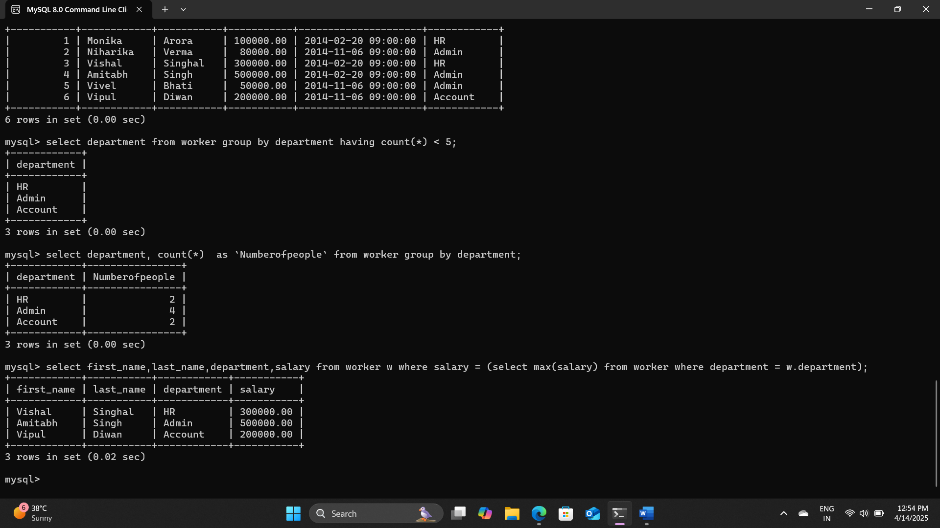

1. Write an SQL query to print the name of employees having the highest salary in each department.

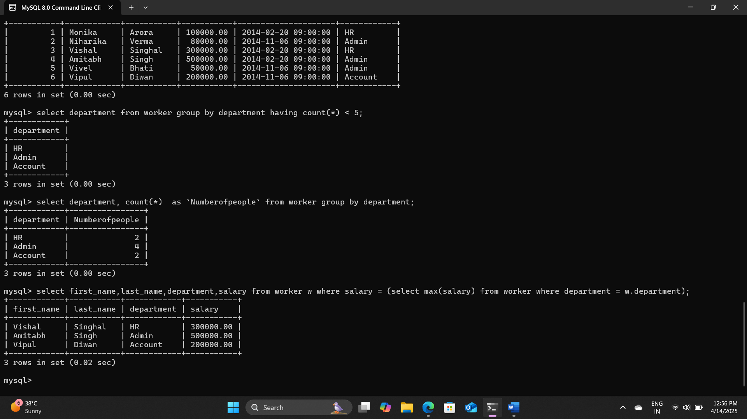

Question 2: Open school database, then select student table and use following SQL statements. TYPE THE STATEMENT, PRESS ENTER AND NOTE THE OUTPUT

1 To display all the records form STUDENT table.

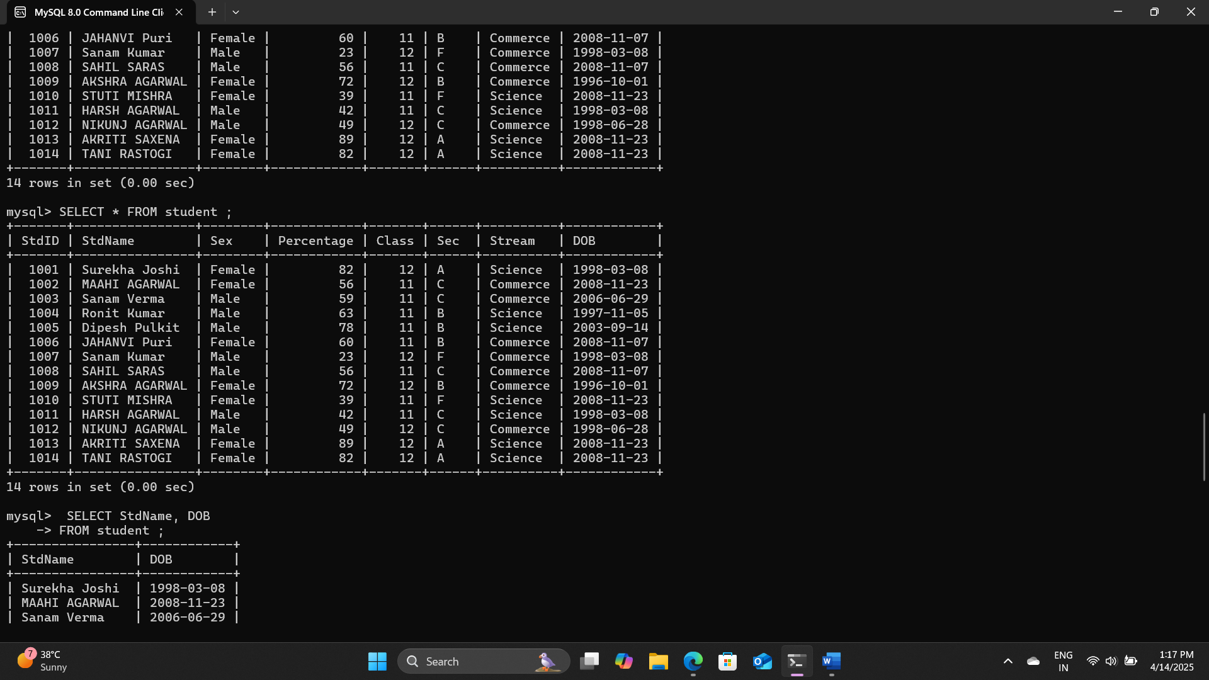

2. To display any name and date of birth from the table STUDENT.

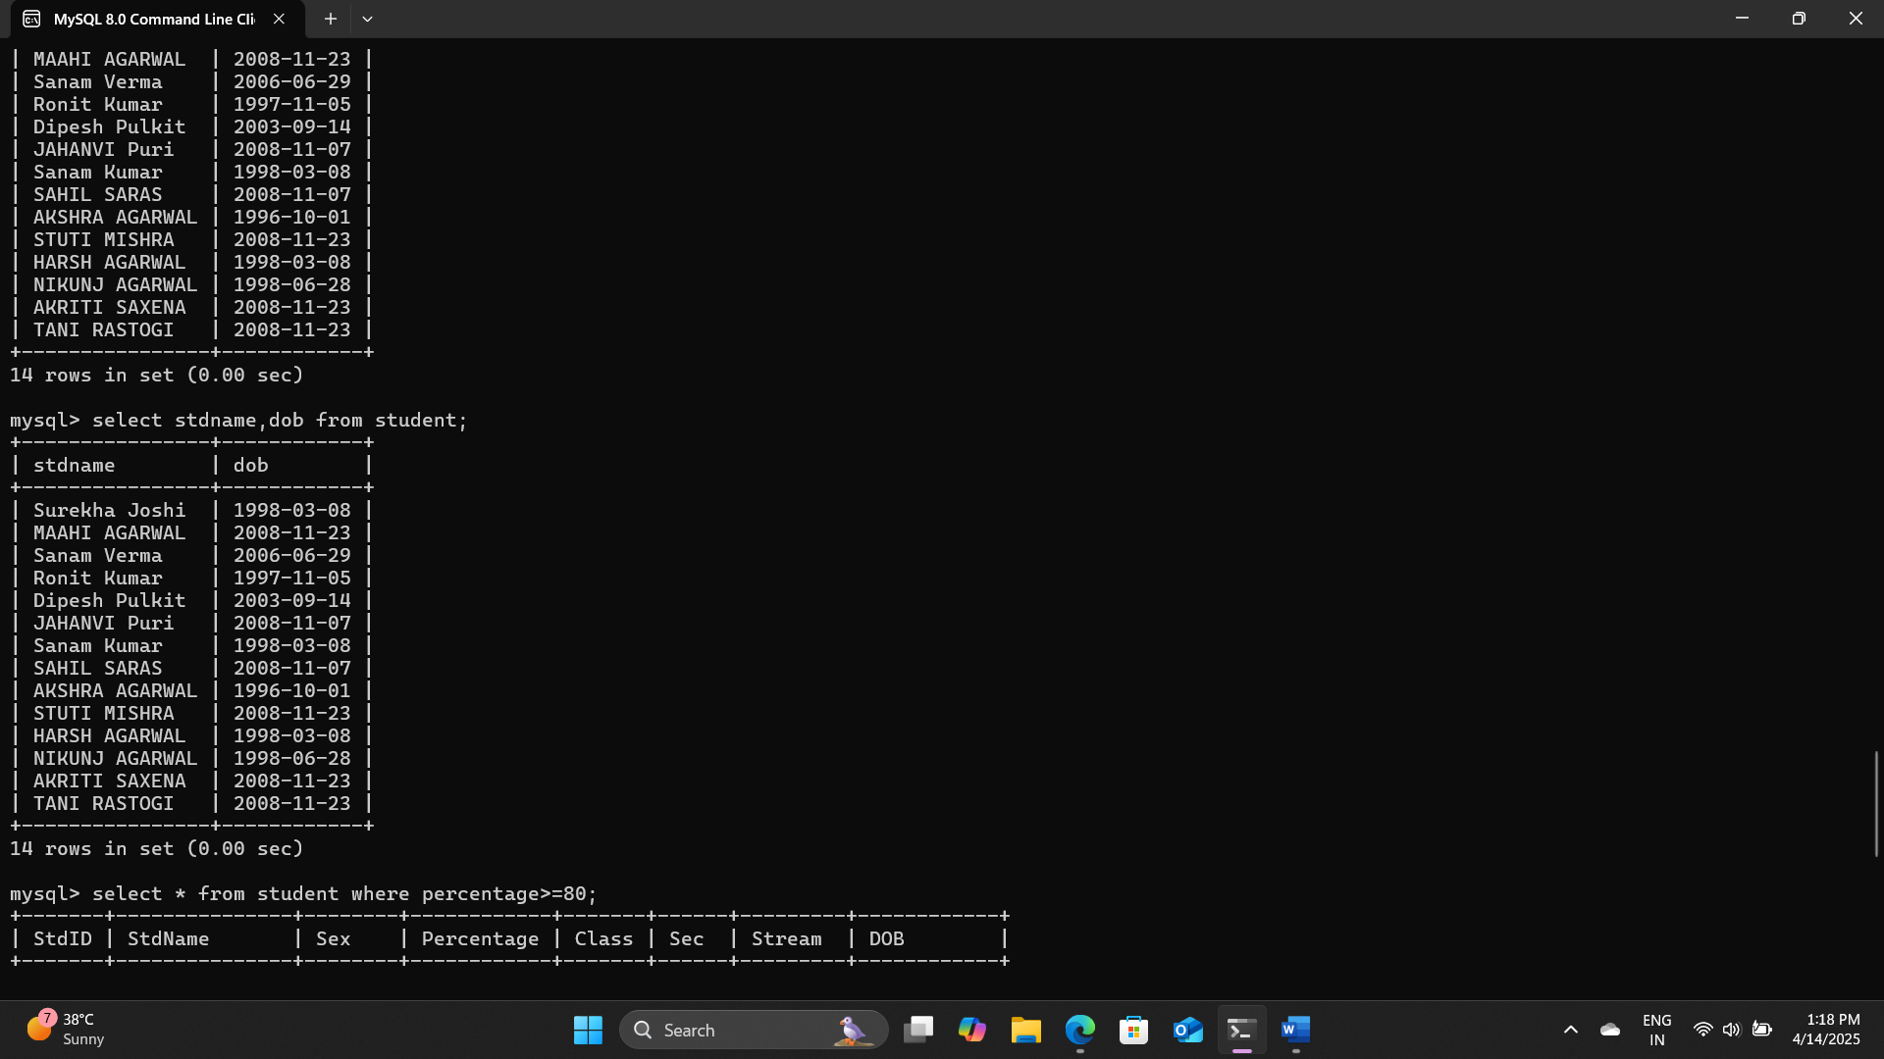

3. To display all students record where percentage is greater of equal to 80 FROM student table.

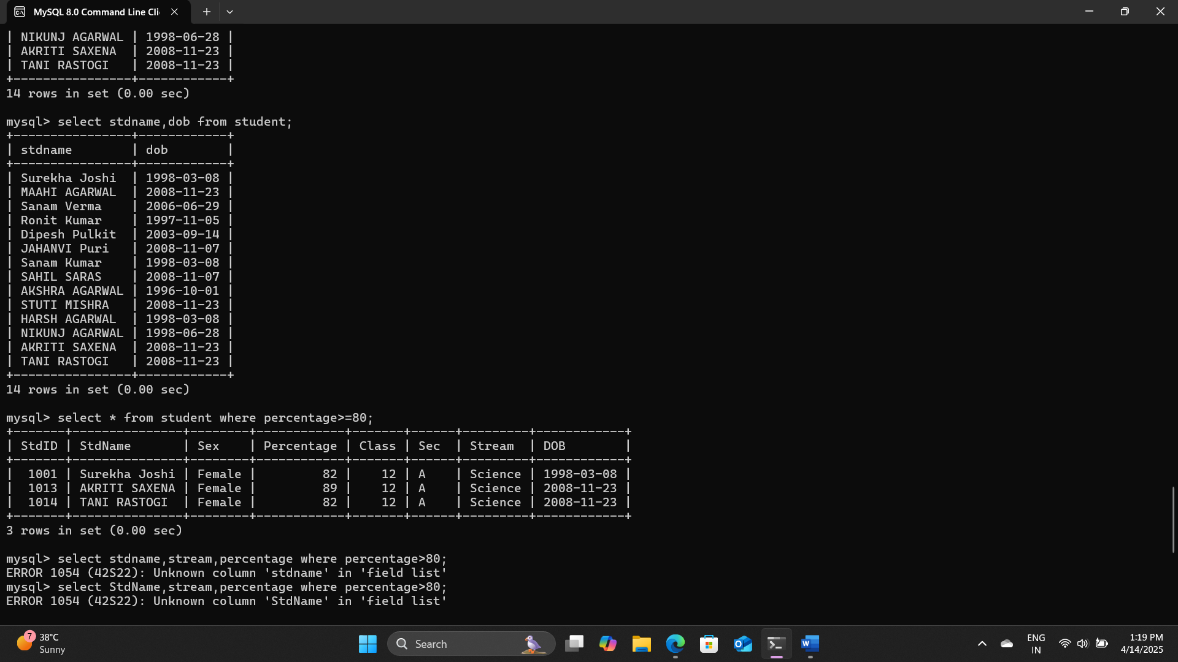

4. To display student name, stream and percentage where percentage of student is more than 80

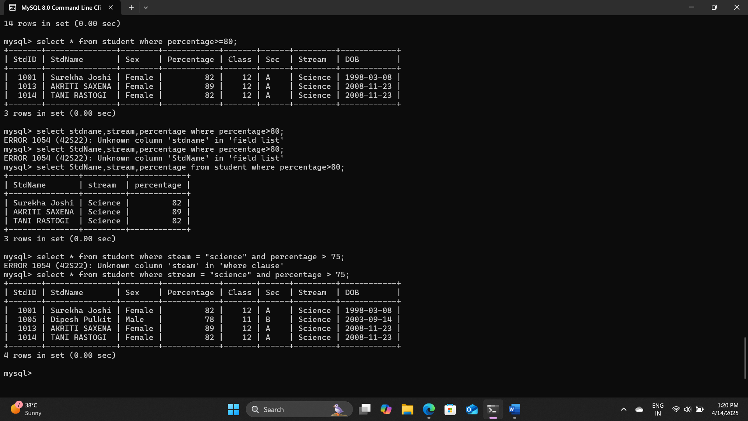

5. To display all records of science students whose percentage is more than 75 form student table.

