Name: Bhargav Patel

Course: Data Analyst

Assignment: SQL Database

1. Statement to create the Contact table

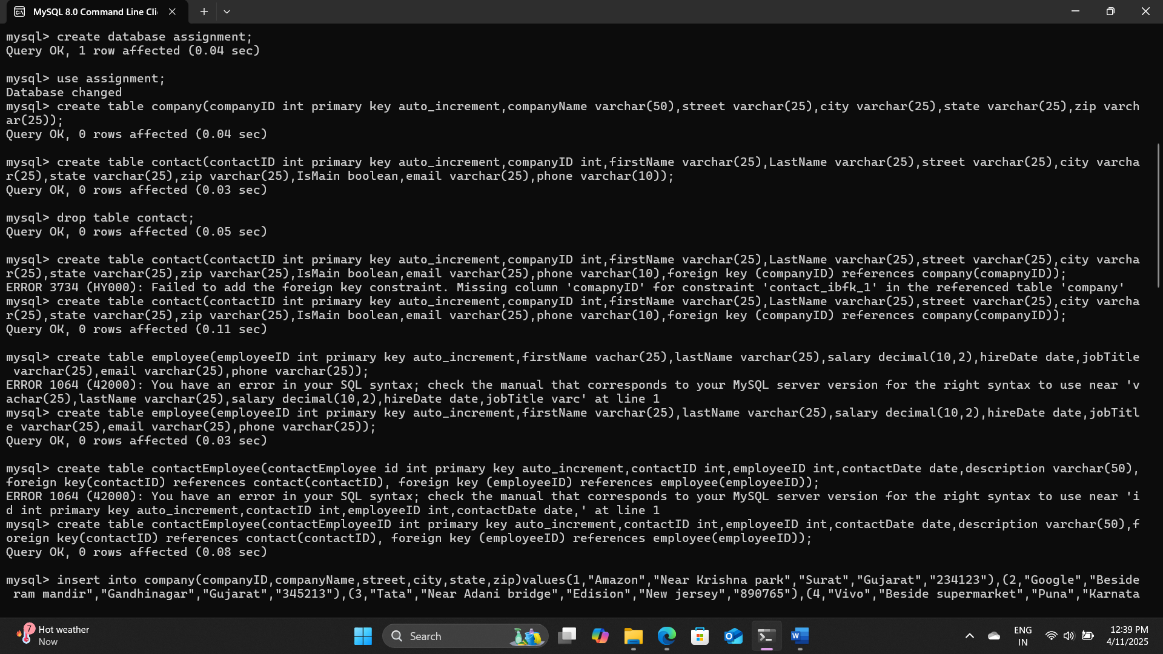

1. Statement to create the Employee table

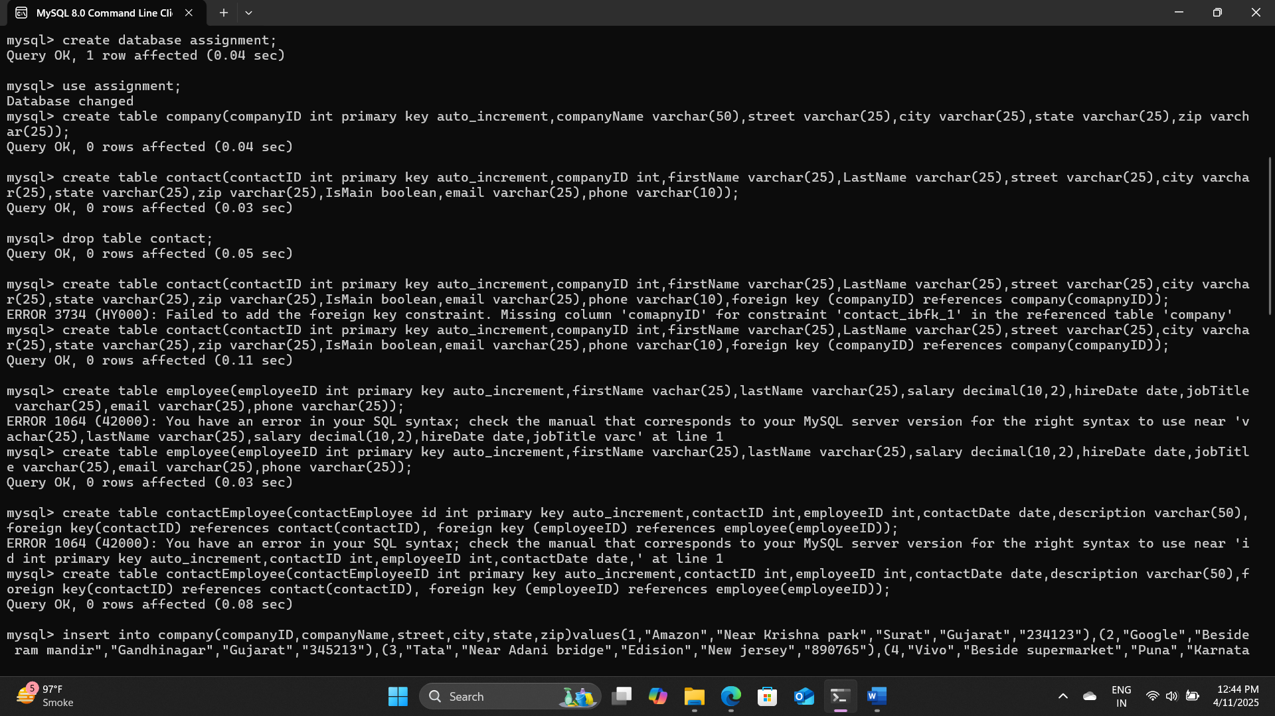

1. Statement to create the ContactEmployee table

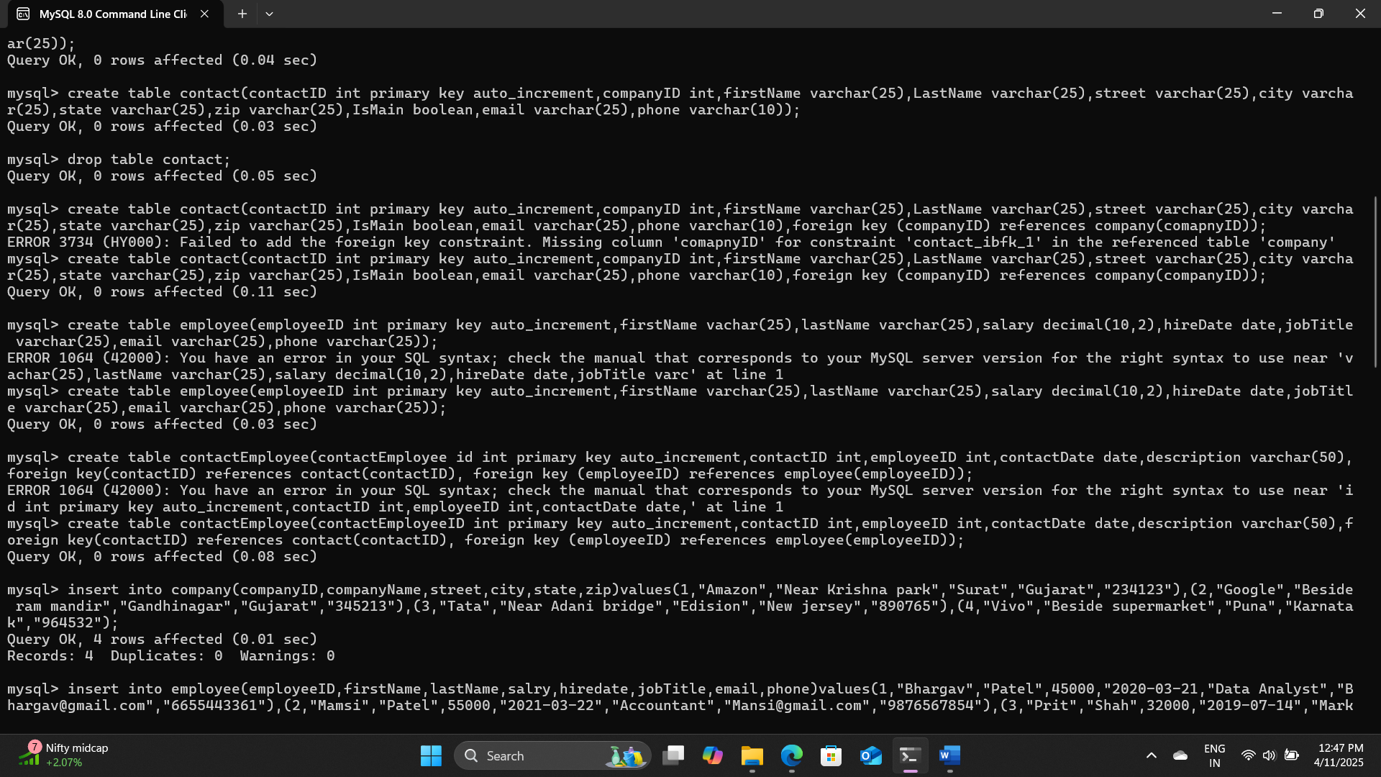

1. In the Employee table, the statement that changes Lesley Bland’s phone number to 215-555-8800

Note: here I have added different name

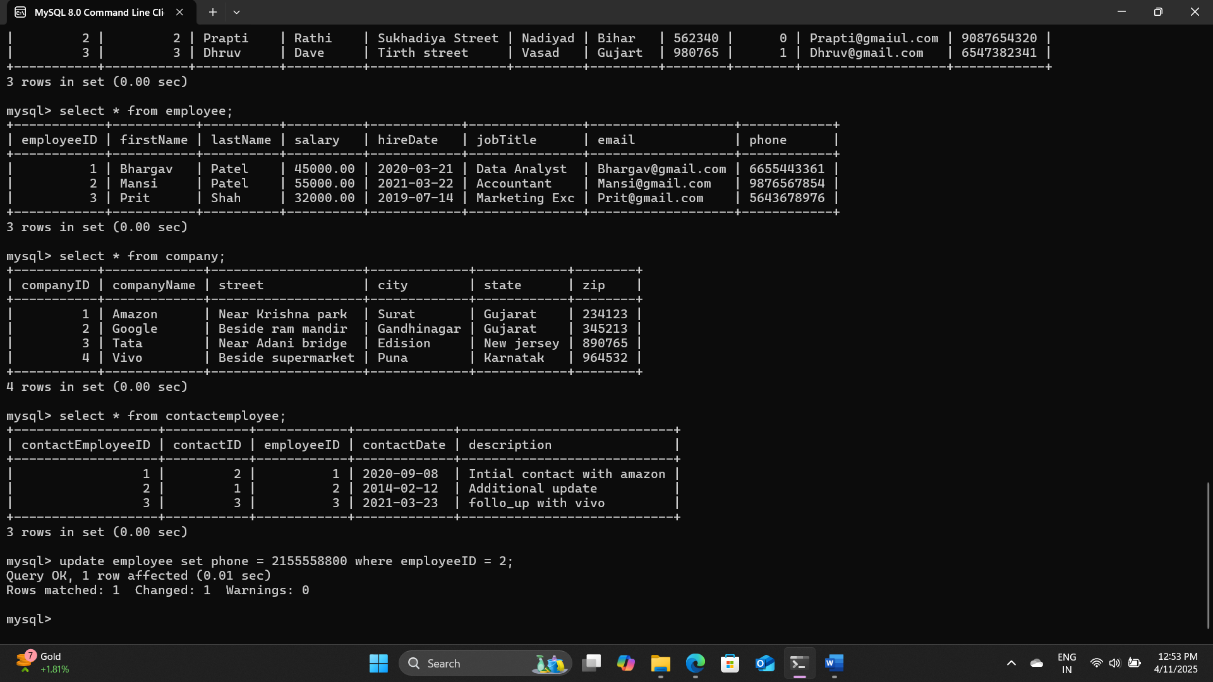

1. In the Company table, the statement that changes the name of “Urban Outfitters, Inc.” to “Urban Outfitters”.

Note: here I have added different statement

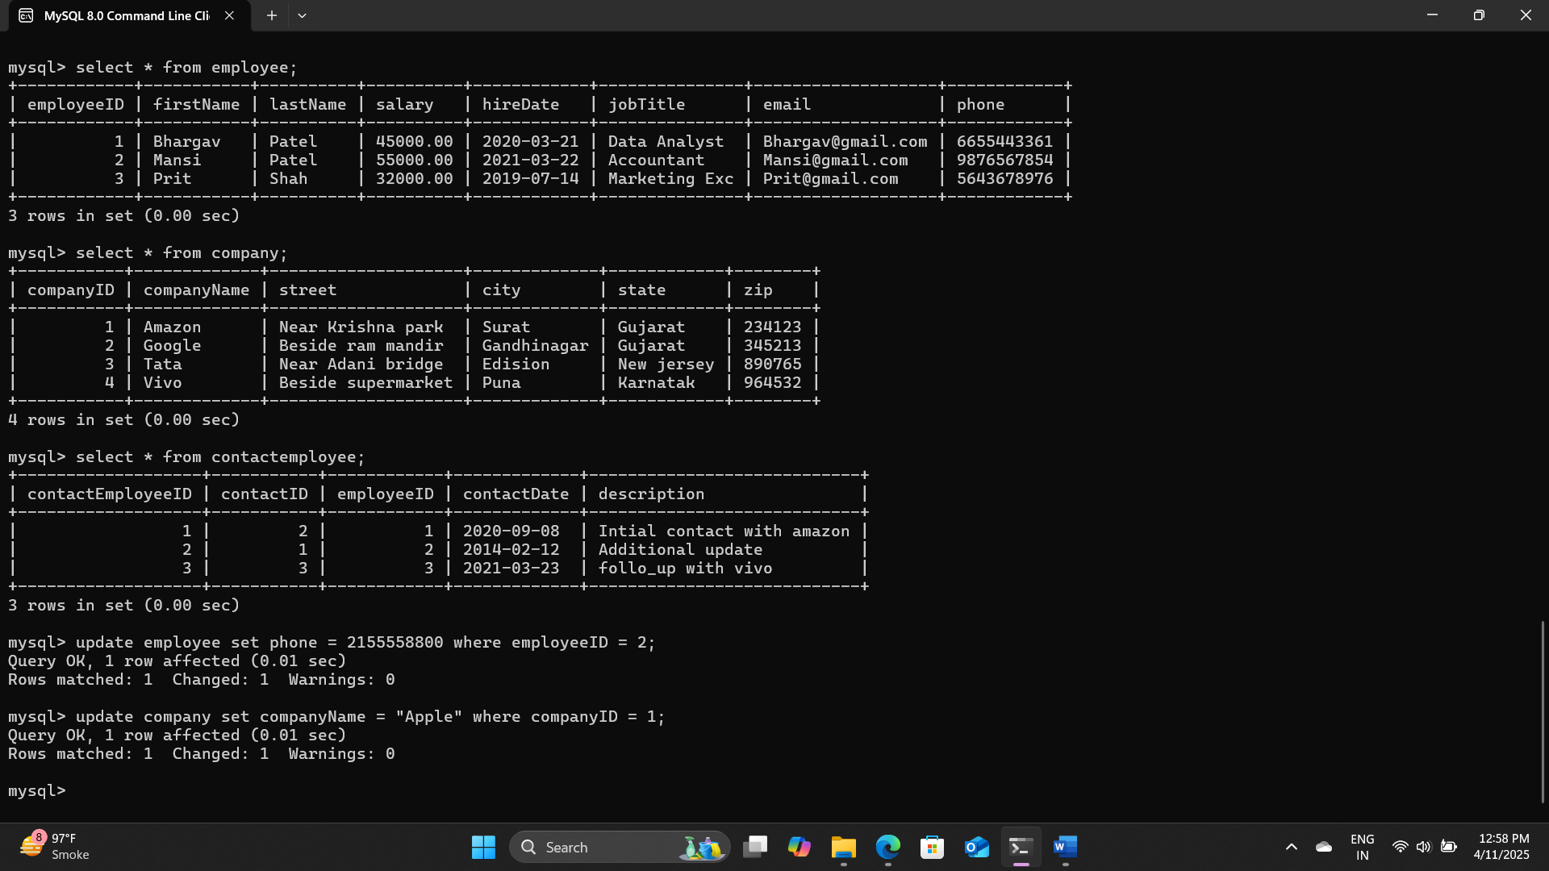

1. In ContactEmployee table, the statement that removes Dianne Connor’s contact event with Jack Lee (one statement).

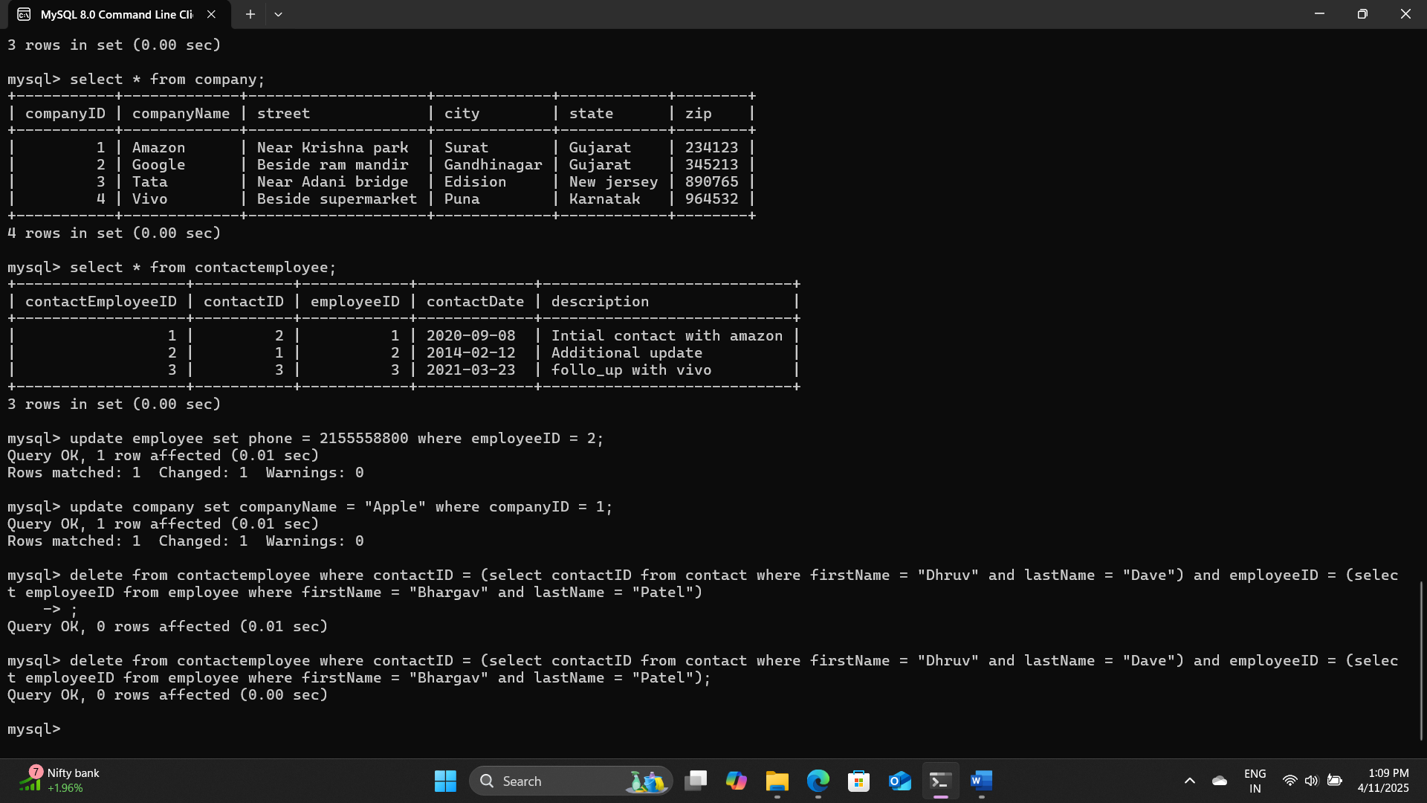

1. Write the SQL SELECT query that displays the names of the employees that have contacted Toll Brothers (one statement). Run the SQL SELECT query in MySQL Workbench. Copy the results below as well.

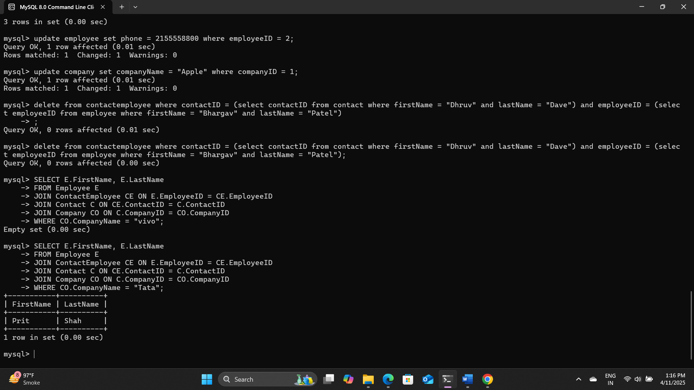

1. What is the significance of “%” and “_” operators in the LIKE statement?

% = Matches zero or more characters.

_ = Matches exactly one character.

1. Explain normalization in the context of databases.

Normalization is the process of organizing data to reduce redundancy and improve data integrity. It involves breaking tables into smaller related ones and using foreign keys to relate them. Common normal forms: 1NF, 2NF, 3NF,4NF.

10) What does a join in MySQL mean?

A JOIN combines rows from two or more tables based on a related column. It helps retrieve data across multiple tables.

11) What do you understand about DDL, DCL, and DML in MySQL?

DDL (Data definition language): defines database structure. (Create, Alter, Drop)

DML (Data manipulation language): Manages data in tables. (insert, update, delete)

DCL (Data control language): controls access. (grand, revote)

12) What is the role of the MySQL JOIN clause in a query, and what are some common types of joins?

Inner join: Matches records with values in both tables.

Left join: All from left table + matched in both right.

Right join: All from right + matched from left.

Full outer join: All records with or without matched from both tables.