DAA ASSIGNMENT-1
V.S.R. BHARGAV
CH.SC.U4CSE24250

Q1) Sum of first n natural numbers using user-defined function.
CODE:-
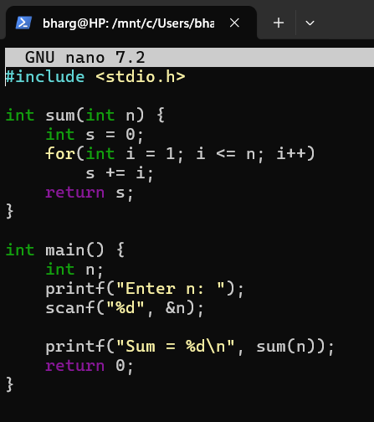
OUTPUT:-

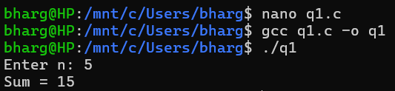

Interpretation:-
This program takes a number(n) from the user and adds all the numbers from 1 up to that number(n) using a user-defined function that runs a loop and keeps adding each number to get the final total.

Q2) Sum of squares of first n natural numbers using user-defined function.
CODE:-
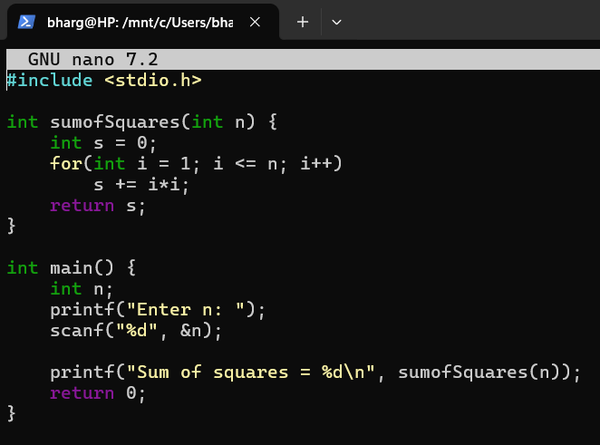

OUTPUT:-
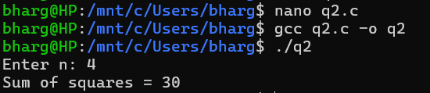

Interpretation:
This program asks user to enter a number (n). The function adds the squares of numbers from 1 to n. Each number is multiplied by itself and then added to the sum. This is by using a user defined function.

Q3) Sum of cubes of first n natural numbers using user-defined function.
CODE:-
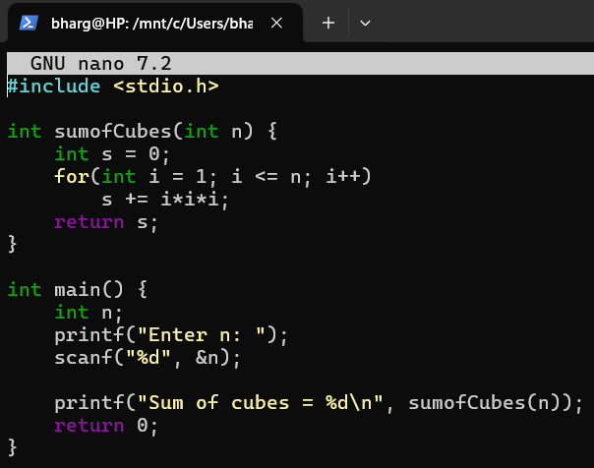

OUTPUT:-
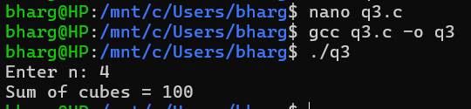
Interpretation:-
This program asks user to enter a number (n). The function adds the cubes of numbers from 1 to n. Each number is multiplied by itself three times and then added to the sum. This is also by using a user defined function
Q4) Factorial of a number using recursive function
CODE:-

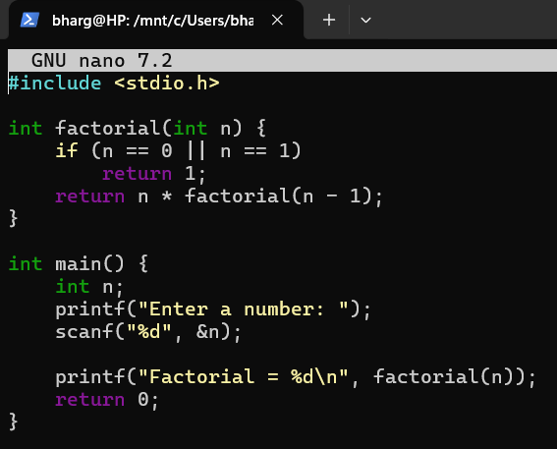

OUTPUT:-
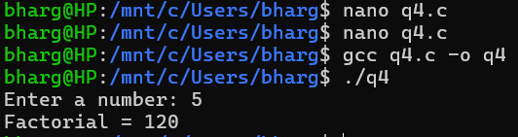
Interpretation:
This program asks the user for a number(n) and finds its factorial using recursion. The factorial is calculated by multiplying the number with the factorial of the number before it, until it reaches 1. And the final answer is printed.
Q5) Transpose of a 3×3 matrix
CODE:-
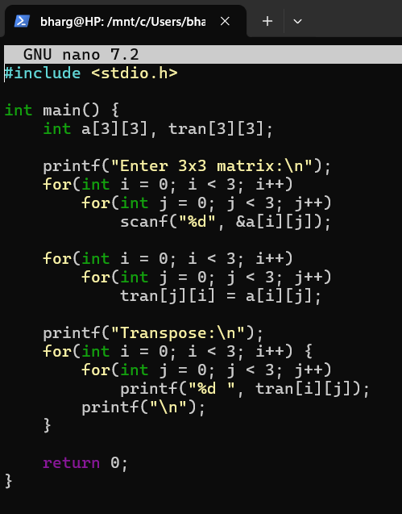
OUTPUT:-
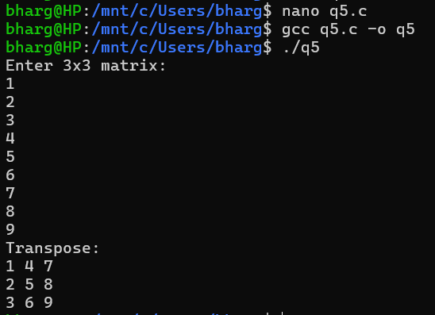

Interpretation:
This program takes a 3×3 matrix as input from the user and produces its transpose. The program copies elements into a new matrix by just swapping their row and column positions.
Q6) Fibonacci series up to a given number using user-defined function
CODE:-
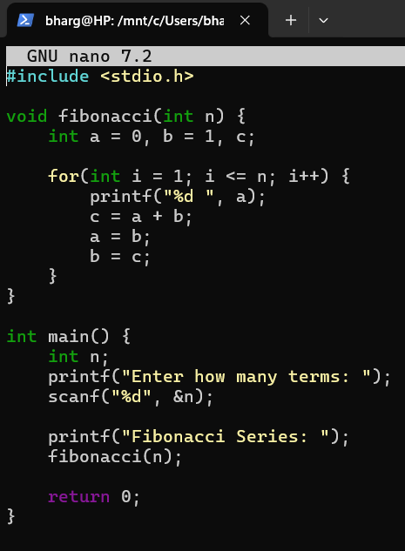
OUTPUT:-

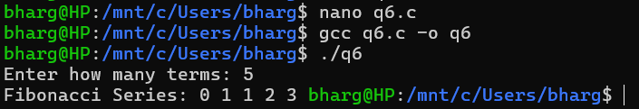
Interpretation:
This program asks the user to enter how many terms of the Fibonacci series should be printed. A function then prints the series starting from 0 and 1, and each next number is found by adding the previous two.

