Name: Bhargav Dhole
Roll No: 150096724014
P.S. No: 8. PageTrack (Digital Library Book Issue & Return App)

PAGETRACK: Digital Library Book Issue & Return Application Final Project Report
- Problem Understanding: PageTrack is a Flutter-based digital library application for browsing a college library catalog, searching for books, viewing book details, issuing available books, tracking due dates, and returning books.Catalog and issue information is persisted locally on the device so the core workflow remains available offline.
PROBLEM STATEMENT: College libraries often require students to manually search for books, check their availability, keep track of issued books, and remember return dates. This can make the process inconvenient and difficult to manage.
PageTrack is a Flutter-based digital library application designed to provide a simple and responsive way for students to browse a library catalog, search for books, issue available books, track due dates, and return issued books.
The application also stores catalog and issue information locally so that the data remains available between app sessions.
Objectives
- Search and browse the library catalog.
- View detailed information about books.
- Display Available/Issued status.
- Issue available books and generate a 14-day due date.
- Track issued and overdue books.
- Return books and update their availability.
- Persist application data locally.
2. Application Design: The application uses a layered structure: main.dart configures the app and Material 3 theme; LibraryShell manages state, navigation, search, filtering, issue and return operations; screen widgets provide the UI; Book models the data; and StorageService handles local persistence.

Navigation Flow Launch → Catalog → Search/Filter → Select Book → Book Details → Issue → My Issued Books → Return → Available
Main Screens
- Catalog Screen — responsive GridView of book Cards, search, category filtering and availability badges.
- Book Detail Screen — cover, title, author, description, ISBN, year, pages, status and Issue/Return action.
- My Issued Books — ListView of current loans, due dates, overdue indication and Return action.
Responsiveness is implemented with LayoutBuilder so the catalog adapts its GridView columns to screen width. Desktop uses sidebar navigation while smaller layouts use a NavigationBar.
- Implementation
Project Structure
- lib/main.dart
- lib/models/book.dart
- lib/services/storage_service.dart
- lib/screens/library_shell.dart
- lib/screens/catalog_screen.dart
- lib/screens/book_detail_screen.dart
- lib/screens/issued_books_screen.dart
- pubspec.yaml
- README.md
- test/widget_test.dart
Book Model and Dart Logic The Book class encapsulates id, title, author, category, description, ISBN, year, pages, coverUrl, isIssued and an optional dueDate. final is used for properties that normally do not change; isIssued and dueDate are mutable because issue/return operations change them.
The catalog is maintained as List. Issued books are derived by filtering books where isIssued is true. Map<String, dynamic> is used by toMap() and fromMap() to serialize and restore book data.
Material 3 and UI Widgets Material 3 is enabled in main.dart with ThemeData(useMaterial3: true). The catalog uses GridView and Card widgets; the issued-books screen uses ListView; the detail screen presents the selected Book object and its current state.
Issue / Return Workflow On issue, isIssued becomes true and dueDate is set to the current date plus 14 days.StorageService saves the updated list and setState() refreshes the UI. On return, isIssued becomes false, dueDate becomes null, the data is saved, and the UI refreshes.
Local Storage The shared_preferences package stores JSON locally. Book objects are converted to Maps, encoded as JSON, saved under a local key, and reconstructed with fromMap() when the app starts. If no saved data exists, the seeded catalog is loaded.
Search and Overdue Logic Search performs case-insensitive matching against title and author, while category chips provide additional filtering. The isOverdue getter checks that a book is issued, has a due date, and that the due date is before DateTime.now().
4. Screenshots / Demonstration

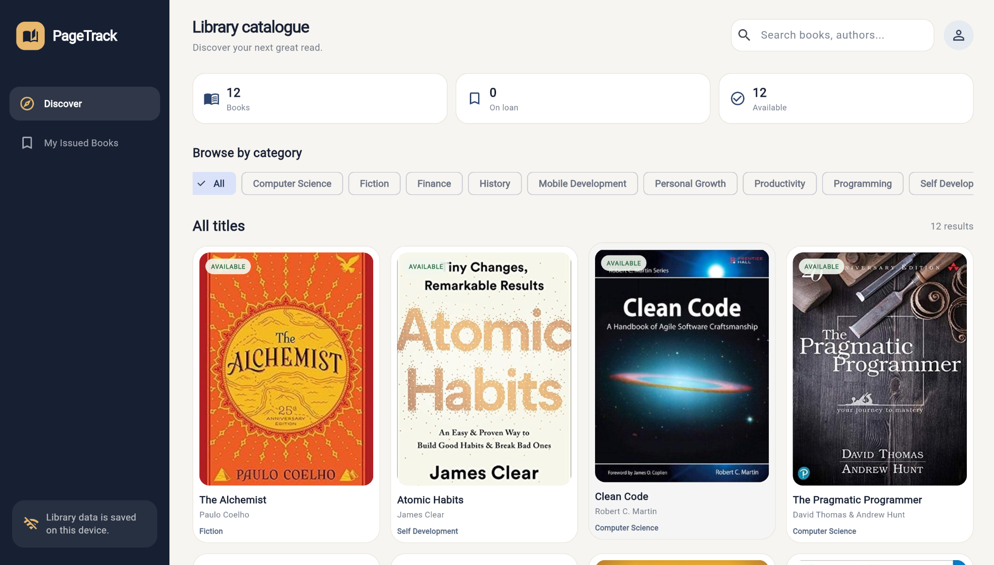

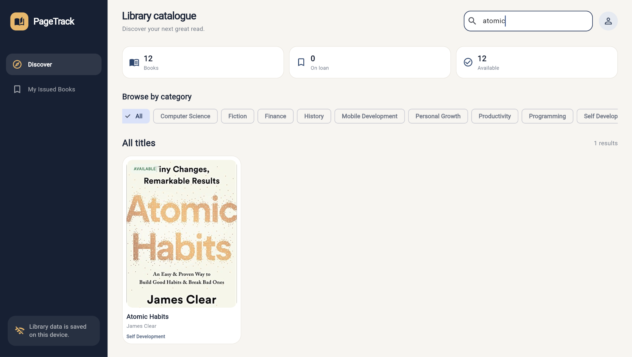
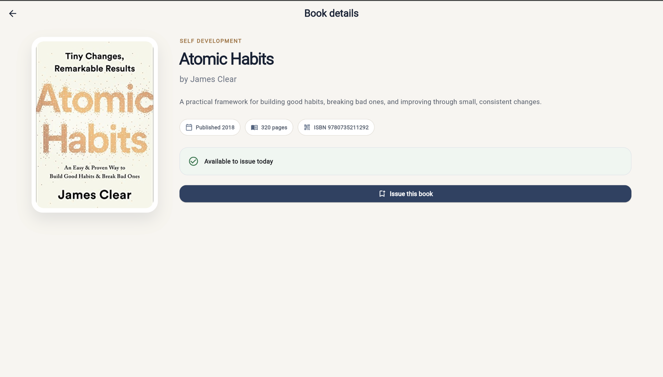
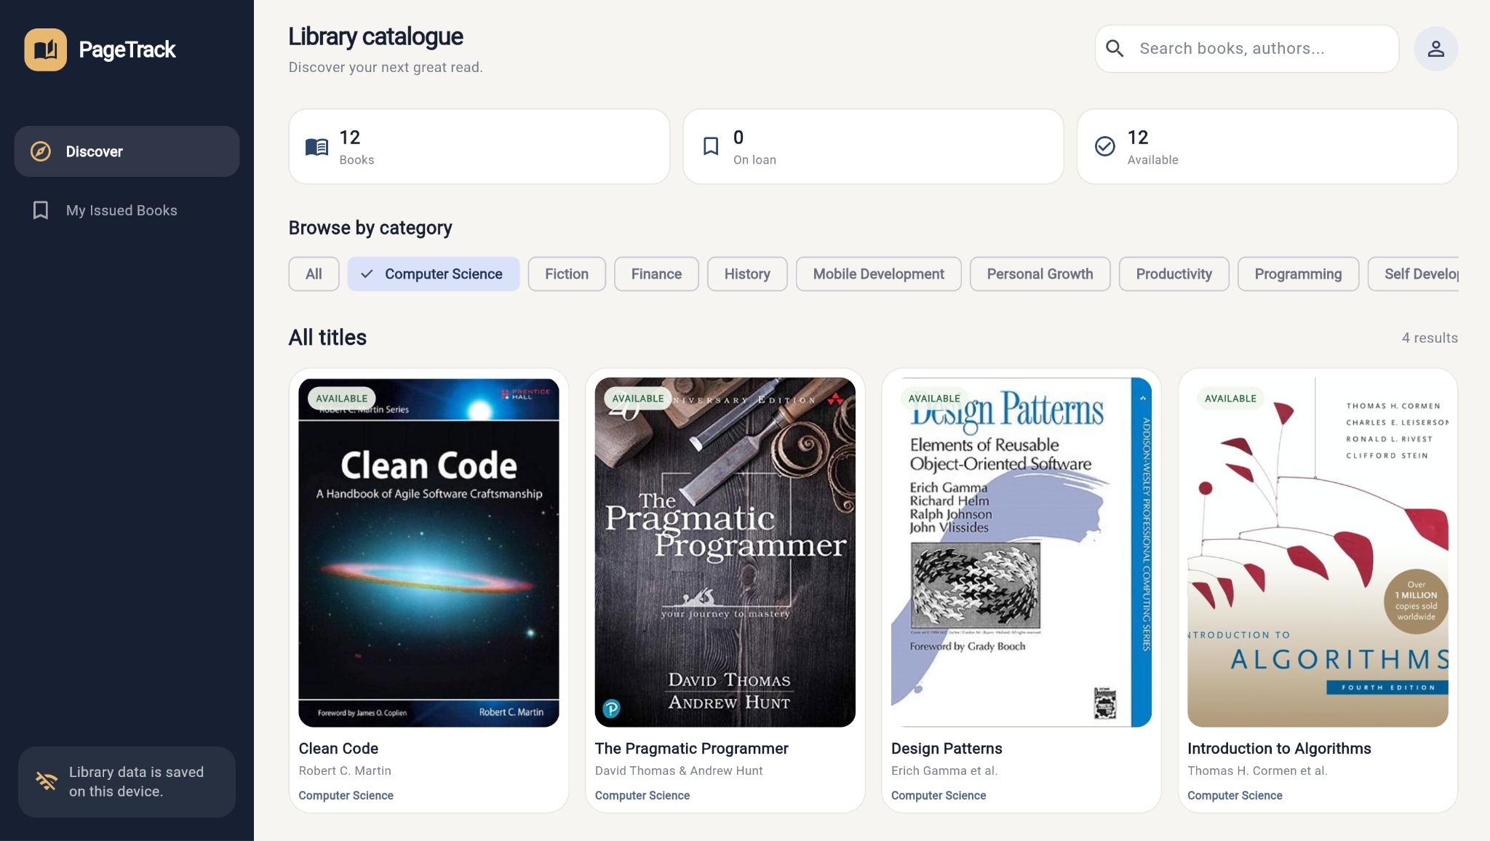
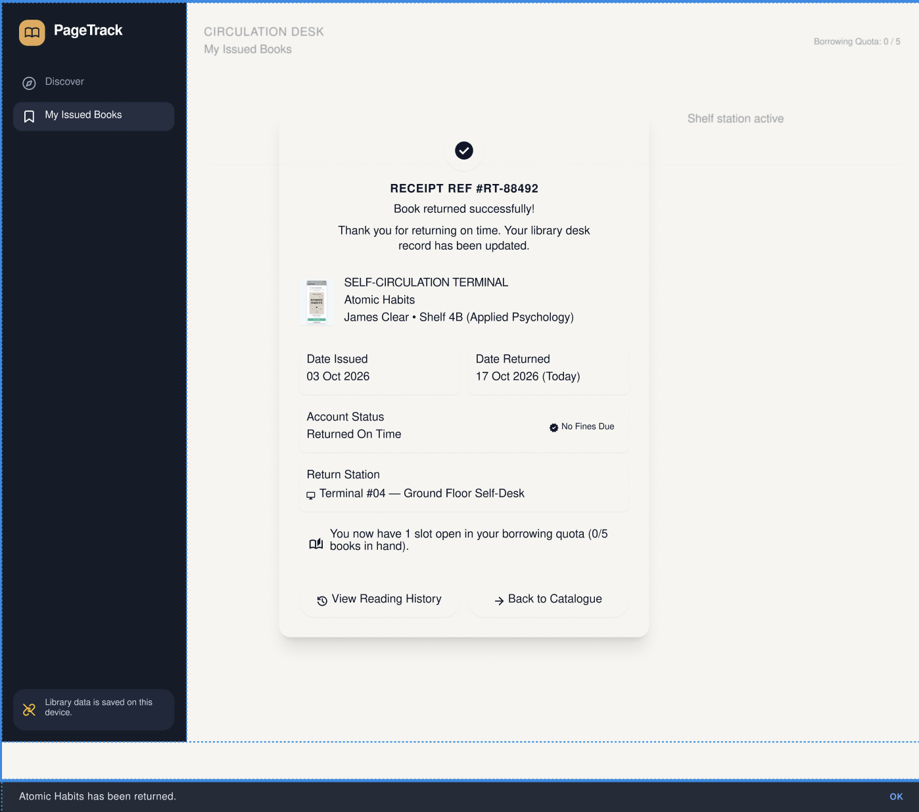

- Documentation
Application Workflow The user starts on the catalog, searches or filters books, selects a book and opens its details. Issuing changes the status to Issued, generates a 14-day due date, saves the state locally and updates the UI. The book appears in My Issued Books. Returning it clears the issue state and due date and makes the book available again.
Features Implemented
- Responsive Material 3 interface
- Catalog search and category filtering
- Book detail screen
- Available / Issued badges
- Book issue and return
- Automatic 14-day due date
- Issued-book tracking
- Overdue detection
- SharedPreferences local persistence
- JSON serialization with Maps
- Responsive desktop and smaller-screen navigation

Technology Used
- Flutter
- Dart
- Material 3
- SharedPreferences
- JSON serialization
- Responsive Flutter layouts
Testing
- Application launch — verified as part of the project workflow.
- Catalog display — verified as part of the project workflow.
- Search and category filtering — verified as part of the project workflow.
- Book details — verified as part of the project workflow.
- Issue and due-date generation — verified as part of the project workflow.
- Issued-books display — verified as part of the project workflow.
- Return operation — verified as part of the project workflow.
- Local persistence — verified as part of the project workflow.
- Responsive layout — verified as part of the project workflow.
Conclusion: PageTrack demonstrates a complete Flutter digital library workflow combining responsive Material 3 UI, Dart object-oriented modeling, List and Map collections, search/filtering, issue/return state management, due-date and overdue logic, and local data persistence.

Thank You.

