**Name** – Bhargav Shamuvel Gurav

**Class** – L.Y. B-Tech (Computer)

**Course Code** – CO406U

**PRN** – 2041009

**Batch** – B1

**Course Name** - CDL

**Practical no. 5**

**Aim:** Simulate First and Follow of a Grammar.

# Theory :

FIRST and FOLLOW are two functions associated with grammar that help us fill in the entries of an M-table.

FIRST ()− It is a function that gives the set of terminals that begin the strings derived from the production rule.

A symbol c is in FIRST (α) if and only if α ⇒ cβ for some sequence β of grammar symbols.

A terminal symbol a is in FOLLOW (N) if and only if there is a derivation from the start symbol S of the grammar such that S ⇒ αNαβ, where α and β are a (possible empty) sequence of grammar symbols. In other words, a terminal c is in FOLLOW (N) if c can follow N at some point in a derivation.

# Benefit of FIRST ( ) and FOLLOW ( )

* It can be used to prove the LL (K) characteristic of grammar.
* It can be used to promote in the construction of predictive parsing tables.
* It provides selection information for recursive descent parsers.

# Computation of FIRST

FIRST (α) is defined as the collection of terminal symbols which are the first letters of strings derived from α.

FIRST (α) = {α |α →∗ αβ for some string β }

If X is Grammar Symbol, then First (X) will be −

If X is a terminal symbol, then FIRST(X) = {X} If X → ε, then FIRST(X) = {ε}

If X is non-terminal & X → a α, then FIRST (X) = {a}

If X → Y1, Y2, Y3, then FIRST (X) will be

1. If Y is terminal, then

FIRST (X) = FIRST (Y1, Y2, Y3) = {Y1}

1. If Y1 is Non-terminal and

If Y1 does not derive to an empty string i.e., If FIRST (Y1) does not contain ε then, FIRST (X) = FIRST (Y1, Y2, Y3) = FIRST(Y1)

1. If FIRST (Y1) contains ε, then.

FIRST (X) = FIRST (Y1, Y2, Y3) = FIRST(Y1) − {ε} ∪ FIRST(Y2, Y3)

Similarly, FIRST (Y2, Y3) = {Y2}, If Y2 is terminal otherwise if Y2 is Non- terminal then

FIRST (Y2, Y3) = FIRST (Y2), if FIRST (Y2) does not contain ε. If FIRST (Y2) contain ε, then

FIRST (Y2, Y3) = FIRST (Y2) − {ε} ∪ FIRST (Y3)

Similarly, this method will be repeated for further Grammar symbols, i.e., for Y4, Y5, Y6 … . YK.

# Computation of FOLLOW

Follow (A) is defined as the collection of terminal symbols that occur directly to the right of A.

FOLLOW(A) = {a|S ⇒* αAaβ where α, β can be any strings}

# Rules to find FOLLOW

If S is the start symbol, FOLLOW (S) ={$} If production is of form A → α B β, β ≠ ε.

1. If FIRST (β) does not contain ε then, FOLLOW (B) = {FIRST (β)}

Or

1. If FIRST (β) contains ε (i. e. , β ⇒* ε), then FOLLOW (B) = FIRST (β) − {ε} ∪ FOLLOW (A)

∵ when β derives ε, then terminal after A will follow B.

If production is of form A → αB, then Follow (B) ={FOLLOW (A)}.

# Program Code:

#include<bits/stdc++.h> using namespace std;

set<char> ss;

bool dfs(char i, char org, char last, map<char,vector<vector<char>>> &mp){ bool rtake = false;

for(auto r : mp[i]){ bool take = true; for(auto s : r){

if(s == i) break; if(!take) break;

if(!(s>='A'&&s<='Z')&&s!='e'){ ss.insert(s);

break;

}

else if(s == 'e'){

if(org == i||i == last) ss.insert(s);

rtake = true; break;

}

else{

take = dfs(s,org,r[r.size()-1],mp); rtake |= take;

}

}

}

return rtake;

}

int main(){ int i,j;

ifstream fin("inputfirstfollow.txt"); string num;

vector<int> fs; vector<vector<int>> a;

map<char,vector<vector<char>>> mp; char start;

bool flag = 0; cout<<"Grammar: "<<'\n'; while(getline(fin,num)){

if(flag == 0) start = num[0],flag = 1; cout<<num<<'\n';

vector<char> temp; char s = num[0];

for(i=3;i<num.size();i++){

if(num[i] == '|'){ mp[s].push_back(temp); temp.clear();

}

else temp.push_back(num[i]);

}

mp[s].push_back(temp);

}

map<char,set<char>> fmp; for(auto q : mp){

ss.clear(); dfs(q.first,q.first,q.first,mp); for(auto g : ss) fmp[q.first].insert(g);

}

cout<<'\n'; cout<<"FIRST: "<<'\n';

for(auto q : fmp){ string ans = ""; ans += q.first; ans += " = {";

for(char r : q.second){

ans += r; ans += ',';

}

ans.pop_back(); ans+="}"; cout<<ans<<'\n';

}

map<char,set<char>> gmp; gmp[start].insert('$');

int count = 10; while(count--){

for(auto q : mp){ for(auto r : q.second){

for(i=0;i<r.size()-1;i++){

if(r[i]>='A'&&r[i]<='Z'){

if(!(r[i+1]>='A'&&r[i+1]<='Z')) gmp[r[i]].insert(r[i+1]); else {

char temp = r[i+1]; int j = i+1;

while(temp>='A'&&temp<='Z'){ if(*fmp[temp].begin()=='e'){

for(auto g : fmp[temp]){ if(g=='e') continue; gmp[r[i]].insert(g);

} j++;

if(j<r.size()){ temp = r[j];

if(!(temp>='A'&&temp<='Z')){

gmp[r[i]].insert(temp); break;

}

}

else{

for(auto g : gmp[q.first]) gmp[r[i]].insert(g); break;

}

}

else{

for(auto g : fmp[temp]){ gmp[r[i]].insert(g);

}

break;

}

}

}

}

}

if(r[r.size()-1]>='A'&&r[r.size()-1]<='Z'){

for(auto g : gmp[q.first]) gmp[r[i]].insert(g);

}

}

}

}

cout<<'\n'; cout<<"FOLLOW: "<<'\n';

for(auto q : gmp){ string ans = ""; ans += q.first; ans += " = {";

for(char r : q.second){ ans += r;

ans += ',';

}

ans.pop_back(); ans+="}"; cout<<ans<<'\n';

}

return 0;

}

# Input (inputfirstfollow.txt):

S->aBDh B->cC

C->bc|e D->EF

E->g|e F->f|e

# Output:

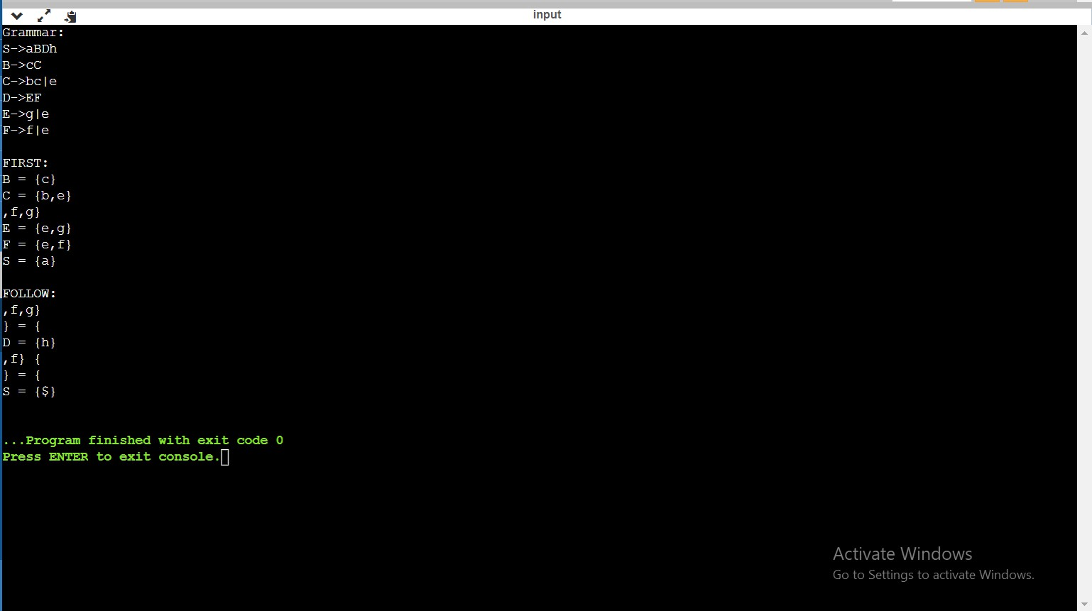

**Conclusion :** In this practical we implemented a program that simulate the process of finding first and follow of a grammar.