**Name** – Bhargav Shamuvel Gurav **PRN** – 2041009

**Class** – L.Y. B-Tech (Computer) **Batch** – B1

**Course Code** – CO406U **Course Name** - CDL

**Practical no. 8**

**Aim:** Design of a Predictive parser of a given language.

**Theory :**

Predictive Parser is also another method that implements the technique of Top- Down parsing without Backtracking. A predictive parser is an effective technique of executing recursive-descent parsing by managing the stack of activation records, particularly.

Predictive Parsers has the following components −

* **Input Buffer** − The input buffer includes the string to be parsed followed by an end marker $ to denote the end of the string.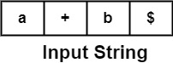

Here a, +, b are terminal symbols.

**Stack** − It contains a combination of grammar symbols with $ on the bottom of the stack. At the start of Parsing, the stack contains the start symbol of Grammar followed by $.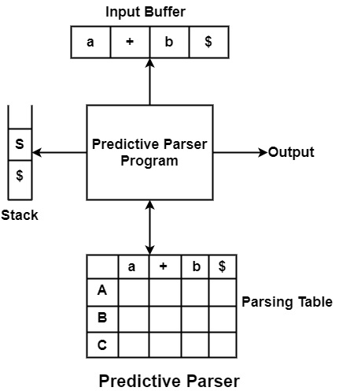

* **Parsing Table** − It is a two-dimensional array or Matrix M [A, a] where A is nonterminal and 'a' is a terminal symbol.

All the terminals are written column-wise, and all the Non-terminals are written rowwise.

* **Parsing Program** − The parsing program performs some action by comparing the symbol on top of the stack and the current input symbol to be read on the input buffer.
* **Actions** − Parsing program takes various actions depending upon the symbol on the top of the stack and the current input symbol. Various Actions taken are given below −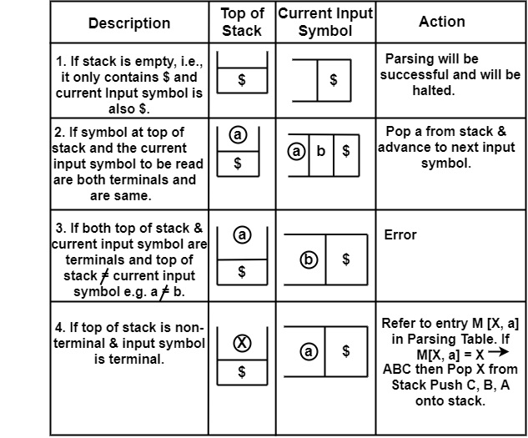

**Algorithm to construct Predictive Parsing Table**

**Input** − Context-Free Grammar G

**Output** − Predictive Parsing Table M

**Method** − For the production A → α of Grammar G.

* For each terminal, a in FIRST (𝛼) add A → α to M [A, a].
* If ε is in FIRST (α), and b is in FOLLOW (A), then add A → α to M[A, b].
* If ε is in FIRST (α), and $ is in FOLLOW (A), then add A → α to M[A, $].
* All remaining entries in Table M are errors.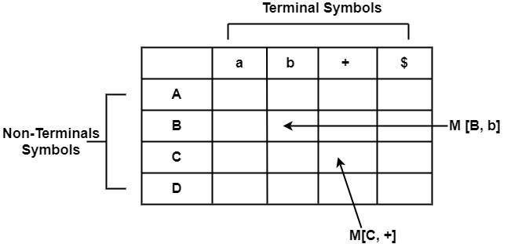

**Following are the steps to perform Predictive Parsing**

* Elimination of Left Recursion
* Left Factoring
* Computation of FIRST & FOLLOW
* Construction of Predictive Parsing Table
* Parse the Input String

**Program Code:**

#include<stdio.h>

#include<conio.h>

#include<string.h>

char prol[7][10]={"S","A","A","B","B","C","C"};

char pror[7][10]={"A","Bb","Cd","aB","@","Cc","@"};

char prod[7][10]={"S->A","A->Bb","A->Cd","B->aB","B->@","C->Cc","C->@"};

char first[7][10]={"abcd","ab","cd","a@","@","c@","@"};

char follow[7][10]={"$","$","$","a$","b$","c$","d$"};

char table[5][6][10];

numr(char c)

{

switch(c)

{

case 'S': return 0;

case 'A': return 1;

case 'B': return 2;

case 'C': return 3;

case 'a': return 0;

case 'b': return 1;

case 'c': return 2;

case 'd': return 3;

case '$': return 4;

}

return(2);

}

void main()

{

int i,j,k;

for(i=0;i<5;i++)

for(j=0;j<6;j++)

strcpy(table[i][j]," ");

printf("\nThe following is the predictive parsing table for the following grammar:\n");

for(i=0;i<7;i++)

printf("%s\n",prod[i]);

printf("\nPredictive parsing table is\n");

fflush(stdin);

for(i=0;i<7;i++)

{

k=strlen(first[i]);

for(j=0;j<10;j++)

if(first[i][j]!='@')

strcpy(table[numr(prol[i][0])+1][numr(first[i][j])+1],prod[i]);

}

for(i=0;i<7;i++)

{

if(strlen(pror[i])==1)

{

if(pror[i][0]=='@')

{

k=strlen(follow[i]);

for(j=0;j<k;j++)

strcpy(table[numr(prol[i][0])+1][numr(follow[i][j])+1],prod[i]);

}

}

}

strcpy(table[0][0]," ");

strcpy(table[0][1],"a");

strcpy(table[0][2],"b");

strcpy(table[0][3],"c");

strcpy(table[0][4],"d");

strcpy(table[0][5],"$");

strcpy(table[1][0],"S");

strcpy(table[2][0],"A");

strcpy(table[3][0],"B");

strcpy(table[4][0],"C");

printf("\n--------------------------------------------------------\n");

for(i=0;i<5;i++)

for(j=0;j<6;j++)

{

printf("%-10s",table[i][j]);

if(j==5)

printf("\n--------------------------------------------------------\n");

}

getch();

}

**Output:**

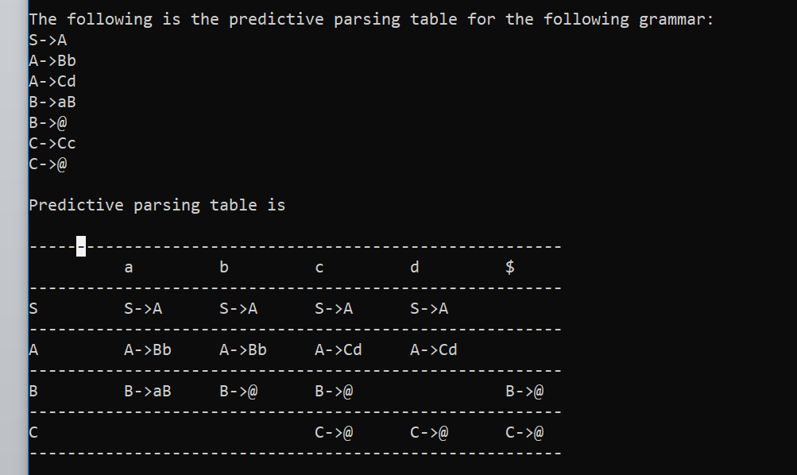

**Conclusion :** In this practical we implemented predictive parser.