**Source Code :**

import random  
  
def feistelWorking(binary_input: str):  
 left = binary_input[:32]  
 right = binary_input[32:]  
 # print(left + right)  
 k = random.randint(1, 42949672)  
 k = format(k, '032b')  
 xor = []  
 for i in range(32):  
 xor.append(int(right[i]) ^ int(k[i]))  
 new_xor = []  
 for i in range(32):  
 new_xor.append(int(xor[i]) ^ int(left[i]))  
 right = "".join(str(i) for i in new_xor)  
 temp = left  
 left = right  
 right = temp  
 total = left + right  
 # print(total)  
 print("The cipher text after 1 round is : ", end=" ")  
 for i in range(0, len(total), 8):  
 print(chr(int(total[i:i+8], 2)), end="")  
 print()  
  
  
  
if __name__ == "__main__":  
 message = input("Enter a message (it should be 8 character long only) : ")  
 binary_of_message = "".join(format(ord(i), '08b') for i in message)  
 feistelWorking(binary_of_message)  
 # print(binary_of_message)

**Output :**

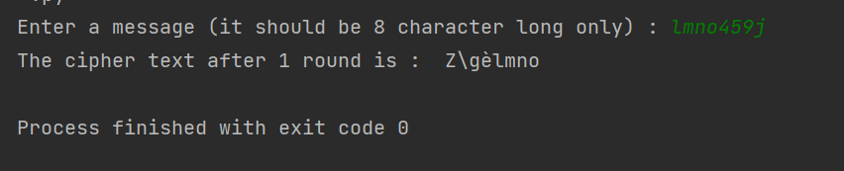

Feistel cipher structure converts plain text to cipher text using the following steps:

