**Source Code :**

import random   
from time import sleep   
  
if __name__ == "__main__":  
 p = int(input("Enter value for p (it must be prime number ) : "))  
 g = int(input("Enter value for g i.e. base : "))  
  
 alice_a = random.randint(1, 20)  
 alice_A = (g ** alice_a) % p   
 print("Alice sent key {} to bob".format(alice_A))  
 sleep(3)  
  
 bob_b = random.randint(1, 20)  
 bob_B = (g ** bob_b) % p   
 print("Bob sent key {} to Alice".format(bob_B))  
 sleep(3)  
  
  
 print("Darth got keys {} and {} from both and he didn't sent the actula keys".format(alice_A, bob_B))  
 sleep(3)  
  
 eve_c = random.randint(1, 20)  
 eve_d = random.randint(1, 20)  
  
 eve_C = (g ** eve_c) % p   
 eve_D = (g ** eve_d) % p  
 print("Darth sent {} key to Bob and {} key to Alice".format(eve_C, eve_D))  
 sleep(3)  
  
 alice_Calculates = (g ** (eve_d * alice_a )) % p   
 bob_calculates = (g ** ( bob_b * eve_c )) % p  
  
 print("Now alice calculates last key {} and bob calculates {} key after Darth intervention.".format(alice_Calculates, bob_calculates))  
 sleep(3)  
   
 alice_acutal_key = (bob_B ** alice_a) % p  
 bob_actual_key = (alice_A ** bob_b) % p   
 print("Actually alice should have key {} and bob should have key {} if Darth didn't intervine".format(alice_acutal_key, bob_actual_key))

**Output :**

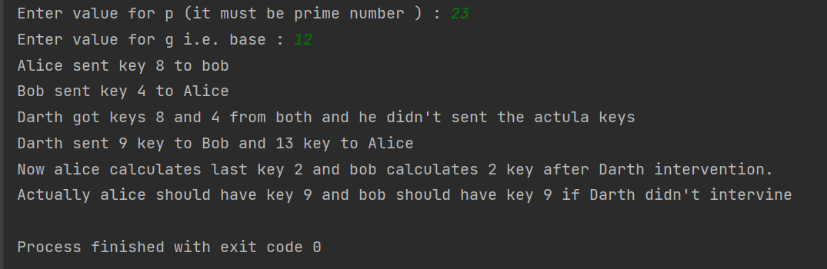

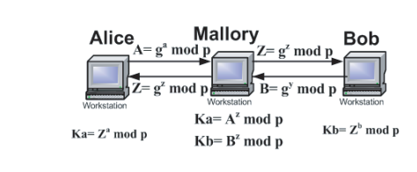

**Fig**. **Man in middle Attack against Diffe-Hellman algorithm**