### Source Code : # organizing imports import cv2 import numpy as np # path to input images are specified and # images are loaded with imread command image1 = cv2.imread('practical_7_inp1.jpg') image2 = cv2.imread('practical_7_inp2.jpg') # cv2.addWeighted is applied over the # image inputs with applied parameters weightedSum = cv2.addWeighted(image1, 0.5, image2, 0.4, 0) weightedSub = cv2.subtract(image1, image2) logicalAnd = cv2.bitwise_and(image1, image2) logicalOR = cv2.bitwise_or(image1, image2) logicalXOR = cv2.bitwise_xor(image1, image2) logicalNot = cv2.bitwise_not(image1) multiplication = cv2.multiply(image1, image2) division = cv2.divide(image1, image2) # the window showing output image # with the weighted sum cv2.imshow('Weighted Image', weightedSum) cv2.imshow('Weighted Image subtraction', weightedSub ) cv2.imshow('Weighted Image multiply', multiplication ) cv2.imshow('Weighted Image division', division ) cv2.imshow('Logical And', logicalAnd) cv2.imshow('Logical OR', logicalOR) cv2.imshow('Logical XOR', logicalXOR) cv2.imshow('Logical Not', logicalNot) # De-allocate any associated memory usage if cv2.waitKey(0) & 0xff == 27: cv2.destroyAllWindows()

**Input :**

 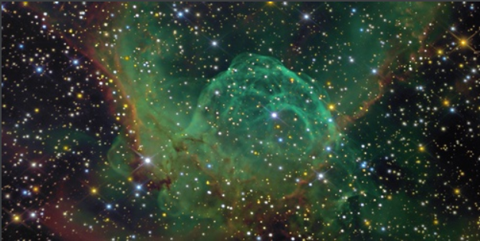

**Addition Subtraction**

 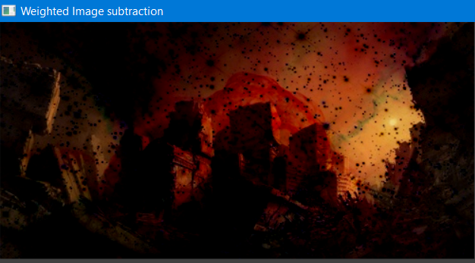

**Multiply Division**

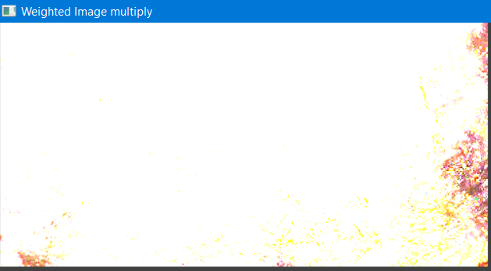 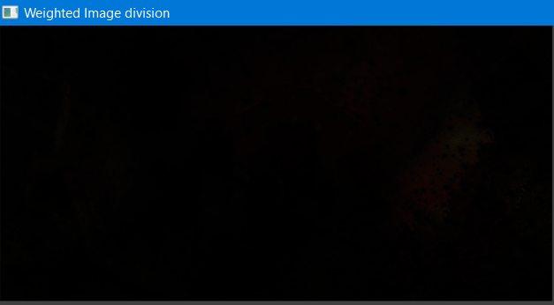

**AND OR**

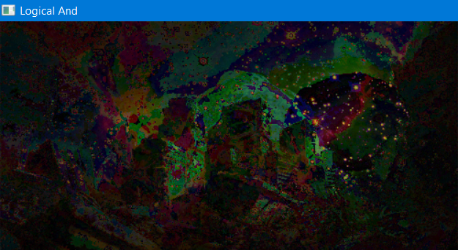 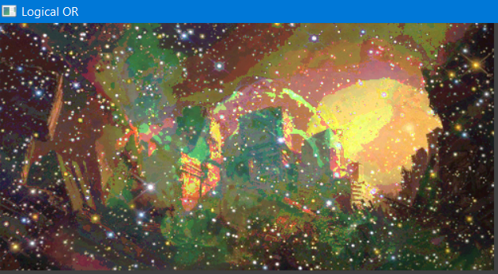

**XOR NOT**

