**Source Code :**

import cv2  
import numpy as np  
  
# Image negative  
img = cv2.imread('practical_2.jpg', 0)  
  
m, n = img.shape  
  
L = img.max()  
  
img_neg = L - img  
  
cv2.imwrite('practical_2_Negative.png', img_neg)  
  
T = 150  
  
img_thresh = np.zeros((m, n), dtype=int)  
  
for i in range(m):  
 for j in range(n):  
 if img[i, j] < T:  
 img_thresh[i, j] = 0  
 else:  
 img_thresh[i, j] = 255  
  
cv2.imwrite('practical_2_Thresh.png', img_thresh)  
T1 = 100  
T2 = 180  
  
img_thresh_back = np.zeros((m, n), dtype=int)  
  
for i in range(m):  
 for j in range(n):  
 if T1 < img[i, j] < T2:  
 img_thresh_back[i, j] = 255  
 else:  
 img_thresh_back[i, j] = img[i, j]  
  
cv2.imwrite('practical_2_Thresh_Back.png', img_thresh_back)

**Output :**

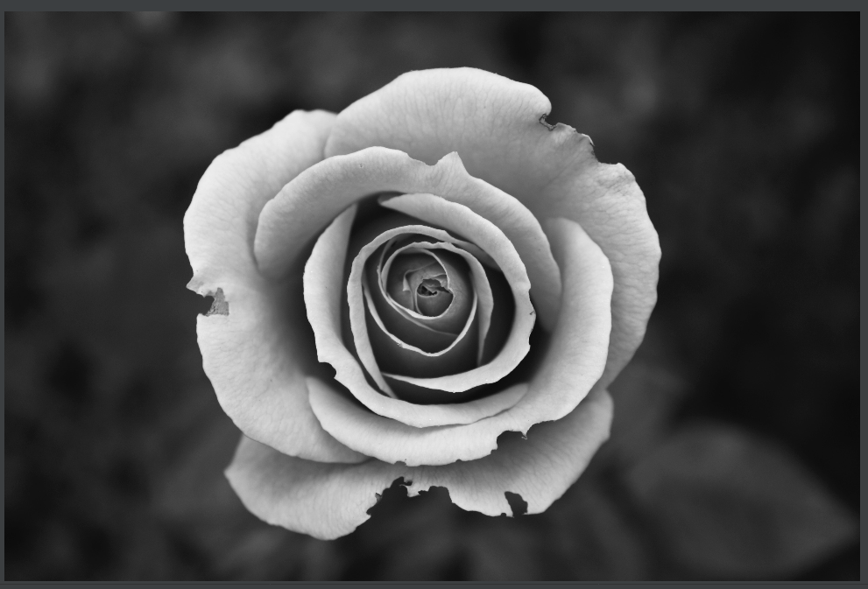 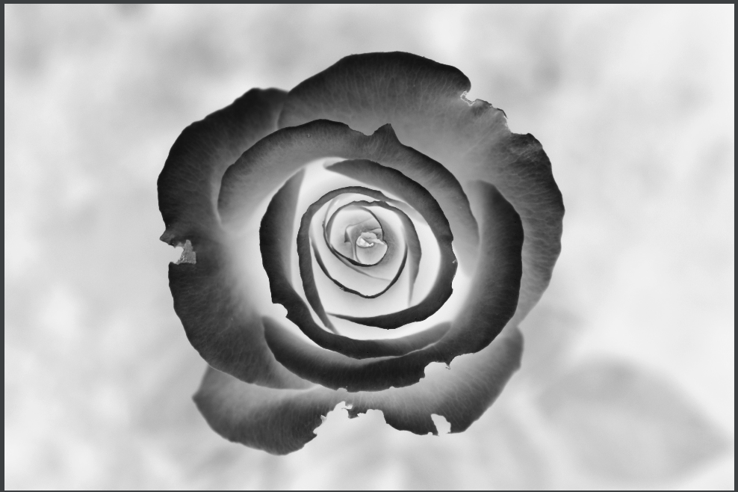

**Original Image Negative image**

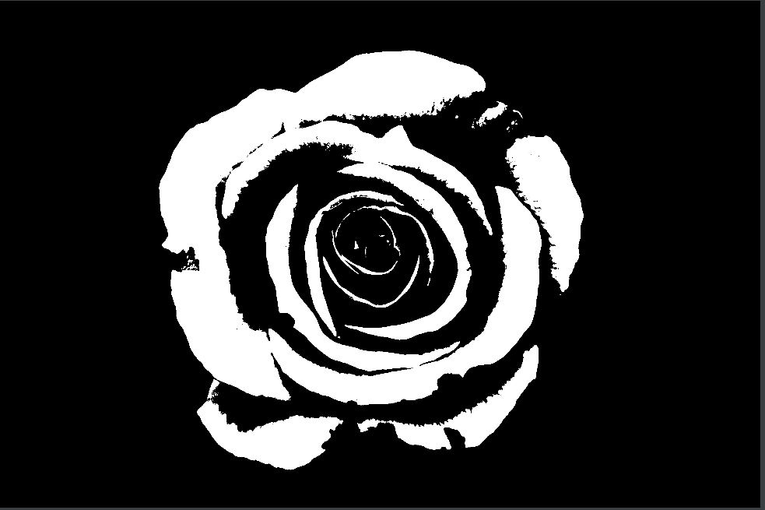 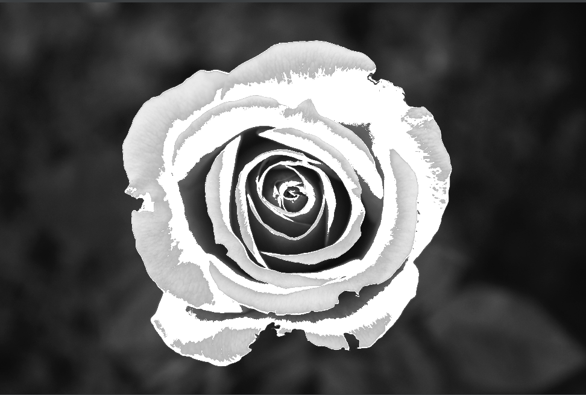

**Image with threshold (150) Image with threshold (180)**